Supplement 1. Estimation of expected annual benefit (EAB) for coastal defence against rising sea levels
Flood risk analysis examines how the risk of coastal flooding changes over time under different sea-level rise scenarios with a focus on the relation between climatic variables (e.g. extreme still water level or sea-level rise) and risks, the latter being hereafter represented by expected monetized flood damages or expected annual damages. This analysis defines avoided risk as benefit from an adaptation option, following conventional flood risk assessments and studies (Grossi and Kunrether, 2005; Hall and Solomartine, 2008). The flood risk analysis assumes that a certain magnitude of coastal event leads to a certain amount of flood damage. Coastal flooding is the consequence of the combining effects of storm surge events and astronomical tides (McMillian et al., 2011). The extents and damages of coastal flood events associated with the possible magnitude of climatic variables (i.e. ESWL+SLR+WAVE) are estimated, assuming for both the current and upgraded defences each year. Hence, this estimation provides a couple of damage curves and a benefit curve for an intervention measure (i.e. raising the crest level of coastal defence) over all the possible climatic variables. Based on that, we have statistically estimated the expected flood damages for both cases and the expected benefit from the intervention each year. This process has been conducted for each SLR scenario. The procedure is summarized in Figure 1.1.

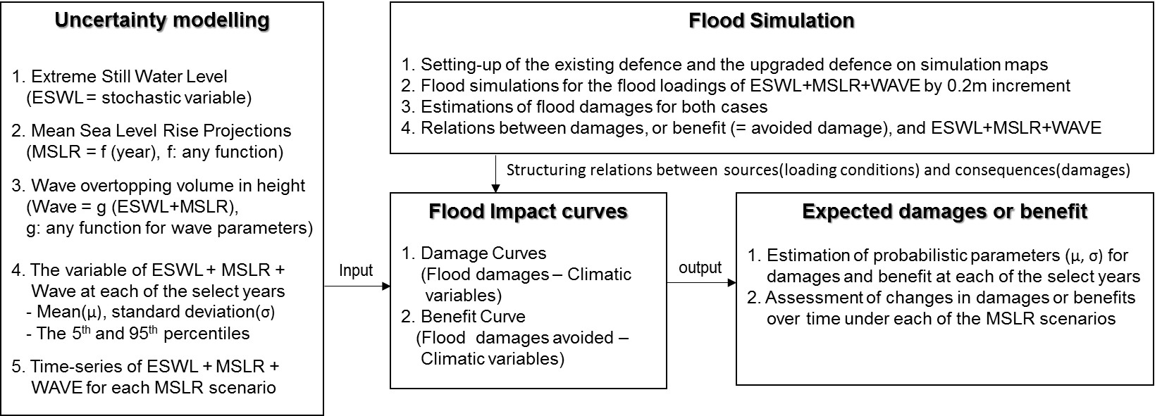
Figure 1.1 The framework of flood risk analysis for evaluating statistically expected monetised damages and benefits in sea-level rise.

  - The effect of sea level rise on coastal flooding
The distributions of extreme still water levels (ESWL) are available every 2km along the UK coastline from the Environment Agency for England and Wales (McMillian et al., 2011; Batstone et al., 2013). The locations of the data points around Lymington are shown in Figure 1.2 a. We assume that the cumulative distribution function (CDF) of ESWL follows an exponential curve for the convenience of data fitting and calculation (R² = 0.99) (Figure 1.2 b).
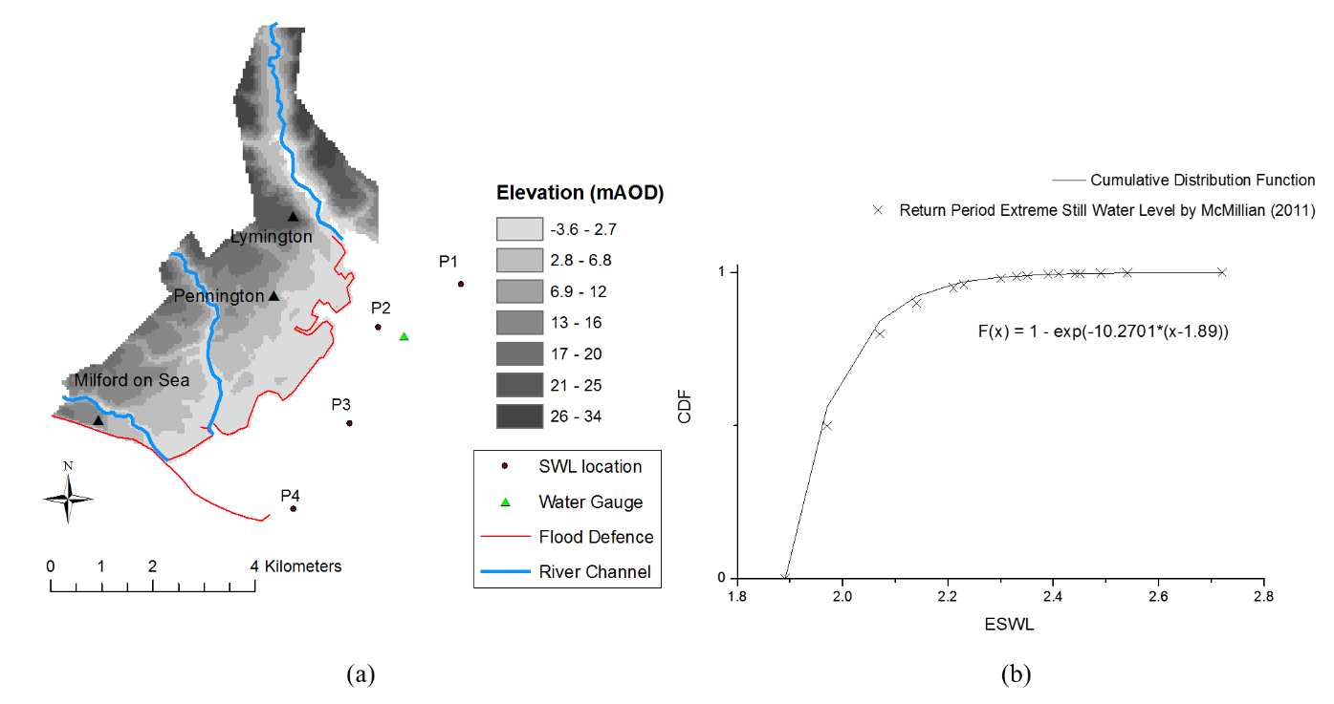
Figure 1.2. (a) Location of data points for extreme still water level around Lymington and (b) Cumulative Distribution Function at the point P1, after McMillan et al (2011)

The UKCP 09 data provides multiple scenarios of sea-level rise depending on greenhouse gas emissions from 1990 to 2100 as shown in Figure 1.3 (Lowe et al., 2009). For illustrative purposes, we also consider a slow-steady projection of historic trends of sea-level rise from the Southampton tidal gauge (Haigh et al., 2009). H1 SLR scenario as an intermediate scenario is generated in order to understand how the flood risk or the performance of coastal adaptation changes between H++ SLR scenario and High SLR scenario.

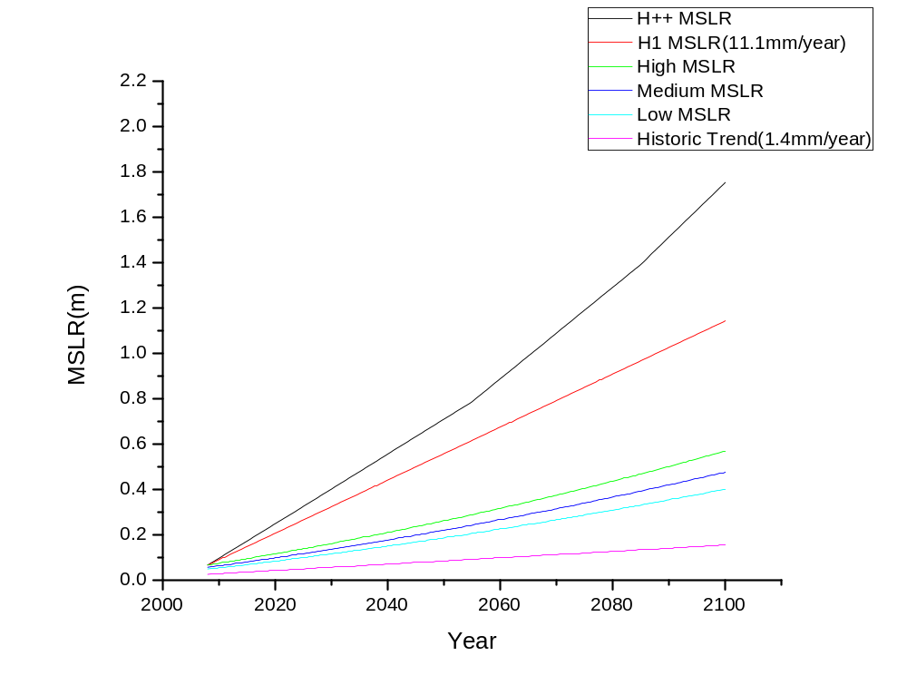
Figure 1.3. Mean sea-level rise (relative to 1990) scenarios for Lymington: 2008 to 2100 (Lowe et al., 2009) - the H++ MSLR is scaled from the global scale sea-level rise scenarios (Nicholls et al., 2014), and the historic trend of sea-level rise (1.4 mm/year) is from the Southampton tidal gauge (Haigh et al., 2009).

We statistically combine mean sea level rise MSLR(t) at the year t with ESWL(t₀), which is a stochastic variable representing extreme still water level at the base year (t₀=2008). Figure 1.4 shows four possible time-series of ESWL+MSLR that result from the combination of MSLR(t) and ESWL(t₀), within the probabilistic range of the corresponding 5th and 95th percentile lines. Sea-level rise shifts the exponential distributions displayed in Figures 1.4 (b) and (c) towards the right, leading to increases in frequency and magnitude of coastal flooding.
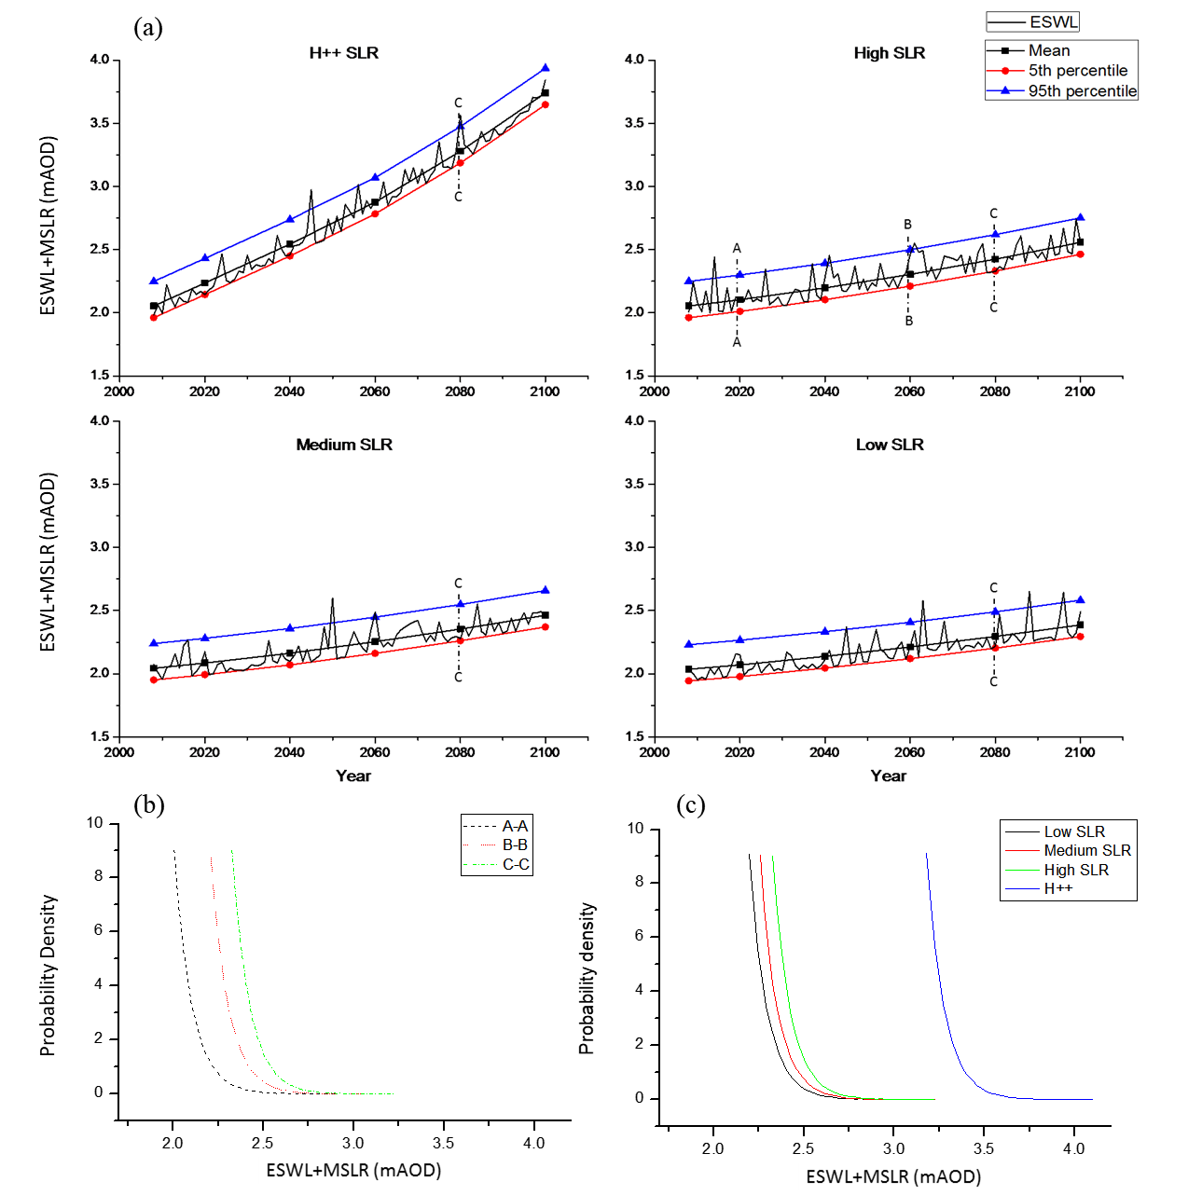
Figure 1.4. (a) Example of stochastically generated time-series of ESWL (annual maximum) for each SLR scenario (b) Temporal change in probability density function (pdf) from the crosslines (A-A, B-B and C-C) for the High SLR scenario (c) Probability density function (PDF) at 2080 from the crossline (C-C) for each SLR scenario (Kim et al., 2018)

1.2. Flood risk analysis
The number of inundated properties and the flood depth of each property have been determined in each flood simulation. Based on property information provided by Ordnance Survey (UK), flood damages for each coastal flood event have been monetised to quantify the risk of the coastal flood event. The monetisation process follows the guideline provided by Environment Agency (2010) and Penning-Rowsell et al. (2010; 2014).
For the estimation of flood risk, this research takes several steps to convert flood extents and depths to economic losses. Firstly, the economic loss of each property within a flooded area has been estimated by a flood depth-damage curve for a property provided by Penning-Roswell et al. (2014). Secondly, all the flood damages for the inundated properties per each flood loading are aggregated for each coastal defence condition. The next step estimates difference in flood damages between the existing and upgraded defence conditions at each flood loading. This estimation shows reduction in flood damage by a flood defence upgrade. Lastly, this process has been iterated with the 0.2m increment of flood loading, providing monetised damage and benefit curves across all the flood loadings (i.e. ESWL+WAVE+SLR) from 1.2 to 4.0 mAOD.

1.2.1 Conversion of flood depth to flood damage in currency
If a property is inundated by a coastal event, the flood event will depreciate the property value with recovery costs incurred. The economic losses also depend on flood depth to which the property is inundated. Multi-Coloured Manual (MCM), which is a commonly used guidance for flood risk analysis in the UK (Penning-Rowsell et al., 2010; 2014), provides a unique relation between damages (£) and flood depths (m) in a property in England and Wales. The MCM defines four types of properties - detached, semi-detached, terraced houses and flat in England and Wales. This analysis, instead, takes the averaged value of the economic losses from all the types of properties at each flood depth. A relationship between the averaged economic losses and the flood depths is plotted as a single square root curve in Figure 1.5.

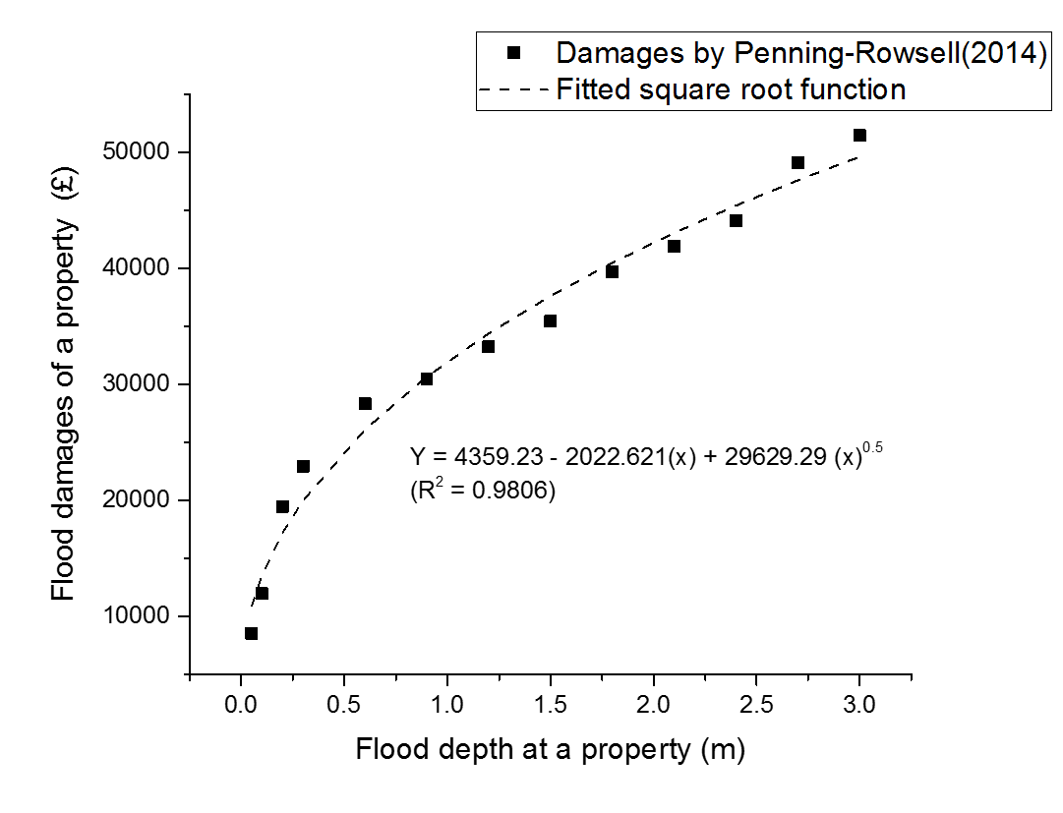
Figure 1.5. Flood damages or economic losses (£) by different flood depths for an inundated property in England and Wales (in 2016 prices)

The economic loss (£) is represented by a square root function of flood depth. This fitted function helps convert a flood depth of each property to a flood damage in currency. All the flood damages of inundated properties are aggregated for each extreme water level discretised with a 0.2m interval. This iterative calculation provides a relation between peak water levels and flood damages for a given coastal defence condition. All the flood damages are monetised in 2016 price. Figure 1.6 show relationships between flood events associated with peak water levels (i.e. ESWL+SLR+WAVE) and flood damages for 5 defence conditions. Each relationship, hereafter called an impact curve, represents the response of the floodplain with the current coastal defence or the upgraded coastal defences to various amounts of coastal flooding.
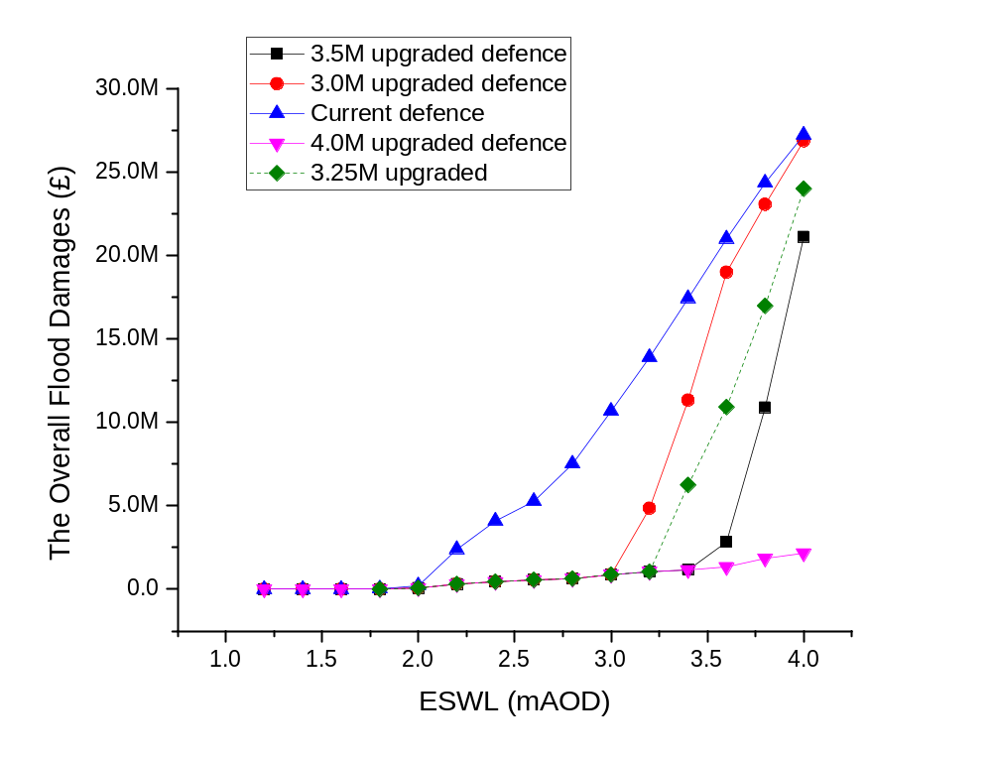
Figure 1.6. The overall flood damages by peak water levels according to different defence conditions in Lymington

1.2.2 Flood risk and expected annual damages (EAD)
Flood risk for any year is represented by expected annual damage (EAD) which is a statistical expectation of flood damage per a year in economic terms (Hall and Solomatine, 2008). This is estimated by integrating all the possible flood damages in respect to the corresponding probabilities. The probability distribution of flood damages, or benefits due to an adaptation measure, is assumed to coincide with the probability distribution of the corresponding flood loadings (i.e. ESWL+SLR+WAVE) that are expected to cause the flood damages or benefits from the adaptation measure. This enables us to estimate expected annual damages (EAD) and expected annual benefits (EAB) for different defence conditions during the period of sea-level rise.
The flood damages are represented with a function of peak water levels (ESWL+WAVE+SLR). To make iterative calculation possible, the relation between flood damages and peak-water levels is expressed in the form of multiple linear functions (R² = 0.99). Thus, the flood damage for each defence condition can be represented by a function of peak water levels (i.e. ESWL+SLR+ WAVE) as shown in equation (1).

 | $$D_{d} = f_{d}(x)$$ | (1)
Here, $D_{d}$ is a flood damage at a certain magnitude of peak water level under a given defence condition, subscribed by d (e.g. the current defence, 3.5m upgrade defence, etc.), $f_{d}$ is any function defining a relation between peak water levels and flood damages, and $x$ is climatic variable of extreme still water level, sea-level rise and wave (i.e. ESWL+SLR+WAVE). As all the componential variables in climatic variable x are random variables, the flood damages represented by equation (1) are also random variables.
The flood damage function ($f_{d}(x)$) for each defence condition is used to convert the probability distribution of ESWL+SLR+ WAVE into the probability distribution of flood damages at any year. This Monte-Carlo simulation-based approach has been conducted for 2008 (the reference year of the probability of ESWL) and every 20 years from 2020 to 2100 in all the SLR scenarios. This paper has modelled changes in flood damages by MSLR, as shown in Figure 1.7.
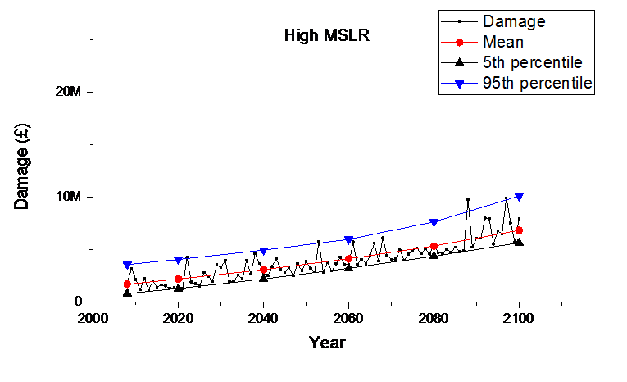
Figure 1.7. Temporal changes in flood damages under the current flood defence in the High MSLR scenario – Note that the time-series of flood damages are randomly generated annual maxima.
The graph in Figure 1.7 shows the possible risk profiles of coastal flooding during sea-level rise by combining storm surge events, astronomical tides and sea-level rise. It shows temporal changes in the mean (red line) and probabilistic range (bounded by blue and black lines) of flood damages under the High SLR scenario. This representation of annual flood damages has important implications in addressing flood risk assessment issues.
Firstly, the random time-series of flood damages for the current coastal flood defence have been quantified based on the current projections of future sea-level rise and the extremity of coastal flooding (i.e. extreme still water level and wave). Thus, the annual flood risk (EAD) reflects all the stochastic properties of factors which have effects on flood damage at a given year. Secondly, the mean value of flood damage at a given year implies the most likely value of flood damage at the year. Thus, the mean value of flood damage represents expected annual damage (EAD) in a given year.

  - Flood reduction and expected annual benefit (EAB)
A selection of a pair of impact curves provides a unique relation as the performance of an adaptation measure taken for a wide range of flood loadings as shown in Figure 1.8.

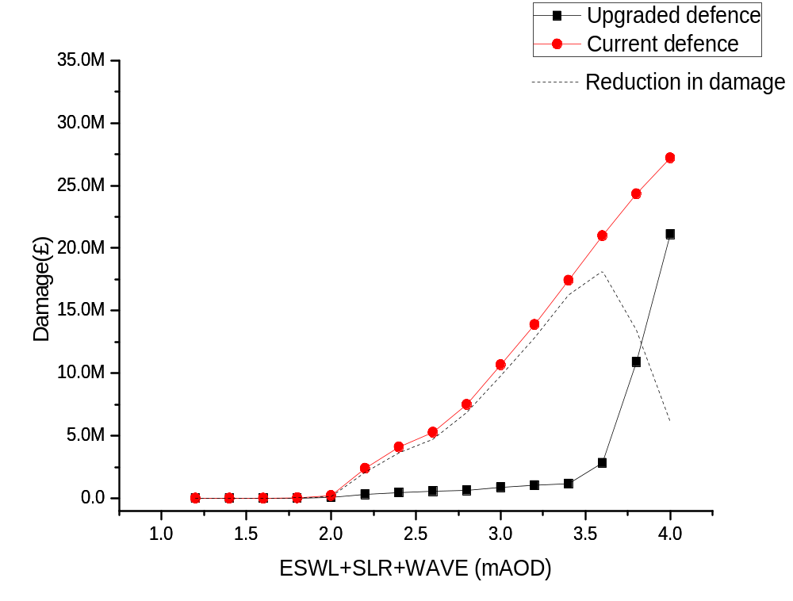
Figure 1.8. Monetised flood damages and reduction in the monetised flood damages (£ in 2016).

The benefit from the upgrade of the coastal defence at any year is also random variable dependant on the loading conditions of ESWL+SLR+WAVE. As seen in Figure 1.8, the benefit from an adaptation option has discontinuity with climatic variable at extremely high water levels. In other words, the flood damage reduction effect declines beyond a certain water level. This is because of the capacity of the adaptation option. In this regard, the estimation of expected annual benefits (EAB) also needs to adopt a computerised approach (i.e. a Monte-Carlo simulation) to sample a large number of variables of ESWL+SLR+ WAVE from a predefined probability distribution at a given year into the benefit relation. This helps construct a new probability distribution of benefit values for a given intervention measure (i.e. the upgrade of coastal defence). The examples of change in EAB (i.e. mean) and its probabilistic range (i.e. 5th and 95th percentiles) over time are shown for an adaptation measure ($U_{c→3.5m}$) in the cases of High MSLR (Figure 1.9).
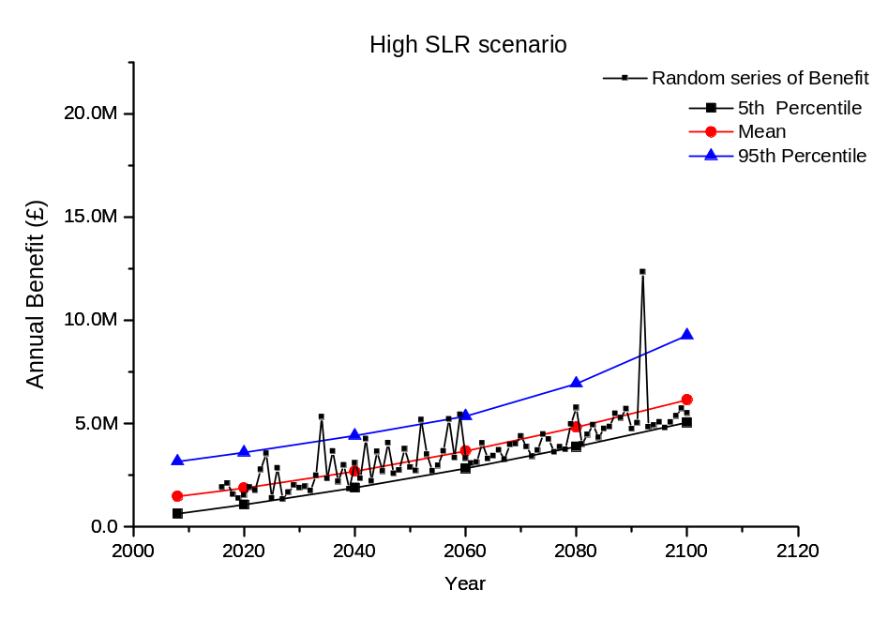
Figure 1.9. Changes in benefit from the upgrade of coastal defence (the current level 3.5 mAOD) and its probabilistic range under each MSLR scenario
As sea level rises, the benefit from the upgrade of coastal defence increases. As the rising sea level increases the likelihood of flood damages in the floodplain, it leads to increase in the utility of the upgraded coastal defence. The mean values (red line) plotted in Figure 1.9 describe the statistical expectation of benefit values (i.e. EAB) from the present perspective. As the future value is uncertain and random, EAB has to be estimated upon the statistical expectation towards the future. Likewise, a real option decision either to invest, or wait, at any year should be based on the statistical expectation of the benefit values in the future. If the investment decision is made with the expectation of a high impact, but low probability, event or past flood events which occurred at any year, the decision will always lead to immediate investment in an adaptation option at any occasion.
As shown in Figure 1.9, the trajectories of the 5th and 95th percentiles allow us to visualise how random benefit values occur with a certain probability (i.e. 90%). This illustrates that, although the extreme events out of the 95th percentile line are plausible in Lymington during the 21st century, EAB after the introduction of an adaptation measure changes smoothly. This also implies that our statistical estimation of the expected values or expected flood damages that may occur in the future gradually change under the non-stationarity of climatic variables, even if we observe a disastrous flood event that has a harmful effect on human environments. Thus, the estimation of EAB provides an economically rational basis upon which to assess real options and to make a real option decision. Note that EAB is the performance of the upgraded coastal defence versus the previous coastal defence against plausible coastal flooding.
The flood risk will be immediately reduced after the first-stage adaptation has been complemented. As long as the first-stage adaptation performs effectively against plausible coastal flooding, the expected flood damage or the number of flood events will decline. Thus, the second-stage adaptation is less useful from the current perspective. If mean sea level does not rise any longer, the second-stage adaptation will remain unimplemented. On contrary, if the sea level keeps rising around Lymington, the utility of the second-stage adaptation will increase. As shown in Figure 1.10, the expected annual benefits of the second adaptation increase with different patterns according to the rates of sea-level rise. The levels of the upgraded coastal adaptation and the previous coastal adaptation determine the benefit curves as well. The EAB of a coastal adaptation at any year implies a statistical value that decision-makers expect to obtain if the coastal adaptation has been made at the year. Temporal changes in EAB for the second-stage coastal adaptations, are drawn by different SLR scenarios as below.
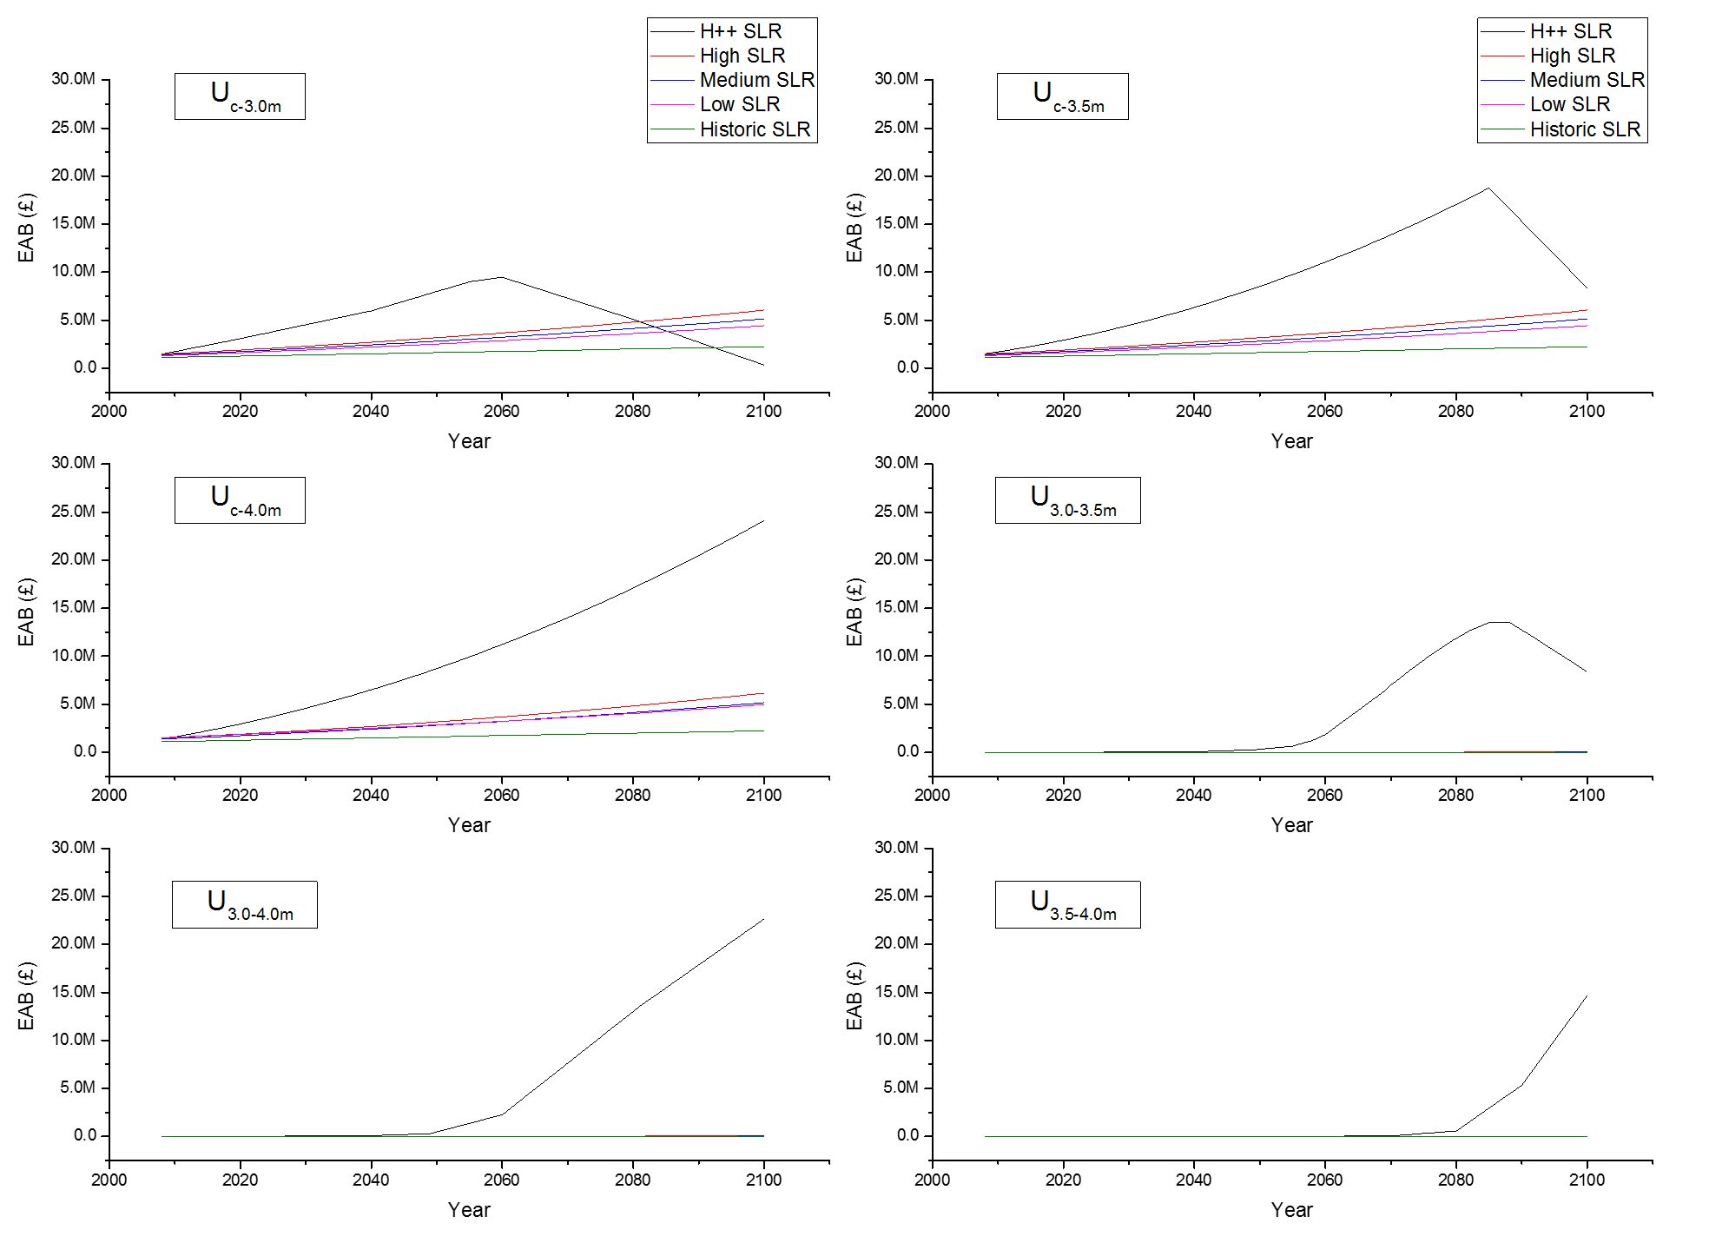
Figure 1.10. Changes in EAB over time for each of the adaptation measures under each sea-level rise scenario for Lymington. Term $U_{i→j}$ is an adaptation measure of raising the crest of coastal defence from the initial height (i) to the upgraded height (j). This terminology also represents adaptation pathways by putting terms together. For example, a two-stage defence upgrade from the current level - it is termed (c) in the paper - through 3.0 mAOD to 3.5 mAOD is denoted by $U_{c→3.0m}*U_{3.0m→3.5m}$.
References
EA. 2010. Flood and Coastal Erosion Risk Management appraisal guidance: FCERM-AG. Published by Environmental Agency. Available: https://assets.publishing.service.gov.uk/government/uploads/system/uploads/attachment_data/file/481768/LIT_4909.pdf [Accessed June 1, 2016].
GROSSI, P. and KUNREUTHER, H. 2005. Catastrophe modeling: a new approach to managing risk, Springer Science & Business Media.
HAIGH, I., NICHOLLS, R. and WELLS, N. 2009. Mean sea level trends around the English Channel over the 20th century and their wider context. Continental Shelf Research, 29, 2083-2098.
HALL, J. and SOLOMATINE, D. 2008. A framework for uncertainty analysis in flood risk management decisions. International Journal of River Basin Management, 6, 85-98.
KIM, M.-J., NICHOLLS, R. J., PRESTON, J. M. and DE ALMEIDA, G. A. M. 2018. An assessment of the optimum timing of coastal flood adaptation given sea-level rise using real options analysis. Journal of Flood Risk Management, 0, e12494.
LOWE, J., HOWARD, T., PARDAENS, A., TINKER, J., HOLT, J., WAKELIN, S., MILNE, G., LEAKE, J., WOLF, J. and HORSBURGH, K. 2009. UK Climate Projections science report: Marine and coastal projections. Published by Met Office Hadely Centre. Available: http://ukclimateprojections.metoffice.gov.uk/media.jsp?mediaid=87906&filetype=pdf [Accessed July 1, 2017].
MCMILLAN, A., BATSTONE, C., WORTH, D., TAWN, J., HORSBURGH, K. and LAWLESS, M. 2011. Coastal flood boundary conditions for UK mainland and islands. Project SC060064/TR2: Design sea levels.
NICHOLLS, R. J., HANSON, S. E., LOWE, J. A., WARRICK, R. A., LU, X. and LONG, A. J. 2014. Sea‐level scenarios for evaluating coastal impacts. Wiley Interdisciplinary Reviews: Climate Change, 5, 129-150.
PENNING-ROWSELL, E., JOHNSON, C., TUNSTALL, S., TAPSELL, S., MORRIS, J., CHATTERTON, J. and GREEN, C. 2010. The benefits of flood and coastal risk management: a handbook of assessment techniques, Middlesex University Press
PENNING-ROWSELL, E., PRIEST, S., PARKER, D., MORRIS, J., TUNSTALL, S., VIAVATTENE, C., CHATTERTON, J. and OWEN, D. 2014. Flood and coastal erosion risk management: a manual for economic appraisal, London, Routledge.

Supplement 2. Investment costs for multiple-stage adaptation
As this analysis evaluates a set of adaptation measures within each adaptation pathway, the investment cost for the upgrade of the coastal defence should be defined for option evaluations under each sea-level rise scenario. As aforementioned, dividing one single-stage adaptation into two parts of sequential adaptations needs additional costs in order to maintain flexibility in the sequential adaptations. Thus, the increases in cost due to the incorporation of flexibility in engineering or physical options need to be considered as variables that affect investment decisions in the real options analysis of future growth options. This analysis assumes that the overall cost of sequential investments is higher than the cost of the equivalent single investment that would be made at once. If any additional expenditure does not occur to maintain flexibility, option holders or options analysts must choose multiple-stage adaptations to address uncertainty in investment decisions. Such a decision will always give decision-makers flexibility at no price. This is not realistic and possible in practice to the best of our knowledge. In climate change adaptation, these additional expenditures for flexibility are attributable to the increased amount of construction work, mobility or additional enabling costs (e.g. approval). Thus, the increase in the overall cost is defined as a premium to be paid for future extension or flexibility, which conceptually corresponds to a call or put option premium (Dixit and Pindyck, 1994; Park, 2002).
This research assumes 20%, 30%, 40% and 50% premium scenarios for the analysis of the option to grow by multiplying an original investment cost (I) by the premium rates. That is, when a single large investment is divided into two sequential investments, the division increases the investment cost of each stage as much as the premium cost as expressed in equation (1).

 | $$I_{o}+I_{f}= I_{1,o}+I_{2,o}$$ | (1)

Here, $I_{o}$is an investment cost for an original option, $I_{f}$ is an option premium to be paid for flexibility, and $I_{1,o}$and $I_{2,o}$ are the first and second stage investment costs, respectively.
The analysis of the costs during the project life involves the identification of all the relevant cash flows relating to the acquisition and use of assets for building coastal defences (EA, 2015). The key components of costs considered during the life of coastal defences are as follows: (1) procurements and design costs; (2) capital construction costs; (3) operation and maintenance costs; (4) monitoring costs; and (5) replacement and decommissioning costs (ibid). As the estimation of a capital cost for construction needs a site-specific information on defence types, environmental conditions (e.g. water levels and coast line), working conditions (e.g. accessibility to construction sites) and the availability of materials, it is difficult to provide an accurate estimate of coastal defence cost in the early stage of projects (EA, 2015). Environment Agency (EA) in the UK provides the indicative costs of coastal defence available for very early-stage projects or natural level assessments as shown in Table 2.1.

Table 2.1 Indicative costs associated with the cost of coastal defences (EA, 2015)
Options | Capital cost | Maintenance cost | Indicative cost (£/m)
Beach recharge and breakwater | High | Medium | –
Beach recharge and groynes | High | Medium | –
Rock armour | High | Low | –
Impermeable revetments and seawalls | High | Low | 2,000–5,000
Timber revetments | Medium | Medium | 20–500
Rock revetments | High | Low | 1,000–3,000
Groynes | Medium | Medium | 10,000 to 100,000 per structure
Nearshore breakwaters | Medium | Low | 400–1,000
Artificial rock dune protection | Medium | Low | 200–600
Gabion revetments | Medium | Medium | 50–500
Beach nourishment | Medium | Medium | 50–2,000
Shingle recycling/ re-profiling | Low | Low | 10–200

The costs for a single large investment have been taken from the North Solent Shoreline management (NFCD, 2010). This plan estimated the investment cost for the replacement of coastal defence for Lymington (i.e. Impermeable revetments and seawalls) at £ 64.2 million, which includes a maintenance cost over the life of the project (100 years). The upgrade of coastal defence is planned to be implemented 30 to 60 years later. To estimate the cost of dike heightening in each stage, this research uses Van dantzig model (1956) which assumes that the cost of defence heightening ($I$) has a linear relation with the raised height ($H$). This model provides a simple representation of relationship between the cost of dike heightening and the increase in dike height in equation (2) (Slijkhuis et al., 1997)
 | $$I=I_{m}+I^{'}*\left(H-H_{0}\right)$$ | (2)
Here, $I_{m}$ is mobilisation cost, $I^{'}$ is a unit cost per the meter of dike heightening, and $H, H_{0}$ is the raised level and the initial level of the defence crest, respectively. The lowest crest level of coastal defence is measured at 2.5 mAOD in Lymington. Thus, $H_{0}$ is set to be 2.5 mAOD in this model. A mobilisation cost ($I_{m}$) is assumed to be approximately 10% of the total capital cost, following the EA guidance (EA, 2015). As the capital cost is proportional to increase in the height of the coastal defence by the model, the capital cost and total cost for different levels of coastal defence are assessed as shown in Table 2.2.

Table 2.2 Estimate of indicative costs for the coastal defence upgrade by different sizes of heightening for a single-stage investment option

Upgrade options | Total costs (I) | Mobilisation costs (I₀) | Capital cost  $$I^{'}*\left(H-H_{0}\right)$$ | Remark
$$U_{c→3.0m}$$ | £ 32.1 M | £ 2.9 M | £ 29.2 M | I₀ = 10% × $$I^{'}*\left(H-H_{0}\right)$$
$$U_{c→3.25m}$$ | £ 48.2 M | £ 4.4 M | £ 43.8 M | I₀ = 10% × $$I^{'}*\left(H-H_{0}\right)$$
$$U_{c→3.5m}$$ | £ 64.2 M | £ 5.8 M | £ 58.4 M | I₀ = 10% × $$I^{'}*\left(H-H_{0}\right)$$
$$U_{c→4.0m}$$ | £ 96.3 M | £ 8.7 M | £ 87.6 M | I₀ = 10% × $$I^{'}*\left(H-H_{0}\right)$$

This paper adds premium values for flexibility on the estimated indicative cost of the upgraded coastal defence (Table 2.2) when the single-stage upgrade is transformed into the two- or more- stage upgrade. For example, if the coastal defence is upgraded to 3.5 mAOD level in two stages, this two-stage upgrade incurs premium costs which are calculated by multiplying the premium rates and the original investment cost (e.g. £ 64.2 M). The estimated premium cost is evenly-distributed to each stage of the investment. This rule applies thoroughly for the evaluation of the premium cost – although three-stage adaptations or adaptations of different increment need more complicated process or assumptions to distribute the investment costs to each stage. The estimated investment costs of each stage for different premium scenarios (e.g. 20%, 30%, 40% and 50%) are shown for 3.5 mAOD and 4.0 mAOD level defence upgrade in Table 2.3 and 2.4.

Table 2.3 Indicative costs for the upgrade of coastal defence up to 3.5 mAOD by different premium scenarios
- $U_{c→3.0m}*U_{3.0m→3.5m}$
Adaptation paths | Premium  scenarios (1) | Original investment cost (2) | Premium cost  (3)=(2)×(1) | Investment cost  (4)=(2)+(3) | Cost for the 1st upgrade  (5)=1/2×(4) | Cost for the 2nd upgrade  (6)=1/2×(4)
$$U_{c→3.5m}$$ | 0% | £ 64.20 M | 0 | £ 64.20 M | - | -
$U_{c→3.0m}*$ $U_{3.0m→3.5m}$ | 20% | £ 64.20 M | £ 9.60 M | £ 77.04 M | £ 38.52 M | £ 38.52 M
$U_{c→3.0m}*$ $U_{3.0m→3.5m}$ | 30% | £ 64.20 M | £ 14.45 M | £ 83.46 M | £ 41.73 M | £ 41.73 M
$U_{c→3.0m}*$ $U_{3.0m→3.5m}$ | 40% | £ 64.20 M | £ 19.26 M | £ 89.88 M | £ 44.94 M | £ 44.94 M
$U_{c→3.0m}*$ $U_{3.0m→3.5m}$ | 50% | £ 64.20 M | £ 24.25 M | £ 96.33 M | £ 48.16 M | £ 48.16 M

Table 2.4. Indicative costs for the upgrade of the coastal defence up to 4.0 mAOD for different premium scenarios
- $U_{c→3.0m}*U_{3.0m→4.0m}$
Adaptation paths | Premium  scenarios  (1) | Original investment cost (2) | Premium cost  (3)=(2)×(1) | Investment cost  (4)=(2)+(3) | Cost for the 1st upgrade  (5)=1/2×(4) | Cost for the 2nd upgrade  (6)=1/2×(4)
$U_{c→3.0m}$* $U_{3.0m→4.0m}$ | 20% | £ 96.30 M | £ 19.38 M | £ 116.28 M | £ 58.14 M | £ 58.14 M
$U_{c→3.0m}$* $U_{3.0m→4.0m}$ | 30% | £ 96.30 M | £ 29.07 M | £ 125.96 M | £ 62.98 M | £ 62.98 M
$U_{c→3.0m}$* $U_{3.0m→4.0m}$ | 40% | £ 96.30 M | £ 38.76 M | £ 135.66 M | £ 67.83 M | £ 67.83 M
$U_{c→3.0m}$* $U_{3.0m→4.0m}$ | 50% | £ 96.30 M | £ 48.45 M | £ 145.36 M | £ 72.68 M | £ 72.68 M

- $U_{C→3.0m}*U_{3.0m→3.5m}*U_{3.5m→4.0m}$
Adaptation  paths | Premium scenario  (1) | Investment cost  (2)=(4)+(5)+(6) | Premium cost  (3) | The cost for the 1st upgrade  (4)* | The cost for the 2nd upgrade  (5)** | The cost for the 3rd upgrade  (6)**
$U_{c→3.0m}$* $U_{3.0m→3.5m}$*  $$U_{3.5m→4.0m}$$ | 20% | £ 127.91 M | £ 31.31 M | £ 58.14 M | £ 34.89 M | £ 34.89 M
$U_{c→3.0m}$* $U_{3.0m→3.5m}$*  $$U_{3.5m→4.0m}$$ | 30% | £ 144.86 M | £ 48.26 M | £ 62.98 M | £ 40.94 M | £ 40.94 M
$U_{c→3.0m}$* $U_{3.0m→3.5m}$*  $$U_{3.5m→4.0m}$$ | 40% | £ 162.79 M | £ 66.19 M | £ 67.83 M | £ 47.48 M | £ 47.48 M
$U_{c→3.0m}$* $U_{3.0m→3.5m}$*  $$U_{3.5m→4.0m}$$ | 50% | £ 181.70 M | £ 85.1 M | £ 72.68 M | £ 54.51 M | £ 54.51 M

* Costs in column (4) are taken from costs in column (5) of $U_{c→3.0m}$* $U_{3.0m→4.0m}$
** Costs in columns (5) and (6) are taken from columns (5) and (6) in $U_{3.0m→3.5m}*U_{3.5m→4.0m}$, respectively.

- $U_{c→3.5m}*U_{3.5m→4.0m}$
Adaptation paths | Premium  scenarios  (1) | Original investment cost (2) | Premium cost  (3)=(2)×(1) | Investment cost  (4)=(2)+(3) | Cost for the 1st upgrade  (5)* | Cost for the 2nd upgrade  (6) = (4) – (5)
$U_{c→3.5m}$* $U_{3.5m→4.0m}$ | 20% | £ 96.30 M | £ 19.32 M | £ 116.28 M | £ 73.89 M | £ 41.79 M
$U_{c→3.5m}$* $U_{3.5m→4.0m}$ | 30% | £ 96.30 M | £ 28.89 M | £ 125.97 M | £ 78.74 M | £ 46.63 M
$U_{c→3.5m}$* $U_{3.5m→4.0m}$ | 40% | £ 96.30 M | £ 38.52 M | £ 135.66 M | £ 83.58 M | £ 51.48 M
$U_{c→3.5m}$* $U_{3.5m→4.0m}$ | 50% | £ 96.30 M | £ 48.15 M | £ 145.35 M | £ 88.42 M | £ 56.33 M

* A cost in column (5) is the sum of the original cost (£ 64.2M) of $U_{c→3.5m}$ and the half of the premium cost in column (3)

- $U_{c→3.25m}*U_{3.25m→4.0m}$
Adaptation paths | Premium  scenarios  (1) | Original investment cost (2) | Premium cost  (3)=(2)×(1) | Investment cost  (4)=(2)+(3) | Cost for the 1st upgrade  (5)* | Cost for the 2nd upgrade  (6)= (4) – (5)
$U_{c→3.25m}$* $U_{3.25m→4.0m}$ | 20% | £ 96.30 M | £ 19.32 M | £ 116.28 M | £ 66.02 M | £ 49.67 M
$U_{c→3.25m}$* $U_{3.25m→4.0m}$ | 30% | £ 96.30 M | £ 28.89 M | £ 125.97 M | £ 70.86 M | £ 54.51 M
$U_{c→3.25m}$* $U_{3.25m→4.0m}$ | 40% | £ 96.30 M | £ 38.52 M | £ 135.66 M | £ 75.71 M | £ 59.36 M
$U_{c→3.25m}$* $U_{3.25m→4.0m}$ | 50% | £ 96.30 M | £ 48.15 M | £ 145.35 M | £ 80.55 M | £ 64.19 M

* A cost in column (5) is the average cost of $U_{c→3.0m}$ in $U_{c→3.0m}*U_{3.0m→4.0m}$ and $U_{c→3.5m}$ in $U_{c→3.5m}*U_{3.5m→4.0m}$
References
DIXIT, A. K. and PINDYCK, R. S. 1994. Investment under uncertainty, Princeton, Princeton university press.
EA. 2015. Cost estimation for coastal protection –summary of evidence, Environment Agency Report –SC080039/R7
NFDC. 2010. North Solent shoreline management plan. Appendix H Economic Appraisal and Sensitivity Testing. Published by New Forest District Council (UK). Available: http://www.northsolentsmp.co.uk/ [Accessed June 1, 2016]
PARK, C. S. 2002. Contemporary engineering economics, Prentice Hall Upper Saddle River, NJ.
SLIJKHUIS, K., VAN GELDER, P. and VRIJLING, J. 1997. Optimal dike height under statistical-construction-and damage uncertainty. Structural Safety and Reliability, 7, 1137-1140.

Supplement 3. Option evaluations for adaptations with flexibility
  - Option evaluation for single-stage adaptation
This paper first considers the single-stage upgrade of raising the crest level from the current level (i.e. approximately 2.5 mAOD) to 3.0 mAOD, 3.5 mAOD or 4.0 mAOD under the uncertainty of future sea-level rise, respectively. The height of 1-in-200 year storm surge event is 2.41 mAOD in Lymington. Thus, the current coastal defence system is marginally capable of protecting Lymington from possible flood events. However, its capacity will not be sufficient due to sea-level rise in the future. Thus, there is a concern of whether the upgrade of coastal defence is necessary for Lymington and when it is implemented in the future. The calculation of a continuation and termination value for each year is conducted under each MSLR scenario. Figure 3.1 illustrates an option evaluation process by the backward induction method.
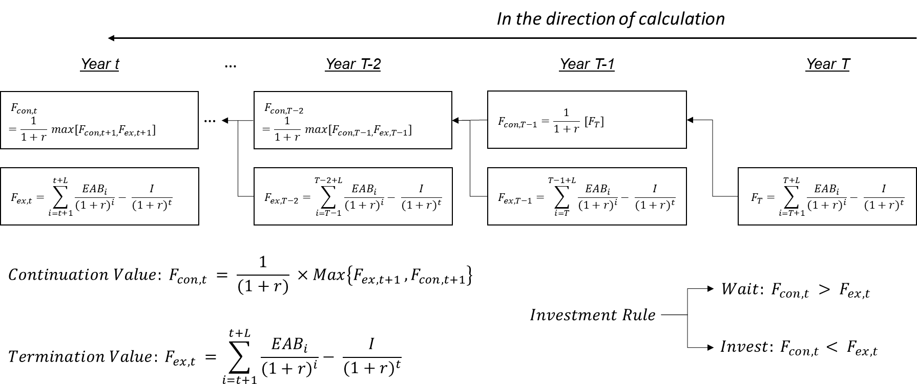
Figure 3.1 The concept and process of real options valuation based on dynamic programming (Bellman, 1952)

The calculation of the continuation and termination values starts from the end of the period of wait (denoted by T) using a backward induction method (Bellman, 1952; Dixit and Pindyck, 1994; Yang and Blyth, 2007). Table 3.1 summarises investment conditions for option evaluation.
Table 3.1. Conditions for real options analysis in Lymington
Investment conditions | Details
Discount Rate  (HM Treasury) | 3.5% (0 – 30 years)  3.0% (31 to 75 years)  2.5% (after 75 years)
Project Life (L) | 100 years
Post 2100 Sea Level Rise  (average rates from 2090 to 2100)  The rates are assumed constant after 2100 | H++ MSLR: 24.1 mm/year  High MSLR: 6.8 mm/year  Medium MSLR: 5.7 mm/year  Low MSLR: 4.7 mm/year  Historical MSLR: 1.4mm/year

Figure 3.2 shows how the option value for the upgrade of coastal defence changes according to investment time in each MSLR scenario. As shown in Figure 3.2, the termination value (black line) is little smaller than the continuation value (red line) at 2016 for all the MSLR scenarios, except the fastest rise in sea level (the H++ SLR scenario). As we move forwards in time, the termination value exceeds the continuation value at a certain time, indicating the optimum time to invest. By this information, we can determine when the investment should be implemented in order to produce the largest net profit (i.e. the overall benefits minus the overall costs) given a sea-level rise scenario. After the optimum investment time, the option value keeps declining with time so that the deferrable adaptation option becomes less and less efficient in economic term.

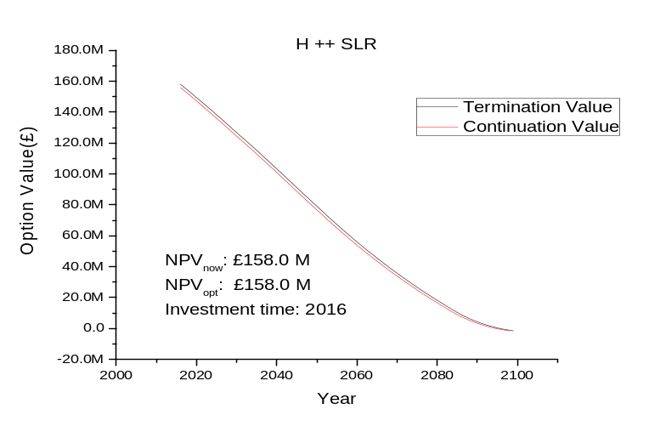
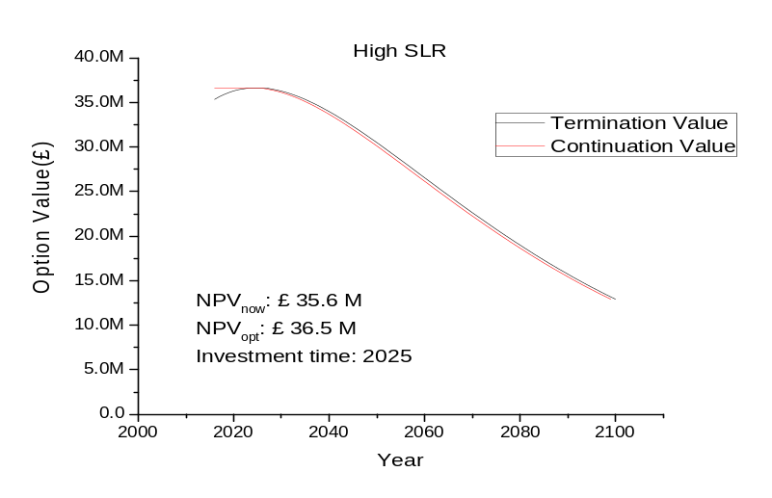
(Continue)
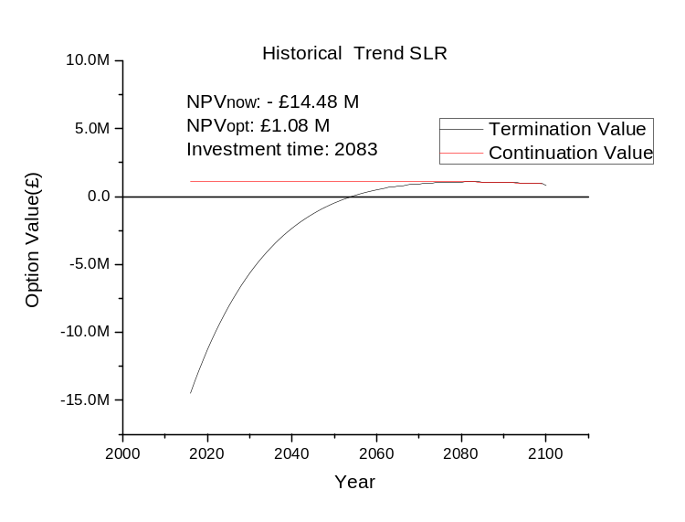
Figure 3.2 Option values by termination value (black line) and continuation value (orange line) for different sea-level rise scenarios – all the option values are present value in 2016. Note the very different scales on the y-axis.
Importantly, the more extreme the MSLR scenario is, the earlier the optimum investment time occurs. For rapid sea-level rise, we need to react quickly, while. for slow sea-level rise, we have more time to act. In addition, the difference between the option values of the optimum investment (i.e. NPV_{opt}) and the immediate investment (i.e. NPV_{now}) indicates the value of flexibility that option holders can gain from delaying the adaptation option under a given MSLR scenario. As the Historic trend scenario has the slowest rate of sea-level rise (i.e. 1.4mm/yr), both option values (i.e. NPV_{now}, NPV_{opt}) are the lowest among all the MSLR scenarios with NPV_{now} estimated to be negative.
Table 3.2. Results of real options analysis by different MSLR scenarios.
Scenarios | H++ | High | Medium | Low | Historic trend
Investment cost | £ 64.20 M | £ 64.20 M | £ 64.20 M | £ 64.20 M | £ 64.20 M
Optimal Investment Time | 2016  (i.e. now) | 2025 | 2029 | 2033 | 2083
NPV_{now} | £ 158.0 M | £ 35.3 M | £ 23.19 M | £ 13.92 M | £ (-) 14.48 M
NPV_{opt} | £ 158.0 M | £ 36.5 M | £ 25.46 M | £ 17.77 M | £ 1.08 M
∆(=NPV_{opt}- NPV_{now}) | 0 M | £ 1.2 M | £ 2.27 M | £ 3.85 M | £ 15.56 M

In the H++ MSLR scenario, sea level will rise by 1.75m in 2100. As expected, this scenario gives the highest NPV_{now} and NPV_{opt} and the earliest optimal investment time (2016) among all the MSLR scenarios. This is acceptable because the risk of coastal flooding is very high and fast-growing. In this case, the investment in 2016 already gives a larger option value than delaying the option. Thus, the investment was already optimal in 2016 in the most extreme scenario. (More generally, it is found that, when the rate of sea-level rise exceeds 4.9mm/year, the optimal investment time occurs in 2016).
There are two noteworthy points from the results of this extreme scenario. Firstly, the upgrade of coastal defence up to 3.5 mAOD will become less and less useful with time unless the investment is made. The extremity of coastal flooding due to sea-level rise will have reached the limit of coastal defence capacity in 2080. Thus, the expected annual benefit (EAB) starts to decline (See graph U_{c-3.5m} in Figure 1.10) from this time because of the capacity of the upgraded defence. This implies that the coastal defence needs to be raised higher than the current plan (raising up to 3.5 mAOD) if sea-level rise follows the H++ MSLR scenario. Thus, an additional adaptation option or a higher standard-of-protection defence should be considered for the protection of Lymington under the H++ SLR scenario. The real options analysis explicitly shows that the real option values –continuation and termination values – are below zero after 2095 as shown in the H++ SLR scenario (Figure 3.2). This implies there is no use of an adaptation measure with such a low standard of protection after 2095, even if the coastal flooding is very severe due to sea-level rise. Secondly, the option value in the H++ MSLR scenario rapidly declines from £158 million in 2016. Thus, the early detection of the rate of sea-level rise is a critical task for the optimal investment, if the extreme sea-level rise is occurring.
Single-stage adaptation options for different levels (e.g. 3.0 mAOD, 3.5 mAOD and 4.0 mAOD) are assessed across different SLR scenarios. In addition, since the investment is made only in one stage, there is no additional cost to be paid for flexibility. These simple investments (i.e. $U_{c→3.0m}, U_{c→3.5m}$and $U_{c→4.0m}$) are used, as baselines, to compare the efficiency of multiple-stage adaptations. The option value (NPV_{opt}) and optimal investment time (OIT) are calculated for each single-stage adaptation. Also, the option value of the immediate investment is assessed for each adaptation in Table 3.3.
As seen in Table 3.3, for $U_{c→3.0m}$ whose adaptation cost is the least, the optimal investment time is all now regardless of SLR scenarios. As the overall benefit from the investment now is much higher than the investment cost, the optimal investment for $U_{c→3.0m}$ is to invest now. The result of option evaluations concludes that adaptation options at such a low cost need to be implemented now regardless of SLR scenarios. On the other hand, for the adaptations of $U_{c→3.5m}$ and $U_{c→4.0m}$, the optimal investment time changes depending on SLR scenarios. Although the optimal investment time differs depending on SLR scenarios for this case, the values of sea-level rise at the optimal investment time are similar to each other for all the SLR scenarios. Thus, the value of sea-level rise at the optimal investment time can be used as an indicative value to tigger an adaptation option (Kim et al., 2018). However, in the H++ SLR scenario, sea-level is fast-growing and has increased over the capacity of the coastal defence so that the optimal investment time occurs now (2016) for all the adaptation options. It is because the later the investment is in such an extreme condition, the less likely the investment gain benefits in the future.

Table 3.3 Option values (i.e. NPV_{now} and NPV_{opt}) of investments now and at the optimal time by different SLR scenarios for each single-stage adaptation – Note that, if NPV_{now} is maximum, NPV_{opt} is NPV_{now}.
Adaptation paths | SLR scenarios | Investment cost | NPV_{now} | NPV_{opt} | Investment time | SLR at the optimal time
$$U_{c→3.0m}$$ | H++ | £ 32.1M | £ 124.8 M | £ 124.8 M | Now (i.e. 2016) | 19 cm
$$U_{c→3.0m}$$ | H1 | £ 32.1M | £131.4 M | £131.4 M | Now (i.e. 2016) | 16cm
$$U_{c→3.0m}$$ | High | £ 32.1M | £ 67.2 M | £ 67.2 M | Now (i.e. 2016) | 10 cm
$$U_{c→3.0m}$$ | Medium | £ 32.1M | £ 54.9 M | £ 54.9 M | Now (i.e. 2016) | 8 cm
$$U_{c→3.0m}$$ | Low | £ 32.1M | £ 45.7 M | £ 45.7 M | Now (i.e. 2016) | 7 cm
$$U_{c→3.0m}$$ | Historic | £ 32.1M | £ 17.3 M | £ 17.3 M | Now (i.e. 2016) | 4 cm
$$U_{c→3.25m}$$ | H++ | £ 48.2M | £145.6 M | £ 145.6 M | Now (i.e. 2016) | 19 cm
$$U_{c→3.25m}$$ | H1 | £ 48.2M | £137.0 M | £137.0 M | Now (i.e. 2016) | 16 cm
$$U_{c→3.25m}$$ | High | £ 48.2M | £ 51.1 M | £ 51.1 M | Now (i.e. 2016) | 10 cm
$$U_{c→3.25m}$$ | Medium | £ 48.2M | £ 40.0 M | £ 40.0 M | Now (i.e. 2016) | 8 cm
$$U_{c→3.25m}$$ | Low | £ 48.2M | £ 29.6 M | £ 29.6 M | Now (i.e. 2016) | 7 cm
$$U_{c→3.25m}$$ | Historic | £ 48.2M | £ 0.9 M | £ 4.5 M | 2042
$$U_{c→3.5m}$$ | H++ | £ 64.2M | £ 158.0 M | £ 158.0 M | Now (i.e. 2016) | 19 cm
$$U_{c→3.5m}$$ | H1 | £ 64.2M | £ 135.5 M | £ 135.5 M | Now (i.e. 2016) | 16 cm
$$U_{c→3.5m}$$ | High | £ 64.2M | £ 35.3 M | £ 36.5 M | 2025 | 14 cm
$$U_{c→3.5m}$$ | Medium | £ 64.2M | £ 23.2 M | £ 25.5 M | 2029 | 13 cm
$$U_{c→3.5m}$$ | Low | £ 64.2M | £ 13.9 M | £ 17.7 M | 2033 | 13 cm
$$U_{c→3.5m}$$ | Historic | £ 64.2M | £ (-) 14.5 M | £ 1.08 M | 2083 | 13 cm
$$U_{c→4.0m}$$ | H++ | £ 96.3M | £ 175.4 M | £ 175.4 M | Now (i.e. 2016) | 19 cm
$$U_{c→4.0m}$$ | H1 | £ 96.3M | £ 103.9 M | £ 105.8 M | 2022 | 23cm
$$U_{c→4.0m}$$ | High | £ 96.3M | £ 3.26 M | £ 20.6 M | 2048 | 25 cm
$$U_{c→4.0m}$$ | Medium | £ 96.3M | £ (-) 8.98 M | £ 12.4 M | 2056 | 25 cm
$$U_{c→4.0m}$$ | Low | £ 96.3M | £ (-) 18.2 M | £ 7.2 M | 2066 | 25 cm
$$U_{c→4.0m}$$ | Historic | £ 96.3M | £ (-) 46.6 M | £ (-) 0.84 M | No investment | -

Option evaluation for two- or three- stage adaptation options
Based on the temporal changes in EAB, the continuation and termination values can be calculated from the end of the project year (i.e. 2100) by using the backward induction method as done in the calculation of the single-stage adaptation. For an illustrative purpose, this supplementary document takes an example of $U_{3.0m→3.5m}$ to calculate both the termination and continuation values as shown in Figure 3.3. This graph enables us to know not only the maximum option value decision-makers can gain by the future growth option, but also the investment time when the second-stage adaptation should be made. The option value of the upgraded coastal adaptation (i.e. $U_{3.0m→3.5m})$ adds to the option value of the previous coastal adaptation (i.e. $U_{c→3.0m})$ under each SLR scenario. The overall option values of the multiple-stage adaptations are evaluated in this way.
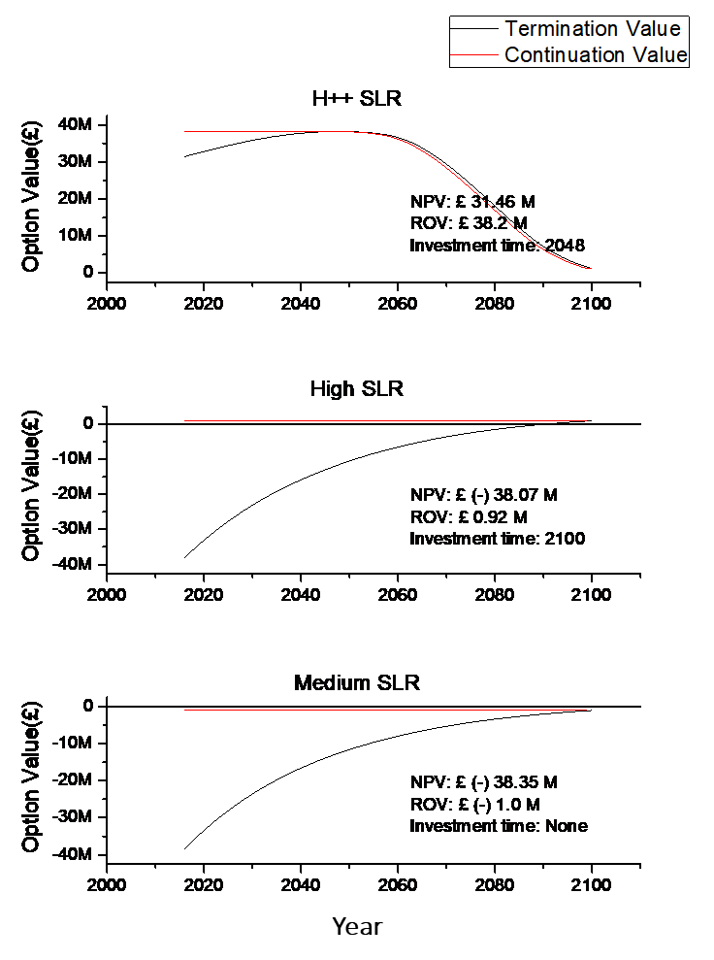
Figure 3.3. The option values (i.e. termination and continuation values) and optimal investment times for the next-stage coastal adaptation ($U_{3.0m→3.5m})$ by different SLR scenarios – The investment cost is £ 38.52 M.
In H++ SLR scenario, the option value (NPV_{opt}) of $U_{3.0m→3.5m}$ is £ 38.2M with the investment time of 2048. Until 2048, the termination value (black line) is lower than the continuation value (red line). This implies that the adaptation needs to be awaited until the termination value exceeds the continuation value. Thus, the second-stage adaptation option should be deferred for the optimality. As the first-stage adaptation $U_{c→3.0m}$ has been implemented in 2016 and this adaptation is expected to perform well during the wait, the decision made on the second-stage coastal adaptation will give the maximum option value for the adaptation path of $U_{c→3.0m}*U_{3.0m→3.5m}$ under the H++ SLR scenario.
However, the continuation value in High SLR scenario is so close to zero that the optimal investment time occurs around 2100. As seen in Figrue d, the termination value (black line) reaches the continuation value (red line) at 2100 in High SLR scenario. Even in milder SLR scenarios, the continuation value is below zero over the 21st century so that the investment in the second stage adaptation will not occur. For Medium, Low and Historical trend SLR scenarios, the second-stage adaptation will not be implemented. The investment cost for the second-stage adaptation will be saved for option evaluation. Thus, the investment cost and option value for the second stage adaptation becomes zero under Medium, Low and Historical SLR scenarios. The overall option values, investment costs and optimal investment times for each adaptation path are estimated under different SLR scenarios.

- $U_{c→3.0m}*U_{3.0m→3.5m}$
When the coastal defence is raised to 3.0 mAOD in the first stage, the optimal investment time occurs now (i.e. 2016) for all the SLR scenarios. It is because, as the initial investment cost in the first stage is the least among all the adaptation options, the investment now (NPV_{now}) provides the highest option value. Thus, for the first stage adaptation ($U_{c→3.0m}$), the investment now is optimal (i.e. NPV_{now} = NPV_{opt}). However, in the Historical SLR scenario, $U_{c→3.0m}$ needs to be deferred a little as this option is also excessive. In this mildest scenario, the optimal investment is to invest in 2025, 2033 and 2042 for 30%, 40% and 50% flexibility costs, respectively.
For the H++ SLR scenario, coastal flooding over the surge level of 3.0 mAOD are expected to occur more frequently from 2050 onwards. As sea-level rise reaches 1.75m at the end of the 21st century in this scenario, the second upgrade ($U_{3.0m→3.5m}$) will be needed to protect Lymington in a short period. On the contrary, for other SLR scenarios, coastal flooding over 3.0 mAOD will rarely occur during the 21st century. Thus, the adaptation measure ($U_{3.0m→3.5m}$) may be considered to be excessive or inefficient in these mild SLR scenarios. For instance, if the High SLR scenario realise, the implementation of the second adaptation option will just be needed at the end of 21st century (i.e. 2100). In SLR scenario milder than the High SLR scenario, the optimal investment for the second adaptation option is to do nothing. The option values and the optimal investment times of the second adaptation option ($U_{3.0m→3.5m}$) have also been estimated under different SLR scenarios. The overall results of option evaluations are shown in Table 3.4. Generally, the faster sea levels rise, the higher the option values of adaptation options are. In addition, as the cost of flexibility increases, the overall option value decreases.
Table 3.4. Option values (NPV_{opt}) and optimal investment times (OIT) by different premium costs in different SLR scenarios for the adaptation path of $U_{c→3.0m}*U_{3.0m→3.5m}$.
SLR scenario | Premium scenario | The first phase adaptation ($U_{c→3.0m})$ |  |  | The second phase adaptation ($U_{3.0m→3.5m})$ |  |  | The overall adaptations  ($U_{c→3.0m}*U_{3.0m→3.5m})$
SLR scenario | Premium scenario | I+I_{f}  (£ M) | NPV_{OPT}  (£ M) | OIT | I+I_{f}  (£ M) | NPV_{OPT}  (£ M) | OIT | I+I_{f}  (£ M) | NPV_{OPT}  (£ M)
H++ | 20% | 38.52 | 118.4 | Now | 38.52 | 38.2 | 2048 | 77.04 | 156.6
H++ | 30% | 41.73 | 115.3 | Now | 41.73 | 37.6 | 2049 | 83.46 | 152.9
H++ | 40% | 44.94 | 112.0 | Now | 44.94 | 36.6 | 2051 | 89.88 | 148.6
H++ | 50% | 48.16 | 108.8 | Now | 48.16 | 35.7 | 2052 | 96.33 | 144.5
H1 | 20% | 38.52 | 125.0 | Now | 38.52 | 26.3 | 2060 | 77.04 | 151.3
H1 | 30% | 41.73 | 121.8 | Now | 41.73 | 25.6 | 2062 | 83.46 | 147.4
H1 | 40% | 44.94 | 118.6 | Now | 44.94 | 24.9 | 2064 | 89.88 | 143.5
H1 | 50% | 48.16 | 115.4 | Now | 48.16 | 24.3 | 2065 | 96.33 | 139.7
High | 20% | 38.52 | 60.6 | Now | 38.52 | 0.92 | 2100 | 77.04 | 61.52
High | 30% | 41.73 | 57.4 | Now | 41.73 | 0.81 | 2100 | 83.46 | 58.21
High | 40% | 44.94 | 54.32 | Now | 44.94 | 0.64 | 2100 | 89.88 | 54.96
High | 50% | 48.16 | 50.9 | Now | 48.16 | 0.46 | 2100 | 96.33 | 51.36
Medium | 20% | 38.52 | 48.5 | Now | 38.52(0) | -1.0 (0) | - | 38.52 | 48.5
Medium | 30% | 41.73 | 45.4 | Now | 41.73(0) | -1.1 (0) | - | 41.73 | 45.4
Medium | 40% | 44.94 | 42.2 | Now | 44.94(0) | -1.3 (0) | - | 44.94 | 42.2
Medium | 50% | 48.16 | 38.9 | Now | 48.16(0) | -1.5 (0) | - | 48.16 | 38.9
Low | 20% | 38.52 | 39.3 | Now | 38.52(0) | -1.6 (0) | - | 38.52 | 39.3
Low | 30% | 41.73 | 36.2 | Now | 41.73(0) | -1.7 (0) | - | 41.73 | 36.2
Low | 40% | 44.94 | 32.9 | Now | 44.94(0) | -1.9 (0) | - | 44.94 | 32.9
Low | 50% | 48.16 | 29.6 | Now | 48.16(0) | -2.0 (0) | - | 48.16 | 29.6
Historical  Trend | 20% | 38.52 | 10.9 | Now | 38.52(0) | -2.1 (0) | - | 38.52 | 10.9
Historical  Trend | 30% | 41.73 | 8.3 | 2025 | 41.73(0) | -2.3 (0) | - | 41.73 | 8.3
Historical  Trend | 40% | 44.94 | 6.1 | 2033 | 44.94(0) | -2.4 (0) | - | 44.94 | 6.1
Historical  Trend | 50% | 48.16 | 4.6 | 2042 | 48.16(0) | -2.6 (0) | - | 48.16 | 4.6
* In the second phase, if NPV_{opt} is estimated to be negative, there is no need to invest in the second phase upgrade. Thus,
the investment cost and NPV_{opt} is represented to be zero with no investment in the column of optimal investment time.

- $U_{c→3.5m}*U_{3.5m→4.0m}$
As investigated in the previous adaptation path, the two-stage upgrade up to 3.5 mAOD cannot protect Lymington in the H++ SLR scenario where extreme water levels above 3.5 mAOD are likely to occur. The higher level of coastal defence will be needed if this scenario is expected to occur. In the H++ SLR scenario, the adaptation path with the start of 3.5 mAOD level upgrade in the first stage may be more efficient than other adaptation paths including 3.0 mAOD level coastal defence in the first stage. The first adaptation option ($U_{c→3.5m}$) of $U_{c→3.5m}*U_{3.5m→4.0m}$ is more costly than the equivalent single-stage adaptation option ($U_{c→3.5m}$) due to the cost of flexibility. Table 3.5 shows the results of $U_{c→3.5m}*$ $U_{3.5m→4.0m}$ by different costs of flexibility (I_{f}) in different SLR scenarios.
For the H++ SLR scenario, the optimal investment for the first adaptation option is to implement now. The second investment will follow in the second optimal investment time (i.e. 2068 to 2077) which depends on flexibility costs. The optimal investment in milder SLR scenarios (i.e. High, Medium and Low SLR scenarios) differ form that in the H++ SLR scenario. The first adaptation option will be implemented in 2032 to 2058 or the no investment will be made in the Historical SLR scenario. Investment in the second adaption will not be made for any mild SLR scenarios as it is considered excessive. This is a case where the investment cost is inefficiently allocated for the first and second stage adaptations. It is because the costs of first and second adaptations are excessive and inefficient.

- $U_{c→3.0m}*U_{3.0m→4.0m}$
The previous two-stage upgrades have evenly distributed the cost of flexibility into each stage of the adaptation path. When considering a higher standard-of-protection coastal defence in the final stage, the distribution rule for investment costs needs to be modified to allocate more costs in the first stage than in the later stage. For example, the first-stage investment which is extendable to 4.0 mAOD in all the stages should cost more than the investment extendable up to 3.5 mAOD. In practice, more extendable coastal adaptations may require stronger base and wider area than less extendable one. For simplicity, flexibility cost (I_{f}) has been added to the original cost of $U_{c→4.0m}$ and the overall cost including flexibility cost (I_{o}+I_{f}) has been halved into the costs of $U_{c→3.0m}$ and $U_{3.0→4.0m}$. Table 3.6 shows the option values of $U_{c→3.0m}*U_{3.0→4.0m}$ under different SLR scenarios and costs of flexibility.
In the H++ SLR scenario, the optimal investment for the first adaptation option is to implement immediately while the optimisation of the second adaptation option is to invest in 2050 to 2052. On the contrary, in other mild SLR scenarios (i.e. High, Medium and Low SLR scenarios), the first adaptation option has different optimal investment times (2019 to 2100) whereas the second adaptation option will not be made in the 21st century. The overall investment cost will be spent on the first stage adaptation option in these mild scenarios.

Table 3.5. Option values (NPV_{opt}) and optimal investment times (OIT) by different premium values in different SLR scenarios for the adaptation path of $U_{c→3.5m}*U_{3.5m→4.0m}$
SLR scenario | Premium scenario | The first phase adaptation $(U_{c→3.5m})$ |  |  | The second phase adaptation ($U_{3.5m→4.0m})$ |  |  | The overall adaptations  ($U_{c→3.5m}*U_{3.5m→4.0m})$
SLR scenario | Premium scenario | I+I_{f}  (£ M) | NPV_{OPT}  (£ M) | OIT | I+I_{f}  (£ M) | NPV_{OPT}  (£ M) | OIT | I+I_{f}  (£ M) | NPV_{OPT}  (£ M)
H++ | 20% | 73.89 | 146.5 | Now | 41.79 | 13.89 | 2068 | 116.28 | 160.39
H++ | 30% | 78.74 | 143.5 | Now | 46.63 | 13.62 | 2071 | 125.97 | 157.12
H++ | 40% | 83.58 | 138.6 | Now | 51.48 | 12.82 | 2074 | 135.66 | 151.42
H++ | 50% | 88.42 | 133.8 | Now | 56.32 | 12.31 | 2077 | 145.35 | 146.11
H1 | 20% | 73.89 | 125.9 | Now | 41.79 | 9.11 | 2094 | 116.28 | 135.01
H1 | 30% | 78.74 | 121.1 | Now | 46.63 | 8.83 | 2095 | 125.97 | 129.93
H1 | 40% | 83.58 | 116.4 | 2018 | 51.48 | 8.52 | 2096 | 135.66 | 124.92
H1 | 50% | 88.42 | 111.9 | 2019 | 56.32 | 8.28 | 2097 | 145.35 | 120.18
High | 20% | 73.89 | 30.4 | 2032 | 41.79(0) | -2.32(0) | - | 73.89 | 30.4
High | 30% | 78.74 | 27.8 | 2036 | 46.63(0) | -2.59(0) | - | 78.74 | 27.8
High | 40% | 83.58 | 25.5 | 2039 | 51.48(0) | -2.86(0) | - | 83.58 | 25.5
High | 50% | 88.42 | 23.5 | 2043 | 56.32(0) | -3.13(0) | - | 88.42 | 23.5
Medium | 20% | 73.89 | 20.1 | 2038 | 41.79(0) | -2.32(0) | - | 73.89 | 20.1
Medium | 30% | 78.74 | 18 | 2042 | 46.63(0) | -2.59(0) | - | 78.74 | 18
Medium | 40% | 83.58 | 16.2 | 2046 | 51.48(0) | -2.86(0) | - | 83.58 | 16.2
Medium | 50% | 88.42 | 14.6 | 2050 | 56.32(0) | -3.13(0) | - | 88.42 | 14.6
Low | 20% | 73.89 | 13.3 | 2044 | 41.79(0) | -2.32(0) | - | 73.89 | 13.3
Low | 30% | 78.74 | 11.5 | 2049 | 46.63(0) | -2.59(0) | - | 78.74 | 11.5
Low | 40% | 83.58 | 10.1 | 2054 | 51.48(0) | -2.86(0) | - | 83.58 | 10.1
Low | 50% | 88.42 | 8.9 | 2058 | 56.32(0) | -3.13(0) | - | 88.42 | 8.9
Historical  Trend | 20% | 73.89(0) | -1.6(0) | - | 41.79(0) | -2.32(0) | - | 0 | 0
Historical  Trend | 30% | 78.74(0) | -1.9(0) | - | 46.63(0) | -2.59(0) | - | 0 | 0
Historical  Trend | 40% | 83.58(0) | -2.1(0) | - | 51.48(0) | -2.86(0) | - | 0 | 0
Historical  Trend | 50% | 88.42(0) | -2.4(0) | - | 56.32(0) | -3.13(0) | - | 0 | 0

Table 3.6. Option values (NPV_{opt}) and optimal investment times (OIT) by different premium values in different SLR scenarios for the adaptation path of $U_{c→3.0m}*U_{3.0m→4.0m}$.
SLR scenario | Premium scenario | The first phase adaptation ($U_{c→3.0m})$ |  |  | The second phase adaptation ($U_{3.0m→4.0m})$ |  |  | The overall adaptations  ($U_{c→3.0m}*U_{3.0m→4.0m})$
SLR scenario | Premium scenario | I+I_{f}  (£ M) | NPV_{OPT}  (£ M) | OIT | I+I_{f}  (£ M) | NPV_{OPT}  (£ M) | OIT | I+I_{f}  (£ M) | NPV_{OPT}  (£ M)
H++ | 20% | 58.14 | 99.11 | Now | 58.14 | 54.97 | 2050 | 116.28 | 154.08
H++ | 30% | 62.98 | 94.27 | Now | 62.98 | 53.49 | 2051 | 125.97 | 147.76
H++ | 40% | 67.83 | 89.42 | Now | 67.83 | 52.04 | 2052 | 135.66 | 141.46
H++ | 50% | 72.68 | 84.57 | Now | 72.68 | 50.63 | 2052 | 145.35 | 135.20
H1 | 20% | 58.14 | 105.4 | Now | 58.14 | 22.63 | 2069 | 116.28 | 128.03
H1 | 30% | 62.98 | 100.6 | Now | 62.98 | 21.86 | 2071 | 125.97 | 122.46
H1 | 40% | 67.83 | 95.6 | Now | 67.83 | 21.13 | 2072 | 135.66 | 116.73
H1 | 50% | 72.68 | 90.9 | Now | 72.68 | 20.43 | 2073 | 145.35 | 111.33
High | 20% | 58.14 | 41.43 | 2019 | 58.14(0) | -0.17(0) | - | 58.14 | 41.43
High | 30% | 62.98 | 37.70 | 2023 | 62.98(0) | -0.41(0) | - | 62.98 | 37.70
High | 40% | 67.83 | 33.91 | 2028 | 67.83(0) | -0.71(0) | - | 67.83 | 33.91
High | 50% | 72.68 | 30.86 | 2031 | 72.68(0) | -0.97(0) | - | 72.68 | 30.86
Medium | 20% | 58.14 | 29.77 | 2022 | 58.14(0) | -2.10(0) | - | 58.14 | 29.77
Medium | 30% | 62.98 | 26.48 | 2027 | 62.98(0) | -2.34(0) | - | 62.98 | 26.48
Medium | 40% | 67.83 | 23.19 | 2032 | 67.83(0) | -2.64(0) | - | 67.83 | 23.19
Medium | 50% | 72.68 | 20.64 | 2037 | 72.68(0) | -2.91(0) | - | 72.68 | 20.64
Low | 20% | 58.14 | 21.49 | 2027 | 58.14(0) | -2.69(0) | - | 58.14 | 21.49
Low | 30% | 62.98 | 18.66 | 2032 | 62.98(0) | -2.94(0) | - | 62.98 | 18.66
Low | 40% | 67.83 | 15.86 | 2037 | 67.83(0) | -3.23(0) | - | 67.83 | 15.86
Low | 50% | 72.68 | 13.70 | 2042 | 72.68(0) | -3.50(0) | - | 72.68 | 13.70
Historical  Trend | 20% | 58.14 | 1.89 | 2067 | 58.14(0) | -3.23(0) | - | 58.14 | 1.89
Historical  Trend | 30% | 62.98 | 1.26 | 2018 | 62.98(0) | -3.48(0) | - | 62.98 | 1.26
Historical  Trend | 40% | 67.83 | 0.77 | 2092 | 67.83(0) | -3.77(0) | - | 67.83 | 0.77
Historical  Trend | 50% | 72.68 | 0.47 | 2100 | 72.68(0) | -4.04(0) | - | 72.68 | 0.47

$U_{c→3.0m}*U_{3.0m→3.5m}*U_{3.5m→4.0m}$
A three-stage adaptation option gives more flexible paths that decision-makers can take in response to sea-level rise than one- or two- stage adaptation. This adaptation path is also more robust against the risk of coastal flooding and future uncertainty. However, the three-stage adaptation option requires more cost of flexibility than the two-stage adaptation option due to the high degree of flexibility. To create three-stage adaptation path ($U_{c→3.0m}*U_{3.0m→3.5m}*U_{3.5m→4.0m}$), the second adaptation ($U_{3.0→4.0m}$) of $U_{c→3.0m}*U_{3.0→4.0m}$ has been divided into $U_{3.0→3.5m}*U_{3.5→4.0m}$. The option values for the three-stage adaptation are listed according to SLR scenarios in Table 3.7.
In the H++ SLR scenario, the first adaptation is implemented in 2016, the second adaptation will be implemented in 2045 to 2055 and the last adaptation will be in 2069 to 2081. The overall investment cost is the highest among all the adaptation paths. In the High SLR scenario, the first and second adaptation option will be implemented while the third option will not. In the Medium, Low and Historical Trend SLR scenarios, only the first stage adaptation option will be implemented with the overall investment cost ranging from £ 58.14 M to 72.68 M.

$U_{c→3.25m}*U_{3.25m→4.0m}$
The option evaluation of $U_{c→3.25m}*U_{3.25m→4.0m}$ is included for comparison to coastal adaptations with different increments (i.e. 0.5m, 0.75m and 1m). Table 3.8 shows the option values of $U_{c→3.25m}*U_{3.25m→4.0m}$ across the costs of flexibility by different SLR scenarios. This adaptation path has the different levels of heightening (i.e. 0.75m). The first stage adaptation in $U_{c→3.25m}*U_{3.25m→4.0m}$ may be considered excessive when compared to $U_{c→3.0m}$ while it may be considered less excessive when compared to $U_{c→3.5m}$. This judgement depends on what future scenario will unfold.
In H++ SLR scenario, the first stage adaptation will be implemented immediately (i.e. now) for all the flexibility premium scenarios. For the second stage adaptation, the investment time differs depending on flexibility costs which occurs in 2062 to 2066. Sea-level rise at this time is read around 92cm in Figure 1.3. Thus, the first- and second- stage adaptations will be implemented in the worst-case SLR scenario. On the contrary, the second-stage adaptation is considered to be excessive for any other SLR scenarios. No investment in the second-stage adaptation is made so that the investment cost will be saved in any other scenarios. It is because the first-stage adaptation that raises coastal defence up to 3.25 mAOD is enough to protect Lyminton from expected coastal flooding. In addition, in High to Historic SLR scenarios, the investment time of the first stage adaptation occurs in 2026 to 2089 for 20% premium scenario. The efficiency of this adaptation path has been evaluated for all the SLR scenarios by different premium scenarios in Table 3.8.
Table 3.7. Option values (NPV_{opt}) and optimal times (OIT) by different premium values in different SLR scenarios for the adaptation path of $U_{c→3.0m}*U_{3.0m→3.5m}*U_{3.5m→4.0m}$
SLR scenario | Pre-mium | The first phase adaptation ($U_{c→3.0m})$ |  |  | The second phase adaptation ($U_{3.0m→3.5m})$ |  |  | The third phase  adaptation ($U_{3.5m→4.0m})$ |  |  | The overall adaptations
SLR scenario | Pre-mium | I + I_{f}  (£ M) | NPV_{OPT} (£ M) | OIT | I +I_{f}  (£ M) | NPV_{OPT} (£ M) | OIT | I +I_{f}  (£ M) | NPV_{OPT} (£ M) | OIT | I +I_{f}  (£ M) | NPV_{OPT}  (£ M)
H++ | 20% | 58.14 | 99.11 | Now | 34.89 | 39.54 | 2045 | 34.89 | 14.29 | 2069 | 127.91 | 152.94
H++ | 30% | 62.98 | 94.27 | Now | 40.94 | 37.48 | 2049 | 40.94 | 13.99 | 2080 | 144.86 | 145.74
H++ | 40% | 67.83 | 89.42 | Now | 47.48 | 35.51 | 2053 | 47.48 | 13.27 | 2080 | 162.79 | 138.2
H++ | 50% | 72.68 | 84.57 | Now | 54.51 | 33.63 | 2055 | 54.51 | 12.80 | 2081 | 181.70 | 131
H1 | 20% | 58.14 | 105.4 | Now | 34.89 | 27.15 | 2058 | 34.89 | 9.59 | 2093 | 127.91 | 142.14
H1 | 30% | 62.98 | 100.6 | Now | 40.94 | 25.78 | 2060 | 40.94 | 9.18 | 2095 | 144.86 | 135.56
H1 | 40% | 67.83 | 95.6 | Now | 47.48 | 24.47 | 2064 | 47.48 | 8.75 | 2095 | 162.79 | 128.82
H1 | 50% | 72.68 | 90.9 | Now | 54.51 | 23.23 | 2067 | 54.51 | 8.30 | 2097 | 181.70 | 122.43
High | 20% | 58.14 | 41.43 | 2019 | 34.89 | 1.13 | 2100 | 0 | 0 | - | 93.03 | 42.56
High | 30% | 62.98 | 37.70 | 2023 | 40.94 | 0.79 | 2100 | 0 | 0 | - | 103.92 | 38.49
High | 40% | 67.83 | 33.91 | 2028 | 47.48 | 0.43 | 2100 | 0 | 0 | - | 115.31 | 34.34
High | 50% | 72.68 | 30.86 | 2031 | 54.51 | 0.04 | 2100 | 0 | 0 | - | 127.19 | 30.9
Medium | 20% | 58.14 | 29.77 | 2022 | 0 | 0 | - | 0 | 0 | - | 58.14 | 29.77
Medium | 30% | 62.98 | 26.48 | 2027 | 0 | 0 | - | 0 | 0 | - | 62.98 | 26.48
Medium | 40% | 67.83 | 23.19 | 2032 | 0 | 0 | - | 0 | 0 | - | 67.83 | 23.19
Medium | 50% | 72.68 | 20.64 | 2037 | 0 | 0 | - | 0 | 0 | - | 72.68 | 20.64
Low | 20% | 58.14 | 21.49 | 2027 | 0 | 0 | - | 0 | 0 | - | 58.14 | 21.49
Low | 30% | 62.98 | 18.66 | 2032 | 0 | 0 | - | 0 | 0 | - | 62.98 | 18.66
Low | 40% | 67.83 | 15.86 | 2037 | 0 | 0 | - | 0 | 0 | - | 67.83 | 15.86
Low | 50% | 72.68 | 13.70 | 2042 | 0 | 0 | - | 0 | 0 | - | 72.68 | 13.70
Histori-cal  Trend | 20% | 58.14 | 1.89 | 2067 | 0 | 0 | - | 0 | 0 | - | 58.14 | 1.89
Histori-cal  Trend | 30% | 62.98 | 1.26 | 2088 | 0 | 0 | - | 0 | 0 | - | 62.98 | 1.26
Histori-cal  Trend | 40% | 67.83 | 0.77 | 2092 | 0 | 0 | - | 0 | 0 | - | 67.83 | 0.77
Histori-cal  Trend | 50% | 72.68 | 0.47 | 2100 | 0 | 0 | - | 0 | 0 | - | 72.68 | 0.47

Table 3.8. Option values (NPV_{opt}) and optimal investment times (OIT) by different premium values in different SLR scenarios for the adaptation path of $U_{c→3.25m}*U_{3.25m→4.0m}$.
SLR scenario | Premium scenario | The first phase adaptation ($U_{c→3.25m})$ |  |  | The second phase adaptation ($U_{3.25m→4.0m})$ |  |  | The overall adaptations  ($U_{c→3.25m}*U_{3.25m→4.0m})$
SLR scenario | Premium scenario | I+I_{f}  (£ M) | NPV_{OPT}  (£ M) | OIT | I+I_{f}  (£ M) | NPV_{OPT}  (£ M) | OIT | I+I_{f}  (£ M) | NPV_{OPT}  (£ M)
H++ | 20% | 66.02 | 127.80 | Now | 49.67 | 30.07 | 2062 | 116.31 | 157.87
H++ | 30% | 70.86 | 122.99 | Now | 54.51 | 29.08 | 2063 | 125.97 | 152.07
H++ | 40% | 75.71 | 118.15 | Now | 59.36 | 28.15 | 2065 | 135.66 | 146.3
H++ | 50% | 80.55 | 113.35 | Now | 64.19 | 27.26 | 2066 | 145.43 | 140.61
H1 | 20% | 66.02 | 119.3 | Now | 49.67 | 0 | None | 66.03 | 119.3
H1 | 30% | 70.86 | 114.5 | Now | 54.51 | 0 | None | 70.86 | 114.5
H1 | 40% | 75.71 | 109.6 | Now | 59.36 | 0 | None | 75.7 | 109.6
H1 | 50% | 80.55 | 104.8 | Now | 64.19 | 0 | None | 80.55 | 104.8
High | 20% | 66.02 | 35.14 | 2026 | 49.67 | 0 | None | 66.03 | 35.14
High | 30% | 70.86 | 31.98 | 2029 | 54.51 | 0 | None | 70.86 | 31.98
High | 40% | 75.71 | 29.12 | 2033 | 59.36 | 0 | None | 75.7 | 29.12
High | 50% | 80.55 | 26.59 | 2036 | 64.19 | 0 | None | 80.55 | 26.59
Medium | 20% | 66.02 | 24.33 | 2030 | 49.67 | 0 | None | 66.03 | 24.33
Medium | 30% | 70.86 | 21.60 | 2036 | 54.51 | 0 | None | 70.86 | 21.6
Medium | 40% | 75.71 | 19.31 | 2039 | 59.36 | 0 | None | 75.7 | 19.31
Medium | 50% | 80.55 | 17.29 | 2043 | 64.19 | 0 | None | 80.55 | 17.29
Low | 20% | 66.02 | 16.72 | 2037 | 49.67 | 0 | None | 66.03 | 16.72
Low | 30% | 70.86 | 14.55 | 2041 | 54.51 | 0 | None | 70.86 | 14.55
Low | 40% | 75.71 | 12.69 | 2046 | 59.36 | 0 | None | 75.7 | 12.69
Low | 50% | 80.55 | 11.11 | 2051 | 64.19 | 0 | None | 80.55 | 11.11
Historical  Trend | 20% | 66.02 | 0.92 | 2089 | 49.67 | 0 | None | 66.03 | 0.92
Historical  Trend | 30% | 70.86 | 0.60 | 2100 | 54.51 | 0 | None | 70.86 | 0.6
Historical  Trend | 40% | 75.71 | 0.30 | 2100 | 59.36 | 0 | None | 75.7 | 0.3
Historical  Trend | 50% | 80.55 | 0.06 | 2100 | 64.19 | 0 | None | 80.55 | 0.06

References

BELLMAN, R. 1952. On the Theory of Dynamic Programming. Proceedings of the National Academy of Sciences of the United States of America, 38, 716-719.
DIXIT, A. K. and PINDYCK, R. S. 1994. Investment under uncertainty, Princeton, Princeton university press
KIM, M.-J., NICHOLLS, R. J., PRESTON, J. M. and DE ALMEIDA, G. A. M. 2018. An assessment of the optimum timing of coastal flood adaptation given sea-level rise using real options analysis. Journal of Flood Risk Management, 0, e12494.
YANG, M. and BLYTH, W. 2007. Modeling investment risks and uncertainties with real options approach. International Energy Agency.

