Supplementary material
Evapotranspiration in hydrological models under rising CO₂: a jump into the unknown
Fig. S1 presents observed runoff (Q observed) for a set of catchments over contrasted climate conditions in France compared to runoff derived from non-parametric Budyko curve. We used the set of 171 French catchments selected by de Lavenne and Andréassian (2018). Fig. S1 shows good similarity between observed runoff and runoff derived from the non-parametric Budyko curve, to validate the use of this equation over France.
To compute Budyko curve we used hydro-climatic data from the (Brigode et al. 2020) database, for which daily climate data come from the (Système d’Analyse Fournissant des Renseignements atmosphériques à la Neige ) SAFRAN meteorological reanalysis (Vidal et al. 2010) and daily observed streamflow series come from the Banque Hydro database (Leleu et al. 2014).
In Figure S1, we see that the correspondence between Budyko simulated streamflow and observed streamflow is very high under these 171 catchments, indicating that the Budyko framework can be considered as reliable over France for the present study.

Fig S1 Evaluation of the non-parametric Budyko framework against streamflow observations for a set of 171 water catchments (in blue) over 30 years (1970–1999).
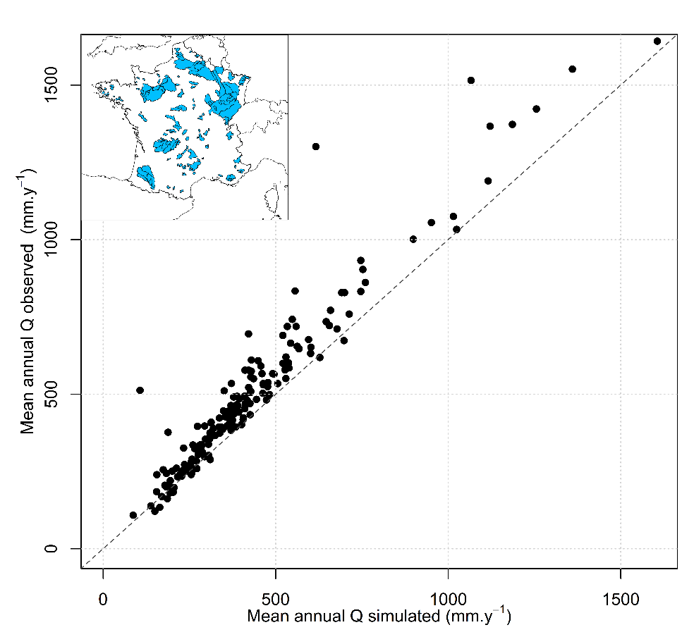

References SI:

Brigode P, Génot B, Lobligeois F, Delaigue O (2020) Summary sheets of watershed-scale hydroclimatic observed data for France
de Lavenne A, Andréassian V (2018) Impact of climate seasonality on catchment yield: A parameterization for commonly-used water balance formulas. J Hydrol 558:266–274. https://doi.org/10.1016/j.jhydrol.2018.01.009
Vidal J-P, Martin E, Franchistéguy L, et al (2010) A 50-year high-resolution atmospheric reanalysis over France with the Safran system. International Journal of Climatology 30:1627–1644. https://doi.org/10.1002/joc.2003
Leleu I, Tonnelier I, Puechberty R, et al (2014) La refonte du système d’information national pour la gestion et la mise à disposition des données hydrométriques. La Houille Blanche 100:25–32. https://doi.org/10.1051/lhb/2014004

