SUPPLEMENTARY INFORMATION for “Extreme heat in New Zealand: a synthesis”
----
Station Location | Latitude (°S) | Longitude (°E) | Population (2021) | Start date (yyyy-mm-dd) | # Missing days, 1980-2019
1) Kerikeri | 35.183 | 173.926 | 8,000 | 1972-01-01 | 0
2) Whangārei | 35.769 | 174.364 | 99,000 | 1967-01-01 | 0
3) Whangaparāoa | 36.606 | 174.835 | 31,000 | 1972-01-01 | 0
4) Auckland | 37.008 | 174.789 | 1,710,000 | 1966-01-01 | 0
5) Hamilton | 37.861 | 175.332 | 179,000 | 1972-01-01 | 0
6) Tauranga | 37.673 | 176.196 | 155,000 | 1941-01-01 | 0
7) Gisborne | 38.659 | 177.985 | 51,000 | 1940-01-01 | 0
8) Napier | 39.498 | 176.912 | 67,000 | 1940-01-01 | 0
9) Rotorua | 38.106 | 176.315 | 77,000 | 1951-01-01 | 0
10) Taupō | 38.743 | 176.081 | 41,000 | 1972-01-01 | 0
11) Taumarunui | 38.888 | 175.260 | 5,000 | 1947-01-01 | 0
12) Waiouru | 39.462 | 175.663 | 1,000 | 1972-01-01 | 0
13) New Plymouth | 39.008 | 174.184 | 87,000 | 1944-01-01 | 0
14) Whanganui | 39.937 | 175.045 | 49,000 | 1972-01-01 | 0
15) Dannevirke | 40.210 | 176.109 | 5,000 | 1951-01-01 | 0
16) Wellington | 41.285 | 174.768 | 217,000 | 1927-01-01 | 0
17) Nelson | 41.299 | 173.226 | 55,000 | 1943-01-01 | 0
18) Blenheim | 41.521 | 173.864 | 29,000 | 1972-01-01 | 0
19) Masterton | 40.957 | 175.707 | 28,000 | 1972-01-01 | 0
20) Christchurch | 43.493 | 172.537 | 392,000 | 1954-01-01 | 0
21) Timaru | 44.305 | 171.221 | 48,000 | 1972-01-01 | 0
22) Reefton | 42.116 | 171.860 | 1,000 | 1972-01-01 | 0
23) Lake Tekapo | 44.002 | 170.441 | 1,000 | 1928-01-01 | 81
24) Tara Hills | 44.526 | 169.889 | N/A | 1947-01-01 | 46
25) Queenstown | 45.018 | 168.740 | 48,000 | 1972-01-01 | 0
26) Gore | 46.115 | 168.887 | 13,000 | 1972-01-01 | 5
27) Dunedin | 45.901 | 170.515 | 133,000 | 1940-01-01 | 0
28) Invercargill | 46.417 | 168.331 | 57,000 | 1948-01-01 | 0
29) Hokitika | 42.712 | 170.984 | 3,000 | 1964-01-01 | 0
30) Milford Sound | 44.674 | 167.924 | <1,000 | 1934-01-01 | 0
Table S1: List of (1) the thirty locations where weather stations used for this analysis are situated, (2) the coordinates of each station, (3) the population of the weather station location, (4) the start date of the temperature dataset and (5) the number of missing days over the forty-year period of focus for the majority of the analysis.

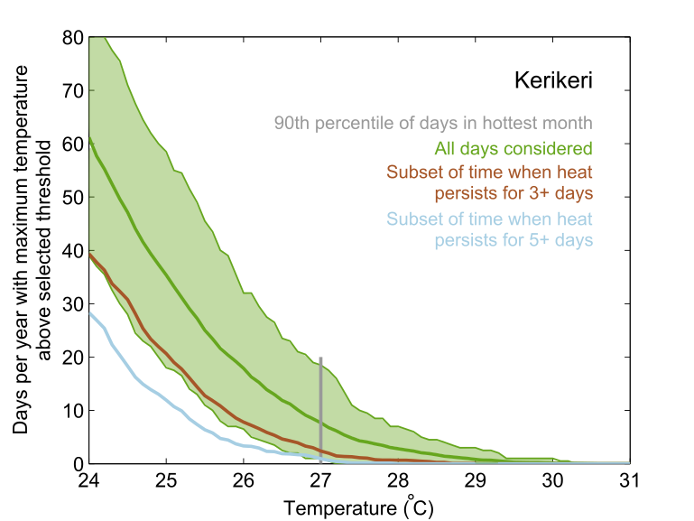
Figure S1: Same as Figure 2 of the main article, but showing corresponding results for Kerikeri only.
 |  | Daily maximum temperature threshold (°C)
 |  | 23 | 24 | 25 | 26 | 27 | 28 | 29 | 30 | 31
Number of consecutive days equal to or above threshold | 1 | 840 | 776 | 611 | 389 | 198 | 81 | 24 | 5 | 0
Number of consecutive days equal to or above threshold | 2 | 510 | 445 | 295 | 160 | 65 | 22 | 7 | 0 | 0
Number of consecutive days equal to or above threshold | 3 | 360 | 283 | 175 | 73 | 24 | 8 | 1 | 0 | 0
Number of consecutive days equal to or above threshold | 4 | 279 | 209 | 100 | 36 | 9 | 2 | 0 | 0 | 0
Number of consecutive days equal to or above threshold | 5 | 232 | 154 | 69 | 19 | 6 | 0 | 0 | 0 | 0
Number of consecutive days equal to or above threshold | 6 | 193 | 111 | 46 | 15 | 5 | 0 | 0 | 0 | 0
Number of consecutive days equal to or above threshold | 7 | 160 | 84 | 31 | 10 | 2 | 0 | 0 | 0 | 0
Number of consecutive days equal to or above threshold | 8 | 140 | 68 | 27 | 7 | 1 | 0 | 0 | 0 | 0
Number of consecutive days equal to or above threshold | 9 | 117 | 56 | 16 | 4 | 0 | 0 | 0 | 0 | 0
Number of consecutive days equal to or above threshold | 10 | 100 | 44 | 12 | 2 | 0 | 0 | 0 | 0 | 0
Table S2: Absolute frequency of extreme hot spells in Kerikeri for the forty-year period spanning 1980-2019. The top row shows the number of individual days during which daily maximum temperatures equalled or exceeded each of the specified integer temperature thresholds. For example, if the daily maximum temperature on one day was recorded as 27.3 degrees, this would be recorded as an additional day in all boxes up to and including the “27°C” threshold. The other rows of the table show the number of discrete occasions where exceedances of the specified temperature threshold occurred as part of a hot spell of persisting for at least the specified length, with the third row (pink) used to select heatwave temperature thresholds (light blue). For example, the fifth row aligning with the 26°C column contains 19 counts: this means that there were 19 separate occasions throughout the 40-year record which were associated with hot spells equal to or longer than five days, and where daily maximum temperatures were equal to or above 26°C for each of these consecutive days. If an individual hot spell lasted seven rather than five days, that would be recorded as one additional count in each of the rows up to and including the seventh row, rather than up to and including the fifth row.
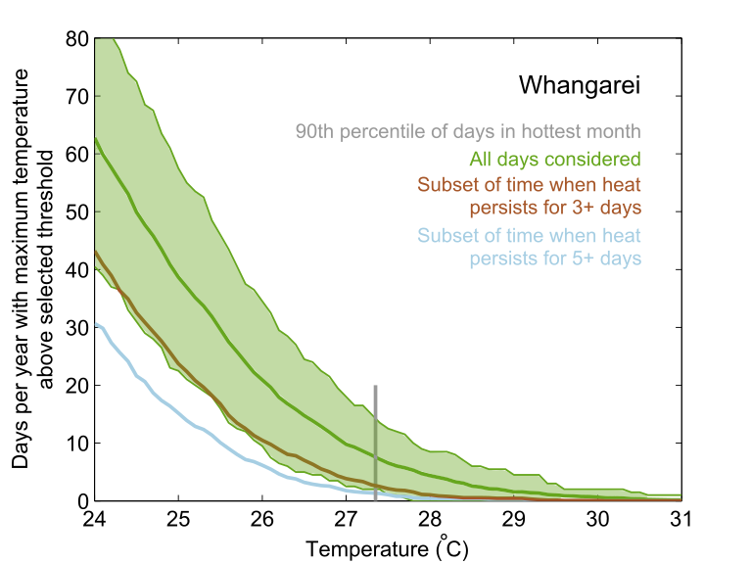
Figure S2: Same as Figure S1, but for Whangārei.
 |  | Daily maximum temperature threshold (°C)
 |  | 23 | 24 | 25 | 26 | 27 | 28 | 29 | 30 | 31
Number of consecutive days equal to or above threshold | 1 | 867 | 792 | 618 | 420 | 224 | 114 | 41 | 20 | 6
Number of consecutive days equal to or above threshold | 2 | 542 | 475 | 330 | 178 | 86 | 36 | 11 | 3 | 0
Number of consecutive days equal to or above threshold | 3 | 387 | 316 | 187 | 92 | 37 | 10 | 4 | 1 | 0
Number of consecutive days equal to or above threshold | 4 | 298 | 218 | 120 | 52 | 16 | 3 | 3 | 0 | 0
Number of consecutive days equal to or above threshold | 5 | 240 | 166 | 85 | 39 | 11 | 2 | 2 | 0 | 0
Number of consecutive days equal to or above threshold | 6 | 201 | 126 | 60 | 20 | 6 | 2 | 1 | 0 | 0
Number of consecutive days equal to or above threshold | 7 | 153 | 93 | 41 | 13 | 5 | 2 | 0 | 0 | 0
Number of consecutive days equal to or above threshold | 8 | 130 | 73 | 34 | 10 | 3 | 1 | 0 | 0 | 0
Number of consecutive days equal to or above threshold | 9 | 106 | 60 | 28 | 5 | 1 | 1 | 0 | 0 | 0
Number of consecutive days equal to or above threshold | 10 | 92 | 45 | 19 | 4 | 1 | 1 | 0 | 0 | 0
Table S3: Same as Table S2, but showing counts for Whangārei.

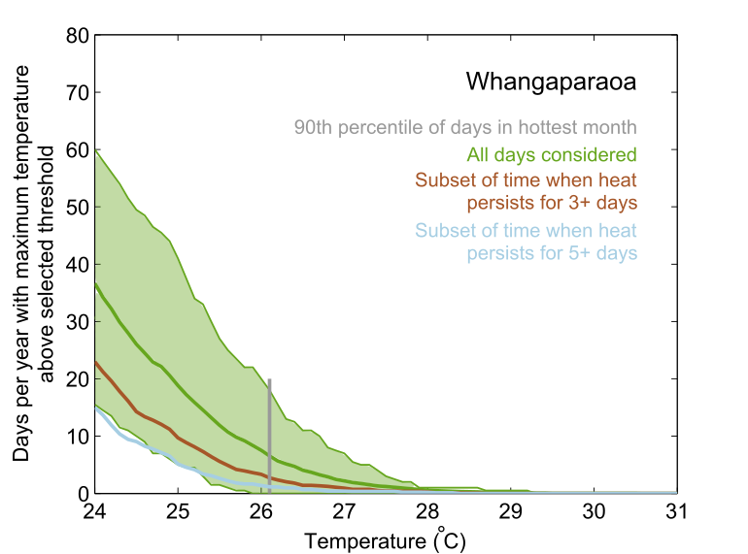
Figure S3: Same as Figure S1, but for Whangaparāoa.
 |  | Daily maximum temperature threshold (°C)
 |  | 23 | 24 | 25 | 26 | 27 | 28 | 29 | 30 | 31
Number of consecutive days equal to or above threshold | 1 | 678 | 563 | 353 | 163 | 55 | 12 | 5 | 0 | 0
Number of consecutive days equal to or above threshold | 2 | 425 | 296 | 168 | 64 | 13 | 2 | 0 | 0 | 0
Number of consecutive days equal to or above threshold | 3 | 297 | 178 | 83 | 31 | 9 | 2 | 0 | 0 | 0
Number of consecutive days equal to or above threshold | 4 | 220 | 117 | 50 | 16 | 2 | 1 | 0 | 0 | 0
Number of consecutive days equal to or above threshold | 5 | 169 | 83 | 29 | 8 | 2 | 1 | 0 | 0 | 0
Number of consecutive days equal to or above threshold | 6 | 132 | 60 | 24 | 7 | 2 | 1 | 0 | 0 | 0
Number of consecutive days equal to or above threshold | 7 | 95 | 47 | 13 | 3 | 1 | 1 | 0 | 0 | 0
Number of consecutive days equal to or above threshold | 8 | 77 | 36 | 9 | 3 | 1 | 1 | 0 | 0 | 0
Number of consecutive days equal to or above threshold | 9 | 65 | 25 | 8 | 2 | 1 | 0 | 0 | 0 | 0
Number of consecutive days equal to or above threshold | 10 | 50 | 17 | 6 | 1 | 1 | 0 | 0 | 0 | 0
Table S4: Same as Table S2, but showing counts for Whangaparāoa.

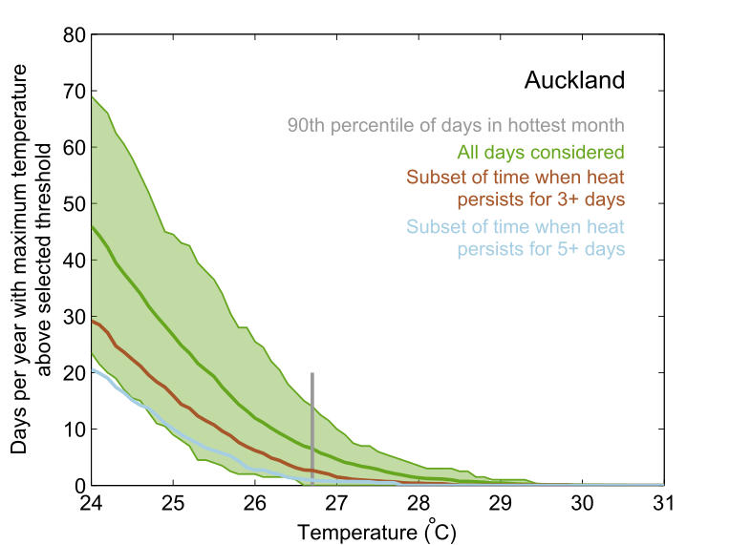
Figure S4: Same as Table S1, but showing counts for Auckland only.
 |  | Daily maximum temperature threshold (°C)
 |  | 23 | 24 | 25 | 26 | 27 | 28 | 29 | 30 | 31
Number of consecutive days equal to or above threshold | 1 | 718 | 606 | 457 | 238 | 115 | 37 | 13 | 1 | 0
Number of consecutive days equal to or above threshold | 2 | 427 | 326 | 210 | 101 | 38 | 11 | 2 | 1 | 0
Number of consecutive days equal to or above threshold | 3 | 289 | 209 | 130 | 57 | 14 | 5 | 1 | 0 | 0
Number of consecutive days equal to or above threshold | 4 | 211 | 139 | 87 | 35 | 7 | 1 | 0 | 0 | 0
Number of consecutive days equal to or above threshold | 5 | 170 | 106 | 60 | 17 | 4 | 0 | 0 | 0 | 0
Number of consecutive days equal to or above threshold | 6 | 140 | 89 | 42 | 9 | 4 | 0 | 0 | 0 | 0
Number of consecutive days equal to or above threshold | 7 | 124 | 70 | 23 | 5 | 1 | 0 | 0 | 0 | 0
Number of consecutive days equal to or above threshold | 8 | 105 | 56 | 16 | 4 | 1 | 0 | 0 | 0 | 0
Number of consecutive days equal to or above threshold | 9 | 81 | 44 | 11 | 4 | 1 | 0 | 0 | 0 | 0
Number of consecutive days equal to or above threshold | 10 | 68 | 36 | 9 | 3 | 0 | 0 | 0 | 0 | 0
Table S5: Same as Table S2, but showing counts for Auckland.
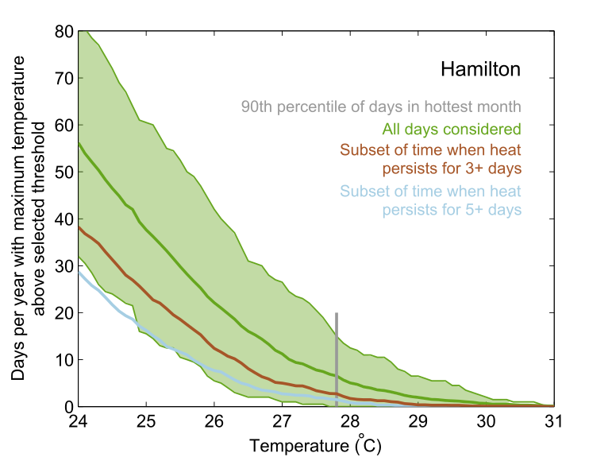
Figure S5: Same as Figure S1, but for Hamilton.
 |  | Daily maximum temperature threshold (°C)
 |  | 23 | 24 | 25 | 26 | 27 | 28 | 29 | 30 | 31
Number of consecutive days equal to or above threshold | 1 | 707 | 646 | 549 | 391 | 236 | 122 | 56 | 21 | 3
Number of consecutive days equal to or above threshold | 2 | 454 | 387 | 296 | 186 | 94 | 43 | 14 | 2 | 1
Number of consecutive days equal to or above threshold | 3 | 330 | 264 | 182 | 97 | 44 | 16 | 4 | 1 | 0
Number of consecutive days equal to or above threshold | 4 | 253 | 194 | 121 | 62 | 19 | 7 | 2 | 1 | 0
Number of consecutive days equal to or above threshold | 5 | 210 | 151 | 87 | 41 | 15 | 5 | 1 | 0 | 0
Number of consecutive days equal to or above threshold | 6 | 175 | 126 | 67 | 33 | 11 | 4 | 0 | 0 | 0
Number of consecutive days equal to or above threshold | 7 | 143 | 91 | 52 | 23 | 8 | 2 | 0 | 0 | 0
Number of consecutive days equal to or above threshold | 8 | 118 | 71 | 40 | 20 | 7 | 2 | 0 | 0 | 0
Number of consecutive days equal to or above threshold | 9 | 95 | 58 | 33 | 16 | 6 | 1 | 0 | 0 | 0
Number of consecutive days equal to or above threshold | 10 | 82 | 48 | 22 | 10 | 2 | 0 | 0 | 0 | 0
Table S6: Same as Table S2, but showing counts for Hamilton.
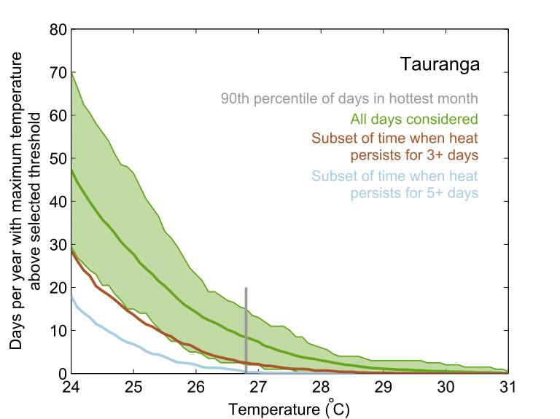
Figure S6: Same as Figure S1, but for Tauranga.
 |  | Daily maximum temperature threshold (°C)
 |  | 23 | 24 | 25 | 26 | 27 | 28 | 29 | 30 | 31
Number of consecutive days equal to or above threshold | 1 | 853 | 752 | 566 | 338 | 201 | 93 | 39 | 18 | 3
Number of consecutive days equal to or above threshold | 2 | 519 | 389 | 246 | 122 | 57 | 20 | 4 | 1 | 1
Number of consecutive days equal to or above threshold | 3 | 336 | 227 | 123 | 58 | 24 | 8 | 2 | 0 | 0
Number of consecutive days equal to or above threshold | 4 | 238 | 144 | 73 | 27 | 11 | 2 | 0 | 0 | 0
Number of consecutive days equal to or above threshold | 5 | 188 | 100 | 42 | 12 | 2 | 1 | 0 | 0 | 0
Number of consecutive days equal to or above threshold | 6 | 149 | 75 | 23 | 9 | 2 | 0 | 0 | 0 | 0
Number of consecutive days equal to or above threshold | 7 | 113 | 50 | 16 | 7 | 0 | 0 | 0 | 0 | 0
Number of consecutive days equal to or above threshold | 8 | 94 | 41 | 11 | 3 | 0 | 0 | 0 | 0 | 0
Number of consecutive days equal to or above threshold | 9 | 82 | 31 | 8 | 1 | 0 | 0 | 0 | 0 | 0
Number of consecutive days equal to or above threshold | 10 | 63 | 20 | 4 | 1 | 0 | 0 | 0 | 0 | 0
Table S7: Same as Table S2, but showing counts for Tauranga.
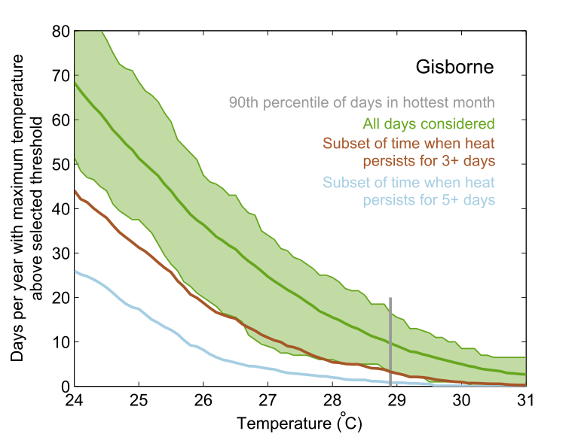
Figure S7: Same as Figure S1, but for Gisborne.
 |  | Daily maximum temperature threshold (°C)
 |  | 23 | 24 | 25 | 26 | 27 | 28 | 29 | 30 | 31
Number of consecutive days equal to or above threshold | 1 | 1159 | 1066 | 895 | 736 | 548 | 379 | 233 | 143 | 81
Number of consecutive days equal to or above threshold | 2 | 700 | 591 | 456 | 331 | 227 | 138 | 80 | 41 | 21
Number of consecutive days equal to or above threshold | 3 | 466 | 368 | 276 | 179 | 111 | 56 | 32 | 11 | 4
Number of consecutive days equal to or above threshold | 4 | 303 | 236 | 166 | 98 | 51 | 22 | 11 | 4 | 0
Number of consecutive days equal to or above threshold | 5 | 224 | 154 | 110 | 53 | 26 | 13 | 6 | 1 | 0
Number of consecutive days equal to or above threshold | 6 | 164 | 113 | 64 | 30 | 16 | 6 | 2 | 0 | 0
Number of consecutive days equal to or above threshold | 7 | 115 | 69 | 43 | 19 | 8 | 5 | 1 | 0 | 0
Number of consecutive days equal to or above threshold | 8 | 83 | 44 | 22 | 10 | 3 | 1 | 0 | 0 | 0
Number of consecutive days equal to or above threshold | 9 | 57 | 24 | 11 | 3 | 1 | 1 | 0 | 0 | 0
Number of consecutive days equal to or above threshold | 10 | 48 | 18 | 6 | 1 | 1 | 1 | 0 | 0 | 0
Table S8: Same as Table S2, but showing counts for Gisborne.
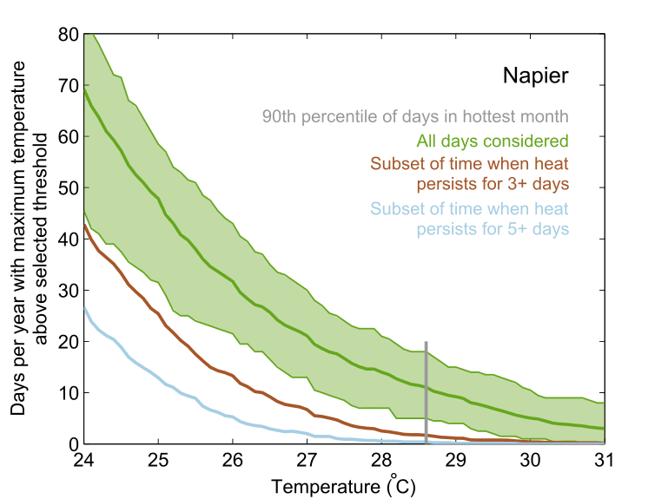
Figure S8: Same as Figure S1, but for Napier.
 |  | Daily maximum temperature threshold (°C)
 |  | 23 | 24 | 25 | 26 | 27 | 28 | 29 | 30 | 31
Number of consecutive days equal to or above threshold | 1 | 1181 | 1068 | 901 | 707 | 541 | 406 | 287 | 161 | 95
Number of consecutive days equal to or above threshold | 2 | 702 | 588 | 437 | 290 | 183 | 112 | 63 | 33 | 21
Number of consecutive days equal to or above threshold | 3 | 463 | 347 | 233 | 133 | 73 | 29 | 13 | 5 | 2
Number of consecutive days equal to or above threshold | 4 | 324 | 225 | 128 | 62 | 25 | 9 | 5 | 1 | 1
Number of consecutive days equal to or above threshold | 5 | 220 | 155 | 82 | 35 | 14 | 4 | 1 | 0 | 0
Number of consecutive days equal to or above threshold | 6 | 154 | 110 | 46 | 20 | 7 | 1 | 0 | 0 | 0
Number of consecutive days equal to or above threshold | 7 | 123 | 75 | 23 | 11 | 3 | 0 | 0 | 0 | 0
Number of consecutive days equal to or above threshold | 8 | 95 | 51 | 15 | 3 | 0 | 0 | 0 | 0 | 0
Number of consecutive days equal to or above threshold | 9 | 78 | 32 | 12 | 1 | 0 | 0 | 0 | 0 | 0
Number of consecutive days equal to or above threshold | 10 | 66 | 26 | 11 | 1 | 0 | 0 | 0 | 0 | 0
Table S9: Same as Table S2, but showing counts for Napier.
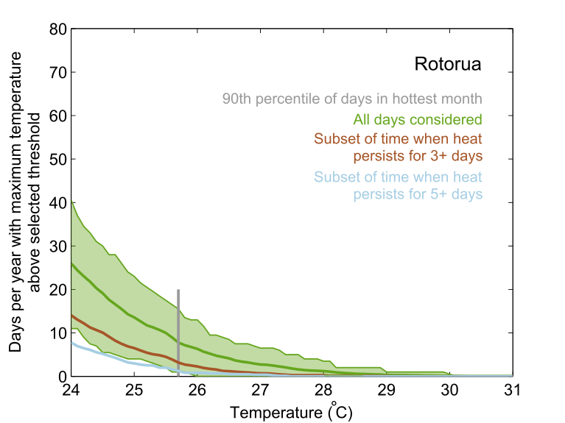
Figure S9: Same as Figure S1, but for Rotorua.
 |  | Daily maximum temperature threshold (°C)
 |  | 23 | 24 | 25 | 26 | 27 | 28 | 29 | 30 | 31
Number of consecutive days equal to or above threshold | 1 | 625 | 469 | 291 | 158 | 76 | 34 | 9 | 3 | 0
Number of consecutive days equal to or above threshold | 2 | 338 | 226 | 111 | 50 | 18 | 8 | 2 | 1 | 1
Number of consecutive days equal to or above threshold | 3 | 212 | 120 | 60 | 23 | 7 | 3 | 1 | 0 | 0
Number of consecutive days equal to or above threshold | 4 | 145 | 67 | 33 | 9 | 4 | 2 | 0 | 0 | 0
Number of consecutive days equal to or above threshold | 5 | 102 | 44 | 18 | 5 | 3 | 0 | 0 | 0 | 0
Number of consecutive days equal to or above threshold | 6 | 68 | 33 | 12 | 3 | 0 | 0 | 0 | 0 | 0
Number of consecutive days equal to or above threshold | 7 | 45 | 22 | 6 | 2 | 0 | 0 | 0 | 0 | 0
Number of consecutive days equal to or above threshold | 8 | 37 | 15 | 4 | 1 | 0 | 0 | 0 | 0 | 0
Number of consecutive days equal to or above threshold | 9 | 24 | 11 | 4 | 1 | 0 | 0 | 0 | 0 | 0
Number of consecutive days equal to or above threshold | 10 | 20 | 10 | 3 | 1 | 0 | 0 | 0 | 0 | 0
Table S10: Same as Table S2, but showing counts for Rotorua.
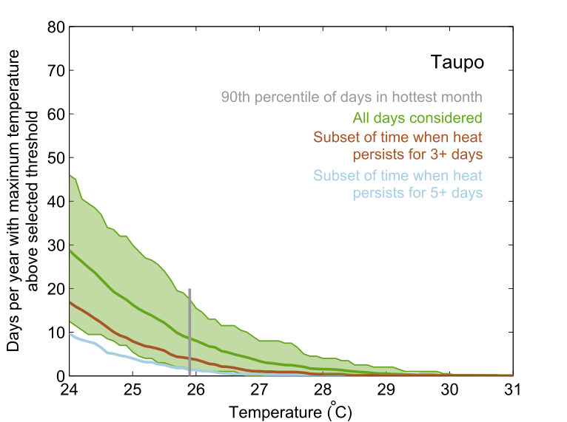
Figure S10: Same as Figure S1, but for Taupō.
 |  | Daily maximum temperature threshold (°C)
 |  | 23 | 24 | 25 | 26 | 27 | 28 | 29 | 30 | 31
Number of consecutive days equal to or above threshold | 1 | 636 | 503 | 338 | 179 | 88 | 40 | 15 | 5 | 1
Number of consecutive days equal to or above threshold | 2 | 341 | 236 | 147 | 67 | 29 | 16 | 4 | 1 | 1
Number of consecutive days equal to or above threshold | 3 | 220 | 141 | 72 | 37 | 12 | 5 | 1 | 1 | 0
Number of consecutive days equal to or above threshold | 4 | 140 | 86 | 41 | 19 | 3 | 1 | 0 | 0 | 0
Number of consecutive days equal to or above threshold | 5 | 97 | 56 | 25 | 9 | 3 | 0 | 0 | 0 | 0
Number of consecutive days equal to or above threshold | 6 | 76 | 43 | 13 | 6 | 0 | 0 | 0 | 0 | 0
Number of consecutive days equal to or above threshold | 7 | 59 | 27 | 10 | 3 | 0 | 0 | 0 | 0 | 0
Number of consecutive days equal to or above threshold | 8 | 42 | 20 | 7 | 1 | 0 | 0 | 0 | 0 | 0
Number of consecutive days equal to or above threshold | 9 | 29 | 12 | 4 | 0 | 0 | 0 | 0 | 0 | 0
Number of consecutive days equal to or above threshold | 10 | 27 | 8 | 1 | 0 | 0 | 0 | 0 | 0 | 0
Table S11: Same as Table S2, but showing counts for Taupō.
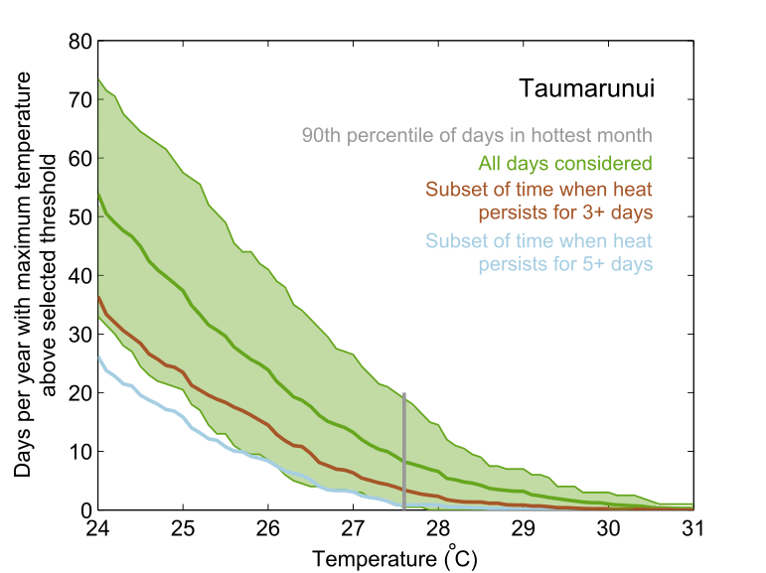
Figure S11: Same as Figure S1, but for Taumarunui.
 |  | Daily maximum temperature threshold (°C)
 |  | 23 | 24 | 25 | 26 | 27 | 28 | 29 | 30 | 31
Number of consecutive days equal to or above threshold | 1 | 794 | 705 | 570 | 414 | 275 | 162 | 84 | 30 | 10
Number of consecutive days equal to or above threshold | 2 | 494 | 401 | 284 | 189 | 119 | 55 | 29 | 7 | 0
Number of consecutive days equal to or above threshold | 3 | 336 | 267 | 178 | 120 | 60 | 24 | 10 | 3 | 0
Number of consecutive days equal to or above threshold | 4 | 250 | 181 | 114 | 80 | 30 | 10 | 3 | 0 | 0
Number of consecutive days equal to or above threshold | 5 | 194 | 143 | 86 | 49 | 20 | 6 | 1 | 0 | 0
Number of consecutive days equal to or above threshold | 6 | 156 | 100 | 62 | 35 | 12 | 1 | 0 | 0 | 0
Number of consecutive days equal to or above threshold | 7 | 119 | 82 | 48 | 20 | 6 | 1 | 0 | 0 | 0
Number of consecutive days equal to or above threshold | 8 | 97 | 63 | 40 | 15 | 4 | 1 | 0 | 0 | 0
Number of consecutive days equal to or above threshold | 9 | 80 | 50 | 31 | 13 | 1 | 1 | 0 | 0 | 0
Number of consecutive days equal to or above threshold | 10 | 65 | 37 | 23 | 7 | 1 | 1 | 0 | 0 | 0
Table S12: Same as Table S2, but showing counts for Taumarunui.
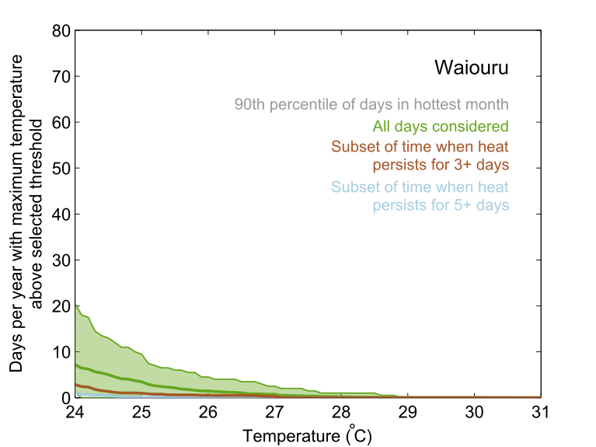
Figure S12: Same as Figure S1, but for Waiouru.
 |  | Daily maximum temperature threshold (°C)
 |  | 23 | 24 | 25 | 26 | 27 | 28 | 29 | 30 | 31
Number of consecutive days equal to or above threshold | 1 | 290 | 162 | 89 | 40 | 20 | 6 | 2 | 2 | 0
Number of consecutive days equal to or above threshold | 2 | 135 | 66 | 32 | 9 | 5 | 0 | 0 | 0 | 0
Number of consecutive days equal to or above threshold | 3 | 71 | 27 | 10 | 6 | 4 | 0 | 0 | 0 | 0
Number of consecutive days equal to or above threshold | 4 | 34 | 16 | 5 | 1 | 0 | 0 | 0 | 0 | 0
Number of consecutive days equal to or above threshold | 5 | 24 | 6 | 1 | 1 | 0 | 0 | 0 | 0 | 0
Number of consecutive days equal to or above threshold | 6 | 11 | 4 | 1 | 1 | 0 | 0 | 0 | 0 | 0
Number of consecutive days equal to or above threshold | 7 | 7 | 4 | 1 | 0 | 0 | 0 | 0 | 0 | 0
Number of consecutive days equal to or above threshold | 8 | 3 | 2 | 1 | 0 | 0 | 0 | 0 | 0 | 0
Number of consecutive days equal to or above threshold | 9 | 1 | 1 | 0 | 0 | 0 | 0 | 0 | 0 | 0
Number of consecutive days equal to or above threshold | 10 | 0 | 0 | 0 | 0 | 0 | 0 | 0 | 0 | 0
Table S13: Same as Table S2, but showing counts for Waiouru.
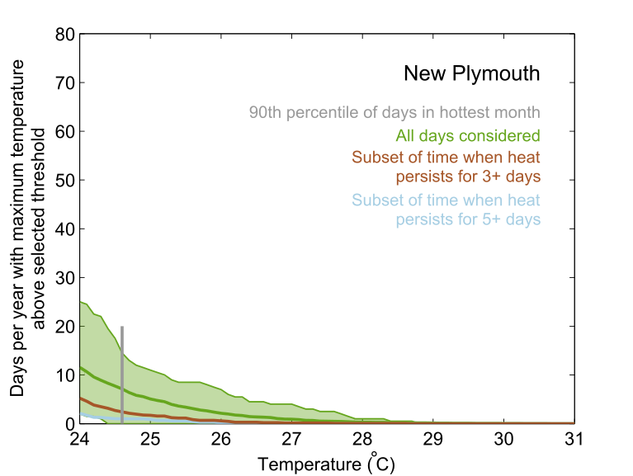
Figure S13: Same as Figure S1, but for New Plymouth.
 |  | Daily maximum temperature threshold (°C)
 |  | 23 | 24 | 25 | 26 | 27 | 28 | 29 | 30 | 31
Number of consecutive days equal to or above threshold | 1 | 413 | 259 | 132 | 59 | 29 | 8 | 4 | 1 | 0
Number of consecutive days equal to or above threshold | 2 | 190 | 94 | 35 | 15 | 5 | 2 | 1 | 0 | 0
Number of consecutive days equal to or above threshold | 3 | 111 | 51 | 17 | 6 | 2 | 1 | 0 | 0 | 0
Number of consecutive days equal to or above threshold | 4 | 69 | 27 | 7 | 2 | 0 | 0 | 0 | 0 | 0
Number of consecutive days equal to or above threshold | 5 | 48 | 14 | 6 | 1 | 0 | 0 | 0 | 0 | 0
Number of consecutive days equal to or above threshold | 6 | 29 | 7 | 3 | 1 | 0 | 0 | 0 | 0 | 0
Number of consecutive days equal to or above threshold | 7 | 21 | 3 | 2 | 1 | 0 | 0 | 0 | 0 | 0
Number of consecutive days equal to or above threshold | 8 | 16 | 2 | 0 | 0 | 0 | 0 | 0 | 0 | 0
Number of consecutive days equal to or above threshold | 9 | 15 | 2 | 0 | 0 | 0 | 0 | 0 | 0 | 0
Number of consecutive days equal to or above threshold | 10 | 11 | 1 | 0 | 0 | 0 | 0 | 0 | 0 | 0
Table S14: Same as Table S2, but showing counts for New Plymouth.
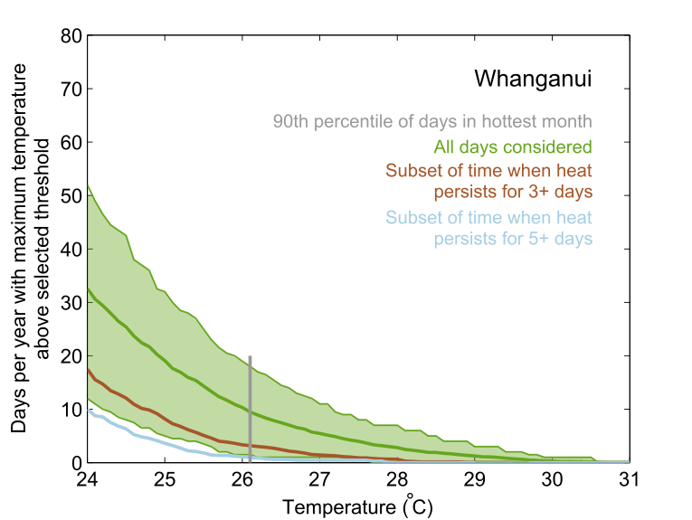
Figure S14: Same as Figure S1, but for Whanganui.
 |  | Daily maximum temperature threshold (°C)
 |  | 23 | 24 | 25 | 26 | 27 | 28 | 29 | 30 | 31
Number of consecutive days equal to or above threshold | 1 | 756 | 611 | 432 | 267 | 150 | 85 | 42 | 10 | 2
Number of consecutive days equal to or above threshold | 2 | 382 | 284 | 164 | 83 | 41 | 18 | 6 | 1 | 0
Number of consecutive days equal to or above threshold | 3 | 237 | 151 | 79 | 34 | 16 | 8 | 1 | 0 | 0
Number of consecutive days equal to or above threshold | 4 | 151 | 90 | 38 | 16 | 4 | 1 | 0 | 0 | 0
Number of consecutive days equal to or above threshold | 5 | 107 | 61 | 23 | 7 | 3 | 0 | 0 | 0 | 0
Number of consecutive days equal to or above threshold | 6 | 77 | 42 | 13 | 3 | 1 | 0 | 0 | 0 | 0
Number of consecutive days equal to or above threshold | 7 | 64 | 24 | 7 | 2 | 1 | 0 | 0 | 0 | 0
Number of consecutive days equal to or above threshold | 8 | 43 | 16 | 6 | 2 | 1 | 0 | 0 | 0 | 0
Number of consecutive days equal to or above threshold | 9 | 29 | 8 | 4 | 1 | 0 | 0 | 0 | 0 | 0
Number of consecutive days equal to or above threshold | 10 | 24 | 5 | 0 | 0 | 0 | 0 | 0 | 0 | 0
Table S15: Same as Table S2, but showing counts for Whanganui.
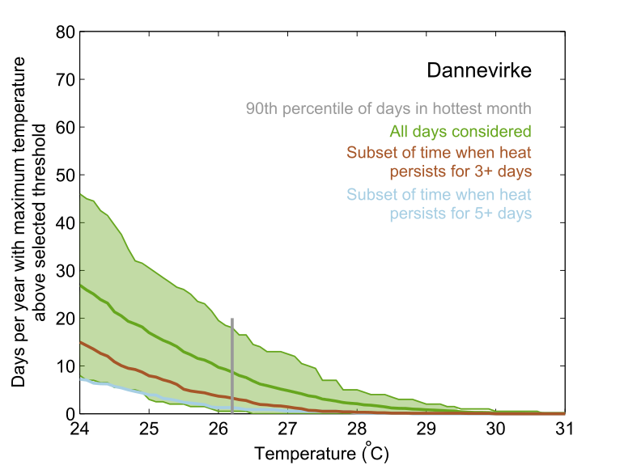
Figure S15: Same as Figure S1, but for Dannevirke.
 |  | Daily maximum temperature threshold (°C)
 |  | 23 | 24 | 25 | 26 | 27 | 28 | 29 | 30 | 31
Number of consecutive days equal to or above threshold | 1 | 660 | 514 | 360 | 229 | 126 | 68 | 26 | 5 | 2
Number of consecutive days equal to or above threshold | 2 | 336 | 241 | 144 | 83 | 36 | 9 | 4 | 1 | 0
Number of consecutive days equal to or above threshold | 3 | 211 | 137 | 70 | 36 | 14 | 3 | 1 | 0 | 0
Number of consecutive days equal to or above threshold | 4 | 140 | 80 | 46 | 20 | 6 | 2 | 1 | 0 | 0
Number of consecutive days equal to or above threshold | 5 | 96 | 45 | 24 | 8 | 3 | 1 | 0 | 0 | 0
Number of consecutive days equal to or above threshold | 6 | 64 | 29 | 17 | 5 | 2 | 0 | 0 | 0 | 0
Number of consecutive days equal to or above threshold | 7 | 41 | 17 | 10 | 2 | 2 | 0 | 0 | 0 | 0
Number of consecutive days equal to or above threshold | 8 | 28 | 9 | 5 | 2 | 2 | 0 | 0 | 0 | 0
Number of consecutive days equal to or above threshold | 9 | 19 | 6 | 4 | 1 | 1 | 0 | 0 | 0 | 0
Number of consecutive days equal to or above threshold | 10 | 14 | 3 | 1 | 1 | 0 | 0 | 0 | 0 | 0
Table S16: Same as Table S2, but showing counts for Dannevirke.
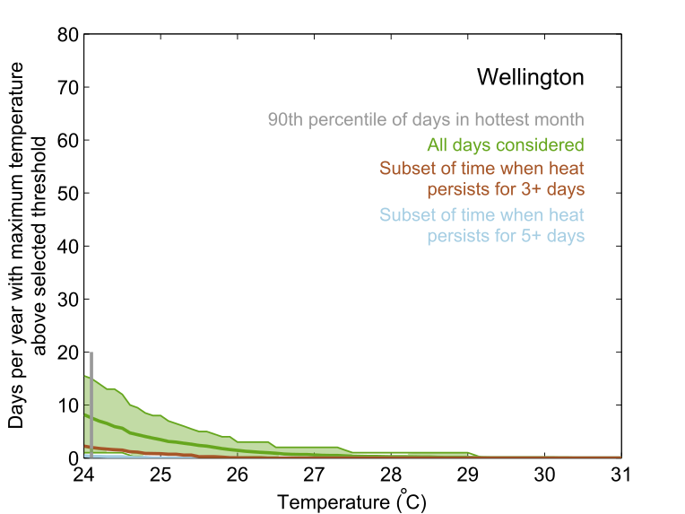
Figure S16: Same as Figure S1, but for Wellington.
 |  | Daily maximum temperature threshold (°C)
 |  | 23 | 24 | 25 | 26 | 27 | 28 | 29 | 30 | 31
Number of consecutive days equal to or above threshold | 1 | 365 | 224 | 92 | 46 | 18 | 9 | 4 | 1 | 0
Number of consecutive days equal to or above threshold | 2 | 123 | 64 | 33 | 10 | 4 | 0 | 0 | 0 | 0
Number of consecutive days equal to or above threshold | 3 | 56 | 25 | 10 | 1 | 0 | 0 | 0 | 0 | 0
Number of consecutive days equal to or above threshold | 4 | 35 | 10 | 3 | 0 | 0 | 0 | 0 | 0 | 0
Number of consecutive days equal to or above threshold | 5 | 22 | 3 | 0 | 0 | 0 | 0 | 0 | 0 | 0
Number of consecutive days equal to or above threshold | 6 | 7 | 1 | 0 | 0 | 0 | 0 | 0 | 0 | 0
Number of consecutive days equal to or above threshold | 7 | 4 | 1 | 0 | 0 | 0 | 0 | 0 | 0 | 0
Number of consecutive days equal to or above threshold | 8 | 1 | 0 | 0 | 0 | 0 | 0 | 0 | 0 | 0
Number of consecutive days equal to or above threshold | 9 | 1 | 0 | 0 | 0 | 0 | 0 | 0 | 0 | 0
Number of consecutive days equal to or above threshold | 10 | 1 | 0 | 0 | 0 | 0 | 0 | 0 | 0 | 0
Table S17: Same as Table S2, but showing counts for Wellington.
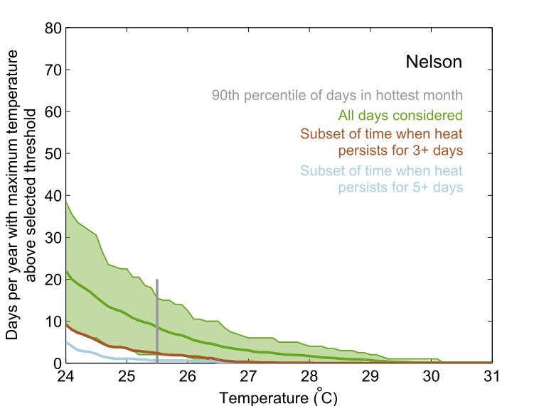
Figure S17: Same as Figure S1, but for Nelson.
 |  | Daily maximum temperature threshold (°C)
 |  | 23 | 24 | 25 | 26 | 27 | 28 | 29 | 30 | 31
Number of consecutive days equal to or above threshold | 1 | 737 | 513 | 306 | 167 | 97 | 58 | 24 | 5 | 3
Number of consecutive days equal to or above threshold | 2 | 315 | 162 | 97 | 45 | 18 | 7 | 2 | 1 | 1
Number of consecutive days equal to or above threshold | 3 | 161 | 81 | 38 | 17 | 4 | 1 | 0 | 0 | 0
Number of consecutive days equal to or above threshold | 4 | 92 | 49 | 14 | 7 | 1 | 0 | 0 | 0 | 0
Number of consecutive days equal to or above threshold | 5 | 66 | 32 | 7 | 4 | 0 | 0 | 0 | 0 | 0
Number of consecutive days equal to or above threshold | 6 | 44 | 18 | 3 | 2 | 0 | 0 | 0 | 0 | 0
Number of consecutive days equal to or above threshold | 7 | 29 | 12 | 2 | 1 | 0 | 0 | 0 | 0 | 0
Number of consecutive days equal to or above threshold | 8 | 22 | 5 | 1 | 1 | 0 | 0 | 0 | 0 | 0
Number of consecutive days equal to or above threshold | 9 | 17 | 4 | 1 | 0 | 0 | 0 | 0 | 0 | 0
Number of consecutive days equal to or above threshold | 10 | 13 | 3 | 0 | 0 | 0 | 0 | 0 | 0 | 0
Table S18: Same as Table S2, but showing counts for Nelson.
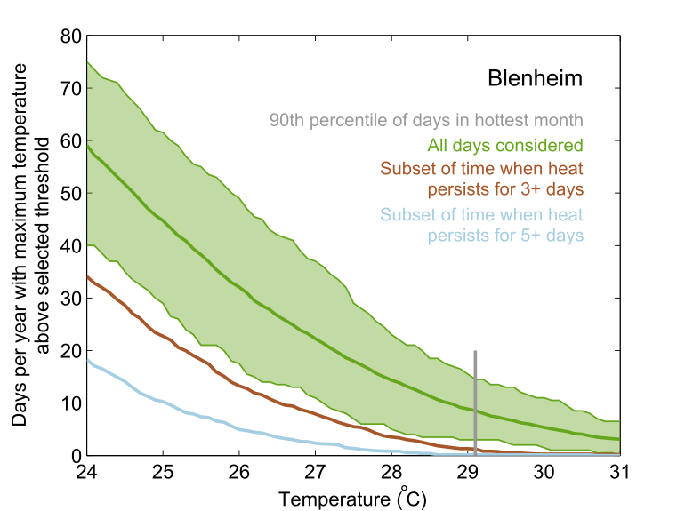
Figure S18: Same as Figure S1, but for Blenheim.
 |  | Daily maximum temperature threshold (°C)
 |  | 23 | 24 | 25 | 26 | 27 | 28 | 29 | 30 | 31
Number of consecutive days equal to or above threshold | 1 | 1163 | 1038 | 891 | 734 | 551 | 400 | 271 | 174 | 102
Number of consecutive days equal to or above threshold | 2 | 662 | 537 | 404 | 281 | 190 | 112 | 65 | 35 | 18
Number of consecutive days equal to or above threshold | 3 | 408 | 303 | 214 | 131 | 83 | 39 | 16 | 3 | 3
Number of consecutive days equal to or above threshold | 4 | 267 | 185 | 120 | 63 | 33 | 15 | 2 | 1 | 0
Number of consecutive days equal to or above threshold | 5 | 179 | 115 | 66 | 31 | 15 | 6 | 1 | 1 | 0
Number of consecutive days equal to or above threshold | 6 | 121 | 68 | 39 | 18 | 10 | 3 | 1 | 0 | 0
Number of consecutive days equal to or above threshold | 7 | 77 | 37 | 17 | 10 | 5 | 0 | 0 | 0 | 0
Number of consecutive days equal to or above threshold | 8 | 56 | 26 | 14 | 8 | 4 | 0 | 0 | 0 | 0
Number of consecutive days equal to or above threshold | 9 | 34 | 15 | 7 | 4 | 0 | 0 | 0 | 0 | 0
Number of consecutive days equal to or above threshold | 10 | 24 | 9 | 4 | 3 | 0 | 0 | 0 | 0 | 0
Table S19: Same as Table S2, but showing counts for Blenheim.
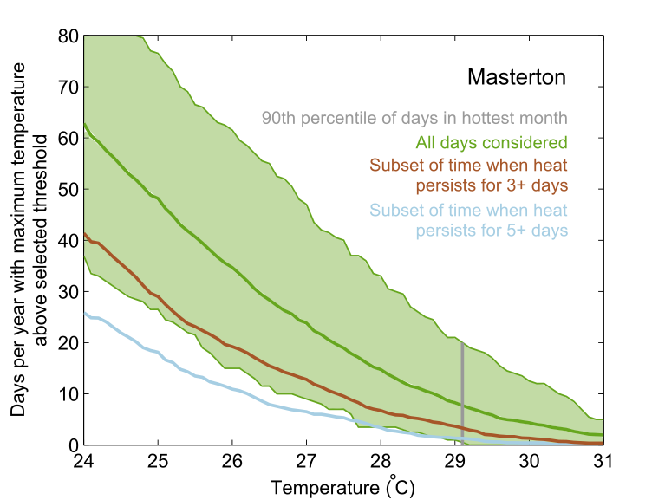
Figure S19: Same as Figure S1, but for Masterton.
 |  | Daily maximum temperature threshold (°C)
 |  | 23 | 24 | 25 | 26 | 27 | 28 | 29 | 30 | 31
Number of consecutive days equal to or above threshold | 1 | 979 | 906 | 779 | 626 | 460 | 318 | 192 | 108 | 54
Number of consecutive days equal to or above threshold | 2 | 606 | 518 | 420 | 312 | 220 | 130 | 66 | 40 | 16
Number of consecutive days equal to or above threshold | 3 | 421 | 330 | 234 | 162 | 118 | 62 | 37 | 14 | 4
Number of consecutive days equal to or above threshold | 4 | 288 | 215 | 153 | 106 | 66 | 40 | 19 | 6 | 2
Number of consecutive days equal to or above threshold | 5 | 219 | 146 | 105 | 65 | 42 | 23 | 9 | 3 | 1
Number of consecutive days equal to or above threshold | 6 | 155 | 108 | 70 | 46 | 26 | 13 | 6 | 2 | 0
Number of consecutive days equal to or above threshold | 7 | 109 | 71 | 47 | 29 | 14 | 7 | 2 | 0 | 0
Number of consecutive days equal to or above threshold | 8 | 81 | 54 | 35 | 19 | 6 | 0 | 0 | 0 | 0
Number of consecutive days equal to or above threshold | 9 | 59 | 41 | 28 | 12 | 3 | 0 | 0 | 0 | 0
Number of consecutive days equal to or above threshold | 10 | 44 | 31 | 20 | 6 | 1 | 0 | 0 | 0 | 0
Table S20: Same as Table S2, but showing counts for Masterton.
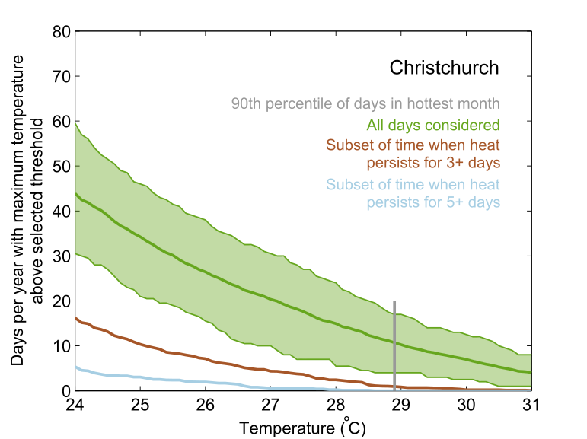
Figure S20: Same as Figure S1, but for Christchurch.
 |  | Daily maximum temperature threshold (°C)
 |  | 23 | 24 | 25 | 26 | 27 | 28 | 29 | 30 | 31
Number of consecutive days equal to or above threshold | 1 | 1180 | 1049 | 868 | 706 | 569 | 440 | 320 | 230 | 144
Number of consecutive days equal to or above threshold | 2 | 531 | 409 | 314 | 223 | 169 | 117 | 77 | 45 | 17
Number of consecutive days equal to or above threshold | 3 | 244 | 173 | 112 | 77 | 50 | 29 | 11 | 3 | 1
Number of consecutive days equal to or above threshold | 4 | 116 | 71 | 48 | 36 | 18 | 8 | 1 | 0 | 0
Number of consecutive days equal to or above threshold | 5 | 63 | 39 | 23 | 15 | 4 | 2 | 0 | 0 | 0
Number of consecutive days equal to or above threshold | 6 | 33 | 12 | 5 | 3 | 2 | 0 | 0 | 0 | 0
Number of consecutive days equal to or above threshold | 7 | 16 | 5 | 2 | 0 | 0 | 0 | 0 | 0 | 0
Number of consecutive days equal to or above threshold | 8 | 7 | 1 | 0 | 0 | 0 | 0 | 0 | 0 | 0
Number of consecutive days equal to or above threshold | 9 | 4 | 1 | 0 | 0 | 0 | 0 | 0 | 0 | 0
Number of consecutive days equal to or above threshold | 10 | 3 | 0 | 0 | 0 | 0 | 0 | 0 | 0 | 0
Table S21: Same as Table S2, but showing counts for Christchurch.
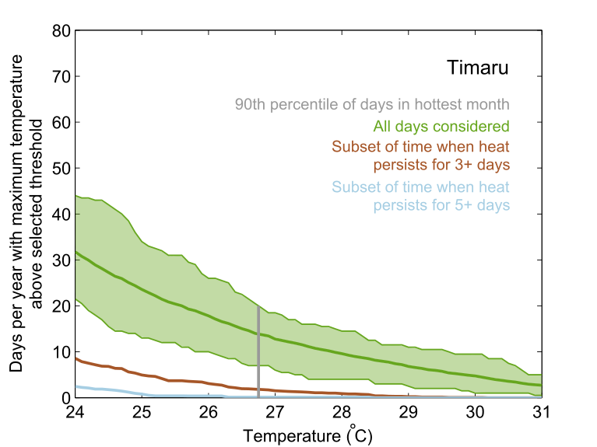
Figure S21: Same as Figure S1, but for Timaru.
 |  | Daily maximum temperature threshold (°C)
 |  | 23 | 24 | 25 | 26 | 27 | 28 | 29 | 30 | 31
Number of consecutive days equal to or above threshold | 1 | 1017 | 845 | 674 | 530 | 405 | 318 | 241 | 168 | 102
Number of consecutive days equal to or above threshold | 2 | 383 | 276 | 190 | 137 | 87 | 57 | 32 | 21 | 5
Number of consecutive days equal to or above threshold | 3 | 143 | 92 | 56 | 36 | 18 | 11 | 3 | 1 | 0
Number of consecutive days equal to or above threshold | 4 | 68 | 41 | 22 | 12 | 6 | 2 | 0 | 0 | 0
Number of consecutive days equal to or above threshold | 5 | 28 | 18 | 6 | 3 | 1 | 1 | 0 | 0 | 0
Number of consecutive days equal to or above threshold | 6 | 15 | 4 | 2 | 0 | 0 | 0 | 0 | 0 | 0
Number of consecutive days equal to or above threshold | 7 | 7 | 2 | 0 | 0 | 0 | 0 | 0 | 0 | 0
Number of consecutive days equal to or above threshold | 8 | 1 | 1 | 0 | 0 | 0 | 0 | 0 | 0 | 0
Number of consecutive days equal to or above threshold | 9 | 1 | 1 | 0 | 0 | 0 | 0 | 0 | 0 | 0
Number of consecutive days equal to or above threshold | 10 | 0 | 0 | 0 | 0 | 0 | 0 | 0 | 0 | 0
Table S22: Same as Table S2, but showing counts for Timaru.
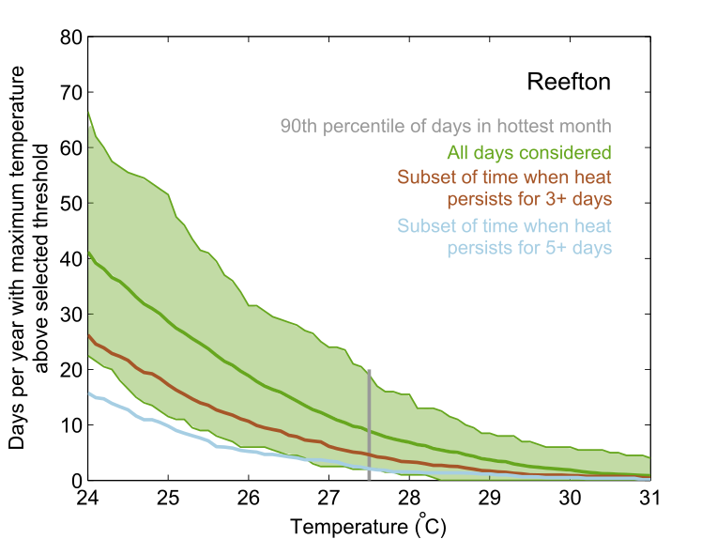
Figure S22: Same as Figure S1, but for Reefton.
 |  | Daily maximum temperature threshold (°C)
 |  | 23 | 24 | 25 | 26 | 27 | 28 | 29 | 30 | 31
Number of consecutive days equal to or above threshold | 1 | 730 | 630 | 474 | 332 | 220 | 137 | 75 | 39 | 20
Number of consecutive days equal to or above threshold | 2 | 418 | 335 | 234 | 165 | 103 | 66 | 35 | 16 | 5
Number of consecutive days equal to or above threshold | 3 | 268 | 210 | 142 | 92 | 54 | 31 | 15 | 8 | 4
Number of consecutive days equal to or above threshold | 4 | 193 | 136 | 88 | 53 | 32 | 19 | 9 | 7 | 3
Number of consecutive days equal to or above threshold | 5 | 136 | 87 | 54 | 28 | 22 | 10 | 8 | 4 | 1
Number of consecutive days equal to or above threshold | 6 | 102 | 67 | 39 | 22 | 15 | 6 | 5 | 0 | 0
Number of consecutive days equal to or above threshold | 7 | 72 | 47 | 29 | 18 | 8 | 3 | 1 | 0 | 0
Number of consecutive days equal to or above threshold | 8 | 52 | 35 | 23 | 14 | 4 | 2 | 0 | 0 | 0
Number of consecutive days equal to or above threshold | 9 | 43 | 27 | 18 | 8 | 2 | 0 | 0 | 0 | 0
Number of consecutive days equal to or above threshold | 10 | 33 | 20 | 13 | 7 | 1 | 0 | 0 | 0 | 0
Table S23: Same as Table S2, but showing counts for Reefton.
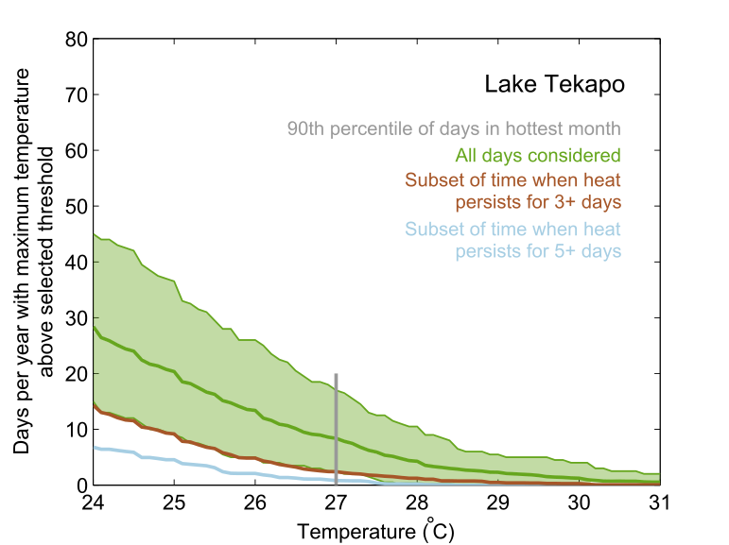
Figure S23: Same as Figure S1, but for Lake Tekapo.
 |  | Daily maximum temperature threshold (°C)
 |  | 23 | 24 | 25 | 26 | 27 | 28 | 29 | 30 | 31
Number of consecutive days equal to or above threshold | 1 | 666 | 543 | 427 | 318 | 222 | 121 | 66 | 37 | 14
Number of consecutive days equal to or above threshold | 2 | 379 | 283 | 192 | 121 | 65 | 27 | 16 | 6 | 5
Number of consecutive days equal to or above threshold | 3 | 197 | 133 | 87 | 48 | 24 | 13 | 5 | 3 | 1
Number of consecutive days equal to or above threshold | 4 | 113 | 74 | 44 | 26 | 15 | 8 | 4 | 2 | 0
Number of consecutive days equal to or above threshold | 5 | 70 | 43 | 30 | 15 | 6 | 2 | 0 | 0 | 0
Number of consecutive days equal to or above threshold | 6 | 44 | 26 | 16 | 6 | 2 | 0 | 0 | 0 | 0
Number of consecutive days equal to or above threshold | 7 | 28 | 15 | 8 | 2 | 1 | 0 | 0 | 0 | 0
Number of consecutive days equal to or above threshold | 8 | 13 | 9 | 4 | 1 | 0 | 0 | 0 | 0 | 0
Number of consecutive days equal to or above threshold | 9 | 10 | 4 | 2 | 0 | 0 | 0 | 0 | 0 | 0
Number of consecutive days equal to or above threshold | 10 | 8 | 3 | 2 | 0 | 0 | 0 | 0 | 0 | 0
Table S24: Same as Table S2, but showing counts for Lake Tekapo.
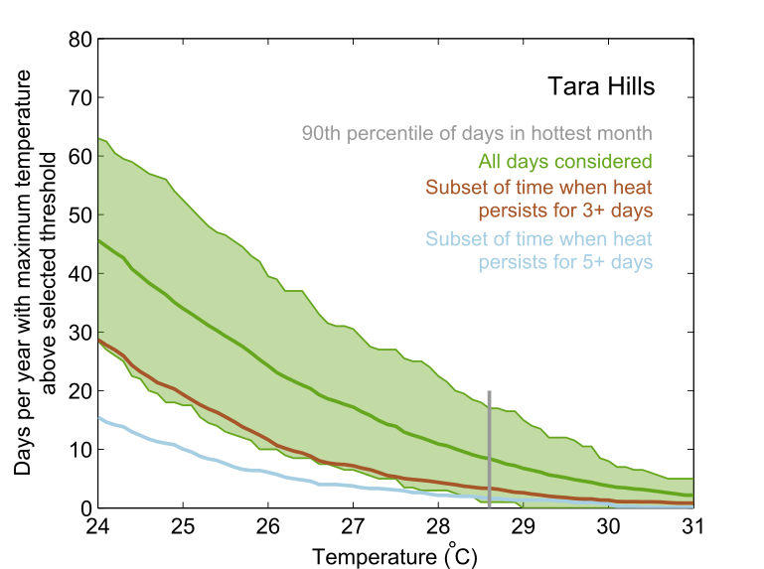
Figure S24: Same as Figure S1, but for Tara Hills.
 |  | Daily maximum temperature threshold (°C)
 |  | 23 | 24 | 25 | 26 | 27 | 28 | 29 | 30 | 31
Number of consecutive days equal to or above threshold | 1 | 828 | 720 | 607 | 484 | 372 | 249 | 159 | 96 | 54
Number of consecutive days equal to or above threshold | 2 | 503 | 409 | 300 | 219 | 152 | 91 | 56 | 25 | 17
Number of consecutive days equal to or above threshold | 3 | 331 | 250 | 173 | 107 | 66 | 41 | 25 | 12 | 9
Number of consecutive days equal to or above threshold | 4 | 211 | 139 | 94 | 54 | 36 | 21 | 14 | 10 | 6
Number of consecutive days equal to or above threshold | 5 | 143 | 90 | 60 | 38 | 24 | 14 | 10 | 5 | 1
Number of consecutive days equal to or above threshold | 6 | 95 | 64 | 39 | 19 | 11 | 8 | 3 | 1 | 0
Number of consecutive days equal to or above threshold | 7 | 64 | 42 | 25 | 12 | 8 | 4 | 1 | 1 | 0
Number of consecutive days equal to or above threshold | 8 | 46 | 28 | 17 | 10 | 7 | 3 | 1 | 0 | 0
Number of consecutive days equal to or above threshold | 9 | 33 | 19 | 12 | 8 | 2 | 1 | 0 | 0 | 0
Number of consecutive days equal to or above threshold | 10 | 25 | 16 | 8 | 4 | 2 | 1 | 0 | 0 | 0
Table S25: Same as Table S2, but showing counts for Tara Hills.
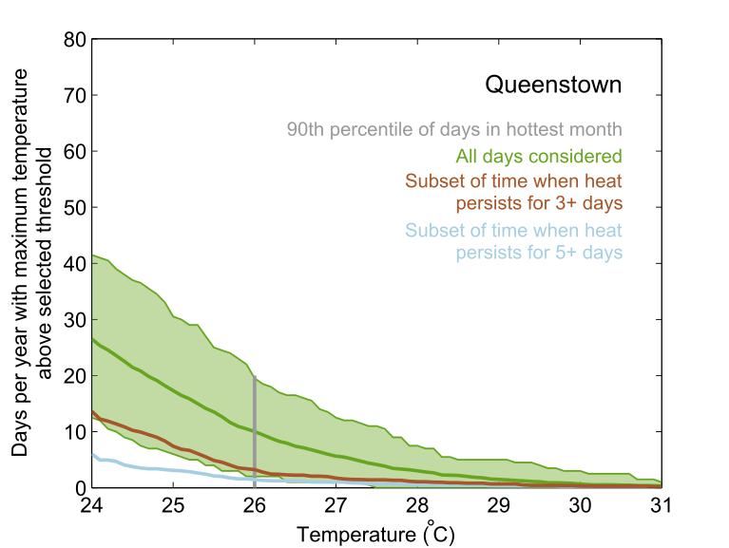
Figure S25: Same as Figure S1, but for Queenstown.
 |  | Daily maximum temperature threshold (°C)
 |  | 23 | 24 | 25 | 26 | 27 | 28 | 29 | 30 | 31
Number of consecutive days equal to or above threshold | 1 | 656 | 508 | 379 | 252 | 148 | 72 | 32 | 13 | 5
Number of consecutive days equal to or above threshold | 2 | 338 | 251 | 157 | 76 | 36 | 23 | 11 | 5 | 3
Number of consecutive days equal to or above threshold | 3 | 188 | 128 | 71 | 29 | 15 | 10 | 6 | 3 | 2
Number of consecutive days equal to or above threshold | 4 | 107 | 73 | 35 | 16 | 8 | 5 | 4 | 3 | 2
Number of consecutive days equal to or above threshold | 5 | 63 | 38 | 19 | 8 | 6 | 3 | 2 | 1 | 0
Number of consecutive days equal to or above threshold | 6 | 41 | 22 | 12 | 7 | 4 | 1 | 1 | 0 | 0
Number of consecutive days equal to or above threshold | 7 | 24 | 12 | 6 | 5 | 3 | 1 | 1 | 0 | 0
Number of consecutive days equal to or above threshold | 8 | 16 | 7 | 4 | 3 | 1 | 1 | 1 | 0 | 0
Number of consecutive days equal to or above threshold | 9 | 11 | 6 | 4 | 2 | 1 | 1 | 1 | 0 | 0
Number of consecutive days equal to or above threshold | 10 | 9 | 4 | 3 | 1 | 1 | 1 | 0 | 0 | 0
Table S26: Same as Table S2, but showing counts for Queenstown.
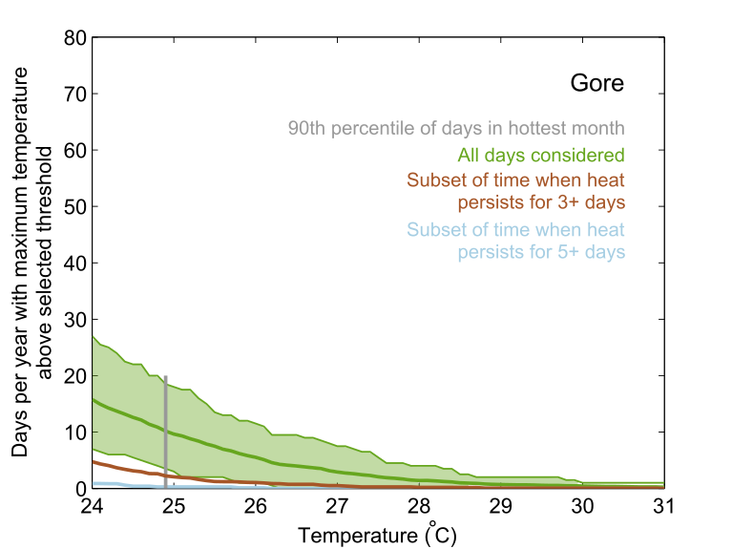
Figure S26: Same as Figure S1, but for Gore.
 |  | Daily maximum temperature threshold (°C)
 |  | 23 | 24 | 25 | 26 | 27 | 28 | 29 | 30 | 31
Number of consecutive days equal to or above threshold | 1 | 539 | 410 | 282 | 167 | 93 | 46 | 23 | 13 | 6
Number of consecutive days equal to or above threshold | 2 | 206 | 140 | 70 | 38 | 17 | 8 | 3 | 2 | 2
Number of consecutive days equal to or above threshold | 3 | 89 | 52 | 23 | 12 | 6 | 2 | 1 | 1 | 0
Number of consecutive days equal to or above threshold | 4 | 36 | 22 | 11 | 5 | 2 | 2 | 0 | 0 | 0
Number of consecutive days equal to or above threshold | 5 | 14 | 6 | 2 | 1 | 0 | 0 | 0 | 0 | 0
Number of consecutive days equal to or above threshold | 6 | 10 | 3 | 1 | 0 | 0 | 0 | 0 | 0 | 0
Number of consecutive days equal to or above threshold | 7 | 6 | 1 | 0 | 0 | 0 | 0 | 0 | 0 | 0
Number of consecutive days equal to or above threshold | 8 | 3 | 1 | 0 | 0 | 0 | 0 | 0 | 0 | 0
Number of consecutive days equal to or above threshold | 9 | 3 | 0 | 0 | 0 | 0 | 0 | 0 | 0 | 0
Number of consecutive days equal to or above threshold | 10 | 3 | 0 | 0 | 0 | 0 | 0 | 0 | 0 | 0
Table S27: Same as Table S2, but showing counts for Gore.

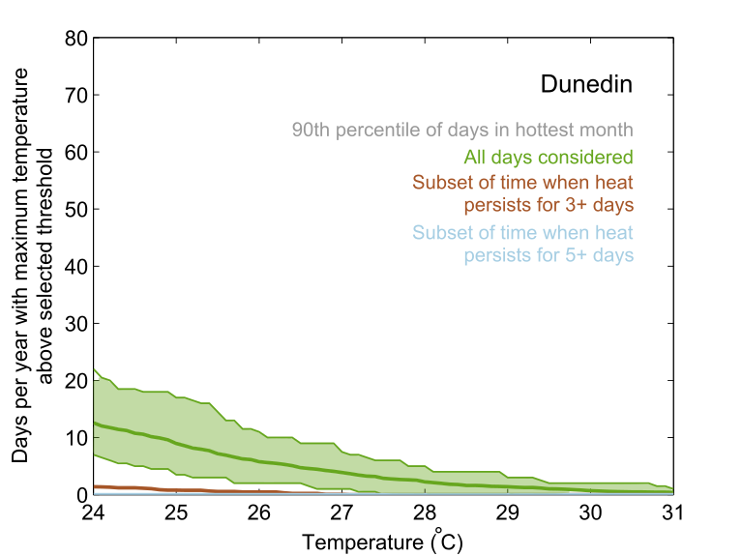
Figure S27: Same as Figure S1, but for Dunedin.
 |  | Daily maximum temperature threshold (°C)
 |  | 23 | 24 | 25 | 26 | 27 | 28 | 29 | 30 | 31
Number of consecutive days equal to or above threshold | 1 | 551 | 394 | 294 | 200 | 138 | 85 | 53 | 26 | 15
Number of consecutive days equal to or above threshold | 2 | 139 | 89 | 54 | 26 | 18 | 5 | 3 | 0 | 0
Number of consecutive days equal to or above threshold | 3 | 31 | 17 | 10 | 6 | 1 | 0 | 0 | 0 | 0
Number of consecutive days equal to or above threshold | 4 | 12 | 5 | 2 | 1 | 0 | 0 | 0 | 0 | 0
Number of consecutive days equal to or above threshold | 5 | 2 | 0 | 0 | 0 | 0 | 0 | 0 | 0 | 0
Number of consecutive days equal to or above threshold | 6 | 1 | 0 | 0 | 0 | 0 | 0 | 0 | 0 | 0
Number of consecutive days equal to or above threshold | 7 | 0 | 0 | 0 | 0 | 0 | 0 | 0 | 0 | 0
Number of consecutive days equal to or above threshold | 8 | 0 | 0 | 0 | 0 | 0 | 0 | 0 | 0 | 0
Number of consecutive days equal to or above threshold | 9 | 0 | 0 | 0 | 0 | 0 | 0 | 0 | 0 | 0
Number of consecutive days equal to or above threshold | 10 | 0 | 0 | 0 | 0 | 0 | 0 | 0 | 0 | 0
Table S28: Same as Table S2, but showing counts for Dunedin.
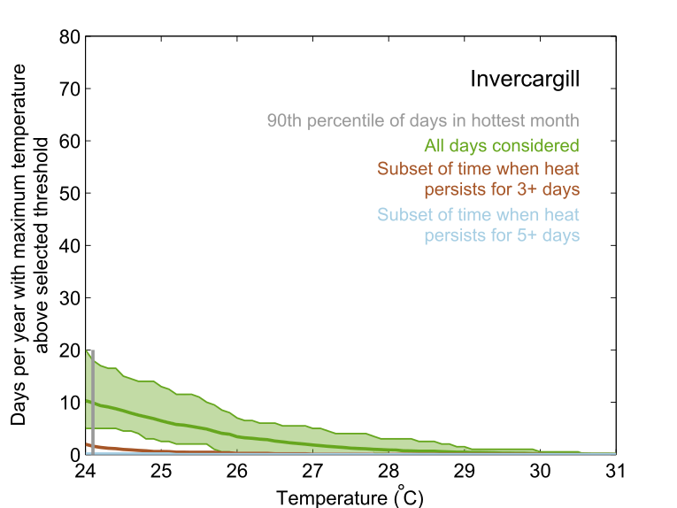
Figure S28: Same as Figure S1, but for Invercargill.
 |  | Daily maximum temperature threshold (°C)
 |  | 23 | 24 | 25 | 26 | 27 | 28 | 29 | 30 | 31
Number of consecutive days equal to or above threshold | 1 | 437 | 310 | 215 | 120 | 63 | 30 | 15 | 4 | 2
Number of consecutive days equal to or above threshold | 2 | 116 | 71 | 34 | 15 | 9 | 4 | 2 | 1 | 0
Number of consecutive days equal to or above threshold | 3 | 41 | 23 | 6 | 3 | 1 | 1 | 1 | 1 | 0
Number of consecutive days equal to or above threshold | 4 | 17 | 8 | 4 | 0 | 0 | 0 | 0 | 0 | 0
Number of consecutive days equal to or above threshold | 5 | 4 | 1 | 1 | 0 | 0 | 0 | 0 | 0 | 0
Number of consecutive days equal to or above threshold | 6 | 0 | 0 | 0 | 0 | 0 | 0 | 0 | 0 | 0
Number of consecutive days equal to or above threshold | 7 | 0 | 0 | 0 | 0 | 0 | 0 | 0 | 0 | 0
Number of consecutive days equal to or above threshold | 8 | 0 | 0 | 0 | 0 | 0 | 0 | 0 | 0 | 0
Number of consecutive days equal to or above threshold | 9 | 0 | 0 | 0 | 0 | 0 | 0 | 0 | 0 | 0
Number of consecutive days equal to or above threshold | 10 | 0 | 0 | 0 | 0 | 0 | 0 | 0 | 0 | 0
Table S29: Same as Table S2, but showing counts for Invercargill.
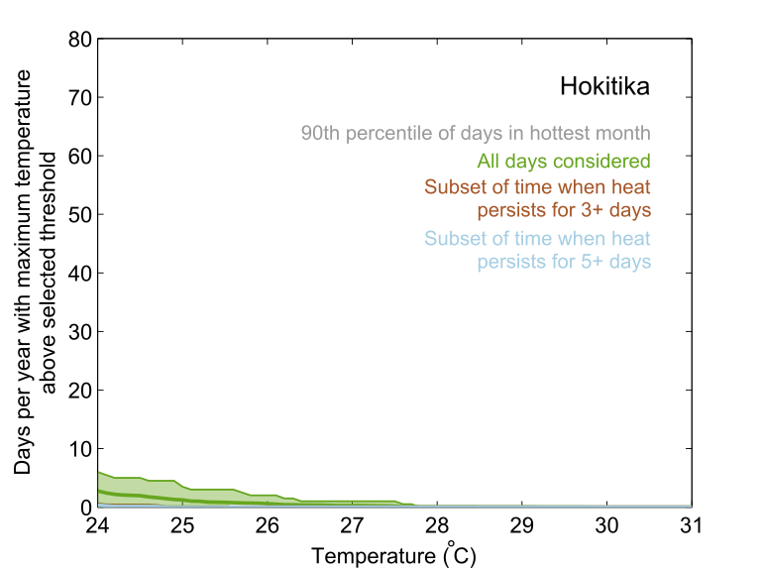
Figure S29: Same as Figure S1, but for Hokitika.
 |  | Daily maximum temperature threshold (°C)
 |  | 23 | 24 | 25 | 26 | 27 | 28 | 29 | 30 | 31
Number of consecutive days equal to or above threshold | 1 | 147 | 80 | 38 | 19 | 9 | 2 | 1 | 0 | 0
Number of consecutive days equal to or above threshold | 2 | 47 | 18 | 10 | 3 | 1 | 0 | 0 | 0 | 0
Number of consecutive days equal to or above threshold | 3 | 16 | 4 | 0 | 0 | 0 | 0 | 0 | 0 | 0
Number of consecutive days equal to or above threshold | 4 | 7 | 2 | 0 | 0 | 0 | 0 | 0 | 0 | 0
Number of consecutive days equal to or above threshold | 5 | 5 | 2 | 0 | 0 | 0 | 0 | 0 | 0 | 0
Number of consecutive days equal to or above threshold | 6 | 4 | 1 | 0 | 0 | 0 | 0 | 0 | 0 | 0
Number of consecutive days equal to or above threshold | 7 | 4 | 1 | 0 | 0 | 0 | 0 | 0 | 0 | 0
Number of consecutive days equal to or above threshold | 8 | 3 | 1 | 0 | 0 | 0 | 0 | 0 | 0 | 0
Number of consecutive days equal to or above threshold | 9 | 3 | 1 | 0 | 0 | 0 | 0 | 0 | 0 | 0
Number of consecutive days equal to or above threshold | 10 | 2 | 0 | 0 | 0 | 0 | 0 | 0 | 0 | 0
Table S30: Same as Table S2, but showing counts for Hokitika.
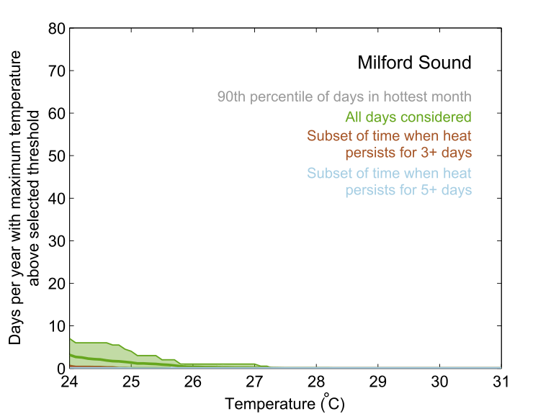
Figure S30: Same as Figure S1, but for Milford Sound.
 |  | Daily maximum temperature threshold (°C)
 |  | 23 | 24 | 25 | 26 | 27 | 28 | 29 | 30 | 31
Number of consecutive days equal to or above threshold | 1 | 174 | 94 | 42 | 13 | 5 | 0 | 0 | 0 | 0
Number of consecutive days equal to or above threshold | 2 | 51 | 23 | 11 | 0 | 0 | 0 | 0 | 0 | 0
Number of consecutive days equal to or above threshold | 3 | 16 | 7 | 0 | 0 | 0 | 0 | 0 | 0 | 0
Number of consecutive days equal to or above threshold | 4 | 10 | 1 | 0 | 0 | 0 | 0 | 0 | 0 | 0
Number of consecutive days equal to or above threshold | 5 | 6 | 0 | 0 | 0 | 0 | 0 | 0 | 0 | 0
Number of consecutive days equal to or above threshold | 6 | 6 | 0 | 0 | 0 | 0 | 0 | 0 | 0 | 0
Number of consecutive days equal to or above threshold | 7 | 5 | 0 | 0 | 0 | 0 | 0 | 0 | 0 | 0
Number of consecutive days equal to or above threshold | 8 | 2 | 0 | 0 | 0 | 0 | 0 | 0 | 0 | 0
Number of consecutive days equal to or above threshold | 9 | 0 | 0 | 0 | 0 | 0 | 0 | 0 | 0 | 0
Number of consecutive days equal to or above threshold | 10 | 0 | 0 | 0 | 0 | 0 | 0 | 0 | 0 | 0
Table S31: Same as Table S2, but showing counts for Milford Sound.
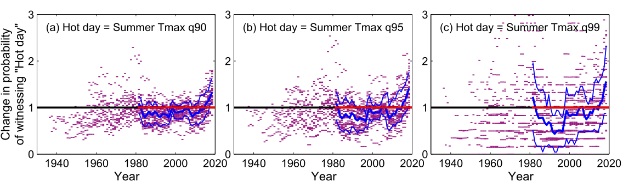
Figure S31: Same as Figure 6 of the main manuscript, but using a longer reference period of 1972-2019 from which to extract baseline percentile thresholds.

