Climatic Controls On The Survival And Loss Of Ancient Types Of Barley On North Atlantic Islands

Peter Martin¹, Terence A. Brown², Timothy S. George³, Björn Gunnarson⁴, Neil Loader⁵, Paul Ross⁶, John Wishart¹, Rob Wilson⁶

¹Agronomy Institute, Orkney College UHI, Kirkwall, UK
²Department of Earth and Environmental Sciences, Manchester Institute of Biotechnology, University of Manchester, Manchester, UK
³The James Hutton Institute, Dundee, UK
⁴Department of Physical Geography, Stockholm University, 106 91 Stockholm, Sweden
⁵Department of Geography, Swansea University, Swansea, UK
⁶School of Earth and Environmental Sciences, University of St Andrews, Fife, UK

Supplementary Material

Supplementary Figures

Fig. S1 Spatial plots of first-differenced correlations (1932-1999) between average June-September temperatures in the North Atlantic region and CSDD for Tórshavn (a) and the Scottish Isles (b)

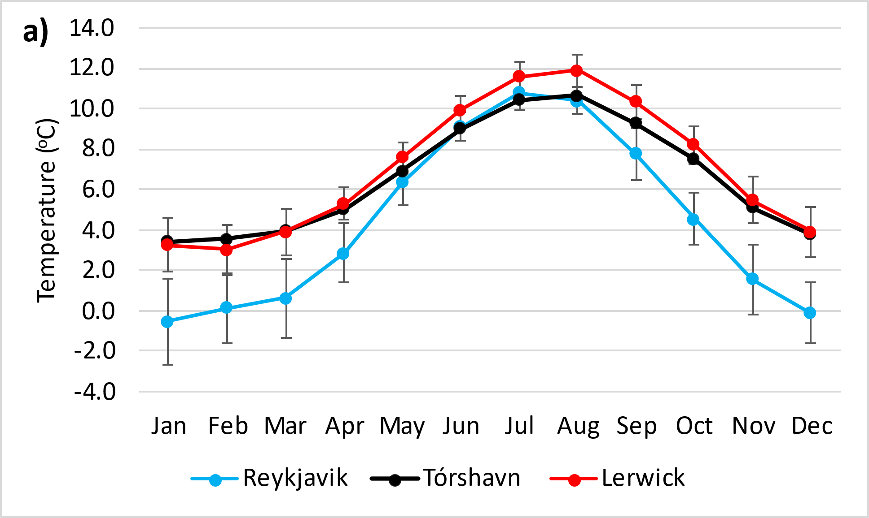

Fig. S2 a) Average (1949-1997) monthly temperatures for Reykjavik, Tórshavn and Lerwick. Error bars indicate one standard deviation either side of the mean for the Reykjavik and Lerwick data; the standard deviation for Lerwick and Tórshavn means were very similar. b) Three-year running averages of temperature (May to September) from 1931 to 2010 for Reykjavik, Tórshavn and Lerwick. The dashed horizontal lines and associated temperature values are the average May-September temperatures during Icelandic cold and warm periods (1962-95 and 1930-60, respectively)

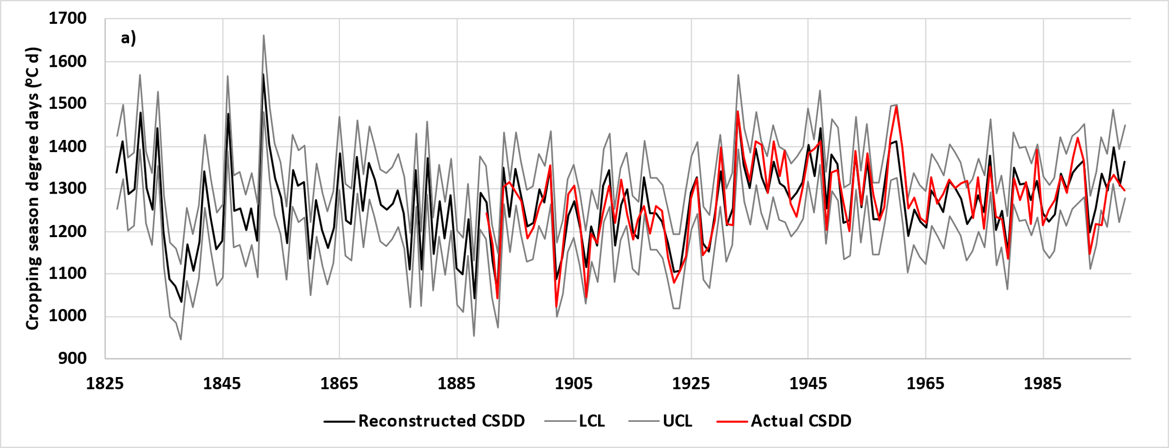
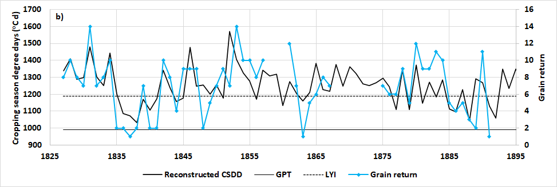
Fig. S3 a) Actual Tórshavn CSDD from 1890 to 1999 and reconstructed values from 1827 to 1999 with lower and upper 95% confidence limits (LCL and UCL, respectively). b) Reconstructed CSDD compared with barley grain returns recorded on a Faroese farm between 1827 and 1891 (Guttesen 2001). The lower and upper horizontal lines are the CSDD values of our grain production threshold (GPT) and low yield indicator (LYI), respectively, for the Faroes

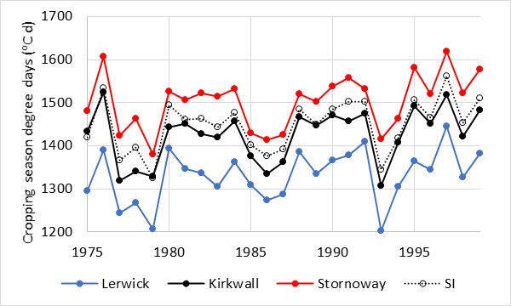

Fig. S4 Cropping season degree days (CSDD) for Lerwick (Shetland), Kirkwall (Orkney) and Stornoway (Western Isles) from 1975 to 1999. Values for the Scottish Isles (SI) were calculated with data from the Scottish Isles temperature series (SIT)

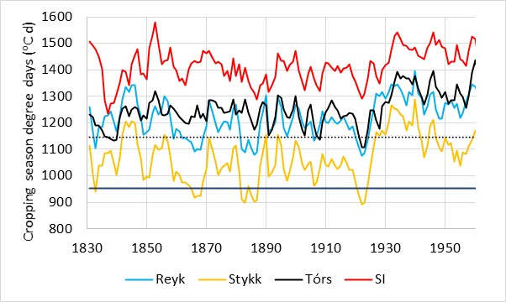
Fig. S5 Three-year running averages of CSDD at Reykjavik (Reyk) and Stykkishólmur (Stykk) in Iceland compared with Tórshavn (Tórs) and the Scottish Isles (SI) from 1831 to 1959. Reykjavik and Tórshavn CSDD values were reconstructed from 1830 to 1929 and 1889, respectively, using Stykkishólmur and SIT data. The upper and lower horizontal lines, respectively, are the estimated LYI and GPT at Reykjavik
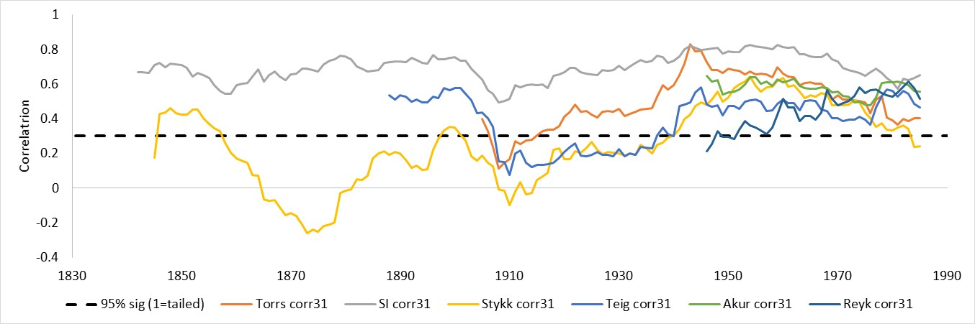

Fig. S6 Sliding 31-year correlations between CSDD and reconstructed CSDD for selected North Atlantic sites

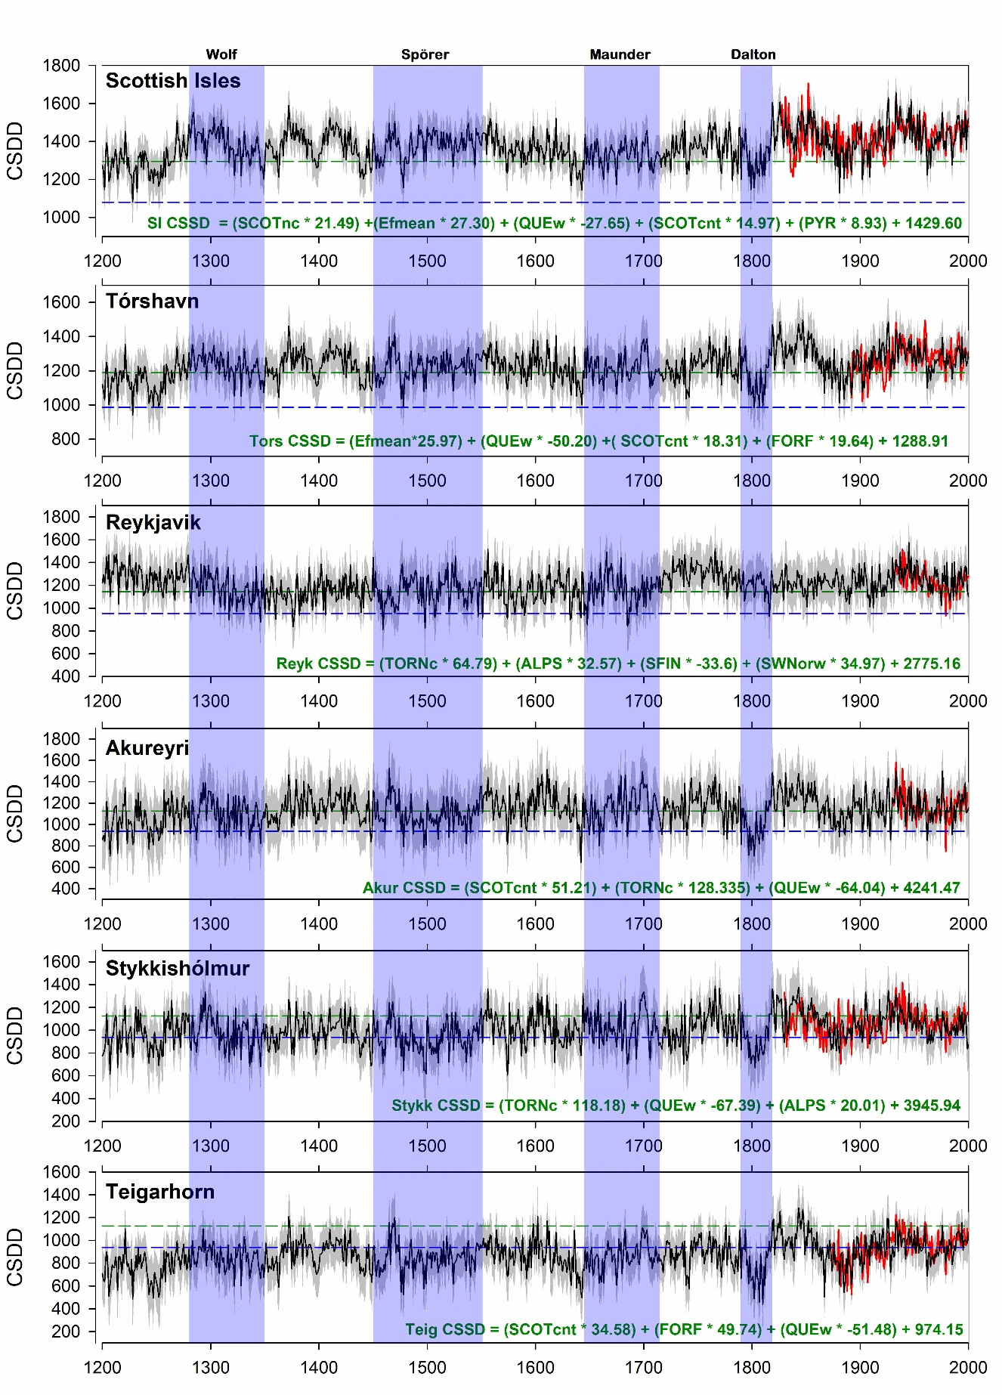
Fig. S7 Reconstructed CSDD for selected North Atlantic sites from AD 1200 to 2000 in relation to periods of grand minima solar activity (Wolf, Spörer, Maunder and Dalton; Usoskin et al. 2011). Black and red lines are for reconstructed and actual CSDD, respectively; dashed grey lines are the upper and lower confidence limits for reconstructed CSDD; upper and lower horizontal lines are the LYI and GPT, respectively, for each site. The multiple regression equations represent the models for the most replicated nested models (see Table S4)
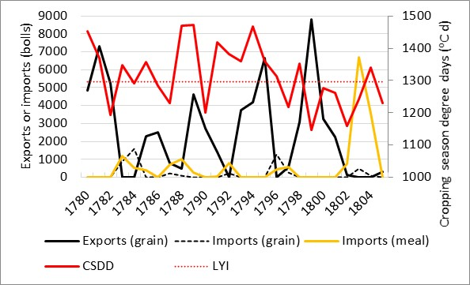

Fig. S8 Annual exports and imports of bere as grain and meal from Kirkwall, Orkney, compared with reconstructed CSDD calculated for the Scottish Isles using tree-ring data. Import and export data were derived from Shirreff (1814)

Supplementary Tables

Table S1 Sources of meteorological data

Meteorological station and country | Latitude, longitude and elevation above sea level | Data source
Scottish Isles Temperature (SIT) | Data compiled from several locations | https://crudata.uea.ac.uk/cru/data/sniffer/
Scottish Mainland Temperature (SMT) | Data compiled from several locations | https://crudata.uea.ac.uk/cru/data/sniffer/
Lerwick, Shetland, Scotland | 60⁰ 08’ N, 01⁰ 10’ W  82 m | https://www.metoffice.gov.uk/research/climate/maps-and-data/historic-station-data
Kirkwall, Orkney, Scotland | 58⁰ 57’ N, 02⁰ 54’ W  21 m | https://en.tutiempo.net/climate/ws-30170.html
Stornoway, North Uist, Scotland | 58⁰ 12’ N, 06⁰ 19’ W  15 m | https://www.metoffice.gov.uk/research/climate/maps-and-data/historic-station-data
Tórshavn, Faroes | 62⁰ 01’ N, 06⁰ 45’ W  54 m | http://research.dmi.dk/data/
Reykjavik, Iceland | 64⁰ 07’ N, 21⁰ 54’ W  23 m | https://en.vedur.is/climatology/data/
Stykkishólmur, Iceland | 65⁰ 05’ N, 22⁰ 44’ W | https://en.vedur.is/climatology/data/
Akureyri, Iceland | 65⁰ 69’ N, 18⁰ 07’ W  23 m | https://en.vedur.is/climatology/data/
Teigarhorn, Iceland | 64⁰ 41’ N, 14⁰ 21’ W  21 m | https://en.vedur.is/climatology/data/
Utsira lighthouse, Norway | 59⁰ 18’ N, 04⁰ 53’ E  78 m | https://seklima.met.no/observations/
Vestlandet, Norway | Data compiled from several locations | Nordli et al. 2003

Table S2 Values of the coefficient of determination (r²) for significant linear relationships between variables identified in this study

Equation number | Data time span | Dependent variable | Independent variable | n | Significance | r²
2 | 2003-19 | 1/t, where t is the number of days from sowing to harvest | Average daily temperature (⁰C) from sowing to harvest | 78 | P<0.001 | 0.336
3 | - | CSDD | Latitude | 5 | P<0.01 | 0.941
4 | 1890-1999 | CSDD Tórshavn | CSDD Stykkishólmur | 110 | P<0.001 | 0.417
5 | 1890-1999 | CSDD Tórshavn | CSDD Utsira | 110 | P<0.001 | 0.497
6 | 1890-1999 | CSDD Tórshavn | CSDD SMT | 110 | P<0.001 | 0.545
7 | 1890-1999 | CSDD Tórshavn | CSDD SIT | 110 | P<0.001 | 0.780
8 | 1827-1891 | Grain return | Reconstructed CSDD Tórshavn | 54 | P<0.001 | 0.461
9 | 1890-1999 | CSDD Tórshavn | Vestlandet temperature (April-August, ⁰C) | 110 | P<0.001 | 0.561
10 | 1931-1999 | CSDD Reykjavik | CSDD Stykkishólmur | 69 | P<0.001 | 0.825
11 | 1931-1999 | CSDD Akureyri | CSDD Stykkishólmur | 69 | P<0.001 | 0.785
12 | 1873-1999 | CSDD Teigarhorn | CSDD Stykkishólmur | 127 | P<0.001 | 0.608
13 | 1780-1804 | Bere exports | CSDD Scottish Isles | 25 | P<0.1 | 0.261

Table S3 Identity of tree-ring site codes and tree-ring parameters used in this study. Site locations are shown in Fig. 1a

Site code | Regional grouping | Tree-ring parameter¹ | Reference
QUEw | Québec | RW | Gennaretti et al. (2014)
FORF | Forfjorddalen | MXD | McCarroll et al. (2013)
TORNc | Northern Sweden | δ¹³C | Loader et al. (2013)
EFmean | Northern Scandinavia | MXD | Esper et al. (2014) and Matskovsky and Helama (2014)
TAA | Tjeggelvas, Arjeplog, Ammarnäs composite | MXD | Linderholm et al. (2014)
JAEM | Jaemtland | MXD | Zhang et al. (2015)
ROG | Rogen | BI | Fuentes et al. (2018)
SFIN | South Finland | MXD | Helama et al. (2014)
SWNorw | Southwest Norway | MXD | Unpublished
SCOTnc | Scotland - northern Cairngorm | RW/BI | Rydval et al. (2017)
SCOTcnt | Scotland - central | DBI | Unpublished
SCOTnw | Scotland - northwest | DBI | Unpublished
ALPSw | W Alps - Lötschental | MXD | Büntgen et al. (2006).
PYR | Pyrenees | MXD | Dorado-Liñan et al. (2012)

¹RW = ring width; MXD = maximum latewood density; δ¹³C - stable carbon isotope; BI = Latewood Blue Intensity; DBI - Delta Blue Intensity

References
Büntgen U, Frank DC, Nievergelt D et al (2006) Summer temperature variations in the European Alps, AD 755-2004. J Clim 19:5606-5623. https://doi.org/10.1175/JCLI3917.1

Dorado-Liñan I, Büntgen U, Gonzalez-Rouco F et al (2012) Estimating 750 years of temperature variations and uncertainties in the Pyrenees by tree-ring reconstructions and climate simulations. Clim Past 8:919-933. https://doi.org/10.5194/cp-8-919-2012

Esper J, Düthorn E, Krusic P et al (2014) Northern European summer temperature variations over the Common Era from integrated tree-ring density records. J Quat Sci 29:487-494. https://doi.org/10.1002/jqs.2726

Fuentes M, Salo R, Björklund J et al (2018) A 970-year-long summer temperature reconstruction from Rogen, west-central Sweden, based on blue intensity from tree rings. Holocene 28:254-266. https://doi.org/10.5194/cp-10-1473-2014

Gennaretti F, Arseneault D, Nicault A et al (2014) Volcano-induced regime shifts in millennial tree-ring chronologies from Northeastern North America. Proc Natl Acad Sci USA 111:10077–10082. https://doi.org/10.1073/pnas.1324220111

Helama S, Vartiainen M, Holopainen J et al (2014) A palaeotemperature record for the Finnish Lakeland based on microdensitometric variations in tree rings. Geochronometria 41:265-277. https://doi.org/10.2478/s13386-013-0163-0

Linderholm H, Björklund J, Seftigen K et al (2014) Fennoscandia revisited: a spatially improved tree-ring reconstruction of summer temperatures for the last 900 years. Clim Dyn 45:933-947. https://doi.org/10.1007/s00382-014-2328-9

Loader NJ, Young GHF, Grudd H et al (2013) Stable carbon isotopes from Torneträsk, northern Sweden provide a millennial length reconstruction of summer sunshine and its relationship to Arctic circulation. Quat Sci Rev 62:97-113.
https://doi.org/10.1016/j.quascirev.2012.11.014

Matskovsky V, Helama S (2014) Testing long-term summer temperature reconstruction based on maximum density chronologies obtained by reanalysis of tree-ring data sets from northernmost Sweden and Finland. Clim Past 10:1473-1487. https://doi.org/10.5194/cp-10-1473-2014

McCarroll D, Loader NJ, Jalkanen R, et al (2013) A 1200-year multiproxy record of tree growth and summer temperature at the northern pine forest limit of Europe. Holocene 23:471-484. https://doi.org/10.1177/0959683612467483

Rydval M, Loader NJ, Gunnarson BE et al (2017) Reconstructing 800 years of summer temperatures in Scotland from tree rings. Clim Dyn 49:2951-2974.
https://doi.org/10.1007/s00382-016-3478-8

Zhang P, Linderholm H, Gunnarson B et al (2015) 1200 years of warm-season temperature variability in central Fennoscandia inferred from tree-ring density. Clim Past Discussion 11:489-519. https://doi.org/10.5194/cpd-11-489-2015

Table S4 Calibration statistics for multiple linear regressions between CSDD at specific North Atlantic island locations and tree-ring records over two nested periods (1611-1999 and 1200-1999). The full regression models for the most replicated 1611-1999 nest are presented in Fig. S7

1611-1999
Location¹ | Entered variables² | r | ar² | DW | LINr
CSDD Tórs | Efmean, QUEw, SCOTcntDB, FORFmxd | 0.62 | 0.35 | 1.52 | -0.10
CSDD SI | SCOTnc, Efmean, QUEw, SCOTcntDB, PYR | 0.76 | 0.55 | 1.75 | -0.01
CSDD Stykk | TORNc, QUEw, ALPS | 0.50 | 0.22 | 1.93 | -0.23
CSDD Teigar | SCOTcntDB, FORFmxd, QUEw | 0.53 | 0.25 | 1.63 | -0.18
CSDD Akur | SCOTcntDB, TORNc, QUEw | 0.61 | 0.34 | 2.00 | -0.14
CSDD Reyk | TORNc, ALPS, SFIN, SWNorw | 0.50 | 0.20 | 1.69 | -0.31

1200-1999
Location¹ | Entered variables² | r | ar² | DW | LINr
CSDD Tórs | Efmean, QUEw, SCOTnc | 0.60 | 0.33 | 1.65 | -0.05
CSDD SI | SCOTnc, Efmean, QUEw | 0.73 | 0.51 | 1.63 | 0.01
CSDD Stykk | TORNc, QUEw, ALPS | 0.50 | 0.22 | 1.93 | -0.23
CSDD Teigar | Efmean, QUEw | 0.43 | 0.16 | 1.54 | 0.00
CSDD Akur | ROG, QUEw, TORNc | 0.50 | 0.21 | 1.94 | -0.03
CSDD Reyk | TORNc, ALPS, SFIN | 0.45 | 0.16 | 1.76 | -0.33

¹ Tórs, Tórshavn; SI, Scottish Isles; Stykk, Stykkishólmur; Teigar, Teigarhorn; Akur, Akureyri
² Variables are specified in Table S3
ar², adjusted r²
DW, Durbin-Watson statistic for residual first order autocorrelation
LINr, the correlation between time and the residual values

Table S5 Periods when four or more consecutive years had reconstructed CSDD below the LYI in the Scottish Isles and Faroes between AD 1200 and 2000 and the average CSDD for these periods

Scottish Isles

Period | Number of years | Average CSDD
1225-1232 | 8 | 1206
1242-1256 | 15 | 1224
1346-1350 | 5 | 1254
1438-1443 | 6 | 1228
1632-1635 | 4 | 1244
1638-1643 | 6 | 1203
1695-1698 | 4 | 1262
1799-1803 | 5 | 1217

Faroes

Period | Number of years | Average CSDD
1205-1211 | 7 | 1111
1223-1232 | 10 | 1105
1241-1256 | 16 | 1067
1345-1350 | 6 | 1128
1395-1400 | 6 | 1143
1438-1443 | 6 | 1103
1452-1461 | 10 | 1147
1475-1479 | 5 | 1095
1638-1643 | 6 | 1082
1659-1663 | 5 | 1136
1715-1720 | 6 | 1164
1739-1742 | 4 | 1060
1799-1803 | 5 | 1056
1809-1812 | 4 | 1078
1885-1888 | 4 | 1111

Table S6 Years with documented poor harvests or famine in Scotland and CSDD for these years from the Scottish Isles reconstruction
Year | CSDD¹ | Comment | Reference |  | Year | CSDD¹ | Comment² | Reference
1256 | 1218 | Poor harvest | 1 |  | 1623 | 1352 |  | 9
1260 | 1352 | Poor harvest | 1 |  | 1630 | 1345
1261 | 1274 | Famine | 1 |  | 1631 | 1433 | Famine * | 3
1262 | 1273 | Famine | 1 |  | 1632 | 1248
1269 | 1509 |  |  |  | 1633 | 1168 | Poor harvest and famine * | 3
1270 | 1408 | Famine | 1 |  | 1634 | 1284 | Poor harvest and famine * | 3
1271 | 1412 |  |  |  | 1635 | 1275
1272 | 1296 | Famine | 1 |  | 1648 | 1374
1292 | 1394 |  |  |  | 1649 | 1298 | Famine 1649-53 | 9
1293 | 1469 | Famine | 1 |  | 1650 | 1277 |  | 9
1296 | 1282 |  | 1 |  | 1651 | 1372 |  | 9
1297 | 1381 | Famine | 1 |  | 1652 | 1386 |  | 9
1314 | 1367 |  |  |  | 1653 | 1252 |  | 9
1315 | 1395 | Famine | 1 |  | 1671 | 1358 | Poor harvest * | 10
1316 | 1476 | Famine | 1 |  | 1673 | 1338
1336 | 1271 |  | 1 |  | 1674 | 1263 | Famine 1674-76* | 2, 9
1337 | 1280 | Famine | 1 |  | 1675 | 1173 |  | 2, 9
1420 | 1467 | Poor harvest | 1 |  | 1676 | 1330 |  | 2
1434 | 1416 |  |  |  | 1695 | 1236 | Poor harvests, famine 1695-99 * | 3
1435 | 1338 | Famine | 1 |  | 1696 | 1253 |  | 3, 9
1438 | 1211 |  | 1 |  | 1697 | 1292 |  | 2, 3
1439 | 1237 | Famine | 1 |  | 1698 | 1267 |  | 2, 3,9
1591 | 1278 |  |  |  | 1699 | 1400 |  | 2, 9
1592 | 1285 | 1592-99. Famines | 2 |  | 1739 | 1283 | Poor harvests 1739-40* | 4, 12
1593 | 1344 |  | 2 |  | 1740 | 1228 |  | 4, 5
1594 | 1327 |  | 2 |  | 1771 | 1252
1595 | 1419 |  | 2 |  | 1772 | 1233 | Profound scarcity* | 10
1596 | 1295 |  | 2 |  | 1782 | 1194 | Poor harvest * | 6
1597 | 1395 |  | 2 |  | 1783 | 1349 | Poor harvest * | 11
1598 | 1479 |  | 2 |  | 1801 | 1261 | Poor harvest, 1801-03 * | 7
1602 | 1411 |  | 10 |  | 1802 | 1158 |  | 7
1620 | 1347 |  |  |  | 1803 | 1241 |  | 7
1621 | 1305 | Famine 1621-23 | 9 |  | 1817 | 1378 | Poor harvest | 10
1622 | 1337 |  | 9 |  | 1835 | 1487 | Poor harvests, 1835-36 * | 8
 |  |  |  |  | 1836 | 1391 |  | 8
¹ Yellow highlighted CSDD values are below the LYI (1296 DD) for the Scottish Isles
² Orange highlighting with an * indicates years with a specific reference to the Scottish Isles
References
1, Oram 2015 | 4, Rössner 2011 | 7, House of Commons 1804 | 10, Dodgshon 2004
2, Dodgshon 2005 | 5, Whyte 1993 | 8, MacAskill 2010 | 11, Cullen 2019
3, Thomson 2001 | 6, Macgregor 1839 | 9, Cullen 2010 | 12, OSA 1791-99

Supplementary Note 1
Climate context
To place our analysis of CSDD within a wider climatic context, we provide an analysis of recent (1949-1997) temperature, precipitation and sunshine data for selected sites (Reykjavik, Tórshavn and Lerwick) and highlight how these can have an important effect on barley cropping in the region.
Average monthly temperatures were lowest at Reykjavik, especially from September to April (Fig. S2a), which would have resulted in later spring cultivations and sowing and a higher risk of frost damage to crops in the spring or prior to harvest. Temperature over the cropping season has an important effect on the length of time from sowing to harvesting (Equation 2, Table S2; Cammarano et al. 2019) which is longer with low temperatures, increasing the risk of crop losses around harvest from rain, wind, frost or snow. Although this would be expected to result in a longer period from sowing to harvesting at Reykjavik and Tórshavn compared with Lerwick, the longer summer daylength at the higher latitudes partly offsets this (Equation 3, Table S2).
Over the last millennium, a frequent feature of the Icelandic climate has been the alternation of cold and relatively warm periods, with the former often coinciding with the occurrence of coastal sea ice (Hartman et al. 2017; Ogilvie and Jónsson 2001). In the 20th century, warm and cold episodes occurred from about 1930-60 and 1962-95, respectively, and were reflected in May-September temperatures (Fig. S2b). During the warm period, the average Reykjavik and Tórshavn temperatures were very similar (9.4 ⁰C and 9.5 ⁰C) but during the cold period Reykjavik was considerably colder (8.7 ⁰C compared with 9.2 ⁰C), suggesting it is more prone to larger variations in cropping season temperatures.
For barley, adequate rainfall is critical during crop establishment and, post-anthesis, for grain filling. After this, dry conditions favour grain ripening and harvesting. Excessive rainfall can result in soil erosion and loss of seed around sowing, crop damage after heading and even premature grain germination in the head. Average (1949-1997) May-September rainfall was highest at Tórshavn followed by Lerwick and Reykjavik (416 mm, 366 mm and 268 mm, respectively). At Reykjavik, 9 out of 49 years had less than 200 mm of rain over the cropping season compared with no years at both Tórshavn and Lerwick, suggesting a greater risk of crops experiencing water stress (Cammarano et al. 2019). This reflects the tendency of Iceland to experience drought events (Spinoni et al. 2015) and historic sources indicate the occurrence of summer drought at the end of the 13th century (Hartman et al. 2017). Rainfall is seldom low enough to constrain barley growth in the Faroes or at Lerwick where the main problem is high rainfall around sowing and during grain maturity and harvesting. This results in slower grain maturation and a high grain moisture at harvesting, making grain drying especially important.
Crop biomass production is driven by the interception of photosynthetically active radiation for which climate station measurements of hours of bright sunshine are often used as an indicator. Average (1949-1997) May-September sunshine hours were highest at Reykjavik, lowest at Tórshavn and intermediate at Lerwick (807 h, 544 h and 658 h, respectively). The much higher hours of sunshine in Iceland may have allowed crops to compensate for other adverse factors like delayed sowing caused by low temperatures. Conversely, the low sunshine hours in the Faroes resulted in a need to maximise the duration of the cropping season through early sowing.
Significant correlations of climate variables between sites demonstrated the stronger climatic links between Lerwick and Tórshavn than between either location and Reykjavik. Thus, although there were significant correlations between May-September temperatures between Reykjavik and Lerwick (r², 0.13) and Reykjavik and Tórshavn (r², 0.28), that between Tórshavn and Lerwick was considerably higher (r², 0.72). There were also significant correlations between May-September sunshine hours (r², 0.31) and rainfall (r², 0.24) between the latter two sites.
Significant correlations between climatic variables occurred at some locations, demonstrating the difficulty of attributing barley production to single climatic factors. These included negative correlations between sunshine and rainfall at Reykjavik (r², 0.46) and Lerwick (r², 0.10), positive correlations between sunshine and temperature at Tórshavn (r², 0.12) and Lerwick (r², 0.20) and a negative correlation between temperature and rainfall at Lerwick (r², 0.10).
Since the islands in this study are close to the climatic limits of barley cultivation, crops are especially susceptible to additional cooling resulting from volcanic eruptions and at least 22 major global eruptions occurred between the 13th and 20th centuries (Rydval et al. 2017). Moreover, with several of these being in the south of Iceland, an important local effect was the loss of agricultural land and damage to crops from ash fall and tephra deposits. This happened, for example, in 1104 and 1362 with the eruptions of Hekla and Öræfajökull, respectively (Gudmundsson et al. 2008) while the huge eruption of Laki in 1783 caused a dry sulphurous fog which reached the Faroes and Scotland (Thordarson and Self 2003), probably damaging crops as reported in some other parts of Europe.
From the early 15th century, there was a marked increase in storminess in the North Atlantic (Dugmore et al. 2007) which would have exacerbated Iceland’s serious soil erosion problems and impacted on lowland areas (Streeter et al. 2012). The sandy soils of the Scottish Isles were also very susceptible to wind erosion and significant areas of arable land were lost to sandblow between the 15th and 18th centuries (Dodgshon 2005; Oram 2015).
There have been a few previous studies within the North Atlantic region linking barley production to climatic variables, and positive correlations between CSDD or temperature and yield have been reported for Orkney (r², 0.41; Martin et al. 2017) and Iceland (r², 0.49; Hilmarsson et al. 2017). For Scotland, the importance of dry, sunny years for good barley yields is also suggested by a positive correlation between national yields (1963-2005) and sunshine (April to July) and a negative one between yield and July rainfall (Brown 2013). In contrast, for the much drier East of Scotland, a positive correlation was found between growing season rainfall and simulated barley yield for 1974-2013 (Cammarano et al. 2019). Neither Brown (2013) nor Cammarano et al. (2019) found a significant correlation between temperature and barley yield, but neither study focused on the Scottish Isles. More widely, for western and central Europe between 1500 and 1800, a highly significant negative correlation was found (Ljungvist et al. 2021) between grain price (an indicator of grain production/scarcity) and the previous year’s reconstructed June-August temperature so that high prices (resulting from scarcity/poor harvests) were associated with low cropping season temperatures; only weak relationships were found with drought or precipitation and there was no robust association with solar forcing.

Supplementary Note 2
Grain Production Threshold (GPT) and Low Yield Indicator (LYI)
Initially, we used growth and temperature data for recent crops of bere to calculate a theoretical temperature threshold (grain production threshold, GPT) expressed in DD which we suggested was likely to be the minimum temperature for producing a crop of grain with viable seed (Section 2.3). The importance of this threshold is that if there were several consecutive cropping seasons below it, isolated island communities dependent on locally adapted types of barley, would no longer have viable seed of these lines and they would be lost. It would then only be possible to re-start barley cultivation by introducing appropriately adapted lines from elsewhere. We later recognised, however, that some grain of food value might still be produced at or below the GPT. As we had no modern data for these conditions, we were not able to associate a grain yield with temperature conditions around the GPT. It seemed likely, though, that it would be low as earlier research (Martin et al. 2017) with a modern barley variety in Orkney had shown that yield decreased as the number of DD in the cropping season declined. The best data we found for investigating this within the study were the Faroese grain return data described in Section 3.2. For these data, the regression line of grain return on CSDD predicted zero grain return at 914 DD which is just below our estimated GPT (986 DD) for the Faroes, and at the GPT the line predicted a grain return of 1.4 (standard error, 0.90). This is only slightly more grain than is required to replenish seed stocks and is about one tenth of the maximum returns recorded (between 10 and 14), but there is considerable uncertainty attached to this value as shown by the standard error. Reports for barley trials in Iceland for 1963 indicated a combination of crop failure and very low yields in this year which was just above the GPT at the sites we investigated (Section 3.3 and Fig. 1b). But, insufficient detail is available to associate a specific grain production with the CSDD value of this year. In Orkney (Section 3.4), the reconstructed CSDD of 1802 was 1158 DD which is about 7% above the GPT (1080 DD). The harvest of 1802 was described (House of Commons, 1804) as being only sufficient for 3 months consumption and this is supported by the very high imports of beremeal and oatmeal in 1803 and the complete absence of bere exports in this year. Again, however, it is not possible to associate a specific grain production with the GPT, although it was clearly extremely low and insufficient for both seed and consumption. The fitted line for Orkney bere exports from 1780 to 1805 on CSDD (Section 3.4) indicated zero exports below a CSDD of 1130 DD which is also compatible with grain production being very low at the GPT of 1080 DD. So, while we can only relate the GPT to a specific grain return with one data set from the Faroes, published data from all the islands in our study indicate that it reflects temperature conditions where grain production is extremely low and is likely to result in severe shortages of grain for seed and food.
The other threshold we used, the low yield indicator (LYI), was identified using the Faroese grain return data (Section 3.2) and was adopted to identify years where grain production was likely to be low, but not as low as at the GPT. In the case of the Faroese data (53 years): 19 years had a CSDD below the LYI, the average return for these years was 4.3 and in ten years (53%) the return was 4 or less. For the 35 years above the LYI, the average return was 8.1 and only 3 years (9%) had a return of 4 or less. In Icelandic trials between 1987 and 1996 (Section 3.3), when most of the trials were in the South, North or West of the country, there were just two years, 1989 and 1992, where the CSDD at Reykjavik was below the LYI (1145 DD). For these years, the average grain yields were about 0.7 t/ha (dry weight) and were the lowest in this period. For 1993, when CSDD was just above the LYI, the average grain yield was 2.0 t/ha (dry weight) while the highest average annual grain yield between 1987 and 1996 was just over 3.0 t/ha. Although the Faroese and Icelandic data support our use of the LYI as an “indicator” of low yields, only the Faroese data allow quantification of this: 53% of years below the LYI had a return of 4 or less. For Scotland’s Western Isles in the late 18th century, Dodgshon (1993) noted that good or exceptional yields were returns of 10 or more on seed, while average yields were between 4 and 6. These figures, therefore, also indicate that a return of 4 is low.
With the caveat that there are inaccuracies within our reconstructed CSDD for the Scottish Isles as well as gaps in the historical data, the famine and poor harvest data in Table S6, provide another data set for relating (indirectly) our LYI to grain production. In this case, out of 581 years from 1256 to 1836, 115 years were below the LYI and 28% of these were associated with poor harvests or famine. This figure is compatible with the above Faroese grain return data where 37% of the years below the LYI had a grain return of only 2 or less which would definitely be considered a very poor harvest.

Supplementary Note 3
Historic data
Faroese farm data
The data on farm barley returns (weight of grain harvested divided by weight of grain sown) were obtained from an analysis (Guttesen 2001) of records for Uppistovu farm located on the northern Faroese island of Borðoy. We used the grain returns for 54 years for which data were available between 1827 and 1891. Total grain production at Uppistovu in a good year was estimated (Guttesen 2001) at about 400 kandbar (8.3 barrels, or about 0.67 t). This compares with a grain harvest for the Faroes of about 1755 barrels (140 t) in 1813 (Guttesen 1999). The Uppistovu crop therefore represents about 0.5% of the national crop. We assume that Uppistovu grain returns are representative of Faroese barley production for the years we have used and also that field management was similar from year to year. This is probably not an unreasonable assumption given the traditional nature of Faroese barley cultivation and that the farm was run by the same family over the years of our study.

Orkney export data
Data for Orkney exports of Bere from 1780 to 1805 were derived from Shirreff (1814) and, because of the delay needed to thresh each year’s crop and prepare it for export, we assume that exports represent the surplus grain (after local needs had been met) from the previous year. However, this may not always have been the case. One factor affecting this was that a considerable proportion of exports were derived from feu duties and land rentals which were often not fully paid in poor harvest years and payment was then deferred to subsequent better years (Shirreff, 1814). This might have contributed to the large variation in exports seen in Fig. S8. Higher than usual exports also occurred in years when grain prices were high in other parts of Britain and exporting grain was especially profitable – e.g. 1799 (Shirreff 1814).

Poor harvest and famine years - Table S6 and Fig. 2
In Table S6, we included years which have been identified in several other published studies as having had poor harvests or famines. For famine years, we have also included the year before the famine, on the assumption that famine usually resulted from a poor harvest in the previous year. Often, famines ran over several years as a result of a succession of poor harvests and, on some occasions, years started with famine but this was then relieved by a better cropping season with a good harvest later in the year. Usually there is insufficient information to ascertain whether this was the case and so we have normally included famine years and their previous years in Table S6. The tendency for poor harvests and famine years to run over several years is also likely to have resulted from insufficient good quality seed being available after poor harvests. This would have been especially likely during wet, stormy harvests where crops lodged and germination of grain in the head would have been likely.
Inevitably, the list of poor harvests and famine years in Table S6 is incomplete because of gaps in the historical records, especially in parts of the 14th century (Oram 2015). With little detail about most of these events in the primary sources, it is likely that they include a wide range of harvest shortfalls, with some very much more severe than others. For many of these events, especially before the 17th century, it is also unclear how extensive they were in Scotland and whether they all impacted the Scottish Isles. Years where our sources make a specific reference to the Isles are highlighted in orange in the comments column of Table S6, but even here there are likely to have been years where the impact on the Northern Isles was different to that on the Western Isles.
There is usually little detailed information about weather for most of the years listed in Table S6, so it is often uncertain which weather factors were the main cause of the events. From the limited information available, it seems likely that weather factors other than temperature were primarily responsible for the famines/poor harvests identified in the below years in Table S6 and in none of these years was the reconstructed CSDD below the LYI for the Scottish Isles:
1260: the poor harvest resulted from violent storms during a dry summer followed by a wet harvest with gales (Oram 2015).
1315-1317: the Great Famine has mainly been attributed to harsh, stormy winters and very wet summers (Huhtamaa 2019).
1649: the summer is thought to have been dry (Whittington 1985).
1652: the summer was one of severe drought and great heat (Whittington 1985).
1671: there was high rainfall in the summer followed by very strong winds at harvest (Dodgshon 2004).
1783: very unusual conditions were experienced in Europe (Thordarson and Self 2003), including Scotland (Dawson et al. 2021), following the huge fission eruption of Laki (in Iceland) in 1783. These included a dry sulphurous fog from about mid-June which burnt leaves on crops and trees, intense heat and violent thunderstorms. Although it is not clear to what extent these events contributed to the poor harvest of 1783, it is likely that their combined effect was significant, as was reported at some other locations (Thordarson and Self 2003).
While famine and poor harvest years were commonly associated with weather factors affecting crops, livestock or both, other influences were also sometimes important. These included political instability and war, as well as diseases of both people and livestock (Oram 2015). The impact of these events was sometimes reduced by famine relief and purchases of grain from elsewhere provided by the Church and some benevolent landowners (Wenham 2003), but formal government famine relief only started in Scotland in the 1780s (Cullen 2019) and a Scottish Poor Law Act was not passed until 1845.
We have not included the Scottish potato famine (mainly 1846-7) in Table S6 as this was mainly caused by disease on the potato crop rather than a failure of the cereal harvest. It is likely that there were also poor harvests in the late 1870s but we have not included these as they have not been well documented for Scotland. This is possibly because they occurred during a period of general agricultural depression in Britain and when cereal imports from North America, distribution systems and poor relief measures could compensate for harvest losses.

Supplementary Note 4
Locally adapted production systems and resilience mechanisms
With many periods of adverse climate in the northeast Atlantic through much of the last millennium (Dugmore et al. 2007; Cunningham et al. 2013; Wilson et al. 2016), locally adapted production systems and resilience mechanisms were crucial for allowing continued cultivation of barley by the isolated communities on the islands in this study. Some of their key aspects are reviewed below.
Locally adapted production systems
In both the Faroes and Iceland, fields were commonly sited with a southerly aspect (Arge et al. 2005) and at low altitude to increase insolation and provide the highest temperatures (Humlum and Christiansen 1998). In Iceland, as the climate deteriorated, cultivation was abandoned first at inland and higher altitude sites but continued at milder low altitude coastal and island sites in the south until about the 16th century (Riddell et al. 2018). In the Scottish Isles, a significant part of the bere crop was grown on sandy soils, possibly because they were freer draining and could be cultivated earlier than heavier land. With their high pH and deficiencies in trace elements (Schmidt et al. 2019), however, they required bere types with special traits to tolerate these extreme conditions (Schmidt et al. 2019). Another key adaptation required by barley in the study area was the ability to grow quickly and reach maturity in a short period (Martin et al. 2017) so that the crop could be harvested before the onset of very poor weather.
Considerable resources were required by the barley crop – especially seaweed or manure as fertiliser, and labour for harvesting and cultivation, the latter often being done with spades rather than ploughs. Spade cultivation often gave higher grain returns than ploughing (Fenton 1963) while heavy manuring resulted in high soil organic matter content which possibly moderated the effects of climatic fluctuations (Adderley and Simpson 2005).
In response to high rainfall and the risk of soil waterlogging, special cultivation systems were developed in the Faroes and parts of the Scottish Isles (reinavelta and lazy beds, respectively) which improved soil drainage and reduced erosion. This was especially important on the peat soils which were common on these islands. Additionally, reinavelta, cultivation increased soil temperatures (Christiansen 1989). Although the origins of reinavelta are unclear, it was practiced from at least the 17th century (Christiansen 1989) and probably evolved from an earlier barley monoculture which relied on small, heavily fertilised fields and was in use during the Viking period around AD 1000 (Church et al. 2005). Even at this time, however, some barley was probably imported (Church et al. 2005).
In the Faroes and Iceland, barley was the only cereal cultivated on a significant scale, and resources were focussed on this. With the milder climate of the Scottish Isles, more diverse arable systems were possible and oats became increasingly important after the Norse occupation (Bond 1998; Sharples et al. 2015). This was facilitated by bere’s short period of growth which allowed farmers to sow oats before bere, but to still be able to harvest bere reasonably early, before the oat crop. In the rotation, oats followed bere, and manure or seaweed were only applied to the bere. This strategy maximised returns but minimised risk (Dodgshon 2004), as bere was more likely to be successfully harvested because of its earlier ripening; it also responded better to manure.
In most years in the Faroes, barley had to be harvested before it was fully ripe and, consequently, with a high grain moisture content. Grain drying was therefore crucial for safe storage and producing good quality seed and was done in specially heated drying houses (sodnhús; Williamson 1970). Kiln-drying of grain was also sometimes practiced in the Western Isles (Dodgshon 1992).
Resilience mechanisms
In addition to the practical measures described in the previous section, there were a number of wider, mainly socio-economic, factors which contributed resilience to barley production by the communities in this study and helped them cope with years when returns were low. This was crucial for maintaining seed stocks of precious locally adapted types which, once lost, could not simply be replaced with seed from other locations.
The Faroes and all the groups of Scottish islands in this study are archipelagos with many islands and a diversity of micro-environments resulting from factors like aspect, altitude and soils. This would make it unlikely, in all but the most extreme years, for a harvest to completely fail everywhere, ensuring a supply of seed in some locations.
For much of the period of this study, bere was used in the Scottish Isles for paying land rents and other in-kind payments. While rents were often collected with little regard for the circumstances of the harvest, there is evidence, at least by the 1690s, for rests or eases of rents (D’Arrigo et al. 2020; Dodgshon 2004) following very poor harvests. A change towards payments of rent in cash from the 17th century probably helped tenants in the Western Isles retain more of their own grain (Dodgshon 2004).
Under famine conditions, a major threat to the survival of local strains of food crops is that seed for the following year is eaten as food but there were several ways in which this was minimised in the study area. The Faroes were probably seldom self-sufficient in barley and, from at least the 13th century, a proportion of the grain used each year normally came from imports (Landt 1810), helping islanders retain local grain for seed. In Scotland, formal government famine relief only started in the 1780s (Cullen 2019) but prior to this some relief was provided through the Church or through landlords purchasing grain and distributing it to tenants (Dodgshon 2004; Wenham 2003). From the late 18th century, there is also evidence in Orkney for a greater proportion of the rural population having access to cash from activities like kelp production or linen making which sometimes allowed them to purchase grain or meal when this was available (Wenham 2003). Between the latter part of the 18th and the early 19th centuries, there were several years with very poor harvests in Scotland and these were often followed by Government prohibitions on using grain for distilling to ensure that as much grain as possible was available for food (Hume and Moss, 2000), Other buffers included access to wild food resources like fish, shellfish, sea-birds, seals and whales (Wylie 1987) or the use of arable weeds as famine foods (Dodgshon 2004). Seasonal migration of labour also helped relieve pressure on scarce food reserves over the summer months and was particularly common in the Western Isles (Devine 1983).
Faced with a limited availability of local barley, in both Iceland and the Faroes, priorities were placed on how local grain was used. In Iceland, barley appears to have become a prestige crop primarily grown at high status farms to provide alcohol (Zori et al. 2013) and bread (Riddell et al. 2018) for feasting. In the Faroes, the reverse is suggested, and local barley was preserved firstly for seed and secondly for food, especially bread (Landt, 1810); beer was normally made from imported malt. With fewer constraints on production in the Scottish Isles, the bere crop was often able to meet food requirements and provide surpluses which were exported or used for brewing or distilling.

Supplementary Note 5
Limitations of the analysis and recommendations for further research
Our analysis used cropping season temperature (as CSDD) as an indicator of the suitability of conditions for growing ancient types of barley in the study area over the past 800 years. While we found significant positive correlations between CSDD and grain returns (Faroes) and grain exports (Orkney) and many instances where low CSDD coincided with poor grain returns (Faroes and Iceland), low or no grain exports (Orkney) and the incidence of poor harvests and famines (Scotland), regression analyses showed a large amount of variance (>55%) was left unaccounted for by CSDD. Although we do not know which are the most important remaining sources of variance, the below discussion identifies some of the most likely factors and areas where further research might improve the present study.
Historical sources show clearly that other climatic factors, especially wind and rainfall have also significantly contributed to crop failures in the study area and their effects on cropping and interaction with each other and temperature have been considered in Supplementary Note 1. While it would be attractive to include these in new models, proxy data for these factors is very limited. Furthermore, detrimental effects of heavy rain and wind on crops is often very brief (close to harvest) and localised, making it difficult to find proxy data which would be relevant to a wide geographical area.
Our reconstructions of CSDD showed clearly the importance of having highly correlated TR data and this was particularly difficult to obtain for Iceland. Since there are few trees older than about 100 years in the country (Levanič and Eggertsson 2008) other proxy data from molluscs (e.g. Butler et al. 2013) or ice cores (e.g. Kobashi et al. 2011) may need to be considered but these would need to have an appropriate calibrated terrestrial temperature signal (i.e. spring/summer rather than annual). Further TR data from Quebec or Nova Scotia/Newfoundland might also be valuable as we found that this had an inverse tele-connected relationship with conditions in Iceland. With better and earlier CSDD reconstructions for Iceland, it might be possible to investigate conditions for barley cultivation following the Viking settlement and during the MCA when it is thought that the climate was more suitable for barley production. Interestingly, although TR data were reasonably well correlated with CSDD for the Faroes, our TR reconstruction failed to identify a cold period between 1835 and 1845 which is indicated by both low grain returns in the Faroese farm return data and the reconstruction of Faroese CSDD derived from SIT (Fig. S3b) as well as data for these years from Norway (Nordli 2001). As the northern hemisphere network of TR data is expanded (Wilson et al. 2016), it may be possible to improve the modelling for the Faroes reconstruction and to also develop CSDD reconstructions for earlier periods than the present study (Wilson et al. 2012).
The Scottish Isles are a diverse group of three distinct archipelagos stretching from latitude 57.0 to 61.0ºN and about longitude 1.0 to 7.5ºW. Inevitably, the archipelagos experience different weather (see Fig. S4 for annual differences in CSDD from 1975 to 2000), but with greater similarity between that of Orkney and Shetland due to their proximity. Our reconstruction of CSDD is based upon SIT which provides a single monthly temperature series for the three archipelagos from 1827-2000 (Jones and Lister 2004). With appropriate TR and temperature data, future analyses might develop separate CSDD reconstructions for the 3 achipelagos to compare their historic suitability for barley cultivation. One of the most useful periods for comparison might be around 1780-1805 because of the availability of Orkney bere export data (e.g. Shirreff 1814) and agricultural survey data from the Western Isles (Dodgshon 1993).
Barley grain production is very responsive to changes in husbandry like measures to increase soil fertility or improve drainage or soil pH. Major changes in husbandry would be expected to alter the relationships between grain production and CSDD. In Iceland, there is evidence of minimal manuring strategies in the period leading up to barley abandonment (Simpson et al. 2002) and this may have aggravated the effects of a worsening climate on grain production. Heavy manuring of the Faroese barley crop was described at the end of the 18th century (Landt 1810) and there is evidence for the amendment of early arable soils with organic manures at several sites (Adderley and Simpson 2005). Once the reinavelta system of cultivating barley had been established, it seems unlikely that there were major changes in barley crop husbandry in the Faroes up to the start of the 20th century when traditional methods were still being practiced (Annandale 1905) although the crop was in serious decline. In Scotland, marked agricultural improvements took place from about the middle of the 18th century but these were much slower to reach the Scottish Isles and real change in Orkney, for example, only came around the middle of the 19th century (Thomson 2001); earlier in the century, Shirreff (1814) had suggested that some land in Orkney had been cropped continuously with bere and oats for centuries. In coastal parts of the Scottish Isles, seaweed was an important fertiliser for arable crops (Dodgshon 1993), but between about 1750 and 1850, large quantities were used for making kelp, an alkaline ash used in glass and soap manufacture. The Scottish Isles’ kelp industry provides a good example of how socio-economic factors may have had complex interactions with the effects of temperature on barley production which we have investigated. Firstly, there were several very serious crop failures (e.g. 1782, 1802, 1835) resulting in major shortages of food in the Isles over the life of the industry and during these crises profits from kelp probably allowed many landowners to purchase grain or meal which was supplied to their tenants on various terms (Thomson, 2001; Wenham 2003). This probably helped avoid the large numbers of deaths from starvation that occurred after some of the poor harvests of the 17th century. Furthermore, a small income from kelp helped some tenants to purchase imported grain instead of running into debt (Wenham 2003). On the negative side, however, the industry resulted in landlords neglecting agriculture and fisheries (Shirreff 1804) and placing restrictions on the use of seaweed which must have reduced the amount available for manuring crops (Dodgshon 1993; Rymer 1974). This is likely to have reduced soil fertility, leading to lower grain production which may have aggravated the poor harvests of years when the climate was unfavourable. Finally, in order to maximise profits from kelp, landowners often encouraged or compelled their tenants to move to coastal areas and subdivided farms into units which were hardly agriculturally sustainable. This had serious consequences later, in the 1840s, when the demand for kelp declined and there were poor harvests of both cereals and potatoes.
In our analysis, we have assumed that in each of our study areas the barley types grown all have the same early maturing characteristic and we have therefore used the same values for the GPT and LYI within each area (Table 1) based upon those of bere which is currently grown in Orkney. We do not know, however, whether this was the case or even whether this characteristic has remained constant over time in each area. In the process of traditional crops becoming adapted to the areas in which they were grown, it would seem likely that during cold periods when the cropping season was especially short, there may have been a tendency for earlier maturing lines of barley to become more prominent because it would often not have been possible for farmers to successfully harvest later maturing lines and they would therefore have been less prominent in grain reserved for seed. In prolonged warm periods the reverse may have been the case as later maturing lines would be expected to be higher yielding and may therefore have been specifically selected by growers as a source of seed. Even though traditional crop types like bere have not been subject to improvement by plant breeders, agricultural improvers were already selecting seeds of outstanding plants to generate improved lines of crops early in the 19th century and at least two types of improved bere, Victoria and Buchan bere, are mentioned in the historic literature (Lawson & Son 1852; Pringle 1874). It is not known how these types of bere relate to currently grown types. Recent trials of bere accessions from different Scottish locations, have also shown differences in earliness between some accessions and suggest that those from the Northern Isles are earlier maturing than most of those from the Western Isles (Agronomy Institute unpublished results). It is not known whether this reflects historic differences between bere from the two locations or whether it is simply that these are the accessions which have survived down to modern times in these archipelagos. Nevertheless, these observations suggest that, even for bere, there may have been less uniformity of the GPT and LYI amongst the types grown than we have assumed.
Another aspect of improved husbandry is the use of higher yielding crop varieties. Since these usually required a longer cropping season than was available in the study area, improved barley varieties could generally only be adopted in the 20th century when mechanisation and new methods of processing effectively lengthened the cropping season.
For reconstructing CSDD, it was necessary to make assumptions about the start and end of the cropping season for each of the areas in the study (Section 2.2) and in each location we have used the same start and end dates for every year. This does not happen in practice and will have resulted in differences between the actual value of CSDD and the values we have reconstructed. In the Scottish Isles, a sowing date around 15 May is often mentioned in recent historical documents and appears to have been adopted to allow oats to be planted before the bere crop (Dodgshon, 2004). It is not clear, however, from what period this practice started, but before then it would probably have often been possible to sow bere about one month earlier, increasing the number of degree days within the cropping season. If this was the practice in the early 13th century, it may have helped reduce the effects of low temperatures suggested by our reconstruction at the start of the century.
We have discussed some of the gaps in the historic data and likely sources of error related to this in Supplementary Note 3. It would be particularly useful to identify more information related to the Scottish Isles before the 17th century and to understand more about the impact of the very poor growing conditions suggested by our reconstructions during the early part of the 13th century.
Although it might be possible to extend our methodology to mainland Scotland by calibrating the TR data against the Scottish Mainland Temperature (SMT) series, there are several factors which would make a similar analysis of this region more difficult. Firstly, growing conditions are more variable than in the Isles, due to differences in climate, soil and topography/altitude. It is also likely that, especially in the south of the country, temperature is not so critical for crop production as in the Isles because the cropping season is longer and temperatures are warmer. Secondly, the adoption of agricultural improvements (land enclosures, liming, land drainage, crop rotations, improved crop types) started earlier on mainland Scotland, in the early part of the 18th century, and resulted in gradual increases in productivity with time which might make it more difficult to detect trends related to climate, particularly if the data sets are for relatively few years.

Supplementary Note 6
The decline in growing ancient types of barley in the Scottish Isles and Faroes
Independent of climate, a gradual decline in the cultivation of traditional types of barley in the Scottish Isles and Faroes probably started from about the beginning of the 19th century as a result of several factors.
An important contributor in both areas was the introduction of the potato (Solanum tuberosum L.) in the 18th century (Guttesen 2001; Dodgshon 2004) which increased in popularity through the 19th century as a food and local crop. Other changes in farming systems also had a big impact. In Orkney, the export of livestock gradually replaced that of grain during the 19th century (Thomson 2001) and in both the Western Isles and Shetland widescale evictions of tenants by landowners for more profitable sheep production (the Highland Clearances) led to rural depopulation and less arable agriculture. During the 20th century, the shift to mechanised agriculture effectively added more degree days to the cropping season while ensiling and using grain preservatives reduced the degree day requirement of crops, making it possible to replace bere with later maturing but higher yielding, modern varieties.
During the 19th and 20th centuries all of the North Atlantic islands in this study experienced huge improvements in trade links which reduced the need for food self-sufficiency, one of the original drivers for local barley cultivation. In Iceland, barley cultivation ceased much earlier, at a time of climatic deterioration but also when trade was expanding as a result of increasing European demand for stockfish and oil from the 14th century (Þórhallsson 2012). In the Faroes, trade was liberalised in 1856 with the end of the Danish trade monopoly (Williamson 1970) while the establishment of a fishing industry (Manson 1978) created new wealth for purchasing imports. The industry also attracted labour away from farming and by the start of the 20th century many families had ceased growing barley (Annandale 1905). Cultivation ended shortly after the second world war (Brandt 1996), but at least two types of Faroese barley (Langaks and Stjernebygg) have been preserved in germplasm collections. In the Scottish Isles, imported cereal products became cheaper and more available following the introduction of regular shipping links early in the 19th century, the repeal of the Corn Law in 1846 and greater imports of wheat from North America later in the century.
Remarkably, bere survived in cultivation in the Scottish Isles through the 19th and 20th centuries. While beremeal remained important in many communities, bere also continued to be used for whisky production in some areas until about the end of the 19th century. Although bere’s low alcohol yield on distillation was a serious disadvantage for distillers, during most of the 19th century there was a lower rate of tax on bere malt than on malt made from other barley and this helped to make it economically viable to continue using bere when other types of barley were not available; the malt tax was abolished in 1880 (Stopes 1885). Even under improved agricultural systems in the 19th century, bere appears to have found a niche as its earliness made it very suitable for establishing grassland by undersowing with pasture mixes (Hay 2012). Bere’s survival was also linked to that of small scale farming and crofting, made possible by enlightened land reform measures from the end of the 19th century (Sellar 2006). Many crofting areas, especially in the Northern and Western Isles, included the sandy soils which bere is so well adapted to. In Orkney, a small local market for beremeal and a functioning watermill were crucial for bere’s survival during the 20th century.
Currently, in the Western Isles, bere continues to be grown with rye (Secale cereale L.) and black oats (Avena strigosa Schreb) for forage on nutrient-poor soils while, in Orkney, about 80 ha is grown annually for grain which is used for niche market, high provenance products like beremeal, whisky and beer (Martin et al. 2009). Continued cultivation of bere has allowed distinct genotypes from the Western Isles, Orkney and Shetland (Schmidt et al. 2017) to be collected and preserved in germplasm collections. Although none of the early strains of Icelandic barley survived after growing ceased in the 15th century, recent climate change has encouraged a significant expansion of barley cultivation in both the north and south of the island (Martin et al. 2017). More favourable climatic conditions have also renewed interest in growing barley in the Faroes.

References (not included in the main paper)
Adderley WP, Simpson IA (2005) Early-Norse home-field productivity in the Faroe Islands. Hum Ecol 33:711–736. https://doi.org/10.1007/s10745-005-6423-8
Annandale N (1905) The Faroes and Iceland. Clarendon Press, Oxford
Arge SV, Sveinbjarnardóttir G, Edwards KJ et al (2005) Viking and Medieval Settlement in the Faroes: People, Place and Environment. Hum Ecol 33:597–620 https://doi.org/10.1007/s10745-005-4745-1
Bond JM (1998) Beyond the fringe? Recognising change and adaptation in Pictish and Norse Orkney. In: Mills CM, Coles G (eds.). Human settlement in marginal areas. Oxbow, Oxford, Monograph 100 pp 81–90
Brandt J (1996) The traditional Faeroese village. In Guttesen R (Ed) The Faeroe Islands topographic atlas. Kort & Matrikelstyrelsen, Copenhagen pp 80-81
Brown I (2013) Influence of seasonal weather and climate variability on crop yields in Scotland. Int J Biometeorol 57:605–614. https://doi.org/10.1007/s00484-012-0588-9
Butler PG, Wanamaker AD, Scourse JD, Richardson CA, Reynolds DJ (2013) Variability of marine climate on the North Icelandic Shelf in a 1357-year proxy archive based on growth increments in the bivalve Arctica islandica, Palaeogeogr, Palaeoclimatol, Palaeoecol 373:141-151. https://doi.org/10.1016/j.palaeo.2012.01.016.
Dawson AG, Kirkbride MP, Cole H (2021) Atmospheric effects in Scotland of the AD 1783–84 Laki eruption in Iceland. Holocene 31:830-843. https://doi.org/10.1177%2F0959683620988052
Devine T (1983) Highland migration to lowland Scotland, 1760-1860. Scott Hist Rev 174:137-149. http://www.jstor.org/stable/25529535
Dodgshon R (1992) Farming practice in the Western Highlands and Islands before crofting: A study in cultural inertia or opportunity costs? Rural Hist 3:173-189. https://doi.org/10.1017/S0956793300003083
Dodgshon R (1993) Strategies of farming in the western highlands and islands of Scotland prior to crofting and the clearances. Econ. Hist. Rev. 46: 679-701.
https://doi.org/10.1111/j.1468-0289.1993.tb01357.x
Dodgshon R (2005) The little ice age in the Scottish Highlands and Islands: Documenting its human impact. Scott Geogr J 121:321-337. https://doi.org/10.1080/00369220518737243
Dugmore AJ, Borthwick DM, Church MJ et al (2007) The role of climate in settlement and landscape change in the North Atlantic islands: an assessment of cumulative deviations in high-resolution proxy climate records. Hum Ecol 35:169–178. https://doi.org/10.1007/s10745-006-9051-z
Fenton A (1963) Early and traditional cultivation implements in Scotland. Proc Soc Ant Scot 96:264-317 Gudmundsson MT, Larsen G, Höskuldsson A et al (2008) Volcanic hazards in Iceland. Jökull 58:251-268
Hartman S, Ogilvie AEJ, Ingimundarson JH et al (2017) Medieval Iceland, Greenland, and the new human condition: a case study in integrated environmental humanities. Glob Planet Change 156:123-139. https://doi.org/10.1016/j.gloplacha.2017.04.007
Hay R (2012) Bere barley: rediscovering a Scottish staple. Rev Scottish Cult 24:126-139
Huhtamaa H (2019) Climate and the crises of the early fourteenth century in Northeastern Europe. In: Bauch M and Schenk GJ (Eds) The crisis of the 14th century: teleconnections between environmental and societal change? De Gruyter, Berlin, Boston, pp 80-99. https://doi.org/10.1515/9783110660784-005
Hume JR and Moss MS (2000) The making of scotch whisky: a history of the Scotch whisky distilling industry. Canongate, Edinburgh
Kobashi T, Kawamura K, Severinghaus JP et al (2011) High variability of Greenland surface temperature over the past 4000 years estimated from trapped air in an ice core. Geophys. Res. Lett 38, L21501. https://doi.org/10.1029/2011GL049444
Lawson P & Son (1852) Synopsis of the vegetable products of Scotland in the museum of the Royal Botanic Gardens of Kew. Private press of P. Lawson and Son, Edinburgh
Levanič T, Eggertsson O (2008) Climatic effects on birch (Betula pubescens Ehrh.) growth in Fnjoskadalur valley, northern Iceland. Dendrochronologia 25:135-143. https://doi.org/10.1016/j.dendro.2006.12.001
Ljungqvist FC, Thejll P, Christiansen B et al (2022) The significance of climate variability on early modern European grain prices. Cliometrica 16:29–77. https://doi.org/10.1007/s11698-021-00224-7
Manson TMY (1978) Faroe and its Shetland connections. In: Baldwin JR (ed.). Scandinavian Shetland an ongoing tradition. Econoprint, Edinburgh
OSA = Old Statistical Account (1791-99) Birsay and Harray, County of Orkney, Vol XIV. In: Sir John Sinclair (ed.) The Statistical Account of Scotland. William Creech, Edinburgh
Pringle RO (1874) On the agriculture of the islands of Orkney. Transactions of the Highland and Agricultural Society of Scotland. Neill & Company, Edinburgh
Rössner PR (2011) The 1738-41 harvest crisis in Scotland. Scottish Hist Rev 90:27-63
Rymer L (1974) The Scottish kelp industry, Scottish Geographical Magazine, 90:142-152. https://doi.org/10.1080/00369227408736286
Sellar WDH (2006) The great land debate and the Land Reform (Scotland) Act 2003, Norsk Geogr Tidssr 60:100-109. https://doi.org/10.1080/00291950500535251
Sharples N, Ingrem C, Marshall P et al (2015) The Viking occupation of the Hebrides: evidence from the excavations at Bornais, South Uist. In: Barrett JH, Gibbon SJ (eds). Maritime Societies of the Viking and Medieval World. Maney Publishing, Leeds, Society of Medieval Archaeology Monographs, vol. 37, pp 237-258
Spinoni J, Naumann G, Vogt JV et al (2015) The biggest drought events in Europe from 1950 to 2012. J Hydrol Reg Stud 3:509-524. https://doi.org/10.1016/j.ejrh.2015.01.001
Stopes H (1885) Malt and malting: An historical, scientific and practical treatise. FW Lyon, London
Thordarson T, Self S (2003) Atmospheric and environmental effects of the 1783–1784 Laki eruption: A review and reassessment. J. Geophys Res 108 (D1), 4011. https://doi.org/10.1029/2001JD002042
Usoskin I, Solanki S, Kovaltsov G. (2011) Grand minima of solar activity during the last millennia. Proc Int Astron Union 7:372-382. https://doi.org/10.1017/S174392131200511X
Wenham S (2003) Famine and victuals on the Graemshall Estate. In: Waugh DJ (ed) The faces of Orkney: stones, scalds & saints. Scottish Society for Northern Studies. Shetland Litho, Lerwick, 108-123
Whittington G (1985) The little ice age and Scotland's weather. Scot Geogr Mag 101:174-178 https://doi.org/10.1080/00369228518736634
Whyte ID (1993) Crop yields on the Mains of Yester 1698-1753. Transactions of the East Lothian Antiquarian and Field Naturalists’ Society 22, 23-30
Wilson R, Loader NJ, Rydval M, et al. (2012) Reconstructing Holocene climate from tree rings: The potential for a long chronology from the Scottish Highlands. Holocene 22:3-11. doi:10.1177/0959683611405237
Þórhallsson B (2012) Iceland’s external affairs in the middle ages: the shelter of Norwegian sea power. Stjórnmál & Stjórnsýsla 8:5-37. https://doi.org/10.13177/irpa.a.2012.8.1.1

