Supplementary Information

Understanding perceived climate risks to household water supply and their implications for adaptation: evidence from California

Author information
Kristin B. Dobbin*, UC Berkeley (0000-0001-8499-6850)
Amanda L. Fencl, Union of Concerned Scientists (0000-0002-1914-0930)
Gregory Pierce, Luskin Center for Innovation, UCLA (0000-0002-8164-5825)
Melissa Beresford, San Jose State University (0000-0002-5707-3943)
Silvia Gonzalez, Latino Policy and Politics Institute, UCLA (0000-0002-0338-0438)
Wendy Jepson, Texas A&M University; Texas Water Resources Institute (0000-0002-7693-1376)
* Corresponding author, kbdobbin@berkeley.edu

Table of Contents
Geographic distribution of survey responses 2
Distribution of survey respondents according to
reported concern about future water supply reliability 3
CalSPEAKS Water Security Survey Module 4
Model Term Descriptive Statistics 7
Full Model Results 10
Estimated Marginal Means for Likert levels 1, 2 and 3 13
Correlation Matrix 16

Geographic distribution of survey responses
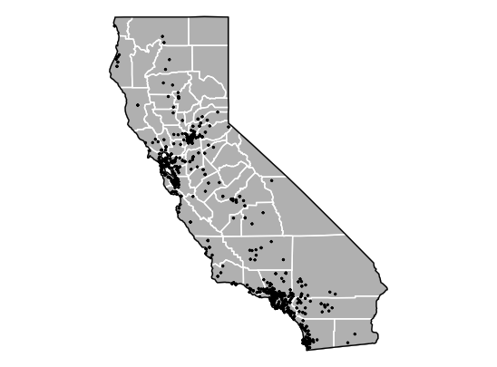
Figure S1. Geographic distribution of survey responses (n=704).

Table S1. Distribution of survey responses by census region (n=704).
Census region | Counties represented | Number of survey respondents
1 | Butte, Colusa, El Dorado, Glenn, Lassen, Modoc, Nevada, Placer, Plumas, Sacramento, Shasta, Sierra, Siskiyou, Sutter, Tehama, Yolo, Yuba | 105
2 | Del Norte, Humboldt, Lake, Mendocino, Napa, Sonoma, Trinity | 25
3 | Alameda, Contra Costa, Marin, San Francisco, San Mateo, Santa Clara, Solano | 167
4 | Alpine, Amador, Calaveras, Madera, Mariposa, Merced, Mono, San Joaquin, Stanislaus, Tuolumne | 21
5 | Monterey, San Benito, San Luis Obispo, Santa Barbara, Santa Cruz, Ventura | 55
6 | Fresno, Inyo, Kern, Kings, Tulare | 29
7 | Riverside, San Bernardino | 46
8 | Los Angeles | 139
9 | Orange | 53
10 | Imperial, San Diego | 64

Distribution of survey respondents according to reported concern about future water supply reliability
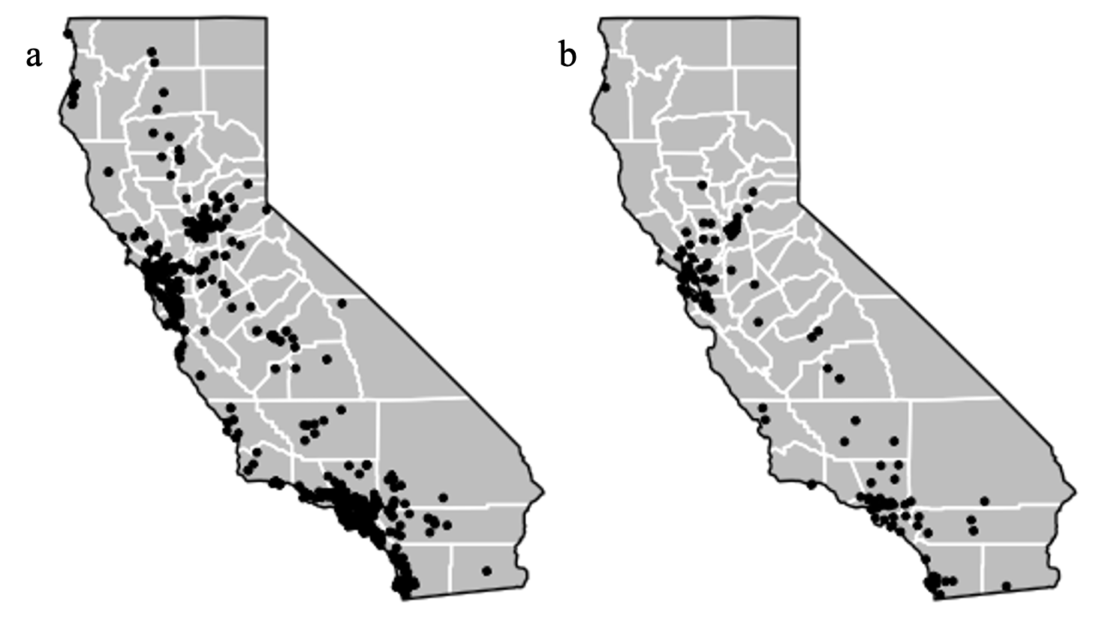
Figure S2. A) Respondents who report agreement or strong agreement with the phrase “I am concerned about California’s water supply reliability due to future extreme weather events (e.g., droughts, wildfires, heat waves, floods).” (n=577) B) Respondents who report disagreement or strong disagreement with the same statement (n=116).

CalSPEAKS Water Security Survey Module
The following questions are about your experiences using tap water in California. By tap water, we mean the water that comes out of the tap in your home with no other filtration and/or treatments. Please answer the questions to the best of your ability based on your knowledge and experiences. There are no right or wrong answers.

- Who provides your tap water?
  - a water system run by my town or city or special district
  - a water system run by a water company
  - a small water system run by my community or neighbors
  - myself, I have private well
  - Other (please specify)
  - I don't know

- Do you have difficulty getting the water your household needs for drinking at home?
  - Never
  - Rarely
  - Sometimes
  - Often
- Do you have any of the following concerns about your tap water? (Select all that apply)
  - My tap water is a bad color
  - My tap water has a bad taste
  - My tap water has a bad smell
  - My tap water is unhealthy
  - Other (please specify)
  - N/A - I have no concerns about my tap water

- On a scale from 0 (worst) to 10 (best), rank the quality of the tap water in your home. By “tap water,” we mean water as it comes out of your tap with no other filtration and/or treatments (e.g., filters; softeners; reverse osmosis systems, etc.). Please select N/A if you do not have tap water available in your home.

N/A 0 - Worst 1 2 3 4 5 6 7 8 9 10 - Best

- How often in an average month do you buy bottled water, water cooler jugs, or water from water dispensers for household consumption?
  - Never
  - Rarely
  - Sometimes
  - Often

- Choose the top three reasons why you buy bottled water, water cooler jugs, or water from water dispensers for household consumption: (Choose up to three)
  - I don’t trust that my tap water is safe to drink
  - I received official notice that my tap water is not safe
  - I don’t like the taste, smell, and/or color of my tap water
  - My tap water is unreliable
  - My tap water has been shut off
  - To have an emergency supply of water
  - Other (Please fill in):
  - N/A, I don't purchase bottled water, water cooler jugs, or water from vending machines/water dispensers

- In the last 12 months, have you experienced any hardship in paying for your water service?
  - Never
  - Rarely
  - Sometimes
  - Often
  - I don’t pay for a water service

- If you can’t afford to pay all of your monthly bills & expenses, what are the first three that you pay? (Choose up to three):
  - Food
  - Housing (rent/mortgage payment)
  - Water bill
  - Electricity and/or gas bill
  - Communications bills (internet and/or phone)
  - Transportation or car payment
  - Health care expenses (including insurance)
  - Personal debt (credit card bills)
  - Student loans
  - Other (Please fill in):
  - I never have a problem paying my monthly bills

- In April 2020, the Governor of California banned water shut-offs due to non-payment during the COVID+ emergency. Do you benefit from this shut-off protection?
  - Yes
  - No
  - I’m not sure
  - I don’t know what this is

- If you had concerns about your tap water quality or water service, what are the top three actions you would take? (Choose up to three)
  - Contact my water system
  - Contact my landlord
  - Contact local government officials or politicians
  - Contact a plumber
  - Purchase and/or install a filter
  - Join or work with a local group
  - Post to social media (e.g., Nextdoor, Facebook, Twitter etc.)
  - I would not do anything

- How much do you agree with this statement: “I feel empowered to directly influence policies or decisions related to my drinking water.”
  - Strongly disagree
  - Disagree
  - Agree
  - Strongly agree

- In the last five years, has your household water supply been impacted by an extreme weather event? (Select all that apply)
  - Drought
  - Wildfire
  - Heat waves
  - Flood
  - Landslide
  - Other (please specify)
  - N/A - my water supply has not been impacted by an extreme weather event in the past 5 years

- How much do you agree with this statement: “I am concerned about California’s water supply reliability due to future extreme weather events (e.g., droughts, wildfires, heat waves, floods).”
  - Strongly disagree
  - Disagree
  - Agree
  - Strongly agree

- Do you worry about getting enough water for your household’s needs?
  - Never
  - Rarely
  - Sometimes
  - Often

- Does your water situation make you feel embarrassed or ashamed?
  - Never
  - Rarely
  - Sometimes
  - Often

- Does your water situation make you worry about the health of people in your household?
  - Never
  - Rarely
  - Sometimes
  - Often

- Does your water situation cause conflict in your household, neighborhood, or community?
  - Never
  - Rarely
  - Sometimes
  - Often

Model Term Descriptive Statistics
Table S2. Descriptive statistics for categorical model terms (*indicates dependent variable, remaining terms are independent variables)
Variable | Levels | Frequency (%)
Concerned about future water supply?* | Strongly agree | 249 (35.9%)
Concerned about future water supply?* | Agree | 328 (47.3%)
Concerned about future water supply?* | Disagree | 67 (9.7%)
Concerned about future water supply?* | Strongly disagree | 49 (7.1%)
Water supply impacted by one or more extreme event? | Yes | 477 (67.8%)
Water supply impacted by one or more extreme event? | No | 227 (32.2%)
Water supply impacted by drought? | Yes | 188 (26.7%)
Water supply impacted by drought? | No | 516 (73.3%)
Water supply impacted by wildfire? | Yes | 40 (5.7%)
Water supply impacted by wildfire? | No | 664 (94.3%)
Water supply impacted by heat waves? | Yes | 5.5%
Water supply impacted by heat waves? | No | 665 (94.5%)
Water supply impacted by flood? | Yes | 698 (99.1%)
Water supply impacted by flood? | No | 6 (0.9%)
Water supply impacted by landslide? | Yes | 3 (0.4%)
Water supply impacted by landslide? | No | 701 (99.6%)
Water supply impacted by other extreme event? | Yes | 7 (1%)
Water supply impacted by other extreme event? | No | 697 (99%)
Gender¹ | Female | 394 (57.1%)
Gender¹ | Male | 296 (42.9%)
Ideology | Very conservative | 18 *2.6%)
Ideology | Conservative | 78 (11.1%)
Ideology | Moderate, middle of the road | 267 (38.1%)
Ideology | Progressive | 223 (31.9%)
Ideology | Very progressive | 114 (16.3%)
Race | Asian american pacific islander | 79 (11.1%)
Race | Black | 28 (4%)
Race | Latino | 121 (17.2%)
Race | Non-hispanic white | 450 (63.9%)
Race | Other | 26 (3.7%)
Education | Less than high-school | 5 (0.7%)
Education | High school | 34 (4.8%)
Education | Some college | 116 (16.5%)
Education | Associates | 59 (8.4%)
Education | Bachelors | 224 (31.8%)
Education | Postgraduate | 266 (37.8%)
Household income | $0-$50,000 | 162 (23%)
Household income | $50,000-$100,000 | 188 (26.7%)
Household income | $100,000-$200,000 | 196 (27.9%)
Household income | $200,000 or above | 65 (9.2%)
Household income | Decline to state | 92 (13.1%)
¹ For the purposes of multivariate analysis, respondents who identified as genderqueer/non-binary were excluded from analysis due to small sample size (n=3)

Table S3. Descriptive statistics for numerical model terms (independent variables)
Term | Mean | SD | Median | Min | Max
Age | 55.017 | 16.879 | 58 | 20 | 93
Mean mid-century risk | 25.743 | 5.783 | 24.758 | 0 | 55.954
NOAA extreme events | 41.524 | 36.085 | 22 | 2 | 144

Table S4. Descriptive statistics for scaled mean mid-century risk score components
Component | Mean | SD | Median | Min | Max
Months with SPEI ≤ -1 | 38.1 | 23.5 | 40.6 | 0 | 99
Number of extreme heat days | 34.3 | 20.7 | 31.7 | 0 | 96
Maximum 1-day precipitation | 29.6 | 12.6 | 27.8 | 0 | 74.7
Wildfire area burned | 1.0 | 3.5 | 0.1 | 0 | 39.7

Full Model Results
Table S5. Full model results, model version A: reported impacts by type
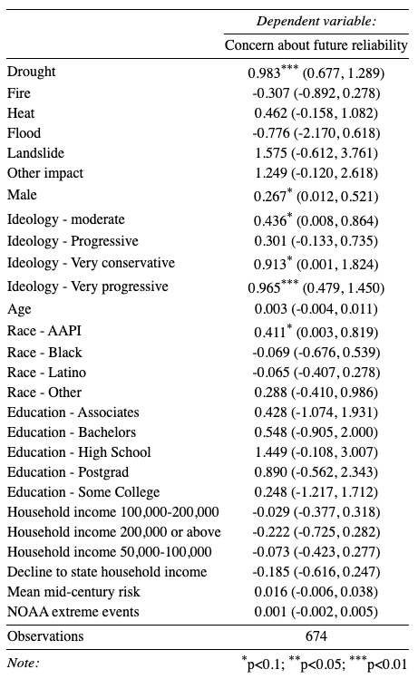

Table S6. Full model results, model version B: Dichotomous impacted yes/no
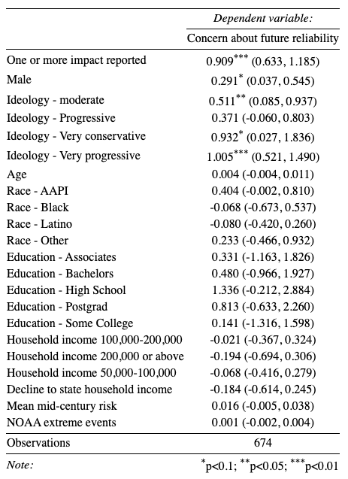

Table S7. Full model results, model version C: Sum of distinct impact types reported
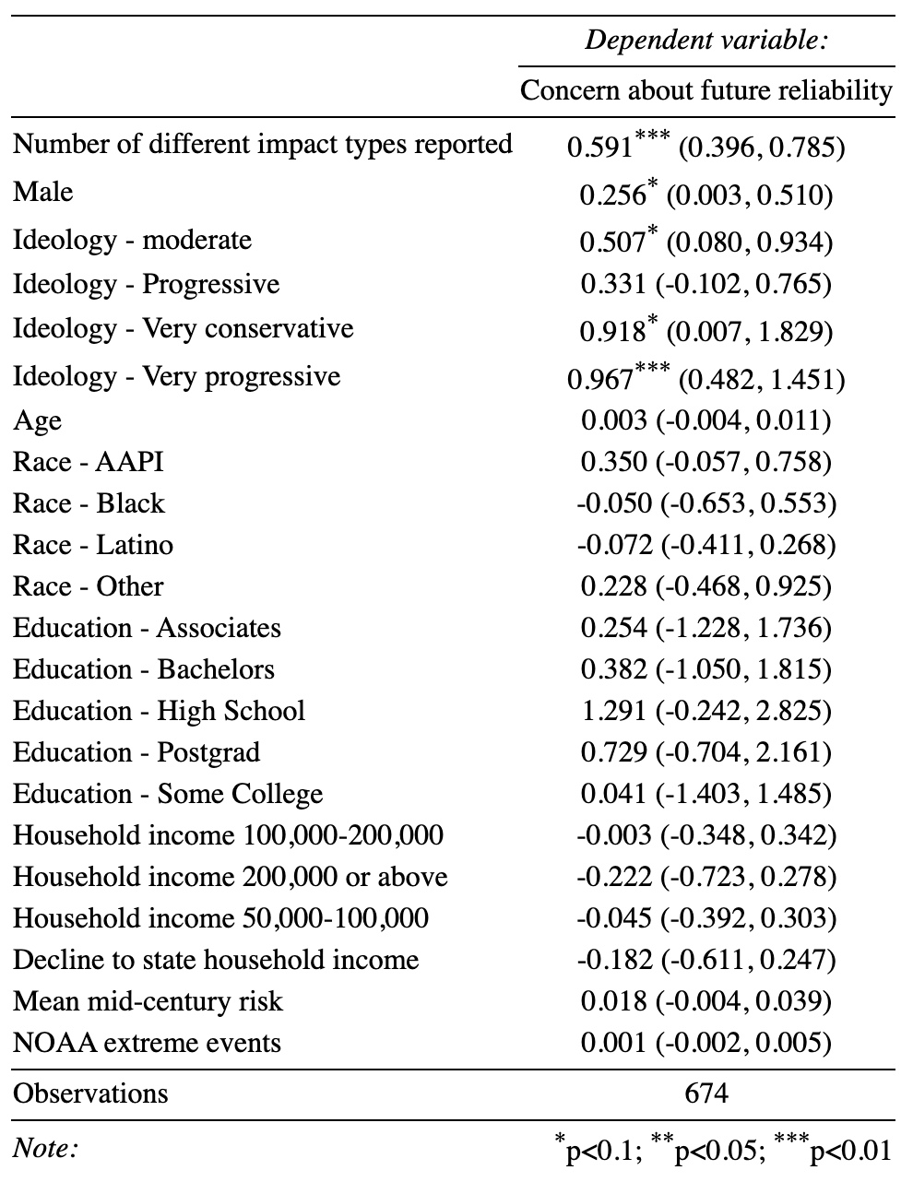

Estimated Marginal Means for Likert levels 1, 2 and 3
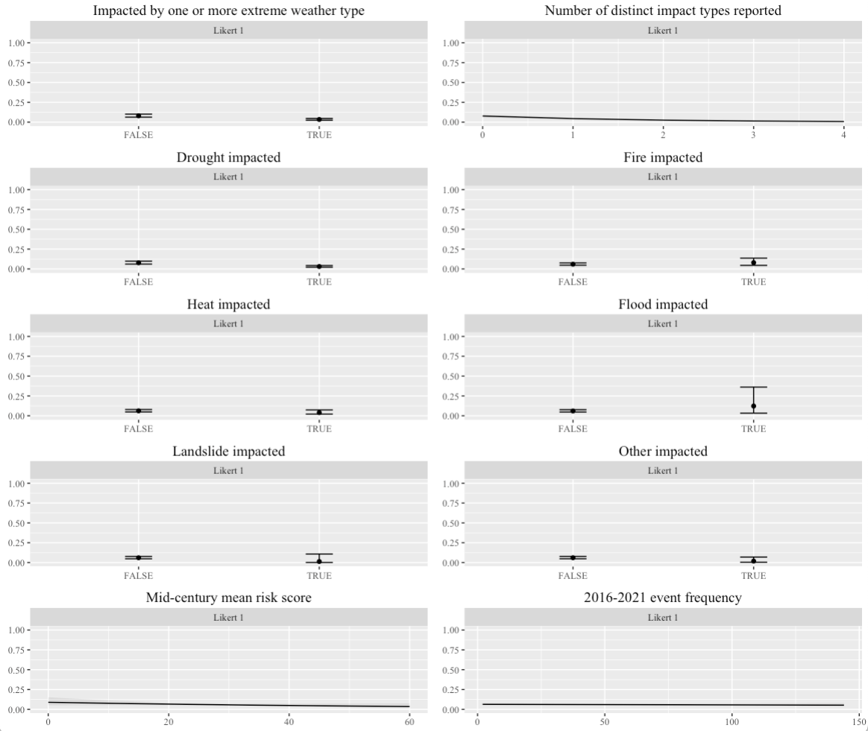
Figure S3. Estimated marginal means (predicted probabilities) of strong non-concern (Likert 1, strongly disagree with statement that they are concerned) for focal model term.

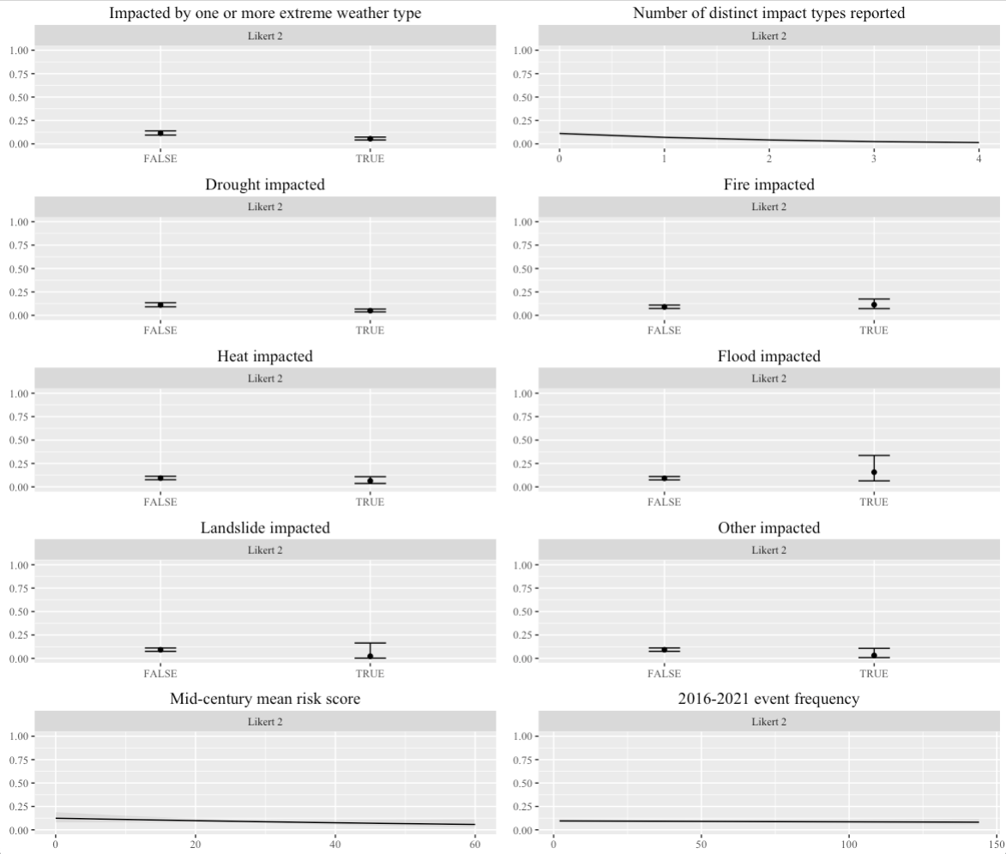
Figure S4. Estimated marginal means (predicted probabilities) of strong non-concern (Likert 2, disagree with statement that they are concerned) for focal model term.

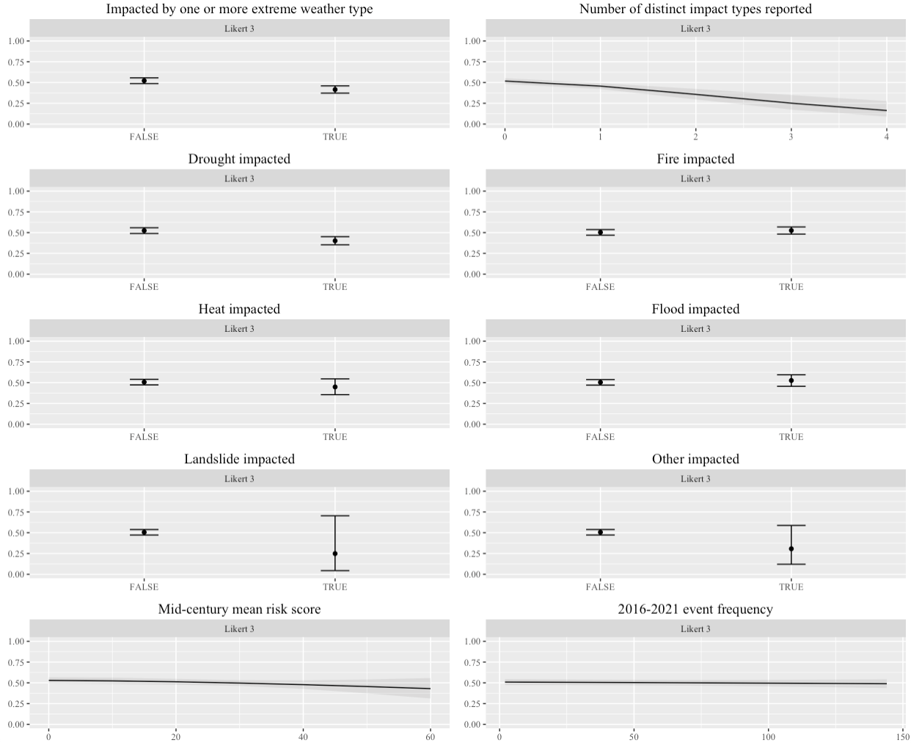
Figure S5. Estimated marginal means (predicted probabilities) of strong non-concern (Likert 3, agree with statement that they are concerned) for focal model term.

Correlation Matrix

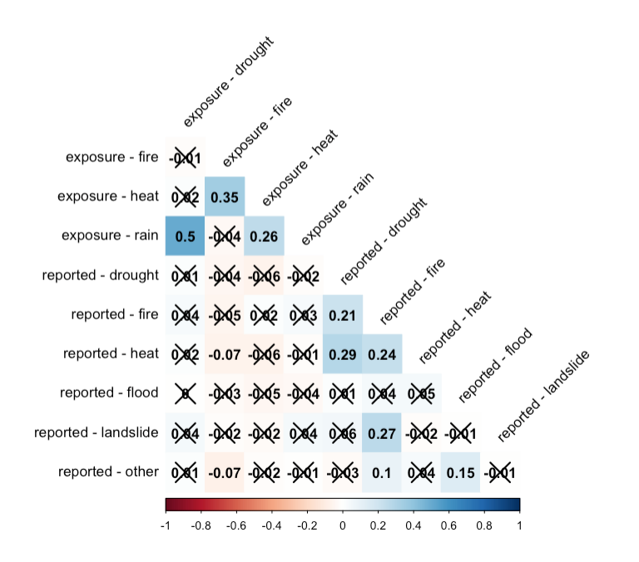
Figure S6. Correlation matrix for survey reported household water supply impacts by type and recently recorded hazard events by type for each respondents’ county. Correlation coefficients are displayed in each cell. Crossed out coefficients are not statistically significant at the P<0.1 level.

