Supplementary Materials

CMIP5 model evaluation

Annual cycle
we evaluated the mean annual cycle of simulated rainfall from the 24 CMIP models that are common across preindustrial, historical, and different RCP scenarios (see Supplementary Table 1) against the observed mean annual cycle of rainfall for the period 1900 – 2018 over the three sub-regions of Victoria to check if CMIP5 models used in this study are fit for purpose. Supplementary Figure 1 shows large inter-model spread in skill in all three sub-regions, consistent with the results of previous studies in this region (e.g., Grose et al. 2015a,b; Moise et al. 2015; Timbal et al. 2015; Bhend and Whetton 2017; Rauniyar and Power 2020). The majority of models were able to simulate the timing of seasonal rainfall pattern over MBVic and SEVic (Supplementary Figs. 1a and b), while over SWVic all 24 models simulated the same reasonably well (Supplementary Figure 1c). Five out of 24 models (i.e., CCSM4, CESM1-BGC, CanESM2, NorESM1-M, and inmcm4) show a reversed annual cycle (i.e., a summer peak in rainfall) over SEVic while the number reduces to four (i.e., CCSM4, CESM1-BGC, CNRM-CM5, and NorESM1-M) for MBVic. The first harmonic for these models explains more than 70% of total annual variance, meaning the models have significant problems with the annual cycle. In addition, ACCESS1-3 model shows a double peak in annual rainfall over MBVic and SEVic as the fractional contribution (~60%) of second harmonic to the total annual variance is substantially larger than the contribution (~15%) of first harmonic. Similarly, CCSM4 exhibits the double peak over the SWVic with more than 68% of variance is explained by the second harmonic. Nevertheless, the multi-model ensemble mean exhibits a seasonal evolution similar to its observed with winter maxima in all three sub-regions but tends to underestimate the observed peak during the cool season months (Supplementary Fig. 1). The variance explained by the first harmonic is more than 92% of total variance in SWVic while the same is 70% and 60 % for MBVic and SEVic.
The amplitude of annual cycle is also well simulated by models in SWVic while it is underestimated in other two sub-regions. The underestimation of peak-to-peak amplitude of multi-model mean compared to the observation is found to be the largest in SEVic (45%), followed by MBVic (20%) and is the smallest in SWVic (13%). The observed peak-to-peak amplitudes values are 32-, 33-, and 48-mm month⁻¹ for MBVic, SEVic, and SWVic. Right column of Supplementary Fig. 1 shows that this is due to overestimation of rainfall during the warm season, but underestimation during the cool season. Furthermore, the multi-model mean tends to slightly delay (by a month) the start of the rainy season over all three sub-regions compared to the observations. Our analysis shows that the annual cycle of rainfall under historical conditions is slightly drier in the cool season and wetter in the warm season compared with pre-industrial runs of the same models. We recomputed all the statistics by excluding the models with reversed annual cycle, however we did not find any substantial differences in the values shown in Supplementary Table 2 and Table 3 in the main text.

Long-term trend
It is also important to test whether the historical all-forcing models are consistent or not with the observations. To do this, we compared the simulated trends in the models using all available historical simulations (for 1900-2005) plus different RCP simulations (for the period 1900 – 2018) with the observed trend for the same period (Supplementary Fig. 2). In addition, we also estimated the possible range of 119-year trends that can arise due to internal variability only using the models with at least 200 years of pre-industrial simulations. This is represented by the shaded distribution in Supplementary Fig. 2. This suggests that the observed drying trends are unusual in terms of internally-generated variability, except for SWVic. We found that more than 70% of models under historical plus future scenario forcing exhibit negative trends in SWVic for the 1900-2018 period, while this number reduces to 60% for SEVic and MBVic. The ensemble means of CanESM2 and CNRM-CM5 show a positive trend across all three sub-regions. The 5th and 95th percentiles values for the internally-generated trends (mm year⁻¹) are -0.13 and 0.18 for MBVic, -0.13 and 0.17 for SEVic, and -0.17 and 0.18 for SWVic. The observed trends (mm year⁻¹) for MBVic, SEVic and SWVic are -0.34, -0.35 and -0.18, respectively (see Table 1 in the main text) and their probability of occurrences due to the modelled internal variability alone are 1.8%, 1.5% and 15% for MBVic, SEVic and SWVic, respectively. The multi-model median of the ensemble mean trends (i.e., our estimate of the externally-forced component) are -0.06, -0.08, and -0.1 mm year⁻¹ for MBVic, SEVic and SWVic, respectively. This suggests, according to the models, that the magnitude of the external forcing contributions to the observed long-term trend for MBVic, SEVic and SWVic are around 17%, 24% and 56%, respectively.

Supplementary Figures
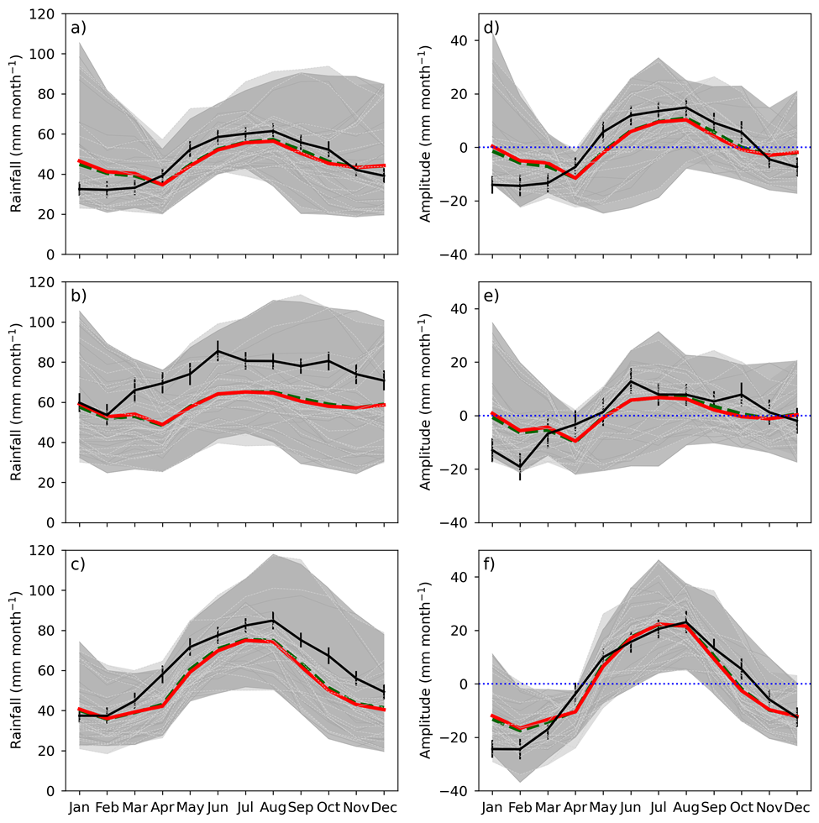
Supplementary Fig. 1 CMIP5 simulated (left column) mean annual cycle of rainfall using the 1900 – 2018 period and (right column) corresponding amplitudes relative to the long-term annual mean climatology for (a, d) MBVic (b, e) SEVic and (c, f) SWVic sub-regions of Victroia. Observations based on AWAP are shown by the black line. Multi model ensemble mean for the same period under histALL simulation patched with RCP8.5 (HIST/RCP8.5) scenario is shown by the red line and ensemble mean of piCTL models with at least 500 years of simulation is shown by the green dashed line. Individual HIST/RCP8.5 and piCTL models are shown in dark and light gray colours. Shaded areas indicate the minimum and maximum values of HIST/RCP8.5 models (dark gray) and piCTL models (light gray), respectively. Error bar shows the 5th and 95th percentiles confidence interval estimated using bootstrapping of monthly average rainfall
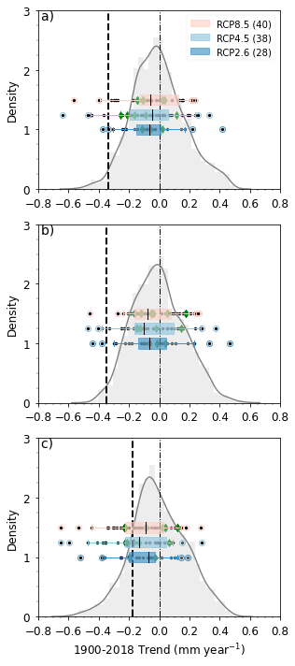

Supplementary Fig. 2 The same as the right column of Fig. 5 in the main text, but for the long-term trend (i.e., 1900 – 2018) using all the available ensemble members shown in Supplementary Table 1. Each scatter point over the boxes shows the simulated trend in the individual models. If a model has multiple simulations then the scatter point for that model represents the mean trend of available ensmeble members for that model. Mean ensemble trends of models with more than five ensmeble members are shown with green diamonds. Shaded curve represents a possible range of 119-years of trend due to internal variability only based on the models that have at least 200-years of rainfall simulations under pre-industrial condition
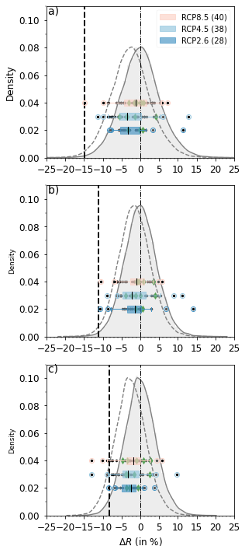

Supplementary Fig. 3 Equivalent of left column of Fig. 5 in the main text, except that all the available ensemble members shown in Supplementary Table 1 are being used. Each scatter point over the boxes shows rainfall changes in the individual models. If a model has multiple simulations then the scatter point for that model shows the mean of rainfall changes across its all ensmeble members. Ensemble mean changes for models with more than five ensmeble members are shown as green diamonds

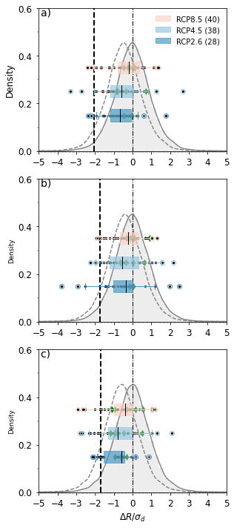
Supplementary Fig. 4 Same as in Supplementary Fig. 3, but for the standarized changes. The standardized change is computed by deviding the difference in area-averaged mean rainfall between 1997 – 2018 and 1900 – 1959 with the decadal standard deviation of the 1900 – 1959 period

Supplementary Table 1: List of models and number of available ensemble members under different CMIP5 experiments that are used in this study. Most of the analysis in this paper are based on the first run ('r1i1p1') of 24 models (name in bold) that have at least 500 years of piCTL runs as well as have simulations under historical all-forcing, RCP4.5 and the RCP8.5 scenarios. 35 models have at least 200 years of simulations under preindustrial condition (model names in italic). Similarly, 48 models provide historical simulation using all-forcing for the period 1900 – 2005, but out of this only 18 and 16 models have historical simulations under natural-only and GHG-only forcings. 40, 38 and 28 models provide rainfall historical simulations for the period 1900 – 2005 and have future projections for the period 2006 – 2100 under high (RCP8.5), medium (RCP4.5) and low (RCP2.6) emission scenarios.
Model Name | Pre-industrial |  | Historical (1900 – 2005) |  |  | Future RCPs (2006 – 2100)
Model Name | 500-yr | 200-yr | ALL | NAT | GHG | 8.5 | 4.5 | 2.6
ACCESS1-0 | 1 | 1 | 3 |  |  | 1 | 1 | NA
ACCESS1-3 | 1 | 1 | 3 | 3 | 3 | 1 | 1 | NA
bcc-csm1-1 | 1 | 1 | 3 | 1 | 1 | 1 | 1 | 1
bcc-csm1-1-m | NA | 1 | 3 | NA | NA | 1 | 1 | 1
BNU-ESM | 1 | 1 | 1 | 1 | 1 | 1 | 1 | 1
CanESM2 | 1 | 1 | 5 | 5 | 5 | 5 | 5 | 5
CCSM4 | 1 | 1 | 8 | 4 | 3 | 6 | 6 | 6
CESM1-BGC | 1 | 1 | 1 | NA | NA | 1 | 1 | NA
CESM1-CAM5 | NA | 1 | 3 | 3 | 1 | 3 | 3 | 3
CMCC-CESM | NA | NA | 1 | NA | NA | 1 | NA | NA
CMCC-CM | NA | 1 | 1 | NA | NA | 1 | 1 | NA
CMCC-CMS | 1 | 1 | 1 | NA | NA | 1 | 1 | NA
CNRM-CM5 | 1 | 1 | 10 | 6 | 6 | 5 | 1 | 1
CSIRO-Mk3-6-0 | 1 | 1 | 10 | 10 | 10 | 10 | 10 | 10
EC-EARTH | NA | NA | 4 | NA | NA | 4 | NA | NA
FGOALS-g2 | 1 | 1 | 5 | 3 | 1 | 1 | 1 | 1
FGOALS-s2 | 1 | 1 | 3 | NA | NA | 3 | 1 | 1
FIO-ESM | NA | NA | 3 | NA | NA | 3 | 3 | 3
GFDL-CM3 | 1 | 1 | 5 | 3 | 3 | 1 | 3 | 1
GFDL-ESM2G | 1 | 1 | 1 | NA | NA | 1 | 1 | 1
GFDL-ESM2M | 1 | 1 | 1 | 1 | 1 | 1 | 1 | 1
GISS-E2-H | NA | 1 | 18 | 10 | 5 | 5 | 16 | 3
GISS-E2-H-CC | NA | NA | 1 | NA | NA | 1 | 1 | NA
GISS-E2-R | NA | NA | 26 | 10 | 5 | 5 | 17 | 3
GISS-E2-R-CC | NA | NA | 1 | NA | NA | 1 | 1 | NA
HadGEM2-AO | NA | NA | 1 | NA | NA | 1 | 1 | 1
HadGEM2-CC | NA | NA | 1 | NA | NA | 1 | 1 | NA
HadGEM2-ES | 1 | 1 | 5 | 4 | 4 | 4 | 4 | 4
inmcm4 | 1 | 1 | 1 | NA | NA | 1 | 1 | NA
IPSL-CM5A-LR | 1 | 1 | 6 | 3 | 5 | 4 | 4 | 4
IPSL-CM5A-MR | NA | 1 | 3 | 3 | 3 | 1 | 1 | 1
IPSL-CM5B-LR | NA | 1 | 1 | NA | NA | 1 | 1 | NA
MIROC-ESM | 1 | 1 | 3 | 3 | 3 | 1 | 1 | 1
MIROC-ESM-CHEM | NA | NA | 1 | 1 | 1 | 1 | 1 | 1
MIROC5 | 1 | 1 | 5 | NA | NA | 3 | 3 | 3
MPI-ESM-LR | 1 | 1 | 3 | NA | NA | 3 | 3 | 3
MPI-ESM-MR | 1 | 1 | 3 | NA | NA | 1 | 3 | 1
MRI-CGCM3 | 1 | 1 | 5 | 1 | 1 | 1 | 1 | 1
NorESM1-M | 1 | 1 | 3 | 1 | 1 | 1 | 1 | 1
NorESM1-ME | NA | 1 | 1 | NA | NA | 1 | 1 | 1

Supplementary Table 2: Percentage changes in cool season rainfall in 20-year blocks from 1900 – 1919 through to 2100 for three RCP scenarios relative to mean of 500 years of preindustrial runs. Estimated values using RCP4.5 and RCP2.6 scenarios are given in the parenthesis below the statistics of RCP8.5. The estimates are based on 24 models for RCP8.5 and RCP4.5 scenarios and 19 models for RCP2.6 scenario. Only the first ensemble member (i.e., r1i1p1) is used. Statistics for recent period (1997 – 2018) is highlighted in italic and multi-model median (50th percentile) values are shown in bold.

Regions | Descriptive  statistics | Percentage changes in cool season rainfall in 20-year blocks from 1900 - 1919 through to 2100
Regions | Descriptive  statistics | 1900-1919 | 1920-1939 | 1940-  1959 | 1960-  1979 | 1980-  1999 | 1997-  2018 | 2010-  2029 | 2018-  2037 | 2041-  2060 | 2061-  2080 | 2081-  2100
MBVic | Mean | -1.9 | -1.4 | -1.5 | -2.7 | 0.9 | -1.3  (-3.0, -3.7) | -4.1  (-6.0, -5.4) | -5.7  (-6.8, -5.3) | -7.7  (-7.5, -5.5) | -13.5  (-8.5, -6.1) | -17.5  (-9.3, -7.3)
MBVic | Standard deviation | 4.0 | 4.9 | 5.2 | 4.9 | 7.0 | 4.4  (5.1, 4.9) | 5.9  (4.1, 4.5) | 5.5  (4.8, 4.3) | 8.3  (8.8, 7.0) | 12.3  (9.8, 6.7) | 16.1  (8.3, 5.6)
MBVic | Minimum | -8.1 | -9.1 | -8.8 | -11.4 | -10.4 | -8.1  (-11.7, -10.9) | -16.9  (-16.8, -13.1) | -22.3  (-16.8, -14.9) | -20.0  (-27.3, -19.6) | -36.3  (-21.9, -16.5) | -44.7  (-26.3, -16.5)
MBVic | 25th percentile | -5.1 | -5.1 | -4.9 | -5.3 | -2.4 | -4.6  (-7.7, -7.4) | -7.3  (-9.0, -7.5) | -7.3  (-8.8, -7.8) | -17.2  (-13.1, -10.7) | -23.5  (-17.2, -10.3) | -30.5  (-14.6, -10.5)
MBVic | 50th percentile | -1.2 | -1.2 | -2.3 | -2.6 | 0.6 | -0.4  (-2.3, -3.9) | -3.4  (-5.7, -4.8) | -4.6  (-6.3, -5.0) | -5.4  (-4.8, -5.0) | -13.4  (-9.8, -8.5) | -17.5  (-8.5, -9.0)
MBVic | 75th percentile | 0.6 | 1.7 | 1.6 | 0.3 | 4.7 | 2.4  (0.9, -2.1) | -0.7  (-3.4, -1.8) | -2.1  (-3.1, -1.9) | -1.4  (-0.4, -2.3) | -3.3  (0.7, -0.5) | -5.4  (-5.0, -4.1)
MBVic | Maximum | 5.3 | 9.6 | 9.3 | 6.0 | 18.8 | 5.4  (7.6, 10.8) | 7.8  (1.8, 1.2) | 1.0  (1.4, 0.7) | 6.4  (5.2, 7.5) | 5.2  (11.5, 3.5) | 9.7  (5.8, 2.6)
SEVic | Mean | -1.1 | 0.1 | -1.2 | -1.6 | 1.0 | -0.7  (-1.4, -1.6) | -2.8  (-4.0, -3.0) | -4.3  (-4.7, -2.8) | -5.2  (-4.0, -3.8) | -10.4  (-6.0, -4.5) | -13.0  (-7.2, -5.9)
SEVic | Standard deviation | 3.2 | 3.7 | 4.0 | 3.9 | 5.4 | 4.2  (5.0, 5.5) | 5.4  (4.2, 4.4) | 5.3  (4.4, 4.3) | 8.2  (7.7, 6.5) | 10.9  (9.1, 5.5) | 13.5  (7.2, 4.8)
SEVic | Minimum | -7.4 | -5.8 | -8.2 | -9.6 | -8.9 | -8.4  (-9.5, -9.4) | -11.4  (-11.6, -11.3) | -15.2  (-12.5, -10.7) | -19.4  (-20.4, -14.5) | -27.2  (-19.5, -13.5) | -35.0  (-19.4, -13.7)
SEVic | 25th percentile | -2.8 | -2.5 | -4.6 | -4.0 | -2.7 | -4.1  (-5.6, -5.0) | -7.5  (-6.9, -5.6) | -7.2  (-7.0, -5.2) | -13.0  (-9.8, -7.7) | -18.5  (-13.9, -8.9) | -24.3  (-11.4, -9.7)
SEVic | 50th percentile | -0.6 | 0.3 | -1.7 | -1.4 | 1.1 | -0.6  (-1.9, -1.4) | -2.9  (-4.3, -3.3) | -5.1  (-3.2, -3.8) | -4.1  (-2.4, -3.8) | -13.0  (-6.8, -5.4) | -14.1  (-9.0, -6.7)
SEVic | 75th percentile | 1.3 | 2.2 | 1.1 | 1.6 | 3.6 | 2.0  (1.1, -0.4) | -0.1  (-0.4, -0.9) | 0.1  (-1.9, -0.5) | -1.0  (2.5, -0.8) | -1.9  (0.6, 1.0) | -4.9  (-2.9, -1.7)
SEVic | Maximum | 4.7 | 8.2 | 6.2 | 4.4 | 12.6 | 9.2  (9.3, 13.7) | 9.0  (3.7, 6.5) | 4.8  (3.0, 6.0) | 13.8  (5.9, 8.8) | 8.9  (17.0, 5.8) | 13.5  (10.5, 3.2)
SWVic | Mean | -0.9 | -1.0 | -1.8 | -2.6 | -1.0 | -2.4  (-3.3, -3.8) | -4.9  (-6.2, -5.7) | -5.7  (-7.1, -5.8) | -8.0  (-7.0, -5.3) | -13.9  (-8.4, -5.8) | -16.7  (-8.5, -5.4)
SWVic | Standard deviation | 3.3 | 3.8 | 4.4 | 3.7 | 5.8 | 4.1  (4.1, 3.5) | 4.0  (3.1, 3.2) | 3.9  (4.2, 4.0) | 5.8  (6.6, 4.1) | 8.7  (6.4, 4.8) | 11.1  (5.9, 3.9)
SWVic | Minimum | -6.1 | -7.9 | -9.3 | -9.2 | -9.9 | -8.6  (-10.7, -8.9) | -11.8  (-10.1, -11.2) | -16.5  (-15.7, -12.0) | -18.1  (-21.3, -16.6) | -30.2  (-18.7, -13.2) | -32.0  (-17.5, -14.8)
SWVic | 25th percentile | -4.1 | -4.0 | -4.8 | -4.9 | -4.4 | -4.5  (-7.0, -6.5) | -7.0  (-8.7, -8.1) | -8.0  (-10.7, -8.9) | -12.7  (-11.6, -7.2) | -20.3  (-12.8, -10.6) | -26.6  (-13.2, -8.0)
SWVic | 50th percentile | -0.3 | -1.3 | -2.4 | -2.8 | -2.1 | -2.0  (-2.2, -4.5) | -5.3  (-6.2, -5.9) | -5.4  (-6.1, -6.4) | -8.6  (-6.5, -4.7) | -16.4  (-9.5, -4.1) | -19.7  (-8.9, -5.2)
SWVic | 75th percentile | 1.7 | 2.4 | -0.2 | -0.1 | 2.6 | -0.5  (-0.7, -0.8) | -3.5  (-4.6, -4.0) | -3.5  (-4.9, -1.5) | -4.3  (-1.9, -2.7) | -6.8  (-3.3, -2.6) | -9.3  (-6.3, -2.4)
SWVic | Maximum | 3.5 | 5.6 | 8.6 | 3.4 | 14.7 | 6.2  (4.5, 2.1) | 6.2  (1.5, 1.4) | 1.4  (1.2, 0.7) | 2.6  (3.4, 1.0) | 1.1  (4.0, 2.3) | 4.9  (6.1, 0.5)

Supplementary Table 3: Same as Table 2 in the main text, but the statistics are based on the all available ensemble simulations shown in Supplementary Table 1.

Standardization methods | ΔOBS | Weighted Mean change (ΔMOD) |  |  | %  Contribution  (100*ΔMOD /ΔOBS)
Standardization methods | ΔOBS | 25th percentile | 50th percentile | 75th percentile | %  Contribution  (100*ΔMOD /ΔOBS)
Δ (mm mon⁻¹) | -8.2  -8.9  -6.1 | -2.5  -2.3  -2.6 | -1.3  -1.0  -1.6 | 0.3  0.5  -0.3 | 30, 15, -4  26, 12, -6  44, 27, 5
100*Δ/µ (%) | -14.9  -11.2  -8.2 | -5.1  -3.6  -4.4 | -2.6  -1.6  -2.5 | 0.6  0.9  -0.5 | 34, 17, -4  32, 14, -8  54, 31, 5
Δ/σ | -0.62  -0.67  -0.47 | -0.26  -0.23  -0.29 | -0.13  -0.11  -0.16 | 0.03  0.05  -0.03 | 42, 20, -4  35, 16, -8  61, 34, 6
Δ/σ_{d} | -2.06  -1.72  -1.68 | -1.03  -0.95  -1.25 | -0.47  -0.38  -0.59 | 0.12  0.21  -0.13 | 50, 23, -5  55, 22, -12  75, 35, 8

Supplementary References:

Bhend, J, Whetton P (2017) Evaluation of simulated recent climate change in Australia. Aust. Meteorol Oceanogr J 65: 4–18. https://doi.org/10.22499/2.6501.003
Grose M, Abbs D, Bhend J et al (2015a) Southern Slopes Cluster Report, Climate change in Australia projections for Australia’s natural resource management regions. Cluster Reports, eds. Ekström, M. et al., CSIRO and Bureau of Meteorology, Australia. https://www.climatechangeinaustralia.gov.au/media/ccia/2.2/cms_page_media/168/SOUTHERN_SLOPES_CLUSTER_REPORT_1.pdf
Grose M, Timbal B, Wilson L, Bathols J, Kent D (2015b): The subtropical ridge in CMIP5 models, and implications for projections of rainfall in southeast Australia. Aust. Meteorol Oceanogr J 65:90–106. https://doi.org/10.22499/2.6501.007
Moise A, Wilson L, Grose M et al (2015) Evaluation of CMIP3 and CMIP5 models over the Australian region to inform confidence in projections. Aust. Meteorol Oceanogr J 65:19–53. https://doi.org/10.22499/2.6501.004
Rauniyar SP, Power SB (2020) The impact of anthropogenic forcing and natural processes on past, present, and future rainfall over Victoria, Australia. J Clim 33:8087–8106. https://doi.org/10.1175/JCLI-D-19-0759.1

