Evaluation of historical and future thermal conditions for almond trees in north-eastern Portugal

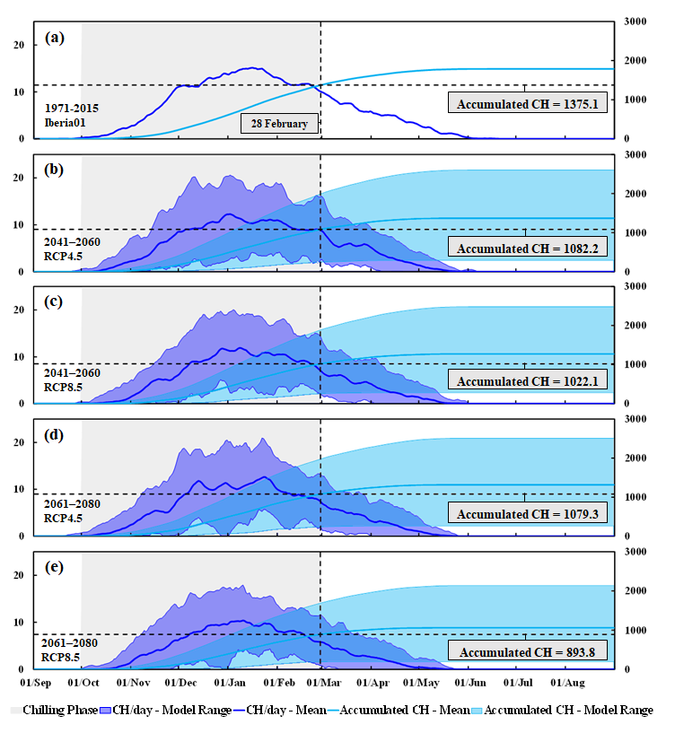
Figure SM 1 – Chilling Hours (CH) index for (a) recent-past period (1971–2015), and future scenarios: RCP4.5 for (b) 2041–2060 and (d) 2061–2080, and RCP8.5 for (c) 2041–2060 and (e) 2061–2080

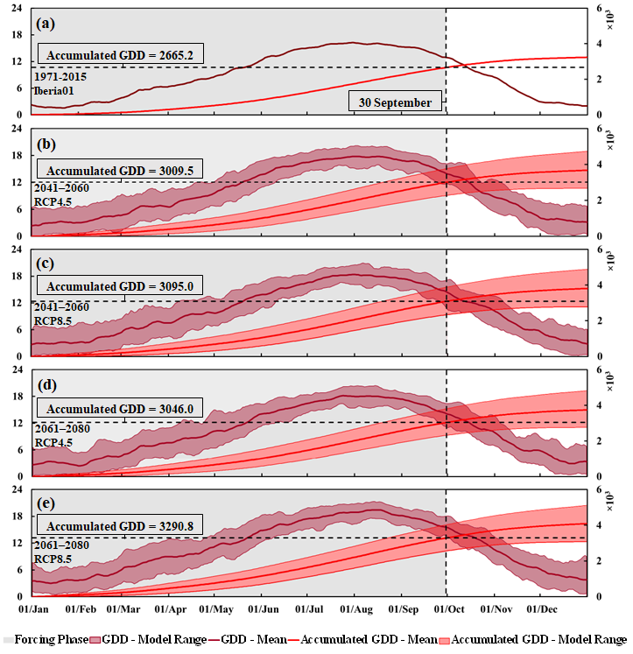
Figure SM 2 – Same as Figure SM1 but for the Growing Degree Days (GDD)

