Ground‑based climate data show evidence of warming and intensification of the seasonal rainfall cycle
during the 1960–2020 period in Yangambi, central Congo Basin

Emmanuel Kasongo Yakusu^{1,2,3*} ·Joris Van Acker¹ · Hans Van de Vyver⁴ ·Nils Bourland^{2,5,6} · José Mbifo Ndiapo⁷ · Théophile Besango Likwela⁷ · Michel Lokonda Wa Kipifo⁷ · Amand Mbuya Kankolongo⁸ · Jan Van den Bulcke¹ · Hans Beeckman² · Marijn Bauters^{9,10} · Pascal Boeckx⁹ · Hans Verbeeck¹⁰ · Kim Jacobsen^{2,10} · Gaston Demarée⁴ · Françoise Gellens‑Meulenberghs⁴ · Wannes Hubau^{1,2}

* Emmanuel Kasongo Yakusu emmakasongo1@yahoo.fr

1 Laboratory of Wood Technology, Department of Environment, Faculty of Bioscience Engineering,
UGent-Woodlab, Ghent University, Coupure Links 653, 9000 Ghent, Belgium
2 Service of Wood Biology, Royal Museum for Central Africa, Leuvensesteenweg 13,
3080 Tervuren, Belgium
3 Faculté de Gestion des Ressources Naturelles Renouvelables, Université de Kisangani, B.P.: 2012,
Avenue Kitima, 3, Kisangani, Democratic Republic of the Congo
4 Meteorological and Climatological Research, Royal Meteorological Institute of Belgium, Avenue
Circulaire, 3 B‑1180 Brussels, Belgium
5 Center for International Forestry Research, Situ Gede, Bogor Barat, Bogor 16115, Indonesia
6 Resources and Synergies Development, Noliktavu Iela 7, Dreilini, Stopinu Novads, Riga 2130,
Latvia
7 Centre de Recherche de Yangambi, Institut National Pour La Recherche Et L’Etude Agronomiques,
Yangambi, Democratic Republic of the Congo
8 Direction Générale, Institut National Pour La Recherche Et L’Etude Agronomiques, Kinshasa13,
Avenue de Cliniques, Gombe, Democratic Republic of the Congo
9 Department of Green Chemistry and Technology, Isotope Bioscience Laboratory—ISOFYS, Ghent
University, Coupure Links 653, 9000 Ghent, Belgium
10 Computational & Applied Vegetation

Climatic Change (2023) 176:142 https://doi.org/10.1007/s10584-023-03606-0

Supplementary Figures

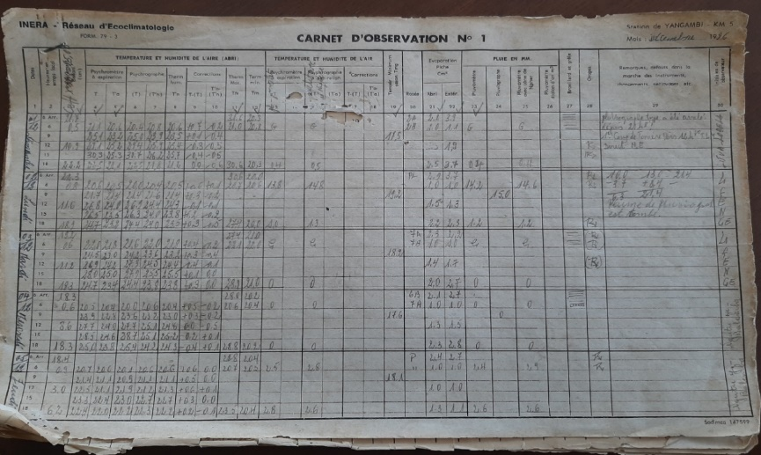
(a)

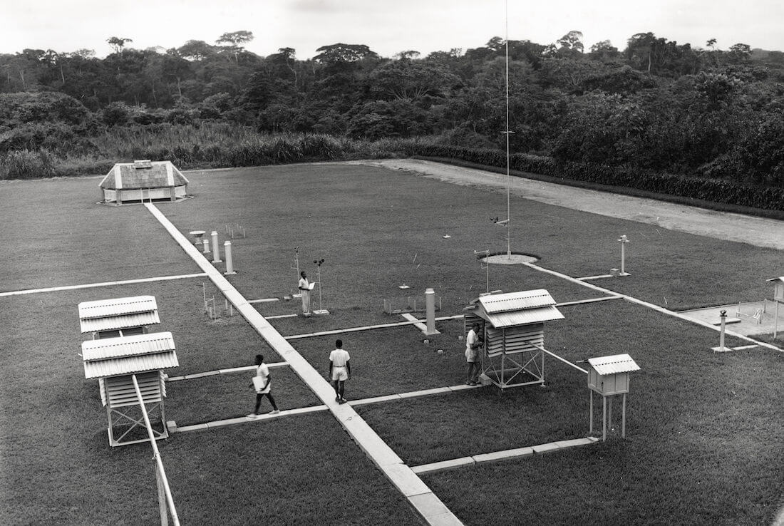
(b)
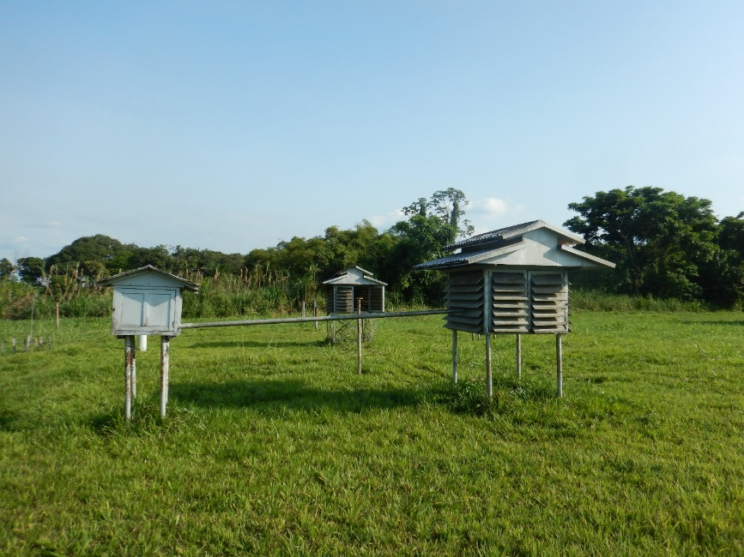
(c)

Supplementary Figure 1 Example of a manual record (a) and pictures of the Yangambi climate station (b and c). (a) Example of recording sheet for analog meteorological observations covering 1-5 December 1996 at Yangambi. Minimum (Tmin) and maximum (Tmax) temperature are recorded in columns 11 and 12 respectively, daily precipitation in column 23 (Photo source: Emmanuel Kasongo Yakusu). (b) INEAC central ecoclimatology station (INEAC, Yangambi, Belgian Congo, circa 1950) (Photo source: CIFOR/INERA Library Collection: https://www.cifor.org/feature/koyebayangambi/a-golden-age-1933-1960/?photo=149741). (c) INERA/Yangambi central ecoclimatology station in 2020 (Photo source: Emmanuel Kasongo Yakusu).

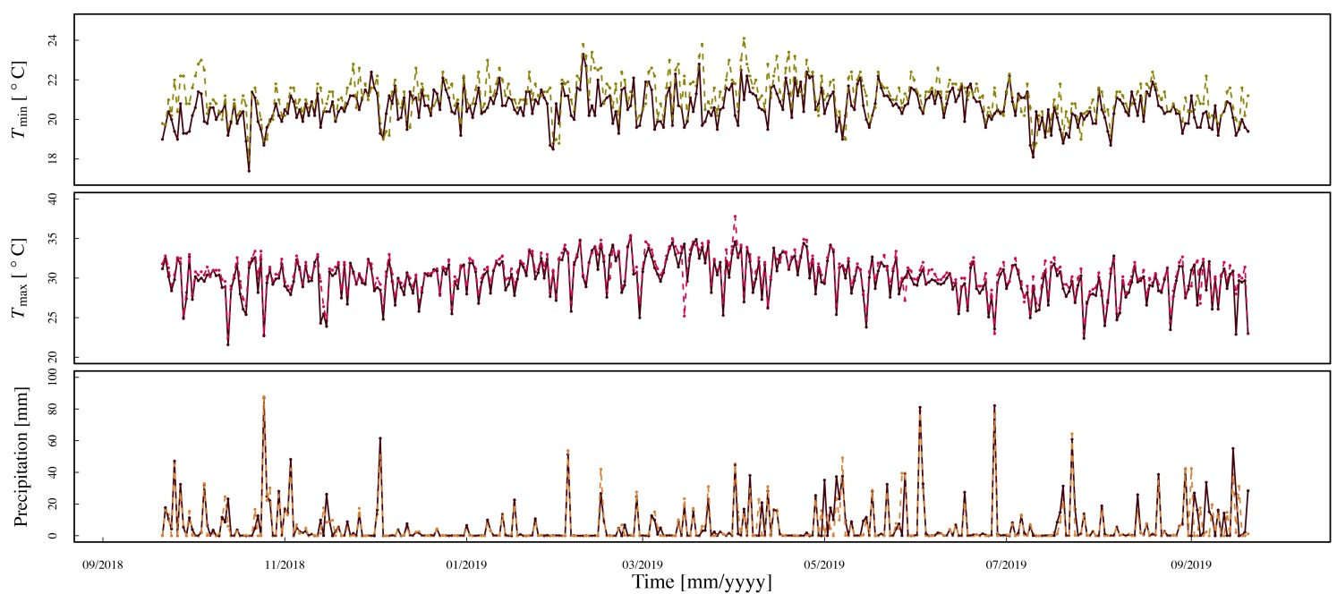
Supplementary Figure 2 Comparison between analog (coloured, dashed lines) and digital (solid black lines) daily measurements of minimum/maximum temperature and precipitation from 30 September 2018 till 30 September 2019 (365 observations) at Yangambi. Digital data are part of the Trans-African Hydro-Meteorological Observatory (TAHMO).

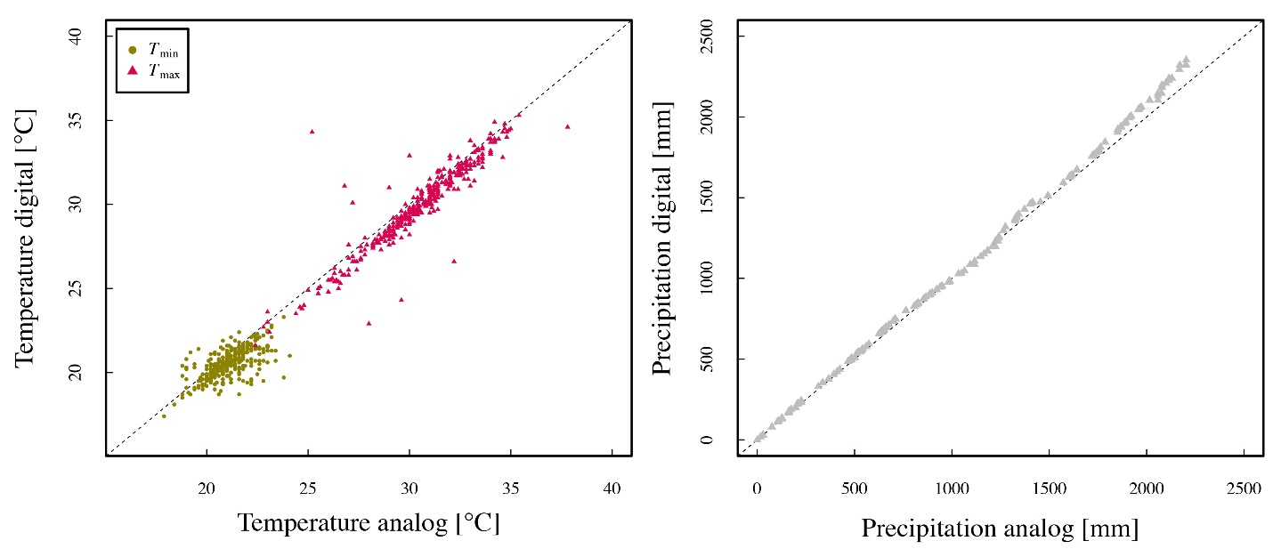
Supplementary Figure 3 Comparison between analog and digital daily measurements of minimum/maximum temperature (left) and precipitation (right) from 30 September 2018 till 30 September 2019 (365 observations) at Yangambi. Sum of analog precipitation is 989 mm and sum of digital precipitation 985 mm. Slight daily biases in precipitation occur due to small temporal shifts of data recording. The dashed line depicts x = y. Digital data are part of the Trans-African Hydro-Meteorological Observatory (TAHMO).

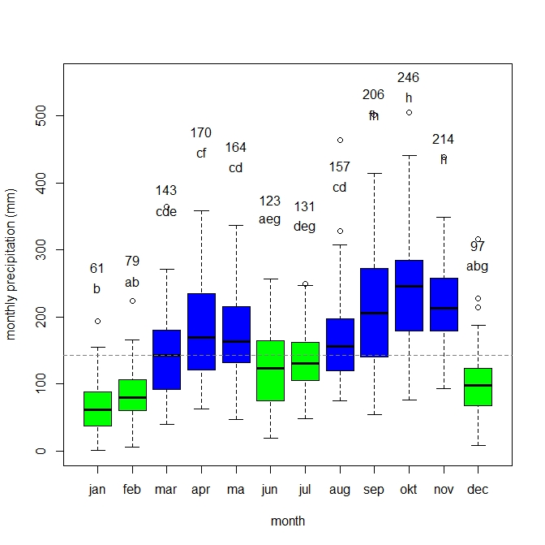
Supplementary Figure 4 Variation in monthly precipitation in Yangambi for the period 1960-2020. Green and blue boxes represent dry and wet season months respectively. Median monthly precipitation is indicated above each box. Letters above each box represent groups defined by Tukey’s post-hoc test. The horizontal dashed line represents overall median precipitation (142 mm month⁻¹). Tukey’s post-hoc test was used to assess significant differences among the months (Figure S4). This shows that the December-January-February dry season months have significantly lower precipitation than any wet season month. September-October-November wet season months have significantly higher precipitation than any dry season month. During the period from March to August, monthly precipitation is close to average monthly precipitation.

Time scale: 3 months
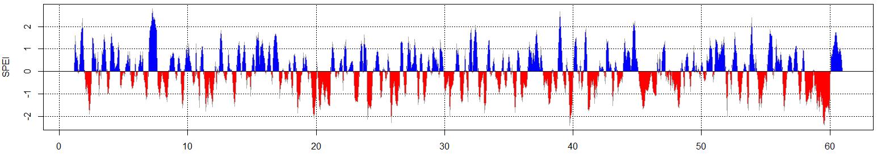
Time scale: 6 months
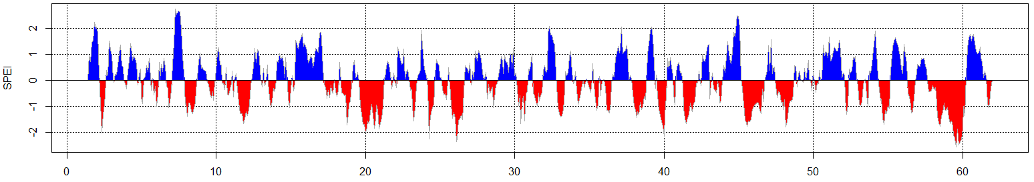
Time scale: 9 months
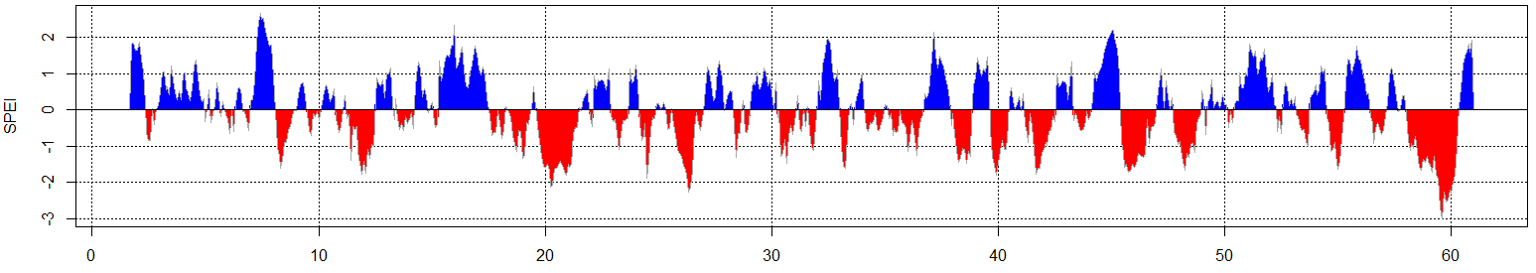
Time scale: 12 months
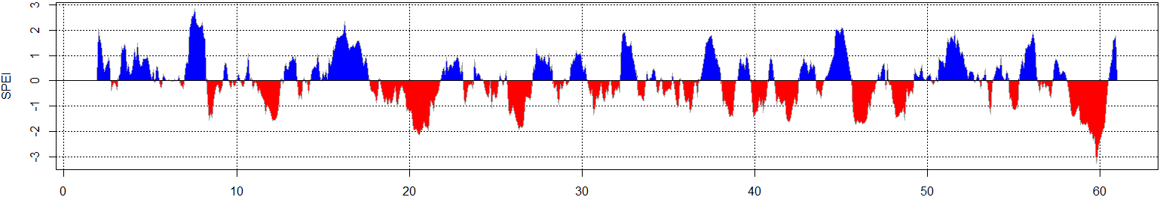
Time scale: 24 months
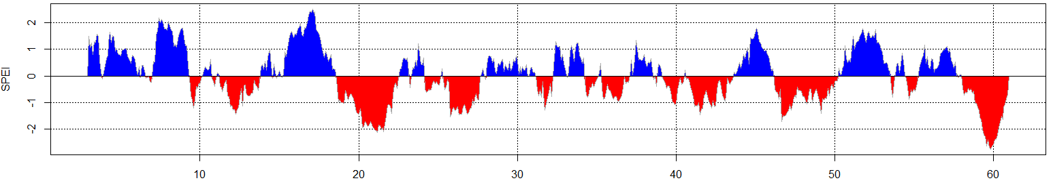
Time scale: 48 months
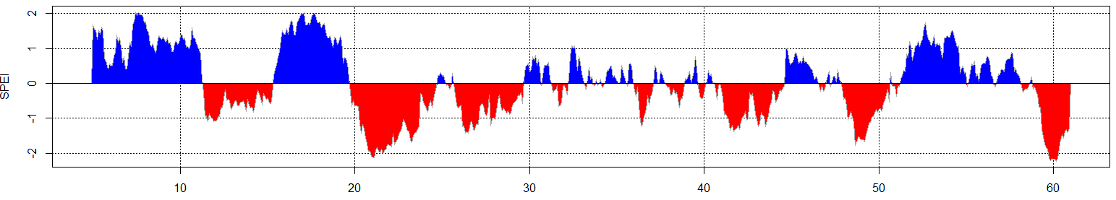

Supplementary Figure 5 Historic evolution of time series of 3-, 6-, 12-, 24- and 48-months Standardised Precipitation-Evapotranspiration Index (SPEI) in Yangambi (1960-2019)

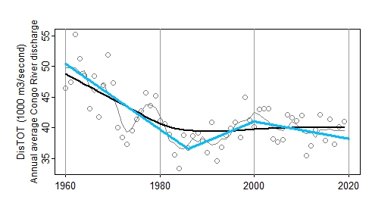
Supplementary Figure 6 Patterns of Congo River discharge, measured in Congo Brazzaville over the period 1960-2019 (Laraque et al. 2013, 2020). Data downloaded from https://hybam.obs-mip.fr. Figure details as in Figure 2.

