Supplementary Material

S1. High and low flow APE for hydrological models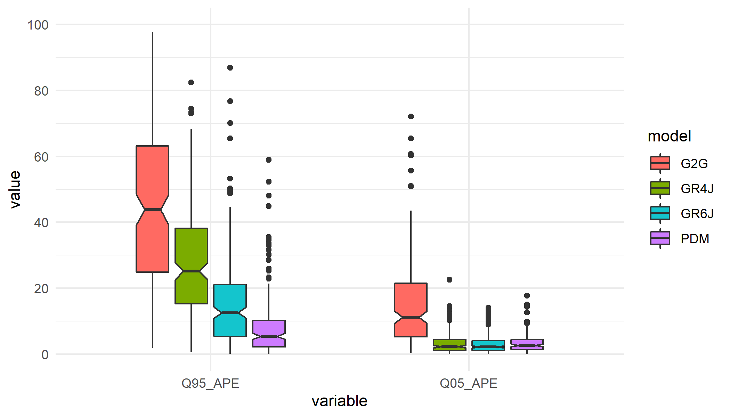
Figure S1: Absolute percentage error boxlplot for 4 different hydrological models and two flow values.

S2. National view of absolute percentage error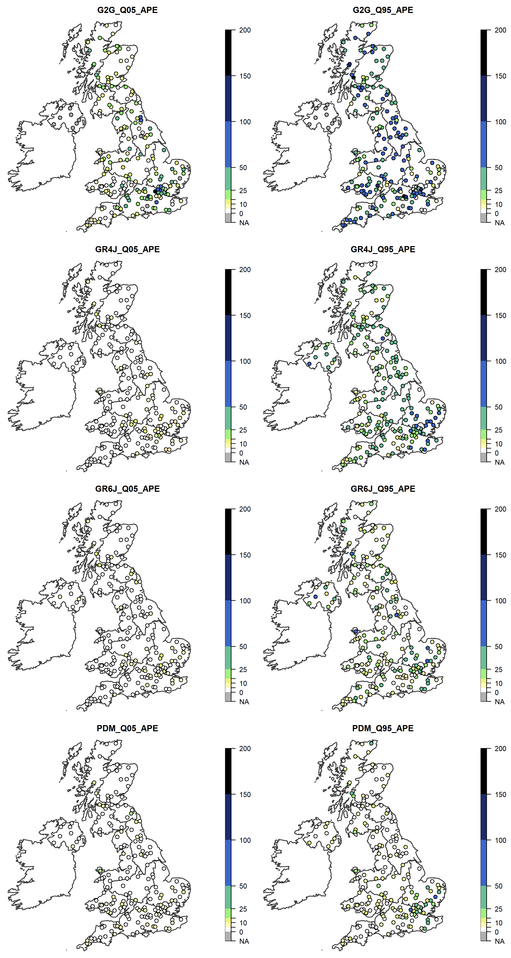
Figure S2: Absolute percentage errors across 200 UK catchments for 4 hydrological models on low and high flows.

S3. Median Flow Change

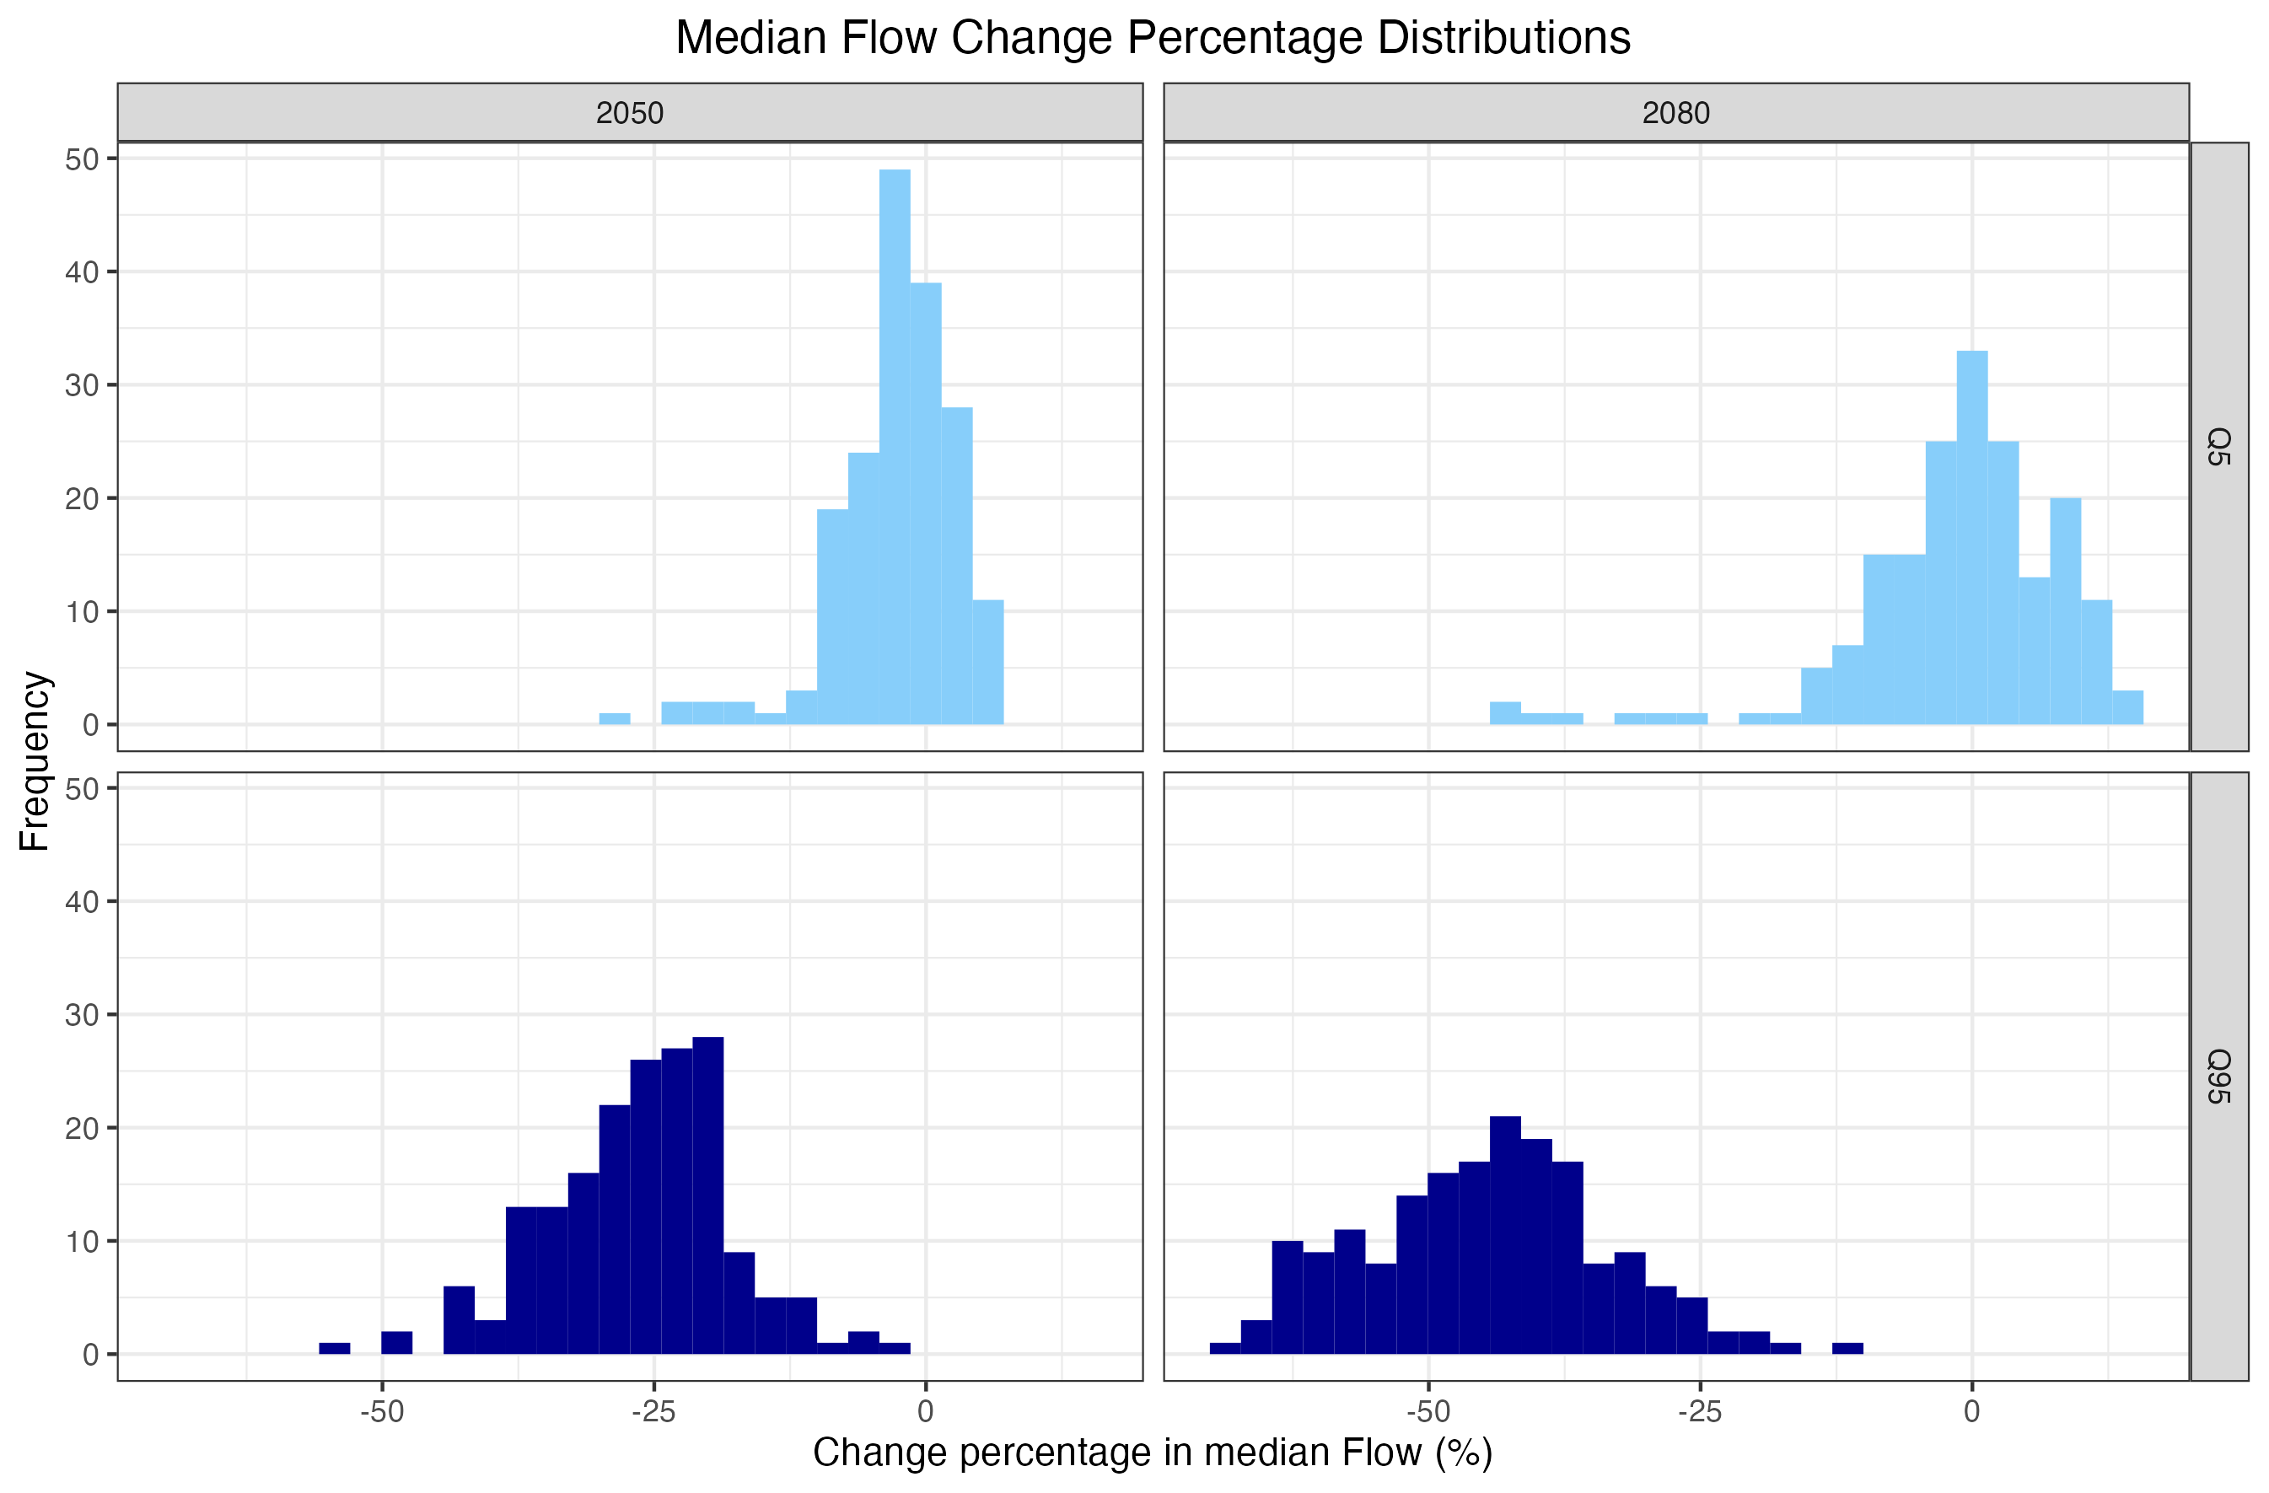
Figure S3:Change percentage distributions for high (Q5) and low (Q95) flows across two time periods (2050/2080).

S4. Cluster Analysis Charrad et al. (2014)]. Charrad et al. (2014)].
In order to explore any controlling factors arising from physical catchment characteristics a clustering analysis of the results was performed. Catchment descriptors which describe topographical, hydro-climatological, soil-related or geological features of catchments were used within the analysis to explore whether there are any particular controls. The results of QE-ANOVA alongside the catchment descriptors were used in the clustering analysis. Clustering aims to separate stations into distinct groups based on the multiple factors (e.g. total uncertainty and catchment upstream area). A K-means clustering approach has been applied to the dataset with no restrictions on the number of clusterings into which the data can be grouped.

Clustering through k-means works by partitioning a set n of observations $(x_{1},x_{2},⋯,x_{n})$ into $k (≤n)$ groups $G=\left\{G_{1},{⋯,G}_{k}\right\}$ to minimise the within-cluster sum of squares (WCSS). This is performed by finding:
$$\underset{G}{\text{arg }min}{\sum_{i=1}^{k}{\sum_{x∈G_{i}}{{\left\|x-μ_{i}\right\|}^{2}}}}= \underset{G}{\text{arg }min}{\sum_{i=1}^{k}{\left|G_{i}\right|\text{Var }G_{i}}}$$

where $μ_{i}$ is the mean of points in $G_{i}$. This has been performed using the “kmeans()” function in the stats R-package [R Core team (2020)]. Additionally, the optimum number of groups was calculated using the “NbClust()” function from the NbClust package [Charrad et al. (2014)].

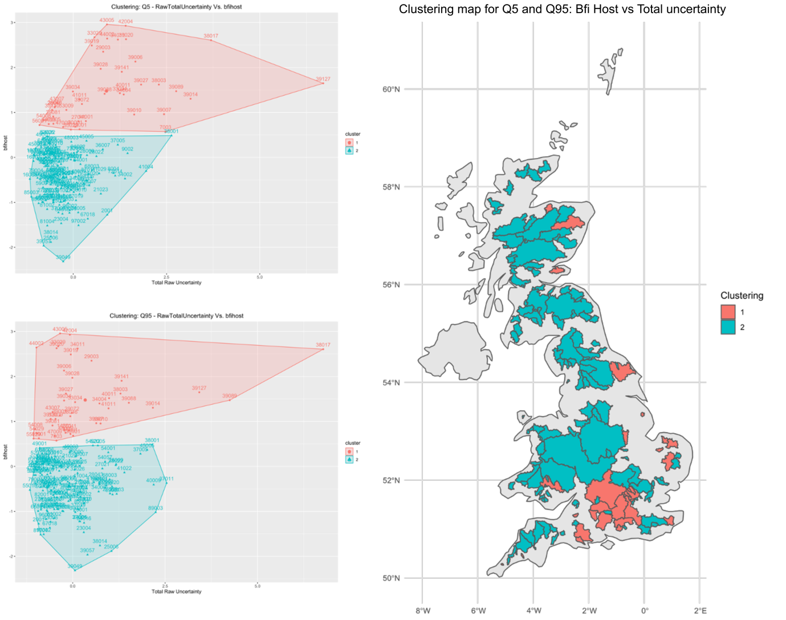
Figure S4: K-means clustering of BFI-host and total uncertainty for Q5 and Q95.
Two clustering groups were identified for total uncertainties with a strong dependence upon the uncertainty value. Figure S4 shows the clustering results for total uncertainty and BFIHOST (Base flow index) with a dependence on the NRFA descriptor. Southern catchments typically fall into group 1 which is characterised by large BFIHOST values and a range of uncertainty values. Catchments remain in the same groups between Q5 and Q95 flows as a result of the influence of BFIHOST. No clear correlation can be found between catchment BFI values and total uncertainty. Further clustering results proved similarly unsuccessful for an additional 17 NRFA descriptors ().

References

Charrad et al. (2014)

R Core team (2020)

