Video Frames
Freeze-thaw cycles
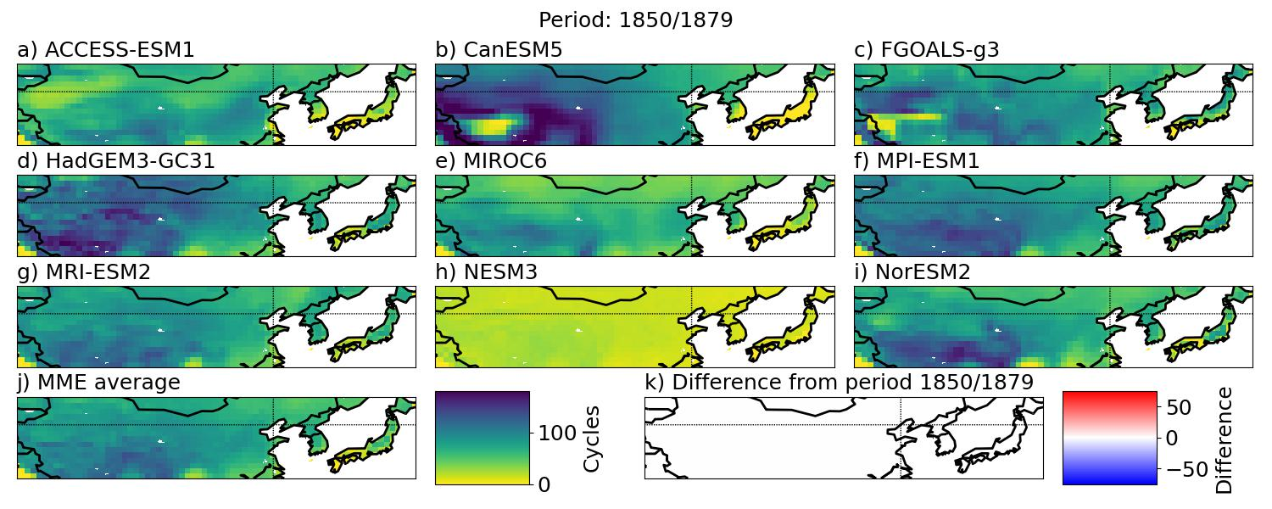
Figure S1: The number of annual freeze-thaw cycles in the period 1850 — 1879 (a-i) the nine CMIP6 models and (j) the ensemble average. (k) show the difference in the ensemble average between the given period and 1850 — 1879.
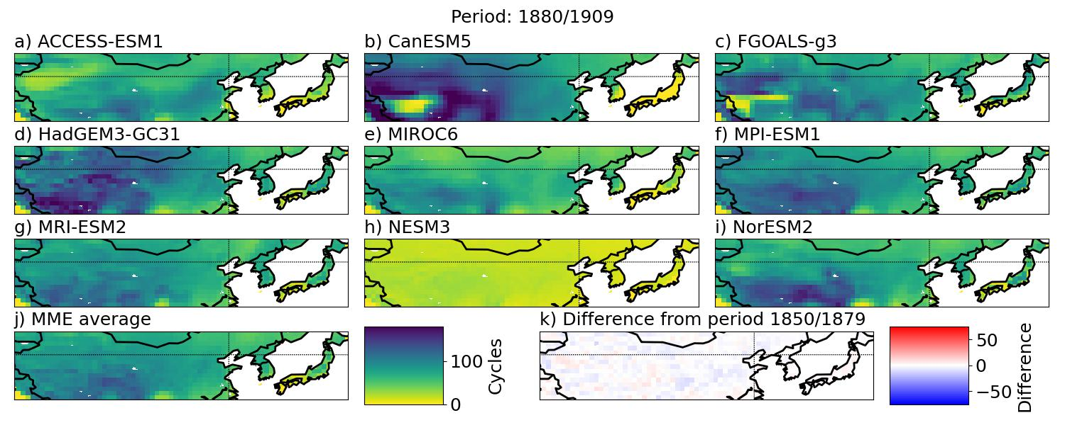
Figure S2: The number of annual freeze-thaw cycles in the period 1880 — 1909 for (a-i) the nine CMIP6 models and (j) the ensemble average. (k) show the difference in the ensemble average between the given period and 1850 — 1879.
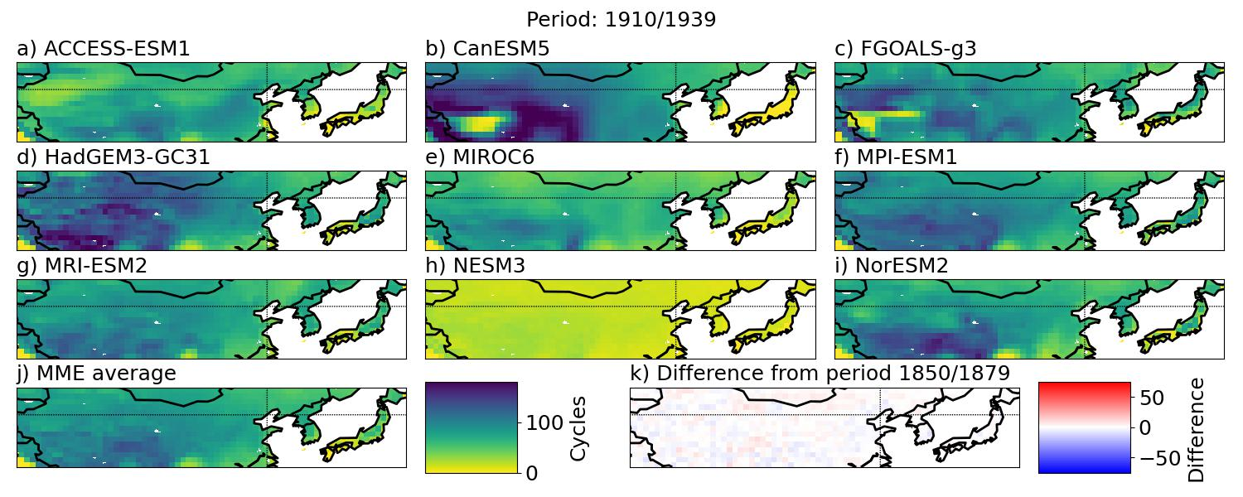
Figure S3: The number of annual freeze-thaw cycles in the period 1910 — 1939 for (a-i) the nine CMIP6 models and (j) the ensemble average. (k) show the difference in the ensemble average between the given period and 1850 — 1879.
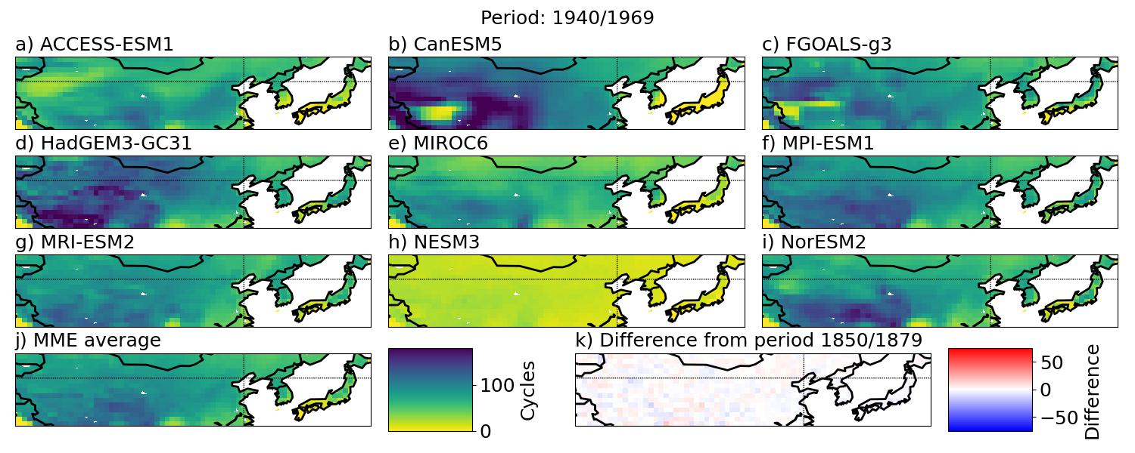
Figure S4: The number of annual freeze-thaw cycles in the period 1940 — 1969 for (a-i) the nine CMIP6 models and (j) the ensemble average. (k) show the difference in the ensemble average between the given period and 1850 — 1879.
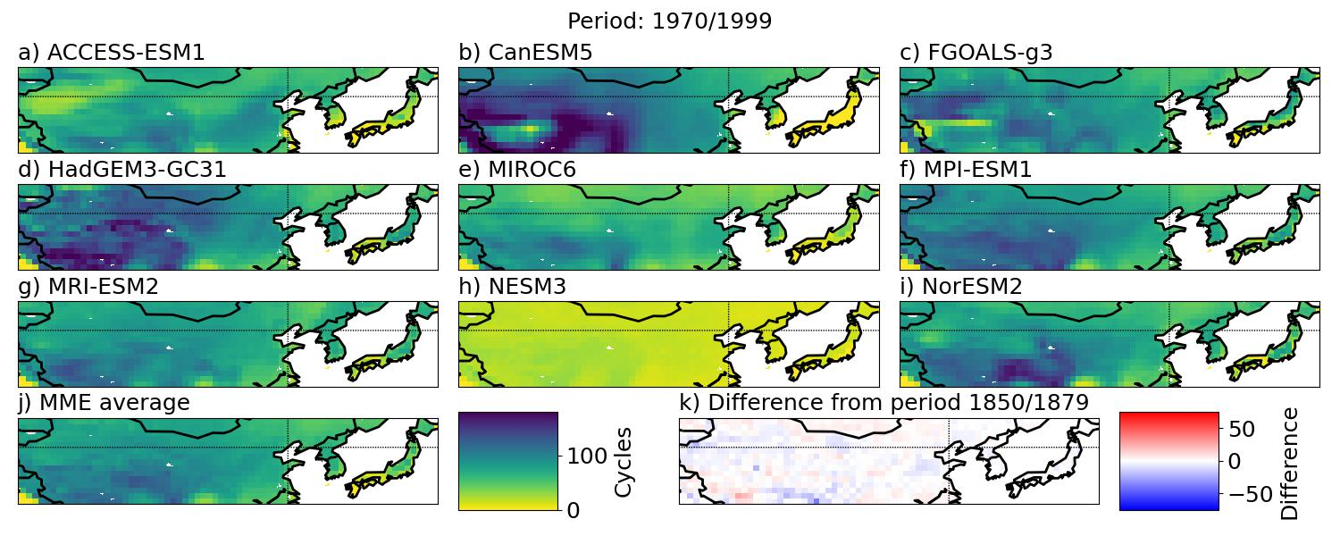
Figure S5: The number of annual freeze-thaw cycles in the periods 1970 — 1999 for (a-i) the nine CMIP6 models and (j) the ensemble average. (k) show the difference in the ensemble average between the given period and 1850 — 1879.
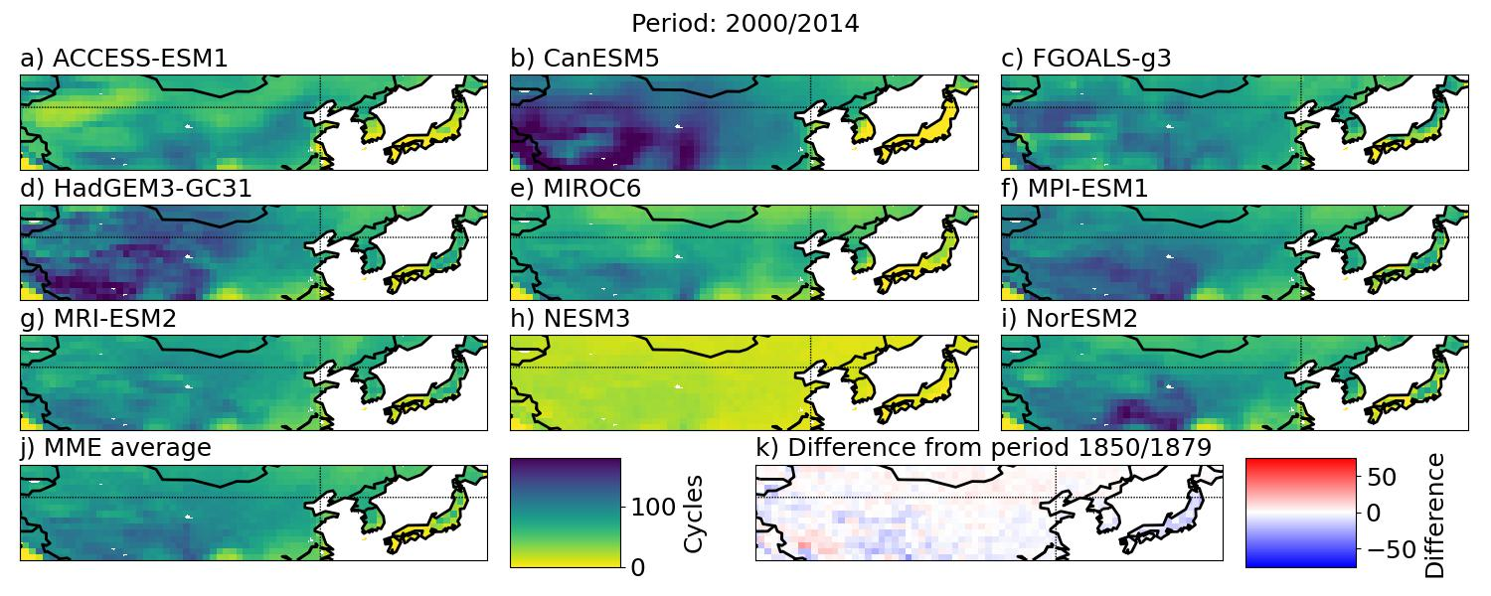
Figure S6: The number of annual freeze-thaw cycles in the period 2000 — 2014 for (a-i) the nine CMIP6 models and (j) the ensemble average. (k) show the difference in the ensemble average between the given period and 1850 — 1879.
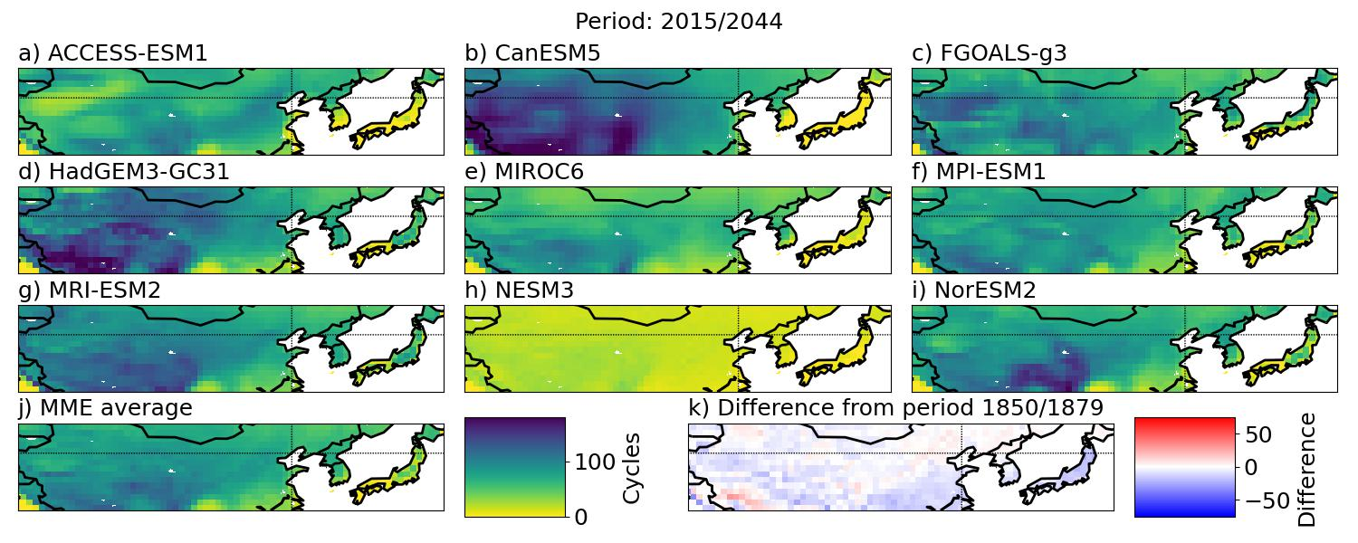
Figure S7: The number of annual freeze-thaw cycles in the period 2015 — 2044 for (a-i) the nine CMIP6 models and (j) the ensemble average. (k) show the difference in the ensemble average between the given period and 1850 — 1879.
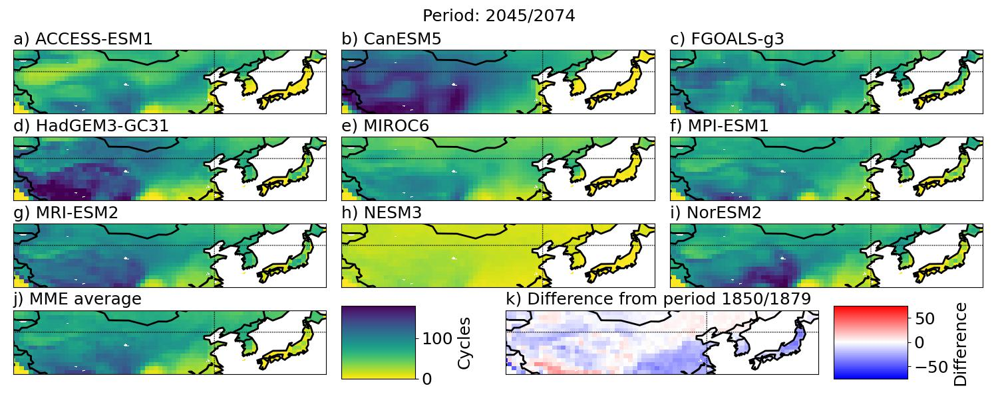
Figure S8: The number of annual freeze-thaw cycles in the period 2045 — 2074 for (a-i) the nine CMIP6 models and (j) the ensemble average. (k) show the difference in the ensemble average between the given period and 1850 — 1879.
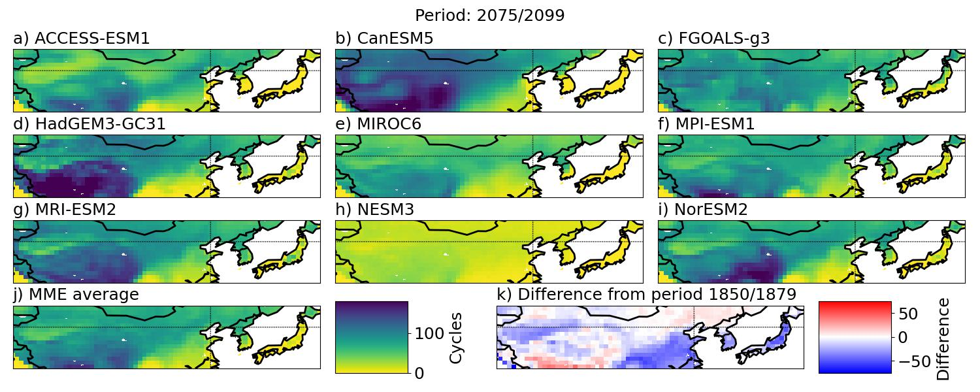
Figure S9: The number of annual freeze-thaw cycles in the period 2075 — 2100 for (a-i) the nine CMIP6 models and (j) the ensemble average. (k) show the difference in the ensemble average between the given period and 1850 — 1879.

Deep frost days

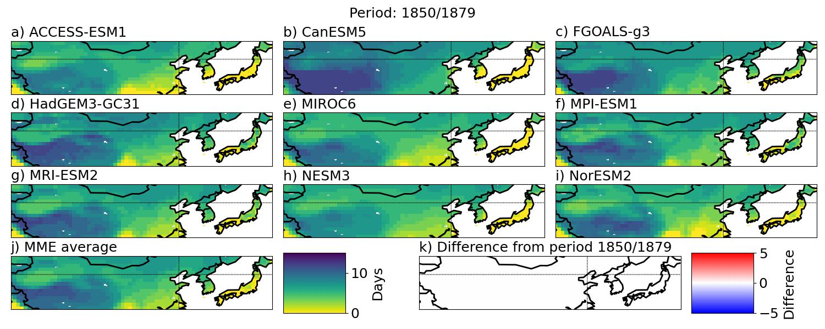
Figure S10: The number of annual deep frost days in the period 1850 — 1879 for (a-i) the nine CMIP6 models and (j) the ensemble average. (k) show the difference in the ensemble average between the given period and 1850 — 1879.
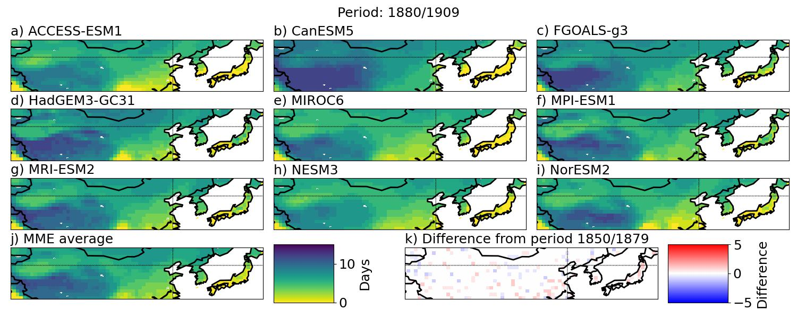
Figure S11: The number of annual deep frost days in the period 1880 — 1909 for (a-i) the nine CMIP6 models and (j) the ensemble average. (k) show the difference in the ensemble average between the given period and 1850 — 1879.
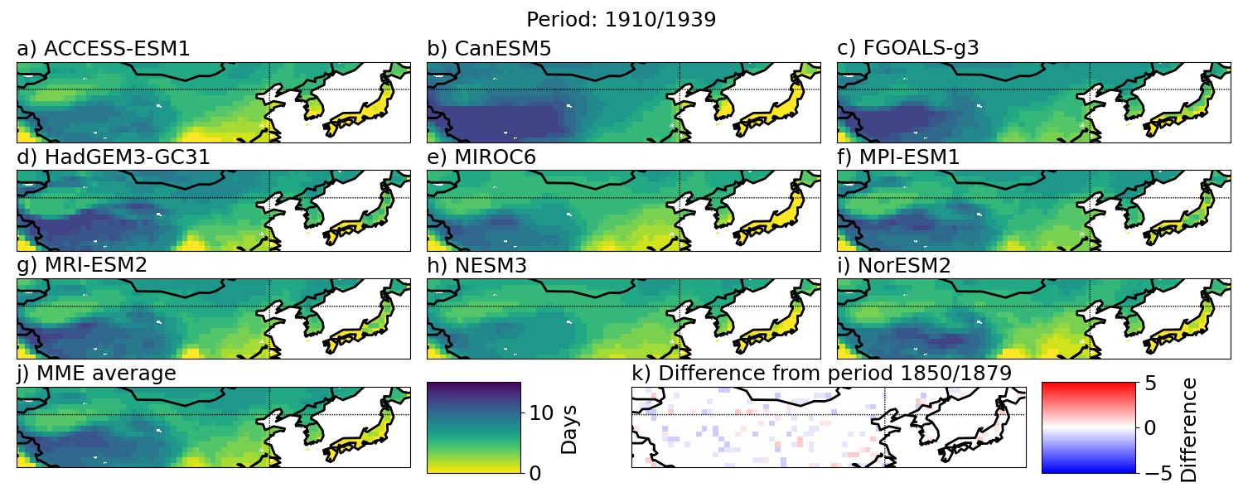
Figure S12: The number of annual deep frost days in the period 1910 — 1939 for (a-i) the nine CMIP6 models and (j) the ensemble average. (k) show the difference in the ensemble average between the given period and 1850 — 1879.
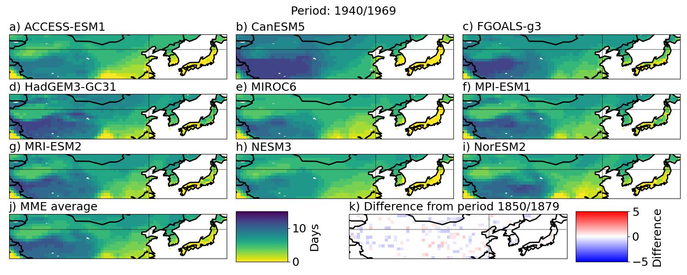
Figure S13: The number of annual deep frost days in the period 1940 — 1969 for (a-i) the nine CMIP6 models and (j) the ensemble average. (k) show the difference in the ensemble average between the given period and 1850 — 1879.
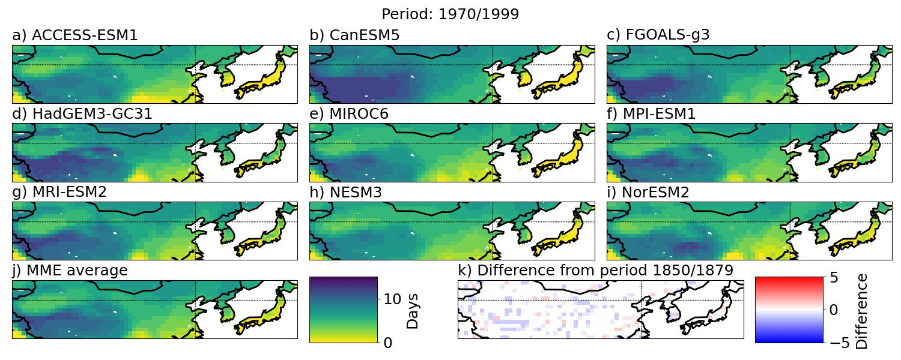
Figure S14: The number of annual deep frost days in the period 1970 — 1999 for (a-i) the nine CMIP6 models and (j) the ensemble average. (k) show the difference in the ensemble average between the given period and 1850 — 1879.
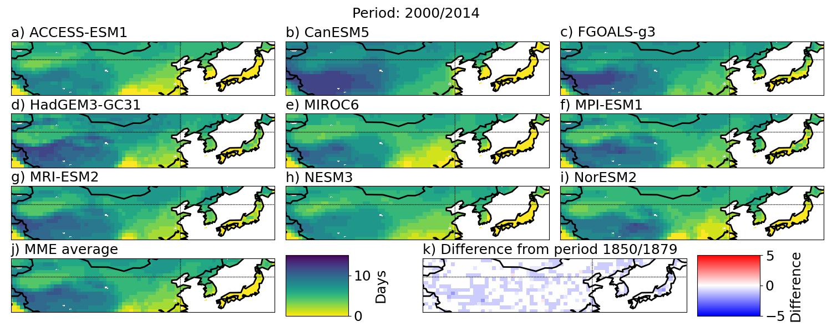
Figure S15: The number of annual deep frost days in the period 2000 — 2014 for (a-i) the nine CMIP6 models and (j) the ensemble average. (k) show the difference in the ensemble average between the given period and 1850 — 1879.
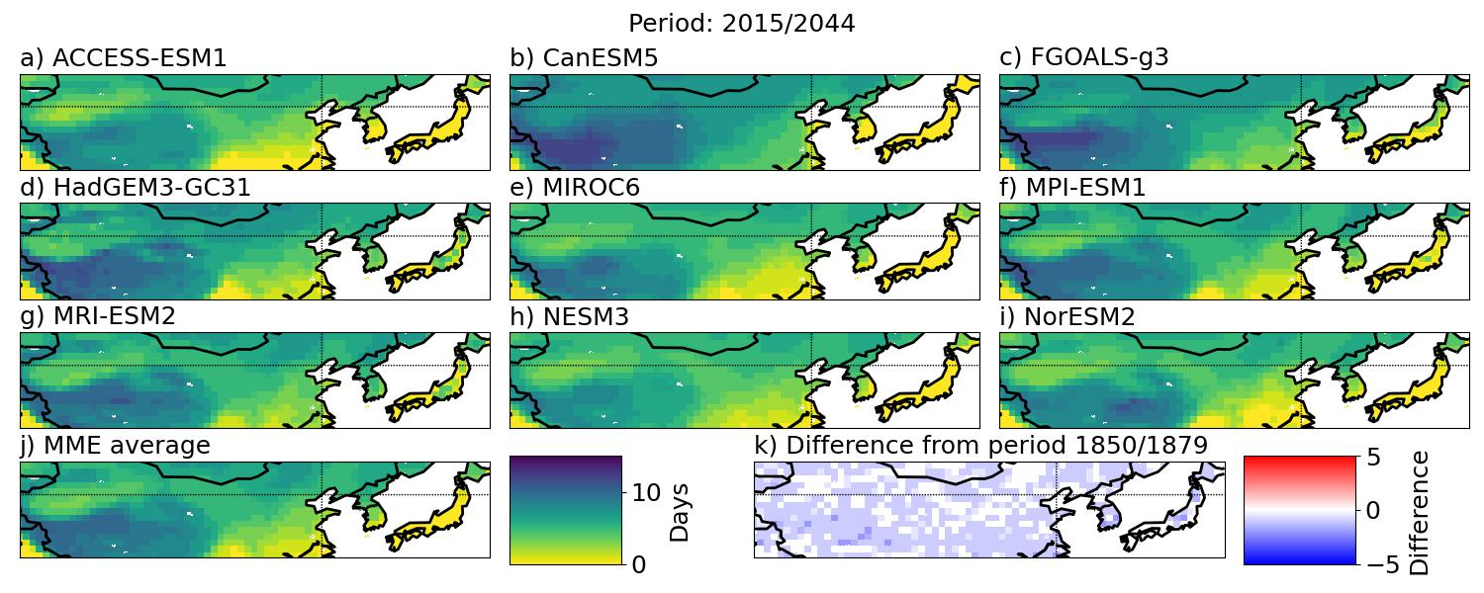
Figure S16: The number of annual deep frost days in the period 2015 — 2044 for (a-i) the nine CMIP6 models and (j) the ensemble average. (k) show the difference in the ensemble average between the given period and 1850 — 1879.
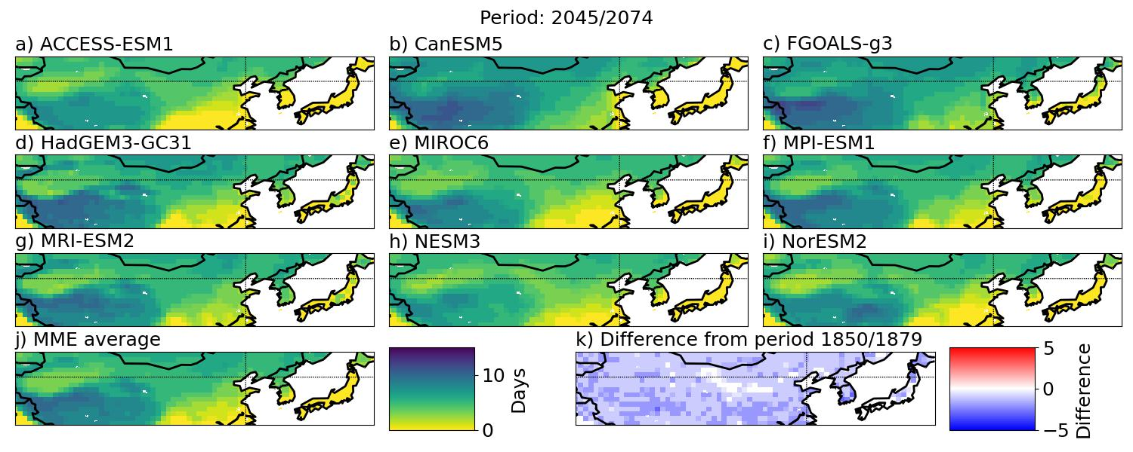
Figure S17: The number of annual deep frost days in the period 2045 — 2074 for (a-i) the nine CMIP6 models and (j) the ensemble average. (k) show the difference in the ensemble average between the given period and 1850 — 1879.
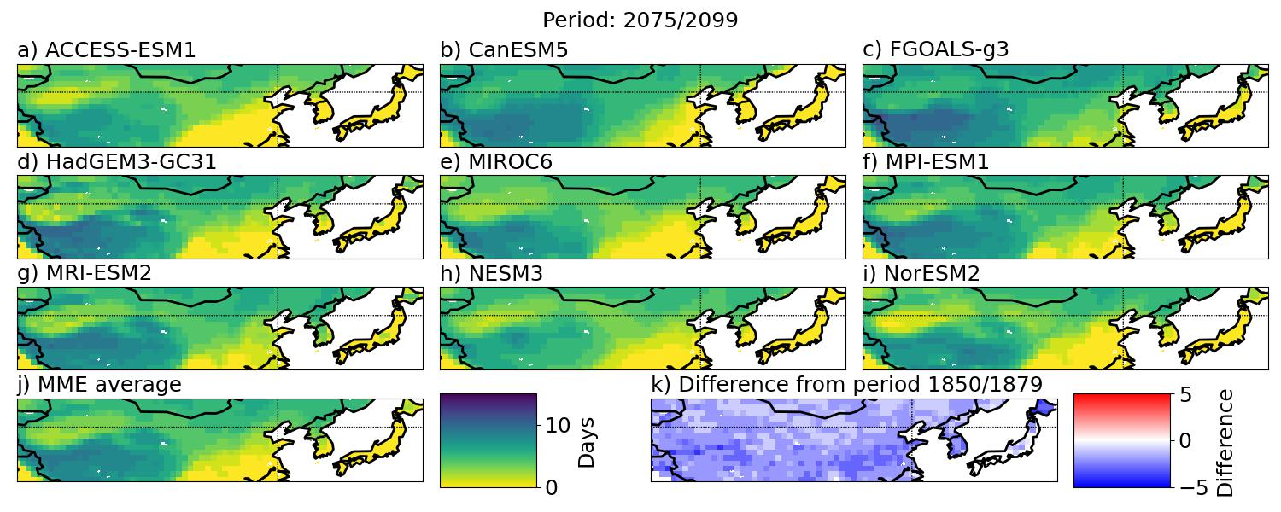
Figure S18: The number of annual deep frost days in the period 2075 — 2100 for (a-i) the nine CMIP6 models and (j) the ensemble average. (k) show the difference in the ensemble average between the given period and 1850 — 1879.

Wet frost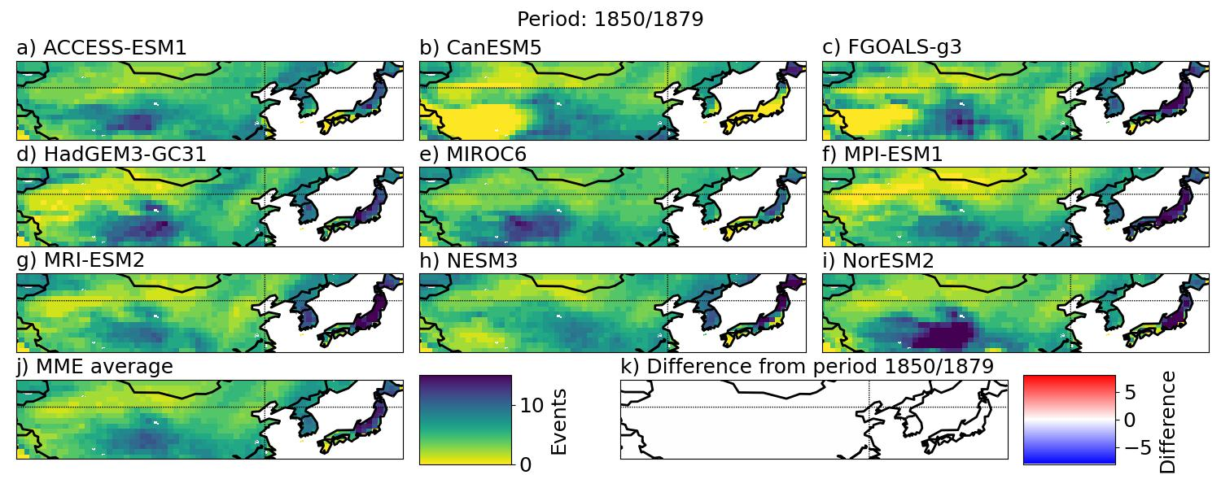
Figure S19:The number of annual wet frost days in the period 1850 — 1879 for (a-i) the nine CMIP6 models and (j) the ensemble average. (k) show the difference in the ensemble average between the given period and 1850 — 1879.
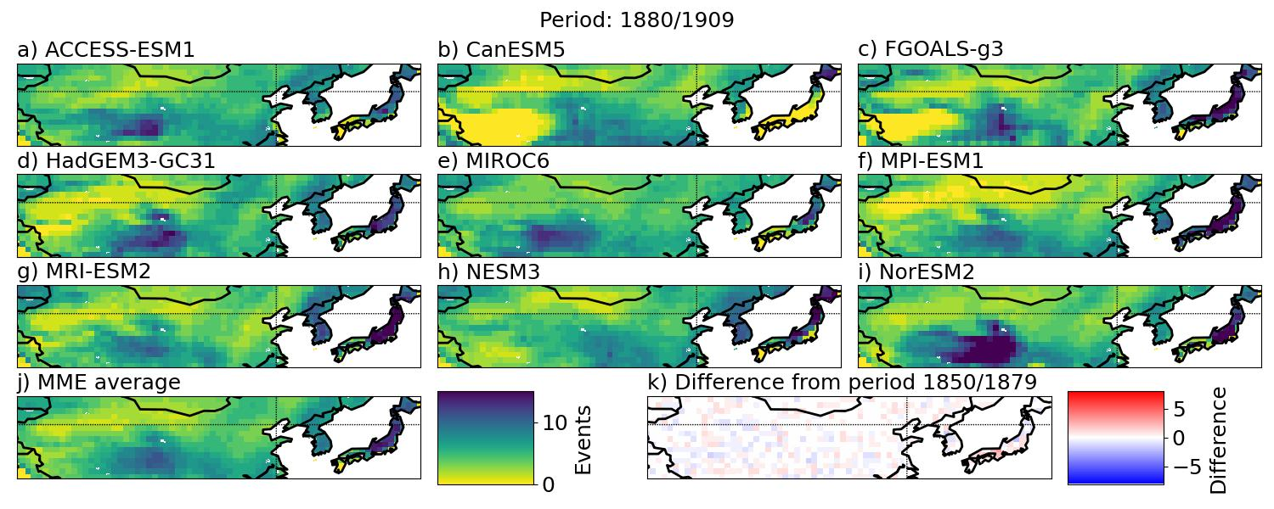
Figure S20: The number of annual wet frost days in the period 1880 — 1909 for (a-i) the nine CMIP6 models and (j) the ensemble average. (k) show the difference in the ensemble average between the given period and 1850 — 1879.
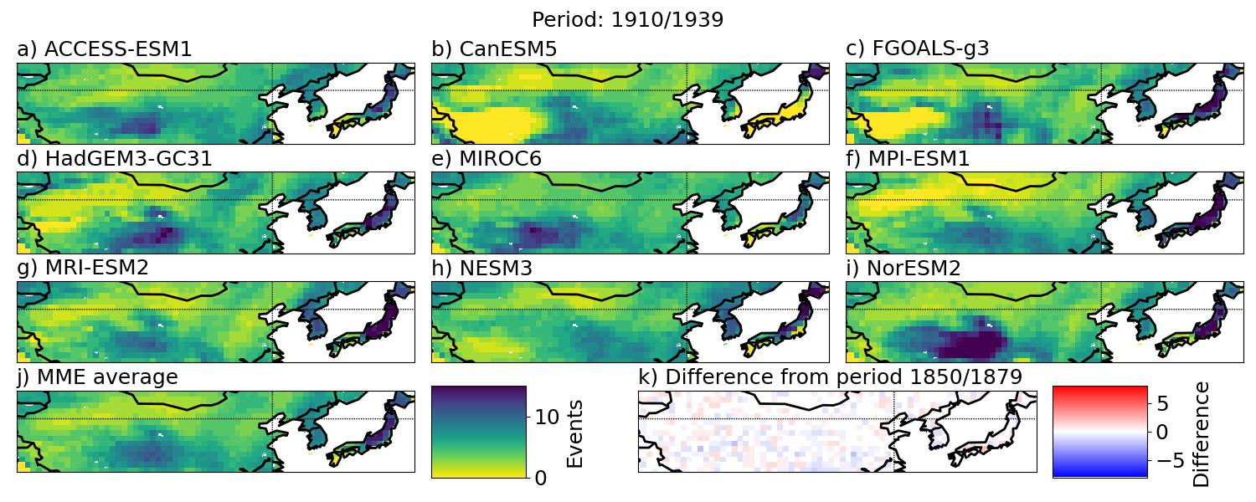
Figure S21:The number of annual wet frost days in the periods 1910 — 1939 for (a-i) the nine CMIP6 models and (j) the ensemble average. (k) show the difference in the ensemble average between the given period and 1850 — 1879.
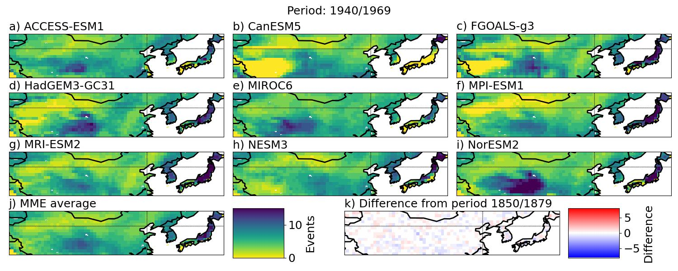
Figure S22: The number of annual wet frost days in the period 1940 — 1969 for (a-i) the nine CMIP6 models and (j) the ensemble average. (k) show the difference in the ensemble average between the given period and 1850 — 1879.
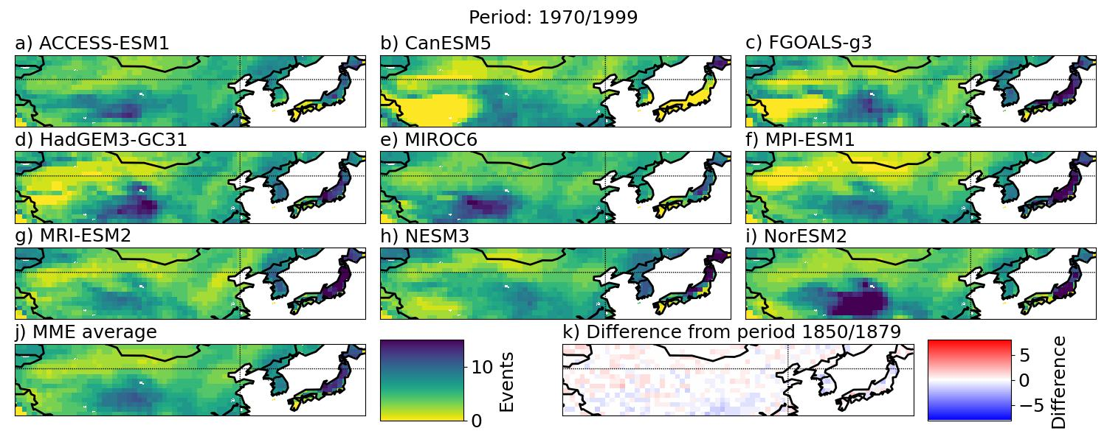
Figure S23: The number of annual wet frost days in the period 1970 — 1999 for (a-i) the nine CMIP6 models and (j) the ensemble average. (k) show the difference in the ensemble average between the given period and 1850 — 1879.
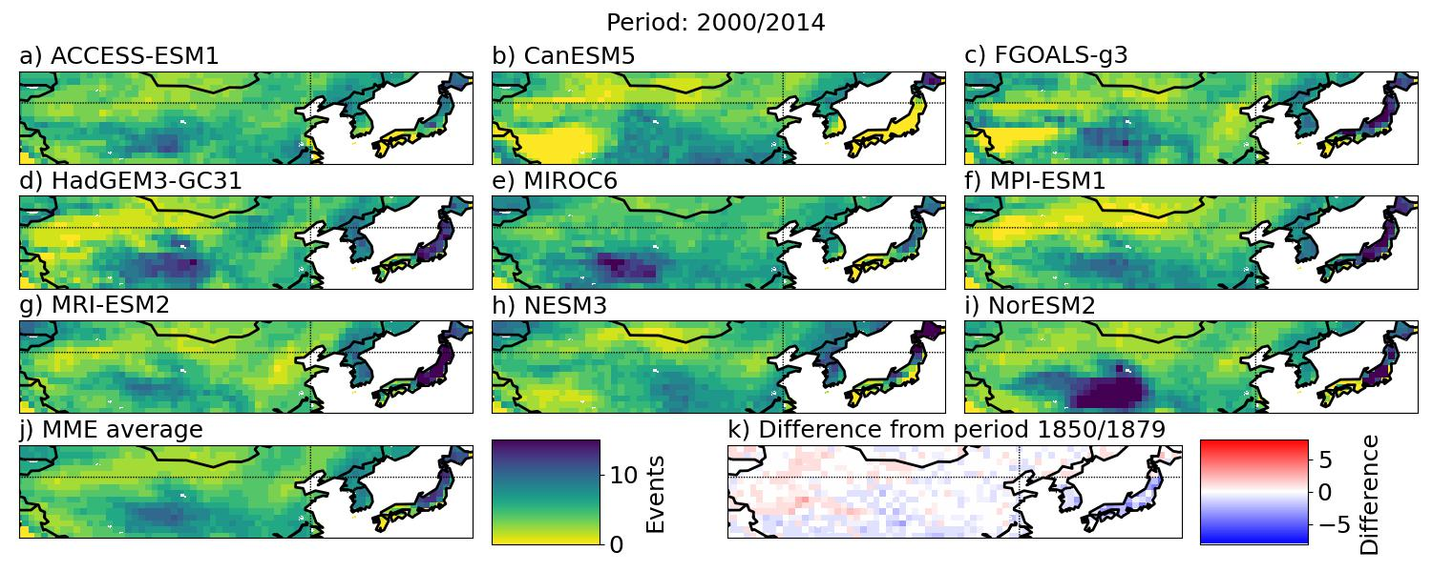
Figure S24: The number of annual wet frost days in the period 2000 — 2014 for (a-i) the nine CMIP6 models and (j) the ensemble average. (k) show the difference in the ensemble average between the given period and 1850 — 1879.
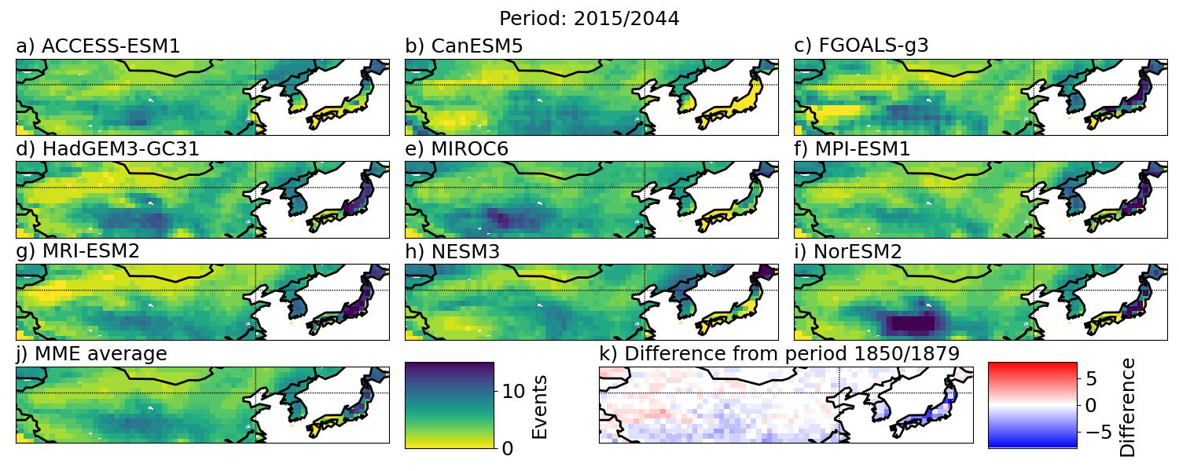
Figure S25: The number of annual wet frost days in the periods 2015 — 2044 for (a-i) the nine CMIP6 models and (j) the ensemble average. (k) show the difference in the ensemble average between the given period and 1850 — 1879.
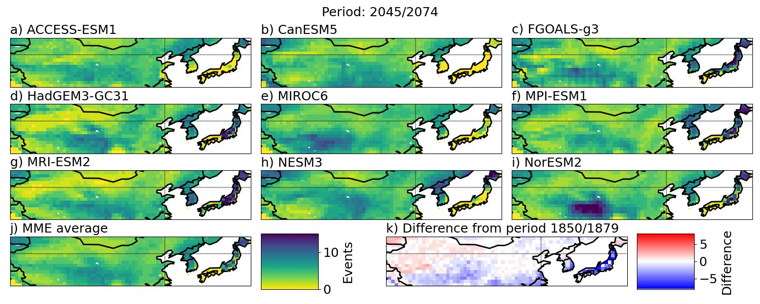
Figure S26: The number of annual wet frost days in the period 2045 — 2074 for (a-i) the nine CMIP6 models and (j) the ensemble average. (k) show the difference in the ensemble average between the given period and 1850 — 1879.
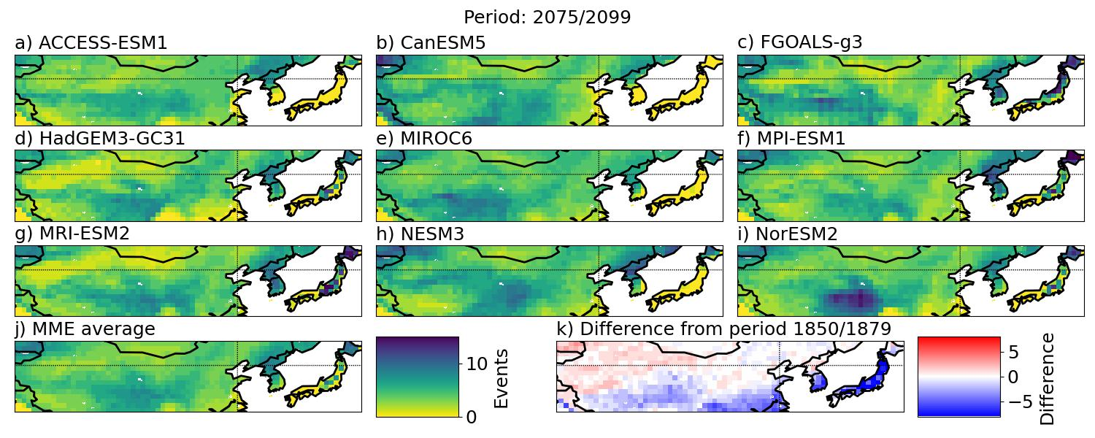
Figure S27: The number of annual wet frost days in the period 2075 — 2100 for (a-i) the nine CMIP6 models and (j) the ensemble average. (k) show the difference in the ensemble average between the given period and 1850 — 1879.

