“Surface Temperature and Ozone Responses to
the 2030 Global Methane Pledge”

Supplementary Information

Identifier | Compound | Anthropogenic  2020 | Biomass burning  2020 | Natural 2020 | Units | Change in  2020-2100  [%]
BC | Black carbon | 4.32 | 2.03 | - | TgC/yr | -
C₁₀H₁₆ | Monoterpenes | - | - | 182.7 | Tg/yr | 16.7
C₂H₄ | Ethene | 220.5 | 135.9 | 404.1 | Gmol/yr | -
C₂H₆ | Ethane | 389.9 | 110.1 | 17.9 | Gmol/yr | -
C₃H₆ | Propene | 120.4 | 75.9 | 80.9 | Gmol/yr | -
C₃H₈ | Propane | 339.0 | 14.2 | 7.9 | Gmol/yr | -
Isoprene | Isoprene | - | - | 613 | Tg/yr | 14.5
CH₂Br₂ | Dibromomethane | - | - | 0.7 | Gmol/yr | -
CH₂ClBr | Bromochloromethane | - | - | 0.1 | Gmol/yr | -
CH₃CHO | Acetaldehyde | 0.03 | 62.3 | - | Gmol/yr | -
CH₃CO₂H | Acetic acid | 215.4 | 230.9 | 56.3 | Gmol/yr | -
CH₃COCH |  | 36.3 | - | - | Gmol/yr | -
CH₃COCH₃ | Acetone | 0.0 | 25.0 | 970.7 | Gmol/yr | 5.1
CH₃OH | Methanol | 0.4 | 0.2 | 4.5 | Tmol/yr | -1.2
CHBr₃ | Bromoform | - | - | 2.4 | Gmol/yr | -
CHCl₂Br | Bromodichloromethane | - | - | 0.1 | Gmol/yr | -
CHClBr₂ | Dibromochloromethane | - | - | 0.1 | Gmol/yr | -
CO | Carbon monoxide | 25.5 | 12.0 | 4.0 | Tmol/yr | -
DMS | Dimethyl sulfide | - | - | 940.3 | Gmol/yr | 3.1
HCHO | Methanal, formaldehyde | 162.2 | 151.8 | - | Gmol/yr | -
HCOOH | Formic acid | 153.6 | 52.3 | 120.9 | Gmol/yr | -
HONO | Nitrous acid | - | 45.0 | - | Gmol/yr | -
LALK₄ | Lumped pentanes | 186.5 | - | - | Gmol/yr | -
LALK₅ | Lumped higher alkanes | 180.0 | - | - | Gmol/yr | -
LARO₁ | Lumped aromatics | 207.6 | - | - | Gmol/yr | -
LARO₂ |  | 126.6 | - | - | Gmol/yr | -
LOLE₁ | Lumped olefins | 115.9 | - | - | Gmol/yr | -
LOLE₂ |  | 91.3 | - | - | Gmol/yr | -
LTERP | Lumped other terpenes | 2.4 | - | - | Gmol/yr | -
MEK | Methyl ethyl ketone | 19.5 | 6.2 | - | Gmol/yr | -
NC₄H₁₀ | n-butane | 1,669.5 | 26.7 | 6.9 | Gmol/yr | -
NH₃ | Ammonia | 3.7 | 0.3 | 0.6 | Gmol/yr | -
NO | Nitrogen oxides | 2.0 | 0.3 | - | Tmol/yr | -
Surface NO | Nitrogen oxides | - | - | 6.1 | TgN/yr | 8.3
Lightning NO_{x} | Nitrogen oxides | - | - | 1.7 | TgN/yr | 13.8
OC | Organic carbon | 11.36 | 16.7 | - | TgC/yr | -
SO₂ | Sulfur Dioxide | 1.44 | 0.04 | 0.47 | Tmol/yr | -

Table S1. Fluxes of primary emitted species used in this study. Tabled changes pertain only to natural sources subject to climate change feedbacks. For selected species, fluxes are given in elemental mass (e.g., TgN/yr).

CH₄ emission source | Mt/year | GMP reduction |  | GMAR reduction
CH₄ emission source | Mt/year | % | Mt/year | % | Mt/year
swamps | 150.6 | - | - | - | -
bogs | 43.6 | - | - | - | -
termites | 21.9 | - | - | - | -
rice paddies | 69.7 | 10 | 7 | 30 | 20.9
animals | 85.1 | 15 | 12.8 | 20 | 17
landfills | 64.5 | 45 | 29 | 55 | 35.5
gas | 42.6 | 55 | 23.4 | 60 | 25.6
coal | 36.2 | 70 | 25.3 | 75 | 27.2
oil | 31.5 | 60 | 18.9 | 60 | 18.9
shale gas | 7.2 | - | - | 60 | 4.3
biomass burning | 22.2 | - | - | - | -
biofuel | 16.8 | - | - | - | -
natural | 216.1 | - | - | - | -
anthropogenic | 375.8 | 30 | 116.4 | 40 | 149.4
total | 591.9 | 19.7 | 116.4 | 25.2 | 149.4

Table S2: Global 2020 methane emissions (Mt/year) from natural and anthropogenic sectors as simulated in EMAC model, along with mitigation measures by sector as proposed to reach the GMP for 30% mitigation scenarios and GMAR for 40% mitigation scenarios.

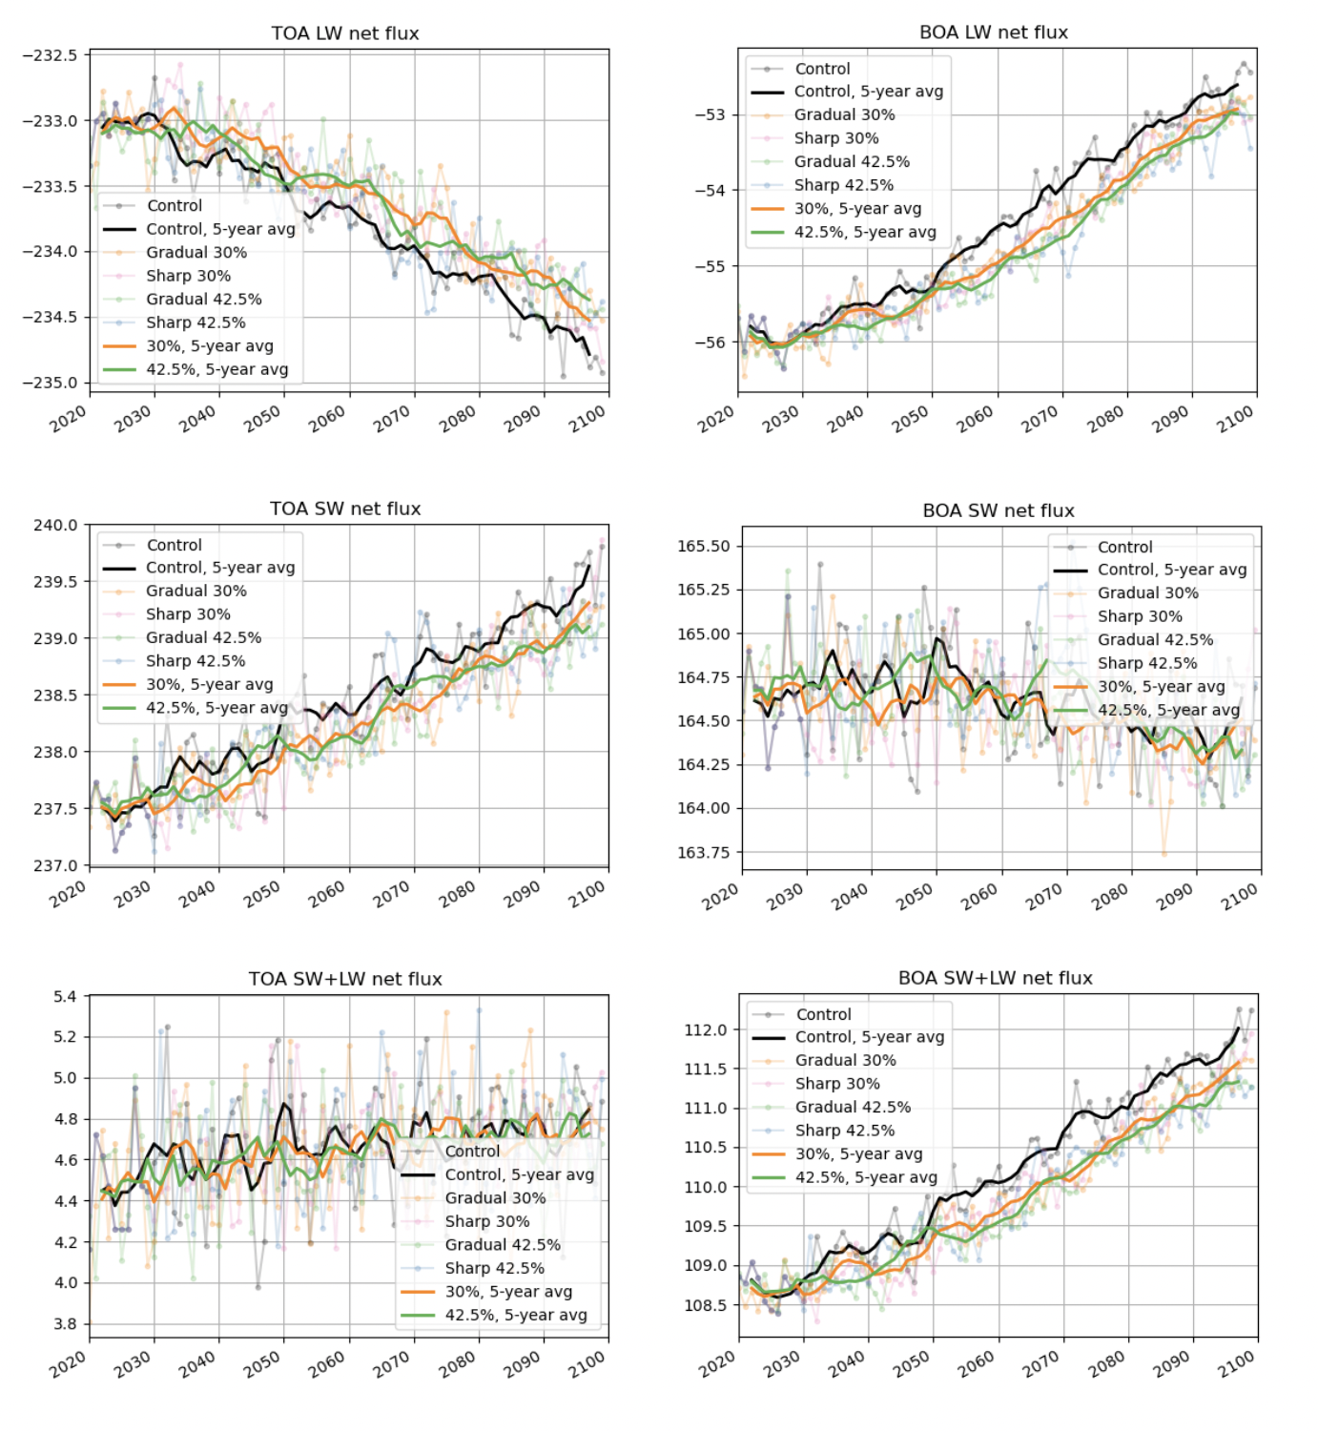
Figure S1-S6. Globally averaged all-sky shortwave (SW) and longwave (LW) radiative fluxes at the top of the atmosphere (TOA) and bottom of the atmosphere (BOA) and SW + LW fluxes (W/m²) calculated with the EMAC model under different methane emission scenarios for the 2020-2100 period. The colored lines represent: control (gray), gradual 30% (orange), sharp 30% (pink), gradual 40% (green), sharp 40% (blue). The GMP corresponds to the 30% mitigation scenarios and the GMAR is basic to the 40% mitigation scenarios.

