Farming on the edge: assessing the impact of historical and future climate change on the Mediterranean cropping margins of Australia.

Supplementary material

Table S1: Range of studies reporting the performance of APSIM simulation of wheat including sample size (n), Coefficient of determination between observed and simulated (R²), the Root Mean Squared Deviation (RMSD) and the observed range of wheat yields.
Note that repetition in some of the test data sets is likely. Care should be taken when comparing studies. As shown in Whitbread and Hancock (2008), prediction can be greatly improved with more information about starting conditions, soil type and management. Measures of prediction are likely to be higher when the primary source of variation in the observed data is a range of years from dry to wet and lower when variation is due to treatments within a single year or small number of years.
Reference | Location | n | R² | RMSD (t/ha) | Observed range (t/ha)
Probert et al. 1995 | Queensland | 88 | 0.3 | 0.94 | 0.3-4.8
Assange et al. 1998 | Western Australia | 42 | 0.77 | 0.4 | 1 to 4
Wang et al. 2003 | Queensland | 106 | 0.8 | 0.74 | 1 to 8
Sadras et al. 2003 | South Australia | 55 | 0.74 | 0.19 | 0.7 to 3.8
Yunusa et al. 2004 | South Australia | 80 | 0.69 | 0.45 | 1.3 to 4.0
Oliver et al., 2006 | Western Australia | 65 | 0.8 | 0.3 | 0.4 to 3.7
Lilley and Kirkegaard 2007 | Sthn New South Wales (Calibration site) | 11 | 0.93 | 0.65 | 1.2 to 8.3
Lilley and Kirkegaard 2007 | Sthn New South Wales (Validation site) | 9 | 0.79 | 0.3 | 0.3 to 2.6
Weeks et al., 2007 | Western Australia 2005 crop season | 7 | 0.52 | 0.55 | 0.6 to 2.3
Weeks et al., 2007 | Western Australia  2006 crop season | 6 | 0.89 | 0.26 | 0.6 to 2.3
Whitbread and Hancock 2008 | South Australia. Research farm average 1972 to 2007 | 35 | 0.66 | 0.64 | 0.1 to 3.6
Whitbread and Hancock 2008 | South Australia. One field with sow date, cultivar & fertiliser. | 9 | 0.79 | 0.3 | 0.3 to 2.6
Whitbread and Hancock 2008 | South Australia. Trial site with characterised soil, sow date, cultivar & fertiliser. | 16 | 0.79 | 0.3 | 0.2 to 2.3
Anwar et al. 2009 | Victoria | 40 | 0.96 | 0.31 | 0.1 to 5.2
Lawes et al. 2009 | Western Australia | 75 | 0.86 | 0.31 | 0.30 to 3.71
Hochman et al. 2009 | Australia | 334 | 0.71 | 0.8 | 0 to 8
Carberry et al. 2009 | South Australia | 28 | 0.88 | 0.26 | 1.1 to 4.9
Monjardino et al. 2013 | South Australia | 16 | 0.65 | 0.82 | 0.5 to 6.6
O'Leary et al. 2016 | New South Wales, Queensland | 672 | 0.03-0.57 | 1.04-1.58 | 0.30 to 6.20
Fletcher et al. 2020 | Western Australia | 46 | 0.69 | 0.77 | 0.35 to 3.20
Lilley and Kirkegaard, 2024 | New South Wales | 17 |  | 0.54 | 1.63 to 8.33

References
Anwar M, O’Leary G, Rab M, Fisher P, Armstrong R (2009) Advances in precision agriculture in south-eastern Australia. V. Effect of seasonal conditions on wheat and barley yield response to applied nitrogen across management zones. Crop and Pasture Science, 60, 901-911.
Asseng S, Keating BA, Fillery IRP, Gregory PJ, Bowden JW, Turner NC, Palta JA, Abrecht DG (1998) Performance of the APSIM-wheat model in Western Australia. Field Crops Research 57 1998 163–179.
Bryan B, King D, Zhao G (2014) Influence of management and environment on Australian wheat: information for sustainable intensification and closing yield gaps. Environmental Research Letters, 9, 044005.
Carberry PS, Hochman Z, Hunt JR, Dalgliesh NP, McCown RL, Whish JPM, Robertson MJ, Foale MA, Poulton PL, van Rees H (2009) Re-inventing model-based decision support with Australian dryland farmers. 3. Relevance of APSIM to commercial crops. Crop & Pasture Science 60, 1044–1056. doi:10.1071/CP09052
Fletcher AL, Chen C, Ota N, Lawes RA, Oliver YM (2020) Has historic climate change affected the spatial distribution of water-limited wheat yield across Western Australia? Climatic Change, 159, 347-364.
Hochman Z Holzworth D, Hunt JR (2009) Potential to improve on-farm wheat yield and WUE in Australia. Crop & Pasture Science, 60: 708–716.
Hunt JR, Browne C, McBeath TM, Verburg K, Craig S, Whitbread AM (2013). Summer fallow weed control and residue management impacts on winter crop yield though soil water and N accumulation in a winter-dominant, low rainfall region of southern Australia. Crop and Pasture Science 64: 922-934.
Lawes R, Oliver Y, Robertson M (2009) Integrating the effects of climate and plant available soil water holding capacity on wheat yield. Field Crops Research, 113, 297-305.
Lilley JM, Kirkegaard JA (2007) Seasonal variation in the value of subsoil water to wheat: simulation studies in southern New South Wales. Australian Journal of Agricultural Research, 58:1115-1128
Lilley JM, Kirkegaard JA (2024) Validated simulation of a long-term cropping experiment reveals a pathway for improved productivity. European Journal of Agronomy, 159, 127225.
Monjardino M, McBeath T, Ouzman J, Llewellyn R, Jones B (2015) Farmer risk-aversion limits closure of yield and profit gaps: A study of nitrogen management in the southern Australian wheatbelt. Agricultural Systems 137: 108–118.
O'Leary GJ, Liu L, Ma Y, Li FY. McCaskill M, Conyers M, Dalal R, Reeves S, Page K, Dang YP, Robertson F (2016). Modelling soil organic carbon 1. Performance of APSIM crop and pasture modules against long-term experimental data. Geoderma, 264 , pp. 227-237.
Oliver Y, Wong M, Robertson M, Wittwer K (2006) PAWC determines spatial variability in grain yield and nitrogen requirement by interacting with rainfall on northern WA sandplain. In ‘Proceedings 13th Australian Agronomy Conference’. (Australian Society of Agronomy: Parkville, Vic.) Available at: www.regional.org.au/au/ asa/2006/concurrent/water/4570_oliver.htm
Probert M, Keating B, Thompson J, Parton W (1995) Modelling water, nitrogen, and crop yield for a long-term fallow management experiment. Australian Journal of Experimental Agriculture, 35, 941-950.
Sadras V, Baldock J, Roget D, Rodriguez D (2003) Measuring and modelling yield and water budget components of wheat crops in coarse-textured soils with chemical constraints. Field Crops Research 84, 241–260. doi: 10.1016/S0378-4290(03)00093-5
Wang E, van Oosterom EJ, Meinke H, Asseng S, Robertson MJ, Huth NI, Keating BA, Probert M (2003) The new APSIM-Wheat model: Performance and future improvements. In: Unkovich M, O'Leary G (Eds.), Proceedings of the 11th Australian Agronomy Conference. Australian Society of Agronomy, Geelong Victoria.
Weeks C, Robertson M, Oliver Y, Fairbanks M (2007) Managing seasonal risk is an important part of farm management but is highly complex and therefore needs a ‘horses for courses’ approach. Department of Agriculture and Food, Western Australia. Available at: www.agric.wa.gov.au/pls/portal30/docs/FOLDER/IKMP/ FCP/2007_farmsystems_part1.pdf
Whitbread A, Hancock J (2008) Estimating grain yield with the French and Schultz approaches Vs simulating attainable yield with APSIM on the Eyre Peninsula. In: Unkovich M, O'Leary G (Eds.), Proceedings of the 14th Australian Agronomy Conference. September 2008, Adelaide South Australia.
Yunusa I, Bellotti W, Moore A, Probert M, Baldock J, Miyan S (2004) An exploratory evaluation of APSIM to simulate growth and yield processes for winter cereals in rotation systems in South Australia. Australian Journal of Experimental Agriculture, 44, 787-800.
Table S2: Details of the 8 climate models (GCMs) used for future projections, including the available representative Concentration Pathways (RCPs) and the projected change values for rainfall and mean temperature from a baseline of 1986-2005 to 2040-2059 (representing 2050) under the high emissions scenario (RCP8.5). The equivalent mean value from a 42 GCM model ensemble is also shown at the bottom of the table for comparison. Values are the regional projected change for May to October for the Southern and South-Western Flatlands region (Hope 2015). Note, this is slightly different to the April to October aggregation used for the past and future climatology in this study, due to their definition of growing season from May-October.
GCM Name | RCPs available | Rainfall change (RCP8.5) | Mean temperature change (RCP8.5) | Notes on projections for May to October for the SSWF region
ACCESS 1.0 | RCP4.5  RCP8.5 | -21% | +1.65°C
CESM1-CAM5 | RCP2.6  RCP4.5  RCP8.5 | -18% | +1.64°C
CNRM-CM5 | RCP2.6  RCP4.5  RCP8.5 | -2.5% | +1.42°C | Represents the smallest reduction in rainfall.
GFDL-ESM2M | RCP2.6  RCP4.5  RCP8.5 | -32% | +1.23°C | Represents the largest reduction in rainfall.
HadGEM2-CC | RCP4.5  RCP8.5 | -20% | +1.64°C
CanESM2 | RCP2.6  RCP4.5  RCP8.5 | -19% | +1.85°C | Represents the largest increase in temperature.
MIROC5 | RCP2.6  RCP4.5  RCP8.5 | -13% | +1.03°C
NorESM1-M | RCP2.6  RCP4.5  RCP8.5 | -15% | +1.25°C | Best ‘maximum consensus’ representation of the model ensemble.
42 GCM ensemble mean for RCP8.5 |  | -13% | +1.5°C

Table S3: Description of soil used in APSIM simulations. Bulk density (BD), lower limit of plant-available water (LL), drained upper limit of water (DUL), plant available water capacity (PAWC), organic carbon (OC) at various soil depths.
Depth  (cm) | BD  (g/cm³) | LL  (v/v) | DUL  (v/v) | SAT  (v/v) | PAWC  (mm) | OC  (%)
0-10 | 1.487 | 0.050 | 0.160 | 0.369 | 10.7 | 2.200
10-20 | 1.661 | 0.060 | 0.142 | 0.303 | 8.1 | 1.090
20-30 | 1.653 | 0.060 | 0.143 | 0.306 | 7.9 | 0.540
30-40 | 1.667 | 0.060 | 0.152 | 0.301 | 8.3 | 0.390
40-60 | 1.629 | 0.090 | 0.183 | 0.315 | 18.1 | 0.267
60-80 | 1.624 | 0.130 | 0.196 | 0.317 | 12.5 | 0.214
80-100 | 1.492 | 0.130 | 0.211 | 0.367 | 10.3 | 0.100
100-120 | 1.663 | 0.130 | 0.178 | 0.302 | 3.6 | 0.130
120-150 | 1.670 | 0.130 | 0.171 | 0.300 | 5.4 | 0.099

Cool season rainfall projections
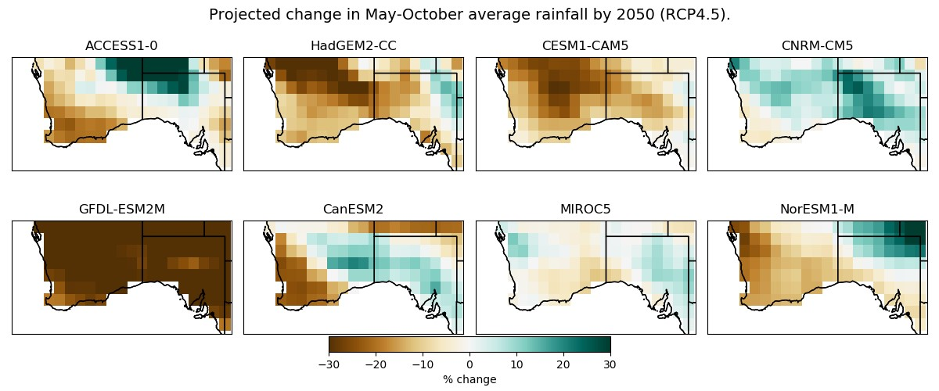
Figure S3.1 Gridded projected change in cool season rainfall by 2050 according to the 8 different global climate models used, under the RCP4.5 emissions scenario.

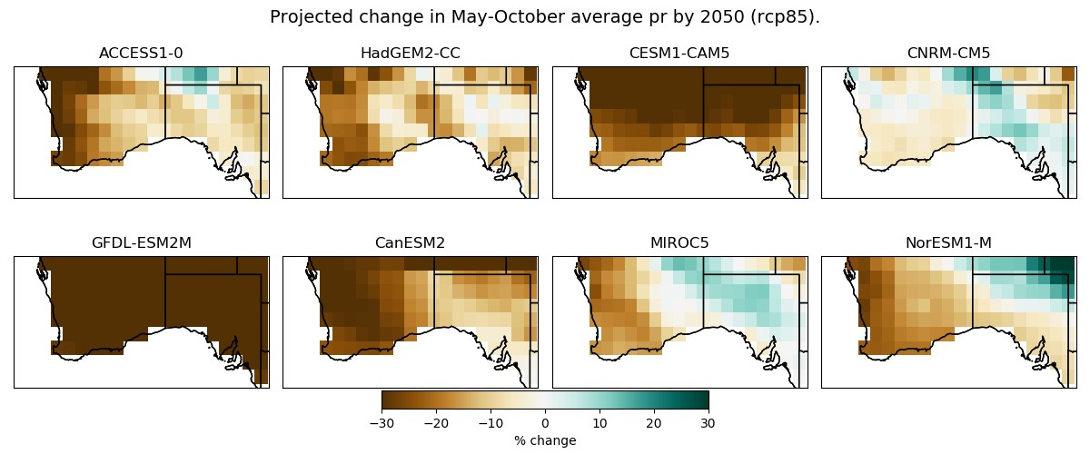
Figure S3.2 Gridded projected change in cool season rainfall (April to October) by 2050 according to the 8 different global climate models used, under the RCP8.5 emissions scenario.

Warm season rainfall projections
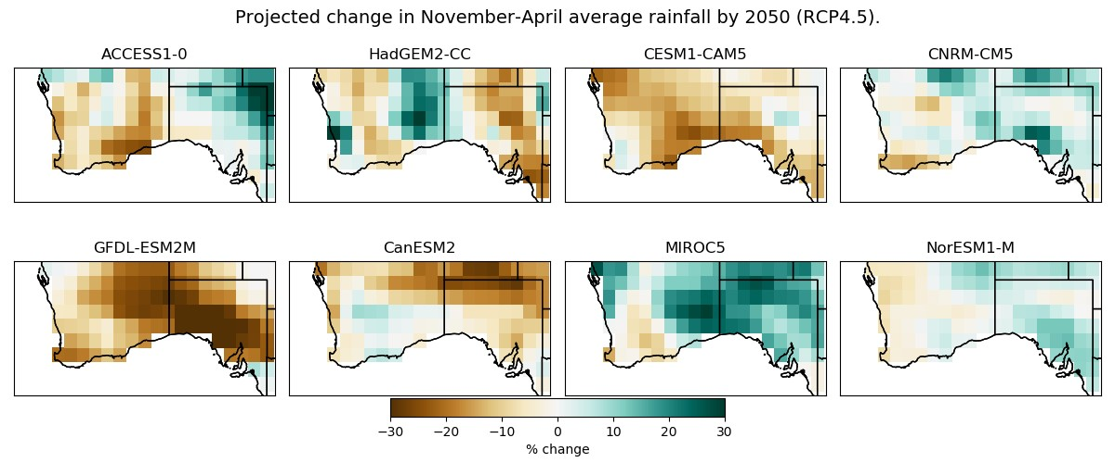
Figure S3.3 Gridded projected change in warm season rainfall (November-April) by 2050 according to the 8 different global climate models used, under the RCP4.5 emissions scenario.

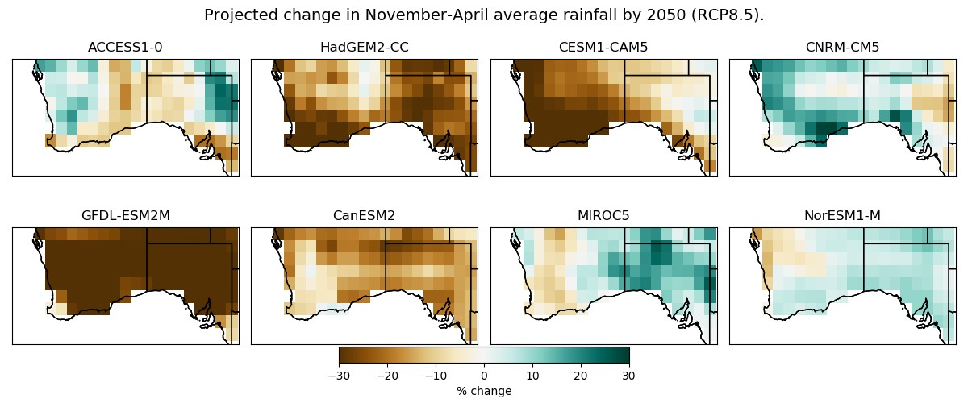
Figure S3.4 Gridded projected change in warm season rainfall (November-April) by 2050 according to the 8 different global climate models used, under the RCP8.5 emissions scenario.
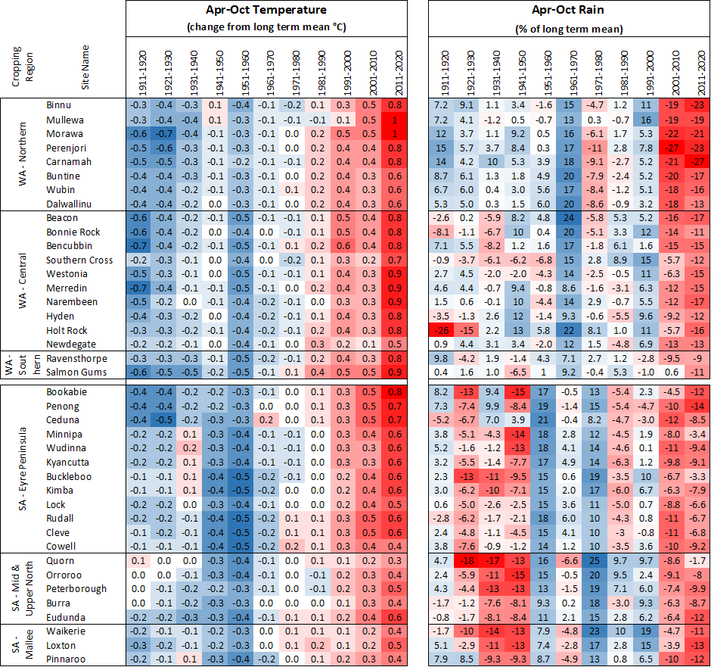Figure S4a Figure S4b
Figure S4 (a) April-October mean temperature anomaly for the Western Australian and South Australian sites by decades; (b) April-October rainfall anomaly (% diff from long term mean) for the Western Australian and South Australian sites by decades., from the long-term average 1911-2020. Red shading indicates increasing temperature and decreasing rainfall while blue shading indicates the opposite.

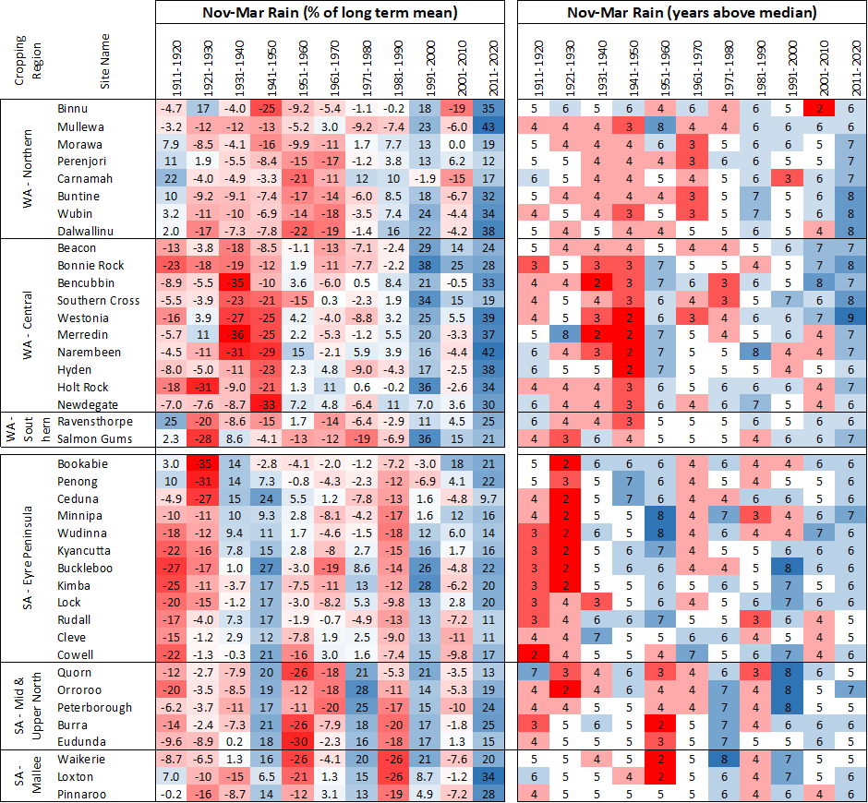
Figure S5a Figure S5b
Figure S5: (a) Nov-Mar rainfall anomaly (% diff) for the Western Australia and South Australia sites by decades; (b) rainfall – years above median Nov-Mar for the Western Australia and South Australia sites by decades, from the long-term average and median 1911-2020 respectively.

350ppm | Historic CO2
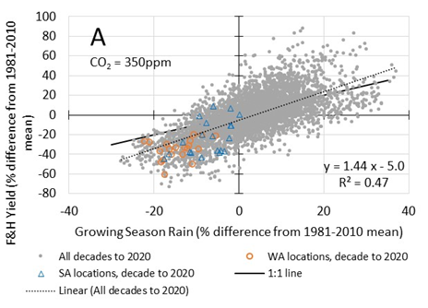 | 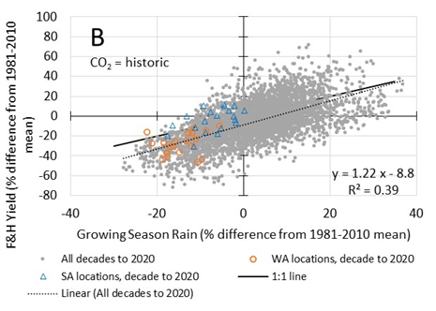
Figure S6. Same graph as Figure 6 but with heat and frost included. Decadal mean growing season rainfall and simulated yield as percentage of 1981 to 2010 average for 101 continuous 10-year periods from 1911 to 20120 for the 20 Western Australia sites and 20 South Australia sites (grey dots, 101 decades x 40 sites = 4040). The single decade 2011 to 2020 for 20 Western Australia sites (orange open circles) and 20 South Australia sites (open blue triangles). Simulated yield at a constant CO² concentration of 350 ppm (A), and at yearly historic concentrations (B).
RCP45 350ppm | RCP45 Historic CO2
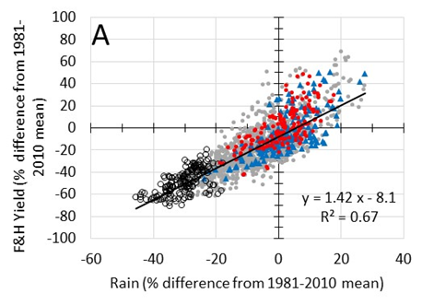 | 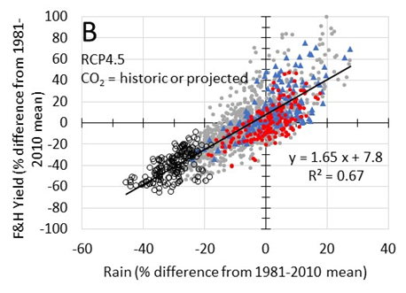
RCP85 350ppm | RCP85 Historic CO2
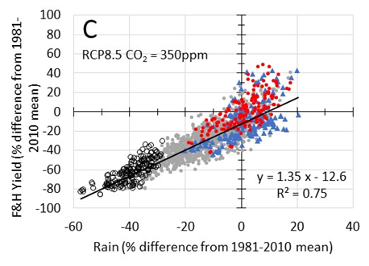 | 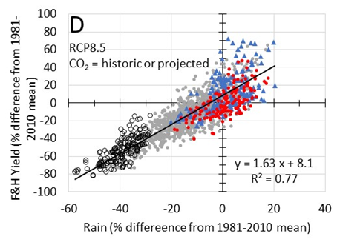
Figure S7 (same as Figure 7, but with frost and heat included). Decadal mean growing season rainfall and simulated yield with frost and heat rules as percentage of 1981 to 2010 average for the 8 focus locations. The 20 continuous decades from historical 1981 to 2010 period (red), and from the projected 2036 to 2065 climate according to CNRM-CM5 (blue triangle), GFDL-ESM2M (open circles), and for the remaining 6 GCM’s (grey circles). The regression line is shown for all 8 GCM’s. Climate projections for RCP 4.5 and wheat simulations at an atmospheric CO₂ concentration of 350 ppm (A), or at yearly historic atmospheric CO₂ concentration in the historic climate or the projected atmospheric CO₂ concentrations in the projected climates (B); Climate projections for RCP 8.5 and wheat simulations at an atmospheric CO₂ concentration of 350 ppm (C), or at yearly historic atmospheric CO₂ concentration in the historic climate or the projected atmospheric CO₂ concentrations in the projected climates (D)

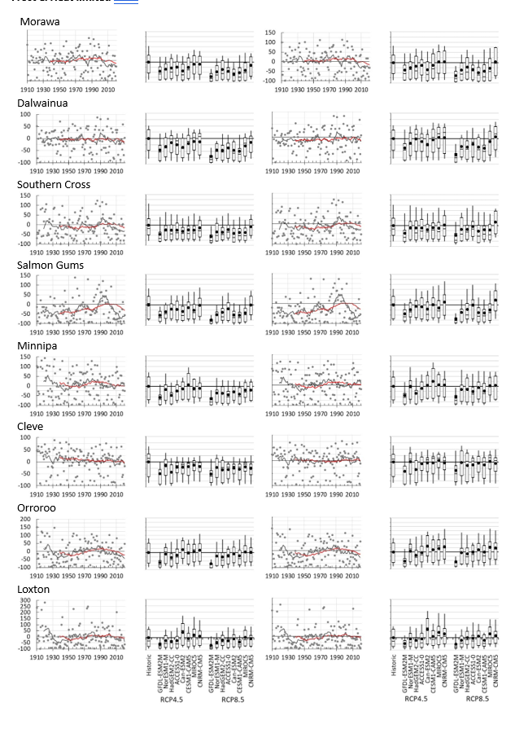Figure S8 (Same as Figure 8 but with frost and heat included). Simulated wheat yields with frost and heat rules at 8 focus sites in WA and SA. Simulated wheat yield as a percentage difference from the 30 year (1981 to 2010) mean, and distribution of annual simulated wheat yield as a percentage difference from the 30 year (1981 to 2010) mean in the historic 1981 to 2010 climate and in the projected thirty years period of 2026 to 2065 (2050 climate). Wheat yields simulated at an atmospheric CO₂ concentration of 350 ppm left hand columns), or at the yearly historic atmospheric CO₂ concentration in the historic climate or the projected atmospheric CO₂ concentrations in the projected climates (right hand columns). Scatter plots show annual simulated yields (grey circles), running decadal means (black line) and running 30 year mean (red line); Histograms show 25th, 50th and 75th percentile as box, 10th and 90th percentile as whiskers, and the average (circle).

