Supplementary Information
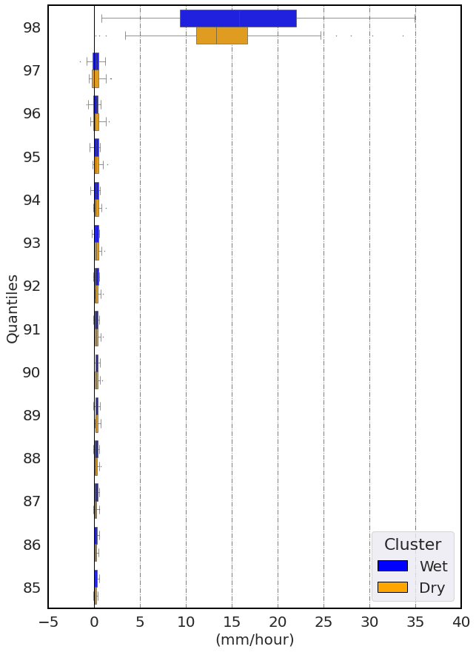
Figure S1. Boxplots of absolute bias in the simulated (uncorrected CPM output) distribution of hourly precipitation data from evaluation simulation at the two clusters of weather stations (blue: Wet cluster, yellow: Dry cluster). The blue vertical lines mean no bias.

(a) | (b) | (c)
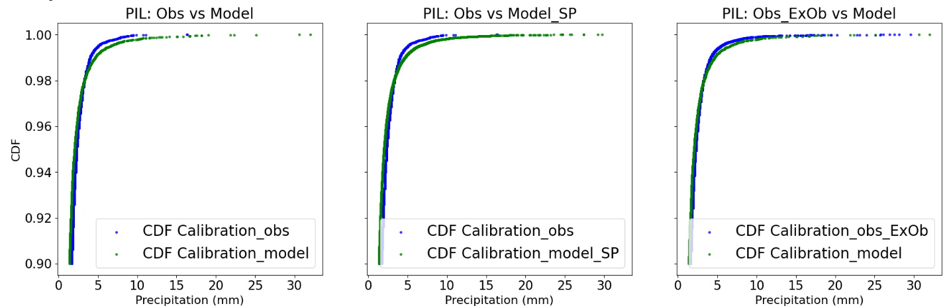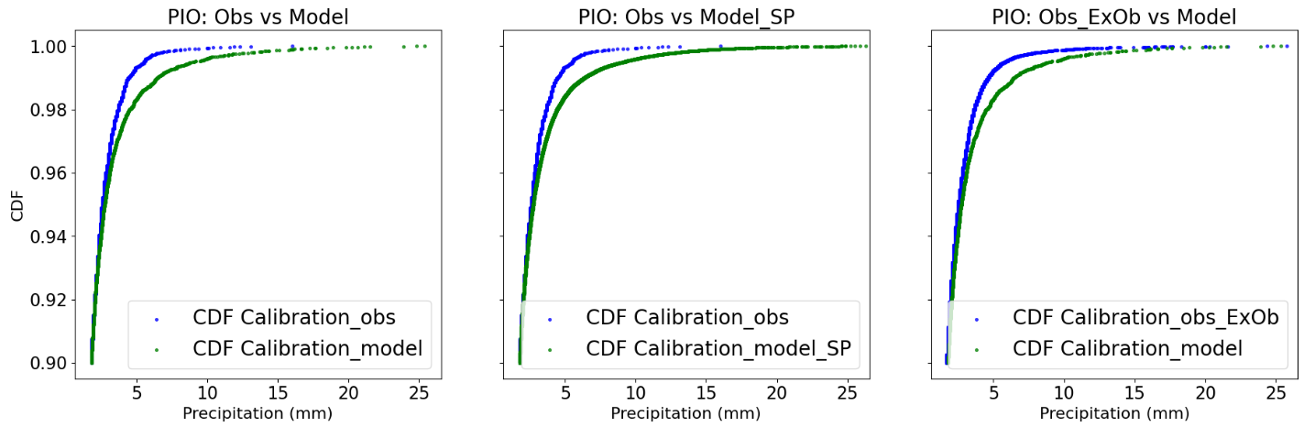
Figure S2. CDF curves for the uppermost 10 quantiles, using two stations, PIL (Pilatus) and PIO (Piotta), as examples. The blue dots represent observational data, while the green dots represent simulation data. The two subplots in (a) correspond to Conventional QM, the two middle subplots in (b) represent Spatial Pooling QM, and the two left subplots in (c) show the case of an Extended Observational Baseline (30 years of observation data). All data points are displayed. The analysis is based on a six-year calibration dataset selected for cross-validation, with the same years used in all three cases—except for the 30-year observational dataset, where the CDF is derived from 26 years of calibration data.
(a) | (b)
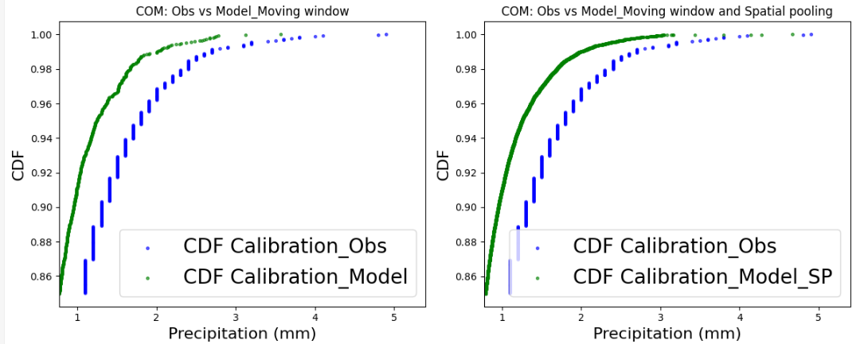
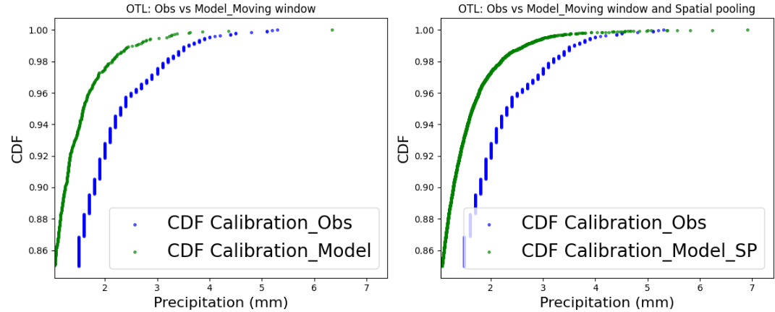
(c )
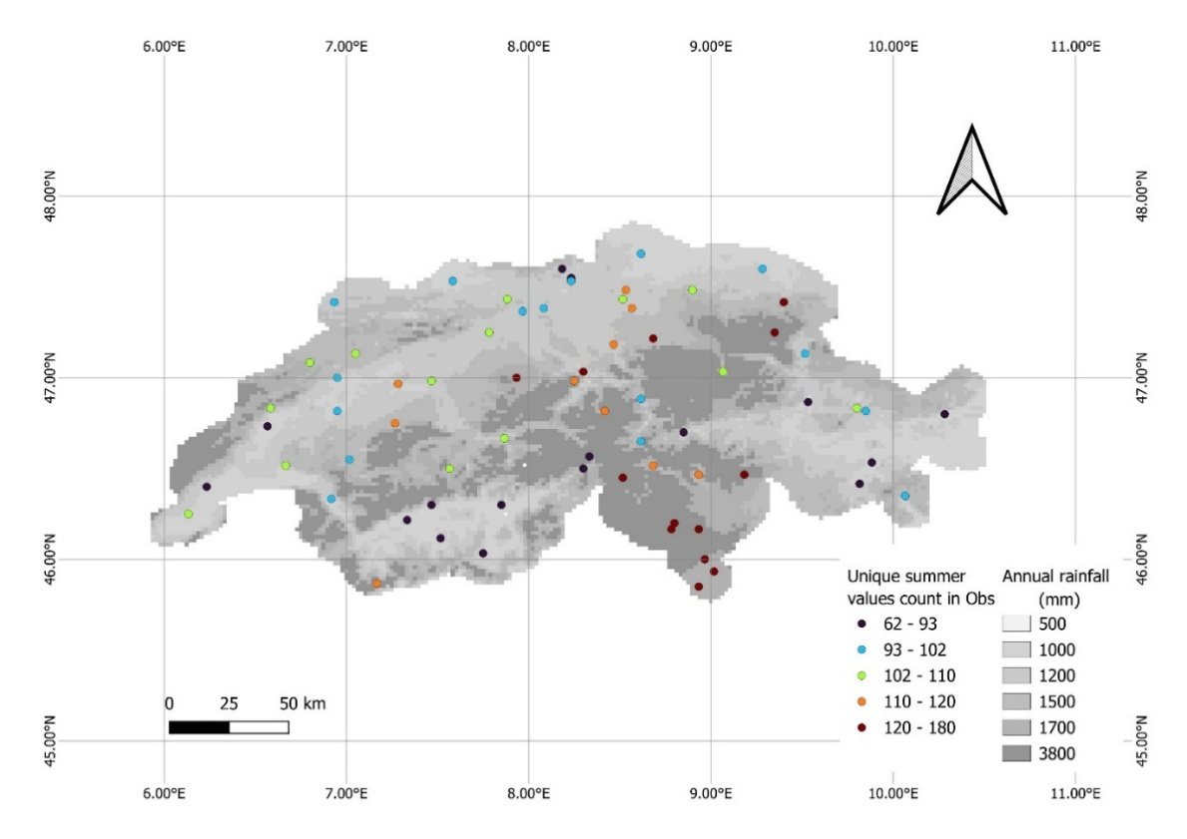
(d)
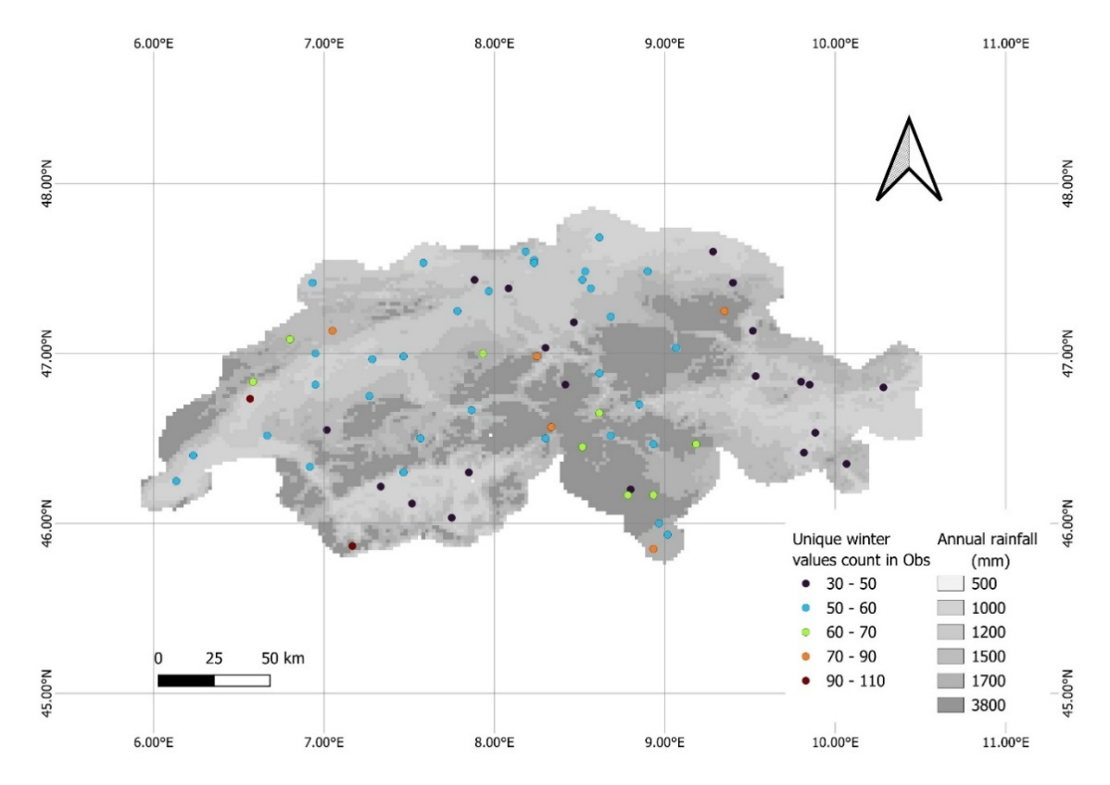
Figure S3. (a) and (b) CDF curves for the most upper 15 quantiles, taking stations COM (Comprovasco) and OTL (Monti) as examples. The blue dots are observation data, the green ones are simulation data. Subplots (a) show the case of Moving window, whereas subplots (b) show the case of Moving window – spatial pooling combination. All the data points are shown in the plots. The analysis is based on a six-year calibration dataset selected for cross-validation, with the same years used in both cases. One DOY was randomly chosen for testing. (c) and (d) are maps showing the count of unique values in observational data, averaged across all DOYs in summer (JJA) and winter (DJF) for the station network.

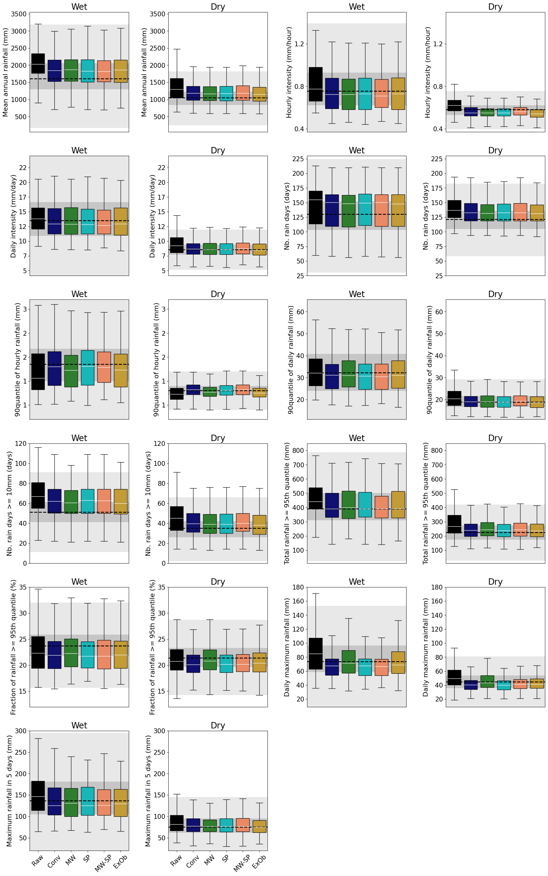
Figure S4. Boxplots showing the full distributions of 11 precipitation indices calculated from uncorrected (black) and corrected evaluation simulations (represented by other colors) for stations in the Wet and Dry clusters. The dashed white lines inside the boxplots representing the median values of simulations averaged across the two clusters. The distribution of observational data is indicated by the dark (25th to 75th percentile) and light (5th to 95th percentile) grey horizontal bands, as well as the dashed black lines (median)

