Supplemental Information 1
Contents
Table S1 2
Table S2 3
Table S3 6
Table S4 7
Table S5 8
Figure S1 9
Figure S2 10
References 11

Table S1 Climate stations for high elevations (1950 – 2500 m) used to calculate temperature and dryness thresholds 1984 – 2021 in Utah, USA. Station data was sourced from the Global Historical Climatology Network (2024).
Station ID | Station name | Elevation | Latitude | Longitude | Tmax coverage for 1961-2021 (%) | Tmax coverage for 1984-2021 (%) | Precip coverage for 1984-2021 (%)
USC00420074 | ALTAMONT | 1967.8 | 40.367 | -110.299 | 93.51 | 94.64 | 93.53
USC00420086 | ALTON | 2163.5 | 37.44 | -112.482 | 97.96 | 96.93 | 97.57
USC00420168 | ANGLE | 1953.8 | 38.249 | -111.961 |  | 90.14
USR0000ASSA | ASSAY - HATCH 10SW | 2468.9 | 37.517 | -112.556 |  | 95.97
USC00420849 | BOULDER | 2026.9 | 37.905 | -111.42 | 99.14 | 98.81 | 99.01
USC00421008 | BRYCE CANYON NP HQRS | 2412.5 | 37.641 | -112.17 | 96.92 | 95.79 | 96.67
USC00423600 | HANS FLAT RS | 2011.7 | 38.255 | -110.18 |  | 99.22 | 99.17
USC00424467 | KAMAS | 1975.4 | 40.644 | -111.282 | 89.12 | 94.59 | 93.67
USC00424947 | LA SAL 1SW | 2068.7 | 38.301 | -109.266 |  | 93.68 | 94.58
USC00425148 | LOA | 2154.9 | 38.406 | -111.643 | 81.12
USR0000MCCO | MCCOOK RIDGE | 2133.6 | 39.634 | -109.266 |  | 96.49
USC00426053 | NATURAL BRIDGES NM | 1983.6 | 37.609 | -109.977 |  | 98.23 | 90.69
USC00426601 | PANGUITCH | 2026.0 | 37.816 | -112.439 | 89.38
USR0000UPRC | UPPER P.R. CANYON UTAH | 2499.4 | 39.468 | -109.284 |  | 99.09

Table S2 Climate stations for low elevations (1400 – 1950 m) used to calculate temperature and dryness thresholds 1984 – 2021 in Utah, USA. Station data was sourced from the Global Historical Climatology Network (2024).
Station ID | Station name | Elevation | Latitude | Longitude | Tmax coverage for 1961-2021 (%) | Tmax coverage for 1984-2021 (%) | Precip coverage for 1984-2021 (%)
USC00420061 | ALPINE | 1545.3 | 40.464 | -111.771 |  | 91.33
USC00420730 | BLACK ROCK | 1498.4 | 38.708 | -112.954 | 98.89 | 98.63 | 97.88
USC00420738 | BLANDING | 1838.6 | 37.613 | -109.485 | 98.41 | 97.46 | 97.67
USC00420819 | BOUNTIFUL BENCH | 1508.8 | 40.891 | -111.85 |  | 99.89 | 99.86
USC00421163 | CANYONLANDS-THE NECK | 1789.5 | 38.46 | -109.821 |  | 97.29 | 97.01
USC00421168 | CANYONLANDS-THE NEEDLES | 1495.3 | 38.168 | -109.76 |  | 97.64 | 95.45
USC00421171 | CAPITOL REEF NP | 1676.4 | 38.292 | -111.262 |  | 99.19 | 98.05
USC00421214 | CASTLE DALE | 1715.7 | 39.208 | -111.012 | 98.26 | 97.94 | 96.49
USW00093129 | CEDAR CITY MUNI AP | 1702.6 | 37.709 | -113.094 | 99.89 | 99.83 | 99.84
USC00421759 | COTTONWOOD WEIR | 1519.7 | 40.619 | -111.784 | 95.79 | 97.43 | 96.04
USC00422057 | DEER CREEK DAM | 1606.3 | 40.405 | -111.529 | 99.15 | 98.65 | 99.02
USW00023162 | DELTA | 1408.2 | 39.338 | -112.586 | 91.98 | 93.18
USR0000DIAM | DIAMOND RIM | 1676.4 | 40.617 | -109.243 |  | 99.19
USC00422173 | DINOSAUR NM-QUARRY AREA | 1463.6 | 40.438 | -109.307 | 94.17 | 92.68
USC00422253 | DUCHESNE | 1691.9 | 40.17 | -110.398 |  | 98.79 | 97.51
USC00422385 | ECHO DAM | 1667.3 | 40.966 | -111.434 | 98.94 | 98.43 | 98.44
USC00422578 | EPHRAIM | 1675.8 | 39.358 | -111.599 | 97.96 | 98.00
USC00422592 | ESCALANTE | 1770.9 | 37.769 | -111.598 | 99.70 | 99.64 | 99.41
USC00422607 | ESKDALE | 1517.9 | 39.108 | -113.953 |  | 96.71 | 96.11
USC00422798 | FERRON | 1805.3 | 39.088 | -111.132 | 96.46 | 96.82 | 95.46
USC00422828 | FILLMORE | 1560.6 | 38.966 | -112.328 | 96.05 | 94.47
USC00422864 | FLAMING GORGE | 1903.2 | 40.932 | -109.412 | 98.28 | 97.55
USC00422996 | FT DUCHESNE | 1539.8 | 40.284 | -109.861 | 92.13 | 90.11
USC00424100 | HOVENWEEP NM | 1597.2 | 37.386 | -109.075 | 96.31 | 94.34
USC00424174 | IBAPAH | 1609.0 | 40.038 | -113.989 | 92.24 | 95.46
USC00424342 | JENSEN | 1443.5 | 40.361 | -109.346 | 98.19 | 98.05 | 99.10
USR0000JENS | JENSEN SPRING - BERYL 12NNE | 1750.8 | 38.033 | -113.517 |  | 97.71
USC00424508 | KANAB | 1493.5 | 37.029 | -112.537 | 99.07 | 99.22 | 99.43
USC00424755 | KODACHROME BASIN PARK | 1769.4 | 37.514 | -111.988 |  | 98.40 | 98.99
USC00424856 | LAKETOWN | 1822.7 | 41.825 | -111.321 | 98.67 | 99.27 | 99.09
USC00425065 | LEVAN | 1614.8 | 39.561 | -111.865 | 96.02 | 93.75
USC00425186 | LOGAN UTAH ST UNIV | 1460.0 | 41.746 | -111.803 | 98.11 | 97.37 | 96.90
USC00425402 | MANTI | 1749.6 | 39.258 | -111.631 | 99.85 | 99.77 | 99.69
USW00023176 | MILFORD MUNI AP | 1536.2 | 38.417 | -113.017 | 93.17
USC00426123 | NEOLA | 1813.6 | 40.418 | -110.051 | 94.60 | 95.50
USC00426135 | NEPHI | 1568.5 | 39.712 | -111.832 | 98.66 | 98.82 | 98.69
USC00426181 | NEW HARMONY | 1574.9 | 37.464 | -113.29 | 95.53 | 93.31
USC00426357 | OAK CITY | 1560.6 | 39.376 | -112.334 | 98.21 | 97.37 | 97.05
USC00426568 | OURAY 4NE | 1424.6 | 40.134 | -109.644 | 93.92 | 96.05
USC00426708 | PARTOUN | 1456.9 | 39.631 | -113.886 | 96.27 | 97.16 | 95.46
USC00426869 | PINEVIEW DAM | 1505.7 | 41.258 | -111.838 | 98.03 | 97.98
USC00426919 | PLEASANT GROVE | 1430.1 | 40.368 | -111.733 | 96.09 | 94.23
USC00427260 | RICHFIELD RADIO KSVC | 1615.4 | 38.762 | -112.077 | 96.80 | 95.33 | 95.30
USC00427271 | RICHMOND | 1426.5 | 41.906 | -111.81 | 98.54 | 97.78 | 97.78
USC00427395 | ROOSEVELT RADIO | 1528.3 | 40.288 | -109.959 | 98.11 | 97.23
USC00427686 | SANTAQUIN CHLORINATOR | 1572.8 | 39.958 | -111.779 | 96.93 | 98.96 | 96.90
USC00427714 | SCIPIO | 1619.7 | 39.245 | -112.107 | 91.12 | 90.28
USC00428119 | SPANISH FK PWR HOUSE | 1438.7 | 40.08 | -111.604 | 99.47 | 99.35 | 98.24
USC00428771 | TOOELE | 1506.9 | 40.535 | -112.322 | 99.88 | 99.83 | 99.83
USR0000SAND | UPPER SAND WASH UTAH | 1920.2 | 39.714 | -109.446 |  | 97.12
USC00429111 | VERNAL | 1629.2 | 40.44 | -109.536 | 97.68 | 96.54 | 97.19
USW00094030 | VERNAL MUNICIPAL AP | 1603.2 | 40.442 | -109.514 | 99.50 | 99.47 | 98.83
USC00429133 | VERNON | 1667.6 | 40.096 | -112.436 |  | 91.85
USC00429165 | WANSHIP DAM | 1810.5 | 40.791 | -111.408 | 98.21 | 97.33 | 97.99
USC00429595 | WOODRUFF | 1924.8 | 41.525 | -111.149 | 98.56 | 97.71 | 97.55

Table S3 The fires with the largest footprint in Utah, USA from 1984 – 2021.
Rank |  | Year | Fire name | Date of ignition | Size (ha)
29 |  | 1984 | Raven | 1984/07/08 | 3,985
30 |  | 1985 | Simpsons p | 1985/06/19 | 3,606
17 |  | 1986 | Twin peaks | 1986/07/04 | 14,015
27 |  | 1987 | Quincy 1 | 1987/09/12 | 6,140
24 |  | 1988 | Whiterocks | 1988/09/07 | 7,642
26 |  | 1989 | Diamond Peak | 1989/07/01 | 6,347
32 |  | 1990 | Cherry | 1990/07/29 | 2,118
37 |  | 1991 | Rockwell | 1991/07/13 | 1,090
34 |  | 1992 | Pioneer | 1992/07/23 | 1,607
35 |  | 1993 | Bottom | 1993/07/09 | 1,571
15 |  | 1994 | Simpson bt | 1994/06/15 | 14,939
16 |  | 1995 | Redlam | 1995/08/27 | 14,328
2 |  | 1996 | Leamington complex | 1996/08/02 | 65,230
33 |  | 1997 | Cogswell point | 1997/05/11 | 1,904
22 |  | 1998 | Tekoi | 1998/07/13 | 8,066
8 |  | 1999 | Railroad | 1999/07/02 | 26,141
13 |  | 2000 | Salt Lake Desert complex | 2000/08/01 | 16,116
14 |  | 2001 | Unnamed | 2001/07/17 | 15,639
6 |  | 2002 | Rattle complex | 2002/06/20 | 35,367
19 |  | 2003 | Bulldog | 2003/07/08 | 12,779
18 |  | 2004 | Hawkins | 2004/07/28 | 13,863
9 |  | 2005 | Westside complex | 2005/06/23 | 23,782
10 |  | 2006 | Jarvis | 2006/06/25 | 20,086
1 |  | 2007 | Milford Flat | 2007/07/06 | 141,143
36 |  | 2008 | Porcupine Ranch | 2008/08/27 | 1,524
12 |  | 2009 | Big Pole | 2009/08/06 | 16,826
11 |  | 2010 | Twitchell Canyon | 2010/07/20 | 17,383
25 |  | 2011 | Lakeside | 2011/07/16 | 6,541
3 |  | 2012 | Clay Springs | 2012/06/27 | 43,459
20 |  | 2013 | State | 2013/08/08 | 12,549
31 |  | 2014 | Rough Haul | 2014/06/07 | 2,174
38 |  | 2015 | Unnamed | 2015/06/03 | 922
21 |  | 2016 | Broadmouth | 2016/08/03 | 8,502
7 |  | 2017 | Brianhead | 2017/06/17 | 30,058
5 |  | 2018 | Pole Creek | 2018/09/06 | 41,450
23 |  | 2019 | Neck | 2019/09/05 | 7,907
4 |  | 2020 | East Fork | 2020/08/21 | 43,071
28 |  | 2021 | Flatt | 2021/06/18 | 5,812

Table S4 The proportional (%) distribution of all ignitions and ignitions that led to fires ≥40 ha in Utah, USA from 1984 – 2021.
Month | All ignitions (%) | Fires (≥40 ha; %)
1 | 0.4 | 0.1
2 | 0.5 | 0.5
3 | 1.7 | 1.7
4 | 3.1 | 2.7
5 | 5.4 | 6.6
6 | 15.9 | 19.3
7 | 33.3 | 27.1
8 | 25.0 | 23.1
9 | 10.7 | 9.0
10 | 2.5 | 5.4
11 | 0.9 | 2.5
12 | 0.2 | 1.5

Table S5 Model output assessing the relationship between number of hot days ( ≥ 26.6 °C) and the annual area burned and fire frequency, by vegetation type, in Utah, USA.
Ecosystem type | R² value | P-value
Aspen  Area burned  Fire frequency | 0.28  0.34 | 0.003*  0.001*
Douglas-fir  Area burned  Fire frequency | 0.32  0.40 | <0.001*  <0.001*
Pinon-Juniper  Area burned  Fire frequency | 0.27  0.20 | 0.004*  0.003*
WUI Woodland  Area burned  Fire frequency | 0.30  0.26 | 0.001*  0.005*
Sagebrush  Area burned  Fire frequency | 0.31  0.15 | 0.004*  0.014*
Shrubland  Area burned  Fire frequency | 0.11  0.08 | 0.292  0.060*
Annual grassland  Area burned  Fire frequency | 0.16  0.09 | 0.107  0.047*
WUI Shrubland  Area burned  Fire frequency | 0.30  0.17 | 0.003*  0.011*

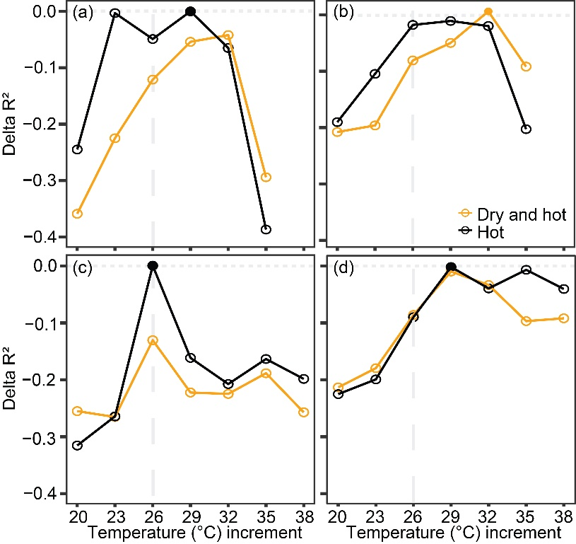
Figure S1 The delta-R² for each model for area burned (a,b) and fire frequency (c;d) for forest (a;c) and non-forest (b;d) vegetation types in Utah, USA. A vertical long-dashed line denotes the temperature threshold (26.6 °C) selected for downstream analysis.
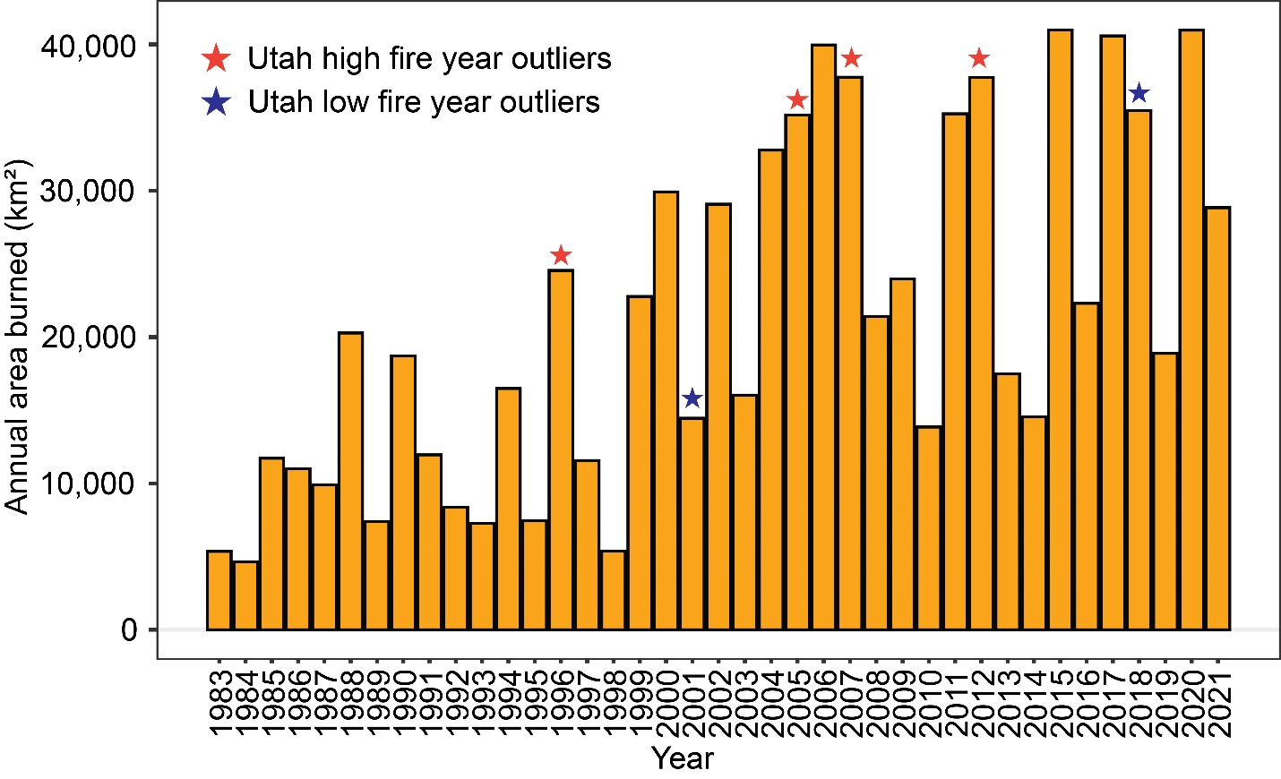
Figure S2 Annual area burned (km²) in the United States from 1983 – present (National Interagency Coordination Center 2024). Years that were consistently outside the confidence intervals of our models (Fig. 5; Fig. 6) are denoted with stars if they were notably above (red stars) or below confidence intervals (blue stars). Data in 2008 does not include the state of North Carolina.

References
National Centers for Environmental Information. 2024. Global Historical Climatology Network.in N. C. f. E. Information, editor. Utah Climate Center.
National Interagency Coordination Center. 2024. Total Wildland Fires and Acres (1983 - 2022).in D. o. t. Interior, editor., Boise, ID.

