Supplementary Materials
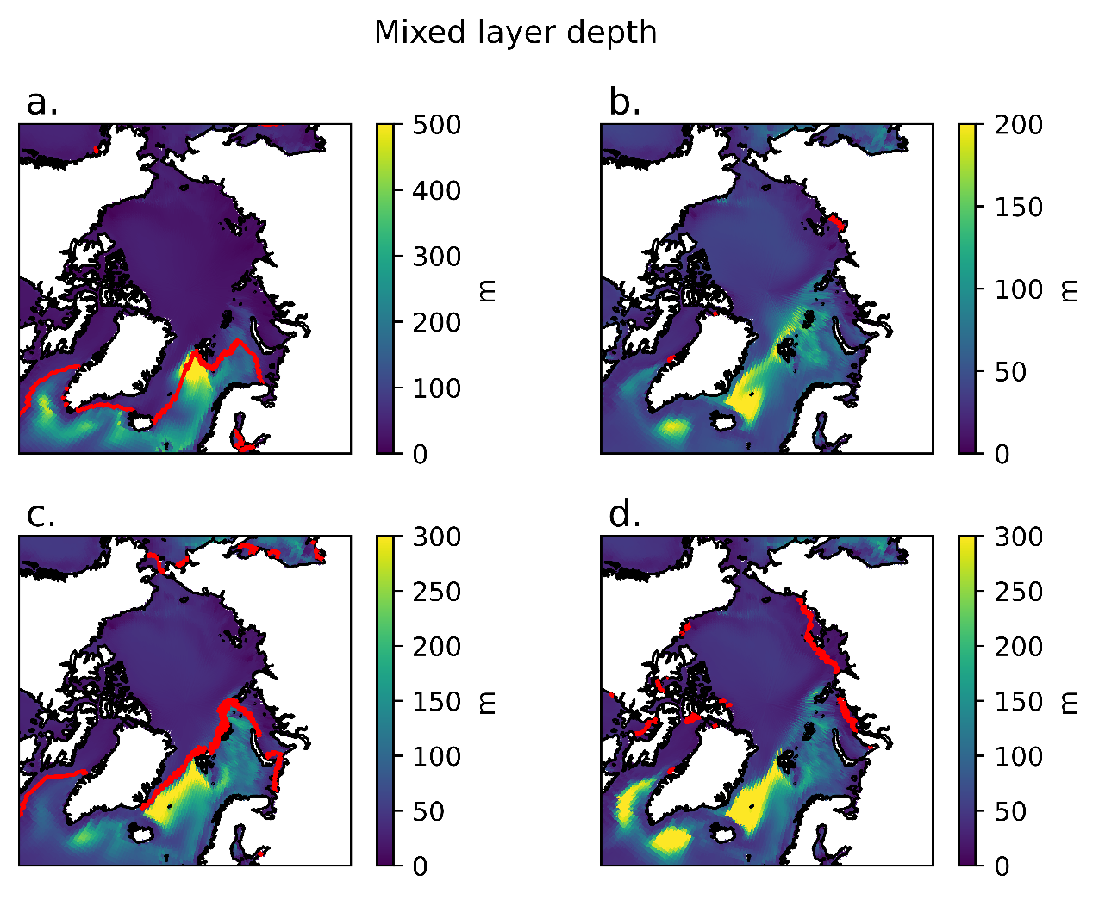
Figure S1. The mean mixed layer patterns during a). The mean of the 500-year piControl b). a 100-year mean of the internal variability pattern in 4xCO2 peaking at year 750 c). a 50 year mean at the end of Abrupt1000f Abrupt250 and d). a 10 year mean from the start of Abrupt1000. The red contour is the 15% ses ice edge

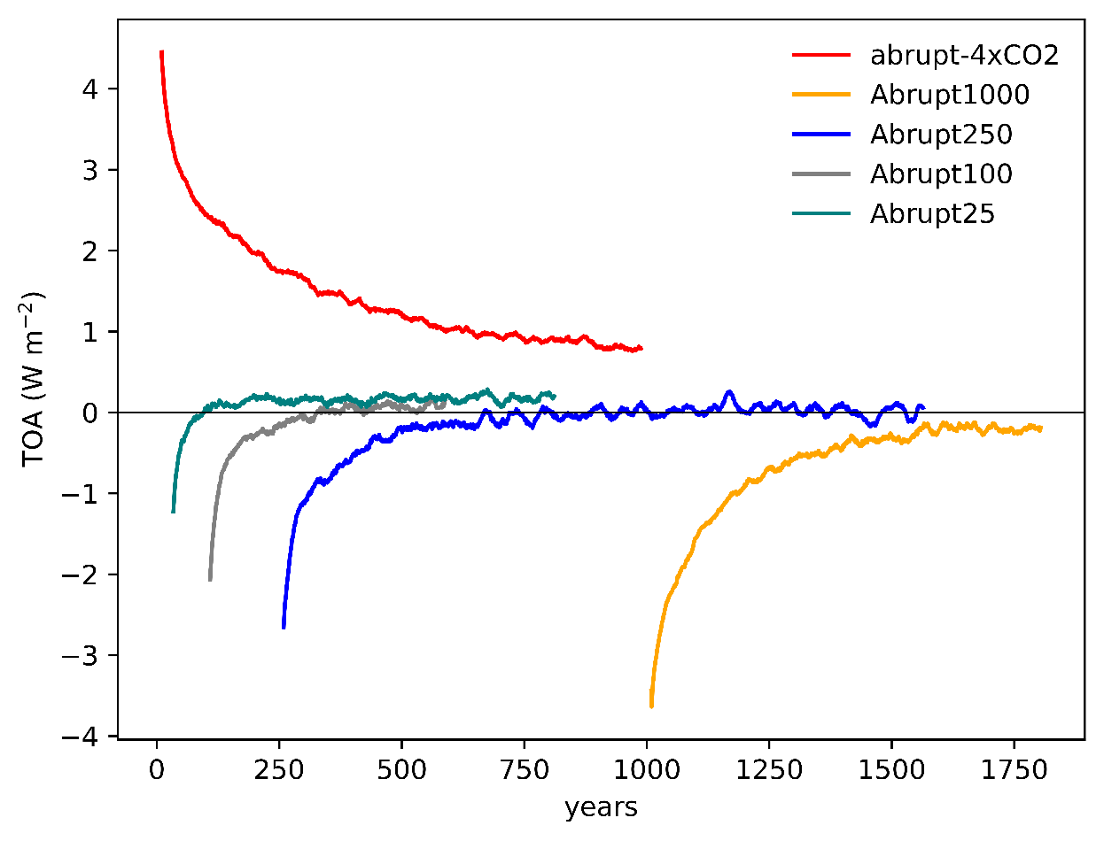
Figure S2. The absolute global top of atmosphere (TOA) radiative balance for the simulations depicted in Figure 1. A 21-year running mean smoothing has been applied to the timeseries. For reference the piControl has a TOA of 0.21 W m⁻²

