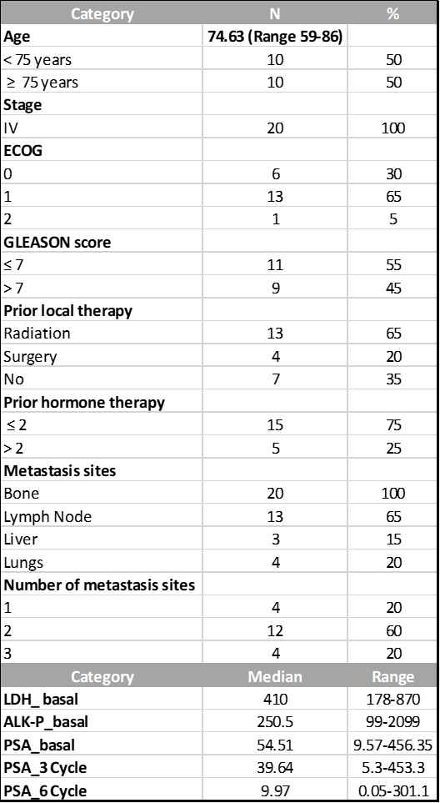

Table S1.Clinic-pathologic characteristics of the cohort of patients with mCRPC (n=20). Median values of LDH, ALK-P and PSA were measured in ng/mL.

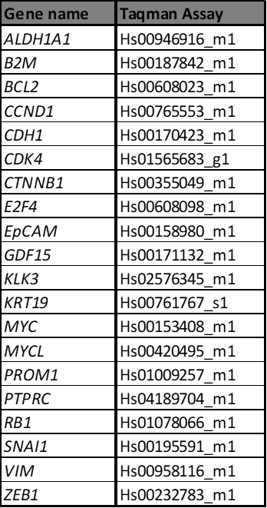

Table S2. List of Taqman probes used for qRT-PCR assay.

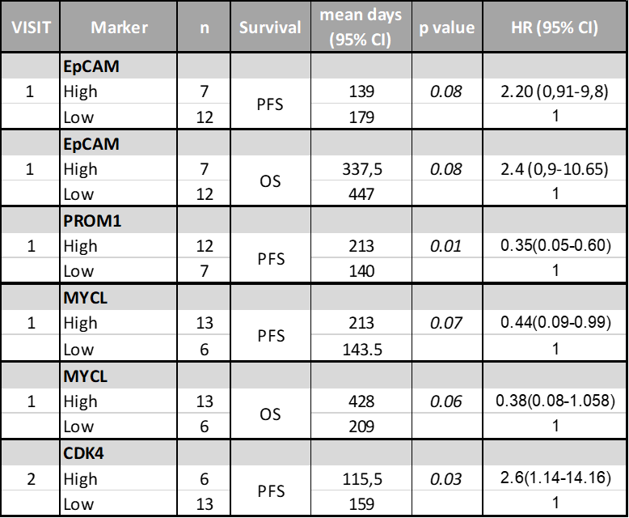
Table S3. Prognostic value of CTCs gene expression levels in mCRPC patients of the indicated markers. P-values were calculated using the log-rank test.

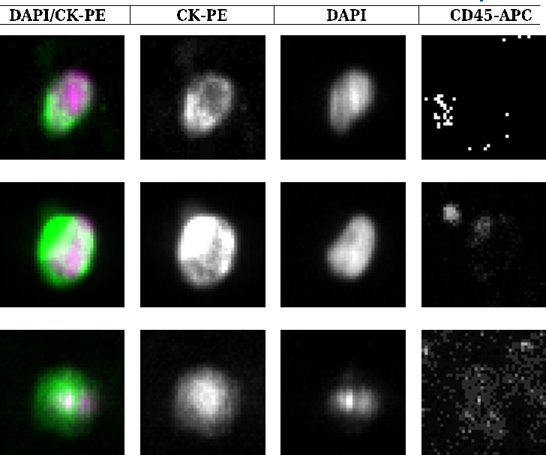

Figure S1. Representative CTCs images from CellSearch®. In the merge, CTCs showing CK 8, 18 and/or 19 (in green), DAPI+ (in pink) and absence of CD45 staining. Using the CellSearch® system, CTCs are enriched based on EpCAM+ expression, representing the epithelial or mixed subpopulation.

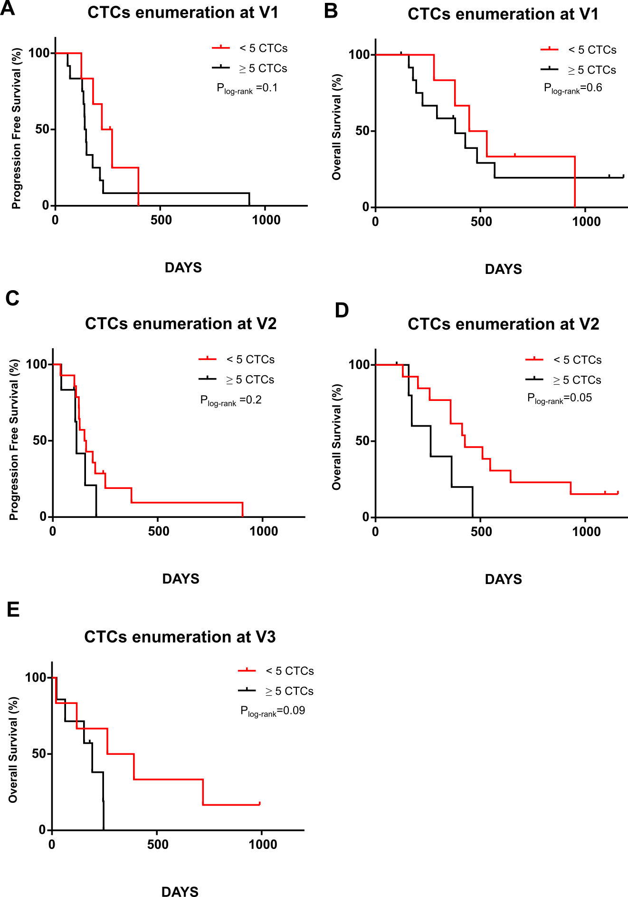

Figure S2. Kaplan–Meier plots for PFS and OS according to the CTCs count (low risk: < 5 CTCs, high risk: ≥ 5 CTCs), at the diagnosis of metastasis (V1: A, B), after one cycle of docetaxel (V2: C, D) and at the clinical progression (V3: E). P-values were calculated using the log-rank test.

