Supplementary Information

Ketogenic diet does not promote triple-negative and luminal mammary tumor growth and metastasis in experimental mice

Meret Grube ¹, Arno Dimmler ², Anja Schmaus ¹, Rafael Saup ¹, Tabea Wagner ¹, Boyan K. Garvalov ¹, Jonathan P. Sleeman ^{1, 3}, Wilko Thiele ^{1*}

¹ Department of Microvascular Biology and Pathobiology, European Center for Angioscience (ECAS), Medical Faculty Mannheim, University of Heidelberg, Mannheim, Germany
² Institute of Pathology, Vincentius Kliniken Karlsruhe, Karlsruhe, Germany
³ Institute for Biological and Chemical Systems, Karlsruhe Institute of Technology (KIT), Campus North, Karlsruhe, Germany

Supplementary Figures

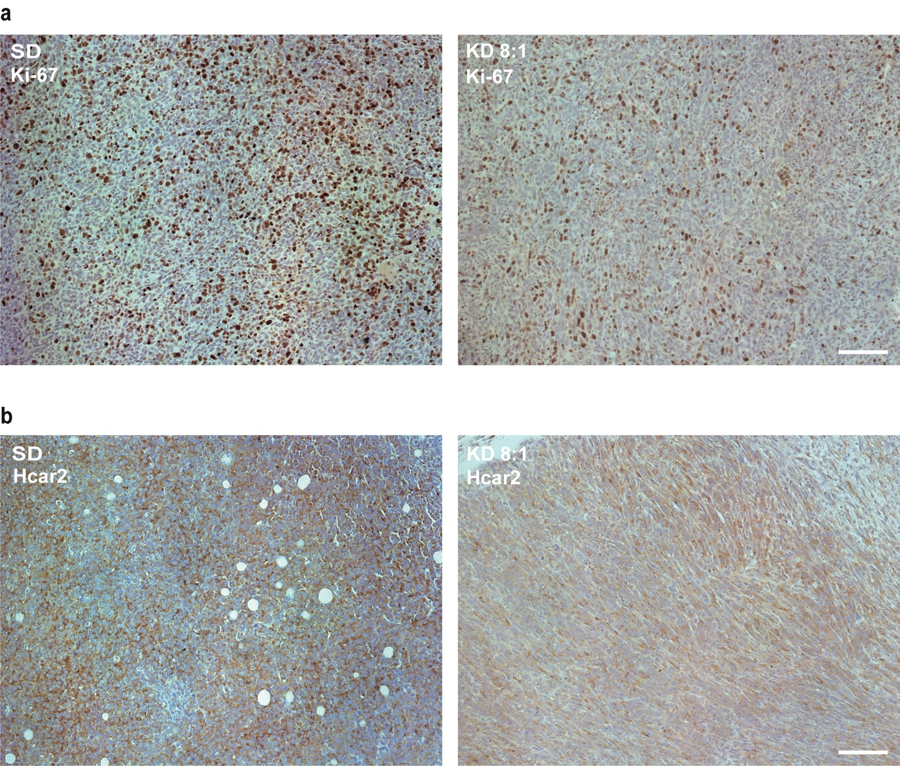
Fig. S1 KD reduces the proliferative index, but does not affect Hcar2 expression of tumor cells within primary tumors in a spontaneous metastasis assay upon orthotopic implantation of 4T1 mammary carcinoma cells. Female BALB/c mice were either fed standard diet (SD; N =11 animals) or ketogenic diet (KD; N = 6 animals) with a ketogenic ratio of 8:1 ad libitum. 4T1 cells (1×10⁶ each animal) were injected orthotopically into the mammary fat pads of syngeneic BALB/c mice 10 days after the initiation of KD. Paraffin sections of the primary tumors were stained with antibodies specific for Ki-67 (a) or Hcar2 (b). (a) Overview images of the Ki-67 stained tumor sections from animals fed with SD or KD, acquired at low magnification (see Fig. 2f for higher magnification images). (b) Overview images of the Hcar2 stained tumor sections from animals fed with SD or KD, acquired at low magnification (see Fig. 2i for higher magnification images). Scale bars: 100 μm.

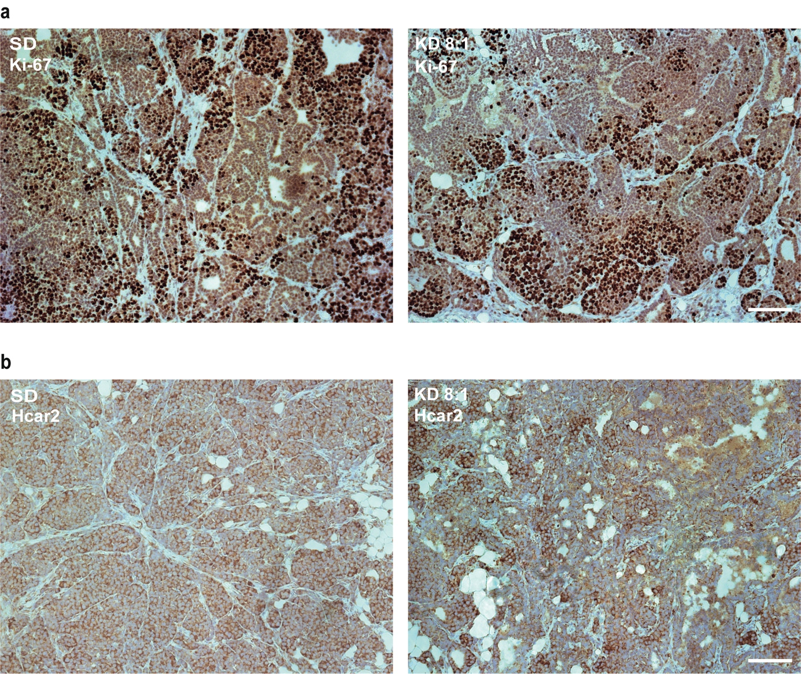
Fig. S2 KD does not affect the proliferative index or Hcar2 expression of autochthonous luminal MMTV-PyMT tumors. MMTV-PyMT mice (N = 13 females per group) aged 8 weeks were either fed standard diet (SD) or ketogenic diet (KD) with a ketogenic ratio of 8:1 ad libitum. Paraffin sections of the primary tumors were stained with antibodies specific for Ki-67 (a) or Hcar2 (b). (a) Overview images of the Ki-67 stained tumor sections from animals fed with SD or KD, acquired at low magnification (see Fig. 5f for higher magnification images). (b) Overview images of the Hcar2 stained tumor sections from animals fed with SD or KD, acquired at low magnification (see Fig. 5i for higher magnification images). Scale bars: 100 μm.

