Supplementary Figures to “Transcriptomic characterization of the histopathological growth patterns in breast cancer liver metastases” by Sophia Leduc*, Ha Linh Nguyen* et al.

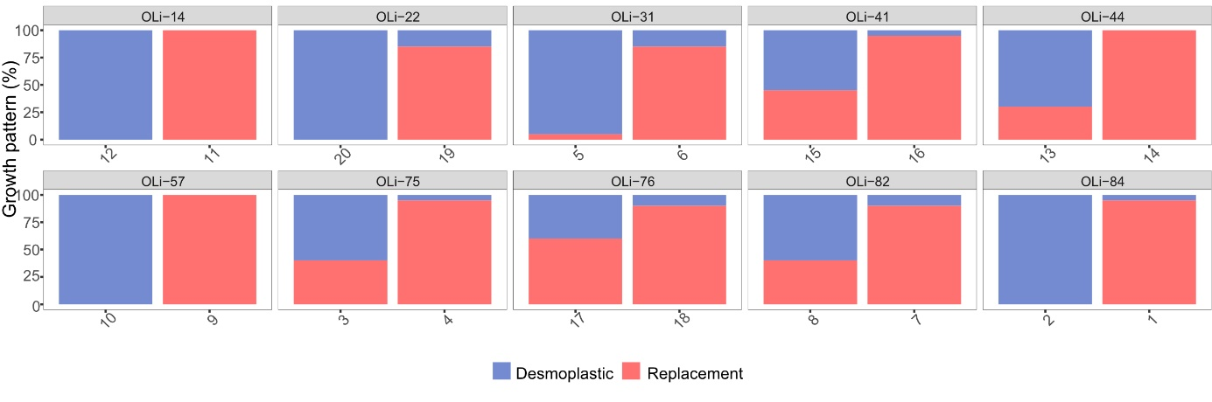
Supplementary Figure 1: HGP distribution. For each patient, we selected two slides from the metastasis with more than 30% of each growth pattern.

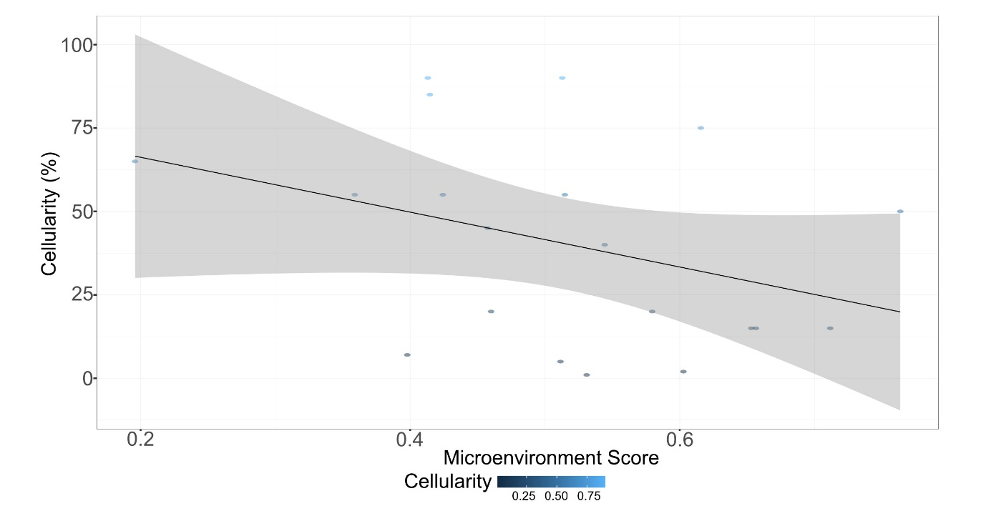
Supplementary Figure 2: Correlation between Tumor Cellularity and Microenvironment Score (MES) (Spearman correlation coefficient= -0.376; p-value=0.102).

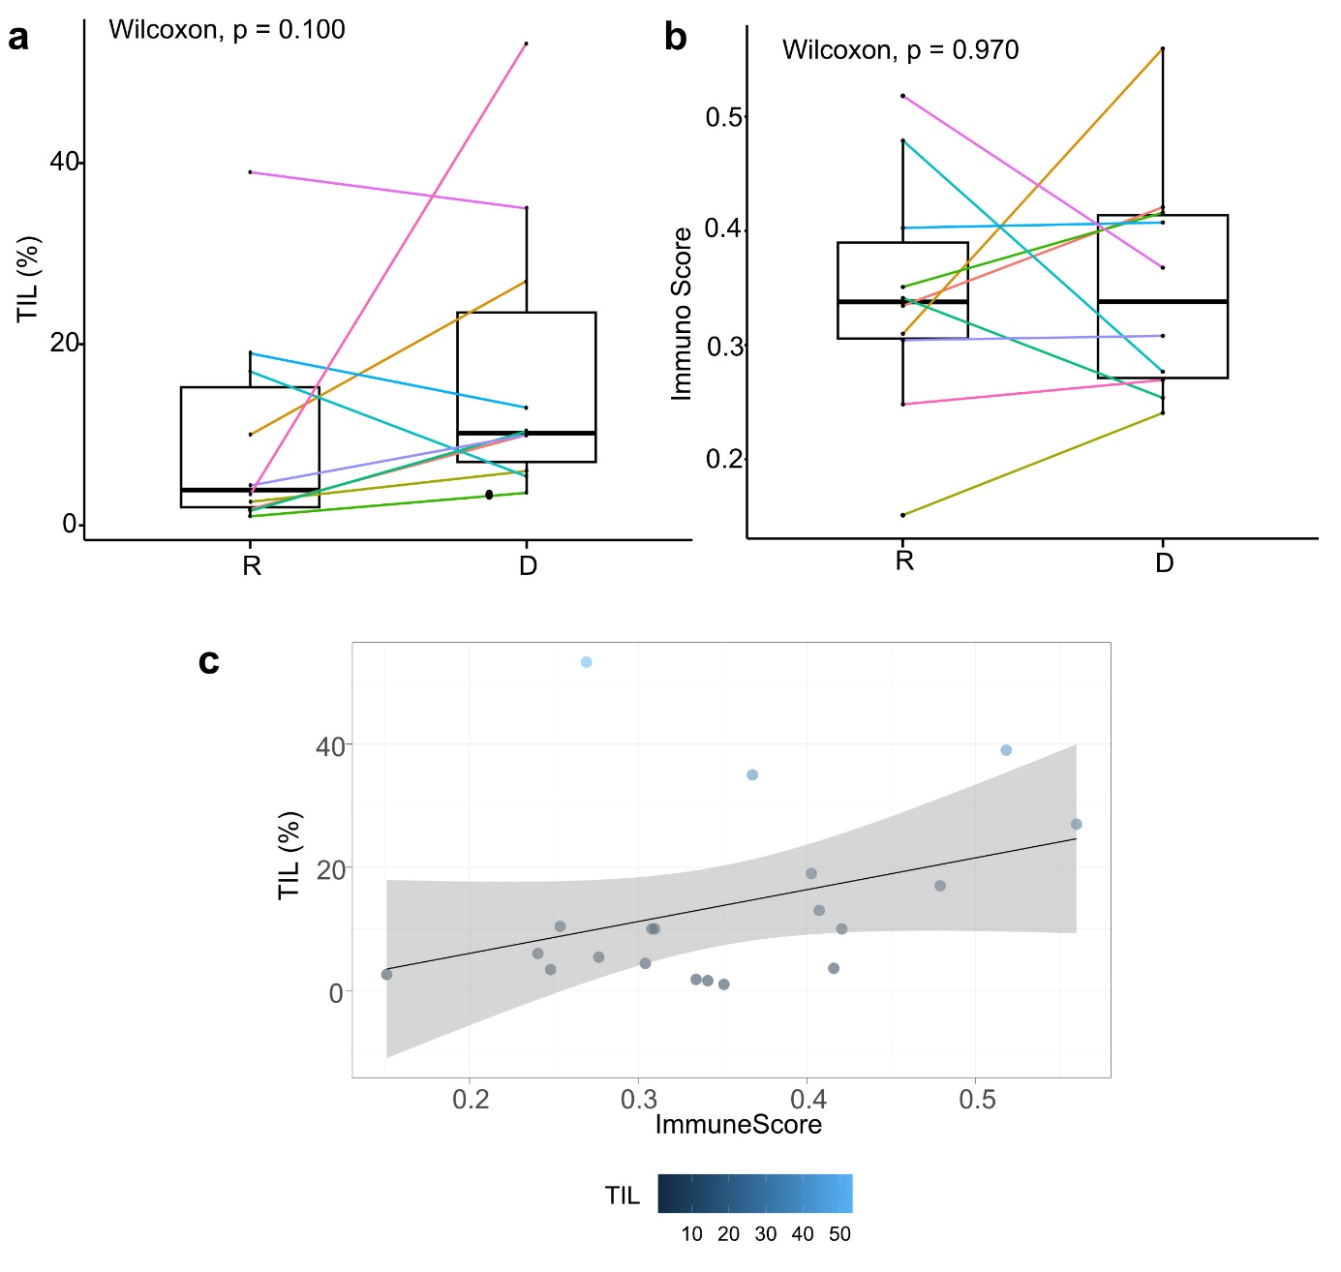
Supplementary Figure 3: TIL distribution and correlation between TIL and ImmunoScore. a. TIL scores according to the HGP (Wilcoxon p-value=0.100). b. Immune Score according to the HGP (Wilcoxon p-value=0.970). c. Correlation between the TIL score and the Immune Score calculated by xCell (Spearman correlation coefficient = 0.382; p-value = 0.096). Abbreviations: R= Replacement; D= Desmoplastic; One color per patient ID.

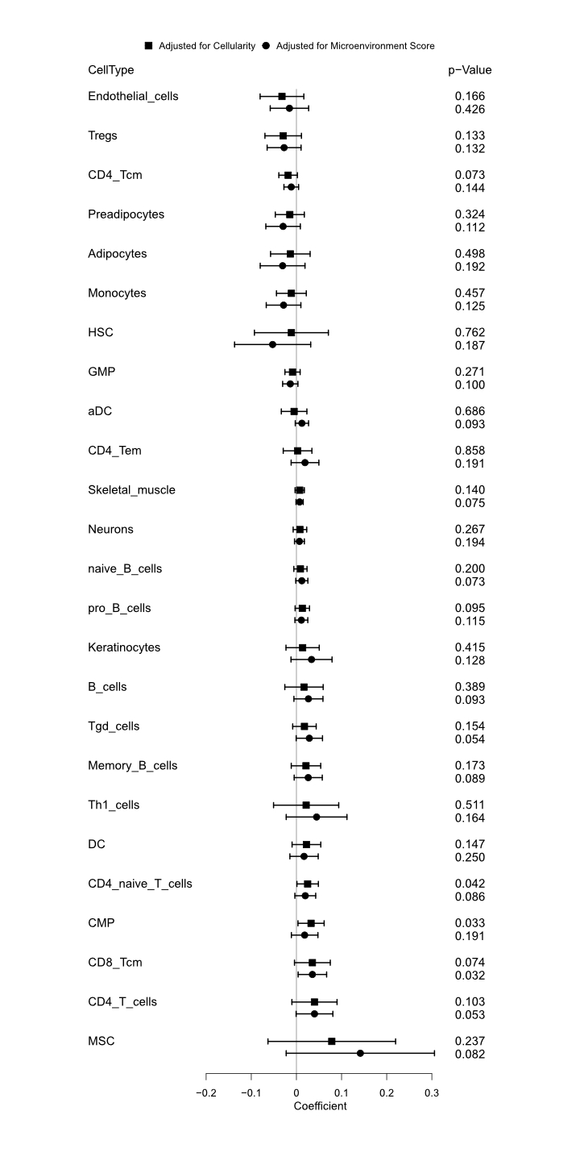
Supplementary Figure 4: Association of immune cell types with HGP. The associations were estimated by linear mixed models adjusted for the tumor cellularity and the Microenvironment Score (MES). Cell types with a p-value < 0.2 in one of the two models are shown. A positive estimate indicates a positive association with the r-HGP. Abbreviations: Tcm = central memory T cells; HSC =Hematopoietic stem cells; GMP = Granulocyte-macrophage progenitors; Th1= Type 1 T-helper cells; DC= dendritic cells; aDC = activated dendritic cells; Tgd cells = gamma-delta T cells; CMP = common myeloid progenitor; MSC = mesenchymal stem cells.

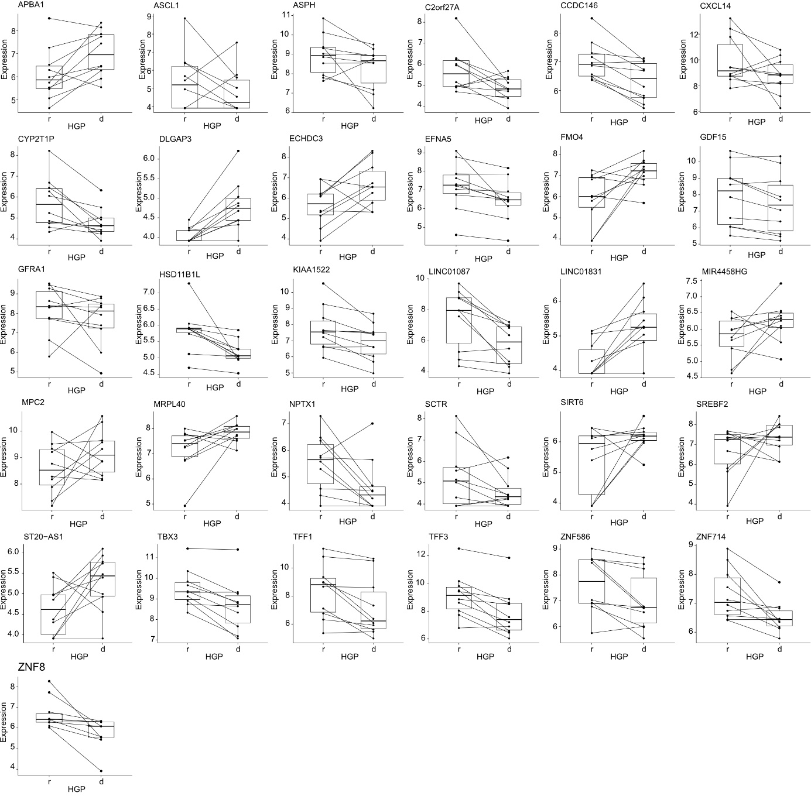
Supplementary Figure 5: Normalized expression of the 31 differential genes according to HGP detected by differential gene expression analyses. Genes with |logFC| > 0.5 and a p-value < 0.001 in analysis with tumor cellularity as covariate were shown. Additionally, genes with |logFC| > 0.5 and p-value < 0.01 in both analyses (tumor cellularity as covariate, and MES as covariate) were also shown. Abbreviations: r= replacement; d= desmoplastic; HGP= histopathological growth pattern.

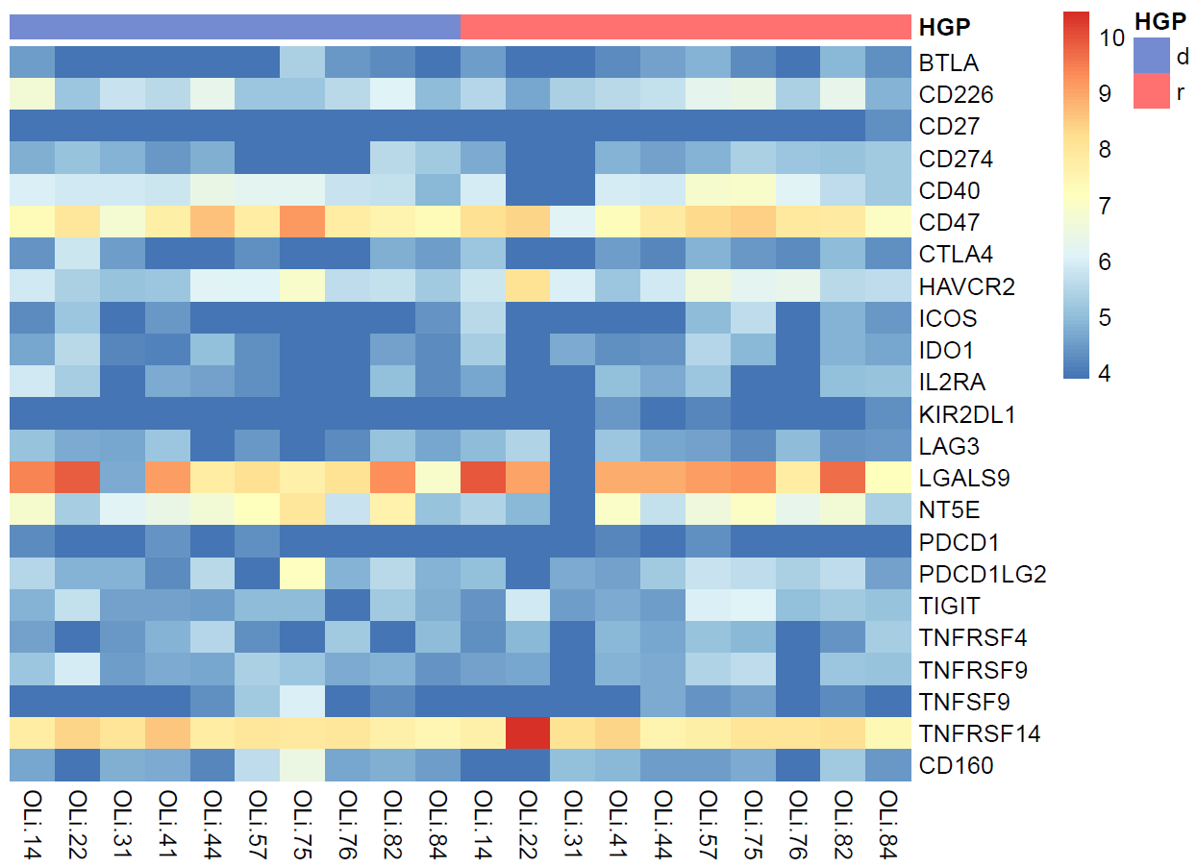
Supplementary Figure 6: Heatmap of Immune Checkpoint (IC) markers expression. No difference in the expression of IC genes between d-HGP and r-HGP samples. CD47, LGALS9 and TNFRSF14 are the top three highly expressed genes in all samples.
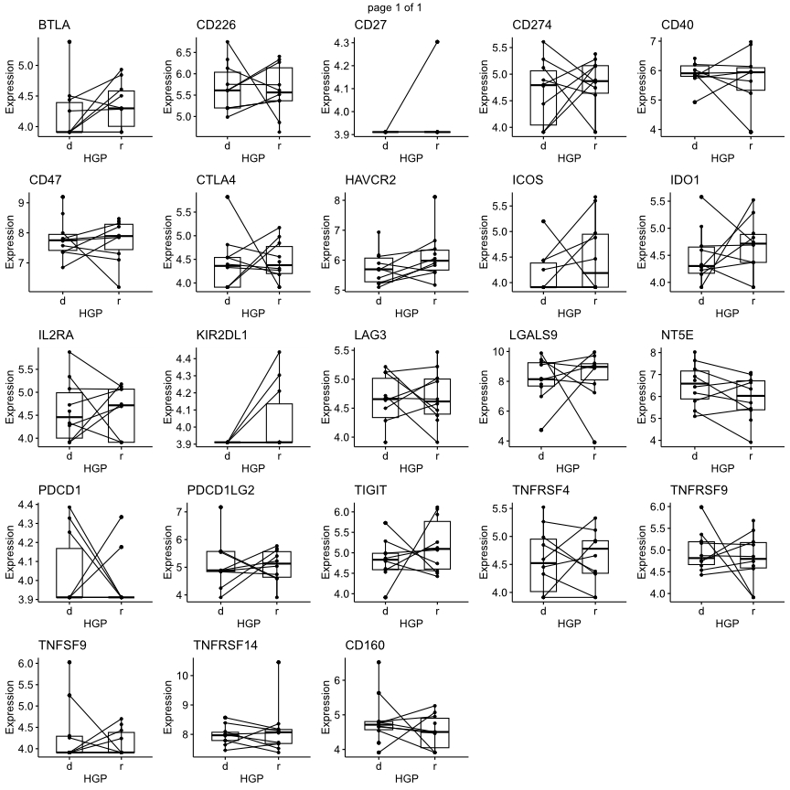
Supplementary Figure 7: Normalized expression of the 23 IC genes according to HGP. Abbreviations: r= replacement; d= desmoplastic; HGP= histopathological growth pattern.

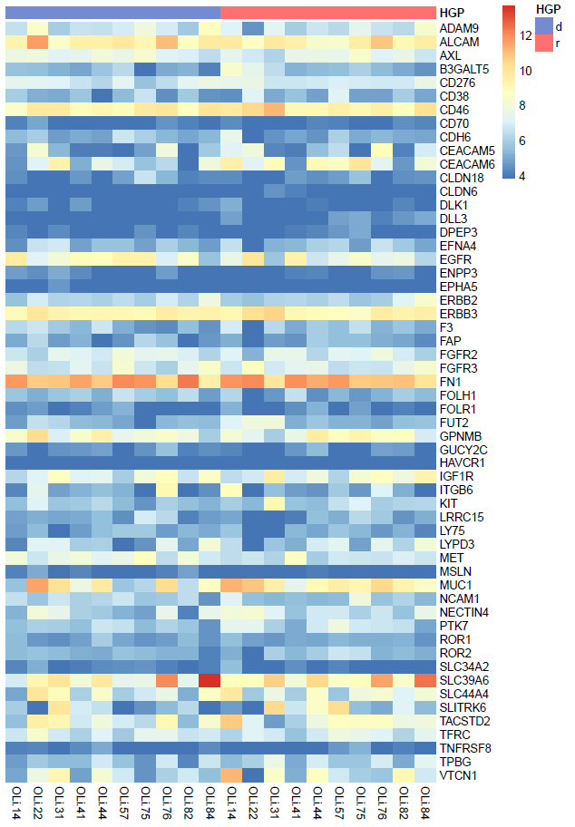
Supplementary Figure 8: Heatmap of Antibody Drug Conjugate (ADC) markers expression. No differences in the expression of ADC gene between d-HGP and r-HGP samples. FN1, ALCAM and CD46 are the top three highly expressed genes in all samples.

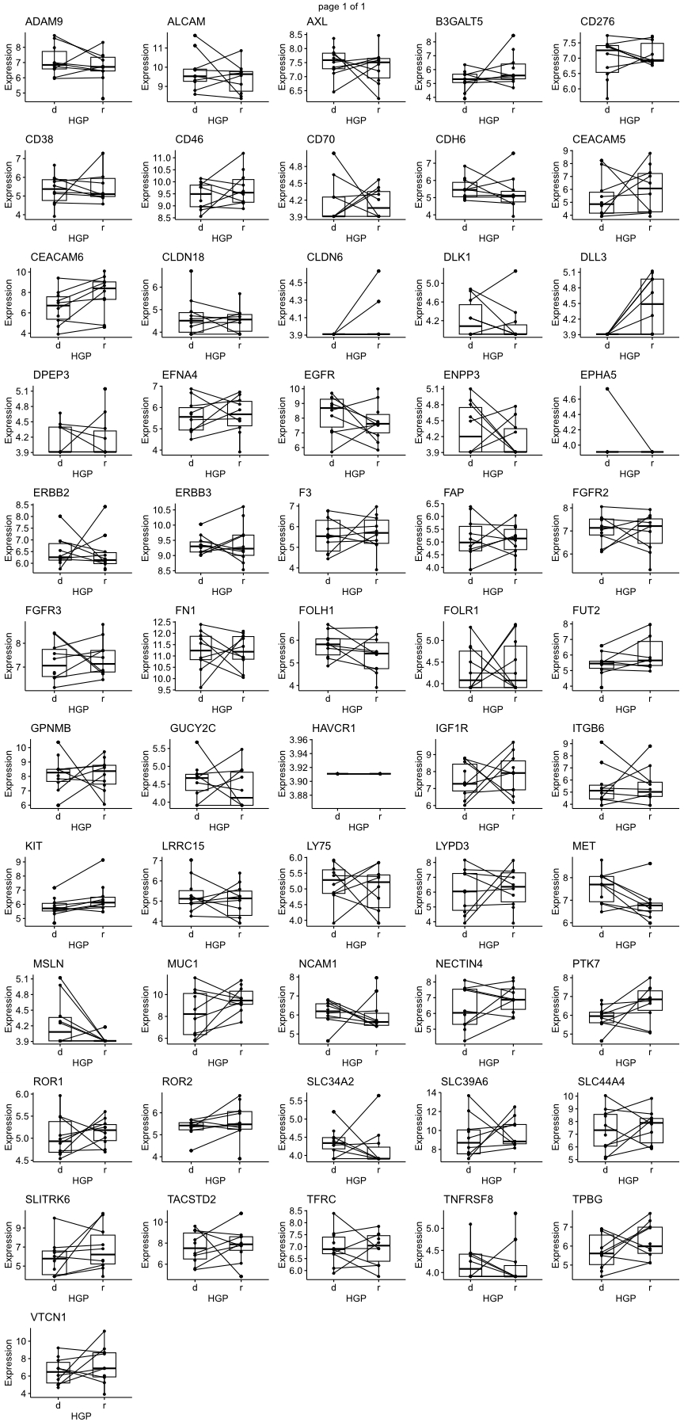
Supplementary Figure 9: Normalized expression of the 56 ADC genes according to HGP. Abbreviations: r= replacement; d= desmoplastic; HGP= histopathological growth pattern.

