Supplementary Materials
Clinical & Experimental Metastasis

GFPT2 expression is induced by gemcitabine administration and enhances invasion by activating the hexosamine biosynthetic pathway in pancreatic cancer

Kent Miyazaki¹, Kyohei Ariake^{1,2}*, Satoko Sato³, Takayuki Miura¹, Xun Jing Yu¹, Daisuke Douchi¹, Masaharu Ishida¹, Hideo Ohtsuka¹, Masamichi Mizuma¹, Kei Nakagawa¹, Takashi Kamei¹, and Michiaki Unno¹

¹Department of Surgery, Tohoku University Graduate School of Medicine, Sendai, Japan
²Department of Gastroenterological Surgery, Sendai City Medical Center Sendai Open Hospital, Sendai, Japan
³Department of Pathology, Tohoku University Hospital, Sendai, Japan

*Corresponding author: Kyohei Ariake, E-mail: ariake@surg.med.tohoku.ac.jp

Online Resource 1 shRNA and primer sequences used in this study
shRNA category | Sequence
shRNA1 | Top:5′GATCCCAAGTTTGCGTATAAGACACTGTGAAGCCACAGATGGGTGTCTTATACGCAAACTTGTTTTTTA3′  Bottom:5′AGCTTAAAAAACAAGTTTGCGTATAAGACACCCATCTGTGGCTTCACAGTGTCTTATACGCAAACTTGG3′
shRNA2 | Top:5′GATCCGAATAATCACGAAGTCAAACTGTGAAGCCACAGATGGGTTTGACTTCGTGATTATTCTTTTTTA3′  Bottom:5′AGCTTAAAAAAGAATAATCACGAAGTCAAACCCATCTGTGGCTTCACAGTTTGACTTCGTGATTATTCG3′

Primer category | Sequence
GFPT2 | Forward:5′-GCTCATCGTGATTGGCTGTGGA-3′  Reverse:5′-CAACCATCACAGGAAGCTCAGTC-3′
β-actin | Forward:5′-CACCATTGGCAATGAGCGGTTC-3′  Reverse:5′-AGGTCTTTGCGGATGTCCACGT-3′

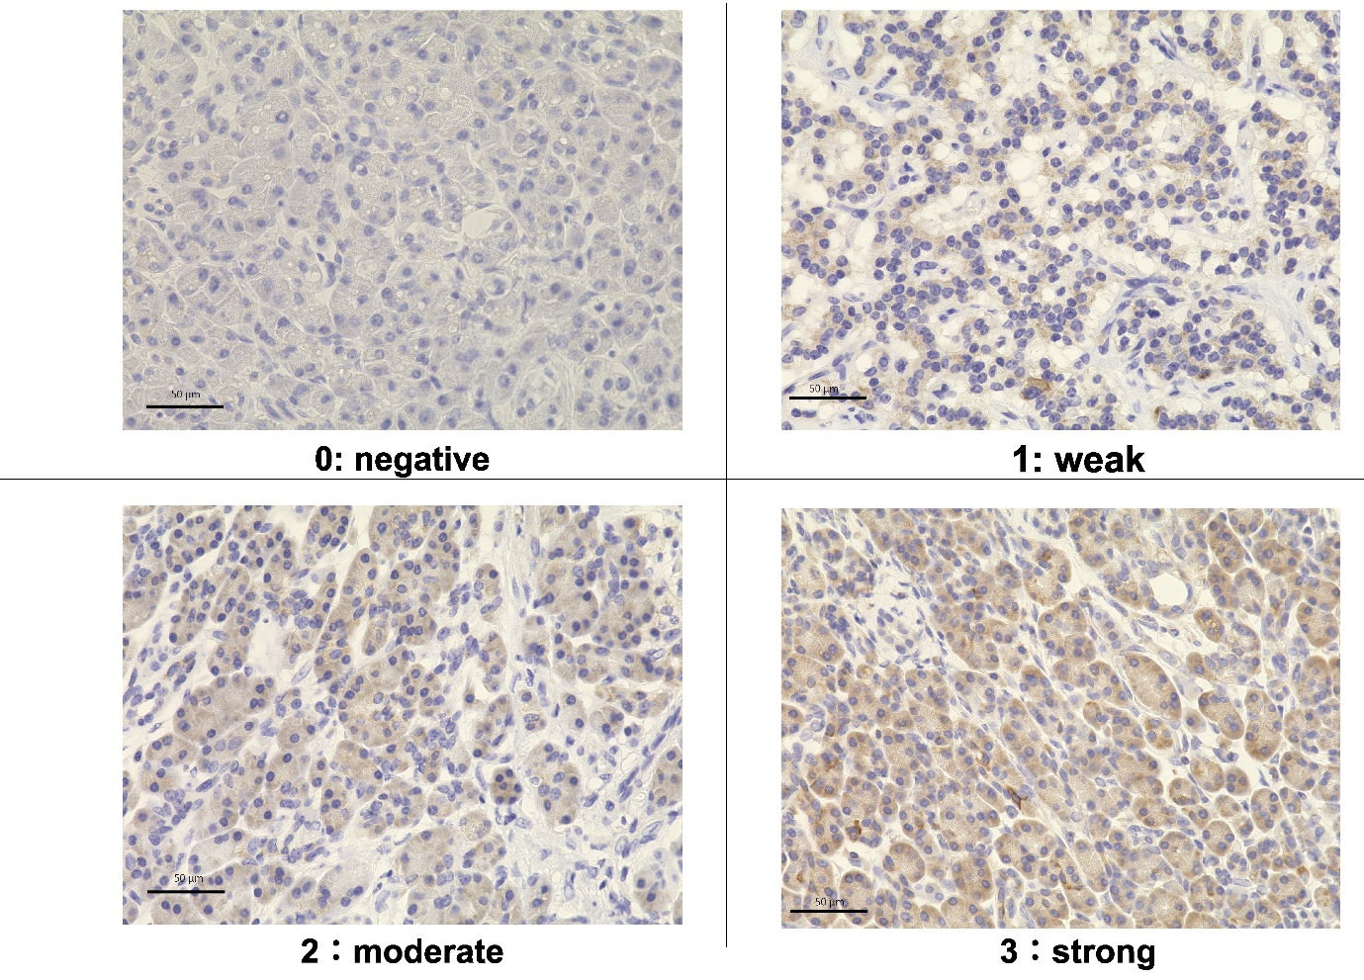
Online Resource 2 Immunohistochemical staining for GFPT2 in pancreatic cancer
Staining intensity is scored as (a) 0 (negative), (b) 1 (weak), (c) 2 (moderate), or (d) 3 (strong). GFPT2, glutamine-fructose-6-phosphate transaminase

Online Resource 3 Gene analysis using GEPIA
(a) Correlation between GFPT2 and ZEB1 expression in patients with pancreatic cancer from large-scale RNA sequence data from GEPIA. (b) Correlation between GFPT2 and ZEB1 vimentin expression. These data show a strong correlation between GFPT2, vimentin, and ZEB1 expression

Online Resource 4 Clinical characteristics of patients
 |  | Neoadjuvant chemotherapy  (n = 62) | Upfront surgery  (n = 99) | P-value
Age (year) | Median | 66 (41–80) | 70 (47–88) | 0.041
Sex | Male:Female | 28:34 | 27:20 | 0.733
Resectability | R:BR:UR | 19:36:7 | 71:27:1 | <0.001
Pretreatment CA19-9 | Median | 564 | 571.1 | 0.972
Residual cancer | R0:R1 | 57:5 | 85:14 | 0.832
Adjuvant chemotherapy | Yes:No | 57:5 | 76:23 | 0.018
Tumor position | Ph:Pbt | 43:19 | 62:37 | 0.493
Tumor size (mm) | median | 26.8 | 27.6 | 0.659
Artery invasion | No:Yes | 56:6 | 95:4 | 0.185
Portal vein invasion | No:Yes | 33:29 | 69:30 | 0.044
UICC-T | 1+2:3 | 4:58 | 10:89 | 0.569
UICC-N | 0:1 | 22:40 | 31:68 | 0.608
GFPT2 staining index | Average | 5.11 | 4.16 | 0.022

Online Resource 5 Clinical characteristics of patients who received neoadjuvant chemotherapy
 |  | Neoadjuvant chemotherapy  (n = 30) | Upfront surgery  (n = 32) | P-value
Age (year) | Median | 65.5 (50–78) | 67 (41–80) | 0.887
Sex | Male:Female | 17:13 | 17:15 | 0.779
Resectability | R:BR:UR | 7:18:5 | 12:18:2 | 0.281
Pretreatment CA19-9 | Median | 113.3 (2–1134100) | 193.8 (0.6–5154) | 0.578
Residual cancer | R0:R1 | 27:3 | 30:2 | 0.588
Adjuvant chemotherapy | Yes:No | 24:6 | 28:4 | 0.422
Tumor position | Ph:Pbt | 22:8 | 20:12 | 0.362
Tumor size (mm) | median | 28.5 (10–44) | 25 (11–50) | 0.154
Artery invasion | No:Yes | 27:3 | 29:3 | 0.934
Portal vein invasion | No:Yes | 15:15 | 18:14 | 0.622
UICC-T | 1+2:3 | 1:29 | 3:29 | 0.333
UICC-N | 0:1 | 9:21 | 13:19 | 0.382

Online Resource 6 Kaplan–Meier curves for overall survival and recurrence-free survival
(a) Overall survival and (b) recurrence-free survival. High (n = 30) or low GFPT2 (n = 32) expression levels are represented using dots or lines, respectively

Online Resource 7 Clinical characteristics of patients with high or low GFPT2 expression
 |  | GFPT2 expression |  | P-value
 |  | high  (n = 67) | low  (n = 94)
Age (year) | Median | 67 (50–85) | 69 (41–88) | 0.810
Sex | Male:Female | 39:28 | 52:42 | 0.715
Resectability | R:BR:UR | 30 33:4 | 60:31:3 | 0.054
Pretreatment CA19-9 | Median | 150 | 94.4 | 0.116
Residual cancer | R0:R1 | 56:11 | 86:8 | 0.125
Adjuvant chemotherapy | Yes:No | 54:13 | 79:15 | 0.571
Neoadjuvant chemotherapy | Yes:No | 30:37 | 32:62 | 0.224
Tumor position | Ph:Pbt | 52:15 | 52:42 | 0.003
Tumor size (mm) | median | 30 | 25 | >0.001
Artery invasion | No:Yes | 62:5 | 88:6 | 0.790
Portal vein invasion | No:Yes | 37:30 | 65:29 | 0.044
UICC-T | 1+2:3 | 1:66 | 13:81 | 0.014
UICC-N | 0:1 | 16:51 | 37:57 | 0.058

