Radiomics for Risk Stratification in Brain Metastases: Potential in Melanoma Brain Metastases

Supplementary Material

Methods

Normalization of ADC maps
To reduce variability among ADC from different scanners, a patient-specific relative ADC (rADC) was calculated, with a method published by Hagiwara et al. [1]. In each patient, three spherical volumes of interest (VOI) (5 mm diameter) were drawn in the anterior, middle and posterior area around 3 mm above the upper end of the lateral ventricles in the contralateral hemisphere in which the metastasis was located. Each VOI was treated as a single region of interest with a specific normal-appearing white matter value to calculate the mean normal-appearing white matter value from all three VOIs. By dividing each ADC map by the corresponding mean normal-appearing white matter value the rADC map was calculated.

Table and Figures

Supplementary Table 1 All Clinical and Radiomic Features
Clinical Features | Radiomic Features
gender | shape | least axis length
age at diagnosis of primary tumor |  | major axis length
age at diagnosis of BM |  | maximum 2D diameter column
primary tumor |  | maximum 2D diameter row
molecular marker |  | maximum 2D diameter slice
number of BM |  | maximum 3D diameter
location of BM |  | mesh volume
presence of extracranial metastases |  | minor axis length
systemic disease status |  | sphericity
therapy of primary tumor |  | surface area
chemotherapy |  | surface volume ratio
neurosurgery |  | elongation
WBRT |  | flatness
SRT |  | voxel volume
KPS | first order | 10 percentile
 |  | 90 percentile
 |  | energy
 |  | entropy
 |  | interquartile range
 |  | kurtosis
 |  | maximum
 |  | mean absolute deviation
 |  | mean
 |  | median
 |  | minimum
 |  | range
 |  | robust mean absolute deviation
 |  | root mean squared
 |  | skewness
 |  | total energy
 |  | uniformity
 |  | variance
 | GLCM | autocorrelation
 |  | cluster prominence
 |  | cluster shade
 |  | cluster tendency
 |  | contrast
 |  | correlation
 |  | difference average
 |  | difference entropy
 |  | difference variance
 |  | id
 |  | idm
 |  | idn
 |  | idmn
 |  | imc 1
 |  | imc 2
 |  | inverse variance
 |  | joint average
 |  | joint energy
 |  | joint entropy
 |  | MCC
 |  | maximum probability
 |  | sum average
 |  | sum entropy
 |  | sum squares
 | GLDM | dependence entropy
 |  | dependence non uniformity
 |  | dependence non uniformity normalized
 |  | dependence variance
 |  | gray level non uniformity
 |  | gray level variance
 |  | high gray level emphasis
 |  | large dependence emphasis
 |  | large dependence high gray level emphasis
 |  | large dependence low gray level emphasis
 |  | low gray level emphasis
 |  | small dependence emphasis
 |  | small dependence high gray level emphasis
 |  | small dependence low gray level emphasis
 | GLRLM | gray level non uniformity
 |  | gray level non uniformity normalized
 |  | gray level variance
 |  | high gray level run emphasis
 |  | long run emphasis
 |  | long run high gray level emphasis
 |  | long run low gray level emphasis
 |  | low gray level run emphasis
 |  | run entropy
 |  | run length non uniformity
 |  | run length non uniformity normalized
 |  | run percentage
 |  | run variance
 |  | short run emphasis
 |  | short run high gray level emphasis
 |  | short run low gray level emphasis
 | GLSZM | gray level non uniformity
 |  | gray level non uniformity normalized
 |  | gray level variance
 |  | high gray level zone emphasis
 |  | large area emphasis
 |  | large area high gray level emphasis
 |  | large area low gray level emphasis
 |  | low gray level zone emphasis
 |  | size zone non uniformity
 |  | size zone non uniformity normalized
 |  | small area emphasis
 |  | small area high gray level emphasis
 |  | small area low gray level emphasis
 |  | zone entropy
 |  | zone percentage
 |  | zone variance
 | NGTDM | busyness
 |  | coarseness
 |  | complexity
 |  | contrast
 |  | strength
BM: brain metastasis, WBRT: whole brain radiotherapy, SRT: stereotactic radiotherapy, KPS: Karnofsky performance score, 2D: 2-dimensional, 3D: 3-dimensional, GLCM: gray level cooccurrence matrix, id: inverse difference, idm: inverse difference moment, idn: inverse difference normalized, idmn: inverse difference moment normalized, imc: informational measure of correlation, MCC: maximal correlation coefficient, GLDM: gray level cooccurrence matrix, GLRLM: gray level run length matrix, GLSZM: gray level size zone matrix, NGTDM: neighboring gray tone difference matrix

Supplementary Table 2 MRI field strengths across acquisition centers
Center |  | Innsbruck prospective | Innsbruck retrospective | Graz retrospective
Fieldstrength | 1.5 T | 12 | 203 | 61
 | 3 T | 20 | 85 | 41

Supplementary Table 3 Models and Hyperparameters
Models | Hyperparameters
Random Forest | n estimators: [250, 300, 350]
Random Forest | max features: [sqrt, log2]
Random Forest | max depth: [3, 5, 7, None]
Random Forest | criterion: [gini, entropy]
Support Vector Machine | kernel: [rbf, poly]
Support Vector Machine | C: [1, 10, 100, 1000]
Support Vector Machine | gamma: [0.1, 1, 10]
Support Vector Machine | degree: [2, 3, 4]
K-Nearest Neighbors | n neighbors: [1, 5, 10, 15, 20]
Ada Boost | n estimators: [25, 50, 75, 100]
Ada Boost | learning rate: [1.0, 0.9, 0.8, 0.7]
Gaussian Naive Bayes
Bootstrap Aggregating | n estimators: [10, 20, 30]
Bootstrap Aggregating | max samples: [0.8, 0.7, 0.6]
Bootstrap Aggregating | max features: [1, 0.75, 0.5]
Extra Trees | n estimators: [75, 100, 125]
Extra Trees | criterion: [gini, entropy, log loss]
Extra Trees | min samples split: [2, 4, 6]
Extra Trees | max features: [log2, sqrt]
Gradient Boosting | n estimators: [75, 100, 125]
Gradient Boosting | criterion: [friedman mse, squared error]
Gradient Boosting | learning rate: [0.1, 0.2, 0.3]
Gradient Boosting | max depth: [None, 3, 4, 5]
Histogram Gradient Boosting | loss: [log loss, binary crossentropy]
Histogram Gradient Boosting | learning rate: [0.1, 0.2, 0.3]
Histogram Gradient Boosting | max depth: [None, 3, 5, 7, 9]

Supplementary Table 4 Results for the different datasets (combined, clinical and radiomics) for each subgroup
 | Combined dataset |  | Clinical dataset |  | Radiomics dataset
Primary Tumor | Accuracy | Macro F-1 | Accuracy | Macro F-1 | Accuracy | Macro F-1
Lung | 0.667 | 0.556 | 0.667 | 0.597 | 0.583 | 0.515
Breast | 0.778 | 0.438 | - | - | 0.778 | 0.438
Melanoma | 0.615 | 0.606 | 0.692 | 0.409 | 0.769 | 0.707
Gastrointestinal | 0.750 | 0.733 | 0.375 | 0.365 | 0.375 | 0.273
Other | 0.632 | 0.490 | 0.895 | 0.802 | 0.684 | 0.406

Supplementary Fig. 1 Confusion matrices of lung cancer patients with BM
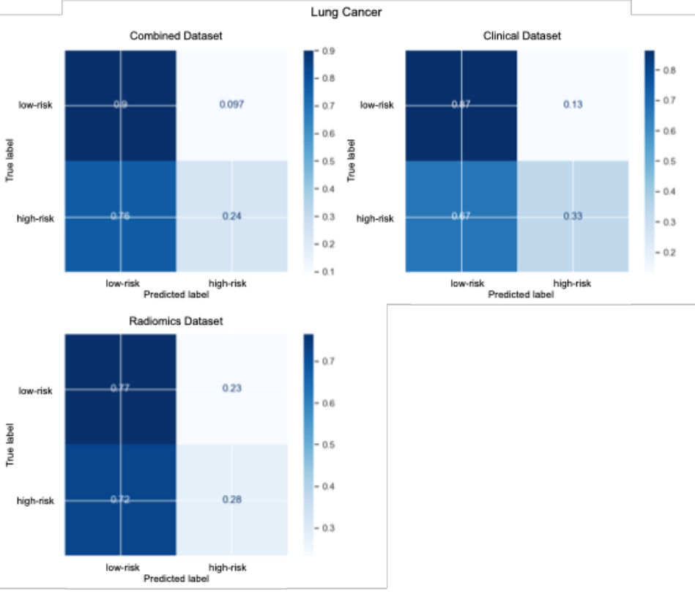

Supplementary Fig. 2 Confusion matrices of breast cancer patients with BM
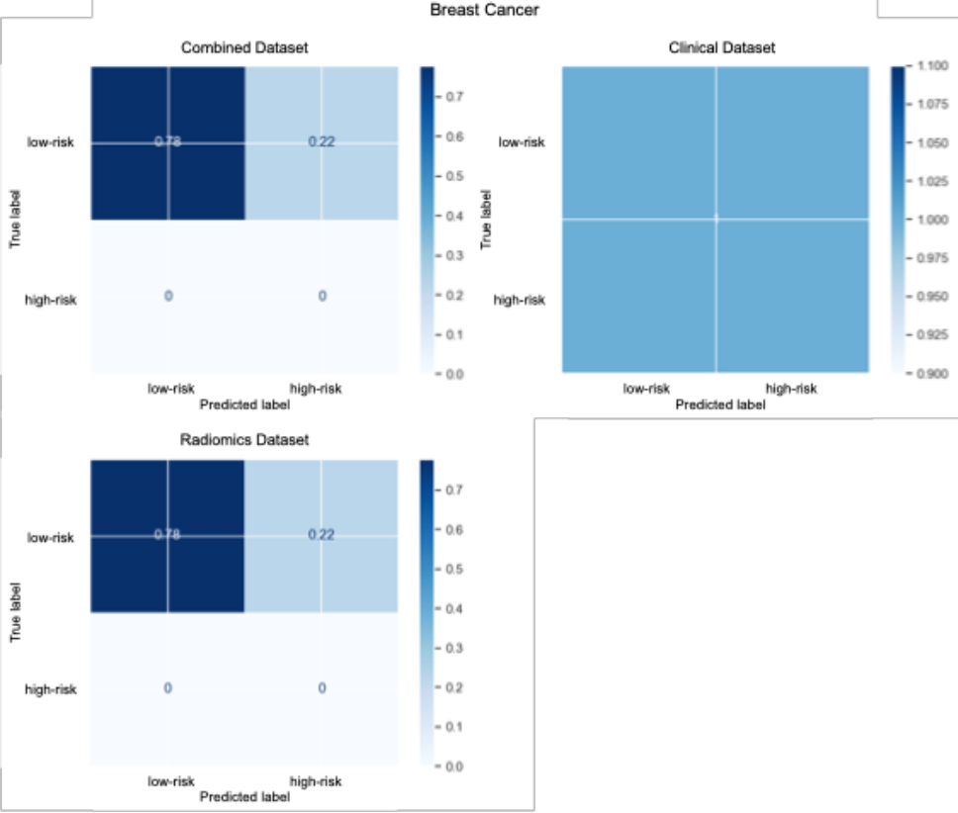

Supplementary Fig. 3 Confusion matrices of gastrointestinal cancer patients with BM
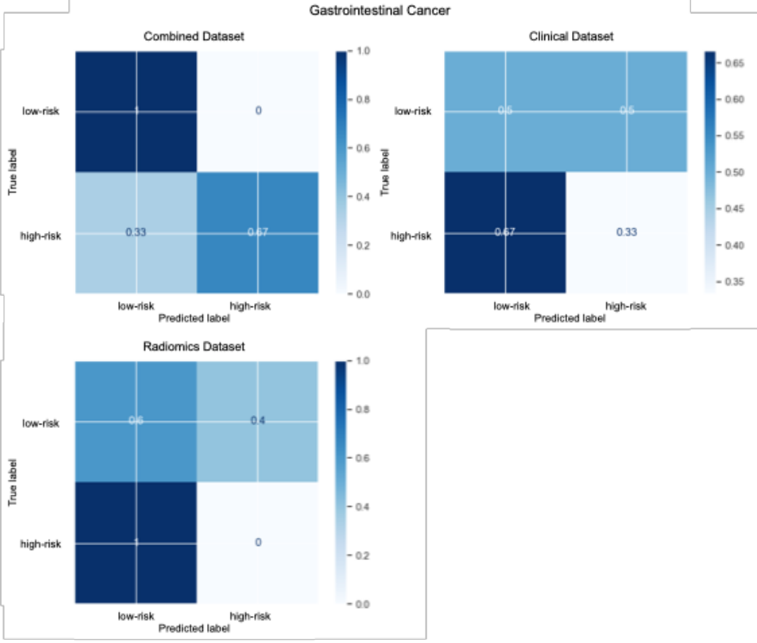

Supplementary Figure 4 Confusion matrices of other cancer patients with BM
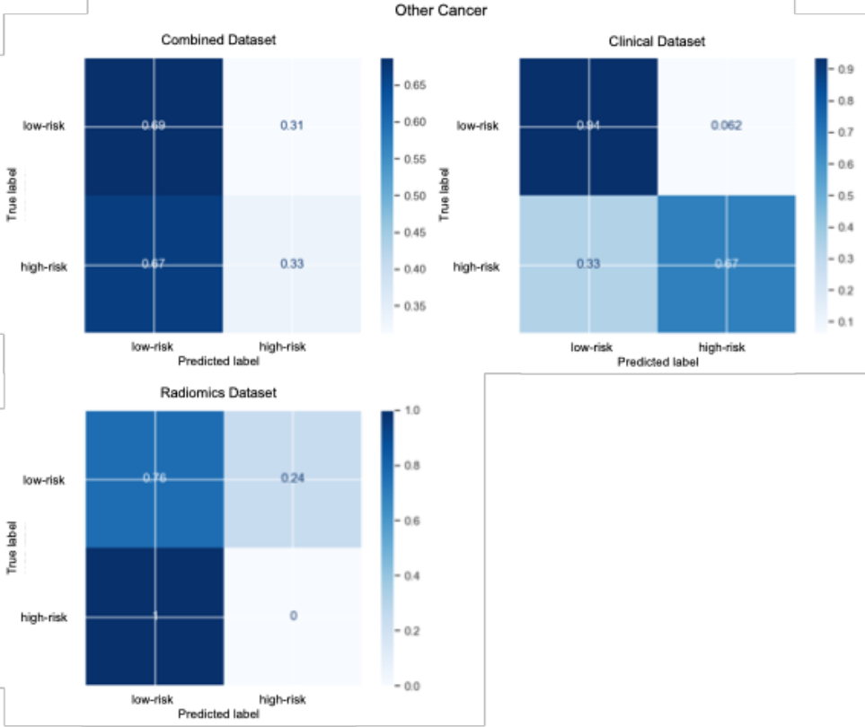

References
1. Hagiwara A, Oughourlian TC, Cho NS, et al (2022) Diffusion MRI is an early biomarker of overall survival benefit in IDH wild-type recurrent glioblastoma treated with immune checkpoint inhibitors. Neuro Oncol 24:1020–1028. https://doi.org/10.1093/neuonc/noab276

