Title: Isolation by distance and non-identical patterns of gene flow within two river populations of the freshwater fish Rutilus rutilus (L. 1758).
Journal: Conservation Genetics

Authors: S Crookes & P Shaw

Affiliation: Royal Holloway, University of London, Egham, London.

Corresponding author: scrookes@uwindsor.ca

 | Sampling location
Locus | MWP | DL | OW | CI | T | W | DO | DY | C | Y | N | B | R
Rru3
N_{A} | 5.000 | 5.000 | 4.000 | 7.000 | 5.000 | 5.000 | 4.000 | 5.000 | 4.000 | 5.000 | 7.000 | 5.000 | 5.000
A_{R} | 4.892 | 4.693 | 3.984 | 5.534 | 4.028 | 5.000 | 4.000 | 4.508 | 3.987 | 4.489 | 6.315 | 4.721 | 4.989
H_{e} | 0.596 | 0.576 | 0.567 | 0.644 | 0.492 | 0.652 | 0.661 | 0.578 | 0.587 | 0.528 | 0.665 | 0.471 | 0.661
H_{o} | 0.500 | 0.290 | 0.479 | 0.351 | 0.451 | 0.588 | 0.476 | 0.333 | 0.500 | 0.364 | 0.500 | 0.391 | 0.636
F_{IS} | 0.163 | 0.498** | 0.156 | 0.458** | 0.084 | 0.101 | 0.284 | 0.427 | 0.150** | 0.315** | 0.252 | 0.173 | 0.038
Lid1
N_{A} | 8.000 | 10.000 | 10.000 | 8.000 | 9.000 | 10.000 | 7.000 | 9.000 | 9.000 | 10.000 | 6.000 | 6.000 | 6.000
A_{R} | 6.450 | 7.881 | 7.910 | 6.174 | 6.156 | 8.888 | 5.810 | 8.206 | 6.321 | 8.439 | 5.857 | 5.192 | 5.429
H_{e} | 0.702 | 0.813 | 0.743 | 0.657 | 0.676 | 0.776 | 0.729 | 0.811 | 0.649 | 0.741 | 0.644 | 0.655 | 0.668
H_{o} | 0.563 | 0.609 | 0.583 | 0.541 | 0.632 | 0.652 | 0.613 | 0.484 | 0.750 | 0.750 | 0.652 | 0.731 | 0.619
F_{IS} | 0.201 | 0.252** | 0.216 | 0.177 | 0.067 | 0.162 | 0.161 | 0.407** | -0.157 | -0.012 | -0.012 | -0.119 | 0.075
CypG3
N_{A} | 17.000 | 18.000 | 16.000 | 20.000 | 22.000 | 15.000 | 15.000 | 13.000 | 18.000 | 14.000 | 15.000 | 15.000 | 13.000
A_{R} | 12.426 | 11.097 | 11.721 | 12.486 | 13.114 | 13.342 | 11.078 | 9.767 | 12.662 | 10.756 | 12.841 | 11.985 | 11.287
H_{e} | 0.755 | 0.746 | 0.811 | 0.870 | 0.798 | 0.818 | 0.706 | 0.700 | 0.785 | 0.720 | 0.808 | 0.739 | 0.697
H_{o} | 0.679 | 0.600 | 0.667 | 0.724 | 0.772 | 0.682 | 0.656 | 0.645 | 0.692 | 0.727 | 0.955 | 0.654 | 0.545
F_{IS} | 0.103 | 0.197 | 0.180 | 0.169 | 0.033 | 0.170 | 0.072 | 0.079 | 0.119 | -0.011 | -0.187 | 0.117 | 0.221
CypG48
N_{A} | 15.000 | 16.000 | 12.000 | 14.000 | 14.000 | 11.000 | 13.000 | 13.000 | 11.000 | 12.000 | 13.000 | NA | 11.000
A_{R} | 12.396 | 11.138 | 10.246 | 10.827 | 10.509 | 9.631 | 11.209 | 11.041 | 9.400 | 10.017 | 11.880 | NA | 10.039
H_{e} | 0.912 | 0.889 | 0.864 | 0.884 | 0.885 | 0.850 | 0.909 | 0.896 | 0.840 | 0.889 | 0.914 | NA | 0.888
H_{o} | 0.939 | 0.922 | 0.700 | 0.857 | 0.759 | 0.739 | 0.844 | 0.879 | 0.816 | 0.625 | 0.769 | NA | 0.900
F_{IS} | -0.030 | -0.037 | 0.193 | 0.031 | 0.144 | 0.133 | 0.073 | 0.019 | 0.029 | 0.300** | 0.161 | NA | -0.013
Ca1
N_{A} | 8.000 | 12.000 | 13.000 | 14.000 | 10.000 | 9.000 | 6.000 | 8.000 | 9.000 | 10.000 | 9.000 | 10.000 | 7.000
A_{R} | 7.453 | 8.625 | 8.867 | 9.407 | 7.200 | 7.829 | 5.371 | 6.820 | 7.266 | 8.147 | 8.066 | 9.034 | 6.554
H_{e} | 0.796 | 0.822 | 0.792 | 0.839 | 0.783 | 0.743 | 0.711 | 0.796 | 0.764 | 0.798 | 0.813 | 0.845 | 0.753
H_{o} | 0.760 | 0.683 | 0.818 | 0.727 | 0.698 | 0.652 | 0.600 | 0.719 | 0.882 | 0.645 | 0.440 | 0.875 | 0.619
F_{IS} | 0.046 | 0.170 | -0.034 | 0.134 | 0.110 | 0.125 | 0.158 | 0.098 | -0.158 | 0.194 | 0.464** | -0.036 | 0.181
Ca3
N_{A} | 16.000 | 17.000 | 17.000 | 19.000 | 22.000 | 15.000 | 18.000 | 16.000 | 16.000 | 19.000 | 16.000 | 18.000 | 16.000
A_{R} | 13.909 | 14.391 | 13.486 | 14.269 | 16.059 | 12.980 | 15.167 | 13.483 | 13.402 | 15.956 | 14.225 | 15.168 | 14.744
H_{e} | 0.929 | 0.936 | 0.928 | 0.931 | 0.944 | 0.903 | 0.940 | 0.911 | 0.926 | 0.941 | 0.925 | 0.934 | 0.931
H_{o} | 0.839 | 0.931 | 0.870 | 0.917 | 0.947 | 0.870 | 0.700 | 0.724 | 0.730 | 0.750 | 0.833 | 0.800 | 0.667
F_{IS} | 0.099 | 0.005 | 0.064 | 0.015 | -0.003 | 0.038 | 0.258 | 0.208 | 0.215 | 0.206** | 0.101 | 0.146 | 0.289
Ca12
N_{A} | 17.000 | 21.000 | 23.000 | 23.000 | 19.000 | 16.000 | 15.000 | 15.000 | 17.000 | 13.000 | 13.000 | 16.000 | 15.000
A_{R} | 12.850 | 13.246 | 13.994 | 13.378 | 13.081 | 14.056 | 11.845 | 11.255 | 13.076 | 10.327 | 10.456 | 13.010 | 13.161
H_{e} | 0.869 | 0.805 | 0.854 | 0.830 | 0.854 | 0.865 | 0.829 | 0.785 | 0.864 | 0.732 | 0.676 | 0.793 | 0.784
H_{o} | 0.897 | 0.800 | 0.857 | 0.726 | 0.817 | 0.818 | 0.727 | 0.636 | 0.794 | 0.697 | 0.680 | 0.720 | 0.682
F_{IS} | -0.032 | 0.006 | -0.003 | 0.126 | 0.044 | 0.055 | 0.124 | 0.192** | 0.082 | 0.048 | -0.006 | 0.093 | 0.133
Lc27
N_{A} | 3.000 | 5.000 | 4.000 | 3.000 | 4.000 | 3.000 | 4.000 | 3.000 | 3.000 | 4.000 | 4.000 | 3.000 | 4.000
A_{R} | 2.746 | 3.568 | 3.355 | 2.263 | 2.955 | 2.739 | 3.746 | 2.514 | 2.892 | 3.308 | 3.304 | 2.952 | 3.848
H_{e} | 0.197 | 0.311 | 0.243 | 0.225 | 0.227 | 0.300 | 0.426 | 0.265 | 0.287 | 0.255 | 0.246 | 0.247 | 0.419
H_{o} | 0.152 | 0.271 | 0.245 | 0.222 | 0.200 | 0.261 | 0.455 | 0.242 | 0.275 | 0.219 | 0.269 | 0.231 | 0.350
F_{IS} | 0.234 | 0.130 | -0.008 | 0.014 | 0.121 | 0.134 | -0.069 | 0.087 | 0.042 | 0.146 | -0.097 | 0.065 | 0.169
Lc290
N_{A} | 10.000 | 10.000 | 8.000 | 8.000 | 9.000 | 7.000 | 8.000 | 9.000 | 9.000 | 10.000 | 7.000 | 10.000 | 10.000
A_{R} | 8.448 | 7.514 | 6.592 | 6.743 | 7.105 | 6.887 | 7.213 | 7.096 | 8.138 | 8.269 | 6.621 | 9.226 | 9.360
H_{e} | 0.795 | 0.801 | 0.746 | 0.791 | 0.756 | 0.797 | 0.821 | 0.723 | 0.786 | 0.808 | 0.798 | 0.869 | 0.814
H_{o} | 0.636 | 0.677 | 0.694 | 0.730 | 0.754 | 0.667 | 0.594 | 0.485 | 0.553 | 0.710 | 0.680 | 0.630 | 0.800
F_{IS} | 0.202 | 0.155 | 0.070 | 0.077 | 0.002 | 0.167 | 0.280 | 0.333 | 0.299 | 0.124 | 0.150 | 0.279 | 0.018
Lco4
N_{A} | 5.000 | 5.000 | 5.000 | 6.000 | 7.000 | 4.000 | 6.000 | 6.000 | 6.000 | 6.000 | 6.000 | 5.000 | 6.000
A_{R} | 4.357 | 4.300 | 4.570 | 4.916 | 6.542 | 3.991 | 5.891 | 5.671 | 5.806 | 4.922 | 5.763 | 4.796 | 5.722
H_{e} | 0.449 | 0.621 | 0.691 | 0.646 | 0.778 | 0.673 | 0.769 | 0.707 | 0.743 | 0.613 | 0.755 | 0.643 | 0.714
H_{o} | 0.364 | 0.656 | 0.646 | 0.508 | 0.714 | 0.500 | 0.710 | 0.548 | 0.600 | 0.531 | 0.500 | 0.520 | 0.773
F_{IS} | 0.192 | -0.057 | 0.066 | 0.215 | 0.083 | 0.262 | 0.079 | 0.227 | 0.195 | 0.135 | 0.343 | 0.195 | -0.085
Mean
N_{A} | 10.400 | 11.900 | 11.200 | 12.200 | 12.100 | 9.500 | 9.600 | 9.700 | 10.200 | 10.300 | 9.600 | 9.778 | 9.300
A_{R} | 8.592 | 8.645 | 8.473 | 8.600 | 8.675 | 8.534 | 8.133 | 8.036 | 8.223 | 8.463 | 8.533 | 8.454 | 8.475
H_{e} | 0.700 | 0.732 | 0.724 | 0.732 | 0.719 | 0.738 | 0.750 | 0.717 | 0.723 | 0.703 | 0.724 | 0.688 | 0.733
H_{o} | 0.633 | 0.644 | 0.656 | 0.630 | 0.674 | 0.643 | 0.637 | 0.570 | 0.659 | 0.602 | 0.628 | 0.617 | 0.659
F_{IS} | 0.098 | 0.121** | 0.095** | 0.140** | 0.063 | 0.131 | 0.152** | 0.208** | 0.089** | 0.145** | 0.136** | 0.106 | 0.103**
Table S1. Individual locus-by-location estimates of genetic variation observed within the River Thames. N_{A} = the number of unique alleles, A_{r} = allelic richness, H_{e} = expected heterozygosity, H_{o} = observed heterozygosity, F_{IS} = population-level inbreeding coefficient (underlined values indicate a significant deviation of allele frequencies from those expected under a null model of Hardy-Weinberg equilibrium; values with * are significant before Bonferroni correction).
 | Sampling location
Locus | BL | DM | SW | AB | SH | MM | RC | SbC | T
Rru3
N_{A} | 6.000 | 6.000 | 7.000 | 13.000 | NA | 8.000 | 7.000 | 5.000 | 6.000
A_{R} | 4.659 | 5.227 | 3.998 | 7.906 | NA | 4.933 | 6.402 | 4.320 | 5.206
H_{e} | 0.691 | 0.790 | 0.759 | 0.806 | NA | 0.756 | 0.806 | 0.698 | 0.629
H_{O} | 0.444 | 0.469 | 0.566 | 0.333 | NA | 0.557 | 0.706 | 0.639 | 0.579
F_{IS} | 0.359** | 0.410** | 0.256** | 0.588** | NA | 0.264** | 0.127 | 0.085 | 0.081
Lid1
N_{A} | 9.000 | 7.000 | 11.000 | 17.000 | 6.000 | 7.000 | 12.000 | 7.000 | 7.000
A_{R} | 5.371 | 4.628 | 7.204 | 8.080 | 4.845 | 4.829 | 10.035 | 5.642 | 6.159
H_{e} | 0.626 | 0.604 | 0.800 | 0.796 | 0.638 | 0.633 | 0.850 | 0.743 | 0.597
H_{O} | 0.577 | 0.559 | 0.547 | 0.662 | 0.656 | 0.576 | 0.882 | 0.583 | 0.550
F_{IS} | 0.079 | 0.076 | 0.318** | 0.170 | -0.028 | 0.090 | -0.039 | 0.217 | 0.081
CypG3
N_{A} | 17.000 | 11.000 | 16.000 | 18.000 | 10.000 | 16.000 | 9.000 | 9.000 | 9.000
A_{R} | 7.111 | 7.157 | 7.259 | 8.148 | 6.589 | 8.336 | 7.500 | 7.626 | 6.292
H_{e} | 0.582 | 0.545 | 0.583 | 0.706 | 0.542 | 0.692 | 0.778 | 0.607 | 0.440
H_{O} | 0.579 | 0.552 | 0.569 | 0.530 | 0.563 | 0.588 | 0.375 | 0.500 | 0.450
F_{IS} | 0.005 | -0.012 | 0.024 | 0.251 | -0.038 | 0.151 | 0.526** | 0.181 | -0.024
CypG48
N_{A} | 16.000 | 11.000 | 13.000 | 19.000 | 10.000 | 14.000 | NA | 11.000 | 9.000
A_{R} | 9.684 | 8.795 | 10.405 | 11.278 | 8.208 | 9.486 | NA | 8.339 | 8.425
H_{e} | 0.884 | 0.885 | 0.874 | 0.910 | 0.861 | 0.891 | NA | 0.862 | 0.847
H_{O} | 0.861 | 0.912 | 0.850 | 0.846 | 0.765 | 0.774 | NA | 0.778 | 0.786
F_{IS} | 0.026 | -0.031 | 0.029 | 0.071 | 0.113 | 0.133 | NA | 0.099 | 0.074
Ca1
N_{A} | 9.000 | 6.000 | 11.000 | 13.000 | 10.000 | 12.000 | 5.000 | 8.000 | 8.000
A_{R} | 6.410 | 4.919 | 7.010 | 7.072 | 8.023 | 7.541 | 4.961 | 5.925 | 6.635
H_{e} | 0.779 | 0.724 | 0.816 | 0.789 | 0.775 | 0.831 | 0.759 | 0.765 | 0.744
H_{O} | 0.605 | 0.588 | 0.528 | 0.574 | 0.758 | 0.690 | 0.600 | 0.618 | 0.579
F_{IS} | 0.224** | 0.190 | 0.355** | 0.274** | 0.023 | 0.171** | 0.215 | 0.195 | 0.227
Ca3
N_{A} | 20.000 | 15.000 | 23.000 | 22.000 | 17.000 | 19.000 | 13.000 | 18.000 | 14.000
A_{R} | 11.712 | 11.588 | 12.749 | 13.681 | 12.687 | 12.945 | 12.347 | 11.545 | 11.704
H_{e} | 0.919 | 0.919 | 0.928 | 0.940 | 0.933 | 0.938 | 0.939 | 0.905 | 0.914
H_{O} | 0.754 | 0.783 | 0.873 | 0.721 | 0.800 | 0.721 | 0.929 | 0.750 | 0.778
F_{IS} | 0.181 | 0.151 | 0.060 | 0.234** | 0.145 | 0.234** | 0.012 | 0.174 | 0.153
Ca12
N_{A} | 21.000 | 17.000 | 17.000 | 23.000 | 14.000 | 16.000 | 8.000 | 16.000 | 8.000
A_{R} | 10.383 | 11.473 | 10.956 | 10.921 | 8.767 | 9.375 | 7.016 | 10.661 | 6.337
H_{e} | 0.860 | 0.907 | 0.886 | 0.894 | 0.846 | 0.803 | 0.761 | 0.856 | 0.704
H_{O} | 0.785 | 0.824 | 0.807 | 0.700 | 0.824 | 0.767 | 0.588 | 0.774 | 0.500
F_{IS} | 0.088 | 0.094 | 0.090 | 0.218** | 0.027 | 0.045 | 0.233 | 0.097 | 0.295
Lc27
N_{A} | 5.000 | 2.000 | 5.000 | 5.000 | 4.000 | 3.000 | 2.000 | 2.000 | 4.000
A_{R} | 2.290 | 1.991 | 2.836 | 2.595 | 2.442 | 2.199 | 1.998 | 1.960 | 3.853
H_{e} | 0.135 | 0.255 | 0.208 | 0.232 | 0.141 | 0.136 | 0.226 | 0.187 | 0.477
H_{O} | 0.141 | 0.235 | 0.190 | 0.214 | 0.147 | 0.127 | 0.250 | 0.206 | 0.474
F_{IS} | -0.048 | 0.077 | 0.091 | 0.077** | -0.041 | 0.067 | -0.111 | -0.100 | 0.006
Lc290
N_{A} | 7.000 | 7.000 | 9.000 | 9.000 | 7.000 | 10.000 | 9.000 | 10.000 | 8.000
A_{R} | 5.879 | 5.431 | 6.570 | 7.215 | 5.563 | 6.608 | 8.188 | 7.161 | 6.968
H_{e} | 0.758 | 0.720 | 0.779 | 0.843 | 0.755 | 0.776 | 0.863 | 0.839 | 0.827
H_{O} | 0.695 | 0.559 | 0.667 | 0.716 | 0.742 | 0.794 | 0.813 | 0.583 | 0.667
F_{IS} | 0.084** | 0.226 | 0.145** | 0.151** | 0.018 | -0.022 | 0.060 | 0.308 | 0.198
Lco4
N_{A} | 5.000 | 3.000 | 5.000 | 10.000 | 3.000 | 5.000 | 6.000 | 5.000 | 6.000
A_{R} | 3.657 | 2.896 | 3.724 | 5.541 | 2.833 | 3.666 | 5.601 | 4.177 | 5.143
H_{e} | 0.586 | 0.525 | 0.565 | 0.728 | 0.551 | 0.590 | 0.740 | 0.606 | 0.704
H_{O} | 0.549 | 0.529 | 0.466 | 0.522 | 0.588 | 0.516 | 0.529 | 0.270 | 0.700
F_{IS} | 0.063 | -0.008 | 0.177 | 0.285** | -0.069 | 0.126 | 0.291 | 0.558** | 0.006
Mean
N_{A} | 11.500 | 8.500 | 11.700 | 14.900 | 9.000 | 11.000 | 7.889 | 9.100 | 7.900
A_{R} | 6.716 | 6.411 | 7.271 | 8.244 | 6.662 | 6.992 | 7.116 | 6.736 | 6.672
H_{e} | 0.682 | 0.687 | 0.720 | 0.764 | 0.672 | 0.705 | 0.747 | 0.707 | 0.688
H_{O} | 0.599 | 0.601 | 0.606 | 0.582 | 0.649 | 0.611 | 0.630 | 0.570 | 0.606
F_{IS} | 0.122** | 0.128 | 0.159** | 0.240** | 0.034 | 0.134** | 0.160** | 0.196** | 0.122
Table S2. Individual locus-by-location estimates of genetic variation observed within the River Stour. N_{A} = the number of unique alleles, A_{r} = allelic richness, H_{e} = expected heterozygosity, H_{o} = observed heterozygosity, F_{IS} = population-level inbreeding coefficient (underlined values indicate a significant deviation of allele frequencies from those expected under a null model of Hardy-Weinberg equilibrium; values with * are significant before Bonferroni correction).
 |  | Upstream
 |  | From
 |  | MWP | DL | OW | CI | T | W | DO | DY | C | E | N | B | R
To | MWP | 0.8850 | 0.0171 | 0.0100 | 0.0091 | 0.0191 | 0.0072 | 0.0086 | 0.0071 | 0.0073 | 0.0073 | 0.0073 | 0.0071 | 0.0072
To | DL | 0.0074 | 0.7470 | 0.1850 | 0.0091 | 0.0132 | 0.0072 | 0.0086 | 0.0042 | 0.0043 | 0.0042 | 0.0043 | 0.0043 | 0.0043
To | OW | 0.0072 | 0.0047 | 0.8570 | 0.0161 | 0.0107 | 0.0054 | 0.0238 | 0.0055 | 0.0054 | 0.0054 | 0.0053 | 0.0054 | 0.0053
To | CI | 0.0046 | 0.0565 | 0.1840 | 0.6920 | 0.0155 | 0.0041 | 0.0179 | 0.0041 | 0.0042 | 0.0042 | 0.0041 | 0.0042 | 0.0041
To | T | 0.0067 | 0.0058 | 0.1850 | 0.0099 | 0.6750 | 0.0042 | 0.0880 | 0.0042 | 0.0043 | 0.0043 | 0.0043 | 0.0043 | 0.0042
To | W | 0.0098 | 0.0091 | 0.0130 | 0.0096 | 0.0095 | 0.6760 | 0.2220 | 0.0083 | 0.0084 | 0.0084 | 0.0082 | 0.0083 | 0.0083
To | DO | 0.0078 | 0.0148 | 0.0414 | 0.0089 | 0.0248 | 0.0074 | 0.8510 | 0.0074 | 0.0071 | 0.0074 | 0.0073 | 0.0072 | 0.0072
To | DY | 0.0073 | 0.0121 | 0.0192 | 0.0067 | 0.2330 | 0.0067 | 0.0074 | 0.6740 | 0.0065 | 0.0066 | 0.0067 | 0.0066 | 0.0064
To | C | 0.0061 | 0.0087 | 0.0196 | 0.0062 | 0.0072 | 0.0057 | 0.2450 | 0.0057 | 0.6730 | 0.0058 | 0.0058 | 0.0058 | 0.0057
To | E | 0.0067 | 0.0259 | 0.2160 | 0.0073 | 0.0147 | 0.0065 | 0.0147 | 0.0066 | 0.0067 | 0.6740 | 0.0067 | 0.0067 | 0.0065
To | N | 0.0082 | 0.0105 | 0.0320 | 0.0082 | 0.0126 | 0.0079 | 0.2060 | 0.0077 | 0.0078 | 0.0079 | 0.6760 | 0.0075 | 0.0077
To | B | 0.0076 | 0.0080 | 0.2190 | 0.0075 | 0.0098 | 0.0076 | 0.0273 | 0.0076 | 0.0075 | 0.0075 | 0.0077 | 0.6760 | 0.0076
To | R | 0.0087 | 0.0103 | 0.0139 | 0.0087 | 0.0200 | 0.0085 | 0.2100 | 0.0085 | 0.0087 | 0.0086 | 0.0085 | 0.0085 | 0.6770

Table S3. BAYEASS+ estimates of migration rates among sub-populations in the River Thames. The proportional values in the diagonal cells represent non-migrants. Underlined values fall within the top 10% of estimates. Significant contributing sub-populations to the migrant pool are highlighted (net negative migration).

 |  | Upstream
 |  | From
 |  | BL | DM | ST | AB | SW | MM | RC | SbC | TH
To | BL | 0.9350 | 0.0035 | 0.0308 | 0.0035 | 0.0035 | 0.0182 | 0.0035 | 0.0035 | 0.0045
To | DM | 0.2820 | 0.6740 | 0.0072 | 0.0062 | 0.0061 | 0.0064 | 0.0062 | 0.0061 | 0.0062
To | ST | 0.2680 | 0.0035 | 0.6990 | 0.0034 | 0.0040 | 0.0120 | 0.0034 | 0.0034 | 0.0037
To | AB | 0.2760 | 0.0046 | 0.0091 | 0.6720 | 0.0046 | 0.0077 | 0.0046 | 0.0046 | 0.0175
To | SW | 0.2960 | 0.0042 | 0.0062 | 0.0042 | 0.6710 | 0.0052 | 0.0042 | 0.0042 | 0.0046
To | MM | 0.2770 | 0.0036 | 0.0208 | 0.0037 | 0.0036 | 0.6800 | 0.0037 | 0.0035 | 0.0040
To | RC | 0.0167 | 0.0100 | 0.2430 | 0.0099 | 0.0098 | 0.0109 | 0.6790 | 0.0098 | 0.0104
To | SbC | 0.0173 | 0.0059 | 0.2720 | 0.0058 | 0.0057 | 0.0080 | 0.0058 | 0.6730 | 0.0061
To | TH | 0.0297 | 0.0152 | 0.0297 | 0.0156 | 0.0158 | 0.0175 | 0.0157 | 0.0143 | 0.8650

Table S4. BAYEASS+ estimates of migration rates among sub-populations in the River Stour. The proportional values in the diagonal cells represent non-migrants. Underlined values fall within the top 10% of estimates. Significant contributing sub-populations to the migrant pool are highlighted (net negative migration).

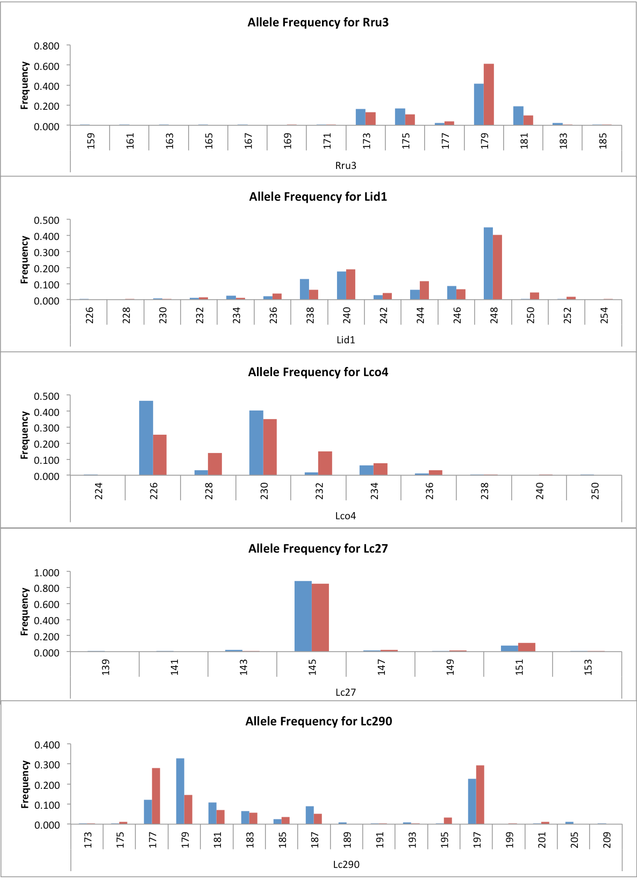
Fig S1a. Allele frequency histograms for each locus utilised in this study summed over each location for the Rivers Thames (red) and Stour (blue). Numbers indicate the number of repeat motifs in each.

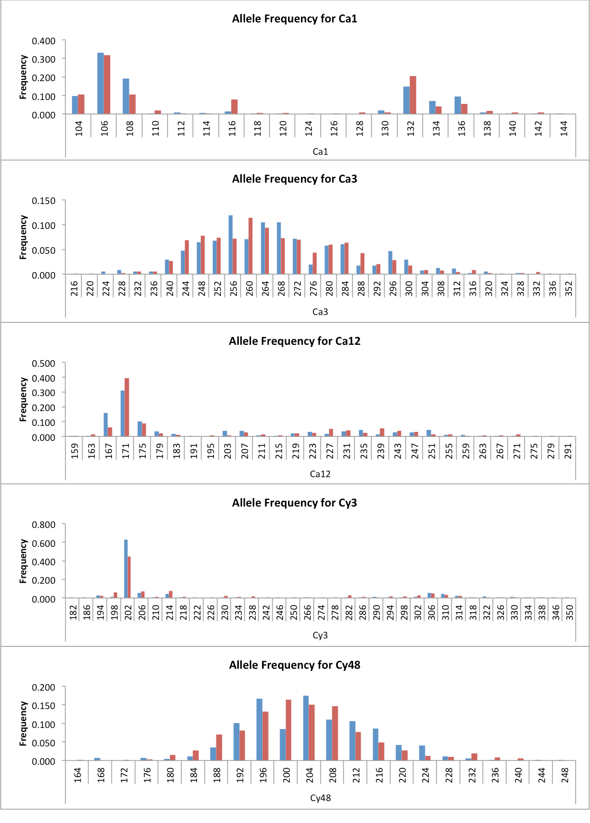
Fig S1b. Continuation of frequency data.

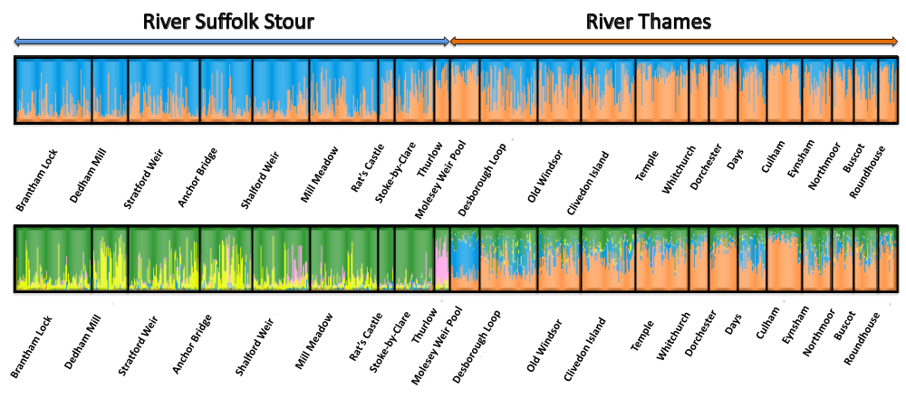
Fig S2. STRUCTURE analysis. We assessed cryptic population structure by adopting a Bayesian framework optimised in the program STRUCTURE 2.3.3 (Pritchard et al. 2000). This program uses allele frequencies to derive prior probabilities of the number of ‘true’ ‘K’ HWE populations into which individuals are clustered (K₁, K₂,…K_{n}, where K_{n} is the nth whole number of populations). The program was run with and without prior information regarding the sampling location of individuals. Utilising sampling information was found to better inform prior distributions of K in instances of high within population diversity and low inter-population divergence (Hubisz et al. 2009). Both runs used an admixture model of inference and correlated allele frequencies to account for the recent evolutionary co-ancestry of populations (Falush et al. 2003). 20 values of K were analysed, with each analysis iterated 5 times (5x10⁵ MCMC iterations after 10⁵were discarded as burn-in). The optimal value of K was calculated according to the ΔK procedure (Evanno et al. 2005) in STRUCTURE HARVESTER (Earl and von Holdt 2011). The output was visualised in DISTRUCT version 1.1 (Rosenberg 2004). Top panel displays K = 2 populations when no geographic information was inputted into the Bayesian analysis. Lower panel displays K = 5 populations when geographic location information was incorporated as prior information in the Bayesian analysis. Each diagram shows the proportion of each inferred K populations’ genomic signal (Q) found in each individual (vertical lines) in each sub-population (shown in strong black outline).
Earl, D. A. & van Holdt, B. M. (2011). STRUCTURE HARVESTER: a website and program for visualizing STRUCTURE output and implementing the Evanno method. Conservation Genetics Resources, DOI:10.1007/s12686-011-9548-7.
Evanno, G., Regnaut, S. & Goudet, J. (2005) Detecting the number of clusters of individuals using the software STRUCTURE: a simulation study. Mol Ecol, 14, 2611-2620.
Falush, D., Stephens, M. & Pritchard, J. (2003) Inference of population structure: extensions to linked loci and correlated allele frequencies. Genetics, 164, 1567-1587.
Hubisz, M., Falush, D., Stephens, M. & Pritchard, J. (2009) Inferring weak population structure with the assistance of sample group information. Mol Ecol Resourc, 9, 1322-1332.
Rosenberg, N. A. (2004) DISTRUCT: a program for the graphical display of population structure. Mol Ecol Notes, 4, 127-138.

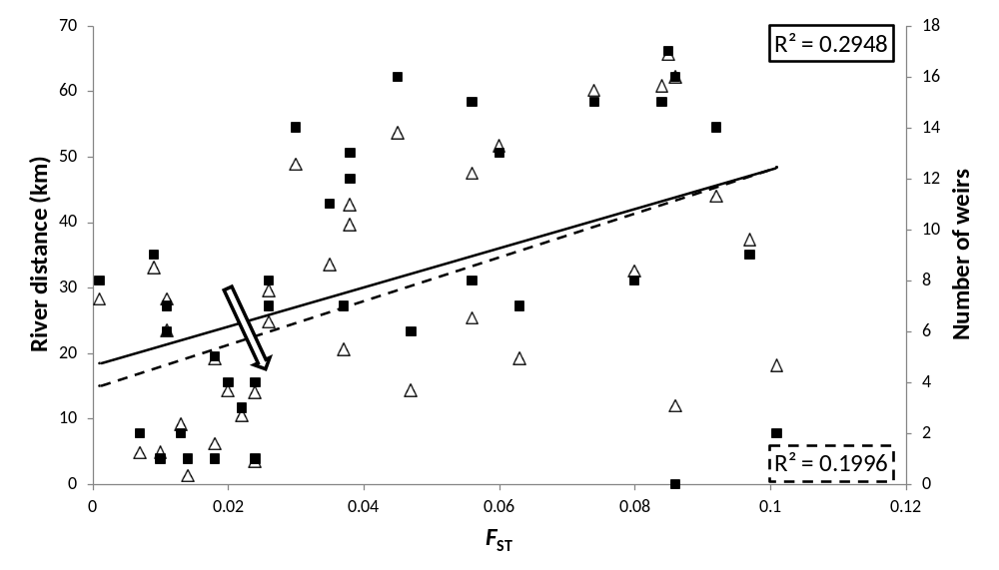
Fig S3. An example of Simpson’s Paradox. Both genetic distance (left hand axis, open triangles and hatched line of best-fit) and the number of weirs (right-hand axis, solid squares and unbroken line of best-fit) are significantly and positively correlated with genetic divergence (x-axis, F_{ST}). However, when one environmental distance variable is regressed against genetic distance whilst controlling for the other, the correlation between the coefficients for the environmental distance variable becomes negative for one of the two comparisons (schematically illustrated by the arrow), in this case weirs and genetic

