Online Resource 1 (Supplementary Material)

Article: Complex genetic diversity patterns of cryptic, sympatric brown trout (Salmo trutta) populations in tiny mountain lakes

Journal: Conservation Genetics

Authors: Anastasia Anderssonª, Eeva Jansson^{a,b}, Lovisa Wennerströmª, Fidel Chiribogaª, Mariann Arnyasi^{c}, Matthew P. Kent^{c}, Nils Rymanª and Linda Laikreª

Affiliations: ªDepartment of Zoology, Division of Population Genetics, Stockholm University S-106 91 Stockholm, Sweden
^{b}Institute of Marine Research, N-5817 Bergen, Norway
^{c}Centre for Integrative Genetics (CIGENE) and Department of Animal and Aquacultural Sciences, Norwegian University of Life Sciences, N-1432 As, Norway

E-mail (corresponding author): anastasia.andersson@zoologi.su.se

Table S1 Frequency of the generally most common allele at 14 codominant allozyme loci for lakes and clusters. Clusters A and B consist of fish from Lakes Östra (ÖT) and Västra (VT) Trollsvattnet collected 1987-2014
Locus | Hästskotjärnen (n = 439) | VVT1  (n = 434) | VVT2  (n = 320) | Trollsflyn  (n = 359) | Alfred Larsa Tjärnen  (n = 168) | Häbbersflyn  (n = 94) | Häbbersvattnet  (n = 105) | Cluster A  in ÖT and VT  (n = 3242) | Cluster B  in ÖT and VT  (n = 2917)
AAT6 | 0.708 | 0.651 | 0.649 | 0.629 | 0.584 | 0.734 | 0.681 | 0.607 | 0.836
AGP2 | 0.761 | 0.751 | 0.834 | 0.867 | 0.862 | 0.894 | 0.846 | 0.883 | 0.608
BGA | 0.796 | 0.828 | 0.772 | 0.839 | 0.836 | 0.835 | 0.864 | 0.851 | 0.759
BGALA2 | 0.970 | 0.971 | 0.966 | 0.980 | 0.970 | 0.989 | 0.957 | 0.971 | 0.969
CPK1 | 0.913 | 0.907 | 0.869 | 0.897 | 0.859 | 0.846 | 0.895 | 0.854 | 0.981
DIA | 0.937 | 0.917 | 0.922 | 0.910 | 0.920 | 0.878 | 0.871 | 0.912 | 0.959
IDH2 | 0.700 | 0.744 | 0.770 | 0.828 | 0.817 | 0.830 | 0.848 | 0.883 | 0.547
LDH5 | 0.732 | 0.752 | 0.688 | 0.738 | 0.632 | 0.697 | 0.695 | 0.650 | 0.772
MAN | 0.728 | 0.763 | 0.749 | 0.769 | 0.786 | 0.761 | 0.757 | 0.799 | 0.617
MDH2 | 0.882 | 0.925 | 0.931 | 0.864 | 0.914 | 0.920 | 0.829 | 0.864 | 0.932
MEL | 0.982 | 0.987 | 0.972 | 0.974 | 0.964 | 0.989 | 0.986 | 0.955 | 0.998
PEPLT | 0.534 | 0.555 | 0.563 | 0.501 | 0.491 | 0.484 | 0.443 | 0.472 | 0.633
PMI | 0.763 | 0.652 | 0.748 | 0.787 | 0.735 | 0.798 | 0.776 | 0.739 | 0.813
SDH1 | 0.847 | 0.842 | 0.777 | 0.783 | 0.734 | 0.758 | 0.750 | 0.749 | 0.932

Table S2 F_{IS} within lakes and clusters over 14 allozyme loci. Clusters A and B include fish collected in Lakes Östra (ÖT) and Västra Trollsvattnet (VT) 1987-2014. *P<0.05, **P<0.01, ***P<0.001; significances retained after Holm’s sequential Bonferroni correction are in bold
Locus | Östra Trollsvattnet  (n =3107) | Västra Trollsvattnet  (n = 3052) | Hästskotjärnen (n = 439) | VVT1  (n = 434) | VVT2  (n = 320) | Trollsflyn (n = 359) | Alfred Larsa Tjärnen  (n = 168) | Häbbersflyn  (n = 94) | Häbbersvattnet  (n = 105) | Cluster A  in ÖT and VT  (n = 3242) | Cluster B  in ÖT and VT  (n = 2917)
AAT6 | 0.024 | 0.040* | 0.075 | -0.053 | 0.107* | 0.056 | 0.079 | 0.025 | -0.025 | -0.048** | -0.012
AGP2 | 0.085*** | 0.087*** | 0.026 | -0.034 | 0.074 | -0.030 | 0.045 | 0.110 | -0.103 | 0.011 | -0.030
BGA | -0.006 | -0.008 | -0.044 | -0.020 | -0.102 | -0.060 | -0.062 | -0.192 | 0.178 | -0.024 | -0.018
BGALA | 0.050* | 0.057** | -0.029 | 0.054 | -0.034 | -0.019 | -0.028 | -0.005 | -0.040 | 0.049* | 0.059**
CPK1 | 0.063** | 0.058** | -0.036 | 0.034 | 0.015 | 0.007 | 0.136 | -0.014 | 0.091 | -0.008 | 0.019
DIA | 0.048** | 0.102*** | 0.051 | -0.059 | 0.090 | -0.031 | 0.157 | -0.035 | 0.027 | 0.077*** | 0.036
IDH2 | 0.093*** | 0.107*** | 0.021 | 0.015 | 0.012 | 0.010 | -0.020 | -0.125 | 0.120 | -0.040** | -0.050**
LDH5 | -0.010 | -0.014 | -0.075 | 0.005 | -0.031 | 0.023 | -0.220** | -0.077 | 0.106 | -0.044* | -0.010
MAN | 0.072*** | 0.039* | -0.003 | -0.055 | -0.031 | 0.034 | -0.058 | -0.017 | 0.047 | -0.001 | 0.028
MDH2 | -0.015 | 0.042* | -0.022 | -0.047 | 0.074 | -0.015 | 0.135 | -0.081 | 0.133 | -0.002 | 0.008
MEL | 0.045* | 0.052* | -0.017 | -0.012 | -0.027 | 0.082 | -0.034 | -0.005 | -0.010 | 0.032 | -0.002
PEPLT | 0.001 | 0.011 | -0.065 | 0.124** | -0.040 | -0.079 | -0.009 | 0.047 | -0.018 | -0.030* | -0.009
PMI | 0.019 | 0.015 | 0.018 | 0.107* | 0.014 | 0.051 | 0.101 | 0.016 | 0.045 | 0.016 | 0.004
SDH1 | 0.048** | 0.039* | 0.130** | -0.012 | 0.056 | -0.014 | -0.085 | 0.046 | -0.124 | -0.024 | 0.004
All loci | 0.035*** | 0.039*** | 0.002 | 0.011 | 0.011 | -0.001 | -0.005 | -0.020 | 0.029 | -0.013 | -0.010

Table S3 Likelihoods for brown trout allozyme data (14 loci, 9 sampling localities) when assuming different numbers of subpopulations (K) obtained using the structure software (Pritchard et al. 2000). lnPrX│K = log likelihood of observed genotypic data for different numbers of K; ΔK = rate of change in the log likelihood of data between successive K-values (Evanno et al. 2005; mean after ten runs; burn-in length 250,000, MCMC 500,000); the highest log likelihood values representing the most likely number of K are in bold. The model used is “admixture with correlated allele frequencies”
Lake
 | Östra Trollsvattnet  (n = 3107) |  | Västra Trollsvattnet  (n = 3052) |  | Hästskotjärnen  (n = 439) |  | VVT1  (n = 434) |  | VVT2  (n = 320) |  | Trollsflyn  (n = 359) |  | Alfred Larsa Tjärnen  (n = 168) |  | Häbbersflyn  (n = 94) |  | Häbbersvattnet  (n = 105)
K | ln PrX│K | ΔK | ln PrX│K | ΔK | ln PrX│K | ΔK | ln PrX│K | ΔK | ln PrX│K | ΔK | ln PrX│K | ΔK | ln PrX│K | ΔK | ln PrX│K | ΔK | ln PrX│K | ΔK
1 | -38774.8 | - | -39441.6 | - | -5414.9 | - | -5331.1 | - | -4020.7 | - | -4327.4 | - | -2120.0 | - | -1122.4 | - | -1321.2 | -
2 | -38399.4 | 215.1 | -38490.8 | 244.6 | -5421.3 | 5.0 | -5618.8 | 2.0 | -4091.5 | 1.6 | -4405.3 | 2.5 | -2141.9 | 1.3 | -1125.5 | 3.0 | -1328.5 | 2.0
3 | -39125.2 | 13.3 | -38631.4 | 1.4 | -5454.6 | 0.8 | -5685.9 | 0.5 | -4110.8 | 0.4 | -4374.7 | 2.9 | -2146.1 | 0.7 | -1125.5 | 0.7 | -1328.3 | 0.2
4 | -41191.1 | 1.4 | -38915.4 | 0.2 | -5502.9 | 1.3 | -5842.6 | 0.1 | -4101.4 | 0.5 | -4374.6 | 0.9 | -2139.8 | 0.3 | -1124.1 | 1.2 | -1328.9 | 0.7
5 | -42698.0 | 3.4 | -39057.0 | 2.5 | -5579.7 | 1.3 | -5979.3 | 0.4 | -4121.4 | 0.4 | -4360.9 | 0.2 | -2130.1 | 1.5 | -1123.9 | 0.4 | -1325.8 | 1.4
6 | -42704.0 | 1.7 | -39309.0 | 3.1 | -5592.8 | 0.4 | -5990.3 | 0.3 | -4104.0 | 0.2 | -4351.2 | 0.7 | -2135.6 | 0.6 | -1124.0 | 0.5 | -1326.5 | 0.2
7 | -43541.4 | 0.4 | -39765.3 | 0.2 | -5614.4 | 0.3 | -6060.5 | 0.9 | -4093.9 | 0.2 | -4353.0 | 0.8 | -2134.7 | 0.1 | -1124.0 | 0.2 | -1326.7 | 0.5
8 | -44598.5 | 2.5 | -40132.3 | 0.8 | -5628.4 | 0.4 | -5885.7 | 0.2 | -4070.7 | 0.8 | -4337.5 | 2.5 | -2132.6 | 0.3 | -1124.1 | 0.4 | -1325.0 | 0.5
9 | -43596.3 | 1.5 | -40809.9 | 1.6 | -5663.6 | 0.4 | -5791.0 | 0.7 | -4083.3 | 1.1 | -4338.5 | 0.3 | -2126.6 | 2.2 | -1123.7 | 0.3 | -1324.8 | 0.2
10 | -43227.0 | - | -41046.6 | - | -5672.8 | - | -5465.6 | - | -4042.8 | - | -4336.6 | - | -2131.6 | - | -1123.7 | - | -1324.2 | -

Table S4 Likelihood for brown trout SNP data (3,093 loci, Lakes Trollsvattnen, total n = 60) when assuming different numbers of subpopulations (K) obtained using the structure software (Pritchard et al. 2000). lnPrX│K = log likelihood of observed genotypic data for different numbers of K; ΔK = rate of change in the log likelihood of data between successive K-values (mean after ten runs; burn-in length 250,000, MCMC 500,000). The model used is “admixture with correlated allele frequencies”
K | ln PrX│K | ΔK
1 | -180962.9 | -
2 | -178459.9 | 43.7
3 | -177605.9 | 1.3
4 | -177500.6 | 2.0
5 | -177683.0 | -

Table S5 F_{IS} for young-of-the-year parr collected in 2013 and 2014 at 12 potential spawning creeks connected to Lakes Trollsvattnen. *P < 0.05, **P < 0.01; none of the significances were retained after Holm’s sequential Bonferroni correction
 | Sampling locality
Locus | A  (n = 216) | B  (n = 9) | C  (n = 181) | D  (n = 170) | E  (n = 39) | F  (n = 205) | G  (n = 46) | H  (n = 12) | I  (n = 7) | K  (n = 3) | All localities  (n = 888)
AAT6 | -0.06 | -0.30 | 0.00 | -0.07 | -0.14 | -0.08 | -0.02 | -0.05 | -0.71 | 0.50 | -0.03
AGP2 | 0.23** | -0.23 | 0.04 | 0.05 | 0.18 | 0.11 | -0.17 | 0.11 | -0.09 | - | 0.13**
BGA | -0.06 | -0.17 | 0.03 | 0.11 | -0.13 | -0.01 | 0.05 | -0.18 | -0.09 | -0.33 | 0.02
BGALA | -0.02 | - | -0.04 | -0.01 | -0.03 | -0.01 | - | -0.05 | -0.33 | - | -0.03
CPK1 | 0.02 | 0.41 | -0.04 | -0.01 | -0.06 | 0.09 | -0.01 | - | - | -0.33 | 0.03
DIA | -0.05 | - | -0.06 | -0.11 | -0.09 | -0.03 | -0.01 | -0.10 | - | -1.00 | -0.06*
IDH2 | -0.02 | - | 0.01 | 0.00 | 0.10 | 0.04 | -0.08 | 0.04 | -0.50 | 0.00 | 0.07*
LDH5 | 0.01 | -0.51 | 0.14* | 0.06 | 0.25 | -0.06 | 0.11 | 0.27 | 0.00 | 0.00 | 0.07*
MAN | -0.05 | 0.35 | 0.07 | -0.10 | -0.20 | -0.05 | -0.05 | 0.26 | 0.22 | -0.33 | -0.03
MDH2 | 0.00 | 0.41 | -0.03 | -0.07 | -0.06 | -0.04 | -0.05 | -0.10 | - | 0.00 | -0.03
MEL | 0.22* | - | -0.02 | -0.02 | - | -0.00 | - | - | - | - | 0.12*
PEPLT | 0.10 | 0.23 | 0.02 | -0.17* | -0.11 | 0.07 | -0.08 | -0.54 | -0.71 | -1.00 | 0.00
PMI | -0.07 | 0.06 | -0.08 | 0.03 | -0.22 | -0.13* | 0.05 | -0.05 | 0.22 | -1.00 | -0.06*
SDH1 | -0.08 | -0.23 | 0.00 | 0.19* | 0.09 | 0.02 | -0.04 | -0.07 | 0.00 | - | 0.07*
All loci | 0.00 | -0.01 | 0.02 | -0.01 | -0.03 | -0.02 | -0.03 | -0.03 | -0.24* | -0.36 | 0.02*

Table S6 Likelihood for different numbers of subpopulations (K) for young-of-the-year parr collected in 2013-2014 (sampling localities A-K; Fig. 1) and adults from Lakes Trollsvattnen collected in 1987-2014 (total n = 7,107) obtained using the structure software (Pritchard et al. 2000). lnPrX│K = log likelihood of observed genotypic data for different numbers of K; ΔK = rate of change in the log likelihood of data between successive K-values (Evanno et al. 2005; mean after ten runs; burn-in length 250,000, MCMC 500,000), the highest log likelihood values representing the most likely number of K are in bold
K | ln PrX│K | ΔK
1 | -91487.7 | -
2 | -90004.2 | 20.9
3 | -90552.6 | 1.2
4 | -90922.6 | 0.6
5 | -91798.5 | -

Fig S1 Scree plot obtained from the pcadapt analysis of the SNPs with a maximum K set to 25

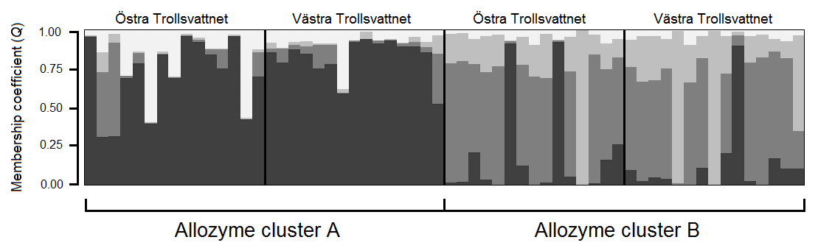
Fig. S2 Membership coefficient (Q) plots showing individuals (n = 60) in the structure K = 4 solutions for SNP data. Each fish is represented by a vertical bar that denotes membership fractions (Q) in the four clusters. The fish were collected in 2004 and 2005 from Lakes Östra (n = 30) and Västra Trollsvattnet (n = 30), representing the allozyme clusters A and B (n = 15 in each cluster from each of the lakes). Dark grey, medium grey, white and light grey represent clusters A, B, C and D, respectively

Fig. S3 Plot of principal component 1 and 2 from the pcadapt analysis of the SNPs. The red dots represent fish assigned to cluster A with allozymes, while the blue dots represent individuals assigned to cluster B (cf. Fig. 2b)

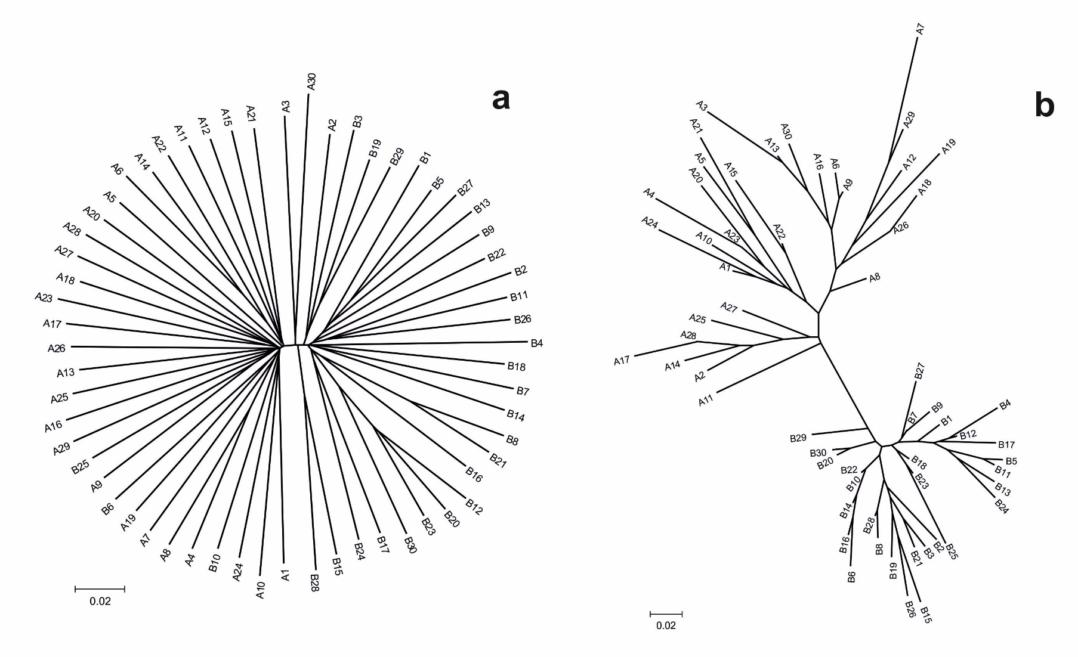
Fig. S4 Phylogenetic trees illustrating genetic relationships among the 60 individuals from allozyme cluster A and B collected in Lakes Östra and Västra Trollsvattnet using (a) SNPs (3,093 loci) and (b) allozymes (14 loci). The trees were generated using poptree2 (Takezaki et al. 2010) and are neighbour-joining and based on D_{A} distance

Fig. S5 Power to detect a heterozygote deficiency when sampling from a mix of two populations (F_{ST} = 0.1) for different sample sizes. Results were obtained using a modified version of powsim (Ryman and Palm 2006)
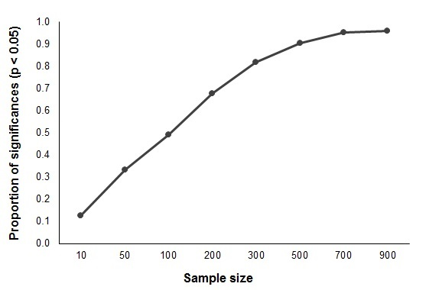

Fig. S6 Genetic differentiation (F_{ST}) between cluster A and B in Lakes Östra and Västra Trollsvattnet estimated from 14 allozyme loci over (a) 28 sampling years (1987-2014) and (b) 30 cohorts (1980-2009). Individuals were assigned to clusters with a probability cut-off = 0.5. There is a decreasing trend of F_{ST} over sampling years (R = -0.66; P < 0.001) as well as over cohorts although the latter is not statistically significant (R = -0.34; P = 0.07)
