Supplementary material

Table S1. Command line employed as input parameters for each replicated run in IMA2P*
Replicate | Command line IMA2P
A | Command line string : -i IMa_mtDNA_input_2pops.txt -o IMa_mtDNA_2pops_OUT20170522A.out -q 250 -m 1.5 -t 10 -u 26.19 -b 1000000 -L 1000000 -p 2357 -s 1478612289
B | Command line string : -i IMa_mtDNA_input_2pops.txt -o IMa_mtDNA_2pops_OUT20170522B.out -q 250 -m 1.5 -t 10 -u 26.19 -b 1000000 -L 1000000 -p 2357 -s 9754689125
C | Command line string : -i IMa_mtDNA_input_2pops.txt -o IMa_mtDNA_2pops_OUT20170522C.out -q 250 -m 1.5 -t 10 -u 26.19 -b 1000000 -L 1000000 -p 2357 -s 6687764563
D | Command line string : -i IMa_mtDNA_input_2pops.txt -o IMa_mtDNA_2pops_OUT20170522D.out -q 250 -m 1.5 -t 10 -u 26.19 -b 1000000 -L 1000000 -p 2357 -s 7852786375
E | Command line string : -i IMa_mtDNA_input_2pops.txt -o IMa_mtDNA_2pops_OUT20170522E.out -q 250 -m 1.5 -t 10 -u 26.19 -b 1000000 -L 1000000 -p 2357 -s 2934856253
F | Command line string : -i IMa_mtDNA_input_2pops.txt -o IMa_mtDNA_2pops_OUT20170522F.out -q 250 -m 1.5 -t 10 -u 26.19 -b 1000000 -L 1000000 -p 2357 -s 2057236262
*For the input data file the following parameters were employed:
Line 1: Sei_whales
Line 2: 2
Line 3: North_Atlantic North_Pacific
Line 4: (0,1):2
Line 5: 1
Line 6: mtDNA_control_region 84 488 487 H 0.25 0.000025811 (0.00000487,0.0000487)

where line 1 is the name of the species, line 2 – the number of populations, line 3 – the population’s name, line 4 – the topology of the tree including an ancestral population, line 5 – the number of loci, line 6 – the name of the loci, the sample sizes for each population, the length of the sequence, the mutation model (H: HKY), the inheritance scalar and the mutation rate per year per locus with the lowest and highest value in parentheses.

Table S2. Maximum-likelihood estimates of IMA2P model parameters with their respective demographic conversions for the North Atlantic and North Pacific sei whale populations
Replicate |  | Model parameters
Replicate |  | Parameter value | MLE | Lower 95% CI | Upper 95% CI
A |  | θ _{NA} | 6.375 | 2.125 | 14.38
B |  | θ _{NA} | 6.125 | 2.125 | 14.12
C |  | θ _{NA} | 6.375 | 2.375 | 14.62
D |  | θ _{NA} | 6.375 | 2.375 | 14.62
E |  | θ _{NA} | 5.375 | 1.875 | 14.12
F |  | θ _{NA} | 6.625 | 2.125 | 14.38
Average |  | θ _{NA} | 6.21 | 2.17 | 14.37
A |  | θ _{NP} | 53.38 | 38.62 | 72.88
B |  | θ _{NP} | 53.62 | 38.88 | 73.12
C |  | θ _{NP} | 53.12 | 38.38 | 72.62
D |  | θ _{NP} | 53.12 | 38.38 | 72.62
E |  | θ _{NP} | 53.88 | 38.62 | 73.62
F |  | θ _{NP} | 53.38 | 38.62 | 72.88
Average |  | θ _{NP} | 53.42 | 38.58 | 72.96
A |  | θ_{A} | 13.38 | 0 | 215.9
B |  | θ_{A} | 14.12 | 0 | 215.9
C |  | θ_{A} | 14.38 | 0 | 215.9
D |  | θ_{A} | 13.88 | 0 | 215.9
E |  | θ_{A} | 15.12 | 0 | 216.1
F |  | θ_{A} | 14.12 | 0 | 215.9
Average |  | θ_{A} | 14.17 | 0 | 215.93
A |  | m _{(NP→NA)} | 0.038 | 0 | 0.649
B |  | m _{(NP→NA)} | 0.043 | 0 | 0.656
C |  | m _{(NP→NA)} | 0.037 | 0 | 0.608
D |  | m _{(NP→NA)} | 0.038 | 0 | 0.613
E |  | m _{(NP→NA)} | 0.040 | 0 | 0.665
F |  | m _{(NP→NA)} | 0.041 | 0 | 0.632
Average |  | m _{(NP→NA)} | 0.040 | 0 | 0.637
A |  | m _{(NA→ NP)} | 0.00075 | 0 | 0.05475
B |  | m _{(NA→ NP)} | 0.00075 | 0 | 0.05475
C |  | m _{(NA→ NP)} | 0.00075 | 0 | 0.05475
D |  | m _{(NA→ NP)} | 0.00075 | 0 | 0.05475
E |  | m _{(NA→ NP)} | 0.00075 | 0 | 0.05325
F |  | m _{(NA→ NP)} | 0.00075 | 0 | 0.05475
Average |  | m _{(NA→ NP)} | 0.00075 | 0 | 0.05450
A |  | t | 4.205 | 1.455 | 9.995
B |  | t | 4.045 | 1.495 | 9.985
C |  | t | 4.345 | 1.465 | 9.985
D |  | t | 4.205 | 1.485 | 9.955
E |  | t | 4.175 | 1.465 | 9.995
F |  | t | 4.245 | 1.465 | 9.945
Average |  | t | 4.203 | 1.472 | 9.977

 |  | Demographic conversions
Replicate |  | Parameter value | MLE | Lower 95% CI | Upper 95% CI
A |  | 2Nm _{(NP→ NA)} | 0.245 | 0 | 1.976
B |  | 2Nm _{(NP→ NA)} | 0.254 | 0 | 1.961
C |  | 2Nm _{(NP→ NA)} | 0.245 | 0 | 1.989
D |  | 2Nm _{(NP→ NA)} | 0.241 | 0 | 1.978
E |  | 2Nm _{(NP→ NA)} | 0.254 | 0 | 1.935
F |  | 2Nm _{(NP→ NA)} | 0.248 | 0 | 1.964
Average |  | 2Nm _{(NP→ NA)} | 0.248 | 0 | 1.9672
A |  | 2Nm _{(NA→ NP)} | 0.0063 | 0 | 1.474
B |  | 2Nm _{(NA→ NP)} | 0.0063 | 0 | 1.487
C |  | 2Nm _{(NA→ NP)} | 0.0066 | 0 | 1.461
D |  | 2Nm _{(NA→ NP)} | 0.0066 | 0 | 1.461
E |  | 2Nm _{(NA→ NP)} | 0.0069 | 0 | 1.468
F |  | 2Nm _{(NA→ NP)} | 0.0069 | 0 | 1.468
Average |  | 2Nm _{(NA→ NP)} | 0.0066 | 0 | 1.4698
A |  | T_{DIV} | 162,915 | 56,371 | 387,238
B |  | T_{DIV} | 156,716 | 57,921 | 386,851
C |  | T_{DIV} | 168,339 | 56,759 | 386,851
D |  | T_{DIV} | 162,915 | 57,534 | 385,688
E |  | T_{DIV} | 161,753 | 56,759 | 387,238
F |  | T_{DIV} | 164,465 | 56,759 | 385,301
Average |  | T_{DIV} | 162,851 | 57,017 | 386,528
Notes: Maximum likelihood estimates (MLE) and 95% credible interval for the lower (Lower 95% CI) and upper (Upper 95% CI) bound for each of the model and demographic parameter values. NA: North Atlantic, NP: North Pacific, A: ancestral population. θ: 4N_{e}μ, where N_{e} denotes the effective population size, and μ the generational mutation rate per locus; m is the mutation scaled migration rate from the NP into the NA (m _{(NP →NA)}) and from the NA into the NP (m _{(NA →NP)}) forward in time; t is the mutation scaled divergence time. 2N_{e}m is the effective number of migrant gene copies per generation, T_{DIV} is the divergence time in years. Demographic conversions are based on a mutation rate of 2.58 x 10⁻⁵ per year (for the entire locus; i.e. 487 sites) and a generation time of 26.19 years. The parameter values are the average of six replicated runs according to Table S1.

Figure S1. Marginal posterior probability densities for theta ($θ$), mutation rate times divergence time (t), mutation scaled migration rate (m) between North Atlantic and North Pacific populations.
Notes: (a) Estimated theta ($θ$), (b) divergence time times mutation rate between North Atlantic and North Pacific populations (t), estimated mutation scaled migration rate (m) from (c) the North Pacific into the North Atlantic (m_{(NP →NA)}) and from (d) the North Atlantic into the North Pacific (m_{(NA →NP)}) forward in time. µ is the mutation rate per year per locus. Results are based on mtDNA data from six replicates employing the coalescent approach in IMA2P.

Table S3. Likelihoods of different values of K estimated with STRUCTURE
Number of clusters (K) | Likelihood of (K) | Standard deviation  of likelihood (K)
North Atlantic and North Pacific
1 | -10254.4 | 0.3
2* | -9332.4 | 3.1
3 | -9503.8 | 202.2
4 | -9659.0 | 212.4
5 | -9644.7 | 203.7
North Atlantic
1* | -2138.0 | 0.5
2 | -2142.9 | 3.3
3 | -2149.7 | 12.1
4 | -2145.2 | 3.7
5 | -2144.3 | 3.6
*K = 2 was estimated as the most likely number of clusters for the North Atlantic and North Pacific samples combined. K = 1 was estimated as the most likely number of clusters for the North Atlantic.

Figure S2. Neighbor-joining haplotype network (left) and genealogy (right) of mtDNA control region haplotypes. Each node in the haplotype network represents a haplotype and node sizes are proportional to haplotype frequencies. Each line segment between nodes represents one nucleotide difference. For convenience, only the North Atlantic haplotype designations and the designations of the four most frequently occurring North Pacific haplotypes are shown. The haplotype tree is drawn to scale, with branch lengths in the evolutionary distance unit of number of base substitutions per site. Only bootstrap values above 60% are shown.
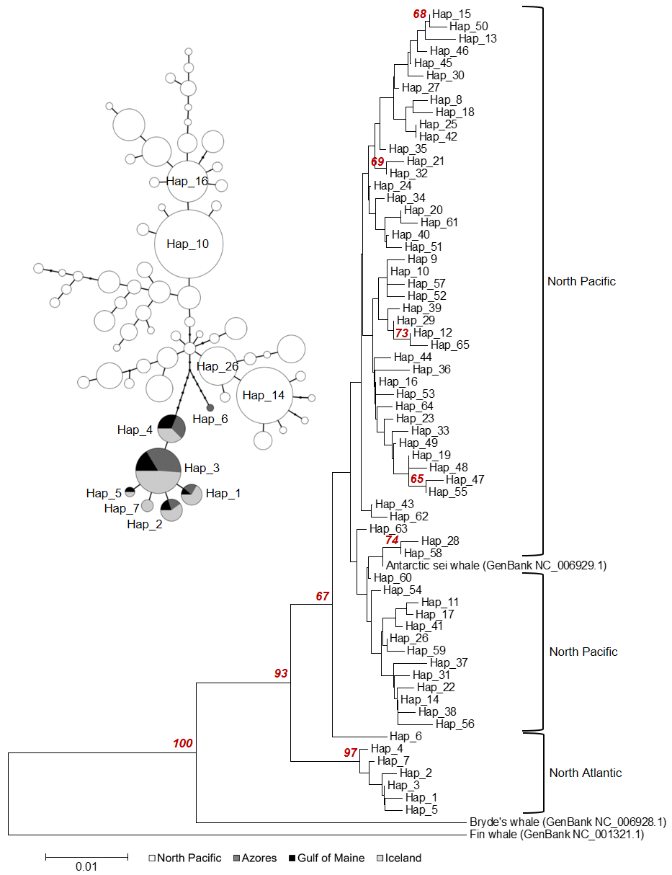

Figure S3. Simulated trajectories of increasing genetic divergence (F_{ST}) over time for a population of exponentially expanding size (continuous line) and for a population of constant size (dotted line), with no gene flow. T_{DIV}: number of generations after population divergence. Input parameters used to obtain these data: sample size (chromosomes): 200, number of loci per estimation: 6, Theta: 0.01, Alpha: 10.
