Supplementary Information.
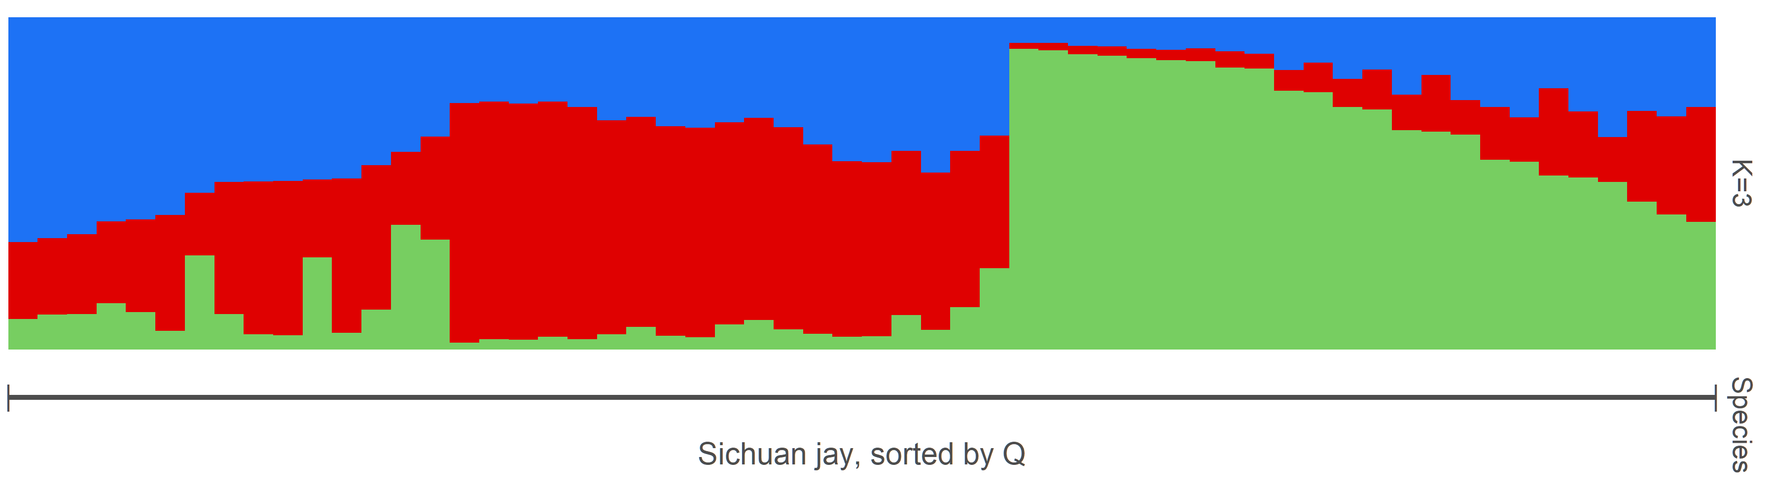
Suppl. Fig. 1. STRUCTURE plot for Sichuan jays given K=3, sorted by assignment probability (Q).
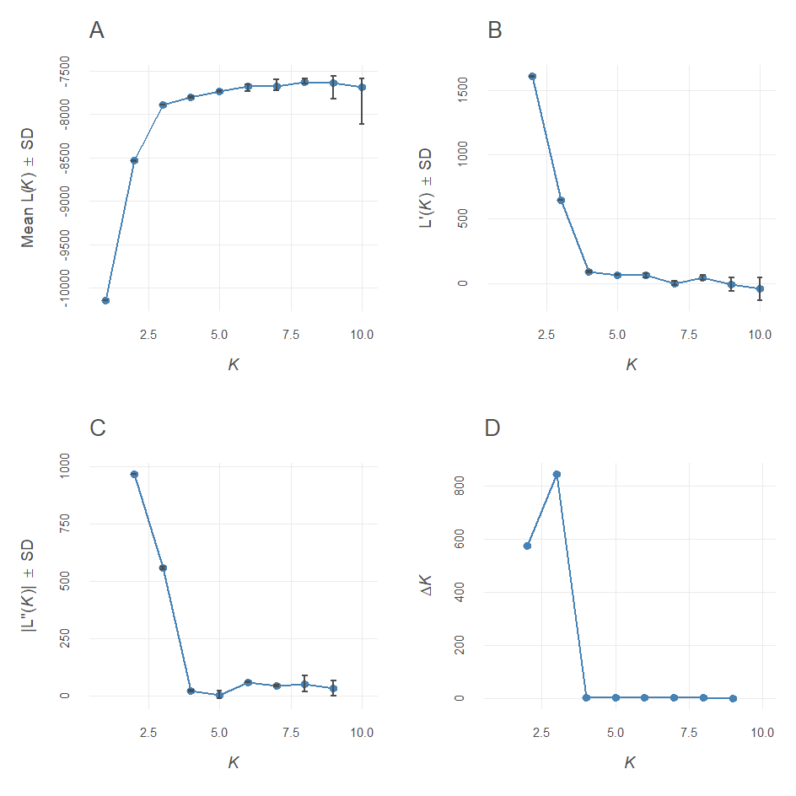
Suppl. Fig. 2. Evanno plots for all jay samples, indicating the number of clusters yielding the highest likelihood is 3
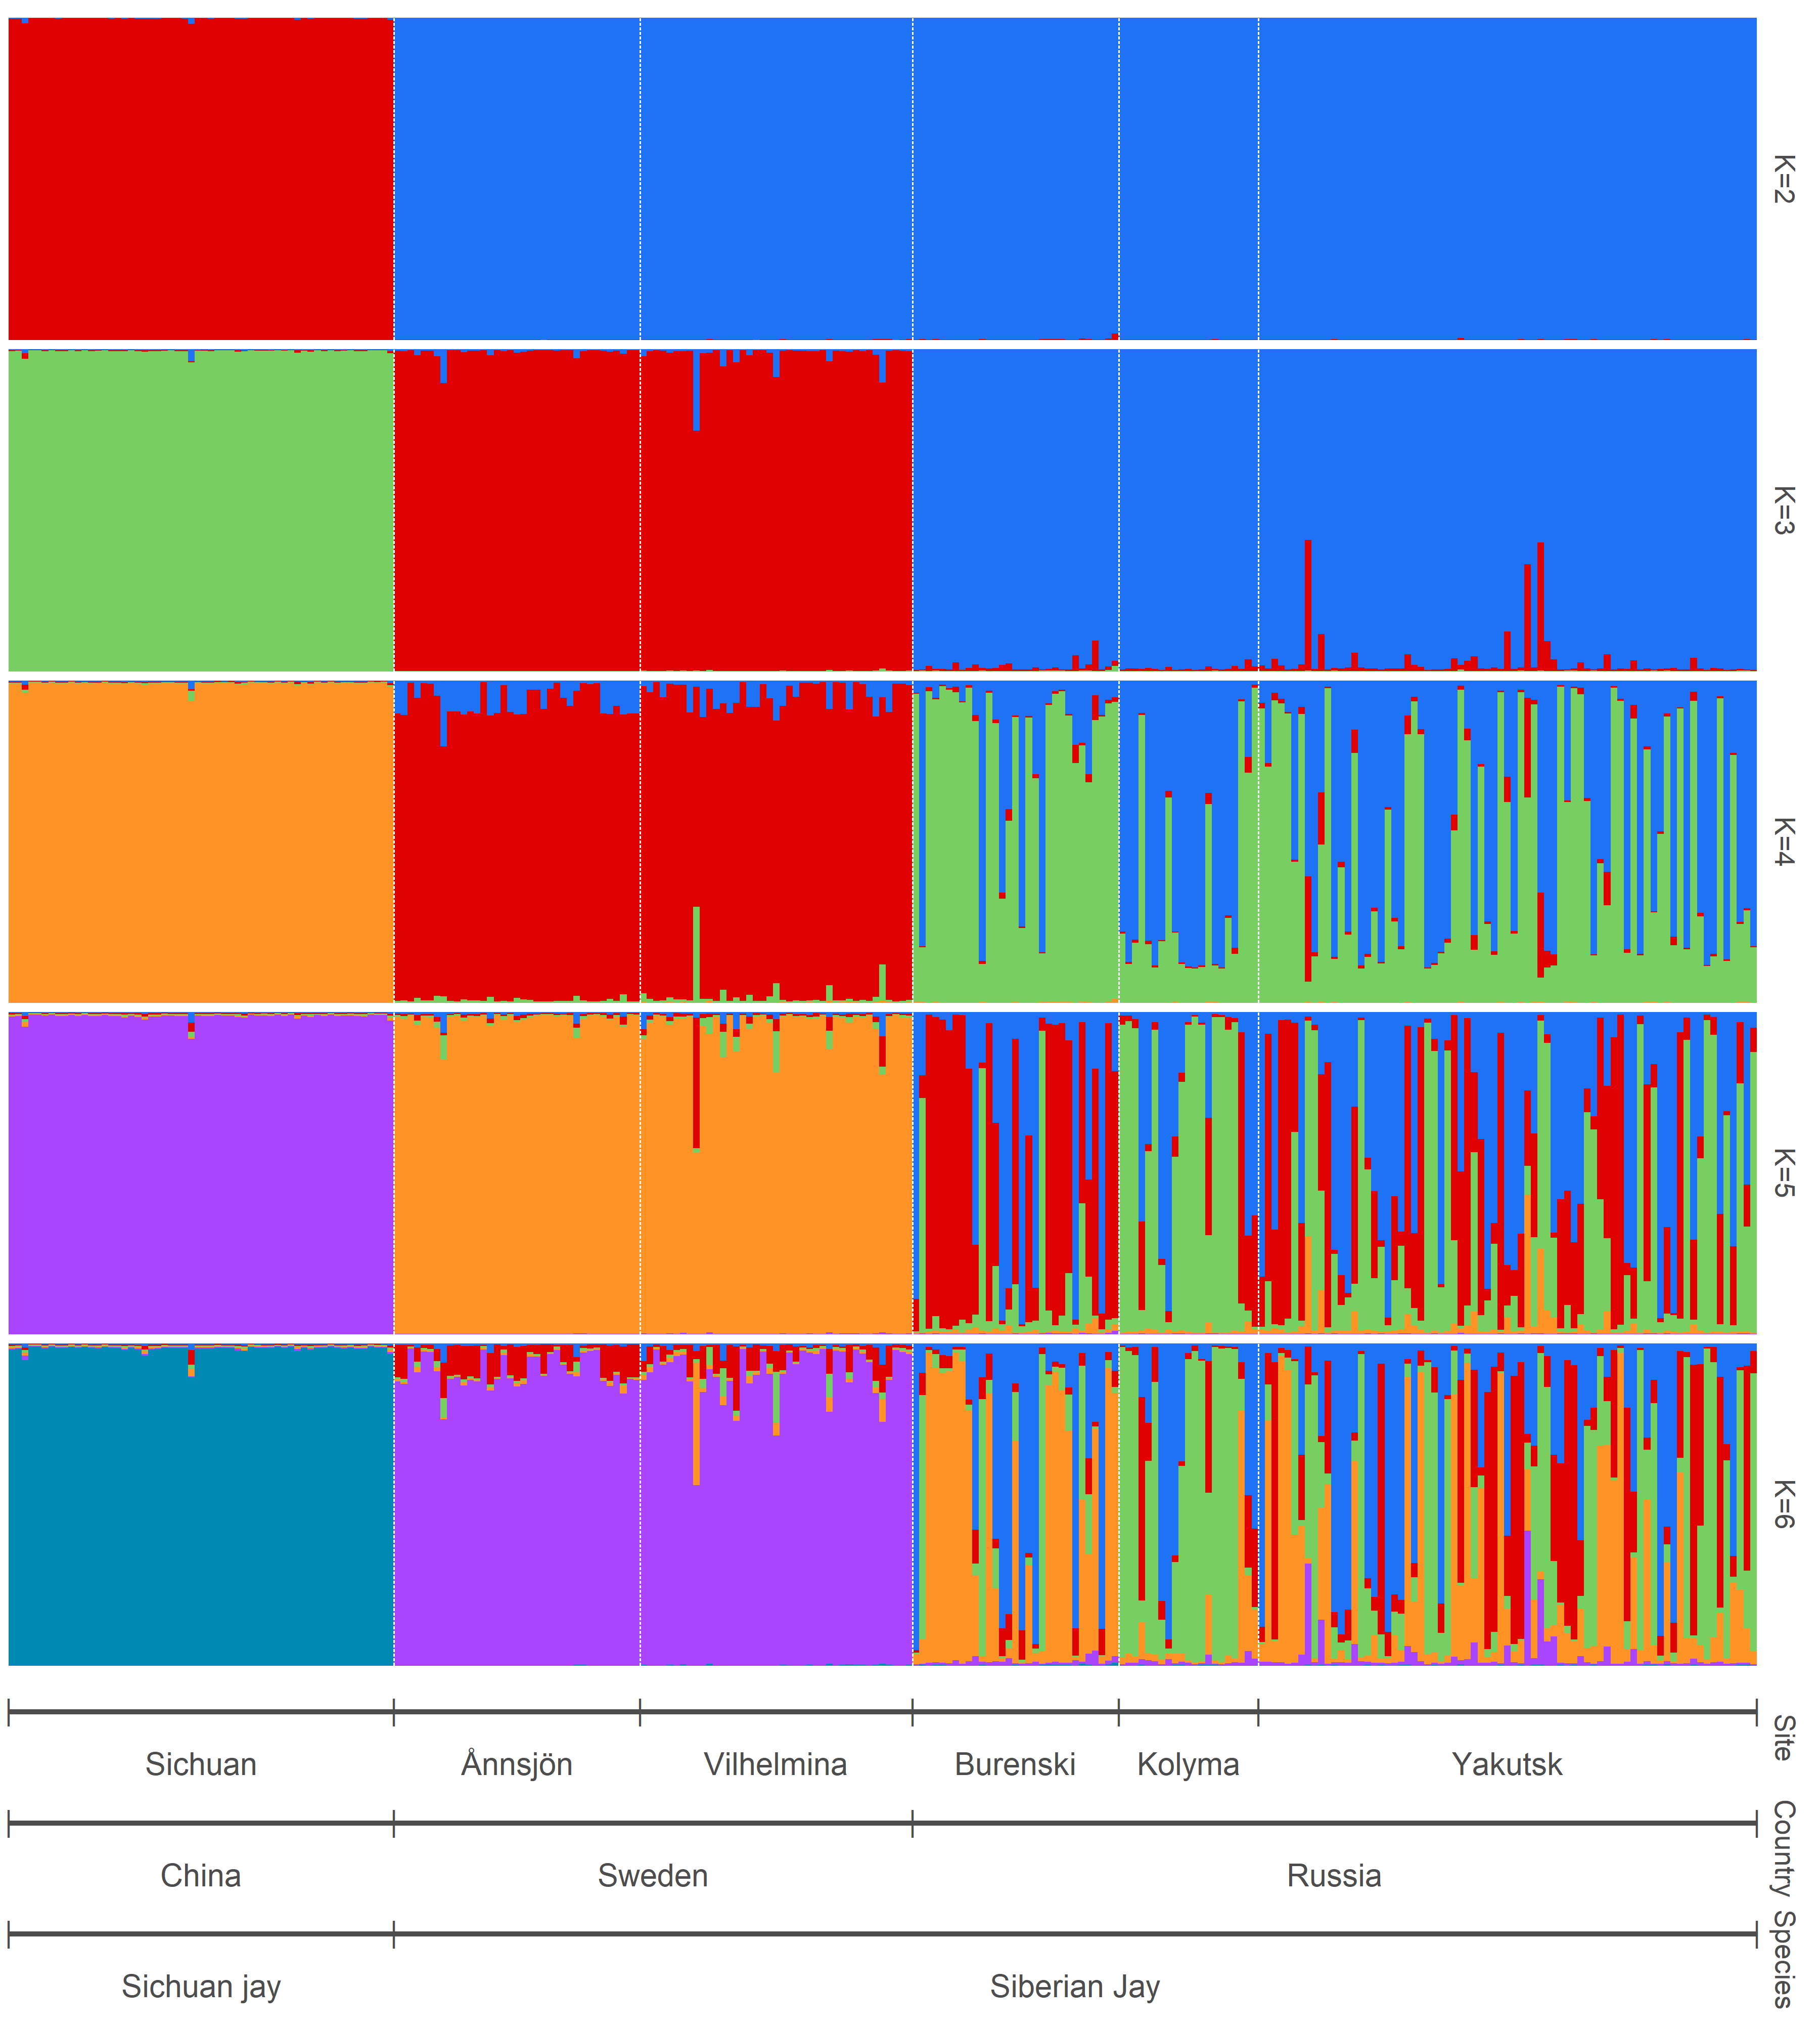
Suppl. Fig. 2. STRUCTURE plots of all jay samples (both species) for K=2-6 showing differentiation among China, Sweden and Russia with weak further substructuring among Siberian locations.

