Appendix 1. Complete breakdown of the 62 PCTs in Lake Macquarie and how they were assigned cell values for the least cost path analysis.
PCT Name | Value
Cladium procerum coastal freshwater wetland | 100
Common Reed on the margins of estuaries and brackish lagoons along the New South Wales coastline | 100
Grey Mangrove low closed forest | 100
Jointed Twig-rush sedgeland | 100
Kangaroo Grass - Coastal Rosemary grassland on coastal headlands | 100
Lepironia articulata sedgeland | 100
Red-fruit Saw-sedge - Baumea - Coral Fern shrubby sedgeland on the margins of freshwater coastal lagoons along the New South Wales coastline | 100
Saltmarsh in estuaries of the Sydney Basin Bioregion and South East Corner Bioregion | 100
Spinifex beach strand grassland Sydney Basin Bioregion and South East Corner Bioregion | 100
Typha rushland | 100
Water Couch - Tall Spike Rush freshwater wetland of the Central Coast and lower Hunter | 100
Woolly Water lily - Sand Couch coastal freshwater wetland | 100
Tuckeroo - Lilly Pilly - Coast Banksia littoral rainforest | 75
Jackwood - Lilly Pilly - Sassafras riparian warm temperate rainforest of the Central Coast | 75
Leptospermum liversidgei-Callistemon citrinus-Xanthorrhoea fulva wet heath on coastal sands of lower North Coast | 75
Lilly Pilly - Grey Myrtle - Rasp Fern warm temperate rainforest on ranges of the Central and lower North Coast | 75
Needlebush - banksia wet heath on sandstone plateaux of the Sydney Basin Bioregion | 75
Bangalay - Old-man Banksia open forest on coastal sands Sydney Basin Bioregion and South East Corner Bioregion | 20
Dwarf Casuarina - Prickly-leaved Paperbark - Hairpin Banksia Coastal Heath of the Central Coast and lower North Coast | 20
Paperbark swamp forest of the coastal lowlands of the NSW North Coast Bioregion and Sydney Basin Bioregion | 20
Paperbarks - Woollybutt swamp forest on coastal lowlands of the Central Coast | 20
Swamp paperbark - Baumea juncea swamp shrubland on coastal lowlands of the Central Coast and Lower North Coast | 20
Wallum Banksia-Monotoca scoparia heath on coastal sands of the Central Coast and lower North Coast | 20
Fern-leaf Banksia - Prickly-leaved Paperbark-Tantoon - Leptocarpus tenax wet heath on coastal sands of the Central Coast and lower North Coast | 10
Melaleuca biconvexa - Swamp Mahogany - Cabbage Palm swamp forest of the Central Coast | 10
Prickly-leaved Paperbark - Fern-leaved Banksia heath on coastal headlands of Central Coast | 10
Prickly-leaved Paperbark forest on coastal lowlands of the Central Coast and Lower North Coast | 10
Smooth-barked Apple - Cabbage Palm - Broad-leaved Mahogany woodland on Wallarah Peninsular | 10
Swamp Mahogany - Broad-leaved Paperbark - Swamp Water Fern - Plume Rush swamp forest on coastal lowlands of the Central Coast and Lower North Coast | 10
Swamp Mahogany - Flax-leaved Paperbark swamp forest on coastal lowlands of the Central Coast | 10
Swamp Mahogany swamp sclerophyll forest on coastal lowlands of the Sydney Basin Bioregion and South East Corner Bioregion | 10
Swamp Oak - Sea Rush - Baumea juncea swamp forest on coastal lowlands of the Central Coast and Lower North Coast | 10
Banksia oblongifolia-Hakea teretifolia/Leptocarpus tenax-Lepyrodia scariosa wet heath on sandstone ranges of the Central Coast | 1
Blackbutt - Narrow-leaved White Mahogany shrubby tall open forest of coastal ranges Northern Sydney Basin Bioregion | 1
Blackbutt - Turpentine - Sydney Blue Gum mesic tall open forest on ranges of the Central Coast | 1
Broad-leaved Paperbark - Swamp Oak - Saw Sedge swamp forest on coastal lowlands of the Central Coast and Lower North Coast | 1
Cabbage Gum - Forest Red Gum - Flax-leaved Paperbark Floodplain Forest of the Central Coast | 1
Coast Banksia - Coast Wattle dune scrub of the Sydney Basin Bioregion and South East Corner Bioregion | 1
Coast Tea Tree - Coast Banksia - Ficinia nodosa low open shrubland on coastal foredunes | 1
Forest Red Gum grassy open forest on floodplains of the lower Hunter | 1
Grey Gum - Smooth-barked Apple - Blue-leaved Stringybark shrub - grass open forest on coastal ranges of the Sydney Basin | 1
Grey Ironbark - Broad-leaved Mahogany - Forest Red Gum shrubby open forest on Coastal Lowlands of the Central Coast | 1
Grey Ironbark - Broad-leaved Mahogany - Smooth-barked Apple coastal headland low open forest of the Central Coast | 1
Red Bloodwood - Silvertop Ash - Stringybark open forest on ironstone in the Sydney region | 1
Red Ironbark - Spotted Gum - Prickly-leaved Paperbark shrubby open forest of the Lower Hunter | 1
Scribbly Gum - Red Bloodwood - Angophora inopina heathy woodland on lowlands of the Central Coast | 1
Smooth-barked Apple - Blackbutt - Old Man Banksia woodland on coastal sands of the Central and Lower North Coast | 1
Smooth-barked Apple - Red Bloodwood - Brown Stringybark - Hairpin Banksia heathy open forest of coastal lowlands | 1
Smooth-barked Apple - Red Bloodwood - Scribbly Gum grass - shrub woodland on lowlands of the Central Coast | 1
Smooth-barked Apple - Red Mahogany - Swamp Mahogany - Melaleuca sieberi heathy swamp woodland of coastal lowlands | 1
Smooth-barked Apple - Swamp Mahogany - Red Mahogany - Cabbage Palm open forest on lowlands of the Central Coast | 1
Smooth-barked Apple - Sydney Peppermint - Turpentine heathy open forest on plateaux areas of the Sydney Basin Bioregion | 1
Smooth-barked Apple - Turpentine - Blackbutt open forest on ranges of the Central Coast | 1
Smooth-barked Apple - Turpentine - Sydney Peppermint heathy woodland on sandstone ranges of the Central Coast | 1
Spotted Gum - Broad-leaved Mahogany - Red Ironbark shrubby open forest | 1
Sydney Blue Gum - Lilly Pilly mesic tall open forest of coastal ranges and tablelands escarpment | 1
Tallowwood - Smooth-barked Apple - Blackbutt grass tall open forest of the Central and lower North Coast | 1
Turpentine - Rough-barked Apple - Mountain Blue Gum shrubby open forest on ranges of the Sydney Basin | 1
White Mahogany - Spotted Gum - Grey Myrtle semi-mesic shrubby open forest of the central and lower Hunter Valley | 1

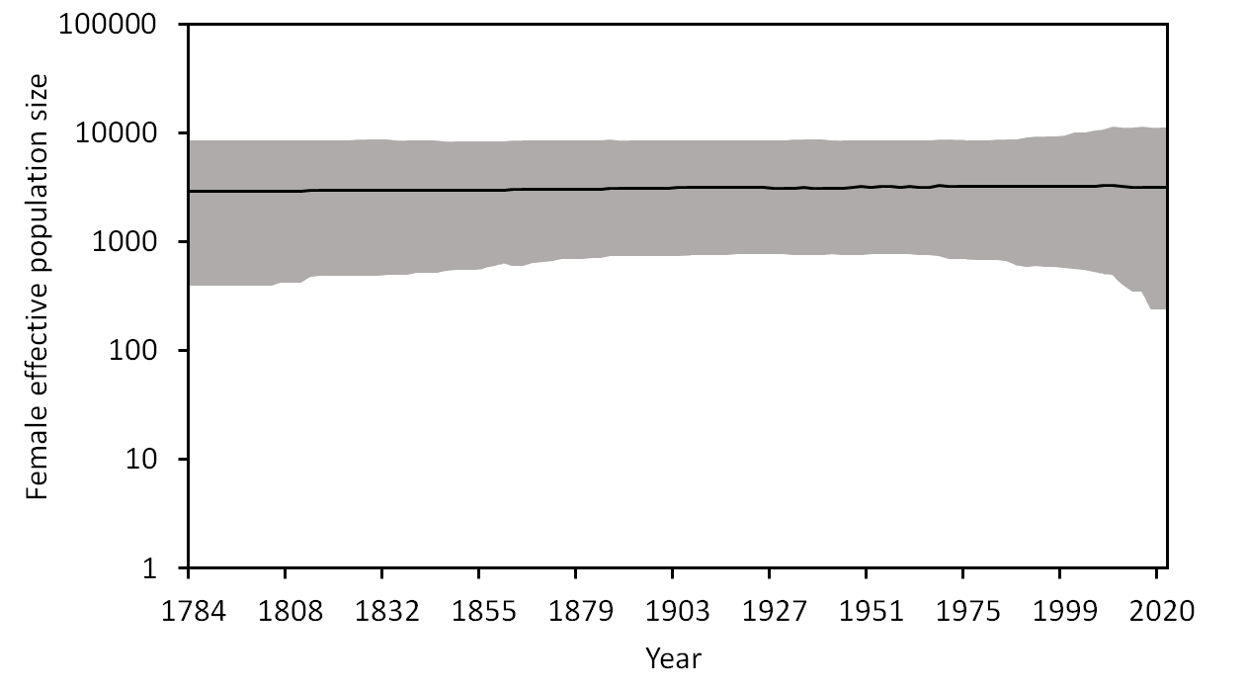

Appendix 2. A Bayesian skyline plot derived from 70 squirrel glider cytochrome b sequences. Plot depicts the estimated mean female effective population size of squirrel gliders in the Lake Macquarie and Forster region over time. The mean is depicted in black, while upper and lower confidence intervals are displayed in grey. The x axis extends to 2020, the year when sampling was completed.

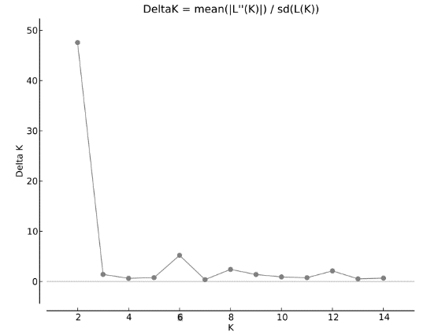

Appendix 3. Squirrel glider Delta K results from the Structure Harvester Evanno method. STRUCTURE tested 15 clusters (K = 1 – 15) with 8 replicates each. DeltaK = mean(|L”(K)|) / sd(L(K)).

