Supplementary material for ‘Genetic diversity and origin of captive lion (Panthera leo) in South Africa: an assessment and comparison to wild populations’
Susan M Miller^{1,2*}, Antoinette Kotze^{3,4}, Cindy K Harper⁵, Jacqueline M. Bishop², Vivienne L. Williams⁶, Marli de Bruyn³, Desiré Lee Dalton^{3,7}, S.A. Jeanetta Selier^{3,8}
¹ FitzPatrick Institute of African Ornithology, DSI-NRF Centre of Excellence, Department of Biological Sciences, University of Cape Town, Cape Town, South Africa
² Institute for Communities and Wildlife in Africa, Department of Biological Sciences, University of Cape Town, Cape Town, South Africa
³ South African National Biodiversity Institute, Pretoria, South Africa
⁴ Genetics Department, University of the Free State, Bloemfontein, South Africa
⁵ Veterinary Genetics Laboratory, Faculty of Veterinary Science, University of Pretoria
⁶ School of Animal, Plant and Environmental Sciences, University of the Witwatersrand, Johannesburg, South Africa
⁷ School of Health and Life Sciences, Teesside University, Middlesbrough, TS1 3BX, United Kingdom
⁸ School of Life Sciences, University of KwaZulu-Natal, Durban, South Africa

*Corresponding author: Susan M Miller, email: sm.miller@uct.ac.za

Susan M Miller: 0000-0002-5976-2742
Antoinette Kotze: 0000-0003-2367-1483 Cindy K Harper: 0000-0003-1766-7218
Jacqueline M. Bishop: 0000-0003-4703-1704 Vivienne L. Williams: 0000-0003-0698-6512 Marli de Bruyn: 0000-0002-0368-1230 Desiré Lee Dalton: 0000-0001-5975-6425
S.A. Jeanetta Selier: 0000-0003-1598-464X

File S1. Questions from National Captive Lion Survey of privately-owned captive lions in South Africa (Williams & ‘t Sas-Rolfes, 2019) that were relevant to this study and an explanation of the additional information that was extracted for this study.

Q5. What year did the facility open?
Linked to Q30 – details below

- From where has the current lion stock in the facility been sourced: (select all that apply to your facility)
  - Lions bred in this facility
  - Lions from breeders in South Africa
  - Lions from breeders elsewhere in Africa
  - Lions from breeders elsewhere
  - Wild-sourced lions from South Africa
  - Wild-sourced lions from elsewhere in Africa
  - Do not know
  - Other*
  - Other (please specify)
Summarised in Figure 1b

- From where was the original lion stock for the facility sourced: (select all that apply to your facility)
  - Lions bred in this facility
  - Lions from breeders in South Africa
  - Lions from breeders elsewhere in Africa
  - Lion breeders elsewhere
  - Circuses
  - Wild-sourced lions from South Africa
  - Wild-sourced lions from elsewhere in Africa
  - Do not know
  - Other*
  - Other (please specify)
Summarised in four-year increments based on the answers to Q5 – Figure 1a

36. Has the facility ever introduced wild lions into its breeding stock?

If yes, indicate when, where and/or which populations(s) the stock was from

Used to supplement answers from Q29 and Q30 to capture any wild lion introductions that were not part of the original stock and are no longer present in the facility.
Williams, V. L., & ‘t Sas-Rolfes, M. J. (2019). Born captive: A survey of the lion breeding, keeping and hunting industries in South Africa. PLOS ONE, 14(5), e0217409. https://doi.org/10.1371/journal.pone.0217409

File S2. Breakdown of data available, data manipulations and dataset used for each analysis based on Table/Figure numbers
Data
Source | Genotypes original | Genotypes 13 | Subset unrelated at 0.25 level
Standardisation exercise | 39 | 39
VGL – captive | 38 | 38
Unistel – captive | 729 | 704
SANBI – captive | 120 | 0*
Total captive | 926 | 781 | 128
VGL – Kruger NP | 54 | 51
VGL – Kgalagadi TP | 11 | 10
VGL – Pilansberg NP (Etosha NP origin) | 26 | 25
VGL – Mapungubwe TFCA | 10 | 9
Total SA open systems | 101 | 95
VGL - metapopulation | 242 | 170
*not enough overlapping markers to include existing SANBI genotypes in most analyses

Analyses
Table 1 – Summary statistics: Genotypes 13 – Kruger NP, Total captive and subset captive, also included SANBI captive for markers where data was available
Figure 2 – STRUCTURE analysis: Genotypes 13– all open systems; Subset – Total captive
Figure 4 – Individual heterozygosity: Genotypes 13 – Total captive, Kruger NP, metapopulation
Figure 5 – Relatedness connectivity: Genotypes 13 – metapopulation; Subset – Total captive
Figure 6 – Relatedness box plot: Genotypes 13 – Kruger NP, metapopulation; Subset – Total captive
Figure 7 – PCA: Genotypes 13 – Total captive, Total SA open systems
Figure 8 – Assignment test: Genotypes 13 – Total captive, Total SA open systems

Table S1 Microsatellite markers used for lion genotypes at all three laboratories and correction factors developed for the three laboratories.
* indicates used in retrospective analysis of captive genotypes

Correction Factors
Microsat | VGL | Unistel | SANBI | Unistel | SANBI | Notes
FCA057* | Y | Y | Y | +10 | +7
FCA275* | Y | Y | Y | +9 | +6
FCA097* | Y | Y |  | +10 | +8
FCA224* | Y | Y | Y | +10 | +4
FCA391* | Y | Y | Y | +9 | +6
FCA453* | Y | Y | Y | +6 | +7
FCA026* | Y | Y | Y | +10/+12 | +8/+10 | A shift from odd to even; likely caused by a 1bp insertion
FCA240* | Y | Y |  | +10 |  | X-linked; useful for parentage
FCA272* | Y | Y |  | +9
FCA506* | Y | Y |  | +11
FCA628* | Y | Y |  | +11
F42* | Y | Y |  | +5
FCA031* | Y | Y |  | +10
FCA075 | Y | Y |  | +11/+9 |  | One small allele that was rounded up at VGL and down at Unistel; useful going  forward
FCA105 | Y | Y |  |  |  | No longer used at VGL as linked to FCA113, but with FCA113 removed, we could  reinstate it; historically used at SANBI
FCA096 | Y |  | Y |  | +6 | Historic challenges at Unistel
FCA113 | Y | Y |  |  |  | Some single bp repeats, hard to standardize
FCA126 | Y | Y | Y |  |  | Rounding issues at larger alleles
FCA001 | Y | Y |  |  |  | Rounding issues at lower end; also a “messy” marker, not great for standardization
FCA230 | Y | Y |  |  |  | Does not amplify consistently at VGL or Unistel
FCA310 | Y | Y | Y |  |  | No longer used at VGL due to linkage with other, more informative markers
FCA069 | Y | Y | Y |  |  | No longer used at VGL due to linkage with other, more informative markers
FCA085 | Y |  | Y |  |  | No longer used at VGL due to linkage with other, more informative markers
FCA441 | Y |  |  |  |  | Historically used at SANBI
FCA193 | Y |  | Y
FCA008 | Y |  | Y

Correction Factors
Microsat | VGL | Unistel | SANBI | Unistel | SANBI | Notes
F37 | Y
FCA719 |  |  | Y
FCA247 |  |  | Y
FCA171 |  |  | Y
FCA211 |  |  | Y
FCA212 |  |  | Y
FCA139 |  |  | Y
FCA077 |  |  | Y
FCA032 |  |  | Y
FCA043 |  |  | Y
FCA014 |  |  | Y
FCA005 |  |  | Y

Table S2 PCR protocol for microsatellite marker amplification of samples in the standardization exercise.

Panel 1 | Dye label | Concentration | Size Range
FCA230 | FAM | 0.08 | 98-116
FCA026 | FAM | 0.07 | 135-152
FCA096 | FAM | 0.06 | 200-218
FCA193 | VIC | 0.07 | 111-119
FCA057 | VIC | 0.08 | 164-180
FCA275 | NED | 0.07 | 128-136
FCA506 | NED | 0.07 | 186-233
ZnF | PET | 0.07
Panel 2
FCA272 | FAM | 0.08 | 105-111
FCA224 | FAM | 0.08 | 158-177
FCA097 | VIC | 0.08 | 144-164
FCA453 | VIC | 0.06 | 192-204
FCA001 | NED | 0.08 | 133-169
F41 | PET | 0.07 | 101-110
F42cht | PET | 0.07 | 234-249
Panel 3
FCA240 | FAM | 0.08 | 189-211
FCA031 | FAM | 0.06 | 239-251
FCA628 | VIC | 0.08 | 108-119
FCA113 | VIC | 0.06 | 149-159
FCA075 | NED | 0.06 | 105-137
FCA391 | NED | 0.07 | 201-233
FCA126 | PET | 0.07 | 186-222

PCR conditions: 10μl reaction with 2x Kapa Master Mix, 1μl DNA
Thermocycler set to:
95°C for 3 minutes
30 cycles of: 95°C for 15 seconds
59°C for 30 seconds 72°C for 30 seconds
72°C for 10 minutes Hold at 4°C

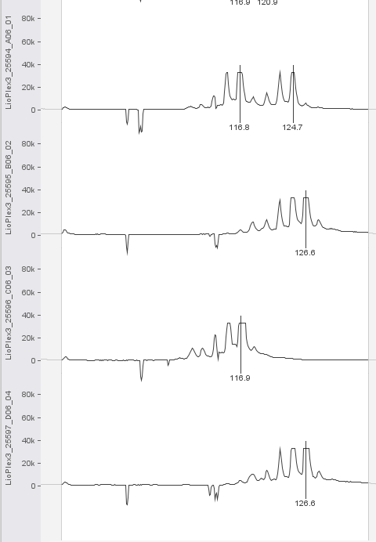

Fig S1. Example of traces of sheared off microsatellite allele peaks for FCA075. The largest peaks are sheared off and thus look similar in size/height to the stutter peaks immediately to the left. It is therefore impossible to reliably tell individuals that are homozygous apart from those that are heterozygous for two alleles that are only two base pairs apart.

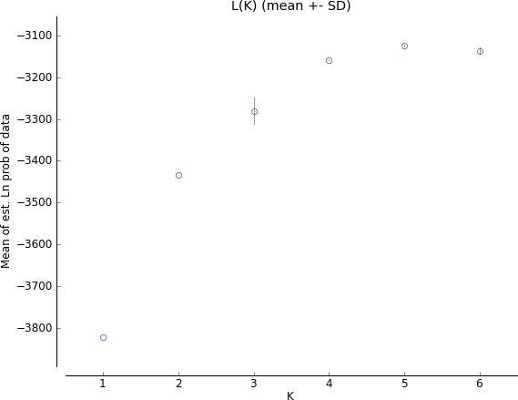

Fig. S2a Plot of the mean of the estimated Ln of the probability for the Open System STRUCTURE run (Figure 1) as created by Structure Harvester.
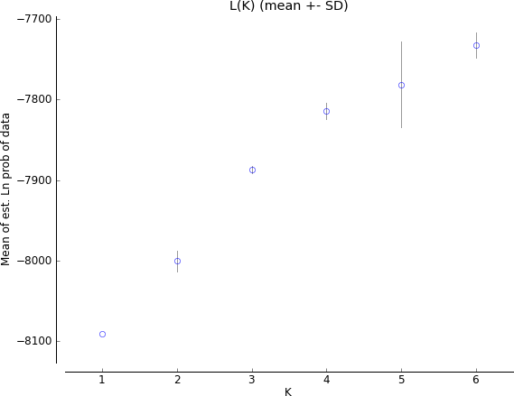

Fig. S2b Plot of the mean of the estimated Ln of the probability for the Captive STRUCTURE run (Figure 5) as created by Structure Harvester

