Supplementary Information

Title
Genetic diversity and inbreeding in an endangered island-dwelling parrot population following repeated population bottlenecks

Authors
Daniel Gautschi^{¶1}, Robert Heinsohn¹, Luis Ortiz-Catedral², Dejan Stojanovic¹, Melinda Wilson³, Ross Crates¹, Nicholas A. Macgregor^{4, 5}, Penny Olsen⁶, Linda Neaves¹

- Fenner School of Environment and Society, Australian National University, Canberra, ACT, Australia
- Oceania Conservation Program, World Parrot Trust, Hayle, UK
- Norfolk Island National Park and Botanic Garden, Norfolk Island, Australia
- Parks Australia, Canberra, ACT, Australia
- Durrell Institute of Conservation and Ecology (DICE), School of Anthropology and Conservation, University of Kent, Canterbury, UK
- Division of Ecology and Evolution, Research School of Biology, Australian National University, Canberra, ACT, Australia

¶ Corresponding Author: daniel.gautschi@anu.edu.au

Fig. S1 Results from the function find.clusters, indicating the most likely number of genetic clusters in the green parrot population. BIC represents the Bayesian information criterion.
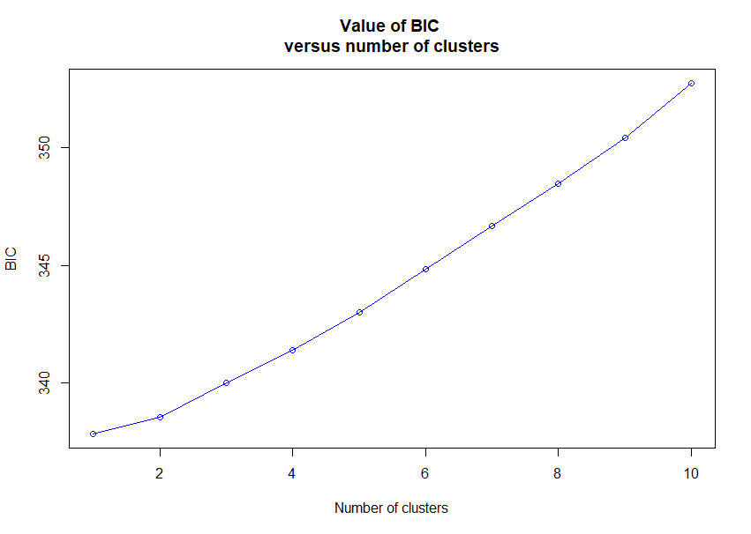

Fig. S2 Plot showing membership coefficients (Q) of individual green parrots to populations A when K = 2 (correlated alleles), and B when K = 3 (uncorrelated alleles), using the program CLUMPAK.
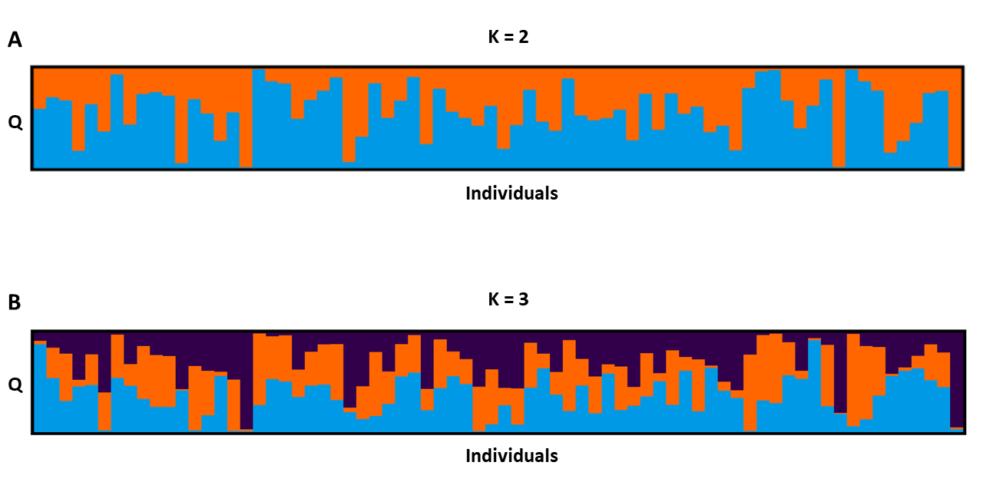

Table S1 Genetic samples (n = 188) submitted for sequencing by year of collection, type of genetic material collected, method of sourcing sample (directly/indirectly from the bird), strategy/method used for collection, and storage type. All birds sampled under the strategy “Management” were nestlings.
Year | Material | Indirect / Direct | Strategy / Method | Storage method | Samples | Included in final sample (n = 157) | Molecular sexing  (n = 155)
2015 | Blood | Direct | Management | Dry | 48 | 36 | 48
2019 | Feathers | Direct | Management | Dry | 5 | 4 | 5
2019 | Feathers | Indirect | Management | Dry | 5 | 1 | 0
2020 | Feathers | Direct | Management | Dry | 35 | 31 | 33
2020 | Feathers | Indirect | Management | Dry | 1 | 1 | 0
2021 | Blood | Direct | Mist-netting | Ethanol | 1 | 1 | 1
2021 | Feathers | Direct | Mist-netting | Dry | 8 | 7 | 0
2021 | Feathers | Direct | Management | Dry | 12 | 11 | 6
2021 | Feathers | Indirect | Opportunistic | Dry | 3 | 0 | 0
2021 | Eggshell | Indirect | Opportunistic | Dry | 2 | 0 | 0
2022 | Blood | Direct | Mist-netting | Dry | 50 | 50 | 50
2022 | Feathers | Indirect | Opportunistic | Dry | 6 | 3 | 0
2022 | Feathers | Direct | Management | Dry | 12 | 12 | 12

Table S2 Duplicate green parrot samples identified using the sequoia package in R v4.2.1. Mismatch indicates the number of single nucleotide polymorphisms (SNPs) at which genotypes differ. SnpdBoth indicates the number of loci at which the two individuals are both successfully genotyped and LLR is the likelihood ratio between self and the most likely non-self.
Sample | Duplicate | Mismatch | SnpdBoth | LLR
NIGP_122 | NIGP_137 | 8 | 780 | 96.70
2022_09 | NIGP_131 | 14 | 780 | 94.43
2022_15 | NIGP_082 | 15 | 780 | 94.26
2022_55 | 2022_56 | 12 | 780 | 94.05
NIGP_001c | NIGP_001f | 31 | 766 | 75.37
2022_44 | NIGP_030 | 39 | 778 | 74.46
NIGP_001a | NIGP_001f | 45 | 762 | 55.15
NIGP_001b | NIGP_001f | 47 | 764 | 54.91
NIGP_001b | NIGP_001c | 49 | 761 | 54.65
NIGP_001a | NIGP_001c | 50 | 761 | 51.43
NIGP_057 | NIGP_127 | 54 | 768 | 37.73
NIGP_009 | NIGP_010 | 49 | 751 | 31.82

Table S3 Recaptures identified through bands and DNA sequencing
ID | Date of Hatching / (First Capture) | Date of Recapture | Age (years) | Distance travelled (m) | Primary  Source of recapture identification
2022_22 | 21/06/2014 | 19/02/2022 | 7.7 | 406 | Bands
2022_50 | 22/07/2014 | 24/02/2022 | 7.6 | 1144 | Bands
NIGP_127 | 16/02/2015 | 21/04/2021 | 6.2 | 88 | Bands
2022_15 | 3/07/2015 | 18/02/2022 | 6.6 | 559 | Bands
2022_21 | 5/07/2016 | 19/02/2022 | 5.6 | 736 | Bands
NIGP_130 | 9/09/2016 | 22/04/2021 | 4.6 | 311 | Bands
2022_41 | 9/09/2016 | 22/02/2022 | 5.5 | 557 | Bands
2022_13 | 2/05/2018 | 18/02/2022 | 3.8 | 693 | Bands
2022_44 | 24/07/2020 | 23/02/2022 | 1.6 | 621 | Bands
2022_09 | (23/04/2021) | 17/02/2022 | NA | 179 | DNA

Table S4 Parameters used for bottleneck simulation parameter testing in fastsimcoal2.7 using 100 individual runs, 50 optimization cycles and 100,000 iterations. All population size parameters represent the number of haploid individuals, and thus represent double the actual number of green parrots. All time parameters represent generations in the past.
Model | NC | NA | NO | NBR | NBO | TRB | TOB | DB
Both | 400 – 1.5K | 4K – 20K | 40K– 200K | 20 – 200 | 20 – 200 | 1 – 30 | 50K – 150K | 10
Recent | 400 – 1.5K | 4K – 20K | - | 20 – 200 | - | 1 – 30 | - | 10
Old | 400 – 1.5K | 4K – 20K | 40K– 200K | - | 20 – 200 | - | 50K – 150K | 10
None | 400 – 1.5K | - | - | - | - | - | - | -
NC = Contemporary population size; NA = Population size before arrival of Europeans of Norfolk Island;
NO = Population size before Cyanoramphus dispersal to Norfolk Island; NBR = Population size during recent bottleneck; NBO = Population size during original bottleneck; TRB = Generations since end of recent bottleneck; TOB = Generations since end of original bottleneck; DB = Duration of bottleneck(s) in generations.

Table S5 Maximum likelihood parameter estimates from bottleneck simulations in fastsimcoal2.7 using 100 individual runs, 50 optimization cycles and 100,000 iterations and associated maximum log likelihood of the estimated values (MEL) and the maximum likelihood based on observed values (MOL). The most likely modelled scenario is indicated by the smallest difference between these values and the lowest AIC value. All population size parameters represent the number of haploid individuals, and thus represent double the actual number of green parrots. All time parameters represent generations in the past.
Model | NC | NA | NO | NBR | NBO | TRB | TOB | MEL | MEL - MOL | AIC
Both | 1,386 | 19,905 | 196,556 | 195 | 192 | 7 | 50,657 | -6,330.5 | 3,358.6 | 29169
Recent | 1,473 | 19,915 |  | 196 |  | 8 |  | -6,585.7 | 3,613.8 | 30338.2
None | 1,497 |  |  |  |  |  |  | -8,005.1 | 5,033.2 | 36868.9
Old | 1,485 | 16,115 | 84,654 |  | 135 |  | 68,435 | -8,008.6 | 5,036.7 | 36892.8
NC = Contemporary population size; NA = Population size before arrival of Europeans of Norfolk Island;
NO = Population size before Cyanoramphus dispersal to Norfolk Island; NBR = Population size during recent bottleneck; NBO = Population size during original bottleneck; TRB = Generations since end of recent bottleneck; TOB = Generations since end of original bottleneck.

Code S1 Code used for analysis in R v4.2.1
Load required libraries.
library(devtools)
library(dartR)
library(SNPRelate)
library(adegenet)
library(ggplot2)
library(tidyverse)
library(sequoia)
library(kinship2)
library(gdsfmt)
library(PopGenReport)
library(rrBLUP)
library(gplots)
Load data, change year to factor & rename “TrimmedSequence”.
NIparrot.gl <- gl.read.dart(filename="dartfile.csv",ind.metafile="sampleinfo.csv")
NIparrot.gl@other$ind.metrics$year <- as.factor(NIparrot.gl@other$ind.metrics$year)
NIparrot.gl@other$loc.metrics$TrimmedSequence <- NIparrot.gl@other$loc.metrics$TrimmedSequenceSnp
Check data using reports from dartR.
gl.report.callrate(NIparrot.gl)
gl.report.reproducibility(NIparrot.gl)
gl.report.hamming(NIparrot.gl)
gl.report.hwe (NIparrot.gl)
gl.report.monomorphs(NIparrot.gl)
gl.report.secondaries(NIparrot.gl)
gl.report.sexlinked (NIparrot.gl, verbose=5)
gl.report.maf(NIparrot.gl)
gl.report.rdepth(NIparrot.gl)
Perform dataset filters to create dataset with all individuals of sufficient quality.
NIparrot.gl.FULL1 <-gl.filter.rdepth(NIparrot.gl, lower = 5, upper = 31) #take 3rd Q for max and 5 as min for read depth
NIparrot.gl.FULL1 <-gl.filter.sexlinked(NIparrot.gl.FULL1, filter = 'drop') #drop sex-linked loci
NIparrot.gl.FULL1 <-gl.filter.callrate(NIparrot.gl.FULL1, method = "loc", threshold = 0.90,verbose = 5)
NIparrot.gl.FULL1 <-gl.filter.reproducibility(NIparrot.gl.FULL1, threshold=0.97,verbose = 5)
NIparrot.gl.FULL1 <-gl.filter.hamming(NIparrot.gl.FULL1,verbose = 5)
NIparrot.gl.FULL1 <-gl.filter.maf(NIparrot.gl.FULL1, threshold=0.01) #determined using Lott et al. (2020) - 3/(2 x N)
NIparrot.gl.FULL1 <-gl.filter.secondaries(NIparrot.gl.FULL1,method = "best",verbose = 5)
NIparrot.gl.FULL1 <-gl.filter.callrate(NIparrot.gl.FULL1, method = "ind", threshold = 0.97, verbose = 5)
NIparrot.gl.FULL1 <-gl.filter.reproducibility(NIparrot.gl.FULL1, threshold=0.97,verbose = 5)
NIparrot.gl.FULL1 <-gl.filter.monomorphs(NIparrot.gl.FULL1,verbose = 5)
NIparrot.gl.FULL1
saveRDS(NIparrot.gl.FULL1,file="NIparrot_FULL1.Rdata")
Now perform first step in sequoia - do additional filtering as sequoia requires high quality data.
gl.filt <- readRDS("NIparrot_FULL1.Rdata")
gl.filt <- gl.filter.maf(gl.filt , threshold=0.05)
gl.filt <- gl.filter.rdepth(gl.filt, lower = 5, upper = 20)
Load additional data and clean up.
gl.filt$chromosome<- as.factor("0")
gl2plink(gl.filt, outfile="pedigree.csv", outpath=getwd())
lifehist <- read.csv("lifehistory_GP.csv")# load data that contains individual's info
lifehist$ID <- as.character(as.factor(lifehist$ID))# convert ID into a factor
GenoM <- GenoConvert(InFile = "pedigree.csv.ped", InFormat= "ped")
genotypes <- CheckGeno(GenoM)
Identify duplicates.
ParOUT <- sequoia(GenoM = GenoM,
LifeHistData = lifehist,
Module = "ped",
Err = 0.02,
Plot=TRUE,
Herm = "no",
quiet = "verbose")
ParOUT$DupGenotype
Use this data to remove duplicates from the dartR genlight object and repeat filtering steps to create Dataset A.
NIparrot.gl <- gl.drop.ind(NIparrot.gl,ind.list=c('NIGP_131','2022_55','NIGP_122', 'NIGP_082', 'NIGP_030', 'NIGP_057','NIGP_009','NIGP_001a','NIGP_001b','NIGP_001f' ))#drop duplicates
NIparrot.gl.A <-gl.filter.rdepth(NIparrot.gl, lower = 5, upper = 31)
NIparrot.gl.A <-gl.filter.sexlinked(NIparrot.gl.A, filter = 'drop')
NIparrot.gl.A <-gl.filter.callrate(NIparrot.gl.A, method = "loc", threshold = 0.90,verbose = 5)
NIparrot.gl.A <-gl.filter.reproducibility(NIparrot.gl.A, threshold=0.97,verbose = 5)
NIparrot.gl.A <-gl.filter.hamming(NIparrot.gl.A,verbose = 5)
NIparrot.gl.A <-gl.filter.maf(NIparrot.gl.A, threshold=0.01)
NIparrot.gl.A <-gl.filter.secondaries(NIparrot.gl.A,method = "best",verbose = 5)
NIparrot.gl.A <-gl.filter.callrate(NIparrot.gl.A, method = "ind", threshold = 0.97, verbose = 5)
NIparrot.gl.A <-gl.filter.reproducibility(NIparrot.gl.A, threshold=0.97,verbose = 5)
NIparrot.gl.A <-gl.filter.monomorphs(NIparrot.gl.A,verbose = 5)
NIparrot.gl.A
saveRDS(NIparrot.gl.A,file="NIparrot_A.Rdata")
NIparrot.gl.A <- readRDS("NIparrot_A.Rdata")
Repeat sequoia steps already performed using Dataset A.
gl.filt <- readRDS("NIparrot_A.Rdata")
gl.filt <- gl.filter.maf(gl.filt , threshold=0.05)
gl.filt <- gl.filter.rdepth(gl.filt, lower = 5, upper = 20)
gl.filt$chromosome<- as.factor("0")
gl2plink(gl.filt, outfile="pedigree.csv", outpath=getwd())
lifehist <- read.csv("lifehistory_GP.csv")# load data that contains individual's info
lifehist$ID <- as.character(as.factor(lifehist$ID))# convert ID into a factor
GenoM <- GenoConvert(InFile = "pedigree.csv.ped", InFormat= "ped")
genotypes <- CheckGeno(GenoM)
ParOUT <- sequoia(GenoM = GenoM,
LifeHistData = lifehist,
Module = "ped",
Err = 0.02,
Plot=TRUE,
Herm = "no",
quiet = "verbose")
ParOUT$DupGenotype
saveRDS(ParOUT, "ParOUT.rds")
Run the rest of the pedigree.
ParOUT<-readRDS("ParOUT.rds")
SummarySeq(ParOUT)ped <- ParOUT$Pedigree
PedP <- sequoia::PedPolish(ped, DropNonSNPd = FALSE, FillParents = TRUE) #ensures all parents & all genotyped individuals are included, remove duplicates, rename columns, and replaces 0 with NA
PedP <- merge(PedP, ParOUT$LifeHist[,c("ID", "Sex")],by.x = "id", by.y = "ID", all.x=TRUE) #add sex to the pedigree dataframe
PedP$Sex <- with(PedP,
ifelse(is.na(Sex),
ifelse(id %in% dam,
"1",
ifelse(id %in% sire,
"2",
"3")
),
Sex)) #assign sex to the dummies individuals (where sex = NA)
head(PedP)
table(PedP$Sex)
RelM <- GetRelM(PedP) #get putative relatives that might be missed by the pedigree itself
SampleIDs <- rownames(genotypes)
RelM <- RelM[match(SampleIDs, rownames(RelM)), match(SampleIDs, rownames(RelM))]
write.csv(RelM, "all putative relatives.csv")
confPed<-EstConf(Pedigree = PedP, LifeHistData = lifehist) #estimate confidence in the reconstructed pedigree
confPed$ConfProb #parent-pair confidence, per category
1 - apply(confPed$PedErrors, c(1,3), sum, na.rm=TRUE) #calculate (correct) assignment rates (ignores co-parent)
AP <- MakeAgePrior(Discrete=TRUE, Plot=FALSE) #separate out only those pairings that are likely to involve relatives (i.e. shed all the unrelated contrasts) and search for all non-assigned relative pairs
MR <- GetMaybeRel(genotypes,
LifeHistData = lifehist,
AgePrior = AP,
Module = "ped",
Complex = "simp",
Err = 0.02,
Herm ="no")
MaybeM <- GetRelM(Pairs=MR$MaybeRel)
PlotRelPairs(MaybeM, drop.U = TRUE)
write.csv(MR$MaybeRel, "maybe relatives.csv")
PairLL <- CalcPairLL(data.frame(MR$MaybeRel[, c("ID1", "ID2")],
focal = "U"),
genotypes,
LifeHistData = lifehist,
AgePrior = AP,
Complex = "simp",
Err = 0.02) #get log10-likelihood values
write.csv(PairLL, "pairwise log likelihoods.csv")
Pairs.random <- data.frame(ID1 = sample(SampleIDs, size=500, replace=TRUE),
ID2 = sample(SampleIDs, size=500, replace=TRUE),
focal = "U")
Pairs.random <- Pairs.random[Pairs.random$ID1 != Pairs.random$ID2, ] #exclude if by chance ID1 == ID2
Pairs.random.LL <- CalcPairLL(Pairs.random,
genotypes,
LifeHistData = lifehist,
AgePrior = AP,
Complex = "simp",
Err = 0.02, Plot=FALSE)
PlotPairLL(Pairs.random.LL, combo = list(c("HS", "FS")), Tassign=1.0) #plot only one panel, change assignment threshold
parentagesp <- PedP %>%
dplyr::left_join(lifehist[,c("ID", "Birth.Year")], by = c('id' = 'ID')) #add to the pedigree nest_id and BirthYear
head(parentagesp)
write.csv(parentagesp, "parentagesp.csv")
ped_fam <- FindFamilies(PedP) #family identities and create a new data frame (this will be needed later for plotting)
ped_kin <- PedP
ped_kin$Sex <- with(ped_kin,
ifelse(Sex == "1", "female",
ifelse(Sex == "2", "male", "unknown")))
pedAll <- pedigree(id = ped_kin$id,
dadid = ped_kin$sire,
momid = ped_kin$dam,
sex = ped_kin$Sex,
famid = ped_fam$FID) #get the columns with the name required by kinship2
print(pedAll)
table(pedAll$famid)
dev.off()
Now you can plot your individual families in order to exclude closely related inividuals. For example - family 24.
ped24basic <- pedAll['24']
plot24<- plot(ped24basic)
Use this data to create a second dataset (Dataset B) that excludes close relations (parents, siblings and grandparents).
SEQ.ALL.SIB <- readLines("Relatives_to_remove.csv") #load list of relatives to remove
NIparrot.gl.B <-gl.drop.ind(NIparrot.gl.A,ind.list=SEQ.ALL.SIB) #drop
#repeat necessary filters
NIparrot.gl.B <-gl.filter.callrate(NIparrot.gl.B, method = "loc", threshold = 0.90)
NIparrot.gl.B <-gl.filter.callrate(NIparrot.gl.B, method = "ind", threshold = 0.97)
NIparrot.gl.B <-gl.filter.monomorphs(NIparrot.gl.B)
NIparrot.gl.B
saveRDS(NIparrot.gl.B,file="NIparrot_B.Rdata")
NIparrot.gl.B <- readRDS("NIparrot_B.Rdata")
gl.filt@ind.names
Check data gaps using smearplots.
gl.smearplot(NIparrot.gl.A)
gl.smearplot(NIparrot.gl.B)
Run diversity analysis using Dataset B.
Year_NIparrot.gl.B <-NIparrot.gl.B #convert pop to year
pop(Year_NIparrot.gl.B)<-Year_NIparrot.gl.B@other$ind.metrics$year
Nest_NIparrot.gl.B<-NIparrot.gl.B #repeat same for nest ID
pop(Nest_NIparrot.gl.B)<-Nest_NIparrot.gl.B@other$ind.metrics$nest
gl.report.heterozygosity(NIparrot.gl.A, method = "pop") #heterozygosity E v O
gl.report.heterozygosity(NIparrot.gl.B, method = "pop")
gl.report.heterozygosity(Year_NIparrot.gl.B, method = "pop") #diversity by year
pcoa <- gl.pcoa (NIparrot.gl.B) #Principal component analysis
gl.pcoa.plot(pcoa, NIparrot.gl.B, pop.labels = "none", pt.colors = "black") #plot
pcoa2 <- gl.pcoa(Nest_NIparrot.gl.B) #Principal component analysis (Nest ID)
gl.pcoa.plot(pcoa2, Nest_NIparrot.gl.B) #plot
grp <- find.clusters(NIparrot.gl.B, max.n.clust = 10) #Discriminant analysis of principal components (50 PCs - 10grps)
Create GRM for both Dataset A & Dataset B.
#Dataset A
Year_NIparrot.gl.B <-NIparrot.gl.B #convert pop to year
NIparrot.gl.A.grm <- gl.grm(NIparrot.gl.A)
diag(NIparrot.gl.A.grm)=NA
NIparrot.gl.A.grm[NIparrot.gl.A.grm<0] <- 0
summary(as.numeric(NIparrot.gl.A.grm))

#Dataset B
NIparrot.gl.B.grm <- gl.grm(NIparrot.gl.B)
diag(NIparrot.gl.B.grm)=NA
NIparrot.gl.B.grm[NIparrot.gl.B.grm<0] <- 0
summary(as.numeric(NIparrot.gl.B.grm))
Calculate inbreeding coefficients (by descent) using Dataset A.
gl2gds(NIparrot.gl.A, outfile ="NIparrot.gl.gds", outpath = ".") #convert data to correct form
NIP.gds<-snpgdsOpen("NIparrot.gl.gds") #read in
NIparrot.ibd.coeff <- snpgdsIndInb(NIP.gds, autosome.only=FALSE)
NIparrot.ibd.coeff.table<-as.data.frame(cbind(NIparrot.ibd.coeff[["sample.id"]], NIparrot.ibd.coeff[["inbreeding"]])) #to create a dataframe
NIparrot.ibd.coeff.table
sum(NIparrot.ibd.coeff.table$V2>0.125) #look at stats
sum(NIparrot.ibd.coeff.table$V2>0.25)
NIparrot.ibd.coeff.table[NIparrot.ibd.coeff.table<0] <- 0
sum(NIparrot.ibd.coeff.table$V2==0)
mean(as.numeric(NIparrot.ibd.coeff.table$V2))
sd(as.numeric(NIparrot.ibd.coeff.table$V2))
summary(as.numeric(NIparrot.ibd.coeff.table$V2))
plot(NIparrot.ibd.coeff.table$V2)
Create structure file from Dataset B for analysis in program STRUCTURE.
gl2structure(NIparrot.gl.B,outfile = "NI_parrots_NHS_structureB", outpath = "")
Calculate Effective Population Size for both datasets.
gl.LDNe(NIparrot.gl.A, outfile="NIParrot.LDNE.A.txt", outpath= getwd(),
neest.path = "",
critical=c(0,0.05), singleton.rm=TRUE, mating='random')
gl.LDNe(NIparrot.gl.B, outfile="NIParrot.LDNE.B.txt", outpath=getwd(),
neest.path = "",
critical=c(0,0.05), singleton.rm=TRUE, mating='random')
Create genind files and clean rename latlong for PopGenReport.
NIparrot.gi.B<-gl2gi(NIparrot.gl.B)
NIparrot.gi.B@other[["latlong"]] <- NIparrot.gi.B@other[["latlon"]]
NIparrot.gi.A<-gl2gi(NIparrot.gl.A)
NIparrot.gi.A@other[["latlong"]] <- NIparrot.gi.A@other[["latlon"]]
Run spatial autocorrelation and genetic dissimilarity vs. geographic distance in PopGenReport - Note: I have changed the “spautocor.snw” code to have 20 bins rather than 10 in the folder “swchunks”.
popgenreport(NIparrot.gi.A, mk.spautocor = TRUE, mk.pdf=FALSE,path.pgr=getwd(),foldername = "PopGen_A_20")
popgenreport(NIparrot.gi.A, mk.gd.smouse = TRUE,mk.pdf=FALSE,path.pgr=getwd(),foldername = "PopGen_A_20")
popgenreport(NIparrot.gi.B,mk.spautocor = TRUE,mk.pdf=FALSE,path.pgr=getwd(),foldername = "PopGen_B_20")
popgenreport(NIparrot.gi.B,mk.gd.smouse = TRUE,mk.pdf=FALSE,path.pgr=getwd(),foldername = "PopGen_B_20")
Test for sex-bias in within: 1. nestling sample 2. sample of birds caught in mist nets
######prop.test for sex-bias in captured vs hatched birds#####
prop.test(54, 105, conf.level = 0.95)
prop.test(49, 50, conf.level = 0.95)
Create map of locations where genetic samples were collected. Note: latitude and longitude are not shown due to the sensitive nature of this information.
### download lat long data
library(ggspatial)
LocDat <- read.csv("Sample_Collection_Locations.csv")
(Map <- ggplot() +
geom_sf()+
geom_count(data = LocDat , aes(x = Long, y = Lat, colour = SOURCE2))+
scale_shape_manual(values = c(1, 16))+
coord_sf(xlim = c(167.930,167.955), ylim = c(-29.035,-29.005))+
annotation_scale()+
scale_color_manual(values = c("navyblue", "red"))+
scale_size_continuous(breaks = round)+
theme_classic()+
theme(axis.ticks = element_blank(), axis.text.x = element_blank(), axis.text.y = element_blank()))+
labs(x="Longitude",y="Latitude", size = "samples", colour = "sampling method")
Filter data and convert genlight object to site frequency spectrum (sfs) format for analysis in fastsimcoal2.7
#first filter so that there is 0 missing data & 0 invariant tags
sfs.gl <- gl.read.dart(filename="Report_DCya22-7200_1_moreOrders_SNP_mapping_2.csv",ind.metafile="NI_parrot_sample_info.csv")
sfs.gl@other$loc.metrics$TrimmedSequence <- sfs.gl@other$loc.metrics$TrimmedSequenceSnp
###filtering
sfs.gl2 <-gl.filter.rdepth(sfs.gl, lower = 5, upper = 31) #take 3rd Q for max and 5 as min for read depth
sfs.gl2 <-gl.filter.reproducibility(sfs.gl2, threshold=0.97,verbose = 5)
sfs.gl2 <-gl.filter.callrate(sfs.gl2, method = "loc", threshold = 0.90,verbose = 5)
sfs.gl2 <-gl.filter.hamming(sfs.gl2,verbose = 5)
sfs.gl2 <-gl.filter.secondaries(sfs.gl2,method = "best",verbose = 5)
sfs.gl2 <- gl.drop.ind(sfs.gl2,ind.list=c('NIGP_131','2022_55','NIGP_122', 'NIGP_082', 'NIGP_030', 'NIGP_057','NIGP_009','NIGP_001a','NIGP_001b','NIGP_001f' )) ## drop duplicate individuals
sfs.gl2 <-gl.filter.callrate(sfs.gl2, method = "ind", threshold = 0.99, verbose = 5)
sfs.gl2 <-gl.filter.callrate(sfs.gl2, method = "loc", threshold = 1,verbose = 5)
sfs.gl2
#now create sfs and save as csv
sfs2<-gl.sfs(sfs.gl2, folded = TRUE, verbose = 5)
write.csv(sfs2, "GPsfs2.csv")

Code S2 Code used for analysis in fastsimcoal2.7 in which “PREFIX” represents the name of each scenario tested
fsc2709 -t PREFIX.tpl -e PREFIX.est -m -L50 -n100000 -M -s0

