Supplementary Information 1

Additional Australian case studies illustrating elements of the five guiding principles for applied conservation genetics and genomics research.

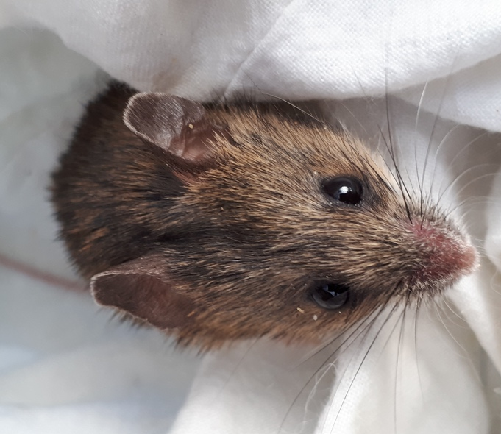
Genetic rescue for the endangered Pookila – The endangered Pookila (New Holland Mouse; Pseudomys novaehollandiae) is a small native rodent distributed across southeastern Australia. Since the 1970s, seven of 12 known Victorian populations have become extinct (Burns 2019). The low abundance and fragmentary distribution of P. novaehollandiae raised concerns about the genetic health of the species in Victoria. In response to this need, a collaborative conservation genomics project was co-designed and initiated by researchers and conservation practitioners at Zoos Victoria, Museums Victoria, the University of Melbourne and the Australian National University, with support from BioPlatforms Australia’s Oz Mammals Genomics Initiative (Principle 2). Leveraging historical and modern samples (Principle 4), this research identified a clear need for genetic rescue in Victoria, with high inbreeding and unevenly distributed diversity across remnant populations (Burns et al. 2023). The co-design and co-execution of this project enabled direct training and knowledge transfer, and therefore direct integration of genetic information into the management and National Recovery Plan for the Pookila (Principle 5). A genetics-informed captive breeding and genetic rescue program, carried out at Zoos Victoria and Moonlit Sanctuary, has so far resulted in the release of genetically-mixed Pookila into Wilson’s Promontory in 2023, and reintroduction into Bunurong Country (Cranbourne) in 2024, where they have been locally extinct for 48 years (Wilsons prom release: https://www.abc.net.au/news/2023-09-07/pookila-mice-released-into-wild-across-wilsons-promontory/102824972; Cranbourne release: https://rbg.vic.gov.au/news-and-stories/pookila-reintroduction/). Photo credit: P. Burns
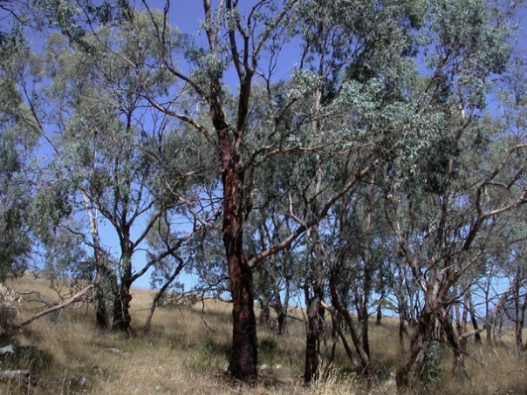
Community conservation to restore a species – Eucalyptus morrisbyi is one of Australia’s most endangered eucalypts, with effectively only six reproductively mature trees remaining in the wild. Researchers recognising the start of population collapse in the 1990s, worked with state government agencies to capture the genetic representation of the two extant populations, and establish large seed orchards in collaboration with Forestry Tasmania (now Sustainable Timber Tasmania). Seed from this orchard was used for long-term storage at the Tasmanian Seed Conservation Centre (Principle 4), community planting campaigns and to expand the species distribution through assisted colonisation championed by a multi-organisation collaboration that was underpinned by eco-evolutionary research (Jones et al. 2005; Mann et al. 2011; Harrison et al. 2014; Gosney et al. 2014; https://www.abc.net.au/news/2023-10-21/morrisby-gums-assisted-migration-project-tasmania/103002572) (Principle 2). Photo credit: R. Wiltshire
Bridging research and management for Tasmanian devil conservation – The Save the Tasmanian Devil Program (a Tasmanian government initiative) established a long-term partnership with the University of Sydney in 2011, under the “Devil Tools & Tech” banner. The two parties worked together to develop scientific research questions based on key conservation management questions (Principle 2), leveraged management funding through the Australian Research Council Linkage program, and built trust and partnerships between academic researchers and students and conservation managers ensuring scientific findings were available for management application prior to peer-review publication (Principle 5). This meant that conservation managers were not having to wait for research publication to apply the findings (Hogg et al. 2017). Photo credit: C. Hogg
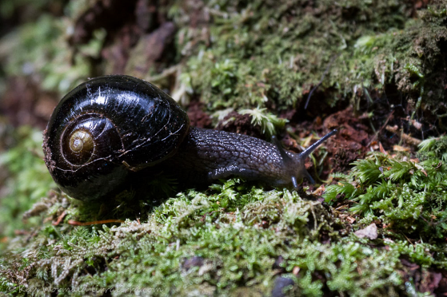
Assessing genetic health to guide conservation in Victoria – The Genetic Risk Index (GRI) describes the genetic health of over 1,100 species of plants and animals in the state of Victoria (https://www.environment.vic.gov.au/biodiversity/genetic-risk-index). The GRI was developed using genetic and demographic metrics to group the overall genetic risk for a given species into a low, medium, high, very high or uncertain risk category. Victoria is the first jurisdiction in Australia to implement an index of genetic risk, which was developed in partnership with the Department of Energy, Environment and Climate Action (DEECA), CESAR Australia, Monash University, and the University of Melbourne (Principle 2). Recognising the importance of genetic diversity to conservation planning, the GRI has been designed to inform decision-making for threatened species management and policy development (Principle 1). There are still gaps in knowledge for some species, so the GRI is also helping inform the collection of future genetic data and recovery actions. The first iteration of the GRI was updated after the 2019-2020 bushfires that impacted numerous species across Victoria. Photo credit: K. Wormald.
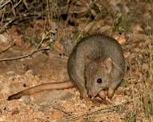
Genetic strategies for successful translocations – Genetic data are becoming increasingly important for informing translocation programmes. In a large collaboration between government and non-government conservation organisations, academics, and museums (funded by BioPlatforms Oz Mammal Genomics), researchers used sequencing data to assess the genetic health of three boodie populations (Bettongia lesueur) now extinct on mainland Australia (Nistelberger et al. 2023) (Principle 2). Populations founded from multiple sources had higher genetic diversity. Mixing the most genetically divergent populations resulted in successful conservation outcomes, as this restored heterozygosity to pre-decline levels. In the initial stages of the project, collaborators invested time into building trust to gain/share genetic samples, and all collaborators contributed to framing the conservation recommendations (Principle 3). Photo credit: J. Dunlop

Supplementary Information 2

Web of Science search
To explore the importance of collaboration in Australian conservation genetics and genomics research, we carried out a Web of Science (WOS) advanced search of the peer-reviewed literature on the 5th of May 2024. We searched titles, abstracts and keywords using topic search terms that targeted conservation genetics or genomics studies (conservation AND genom* OR genet*), restricted to primary literature and to authors with Australian affiliations. We excluded topics or WOS categories associated with human medicine or physics. This initial search returned 3,551 records, which was reduced to 3,474 after removing records that were duplicates, records that included no authors with Australian affiliations, or records that had missing affiliation or address information.

To focus on the Australian literature rather than international collaborations, we filtered the dataset to only include those records with at least two co-authors with Australian affiliations if there was more than one author, reducing the dataset to 2,611 records. All affiliations and addresses of all authors were assigned to the eight entities defined above, plus an ‘other’ category where the affiliation did not fit the existing categories. These steps were achieved using a custom script in R v 4.3.1 (R Core Team 2024) with the packages stringr v 1.5.1 (Gagolewski 2022), tokenizers v 0.3.0 (Mullen et al. 2018), stopwords v 2.3 (Benoit et al. 2021), revtools v 0.4.1 (Westgate 2019) and fuzzyjoin v 0.1.6 (Robinson 2023), using region and entity specific keywords. Keywords were chosen by identifying common terms and using these to assign affiliations and addresses to the correct entity, which was then manually confirmed. We use the count of number of different entities in the co-authorship of each publication as a measure of collaboration, albeit limited to the peer-reviewed literature.

References
Benoit K, Muhr D, Watanabe K (2021) stopwords: Multilingual Stopword Lists. R package version 2.3
Burns PA (2019) Testing the decline of the New Holland mouse (Pseudomys novaehollandiae) in Victoria. Australian Mammalogy 42:185–193. https://doi.org/10.1071/AM19006
Burns PA, Rowe KC, Parrott ML, Roycroft E (2023) Population genomics of decline and local extinction in the endangered Australian Pookila. Biological Conservation 284:110183. https://doi.org/10.1016/j.biocon.2023.110183
Gagolewski M (2022) stringi: fast and portable character string processing in R. Journal of Statistical Software 103:1–59. https://doi.org/10.18637/jss.v103.i02
Gosney BJ, O′Reilly-Wapstra JM, Forster LG, et al (2014) Genetic and ontogenetic variation in an endangered tree structures dependent arthropod and fungal Communities. PLOS ONE 9:e114132. https://doi.org/10.1371/journal.pone.0114132
Harrison PA, Jones RC, Vaillancourt RE, et al (2014) Unravelling the evolutionary history of Eucalyptus cordata (Myrtaceae) using molecular markers. Aust J Bot 62:114–131. https://doi.org/10.1071/BT14019
Hogg CJ, Grueber CE, Pemberton D, et al (2017) “Devil Tools & Tech”: a synergy of conservation research and management practice. Conservation Letters 10:133–138. https://doi.org/10.1111/conl.12221
Jones RC, McKinnon GE, Potts BM, Vaillancourt RE (2005) Genetic diversity and mating system of an endangered tree Eucalyptus morrisbyi. Aust J Bot 53:367–377. https://doi.org/10.1071/BT04182
Mann AN, O’Reilly-Wapstra JM, Lason GR, et al (2011) Mammalian herbivores reveal marked genetic divergence among populations of an endangered plant species. Oikos 121:268–276
Mullen LA, Benoit K, Keyes O, et al (2018) Fast, Consistent Tokenization of Natural Language Text. Journal of Open Source Software 3:655. https://doi.org/10.21105/joss.00655
Nistelberger HM, Roycroft E, Macdonald AJ, et al (2023) Genetic mixing in conservation translocations increases diversity of a keystone threatened species, Bettongia lesueur. Molecular Ecology. https://doi.org/10.1111/mec.17119
R Core Team (2024) R: A Language and Environment for Statistical Computing. R Foundation for Statistical Computing, Vienna, Austria
Robinson D (2023) fuzzyjoin: Join Tables Together on Inexact Matching. R package version 0.1.6
Westgate MJ (2019) revtools: an R package to support article screening for evidence synthesis. Research Synthesis Methods 10:606–614. https://doi.org/10.1002/jrsm.1374

