Supplementary Information
S1 Methods
S1. 1 Study area details
The area receives an average of 449 mm annual rainfall with mean maximum temperature of 31.3°C in January, 14.0°C in July and mean minimum temperature of 13.9°C and 4.5°C, respectively (Bureau of Meteorology, 2024). Three vegetation communities dominate the landscape—Lowan Sands Mallee, occurring on light sandy soil, dominated by desert stringybark (Eucalyptus arenacea), reaching 5-10 m, with a dense heathy understory usually containing grass trees (Xanthorrhoea australis). Sandstone Ridge Shrubland, occurring on sandy sandstone outcrops, contain sparse multi-stemmed eucalypts (predominantly ridge-fruited mallee, E. costata, and slender-leaf mallee, E. leptopylla) reaching < 5 m high, and abundant mid-storey shrubs (broom honey-myrtle, Melaleuca uncinata, Violet honey-myrtle, M. wilsonii, and broom baeckea, Hysterobaeckea behrii). Yellow Gum Woodland exists over clay soils, with yellow gum (E. leucoxylon) the main tree species reaching > 10 m, and a variety of shrubs and grasses creating a relatively open understory.
Early clearing by European colonists began in the late 1800s removing much of the native vegetation, particularly on the more productive ‘Wimmera black soils’ (Landt, 1961). As has happened across the world (Simmonds et al., 2017), vegetation communities on fertile soils were selectively cleared, leaving the majority of native vegetation remaining on less fertile, sandy soils (Landt, 1961). From the 1960s onwards, agriculture expanded into less fertile, sandy soils abutting the Little Desert National Park. Small patches of vegetation were left uncleared to provide shelter for livestock, so that farms comprise a mosaic of patches of remnant vegetation of differing shape and size, surrounded by pasture or cropland. These patches support the same soils and vegetation types to the adjacent national park, providing an opportunity to test for the effect of land modification without the confounding effects of vegetation types. Increasingly, intensification of agricultural practices in the region has diminished remnant vegetation in farming landscapes (Maron and Fitzsimons, 2007).

Table S1. Bioinformatic pipeline used to filter SNP data for shrubland Morethia (Morethia obscura) prior to formal analyses. All filtering steps were performed in R. Number of SNPs and samples retained after each step are shown.
Step | Relevant filters / thresholds | Number of SNPS retained | Number of samples retained
DArT process | NA | 126,377 | 93
Remove low quality samples or samples from poorly sampled populations | Samples > 35% call rate  n > 5 | 120,298 | 90
Sex-biased loci | Remove Y-linked, X-linked, sex-biased, or XY gametologs | 120,298 | 90
Read depth | 10 < read depth < (mean + 2 x standard deviation) | 72,047 | 90
Reproducibility | > 0.99 | 65,151 | 90
Missing data | SNPs > 0.95 | 57,702 | 90
- | Samples > 0.90 | 57,702 | 90
Minor allele count | ≥ 3 | 30,627 | 90
Linkage disequilibrium | Remove secondaries | 21,531 | 90
Close relatives | Remove if kinship > 0.25 | 21,527 | 89

Table S2. Bioinformatic pipeline used to filter SNP data for robust Ctenotus (Ctenotus robustus) prior to formal analyses. All filtering steps were performed in R. Number of SNPs and samples retained after each step are shown.

Step | Relevant filters / thresholds | Number of SNPS retained | Number of samples retained
DArT process | NA | 75,009 | 74
Remove low quality samples or samples from poorly sampled populations | Samples > 35% call rate  n > 5 | 74,365 | 72
Sex-biased loci | Remove Y-linked, X-linked, sex-biased, or XY gametologs | 74,365 | 72
Read depth | 10 < read depth < (mean + 2 x standard deviation) | 40,797 | 72
Reproducibility | > 0.99 | 35,010 | 72
Missing data | SNPs > 0.95 | 27,941 | 72
- | Samples > 0.90 | 27,941 | 70
Minor allele count | ≥ 3 | 22,787 | 70
Linkage disequilibrium | Remove secondaries | 20,228 | 70
Close relatives | Remove if kinship > 0.25 | 20,171 | 61

Table S3. Bioinformatic pipeline used to filter SNP data for the painted dragon (Ctenophorus pictus) prior to formal analyses. All filtering steps were performed in R. Number of SNPs and samples retained after each step are shown.

Step | Relevant filters / thresholds | Number of SNPS retained | Number of samples retained
DArT process | NA | 214,821 | 54
Remove low quality samples or samples from poorly sampled populations | Samples > 35% call rate  n > 5 | 212,917 | 53
Sex-biased loci | Remove Y-linked, X-linked, sex-biased, or XY gametologs | 212,917 | 53
Read depth | 10 < read depth < (mean + 2 x standard deviation) | 87,977 | 53
Reproducibility | > 0.99 | 75,922 | 53
Missing data | SNPs > 0.90 | 12,093 | 53
- | Samples > 0.90 | 11,993 | 51
Minor allele count | ≥ 3 | 9,237 | 51
Linkage disequilibrium | Remove secondaries | 7,667 | 51
Close relatives | Remove if kinship > 0.25 | 7,650 | 45

Table S4. Pairwise F_{ST} values for all sampling sites for three lizard species (shrubland morethia, robust ctenotus, and painted dragon) across isolated farm patches and continuous habitat in western Victoria, Australia.

Shrubland Morethia (Morethia obscura)
 | SDN6 (NP) | BN8 (FARM) | MSN3 (NP) | MS10 (FARM) | MSN10 (NP) | RCN3 (NP) | SDN1 (NP) | ABN7 (NP) | RCN2 (NP) | BNN8 (NP) | RCN1 (NP) | MSN5 (NP) | ABN3 (NP)
SDN6 (NP) (n = 6) | NA | NA | NA | NA | NA | NA | NA | NA | NA | NA | NA | NA | NA
BN8 (FARM) (n = 22) | 0.001673 | NA | NA | NA | NA | NA | NA | NA | NA | NA | NA | NA | NA
MSN3 (NP) (n = 8) | 0.0036 | 0.001802 | NA | NA | NA | NA | NA | NA | NA | NA | NA | NA | NA
MS10 (FARM) (n = 19) | 0.001833 | 0.002917 | 0.001327 | NA | NA | NA | NA | NA | NA | NA | NA | NA | NA
MSN10 (NP) (n = 3) | 0.005257 | 0.003937 | 0.004158 | 0.003249 | NA | NA | NA | NA | NA | NA | NA | NA | NA
RCN3 (NP) (n = 4) | -0.0007 | -0.00145 | -0.00151 | 0.00054 | 0.00255 | NA | NA | NA | NA | NA | NA | NA | NA
SDN1 (NP) (n = 1) | 0.005142 | 0.003507 | 0.013478 | 0.0086 | 0.022142 | 0.002319 | NA | NA | NA | NA | NA | NA | NA
ABN7 (NP) (n = 9) | 0.000928 | 0.002644 | 0.001521 | 0.000523 | 0.004646 | -0.00123 | 0.015516 | NA | NA | NA | NA | NA | NA
RCN2 (NP) (n = 3) | -0.00073 | -0.00148 | 0.002488 | -0.00015 | 0.006475 | -0.00563 | 0.008375 | 0.002546 | NA | NA | NA | NA | NA
BNN8 (NP) (n = 9) | -0.00021 | 0.001059 | 0.001769 | 0.002407 | 0.00403 | -0.00311 | 0.00761 | 0.001743 | -0.00157 | NA | NA | NA | NA
RCN1 (NP) (n = 1) | 0.00579 | 0.003778 | 0.014409 | 0.0052 | 0.018057 | 0.002527 | NaN | 0.008005 | -0.00251 | 0.004275 | NA | NA | NA
MSN5 (NP) (n = 3) | 0.001491 | 0.001492 | 0.002143 | 0.000196 | 0.003599 | -0.00341 | 0.008918 | -0.00061 | -0.00149 | -0.00046 | 0.003681 | NA | NA
ABN3 (NP) (n = 1) | 0.007633 | 0.003281 | 0.011727 | 0.00762 | 0.010932 | 0.005534 | NaN | 0.008188 | 0.004835 | 0.005173 | NaN | −0.000022 | NA
Robust Ctenotus (Ctenotus robustus)
 | BN8 (FARM) | BNN8 (NP) | MS10 (FARM) | SDN1 (NP) | RCN1 (NP)
BN8 (FARM) (n = 28) | NA | NA | NA | NA | NA
BNN8 (NP) (n = 22) | 0.002864 | NA | NA | NA | NA
MS10 (FARM) (n = 9) | 0.016528 | 0.016505 | NA | NA | NA
SDN1 (NP) (n = 1) | 0.014322 | 0.01547 | 0.017877 | NA | NA
RCN1 (NP) (n = 1) | -0.00197 | -0.00651 | 0.011099 | NaN | NA
Painted Dragon (Ctenophorus pictus)
 | RCN3 (NP) | RCN2 (NP) | BN8 (FARM) | SDN6 (NP) | BNN8 (NP) | SDN1 (NP)
RCN3 (NP) (n = 7) | NA | NA | NA | NA | NA | NA
RCN2 (NP) (n = 4) | -0.00459 | NA | NA | NA | NA | NA
BN8 (FARM) (n = 14) | 0.055524 | 0.063219 | NA | NA | NA | NA
SDN6 (NP) (n = 13) | 0.006571 | 0.006386 | 0.057288 | NA | NA | NA
BNN8 (NP) (n = 4) | 0.004093 | 0.001115 | 0.05759 | 0.003387 | NA | NA
SDN1 (NP) (n = 3) | 0.009245 | 0.006417 | 0.072463 | 0.013361 | 0.01371 | NA

Sampling sites and their assigned populations:
BN8 = Farm_W
MS10 = Farm_C
SDN6, SDN1, RCN1 and BNN8 = NP_W_1
RCN2 and RCN3 = NP_W_2
MSN3 = NP_C_1
MSN10, ABN7, MSN5 and ABN3 = NP_C_2

Table S5. Associated p-values for pairwise F_{ST} values listed above in Table S4.
Shrubland Morethia (Morethia obscura)
 | SDN6 (NP) | BN8 (FARM) | MSN3 (NP) | MS10 (FARM) | MSN10 (NP) | RCN3 (NP) | SDN1 (NP) | ABN7 (NP) | RCN2 (NP) | BNN8 (NP) | RCN1 (NP) | MSN5 (NP) | ABN3 (NP)
SDN6 (NP) (n = 6) | NA | NA | NA | NA | NA | NA | NA | NA | NA | NA | NA | NA | NA
BN8 (FARM) (n = 22) | 0.048 | NA | NA | NA | NA | NA | NA | NA | NA | NA | NA | NA | NA
MSN3 (NP) (n = 8) | 0.008 | 0.005 | NA | NA | NA | NA | NA | NA | NA | NA | NA | NA | NA
MS10 (FARM) (n = 19) | 0.034 | 0.000 | 0.051 | NA | NA | NA | NA | NA | NA | NA | NA | NA | NA
MSN10 (NP) (n = 3) | 0.027 | 0.024 | 0.029 | 0.049 | NA | NA | NA | NA | NA | NA | NA | NA | NA
RCN3 (NP) (n = 4) | 0.672 | 0.872 | 0.814 | 0.383 | 0.178 | NA | NA | NA | NA | NA | NA | NA | NA
SDN1 (NP) (n = 1) | 0.252 | 0.292 | 0.026 | 0.091 | 0.002 | 0.394 | NA | NA | NA | NA | NA | NA | NA
ABN7 (NP) (n = 9) | 0.215 | 0.000 | 0.064 | 0.236 | 0.016 | 0.784 | 0.008 | NA | NA | NA | NA | NA | NA
RCN2 (NP) (n = 3) | 0.608 | 0.768 | 0.129 | 0.546 | 0.027 | 0.979 | 0.163 | 0.108 | NA | NA | NA | NA | NA
BNN8 (NP) (n = 9) | 0.562 | 0.059 | 0.045 | 0.000 | 0.039 | 0.971 | 0.141 | 0.035 | 0.75 | NA | NA | NA | NA
RCN1 (NP) (n = 1) | 0.195 | 0.253 | 0.015 | 0.194 | 0.019 | 0.346 | 0.000 | 0.1 | 0.615 | 0.254 | NA | NA | NA
MSN5 (NP) (n = 3) | 0.3 | 0.246 | 0.188 | 0.491 | 0.158 | 0.902 | 0.141 | 0.641 | 0.664 | 0.607 | 0.317 | NA | NA
ABN3 (NP) (n = 1) | 0.147 | 0.279 | 0.04 | 0.105 | 0.089 | 0.21 | 0.000 | 0.097 | 0.278 | 0.205 | 0.000 | 0.493 | NA
Robust Ctenotus (Ctenotus robustus)
 | BN8 (FARM) | BNN8 (NP) | MS10 (FARM) | SDN1 (NP) | RCN1 (NP)
BN8 (FARM) (n = 28) | NA | NA | NA | NA | NA
BNN8 (NP) (n = 22) | 0.000 | NA | NA | NA | NA
MS10 (FARM) (n = 9) | 0.000 | 0.000 | NA | NA | NA
SDN1 (NP) (n = 1) | 0.000 | 0.000 | 0.000 | NA | NA
RCN1 (NP) (n = 1) | 0.746 | 0.984 | 0.001 | 0.000 | NA
Painted Dragon (Ctenophorus pictus)
 | RCN3 (NP) | RCN2 (NP) | BN8 (FARM) | SDN6 (NP) | BNN8 (NP) | SDN1 (NP)
RCN3 (NP) (n = 7) | NA | NA | NA | NA | NA | NA
RCN2 (NP) (n = 4) | 0.938 | NA | NA | NA | NA | NA
BN8 (FARM) (n = 14) | 0.000 | 0.000 | NA | NA | NA | NA
SDN6 (NP) (n = 13) | 0.000 | 0.003 | 0.000 | NA | NA | NA
BNN8 (NP) (n = 4) | 0.114 | 0.393 | 0.000 | 0.108 | NA | NA
SDN1 (NP) (n = 3) | 0.01 | 0.112 | 0.000 | 0.000 | 0.005 | NA

Sampling sites and their assigned populations:
BN8 = Farm_W
MS10 = Farm_C
SDN6, SDN1, RCN1 and BNN8 = NP_W_1
RCN2 and RCN3 = NP_W_2
MSN3 = NP_C_1
MSN10, ABN7, MSN5 and ABN3 = NP_C_
Table S6. Associated p-values for a priori population pairwise F_{ST} values listed in Table 1.
Shrubland morethia (Morethia obscura)
 | Farm W | NP W 1 | NP W 2 | Farm C | NP C 1 | NP C 2
Farm W | NA | NA | NA | NA | NA | NA
NP W 1 | 0.001 | NA | NA | NA | NA | NA
NP W 2 | 0.436 | 0.684 | NA | NA | NA | NA
Farm C | 0.000 | 0.000 | 0.038 | NA | NA | NA
NP C 1 | 0.007 | 0.012 | 0.321 | 0.054 | NA | NA
NP C 2 | 0.000 | 0.001 | 0.071 | 0.005 | 0.145 | NA
Robust ctenotus (Ctenotus robustus)
 | Farm W | NP W 1 | Farm C
Farm W | NA | NA | NA | NA | NA | NA
NP W 1 | 0.000 | NA | NA | NA | NA | NA
Farm C | 0.000 | 0.000 | NA | NA | NA | NA
Painted dragon (Ctenophorus pictus)
 | Farm W | NP W 1 | NP W 2
Farm W | NA | NA | NA | NA | NA | NA
NP W 1 | 0.000 | NA | NA | NA | NA | NA
NP W 2 | 0.000 | 0.000 | NA | NA | NA | NA

Table S7. Mean pairwise relatedness (and standard error) within farm fragments (Farm) compared to within similar sized pseudo-fragments in the Little Desert National Park (NP).

Location | n | Mean pairwise relatedness (SE)
Shrubland Morethia (Morethia obscura)
BN8 (Farm) | 23 | -0.0049 (0.002)
MS10 (Farm) | 19 | -0.0013 (0.003)
BNN8 (NP) | 9 | 0.0045 (0.003)
ABN7 (NP) | 9 | 0.0071 (0.002)
MSN3 (NP) | 8 | 0.0178 (0.003)
SDN6 (NP) | 6 | 0.0126 (0.004)
RCN3 (NP) | 4 | -0.0086 (0.004)
Robust Ctenotus (Ctenotus robustus)
BN8 (Farm) | 31 | 0.0094 (0.002)
MS10 (Farm) | 9 | 0.0002 (0.008)
BNN8 (NP) | 28 | 0.0096 (0.004)
Painted dragon (Ctenophorus pictus)
BN8 (Farm) | 17 | 0.1028 (0.007)
SDN6 (NP) | 14 | -0.0028 (0.009)
RCN3 (NP) | 8 | 0.0215 (0.024)
RCN2 (NP) | 4 | -0.0282 (0.010)
BNN8 (NP) | 4 | -0.0008 (0.007)

Table S8. Model summaries for linear mixed effect models exploring the effect of land use on within-site relatedness of shrubland morethia (SM), robust ctenotus (RC), and painted dragon (PD).
Response variable | Marginal R² | Coefficients | Estimate | CI (85%)
Relatedness – SM | 0.024 | (Intercept) | 0.01 | 0.00 – 0.01
 |  | Land use (farm) | -0.01 | -0.02 – -0.01
Relatedness – RC
 | 0.000 | (Intercept) | 0.01 | 0.00 – 0.02
 |  | Land Use [Farm] | -0.00 | -0.01 – 0.01
Relatedness – PD | 0.313 | (Intercept) | 0.00 | -0.01 – 0.02
 |  | Land use (farm) | 0.10 | 0.08 – 0.12

Table S9. Mantel test results evaluating correlation between genetic distance (F_{ST}) and geographic distance for three lizard species (shrubland Morethia, robust Ctenotus, and painted dragon) in western Victoria.
 | Shrubland morethia (Morethia obscura)  r p |  | Robust ctentous (Ctenotus robustus)  r p |  | Painted dragon (Ctenophorus pictus)  r p
Mantel test | 0.046 | 0.021 | 0.383 | 0.001 | 0.301 | 0.001

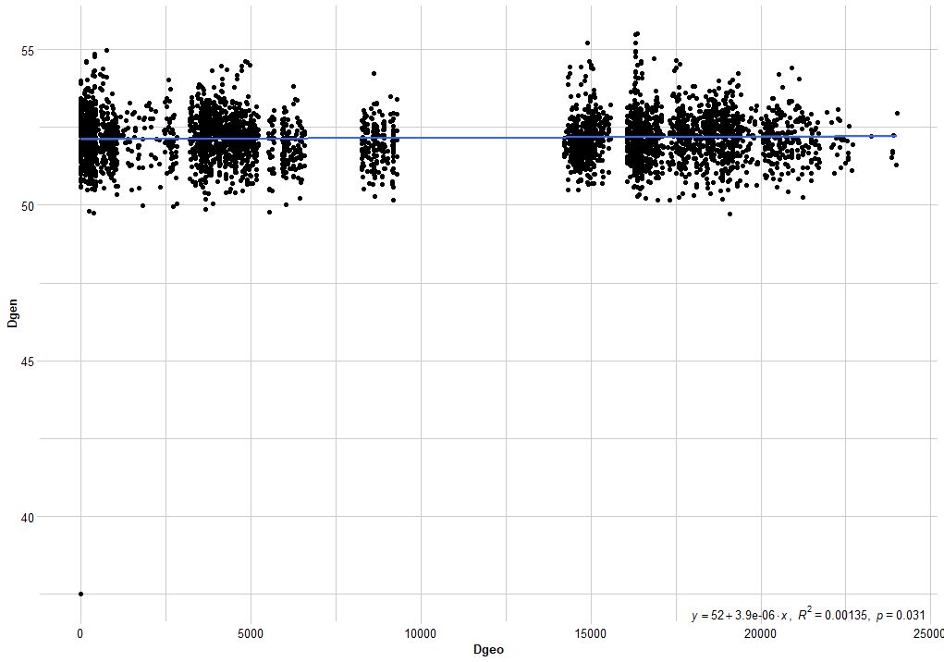

Figure S1. Relationship between geographic distance and genetic distance for shrubland morethia (Morethia obscura).

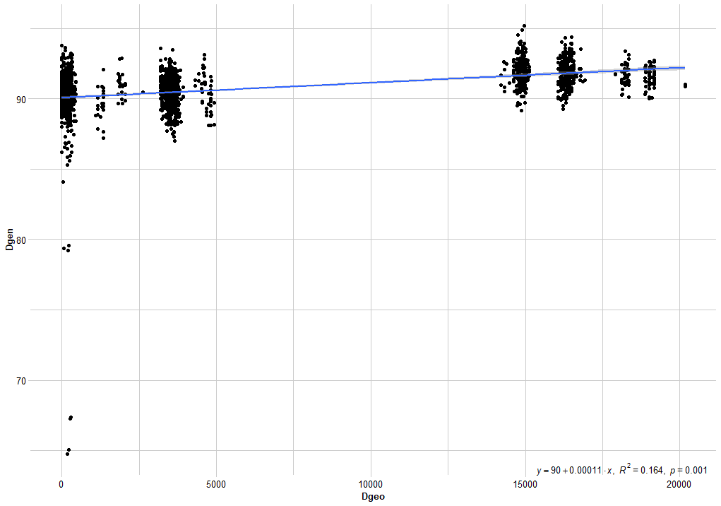

Figure S2. Relationship between geographic distance and genetic distance for robust ctenotus (Ctenotus robustus).

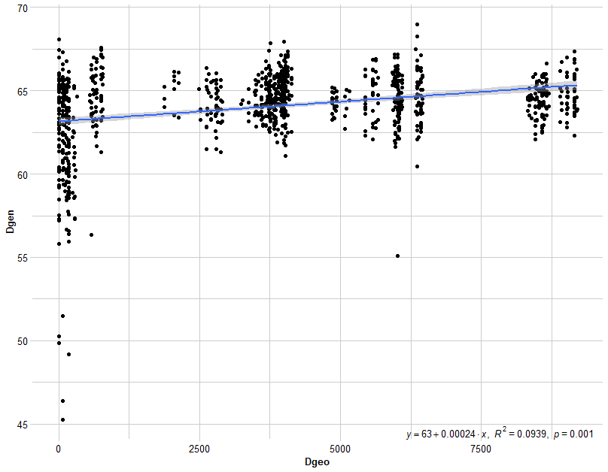
Figure S3. Relationship between geographic distance and genetic distance for painted dragon (Ctenophorus pictus).

Table S10. Pearson’s correlation test results testing the correlation between multi-locus heterozygosity (MLH) and scaled mass index (SMI) as well as the correlation between inbreeding coefficient and SMI for the painted dragon (Ctenophorus pictus). Each test is performed excluding and including outliers.
Correlation test details | df | Estimate | 95% CIs | p
MLH & SMI: outliers excluded | 27 | -0.010 | -0.38 – 0.36 | 0.96
MLH & SMI: full dataset | 29 | -0.224 | -0.54 – 0.14 | 0.23
Inbreeding coefficient & SMI: outliers excluded | 27 | -0.116 | -0.46 – 0.26 | 0.55
Inbreeding coefficient & SMI: full dataset | 29 | 0.297 | -0.06 – 0.59 | 0.10

Table S11. Model summaries showing the effect of predictor variables on scaled mass index (SMI) for the painted dragon (Ctenophorus pictus). Modelling was performed excluding and including outliers.
Model | Predictors | Estimate | CI (95%) | p
SMI ~ pop + mlh | (Intercept) | 4.44 | 1.26 – 7.61 | 0.008
(outliers excluded) | Pop [NP_W_1] | -0.28 | -1.20 – 0.65 | 0.545
 | Pop [NP_W_2] | -0.88 | -1.89 – 0.14 | 0.089
 | MLH | 10.24 | -14.72 – 35.19 | 0.406
SMI ~ pop + mlh | (Intercept) | 7.33 | 4.05 – 10.61 | <0.001
(full dataset) | Pop [NP_W_1] | 0.25 | -1.21 – 1.71 | 0.726
 | Pop [NP_W_2] | -0.44 | -1.99 – 1.11 | 0.564
 | MLH | -13.27 | -37.68 – 11.15 | 0.275
SMI ~ pop + inbreeding coefficient | (Intercept) | 6.68 | 4.28 – 9.07 | <0.001
(outliers excluded) | Pop [NP_W_1] | -0.06 | -0.95 – 0.83 | 0.888
 | Pop [NP_W_2] | -0.65 | -1.56 – 0.26 | 0.156
 | Inbreeding coefficient | -2.74 | -9.09 – 3.60 | 0.382
SMI ~ pop + inbreeding coefficient | (Intercept) | 4.15 | 1.91 – 6.39 | 0.001
(full dataset) | Pop [NP_W_1] | -0.03 | -1.40 – 1.33 | 0.960
 | Pop [NP_W_2] | -0.75 | -2.19 – 0.70 | 0.297
 | Inbreeding coefficient | 4.34 | -0.85 – 9.54 | 0.098

Table S12. Associated p-values for pairwise comparisons of expected heterozygosity (H_{E}). Bold indicates a significant difference between populations.
Shrubland morethia (Morethia obscura)
 | Farm W | NP W 1 | NP W 2 | Farm C | NP C 1 | NP C 2
Farm W | 0
NP W 1 | 0.000 | 0
NP W 2 | 0.000 | 0.000 | 0
Farm C | 0.049 | 0.057 | 0.000 | 0
NP C 1 | 0.000 | 0.000 | 0.152 | 0.000 | 0
NP C 2 | 0.000 | 0.345 | 0.000 | 0.011 | 0.000 | 0
Robust ctenotus (Ctenotus robustus)
 | Farm W | NP W 1 | Farm C
Farm W | 0
NP W 1 | 0.000 | 0
Farm C | 0.000 | 0.066 | 0
Painted dragon (Ctenophorus pictus)
 | Farm W | NP W 1 | NP W 2
Farm W | 0
NP W 1 | 0.000 | 0
NP W 2 | 0.000 | 0.000 | 0

References

LANDT, T. M. 1961. The Story of the Kaniva District, 1845-1961: A Series of Articles, Brown, Prior, Anderson.
MARON, M. & FITZSIMONS, J. A. 2007. Agricultural intensification and loss of matrix habitat over 23 years in the West Wimmera, south-eastern Australia. Biological conservation, 135, 587-593.
SIMMONDS, J. S., VAN RENSBURG, B. J. & MARON, M. 2017. Non-random patterns of vegetation clearing and potential biases in studies of habitat area effects. Landscape Ecology, 32, 729-743.

