SUPPLEMENTARY MATERIAL
Landscape connectivity and genetic structure of animal populations in urban ponds

Yeserin Yildirim, Chaz Hyseni, Jani Heino, Luis Mauricio Bini, Jacob Höglund, and Frank Johansson
Supplementary Methods
The individual-specific barcoded adapters ligated to the methylation-sensitive restriction end
AciI_I1 ACACTCTTTCCCTACACGACGCTCTTCCGATCTTGGTACAG
AciI_I1_P [Phos]CGCTGTACCAAGATCGGAAGAGCGTCGTGTAGGGAAAGAGTGT
AciI_I2 ACACTCTTTCCCTACACGACGCTCTTCCGATCTCACCTGTT
AciI_I2_P [Phos]CGAACAGGTGAGATCGGAAGAGCGTCGTGTAGGGAAAGAGTGT
AciI_I3 ACACTCTTTCCCTACACGACGCTCTTCCGATCTATCACACG
AciI_I3_P [Phos]CGCGTGTGATAGATCGGAAGAGCGTCGTGTAGGGAAAGAGTGT
AciI_I4 ACACTCTTTCCCTACACGACGCTCTTCCGATCTCGACGTTA
AciI_I4_P [Phos]CGTAACGTCGAGATCGGAAGAGCGTCGTGTAGGGAAAGAGTGT
AciI_I5 ACACTCTTTCCCTACACGACGCTCTTCCGATCTGTAGGAGT
AciI_I5_P [Phos]CGACTCCTACAGATCGGAAGAGCGTCGTGTAGGGAAAGAGTGT
AciI_I6 ACACTCTTTCCCTACACGACGCTCTTCCGATCTTTGCAGAC
AciI_I6_P [Phos]CGGTCTGCAAAGATCGGAAGAGCGTCGTGTAGGGAAAGAGTGT
AciI_I7 ACACTCTTTCCCTACACGACGCTCTTCCGATCTCAGTCCAA
AciI_I7_P [Phos]CGTTGGACTGAGATCGGAAGAGCGTCGTGTAGGGAAAGAGTGT
AciI_I8 ACACTCTTTCCCTACACGACGCTCTTCCGATCTAGTGGATC
AciI_I8_P [Phos]CGGATCCACTAGATCGGAAGAGCGTCGTGTAGGGAAAGAGTGT
AciI_I9 ACACTCTTTCCCTACACGACGCTCTTCCGATCTGAAGTTGG
AciI_I9_P [Phos]CGCCAACTTCAGATCGGAAGAGCGTCGTGTAGGGAAAGAGTGT
AciI_I10 ACACTCTTTCCCTACACGACGCTCTTCCGATCTGCTATCCT
AciI_I10_P [Phos]CGAGGATAGCAGATCGGAAGAGCGTCGTGTAGGGAAAGAGTGT
AciI_I11 ACACTCTTTCCCTACACGACGCTCTTCCGATCTTCTAACGC
AciI_I11_P [Phos]CGGCGTTAGAAGATCGGAAGAGCGTCGTGTAGGGAAAGAGTGT
AciI_I12 ACACTCTTTCCCTACACGACGCTCTTCCGATCTGCCTATCA
AciI_I12_P [Phos]CGTGATAGGCAGATCGGAAGAGCGTCGTGTAGGGAAAGAGTGT
PstI_I1 ACACTCTTTCCCTACACGACGCTCTTCCGATCTAGAACGAGTGCA
PstI_I1_P [Phos]CTCGTTCTAGATCGGAAGAGCGTCGTGTAGGGAAAGAGTGT
PstI_I2 ACACTCTTTCCCTACACGACGCTCTTCCGATCTTGCTTCCATGCA
PstI_I2_P [Phos]TGGAAGCAAGATCGGAAGAGCGTCGTGTAGGGAAAGAGTGT
PstI_I3 ACACTCTTTCCCTACACGACGCTCTTCCGATCTCTTCGACTTGCA
PstI_I3_P [Phos]AGTCGAAGAGATCGGAAGAGCGTCGTGTAGGGAAAGAGTGT
PstI_I4 ACACTCTTTCCCTACACGACGCTCTTCCGATCTCCTGATTGTGCA
PstI_I4_P [Phos]CAATCAGGAGATCGGAAGAGCGTCGTGTAGGGAAAGAGTGT
PstI_I5 ACACTCTTTCCCTACACGACGCTCTTCCGATCTTATCGGTCTGCA
PstI_I5_P [Phos]GACCGATAAGATCGGAAGAGCGTCGTGTAGGGAAAGAGTGT
PstI_I6 ACACTCTTTCCCTACACGACGCTCTTCCGATCTATGACGTCTGCA
PstI_I6_P [Phos]GACGTCATAGATCGGAAGAGCGTCGTGTAGGGAAAGAGTGT
PstI_I7 ACACTCTTTCCCTACACGACGCTCTTCCGATCTGAAGGAAGTGCA
PstI_I7_P [Phos]CTTCCTTCAGATCGGAAGAGCGTCGTGTAGGGAAAGAGTGT
PstI_I8 ACACTCTTTCCCTACACGACGCTCTTCCGATCTCAACACCTTGCA
PstI_I8_P [Phos]AGGTGTTGAGATCGGAAGAGCGTCGTGTAGGGAAAGAGTGT
PstI_I9 ACACTCTTTCCCTACACGACGCTCTTCCGATCTACGATGACTGCA
PstI_I9_P [Phos]GTCATCGTAGATCGGAAGAGCGTCGTGTAGGGAAAGAGTGT
PstI_I10 ACACTCTTTCCCTACACGACGCTCTTCCGATCTTGCGTAGATGCA
PstI_I10_P [Phos]TCTACGCAAGATCGGAAGAGCGTCGTGTAGGGAAAGAGTGT
PstI_I11 ACACTCTTTCCCTACACGACGCTCTTCCGATCTACCTCTGTTGCA
PstI_I11_P [Phos]ACAGAGGTAGATCGGAAGAGCGTCGTGTAGGGAAAGAGTGT
PstI_I12 ACACTCTTTCCCTACACGACGCTCTTCCGATCTGTGTCTGATGCA
PstI_I12_P [Phos]TCAGACACAGATCGGAAGAGCGTCGTGTAGGGAAAGAGTGT

The common Y adapter ligated to the sticky end left by MseI
MseI GTGACTGGAGTTCAGACGTGTGCTCTTCCGATCTG
MseI_P [Phos]TACAGATCGGAAGAGCGAGAACAA

Primers used to introduce an Illumina index (at the Y common adapter site):
PCR_AciI_PstI AATGATACGGCGACCACCGAGATCTACACTCTTTCCCTACACGACG
PCR_MseI_S1 CAAGCAGAAGACGGCATACGAGATCTGATCGTGTGACTGGAGTTCAGACGTGTGC
PCR_MseI_S2 CAAGCAGAAGACGGCATACGAGATTGAGCTAGGTGACTGGAGTTCAGACGTGTGC
PCR_MseI_S3 CAAGCAGAAGACGGCATACGAGATGAGACGATGTGACTGGAGTTCAGACGTGTGC
PCR_MseI_S4 CAAGCAGAAGACGGCATACGAGATCTTGTCGAGTGACTGGAGTTCAGACGTGTGC
PCR_MseI_S5 CAAGCAGAAGACGGCATACGAGATCGCATGATGTGACTGGAGTTCAGACGTGTGC
PCR_MseI_S6 CAAGCAGAAGACGGCATACGAGATACGGAACAGTGACTGGAGTTCAGACGTGTGC
PCR_MseI_S7 CAAGCAGAAGACGGCATACGAGATGCAAGATCGTGACTGGAGTTCAGACGTGTGC
PCR_MseI_S8 CAAGCAGAAGACGGCATACGAGATGCTATCCTGTGACTGGAGTTCAGACGTGTGC
PCR_MseI_S9 CAAGCAGAAGACGGCATACGAGATTGGACTCTGTGACTGGAGTTCAGACGTGTGC
PCR_MseI_S10 CAAGCAGAAGACGGCATACGAGATAGAGTAGCGTGACTGGAGTTCAGACGTGTGC
PCR_MseI_S11 CAAGCAGAAGACGGCATACGAGATATCCAGAGGTGACTGGAGTTCAGACGTGTGC
PCR_MseI_S12 CAAGCAGAAGACGGCATACGAGATGACGATCTGTGACTGGAGTTCAGACGTGTGC
PCR_MseI_S13 CAAGCAGAAGACGGCATACGAGATAACTGAGCGTGACTGGAGTTCAGACGTGTGC
PCR_MseI_S14 CAAGCAGAAGACGGCATACGAGATCTTAGGACGTGACTGGAGTTCAGACGTGTGC
PCR_MseI_S15 CAAGCAGAAGACGGCATACGAGATGTGCCATAGTGACTGGAGTTCAGACGTGTGC
PCR_MseI_S16 CAAGCAGAAGACGGCATACGAGATGAATCCGAGTGACTGGAGTTCAGACGTGTGC
PCR_MseI_S17 CAAGCAGAAGACGGCATACGAGATTCGCTGTTGTGACTGGAGTTCAGACGTGTGC
PCR_MseI_S18 CAAGCAGAAGACGGCATACGAGATTTCGTTGGGTGACTGGAGTTCAGACGTGTGC
PCR_MseI_S19 CAAGCAGAAGACGGCATACGAGATAAGCACTGGTGACTGGAGTTCAGACGTGTGC
PCR_MseI_S20 CAAGCAGAAGACGGCATACGAGATCCTTGATCGTGACTGGAGTTCAGACGTGTGC
PCR_MseI_S21 CAAGCAGAAGACGGCATACGAGATGATTACCGGTGACTGGAGTTCAGACGTGTGC
PCR_MseI_S22 CAAGCAGAAGACGGCATACGAGATGCACAACTGTGACTGGAGTTCAGACGTGTGC
PCR_MseI_S23 CAAGCAGAAGACGGCATACGAGATATCCGGTAGTGACTGGAGTTCAGACGTGTGC
PCR_MseI_S24 CAAGCAGAAGACGGCATACGAGATCGTTGCAAGTGACTGGAGTTCAGACGTGTGC
PCR_MseI_S25 CAAGCAGAAGACGGCATACGAGATTGTGACTGGTGACTGGAGTTCAGACGTGTGC
PCR_MseI_S26 CAAGCAGAAGACGGCATACGAGATAGCACTTCGTGACTGGAGTTCAGACGTGTGC
PCR_MseI_S27 CAAGCAGAAGACGGCATACGAGATACAGCTCAGTGACTGGAGTTCAGACGTGTGC
PCR_MseI_S28 CAAGCAGAAGACGGCATACGAGATCAATGTGGGTGACTGGAGTTCAGACGTGTGC
PCR_MseI_S29 CAAGCAGAAGACGGCATACGAGATTGACTGACGTGACTGGAGTTCAGACGTGTGC
PCR_MseI_S30 CAAGCAGAAGACGGCATACGAGATTCGTCTCAGTGACTGGAGTTCAGACGTGTGC
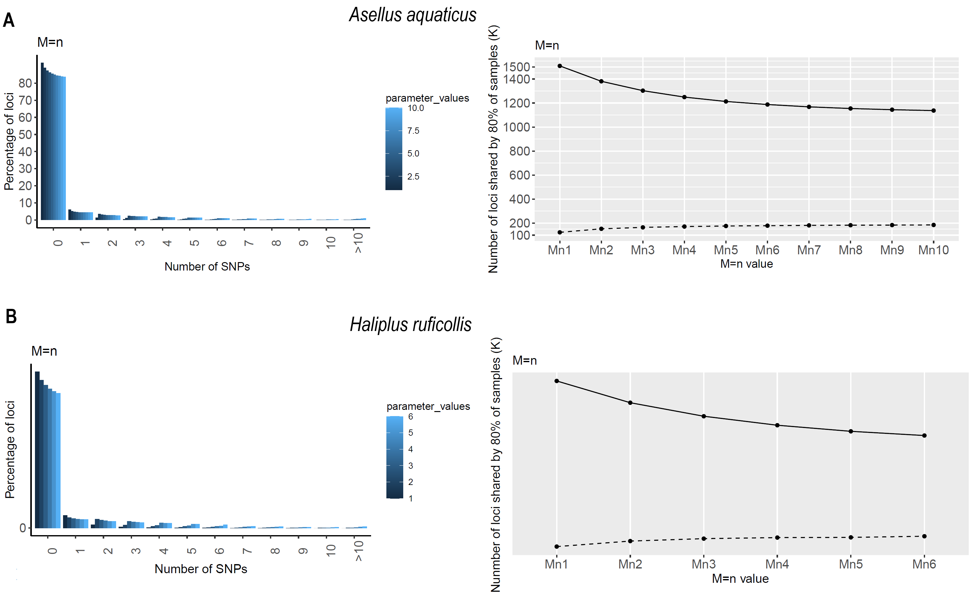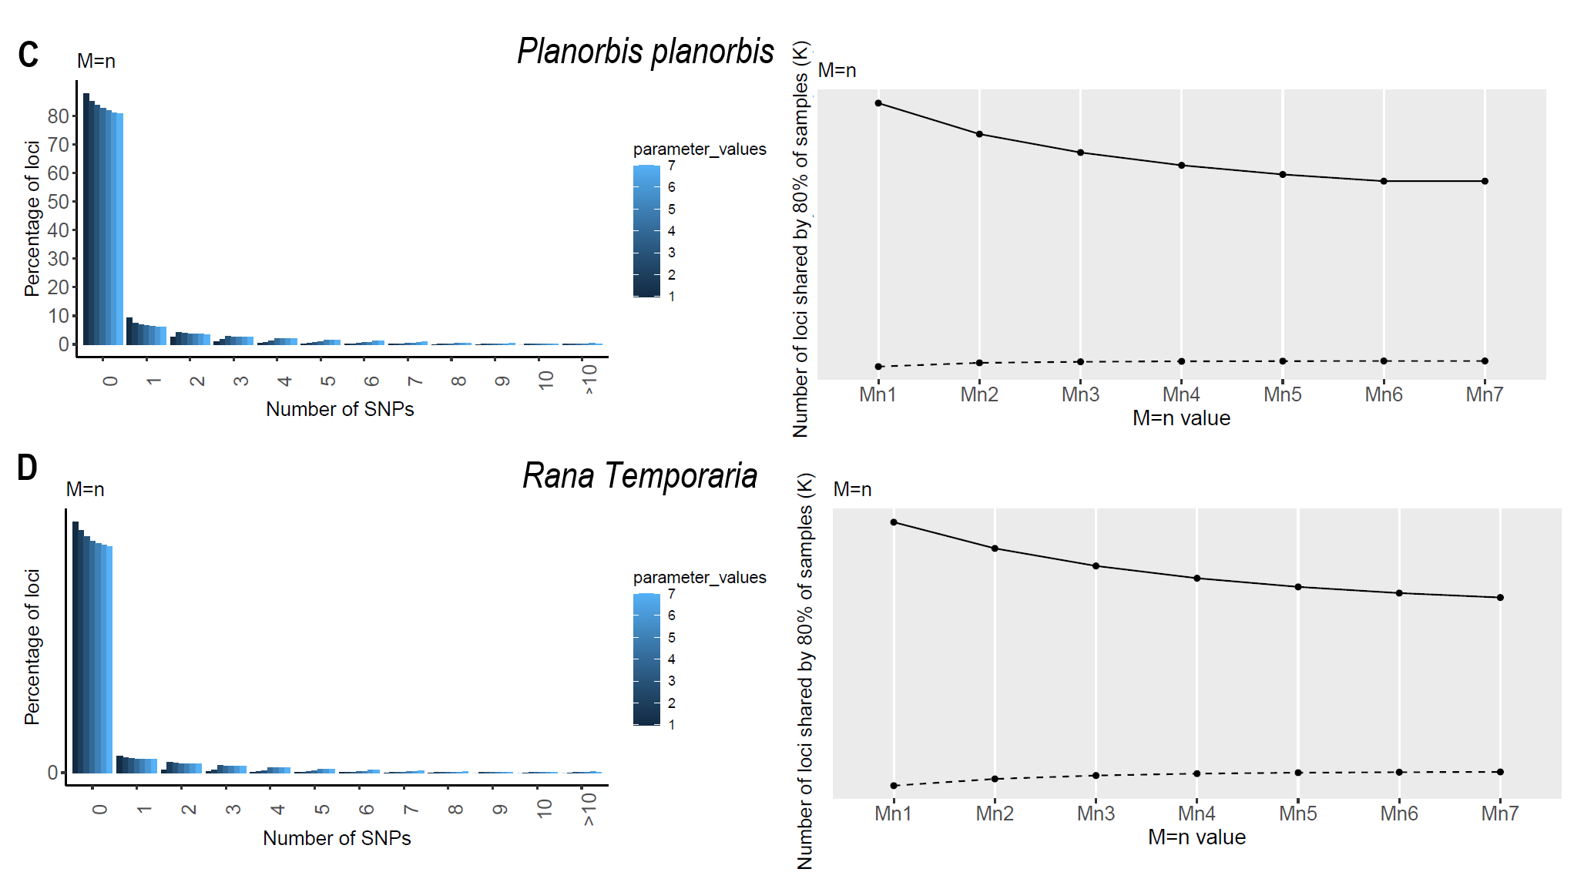
Figure S1 Results from the parameter optimization. To select parameter setting for M and n, the denovo pipeline in Stacks was run while fixing m = 3 and keeping M = n for a range of 1 to at least 6. The upper plot in each panel shows the distribution of number of SNPs per locus while the lower plots show the number of loci shared by 80% of samples for iterated values of M and n following the instructions in (Rochette & Catchen, 2017). Results for A) Asellus aquaticus, the stabilization of the plots occurred at M = n = 4; B) Haliplus ruficollis, stabilization at M = n = 3; C) Planorbis planorbis, stabilization at M = n = 4; D) Rana temporaria, stabilization at M = n = 4.

Table S1. Pond name, species, and genetic- and environmental characteristics of the ponds

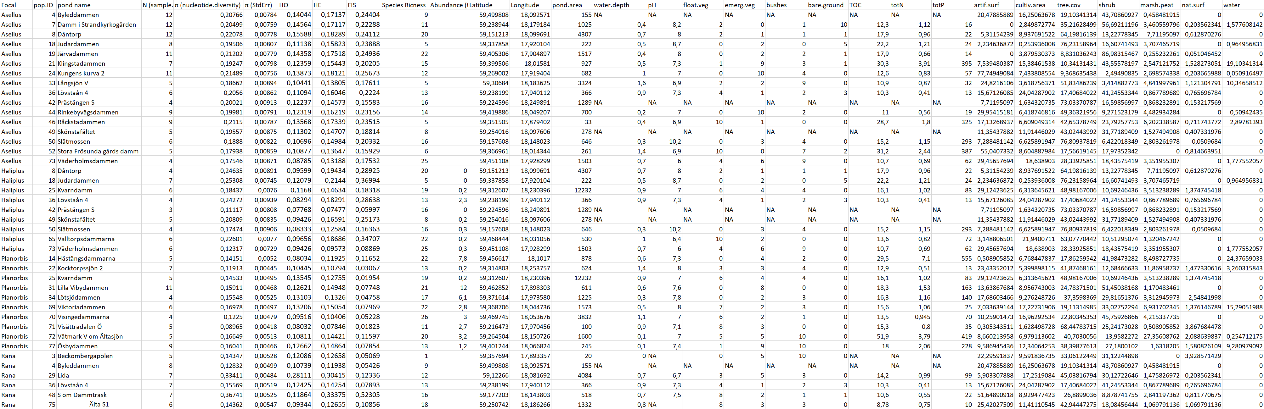

Table S2 Results of the PERMANOVA test conducted among populations for Asellus aquaticus. P-values that remained statistically significant after FDR correction are highlighted in bold. PERMDISP results not presented because of lack of significant results.

 | PERMANOVA |  |  |  | PERMANOVA |  |  |  | PERMANOVA
Groups | t | P |  | Groups | t | P |  | Groups | t | P
4, 7 | 2.39 | 0.000 |  | 8, 52 | 2.13 | 0.001 |  | 24, 49 | 1.36 | 0.000
4, 8 | 2.44 | 0.000 |  | 8, 73 | 1.88 | 0.001 |  | 24, 50 | 1.67 | 0.000
4, 18 | 2.03 | 0.000 |  | 18, 19 | 1.32 | 0.000 |  | 24, 52 | 1.59 | 0.001
4, 19 | 2.05 | 0.000 |  | 18, 21 | 1.48 | 0.000 |  | 24, 73 | 1.45 | 0.001
4, 21 | 2.02 | 0.000 |  | 18, 24 | 1.57 | 0.000 |  | 33, 36 | 1.35 | 0.003
4, 24 | 2.01 | 0.000 |  | 18, 33 | 1.51 | 0.001 |  | 33, 42 | 1.19 | 0.009
4, 33 | 1.86 | 0.001 |  | 18, 36 | 1.61 | 0.001 |  | 33, 44 | 1.62 | 0.001
4, 36 | 1.81 | 0.001 |  | 18, 42 | 1.42 | 0.003 |  | 33, 46 | 1.50 | 0.001
4, 42 | 1.69 | 0.001 |  | 18, 44 | 1.55 | 0.000 |  | 33, 49 | 1.36 | 0.009
4, 44 | 2.12 | 0.000 |  | 18, 46 | 1.24 | 0.003 |  | 33, 50 | 1.44 | 0.003
4, 46 | 1.98 | 0.000 |  | 18, 49 | 1.45 | 0.001 |  | 33, 52 | 1.71 | 0.009
4, 49 | 1.94 | 0.000 |  | 18, 50 | 1.80 | 0.001 |  | 33, 73 | 1.46 | 0.009
4, 50 | 2.11 | 0.000 |  | 18, 52 | 1.31 | 0.003 |  | 36, 42 | 1.22 | 0.017
4, 52 | 2.06 | 0.001 |  | 18, 73 | 1.18 | 0.015 |  | 36, 44 | 1.69 | 0.000
4, 73 | 1.76 | 0.001 |  | 19, 21 | 1.51 | 0.000 |  | 36, 46 | 1.52 | 0.001
7, 8 | 1.77 | 0.000 |  | 19, 24 | 1.62 | 0.000 |  | 36, 49 | 1.37 | 0.005
7, 18 | 2.35 | 0.000 |  | 19, 33 | 1.56 | 0.000 |  | 36, 50 | 1.53 | 0.002
7, 19 | 2.42 | 0.000 |  | 19, 36 | 1.71 | 0.000 |  | 36, 52 | 1.69 | 0.003
7, 21 | 2.39 | 0.000 |  | 19, 42 | 1.50 | 0.001 |  | 36, 73 | 1.48 | 0.005
7, 24 | 2.17 | 0.000 |  | 19, 44 | 1.57 | 0.000 |  | 42, 44 | 1.42 | 0.003
7, 33 | 1.76 | 0.001 |  | 19, 46 | 1.42 | 0.000 |  | 42, 46 | 1.32 | 0.002
7, 36 | 1.77 | 0.001 |  | 19, 49 | 1.53 | 0.001 |  | 42, 49 | 1.25 | 0.008
7, 42 | 1.48 | 0.001 |  | 19, 50 | 1.78 | 0.000 |  | 42, 50 | 1.26 | 0.006
7, 44 | 2.33 | 0.000 |  | 19, 52 | 1.40 | 0.000 |  | 42, 52 | 1.53 | 0.009
7, 46 | 2.22 | 0.000 |  | 19, 73 | 1.22 | 0.009 |  | 42, 73 | 1.28 | 0.028
7, 49 | 1.88 | 0.001 |  | 21, 24 | 1.67 | 0.000 |  | 44, 46 | 1.43 | 0.000
7, 50 | 1.61 | 0.000 |  | 21, 33 | 1.68 | 0.001 |  | 44, 49 | 1.41 | 0.000
7, 52 | 2.31 | 0.000 |  | 21, 36 | 1.77 | 0.002 |  | 44, 50 | 1.85 | 0.001
7, 73 | 1.93 | 0.001 |  | 21, 42 | 1.62 | 0.003 |  | 44, 52 | 1.32 | 0.002
8, 18 | 2.12 | 0.000 |  | 21, 44 | 1.47 | 0.001 |  | 44, 73 | 1.22 | 0.009
8, 19 | 2.30 | 0.000 |  | 21, 46 | 1.58 | 0.001 |  | 46, 49 | 1.30 | 0.002
8, 21 | 2.27 | 0.000 |  | 21, 49 | 1.51 | 0.001 |  | 46, 50 | 1.71 | 0.001
8, 24 | 2.03 | 0.000 |  | 21, 50 | 1.87 | 0.001 |  | 46, 52 | 1.41 | 0.001
8, 33 | 1.69 | 0.000 |  | 21, 52 | 1.61 | 0.002 |  | 46, 73 | 0.97 | 0.601
8, 36 | 1.53 | 0.000 |  | 21, 73 | 1.39 | 0.003 |  | 49, 50 | 1.47 | 0.003
8, 42 | 1.36 | 0.001 |  | 24, 33 | 1.35 | 0.001 |  | 49, 52 | 1.41 | 0.008
8, 44 | 2.31 | 0.000 |  | 24, 36 | 1.44 | 0.000 |  | 49, 73 | 1.29 | 0.008
8, 46 | 2.08 | 0.000 |  | 24, 42 | 1.25 | 0.001 |  | 50, 52 | 1.76 | 0.002
8, 49 | 1.71 | 0.000 |  | 24, 44 | 1.70 | 0.000 |  | 50, 73 | 1.52 | 0.005
8, 50 | 1.57 | 0.001 |  | 24, 46 | 1.58 | 0.000 |  | 52, 73 | 1.10 | 0.176
Table S3 Results of the PERMANOVA and PERMDISP tests conducted among populations for Planorbis planorbis. P-values that remained statistically significant after FDR correction are highlighted in bold.
 | PERMANOVA |  | PERMDISP |  |  |  | PERMANOVA |  | PERMDISP
Groups | t | P | t | P |  | Groups | t | P | t | P
14, 22 | 2.92 | 0.002 | 5.53 | 0.006 |  | 25, 77 | 2.32 | 0.002 | 5.99 | 0.003
14, 25 | 2.43 | 0.009 | 0.07 | 0.950 |  | 31, 34 | 1.91 | 0.003 | 4.05 | 0.258
14, 31 | 2.52 | 0.002 | 10.87 | 0.002 |  | 31, 69 | 2.17 | 0.002 | 0.53 | 0.950
14, 34 | 2.10 | 0.009 | 3.33 | 0.013 |  | 31, 70 | 2.47 | 0.002 | 12.45 | 0.005
14, 69 | 2.07 | 0.005 | 6.14 | 0.013 |  | 31, 71 | 2.93 | 0.002 | 27.50 | 0.002
14, 70 | 1.66 | 0.009 | 3.76 | 0.013 |  | 31, 72 | 1.90 | 0.002 | 2.32 | 0.562
14, 71 | 3.03 | 0.009 | 13.24 | 0.013 |  | 31, 77 | 2.67 | 0.002 | 2.05 | 0.108
14, 72 | 1.88 | 0.009 | 6.30 | 0.013 |  | 34, 69 | 1.66 | 0.008 | 2.55 | 0.106
14, 77 | 2.20 | 0.002 | 8.64 | 0.002 |  | 34, 70 | 2.21 | 0.029 | 5.17 | 0.038
22, 25 | 2.97 | 0.003 | 4.43 | 0.005 |  | 34, 71 | 2.56 | 0.009 | 13.29 | 0.013
22, 31 | 3.31 | 0.002 | 16.39 | 0.002 |  | 34, 72 | 1.55 | 0.009 | 3.18 | 0.013
22, 34 | 2.51 | 0.006 | 7.23 | 0.010 |  | 34, 77 | 1.99 | 0.003 | 2.54 | 0.641
22, 69 | 2.42 | 0.003 | 10.52 | 0.003 |  | 69, 70 | 2.17 | 0.009 | 7.66 | 0.013
22, 70 | 3.14 | 0.006 | 0.71 | 0.736 |  | 69, 71 | 2.44 | 0.004 | 15.83 | 0.009
22, 71 | 3.64 | 0.003 | 5.44 | 0.013 |  | 69, 72 | 1.63 | 0.005 | 1.17 | 0.407
22, 72 | 2.52 | 0.003 | 10.20 | 0.005 |  | 69, 77 | 2.06 | 0.002 | 1.64 | 0.407
22, 77 | 2.83 | 0.002 | 13.82 | 0.002 |  | 70, 71 | 3.34 | 0.009 | 5.13 | 0.013
25, 31 | 2.48 | 0.002 | 7.71 | 0.002 |  | 70, 72 | 2.03 | 0.009 | 7.39 | 0.013
25, 34 | 2.02 | 0.009 | 2.37 | 0.123 |  | 70, 77 | 2.24 | 0.003 | 10.41 | 0.006
25, 69 | 2.05 | 0.005 | 4.95 | 0.010 |  | 71, 72 | 2.14 | 0.009 | 14.31 | 0.013
25, 70 | 2.59 | 0.009 | 2.87 | 0.023 |  | 71, 77 | 2.71 | 0.002 | 24.17 | 0.005
25, 71 | 3.04 | 0.009 | 9.27 | 0.013 |  | 72, 77 | 1.90 | 0.002 | 3.07 | 0.059
25, 72 | 1.96 | 0.009 | 5.25 | 0.013

Table S4 Results of the PERMANOVA and PERMDISP tests conducted among populations for Rana temporaria. P-values that remained statistically significant after FDR correction are highlighted in bold.

 | PERMANOVA |  | PERMDISP
Groups | t | P | t | P
3, 4 | 1.59 | 0.005 | 1.39 | 0.342
3, 29 | 1.72 | 0.051 | 10.26 | 0.003
3, 36 | 1.46 | 0.005 | 1.57 | 0.307
3, 48 | 2.71 | 0.026 | 3.29 | 0.214
3, 75 | 1.44 | 0.008 | 0.16 | 0.949
4, 29 | 2.23 | 0.009 | 13.88 | 0.002
4, 36 | 1.68 | 0.002 | 3.68 | 0.017
4, 48 | 3.52 | 0.009 | 4.50 | 0.002
4, 75 | 1.66 | 0.002 | 1.77 | 0.252
29, 36 | 2.05 | 0.015 | 11.71 | 0.002
29, 48 | 1.67 | 0.056 | 0.09 | 0.966
29, 75 | 1.90 | 0.026 | 12.07 | 0.002
36, 48 | 3.20 | 0.022 | 3.68 | 0.002
36, 75 | 1.13 | 0.034 | 2.78 | 0.023
48, 75 | 2.94 | 0.026 | 3.67 | 0.024

