Electronic Supplementary Material
Article: Weak fine-scale genetic structure and considerable life-history diversity in a near-pristine subarctic Atlantic salmon (Salmo salar) river

Journal: Conservation genetics
Authors: María I. Cádiz, Marion Sinclair-Waters, Jaakko Erkinaro, Panu Orell, Ana S. Lindeza, Morgane Frapin, Amaïa Lamarins, Victoria L Pritchard & Craig R Primmer.
Corresponding autor: María I. Cádiz (maria.cadiz-escobar@helsinki.fi)

Online Resource 1. Description Teno populations

Table S1. Sampling location, abbreviated location name and number of individuals collected in Teno River, genetic diversity (H_{E}, expected heterozygosity; H_{O}, observed heterozygosity) based in 12912 SNPs.

# | Reporting unit | Location Name | River | Abbrev name | #samples | H_{E} | H_{O} | Group
1 | 1, Tana Bru/Luovtejohka | Tana Mainstem | Teno | Tanabru | 42 | 0.338 | 0.341 | B
2 | 1, Tana Bru/Luovtejohka | Luovttejohka | Teno | Luovte | 27 | 0.339 | 0.344 | B
3 | 2a-g. Teno Mainstem* | Alaköngäs | Teno | Alakongas | 37 | 0.342 | 0.347 | B
4 | 2a-g. Teno Mainstem* | Piltamo | Teno | Piltamo | 38 | 0.341 | 0.346 | A
5 | 2a-g. Teno Mainstem* | Sirma | Teno | Sirma | 33 | 0.341 | 0.347 | A
6 | 2a-g. Teno Mainstem* | Garnjarga | Teno | Garnjaga | 39 | 0.342 | 0.346 | A
7 | 2a-g. Teno Mainstem* | Kortsham | Teno | Kortsham | 36 | 0.341 | 0.347 | A
8 | 2a-g. Teno Mainstem* | Yläköngäs | Teno | Ylakongas | 37 | 0.344 | 0.348
9 | 2h. Outakoski | Outakoski | Teno | Outa | 48 | 0.342 | 0.344
10 | 3. Máskejohka | Máskejohka | Teno | maske | 37 | 0.337 | 0.339 | C
11 | 3. Máskejohka | Upper Máskejohka | Teno | u_maske | 28 | 0.333 | 0.339 | C
12 | 4a. Ylä Pulmankijoki/ Luossajoki | Ylä-Pulmankijoki |  | Ypulm | 29 | 0.299 | 0.31
13 | 4a. Ylä Pulmankijoki/ Luossajoki | Luossajoki | Teno | Luossa | 38 | 0.284 | 0.289
14 | 4b. Galddasjoki | Galddasjoki | Teno | Galddas | 49 | 0.29 | 0.288
15 | 5. Vetsijoki | Vetsijoki | Teno | Vetsijoki | 36 | 0.334 | 0.336
16 | 6abc. Lakšjohka/ Gurtejohka/ Deavkkehanjohka | Deavkkehanjohka | Teno | Deav | 38 | 0.278 | 0.281
17 | 6abc. Lakšjohka/ Gurtejohka/ Deavkkehanjohka | Gurtejohka |  | Gurtes | 36 | 0.287 | 0.288
18 | 6abc. Lakšjohka/ Gurtejohka/ Deavkkehanjohka | Lakšjohka | Teno | Laks | 28 | 0.317 | 0.311
19 | 7a. Utsjoki | Utsjoki | Teno | Uts | 84 | 0.323 | 0.321
20 | 7b. Kevojoki | Kevojoki | Teno | Kevo | 33 | 0.311 | 0.307
21 | 7c. Tsarsjoki | Tsarsjoki |  | Tsars | 65 | 0.272 | 0.268
22 | 8a. Kuoppilasjoki/ Birkejohka | Kuoppilasjoki | Teno | Kuopp | 20 | 0.318 | 0.324
23 | 8a. Kuoppilasjoki/ Birkejohka | Birkejohka | Teno | Birke | 15 | 0.3 | 0.312
24 | 8b. Levajohka | Levajohka | Teno | Leva | 45 | 0.332 | 0.326
25 | 8cd. Baisjohka/ Niilijohka | Báišjohka | Teno | Bais | 40 | 0.322 | 0.325
26 | 8cd. Baisjohka/ Niilijohka | Nilijoki | Teno | Nilijoki | 37 | 0.327 | 0.334
27 | 8e. Akujoki | Akujoki |  | Akujoki | 33 | 0.33 | 0.337
28 | 8f. Karigasjoki | Karigasjoki | Teno | Karigas | 40 | 0.332 | 0.333
29 | 8g. Váljohka/ Astejohka | Váljohka | Teno | Valjohka | 30 | 0.319 | 0.327
30 | 8g. Váljohka/ Astejohka |  | Teno | Aste | 19 | 0.299 | 0.318
31 | 9. Geáimmejohka | Geáimmejohka | Teno | Geaim | 41 | 0.307 | 0.312
32 | 10ab. Iešjohka Upper & Lower | Iešjohka Lower | Teno | Ies | 15 | 0.332 | 0.349
33 | 10ab. Iešjohka Upper & Lower | Iešjohka Upper |  | Ala_Ies | 44 | 0.339 | 0.342
34 | 10c. Kárášjohka | Kárášjohka | Teno | Karas | 38 | 0.337 | 0.342
35 | 10c. Kárášjohka |  | Teno | Kara_Ned | 2 | 0.257 | 0.349
36 | 11a-e. Inari Headwaters | Inari MS | Teno | Inari | 95 | 0.335 | 0.337
37 | 11a-e. Inari Headwaters | Iskurasjoki | Teno | Iskuras | 31 | 0.332 | 0.34
38 | 11a-e. Inari Headwaters | Goššjohka | Teno | Gossjohka | 25 | 0.326 | 0.334
39 | 11a-e. Inari Headwaters | Vuomajoki | Teno | Vuoma | 25 | 0.331 | 0.34
40 | 11a-e. Inari Headwaters | Cášcemjohka |  | Casce | 11 | 0.314 | 0.337
41 | 11f. Kietsimäjoki | Kietsimäjoki | Teno | Kietsi | 26 | 0.312 | 0.308
42 |  | Anarjohka | Teno | Anar | 20 | 0.324 | 0.342
43 | Gist-Sili | Gisttahbealjohka | Näätämö |  | 8 | 0.313 | 0.346
44 | Gist-Sili | Silisjoki | Näätämö |  | 43 | 0.339 | 0.343
45 |  | Harrijoki | Näätämö |  | 37 | 0.333 | 0.334
46 | Mainstem | Kuosnijoki | Näätämö |  | 22 | 0.336 | 0.345
47 | Mainstem | MS1 | Näätämö |  | 30 | 0.343 | 0.351
48 | Mainstem | MS2 | Näätämö |  | 22 | 0.339 | 0.349
49 | Mainstem | MS3 | Näätämö |  | 41 | 0.342 | 0.348
50 | Mainstem | MS4 | Näätämö |  | 49 | 0.342 | 0.348

Online Resource 2. Details quality control 60K panel per river

Table S2. Quality control details per system

 | Data | # SNPs |  | # samples
 |  | keep | removed | keep | removed
Update - 91.20% variants were successfully transformed | Merge data | 54761 | 5489 | 1802 | -
(1) removing loci with more than 10% missing data (--geno 0.1) | Merge data | 42486 | 12275 | 1802 | -
(2) removing individuals with more than 10% missing data (--mind 0.1) | Merge data | 42486 | 0 | 1802 | -
(3) removing loci deviating from Hardy–Weinberg equilibrium (--hwe 0.01) | Teno | 42432 | 54 | 1519 | -
 | Näätämö | 42432 | 54 | 283 | -
(4) removing loci with minor allele frequencies below 0.01 (--maf 0.01) | Teno | 41900 | 532 | 1519 | -
 | Näätämö | 41920 | 512 | 283 | -
(5) filtering SNPs in strong linkage disequilibrium | Teno | 20169 | 21731 | - | -
 | Näätämö | 17227 | 24693 | - | -
(6) removing related individuals with a PI_HAT > 0.5 | Teno | - | - | 1399 | 120
 | Näätämö | - | - | 252 | 30
Merge data | Merge data | 12912 | 11568 | 1651 | -
List of IDs of 8 samples detected as unknow population by Admixture analyses | Gistapeljoki tributary:  Sample524, Sample527, Sample529, Sample538  Silisjoki tributary:  Sample1309, Sample1317, Sample1320, Sample1322

Online Resource 3. Details of structure analysis

Fig. S1. Admixture results for two to five genetic clusters (K=2 to K=5) for the Näätämö river dataset.
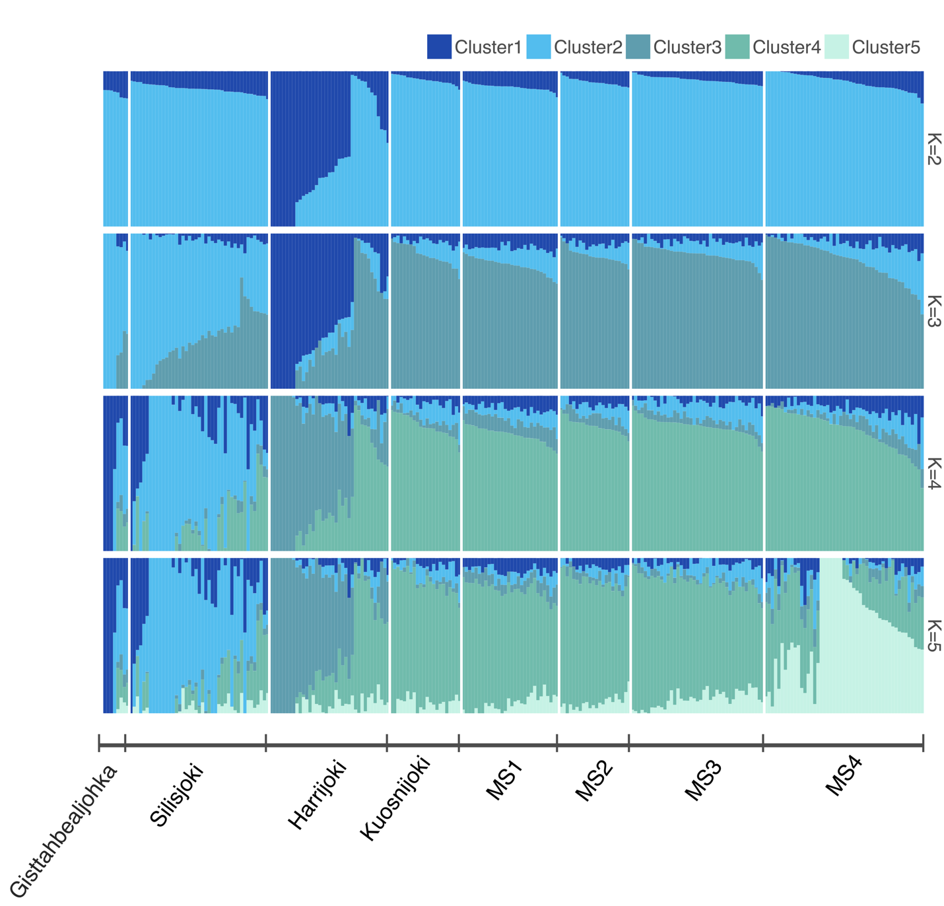

Fig. S2. Principal Component Analysis (PCA) of 1651 individuals from the Näätämö (252 samples; filled blue-violet-green dots) and Teno Rivers (1399 samples; blank red-pink dots). Each sampling location had a unique color. The X- and Y-axis titles show the variation explained by PC1 and PC2, respectively.

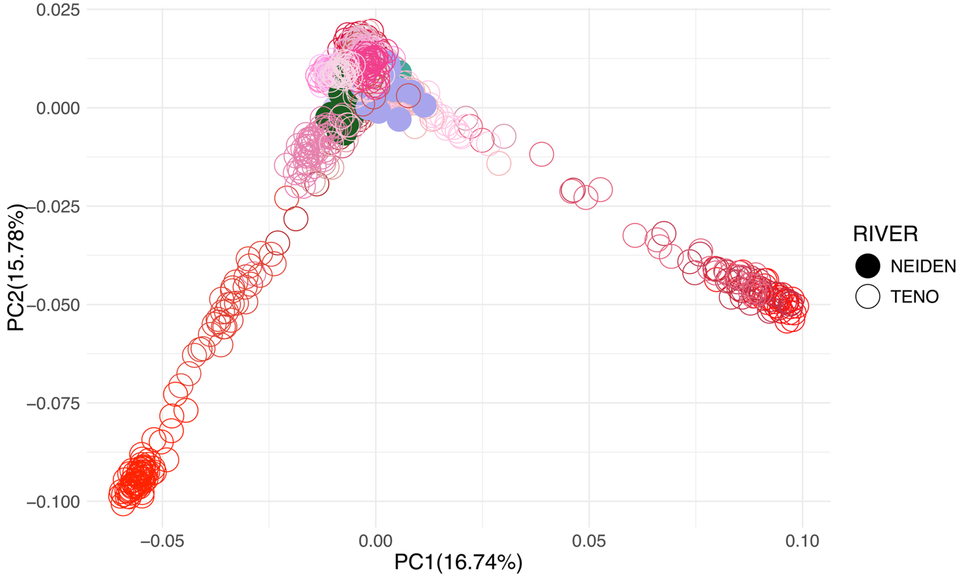

Fig. S3. Admixture results for 23 genetic clusters (K=23) for the Näätämö and Teno (Tana mainstem & Luovttejohka, Upper Teno tributaries, inarijoki headwaters, Iešjohka & Kárásjohka, Geaim, Vetsijoki Maskejohja, Laksjohka: utsojoki and Pulmankijarvi) dataset.
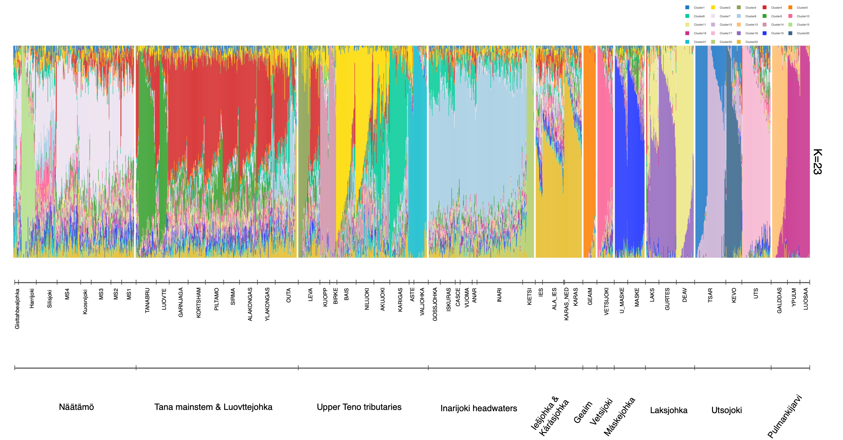

Online Resource 4. Details of F_{ST} results between Näätämö and Teno Rivers locations

Table S3. Pairwise F_{ST} values between Näätämö and Teno Rivers locations. Color code: dark red >0.08; light red 0.08-0.06; yellow 0.06-0.03; light green 0.03-0.02; <0.02 dark green. Blue boxes correspond to Näätämö locations.

Online Resource 5. Details of gene flow among the sampling sites

Table S4. The number of migrants (Nm) values between the Näätämö River (Gisttahbealjohka, Harrijoki, Silisjoki, Kuosnijoki, MS1, MS2, MS3 and MS4) against a) Teno Group A (Piltamo, Sirma, Garnjaga and Kortsham); b) Teno Group B (Tanabru, Luovte and Alakongas) and c) Teno group C (Maske and u_maske). Sampling location abbreviations are in Table 1 and Table S1.

a)
 | Garnjaga | Gisttahbealjohka | Harrijoki | Kort | Kuosnijoki | MS3 | MS2 | MS1 | Piltamo | Silisjoki | Sirma | MS4
Garnjaga | NA | 0.166 | 0.347 | 0.999 | 0.394 | 0.508 | 0.406 | 0.489 | 0.989 | 0.473 | 0.944 | 0.486
Gisttahbealjohka | 0.226 | NA | 0.198 | 0.224 | 0.212 | 0.238 | 0.212 | 0.229 | 0.225 | 0.289 | 0.223 | 0.243
Harrijoki | 0.354 | 0.154 | NA | 0.341 | 0.374 | 0.455 | 0.387 | 0.424 | 0.344 | 0.412 | 0.343 | 0.442
Kort | 1.000 | 0.164 | 0.336 | NA | 0.382 | 0.486 | 0.395 | 0.480 | 0.953 | 0.461 | 0.905 | 0.474
Kuosnijoki | 0.411 | 0.163 | 0.380 | 0.395 | NA | 0.809 | 0.545 | 0.525 | 0.400 | 0.482 | 0.393 | 0.589
MS3 | 0.496 | 0.173 | 0.440 | 0.471 | 0.757 | NA | 0.695 | 0.696 | 0.480 | 0.610 | 0.470 | 0.797
MS2 | 0.416 | 0.161 | 0.388 | 0.400 | 0.532 | 0.727 | NA | 0.660 | 0.402 | 0.491 | 0.401 | 0.601
MS1 | 0.474 | 0.164 | 0.407 | 0.460 | 0.489 | 0.691 | 0.624 | NA | 0.468 | 0.521 | 0.463 | 0.642
piltamo | 1.000 | 0.165 | 0.340 | 0.955 | 0.392 | 0.502 | 0.398 | 0.487 | NA | 0.460 | 0.979 | 0.485
Silisjoki | 0.470 | 0.211 | 0.400 | 0.460 | 0.464 | 0.623 | 0.479 | 0.532 | 0.451 | NA | 0.452 | 0.611
Sirma | 0.962 | 0.164 | 0.339 | 0.913 | 0.385 | 0.490 | 0.394 | 0.482 | 0.987 | 0.462 | NA | 0.481
MS4 | 0.477 | 0.175 | 0.426 | 0.461 | 0.548 | 0.788 | 0.572 | 0.638 | 0.467 | 0.591 | 0.463 | NA

b)
 | Alakongas | Gisttahbealjohka | Harrijoki | Kuosnijoki | MS3 | Luovte | MS2 | MS1 | Silisjoki | Tanabru | MS4
Alakongas | NA | 0.189 | 0.393 | 0.444 | 0.586 | 0.816 | 0.465 | 0.557 | 0.540 | 0.849 | 0.557
Gisttahbealjohka | 0.256 | NA | 0.224 | 0.240 | 0.269 | 0.238 | 0.240 | 0.258 | 0.327 | 0.233 | 0.274
Harrijoki | 0.397 | 0.174 | NA | 0.423 | 0.514 | 0.355 | 0.438 | 0.479 | 0.465 | 0.351 | 0.500
Kuosnijoki | 0.461 | 0.184 | 0.430 | NA | 0.914 | 0.408 | 0.617 | 0.593 | 0.545 | 0.401 | 0.666
MS3 | 0.564 | 0.196 | 0.498 | 0.856 | NA | 0.477 | 0.786 | 0.788 | 0.690 | 0.475 | 0.901
Luovte | 0.840 | 0.178 | 0.353 | 0.394 | 0.494 | NA | 0.407 | 0.492 | 0.472 | 1.000 | 0.489
MS2 | 0.469 | 0.182 | 0.439 | 0.601 | 0.823 | 0.407 | NA | 0.747 | 0.555 | 0.406 | 0.680
MS1 | 0.535 | 0.186 | 0.460 | 0.553 | 0.782 | 0.469 | 0.705 | NA | 0.589 | 0.459 | 0.726
Silisjoki | 0.529 | 0.239 | 0.453 | 0.525 | 0.704 | 0.457 | 0.542 | 0.601 | NA | 0.450 | 0.691
Tanabru | 0.872 | 0.178 | 0.352 | 0.395 | 0.497 | 0.999 | 0.409 | 0.486 | 0.459 | NA | 0.480
MS4 | 0.540 | 0.198 | 0.482 | 0.619 | 0.891 | 0.468 | 0.646 | 0.722 | 0.669 | 0.458 | NA

c)
 | U_Maske | Gisttahbealjohka | Harrijoki | Kuosnijoki | MS3 | Maske | MS2 | MS1 | Silisjoki | MS4
U_Maske | NA | 0.168 | 0.315 | 0.338 | 0.401 | 0.934 | 0.353 | 0.397 | 0.388 | 0.405
Gisttahbealjohka | 0.213 | NA | 0.245 | 0.262 | 0.294 | 0.231 | 0.262 | 0.283 | 0.357 | 0.300
Harrijoki | 0.304 | 0.191 | NA | 0.462 | 0.562 | 0.339 | 0.479 | 0.524 | 0.509 | 0.547
Kuosnijoki | 0.328 | 0.201 | 0.470 | NA | 1.000 | 0.374 | 0.674 | 0.649 | 0.596 | 0.728
MS3 | 0.373 | 0.214 | 0.545 | 0.936 | NA | 0.426 | 0.859 | 0.861 | 0.755 | 0.985
Maske | 0.899 | 0.177 | 0.342 | 0.374 | 0.446 | NA | 0.386 | 0.446 | 0.434 | 0.453
MS2 | 0.341 | 0.199 | 0.480 | 0.658 | 0.900 | 0.383 | NA | 0.817 | 0.607 | 0.744
MS1 | 0.368 | 0.203 | 0.503 | 0.605 | 0.855 | 0.423 | 0.771 | NA | 0.644 | 0.794
Silisjoki | 0.368 | 0.261 | 0.495 | 0.574 | 0.770 | 0.423 | 0.593 | 0.658 | NA | 0.756
MS4 | 0.377 | 0.217 | 0.527 | 0.677 | 0.975 | 0.432 | 0.707 | 0.789 | 0.731 | NA

Online Resource 6. Life-history strategies

Fig. S4. Returning timing during the fishing season between 1975-2022 based on 17994 samples (10887 males and 7107 females) by sea age (1SW, 2SW, 3SW, 4SW and RS, repeat spawners). A) Number of males returning between weeks 22-35; B) Number of females returning between weeks 22-36; C) Proportion of total returning between weeks 22-36.

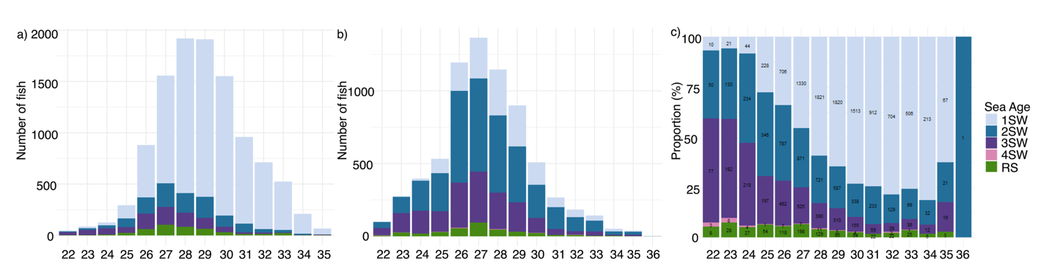

Fig. S5. Individual-based rarefaction (solid lines) and extrapolation (dashed line) plot of the life history strategies for each 6-year period between 1975 and 2022

