SUPPLEMENTARY MATERIAL 1
Genomic evidence for a hybrid origin of the critically endangered shrub Callistemon kenmorrisonii (Myrtaceae) and persistence involving extreme clonality
Conservation Genetics
Mark D. Clifton ^{1,2}, Tamandra H. D’Ombrain^{1,2}, Bryce D. Watts-Parker³, Abigail R. Wills³, Susan E. Hoebee^{1,2}

¹ Department of Ecological, Plant and Animal Sciences, La Trobe University, Bundoora, Victoria 3086, Australia
² Research Centre for Future Landscapes, School of Agriculture, Biomedicine and Environment, La Trobe University, Bundoora, Victoria 3086, Australia

Corresponding author: Mark David Clifton. Mark.Clifton@latrobe.edu.au

Table S1 Initial data filtering of Callistemon dataset in dartR. Dataset contained all C. kenmorrisonii, C. subulatus and C. citrinus samples
Filter | Threshold | SNPs remaining | Samples removed
Pre-filtered | - | 50390 | -
Reproducibility | 1 | 28355 | -
Call rate (loci) | 0.90 | 10331 | -
Call rate (Individual) | 0.75 | 10331 | -
Minor allele frequency | 0.02 | 6601 | -
Secondaries | best | 6139 | -

Table S2 Filtering of Callistemon dataset in dartR after clones were removed. Dataset contained only one individual representing each MLG present within each C. kenmorrisonii, C. subulatus and C. citrinus population
Filter | Threshold | SNPs remaining | Samples removed
Pre-filtered | - | 44849 | -
Reproducibility | 1 | 24982 | -
Call rate (loci) | 0.90 | 6334 | -
Call rate (Individual) | 0.75 | 6334 | -
Minor allele frequency | 0.02 | 5479 | -
Secondaries | best | 5116

Fig. S2 Scatter plots of clonal pairs from initial filtered dataset. A) Scatter plot of distance matrix generated in poppr, with a threshold of 0.022 (red line). Clonal pairs fall under the threshold at 0.00–0.022, while MLGs fall above the threshold at 0.022–0.35. B) Scatter plot of pairwise distance matrix of ‘dyadml’ estimates from related, with a threshold of 0.80 (red line). Clonal pairs fall above the threshold at 0.80–1.00, while MLGs fall below the threshold at 0.00–0.80. Red dots are replicate pairs (5) from the KEN-A, KEN-C and SUB-A populations
A
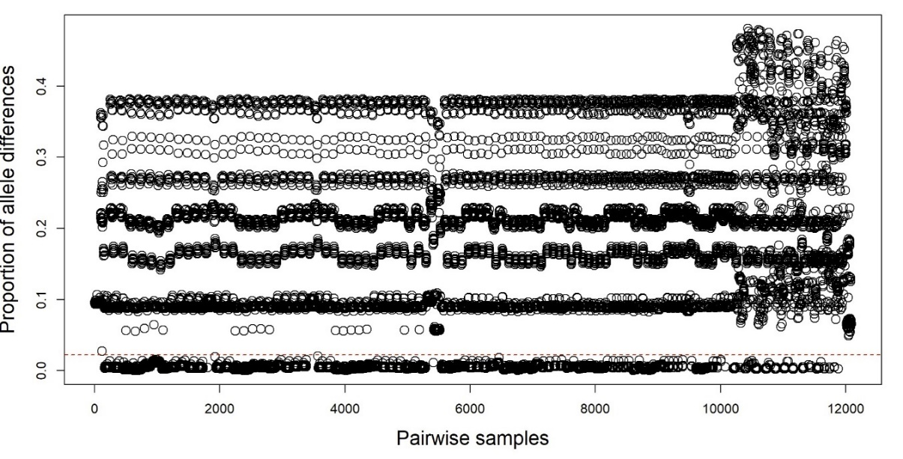
B

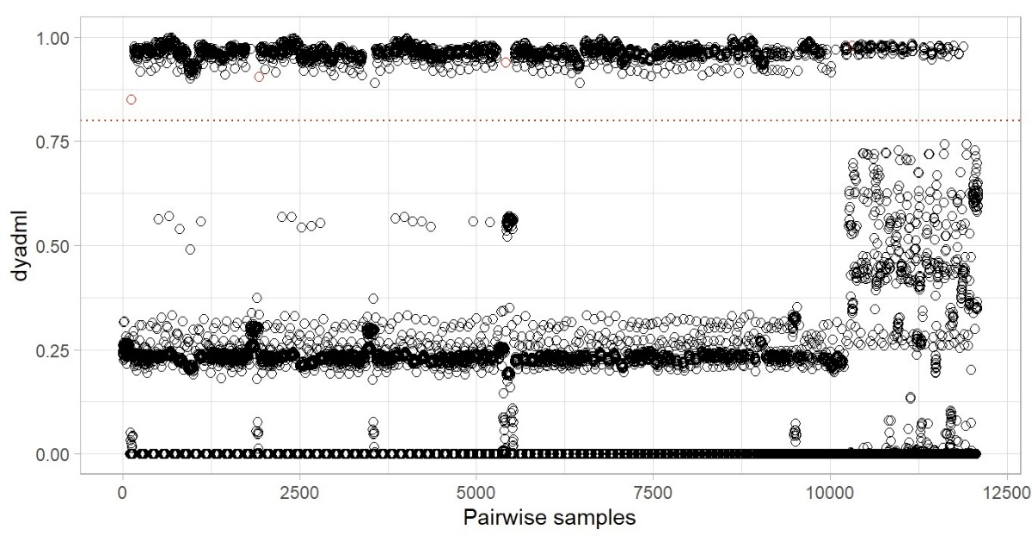

Table S3 Relatedness estimates between unique C. kenmorrisonii MLGs using the dyadml estimator in related (COANCESTRY)
Pair number | Individual 1 | Individual 2 | Group | Dyadml  estimate
1 | KEN-A-01 | KEN-A-02 | KEKE | 0.1842
2 | KEN-A-01 | KEN-A-04 | KEKE | 0.1698
3 | KEN-A-01 | KEN-C-10 | KEKE | 0.1426
4 | KEN-A-01 | KEN-A-12 | KEKE | 0.1294
5 | KEN-A-01 | KEN-B-01 | KEKE | 0.2037
6 | KEN-A-01 | KEN-A-08 | KEKE | 0.1521
7 | KEN-A-02 | KEN-A-04 | KEKE | 0.2404
8 | KEN-A-02 | KEN-C-10 | KEKE | 0.2346
9 | KEN-A-02 | KEN-A-12 | KEKE | 0.2382
10 | KEN-A-02 | KEN-B-01 | KEKE | 0.2028
11 | KEN-A-02 | KEN-A-08 | KEKE | 0.176
12 | KEN-A-04 | KEN-C-10 | KEKE | 0.1864
13 | KEN-A-04 | KEN-A-12 | KEKE | 0.5368
14 | KEN-A-04 | KEN-B-01 | KEKE | 0.2228
15 | KEN-A-04 | KEN-A-08 | KEKE | 0.2546
16 | KEN-C-10 | KEN-A-12 | KEKE | 0.1991
17 | KEN-C-10 | KEN-B-01 | KEKE | 0.209
18 | KEN-C-10 | KEN-A-08 | KEKE | 0.2373
19 | KEN-A-12 | KEN-B-01 | KEKE | 0.1733
20 | KEN-A-12 | KEN-A-08 | KEKE | 0.2747
21 | KEN-B-01 | KEN-A-08 | KEKE | 0.2529

Fig. S3 R package ‘pophelper’ and CLUMMPAK ‘Best K’ plots of optimal K values. (A) Delta K plot giving an optimal value of K = 2 at its peak. (B) L(K) plot giving an optimal value of K = 3, where it plateaus. (C) Rate of change of the likelihood distribution plot giving an optimal value of K = 2, where it plateaus. (D) Absolute values of the second order rate of change of the likelihood distribution plot giving an optimal value of K = 2 and (E) Pr(K=k) plot from CLUMMPAK ‘Best K’ giving an optimal value of K = 3 at its peak
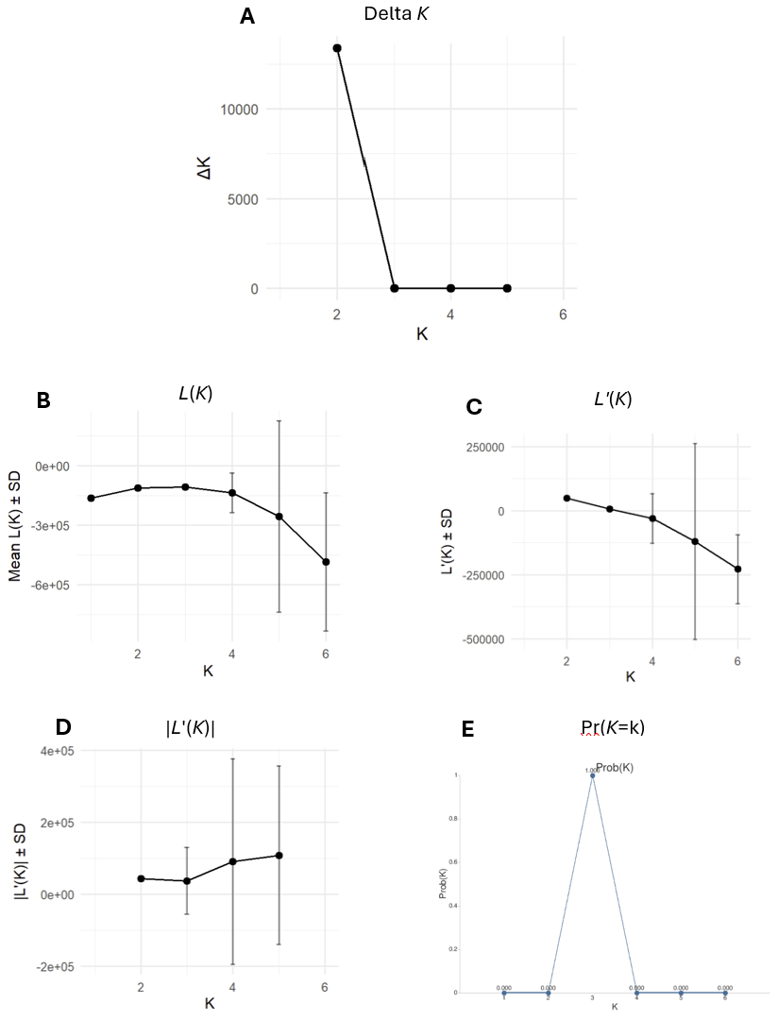
Table S4 NEWHYBRIDS posterior probability estimates after clones removed from dataset when C. citrinus CIT-A was allocated as parent 1 (P1) and C. subulatus SUB-A was allocated as parent 2 (P2)
Sample | Pop | P1 | P2 | F1 | F2 | F1xP1 | F1xP2
CIT-A-01 | CIT-A | 1 | 0 | 0 | 0 | 0 | 0
CIT-A-05 | CIT-A | 1 | 0 | 0 | 0 | 0 | 0
CIT-A-06 | CIT-A | 1 | 0 | 0 | 0 | 0 | 0
CIT-A-07 | CIT-A | 1 | 0 | 0 | 0 | 0 | 0
CIT-A-08 | CIT-A | 1 | 0 | 0 | 0 | 0 | 0
CIT-A-09 | CIT-A | 1 | 0 | 0 | 0 | 0 | 0
CIT-A-11 | CIT-A | 1 | 0 | 0 | 0 | 0 | 0
CIT-A-12 | CIT-A | 1 | 0 | 0 | 0 | 0 | 0
CIT-A-14 | CIT-A | 1 | 0 | 0 | 0 | 0 | 0
CIT-A-15 | CIT-A | 1 | 0 | 0 | 0 | 0 | 0
CIT-B-02 | CIT-B | 1 | 0 | 0 | 0 | 0 | 0
KEN-A-01 | KEN-A | 0 | 0 | 0 | 0 | 0 | 1
KEN-A-02 | KEN-A | 0 | 0 | 0 | 0 | 0 | 1
KEN-A-04 | KEN-A | 0 | 0 | 0 | 0 | 0 | 1
KEN-A-08 | KEN-A | 0 | 0 | 0 | 0 | 0 | 1
KEN-A-12 | KEN-A | 0 | 0 | 0 | 0 | 0 | 1
KEN-B-01 | KEN-B | 0 | 0 | 0 | 0 | 0 | 1
KEN-C-10 | KEN-C | 0 | 0 | 0 | 0 | 0 | 1
SUB-A-01 | SUB-A | 0 | 1 | 0 | 0 | 0 | 0
SUB-A-02 | SUB-A | 0 | 1 | 0 | 0 | 0 | 0
SUB-A-03 | SUB-A | 0 | 1 | 0 | 0 | 0 | 0
SUB-A-04 | SUB-A | 0 | 1 | 0 | 0 | 0 | 0
SUB-A-05 | SUB-A | 0 | 1 | 0 | 0 | 0 | 0
SUB-A-06 | SUB-A | 0 | 1 | 0 | 0 | 0 | 0
SUB-A-07 | SUB-A | 0 | 1 | 0 | 0 | 0 | 0
SUB-A-08 | SUB-A | 0 | 1 | 0 | 0 | 0 | 0
SUB-A-09 | SUB-A | 0 | 1 | 0 | 0 | 0 | 0
SUB-A-10 | SUB-A | 0 | 1 | 0 | 0 | 0 | 0
SUB-A-11 | SUB-A | 0 | 1 | 0 | 0 | 0 | 0
SUB-A-12 | SUB-A | 0 | 1 | 0 | 0 | 0 | 0
SUB-A-13 | SUB-A | 0 | 1 | 0 | 0 | 0 | 0
SUB-A-14 | SUB-A | 0 | 1 | 0 | 0 | 0 | 0
SUB-A-15 | SUB-A | 0 | 1 | 0 | 0 | 0 | 0
SUB-B-01 | SUB-B | 0 | 1 | 0 | 0 | 0 | 0
SUB-B-02 | SUB-B | 0 | 1 | 0 | 0 | 0 | 0
SUB-B-03 | SUB-B | 0 | 1 | 0 | 0 | 0 | 0
SUB-B-04 | SUB-B | 0 | 1 | 0 | 0 | 0 | 0
SUB-B-05 | SUB-B | 0 | 1 | 0 | 0 | 0 | 0
SUB-B-06 | SUB-B | 0 | 1 | 0 | 0 | 0 | 0
SUB-B-07 | SUB-B | 0 | 1 | 0 | 0 | 0 | 0
SUB-B-08 | SUB-B | 0 | 1 | 0 | 0 | 0 | 0
SUB-B-09 | SUB-B | 0 | 1 | 0 | 0 | 0 | 0
SUB-B-10 | SUB-B | 0 | 1 | 0 | 0 | 0 | 0
Pop = source population, P1 = parent 1, P2 = parent 2, F1 = 1st generation hybrid, F2 = 2nd generation hybrid, F1 x P1 =F1 backcross with C. citrinus, F2 = F1 backcross with C. subulatus.
Table S5 NEWHYBRIDS posterior probability estimates after clones removed from dataset when C. citrinus CIT-A was allocated as parent 1 (P1) and C. subulatus SUB-B was allocated as parent 2 (P2)
Sample | Pop | P1 | P2 | F1 | F2 | F1xP1 | F1xP2
CIT-A-01 | CIT-A | 1 | 0 | 0 | 0 | 0 | 0
CIT-A-05 | CIT-A | 1 | 0 | 0 | 0 | 0 | 0
CIT-A-06 | CIT-A | 1 | 0 | 0 | 0 | 0 | 0
CIT-A-07 | CIT-A | 1 | 0 | 0 | 0 | 0 | 0
CIT-A-08 | CIT-A | 1 | 0 | 0 | 0 | 0 | 0
CIT-A-09 | CIT-A | 1 | 0 | 0 | 0 | 0 | 0
CIT-A-11 | CIT-A | 1 | 0 | 0 | 0 | 0 | 0
CIT-A-12 | CIT-A | 1 | 0 | 0 | 0 | 0 | 0
CIT-A-14 | CIT-A | 1 | 0 | 0 | 0 | 0 | 0
CIT-A-15 | CIT-A | 1 | 0 | 0 | 0 | 0 | 0
CIT-B-02 | CIT-B | 1 | 0 | 0 | 0 | 0 | 0
KEN-A-01 | KEN-A | 0 | 0 | 0 | 0.0004 | 0 | 0.9996
KEN-A-02 | KEN-A | 0 | 0 | 0.08607 | 0.00162 | 0 | 0.9123
KEN-A-04 | KEN-A | 0 | 0 | 0 | 0.00001 | 0 | 0.99999
KEN-A-08 | KEN-A | 0 | 0 | 0.29369 | 0.00238 | 0 | 0.70393
KEN-A-12 | KEN-A | 0 | 0 | 0.33914 | 0.07423 | 0 | 0.58663
KEN-B-01 | KEN-B | 0 | 0 | 0 | 0.00027 | 0 | 0.99973
KEN-C-10 | KEN-C | 0 | 0 | 0.31229 | 0.00032 | 0 | 0.68739
SUB-A-01 | SUB-A | 0 | 1 | 0 | 0 | 0 | 0
SUB-A-02 | SUB-A | 0 | 1 | 0 | 0 | 0 | 0
SUB-A-03 | SUB-A | 0 | 1 | 0 | 0 | 0 | 0
SUB-A-04 | SUB-A | 0 | 0.98966 | 0 | 0 | 0 | 0.01034
SUB-A-05 | SUB-A | 0 | 0.34783 | 0 | 0 | 0 | 0.65217
SUB-A-06 | SUB-A | 0 | 0 | 0 | 0 | 0 | 1
SUB-A-07 | SUB-A | 0 | 1 | 0 | 0 | 0 | 0
SUB-A-08 | SUB-A | 0 | 1 | 0 | 0 | 0 | 0
SUB-A-09 | SUB-A | 0 | 1 | 0 | 0 | 0 | 0
SUB-A-10 | SUB-A | 0 | 1 | 0 | 0 | 0 | 0
SUB-A-11 | SUB-A | 0 | 1 | 0 | 0 | 0 | 0
SUB-A-12 | SUB-A | 0 | 1 | 0 | 0 | 0 | 0
SUB-A-13 | SUB-A | 0 | 1 | 0 | 0 | 0 | 0
SUB-A-14 | SUB-A | 0 | 1 | 0 | 0 | 0 | 0
SUB-A-15 | SUB-A | 0 | 1 | 0 | 0 | 0 | 0
SUB-B-01 | SUB-B | 0 | 1 | 0 | 0 | 0 | 0
SUB-B-02 | SUB-B | 0 | 1 | 0 | 0 | 0 | 0
SUB-B-03 | SUB-B | 0 | 1 | 0 | 0 | 0 | 0
SUB-B-04 | SUB-B | 0 | 1 | 0 | 0 | 0 | 0
SUB-B-05 | SUB-B | 0 | 1 | 0 | 0 | 0 | 0
SUB-B-06 | SUB-B | 0 | 1 | 0 | 0 | 0 | 0
SUB-B-07 | SUB-B | 0 | 1 | 0 | 0 | 0 | 0
SUB-B-08 | SUB-B | 0 | 1 | 0 | 0 | 0 | 0
SUB-B-09 | SUB-B | 0 | 1 | 0 | 0 | 0 | 0
SUB-B-10 | SUB-B | 0 | 1 | 0 | 0 | 0 | 0
Pop = source population, P1 = parent 1, P2 = parent 2, F1 = 1st generation hybrid, F2 = 2nd generation hybrid, F1 x P1 =F1 backcross with C. citrinus, F2 = F1 backcross with C. subulatus.

