Supplementary Materials for Phylogenomics of endangered troglobiotic rove beetles (Coleoptera: Staphylinidae: Pselaphinae) from central Texas karst regions

Perry L. Wood, Jr., Donald S. Chandler, Nicholas S. Gladstone, Anna Mitelberg, Julia G. Smith, Kemble White, Jenny Wilson, Amy G. Vandergast

Table S1: Batrisodes and Texamaurops rove beetle samples included in the genetic analysis, including genetic ID, genus and species, location, and collection (DSC = housed in D. Chandler’s collection, University of New Hampshire; USFWS = housed at USFWS; catalog numbers of accessioned specimens at UT Austin).
ID | Species | Cave | Karst Faunal Zone | County | State | Collector | Collection Date | Collection/Cat. No.
BACR57 | Batrisodes cryptotexanus | Blow Hole | North Williamson | Williamson | Texas | P. Paquin | April 2 2007 | DSC
BACR59 | Batrisodes cryptotexanus | Corn Cobb | North Williamson | Williamson | Texas | P. Paquin, B. Parker, L. Baird | October 15 2008 | DSC
BACR48 | Batrisodes cryptotexanus | Dragonfly | North Williamson | Williamson | Texas | M. Reyes | May 29 2001 | 201087
BACR49 | Batrisodes cryptotexanus | Dragonfly | North Williamson | Williamson | Texas | M. Reyes | May 29 2001 | 201086
BACR69 | Batrisodes cryptotexanus | Dragonfly | North Williamson | Williamson | Texas | C. Strickland | March 1 2021 | 94649
BACR65 | Batrisodes cryptotexanus | Dragonfly | North Williamson | Williamson | Texas | M. Reyes | May 29 2001 | DSC
BACR70 | Batrisodes cryptotexanus | Medicine Man | North Williamson | Williamson | Texas | M. Sanders, C. Strickland | April 6 2021 | USFWS
BACR71 | Batrisodes cryptotexanus | Medicine Man | North Williamson | Williamson | Texas | M. Sanders, C. Strickland | April 6 2021 | USFWS
BACR41 | Batrisodes cryptotexanus | Powwow | North Williamson | Williamson | Texas | K. White | October 9 2017 | 218544
BACR42 | Batrisodes cryptotexanus | Powwow | North Williamson | Williamson | Texas | K. White | October 9 2017 | 218545
BACR43 | Batrisodes cryptotexanus | Powwow | North Williamson | Williamson | Texas | K. White | October 9 2017 | 218546
BACR44 | Batrisodes cryptotexanus | Powwow | North Williamson | Williamson | Texas | K. White | October 9 2017 | 218543
BACR45 | Batrisodes cryptotexanus | Powwow | North Williamson | Williamson | Texas | K. White | October 9 2017 | 218542
BACR46 | Batrisodes cryptotexanus | Powwow | North Williamson | Williamson | Texas | K. White | October 9 2017 | 218541
BACR47 | Batrisodes cryptotexanus | Powwow | North Williamson | Williamson | Texas | K. White | October 9 2017 | 218540
BACR88 | Batrisodes cryptotexanus | Priscilla's Well | North Williamson | Williamson | Texas | C. Francke | April 24 2021 | USFWS
BACR89 | Batrisodes cryptotexanus | Priscilla's Well | North Williamson | Williamson | Texas | C. Francke | April 24 2021 | USFWS
BACR58 | Batrisodes cryptotexanus | Rattlesnake Inn | North Williamson | Williamson | Texas | L.J. Graves, J. Reddell, M. Reyes | June 1 2001 | DSC
BACR60 | Batrisodes cryptotexanus | Rattlesnake Inn | North Williamson | Williamson | Texas | P. Paquin, C. Crawford | December 27 2006 | DSC
BACR33 | Batrisodes cryptotexanus | Shaman | North Williamson | Williamson | Texas | K. White | December 2 2019 | 94474
BACR75 | Batrisodes cryptotexanus | Shaman | North Williamson | Williamson | Texas | C. Crawford | October 20 2020 | USFWS
BACR56 | Batrisodes cryptotexanus | Ventilation | North Williamson | Williamson | Texas | R. Reddell, M. Reyes | April 28 2002 | USFWS
BACR74 | Batrisodes cryptotexanus | War Party | North Williamson | Williamson | Texas | M Sanders | April 6 2021 | USFWS
BARE50 | Batrisodes reyesi | Beck Bat | McNeil-Round Rock | Williamson | Texas | C. Crawford | September 19 2017 | 218539
BARE80 | Batrisodes reyesi | Beck Bat | McNeil-Round Rock | Williamson | Texas | C. Crawford | September 26 2019 | USFWS
BARE81 | Batrisodes reyesi | Beck Bat | McNeil-Round Rock | Williamson | Texas | C. Crawford | September 26 2019 | USFWS
BARE82 | Batrisodes reyesi | Beck Bat | McNeil-Round Rock | Williamson | Texas | C. Crawford | September 26 2019 | USFWS
BARE37 | Batrisodes reyesi | Collaboration | Post Oak Ridge | Travis | Texas | M. Sanders, C. Strickland | May 11 2018 | 93223
BARE38 | Batrisodes reyesi | Collaboration | Post Oak Ridge | Travis | Texas | M. Sanders, C. Strickland | May 11 2018 | 93223
BARE72 | Batrisodes reyesi | Collaboration | Post Oak Ridge | Travis | Texas | C Strickland | June 4 2018 | 94648
BARE73 | Batrisodes reyesi | Collaboration | Post Oak Ridge | Travis | Texas | C Strickland | June 4 2018 | 94648
BARE40 | Batrisodes reyesi | Fenceline | Post Oak Ridge | Burnet | Texas | M. Sanders, C. Strickland | November 17 2017 | 92663
BARE95 | Batrisodes reyesi | Leopard | Post Oak Ridge | Travis | Texas | M. Sanders | April 12 2021 | USFWS
BARE91 | Batrisodes reyesi | Simon's Water | Post Oak Ridge | Burnet | Texas | M. Sanders | April 12 2021 | USFWS
BARE92 | Batrisodes reyesi | Simon's Water | Post Oak Ridge | Burnet | Texas | M. Sanders | April 12 2021 | USFWS
BARE39 | Batrisodes reyesi | SW Cave 3 | West Cedar Park | Travis | Texas | J. Krejca | September 12 2017 | 93177
BATE62 | Batrisodes texanus | Inner Space Cavern | Georgetown | Williamson | Texas | P. Paquin, C. Collins, K. White, C. Crawford | March 1 2007 | DSC
BATE63 | Batrisodes texanus | Inner Space Cavern | Georgetown | Williamson | Texas | P. Paquin, C. Collins, K. White, C. Crawford | March 1 2007 | DSC
BATE85 | Batrisodes texanus | On Campus | Georgetown | Williamson | Texas | C. Crawford | April 20 2021 | USFWS
BATE30 | Batrisodes texanus | Shamrock | Georgetown | Williamson | Texas | L. Colucci, K. McDermid | January 22 2021 | 13696
BATE67 | Batrisodes texanus | Waterfall Canyon | Georgetown | Williamson | Texas | P. Paquin, B. Parker | October 31 2008 | DSC
BATE52 | Batrisodes texanus | Cobbs Cavern | North Williamson | Williamson | Texas | J. Reddell, M. Reyes | February 3 2003 | 219919
BATE53 | Batrisodes texanus | Cobbs Cavern | North Williamson | Williamson | Texas | M. Warton | March 30 2004 | 219918
BATE61 | Batrisodes texanus | Cobbs Cavern | North Williamson | Williamson | Texas | J. Reddell, M. Reyes | June 25 2003 | DSC
BATE66 | Batrisodes texanus | Cobbs Cavern | North Williamson | Williamson | Texas | P. Paquin | November 24 2004 | DSC
BATE76 | Batrisodes texanus | Cobbs Cavern | North Williamson | Williamson | Texas | C. Crawford | March 12 2015 | USFWS
BATE77 | Batrisodes texanus | Cobbs Cavern | North Williamson | Williamson | Texas | C. Crawford | March 12 2015 | USFWS
BATE84 | Batrisodes texanus | Cobbs Cavern | North Williamson | Williamson | Texas | K. White | April 19 2021 | USFWS
BATE64 | Batrisodes texanus | Sunless City | North Williamson | Williamson | Texas | P. Paquin | February 28 2007 | DSC
BATE68 | Batrisodes texanus | Sunless City | North Williamson | Williamson | Texas | K. White | Januray 8 2008 | DSC
BATE78 | Batrisodes texanus | Sunless City | North Williamson | Williamson | Texas | K. White | October 27 2016 | USFWS
BATE79 | Batrisodes texanus | Sunless City | North Williamson | Williamson | Texas | K. White | October 27 2016 | USFWS
BATE86 | Batrisodes texanus | Sunless City | North Williamson | Williamson | Texas | K. White | April 22 2021 | USFWS
BATE87 | Batrisodes texanus | Sunless City | North Williamson | Williamson | Texas | C. Crawford | April 22 2021 | USFWS
BATE51 | Batrisodes texanus | Temples of Thor | North Williamson | Williamson | Texas | J. Larsen | April 27 2016 | 218537
BATE97 | Batrisodes texanus | Temples of Thor | North Williamson | Williamson | Texas | K. Passo, J. Maikoetter, J. Macmillan | June 15 2021 | 13721
BAUN25 | Batrisodes uncicornus | Little Demon | Georgetown | Williamson | Texas | K. White | December 13 2019 | USFWS
BAUN15 | Batrisodes uncicornus | Snowmelt | Georgetown | Williamson | Texas | S. van Kampen-Lewis | March 18 2019 | USFWS
BAUN24 | Batrisodes uncicornus | Through Trip | Georgetown | Williamson | Texas | C. Crawford | October 30 2019 | USFWS
BAUN04 | Batrisodes uncicornus | Beck Bat | McNeil-Round Rock | Williamson | Texas | C. Crawford | September 26 2019 | USFWS
BAUN28 | Batrisodes uncicornus | Chaos | McNeil-Round Rock | Williamson | Texas | K. White | October 16 2019 | USFWS
BAVE83 | Batrisodes venyivi | Helotes Hilltop | Helotes | Bexar | Texas | K. White | March 20 2002 | USFWS
TERE90 | Texamaurops reddelli | Amber | Jollyville Plateau | Travis | Texas | C. Strickland | March 16 2021 | tcnr1027
TERE31 | Texamaurops reddelli | Kretschmarr | Jollyville Plateau | Travis | Texas | T. Clark | May 29 2019 | USFWS
TERE32 | Texamaurops reddelli | Kretschmarr | Jollyville Plateau | Travis | Texas | T. Clark | November 18 2020 | USFWS
TERE54 | Texamaurops reddelli | Kretschmarr | Jollyville Plateau | Travis | Texas | P. Paquin | April 3 2007 | DSC
TERE96 | Texamaurops reddelli | Persephone | Jollyville Plateau | Travis | Texas | O. Thompson | April 21 2021 | USFWS
TERE34 | Texamaurops reddelli | Stovepipe | Jollyville Plateau | Travis | Texas | C. Strickland | August 28 2018 | 94458
TERE35 | Texamaurops reddelli | Stovepipe | Jollyville Plateau | Travis | Texas | C. Strickland | August 28 2018 | 94458
TERE36 | Texamaurops reddelli | Stovepipe | Jollyville Plateau | Travis | Texas | C. Strickland | August 28 2018 | 94458
TERE55 | Texamaurops reddelli | Tardus Hole | Jollyville Plateau | Travis | Texas | P. Paquin | April 6 2007 | DSC
TERE93 | Texamaurops reddelli | Tooth | Jollyville Plateau | Travis | Texas | T. Clark | March 3 2021 | tcnr1026
TERE94 | Texamaurops reddelli | Tooth | Jollyville Plateau | Travis | Texas | T. Clark | March 3 2021 | tcnr1026

Table S2. Spades assembly statistics for all Batrisodes and Texamaurops rove beetle samples except BATE53.
Samples | contigs | total bp | mean length | 95 CI length | min length | max length | median length | contigs > 1kb
BACR33 | 31,491 | 8,050,115 | 255.632 | 0.558 | 56 | 2,587 | 245 | 61
BACR41 | 93,075 | 28,876,998 | 310.255 | 0.63 | 55 | 4,576 | 264 | 888
BACR42 | 106,705 | 33,747,718 | 316.271 | 0.649 | 51 | 6,327 | 265 | 1,318
BACR43 | 96,466 | 33,771,883 | 350.091 | 0.816 | 53 | 6,402 | 281 | 2,297
BACR44 | 274,066 | 71,060,065 | 259.281 | 0.368 | 47 | 12,761 | 241 | 1,862
BACR45 | 96,503 | 29,042,683 | 300.951 | 0.619 | 53 | 5,487 | 261 | 875
BACR46 | 85,298 | 27,250,945 | 319.479 | 0.722 | 55 | 6,223 | 266 | 1,127
BACR47 | 93,349 | 29,203,484 | 312.842 | 0.691 | 54 | 7,454 | 263 | 1,194
BACR48 | 72,318 | 20,986,401 | 290.196 | 0.587 | 54 | 4,847 | 259 | 327
BACR49 | 67,575 | 21,188,931 | 313.562 | 0.677 | 55 | 6,861 | 268 | 445
BACR56 | 96,826 | 26,635,572 | 275.087 | 0.454 | 48 | 5,587 | 254 | 341
BACR57 | 115,299 | 36,420,480 | 315.879 | 0.605 | 50 | 6,276 | 266 | 1,276
BACR58 | 108,068 | 28,933,247 | 267.732 | 0.498 | 50 | 7,927 | 247 | 518
BACR59 | 79,537 | 24,760,745 | 311.311 | 0.693 | 50 | 5,445 | 264 | 745
BACR60 | 109,678 | 34,616,872 | 315.623 | 0.618 | 53 | 7,156 | 266 | 1,130
BACR69 | 136,294 | 47,119,139 | 345.717 | 0.916 | 52 | 6,525 | 253 | 7,224
BACR70 | 108,634 | 37,966,453 | 349.49 | 0.931 | 55 | 9,107 | 264 | 4,486
BACR71 | 116,558 | 41,552,712 | 356.498 | 0.919 | 54 | 6,499 | 265 | 5,424
BACR74 | 93,984 | 29,892,516 | 318.06 | 0.988 | 50 | 5,619 | 247 | 3,834
BACR75 | 87,160 | 31,641,367 | 363.026 | 1.008 | 52 | 7,838 | 275 | 3,348
BACR88 | 189,947 | 56,081,372 | 295.247 | 0.597 | 52 | 8,062 | 247 | 4,589
BACR89 | 231,317 | 67,324,267 | 291.048 | 0.52 | 48 | 8,899 | 252 | 4,584
BARE37 | 138,616 | 43,325,666 | 312.559 | 0.695 | 54 | 5,620 | 255 | 3,545
BARE38 | 219,967 | 61,453,978 | 279.378 | 0.486 | 52 | 11,178 | 246 | 3,493
BARE39 | 133,269 | 49,102,479 | 368.446 | 0.978 | 53 | 28,953 | 272 | 5,903
BARE40 | 110,578 | 35,916,870 | 324.81 | 0.799 | 50 | 7,318 | 260 | 3,066
BARE50 | 231,683 | 63,651,130 | 274.734 | 0.415 | 51 | 5,660 | 247 | 2,102
BARE72 | 181,721 | 53,459,112 | 294.182 | 0.6 | 54 | 9,003 | 248 | 4,460
BARE73 | 91,692 | 30,212,411 | 329.499 | 0.88 | 54 | 5,778 | 263 | 2,642
BARE80 | 109,282 | 33,098,111 | 302.869 | 0.821 | 46 | 4,748 | 248 | 2,954
BARE81 | 172,720 | 54,913,861 | 317.936 | 0.696 | 53 | 6,452 | 253 | 5,883
BARE82 | 128,831 | 37,451,573 | 290.703 | 0.762 | 49 | 5,124 | 238 | 3,615
BARE91 | 252,660 | 71,999,599 | 284.966 | 0.551 | 49 | 16,856 | 247 | 4,406
BARE92 | 245,894 | 69,099,961 | 281.015 | 0.504 | 51 | 12,260 | 245 | 4,807
BARE95 | 86,689 | 26,997,806 | 311.433 | 0.864 | 51 | 17,764 | 255 | 2,097
BATE30 | 116,522 | 37,815,710 | 324.537 | 0.746 | 54 | 8,872 | 261 | 2,915
BATE51 | 100,474 | 39,193,877 | 390.09 | 1.484 | 51 | 18,698 | 280 | 3,714
BATE52 | 121,014 | 35,601,299 | 294.192 | 0.578 | 51 | 6,288 | 254 | 1,163
BATE61 | 84,180 | 27,693,282 | 328.977 | 0.786 | 56 | 8,087 | 267 | 1,564
BATE62 | 120,411 | 37,176,602 | 308.748 | 0.647 | 54 | 15,868 | 259 | 1,791
BATE63 | 282,070 | 78,551,726 | 278.483 | 0.412 | 49 | 8,410 | 249 | 3,404
BATE64 | 76,040 | 24,696,201 | 324.779 | 0.721 | 51 | 4,706 | 271 | 827
BACR65 | 203,763 | 60,687,146 | 297.832 | 0.469 | 49 | 7,637 | 255 | 2,125
BATE66 | 238,327 | 65,522,707 | 274.928 | 0.422 | 50 | 12,552 | 248 | 2,307
BATE67 | 131,106 | 41,302,630 | 315.032 | 0.644 | 52 | 10,256 | 261 | 2,332
BATE68 | 75,476 | 25,405,791 | 336.608 | 0.787 | 52 | 4,416 | 278 | 1,214
BATE76 | 104,098 | 34,471,206 | 331.142 | 0.574 | 55 | 4,810 | 271 | 1,377
BATE77 | 14,272 | 3,617,229 | 253.449 | 0.53 | 56 | 1,394 | 251 | 5
BATE78 | 163,981 | 46,882,790 | 285.904 | 0.495 | 52 | 7,728 | 251 | 1,471
BATE79 | 84,080 | 21,193,266 | 252.061 | 0.444 | 54 | 5,173 | 246 | 149
BATE84 | 181,503 | 49,369,047 | 272.001 | 0.628 | 51 | 17,845 | 230 | 4,421
BATE85 | 131,556 | 47,611,941 | 361.914 | 0.993 | 52 | 13,878 | 269 | 5,427
BATE86 | 208,965 | 64,122,353 | 306.857 | 0.581 | 52 | 11,153 | 253 | 5,531
BATE87 | 84,094 | 30,660,089 | 364.593 | 0.963 | 50 | 6,963 | 278 | 2,862
BATE97 | 68,860 | 19,237,438 | 279.37 | 0.928 | 50 | 5,531 | 241 | 1,432
BAUN04 | 245,949 | 77,507,263 | 315.136 | 0.58 | 50 | 17,981 | 256 | 7,519
BAUN15 | 147,830 | 49,208,679 | 332.873 | 0.731 | 51 | 7,851 | 263 | 4,740
BAUN24 | 291,386 | 81,610,810 | 280.078 | 0.456 | 49 | 17,435 | 247 | 4,875
BAUN25 | 117,119 | 38,036,599 | 324.769 | 0.843 | 51 | 7,024 | 256 | 3,978
BAUN28 | 96,686 | 33,472,428 | 346.197 | 0.881 | 50 | 5,434 | 272 | 2,857
BAVE83 | 165,683 | 44,799,925 | 270.395 | 0.535 | 52 | 6,407 | 239 | 1,741
TERE31 | 136,215 | 45,172,095 | 331.623 | 0.737 | 51 | 5,432 | 263 | 4,154
TERE32 | 81,727 | 31,921,647 | 390.589 | 1.046 | 52 | 4,371 | 287 | 3,754
TERE34 | 118,598 | 41,944,006 | 353.665 | 0.849 | 51 | 6,406 | 268 | 4,828
TERE35 | 174,239 | 56,733,344 | 325.606 | 0.668 | 51 | 5,317 | 259 | 5,956
TERE36 | 220,130 | 63,653,592 | 289.164 | 0.511 | 53 | 7,569 | 251 | 4,186
TERE54 | 88,313 | 28,763,338 | 325.698 | 0.64 | 54 | 4,597 | 273 | 877
TERE55 | 74,632 | 24,632,113 | 330.048 | 0.751 | 56 | 6,879 | 272 | 945
TERE90 | 166,349 | 51,261,079 | 308.154 | 0.554 | 54 | 4,901 | 257 | 3,565
TERE93 | 133,507 | 48,035,595 | 359.798 | 0.795 | 51 | 6,650 | 272 | 5,332
TERE94 | 102,920 | 36,399,739 | 353.67 | 0.914 | 50 | 9,739 | 267 | 4,284
TERE96 | 176,866 | 57,928,628 | 327.528 | 0.631 | 51 | 8,339 | 263 | 5,159

Table S3. UCE assembly statistics for all Batrisodes and Texamaurops rove beetle samples per sample from the exploded monolithic FASTAs.
samples | UCE loci | total bp | mean length | 95% CI length | min length | max length | median length | contigs > 1kb
BACR41 | 451 | 337,149 | 747.559 | 10.379 | 56 | 1,646 | 740 | 46
BACR42 | 475 | 401,088 | 844.396 | 11.492 | 56 | 1,939 | 832 | 93
BACR43 | 516 | 545,111 | 1,056.42 | 15.176 | 73 | 2,119 | 1,056 | 297
BACR44 | 424 | 341,916 | 806.406 | 12.398 | 60 | 2,335 | 798.5 | 74
BACR45 | 466 | 361,141 | 774.981 | 11.174 | 58 | 1,917 | 777.5 | 58
BACR46 | 513 | 471,450 | 919.006 | 11.851 | 58 | 2,407 | 920 | 193
BACR47 | 464 | 420,862 | 907.03 | 12.938 | 57 | 2,323 | 904.5 | 163
BACR48 | 546 | 349,484 | 640.081 | 7.809 | 229 | 2,325 | 641 | 12
BACR49 | 539 | 407,971 | 756.904 | 9.055 | 62 | 1,749 | 757 | 49
BACR56 | 517 | 263,590 | 509.845 | 8.031 | 59 | 2,763 | 495 | 6
BACR57 | 525 | 444,152 | 846.004 | 12.335 | 57 | 2,090 | 827 | 111
BACR58 | 517 | 281,955 | 545.368 | 7.369 | 200 | 2,125 | 524 | 6
BACR59 | 537 | 437,393 | 814.512 | 9.982 | 208 | 1,876 | 795 | 88
BACR60 | 532 | 445,004 | 836.474 | 10.799 | 68 | 2,040 | 815.5 | 107
BACR69 | 519 | 736,792 | 1,419.64 | 24.485 | 246 | 4,369 | 1,400 | 417
BACR70 | 536 | 725,768 | 1,354.05 | 21.722 | 59 | 5,330 | 1,337 | 424
BACR71 | 534 | 723,480 | 1,354.83 | 20.342 | 237 | 3,455 | 1,334.50 | 421
BACR74 | 526 | 630,880 | 1,199.39 | 19.725 | 190 | 3,152 | 1,163 | 350
BACR75 | 523 | 633,635 | 1,211.54 | 19.211 | 59 | 3,957 | 1,180 | 368
BACR88 | 542 | 692,895 | 1,278.40 | 19.59 | 66 | 3,418 | 1,255.50 | 394
BACR89 | 531 | 677,900 | 1,276.65 | 20.001 | 57 | 4,174 | 1,267 | 387
BARE37 | 504 | 580,055 | 1,150.90 | 17.764 | 111 | 3,231 | 1,140.50 | 331
BARE38 | 499 | 581,827 | 1,165.99 | 17.626 | 87 | 2,451 | 1,153 | 330
BARE39 | 535 | 642,933 | 1,201.74 | 18.707 | 135 | 5,309 | 1,173 | 378
BARE40 | 541 | 667,866 | 1,234.50 | 16.733 | 209 | 3,270 | 1,214 | 396
BARE50 | 436 | 364,333 | 835.626 | 11.489 | 60 | 1,952 | 831.5 | 90
BARE72 | 512 | 617,992 | 1,207.02 | 19.593 | 59 | 3,624 | 1,210 | 352
BARE73 | 513 | 569,393 | 1,109.93 | 17.356 | 215 | 2,678 | 1,093 | 321
BARE80 | 510 | 574,174 | 1,125.83 | 18.548 | 56 | 3,238 | 1,121.50 | 317
BARE81 | 516 | 632,274 | 1,225.34 | 18.01 | 81 | 2,550 | 1,231 | 372
BARE82 | 521 | 614,264 | 1,179.01 | 19.112 | 192 | 3,123 | 1,176 | 339
BARE91 | 521 | 613,916 | 1,178.34 | 18.14 | 190 | 3,109 | 1,180 | 352
BARE92 | 528 | 647,156 | 1,225.67 | 19.959 | 72 | 3,708 | 1,200 | 358
BARE95 | 522 | 632,171 | 1,211.06 | 17.471 | 68 | 3,068 | 1,213 | 377
BATE30 | 538 | 673,736 | 1,252.30 | 19.145 | 209 | 3,704 | 1,243.50 | 387
BATE51 | 538 | 513,023 | 953.574 | 13.532 | 209 | 3,283 | 964 | 235
BATE52 | 520 | 434,498 | 835.573 | 10.953 | 210 | 2,717 | 837 | 108
BATE61 | 524 | 540,424 | 1,031.34 | 13.634 | 218 | 2,465 | 1,040 | 289
BATE62 | 543 | 558,421 | 1,028.40 | 13.435 | 232 | 2,629 | 1,024 | 283
BATE63 | 526 | 571,323 | 1,086.17 | 14.908 | 66 | 2,650 | 1,073.50 | 306
BATE64 | 546 | 488,688 | 895.033 | 10.286 | 227 | 2,270 | 896.5 | 171
BACR65 | 502 | 402,590 | 801.972 | 10.763 | 59 | 2,113 | 785 | 73
BATE66 | 531 | 522,907 | 984.759 | 13.435 | 57 | 2,439 | 968 | 247
BATE67 | 538 | 588,756 | 1,094.34 | 14.599 | 66 | 2,851 | 1,075 | 328
BATE68 | 534 | 502,090 | 940.243 | 11.742 | 66 | 2,039 | 939.5 | 209
BATE78 | 439 | 310,056 | 706.278 | 9.679 | 66 | 1,620 | 702 | 29
BATE84 | 527 | 663,335 | 1,258.70 | 20.109 | 219 | 3,533 | 1,236 | 376
BATE85 | 536 | 702,085 | 1,309.86 | 20.01 | 110 | 3,333 | 1,284.50 | 406
BATE86 | 510 | 681,426 | 1,336.13 | 20.946 | 61 | 3,416 | 1,330.50 | 389
BATE87 | 535 | 662,207 | 1,237.77 | 17.893 | 111 | 3,320 | 1,219 | 383
BATE97 | 538 | 574,876 | 1,068.54 | 15.251 | 197 | 2,802 | 1,069 | 320
BAUN04 | 491 | 630,686 | 1,284.49 | 24.641 | 57 | 4,225 | 1,268 | 349
BAUN15 | 485 | 577,002 | 1,189.70 | 20.47 | 59 | 2,946 | 1,165 | 317
BAUN24 | 487 | 599,553 | 1,231.12 | 19.927 | 59 | 3,152 | 1,187 | 339
BAUN25 | 498 | 607,634 | 1,220.15 | 21.213 | 99 | 3,159 | 1,214.50 | 344
BAUN28 | 499 | 554,200 | 1,110.62 | 17.321 | 111 | 3,511 | 1,094 | 298
BAVE83 | 442 | 370,316 | 837.819 | 13.073 | 56 | 2,007 | 823.5 | 89
TERE31 | 522 | 649,044 | 1,243.38 | 17.76 | 96 | 3,007 | 1,237 | 386
TERE32 | 536 | 711,958 | 1,328.28 | 18.082 | 273 | 3,082 | 1,307 | 424
TERE34 | 539 | 729,762 | 1,353.92 | 19.902 | 96 | 3,039 | 1,334 | 426
TERE35 | 538 | 762,470 | 1,417.23 | 21.25 | 106 | 3,947 | 1,417 | 437
TERE36 | 530 | 670,636 | 1,265.35 | 17.987 | 224 | 3,026 | 1,270 | 388
TERE54 | 465 | 401,675 | 863.817 | 12.836 | 256 | 2,153 | 857 | 135
TERE55 | 553 | 499,772 | 903.747 | 10.789 | 96 | 2,285 | 899 | 179
TERE90 | 524 | 694,614 | 1,325.60 | 19.777 | 67 | 3,123 | 1,343 | 401
TERE93 | 532 | 738,148 | 1,387.50 | 20.955 | 69 | 4,649 | 1,350 | 426
TERE94 | 539 | 728,767 | 1,352.07 | 19.564 | 207 | 3,449 | 1,387 | 423
TERE96 | 526 | 730,660 | 1,389.09 | 21.484 | 96 | 4,829 | 1,371 | 419

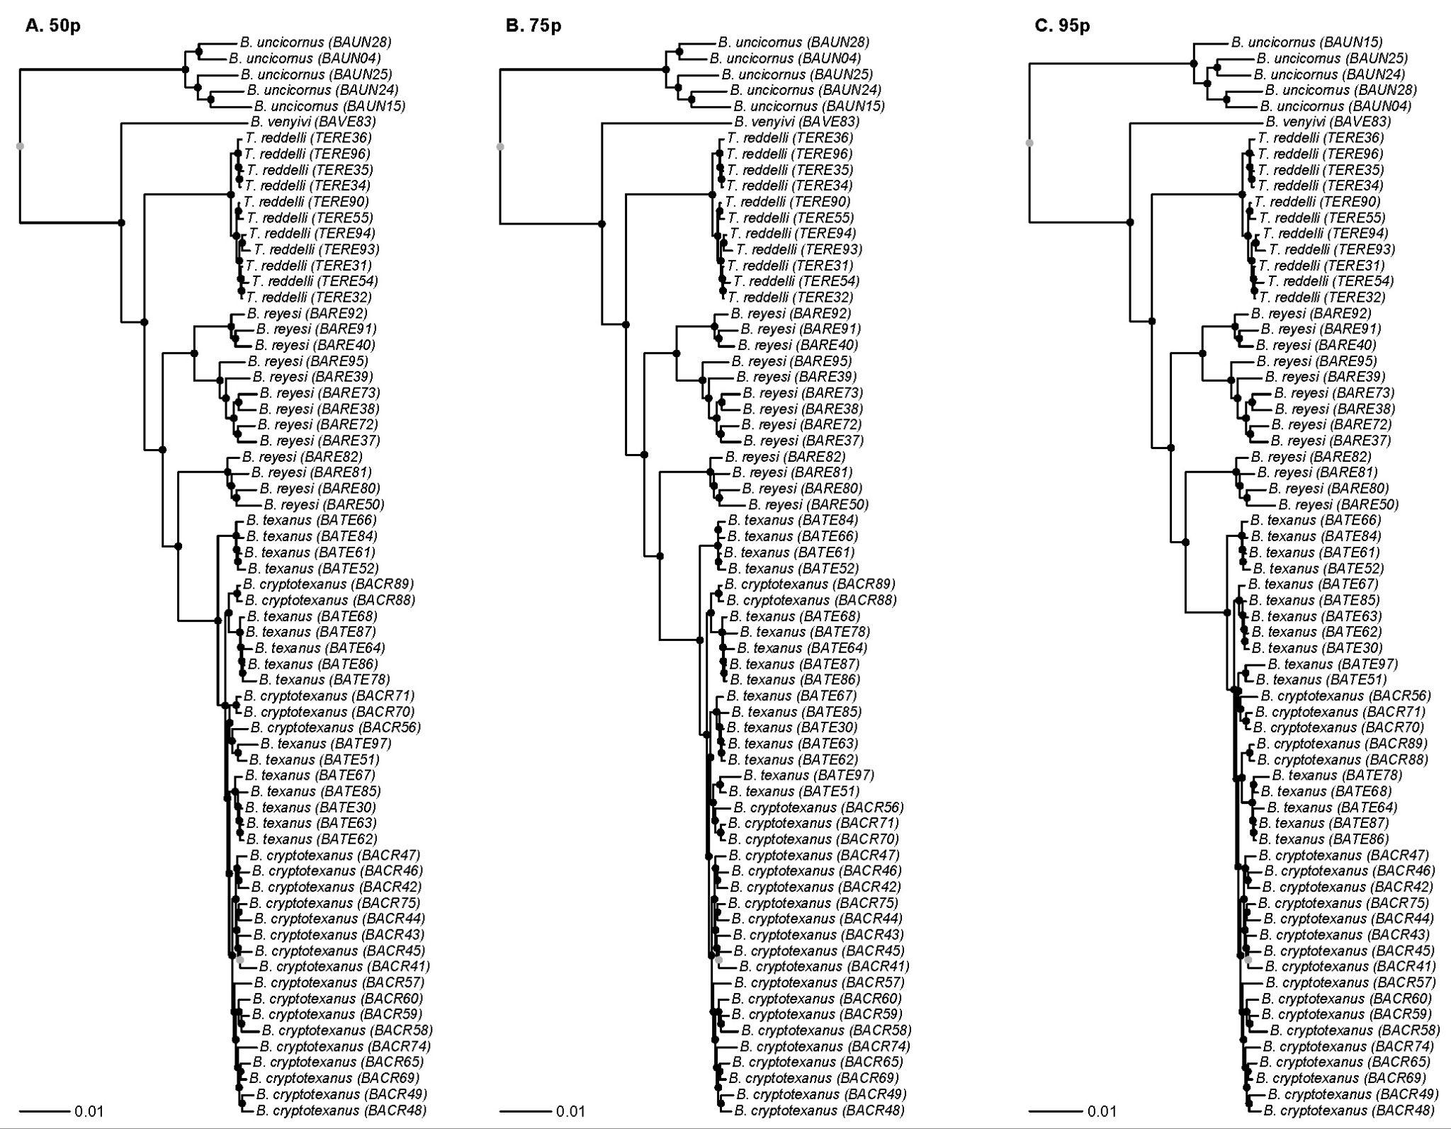 _
Figure S1: Majority rule consensus trees of Batrisodes and Texamaurops rove beetles from concatenated gene matrices of UCE loci with 50%, 75% and 95% completeness. Black circles represent branches with 95% bootstrap support. All analyses recovered very similar tree topologies.

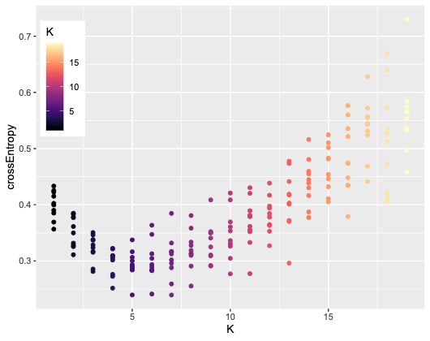

Figure S2. Scatterplot of cross entropy scores from sNMF of the Batrisodes cryptotexanus + texanus group for each of the 10 runs per K (clusters). The cross-entropy scores best support between five to seven ancestral populations (lowest cross-entropy for K=7 was 0.2394, K=5 was 0.2395 and K = 6 was 0.2412).

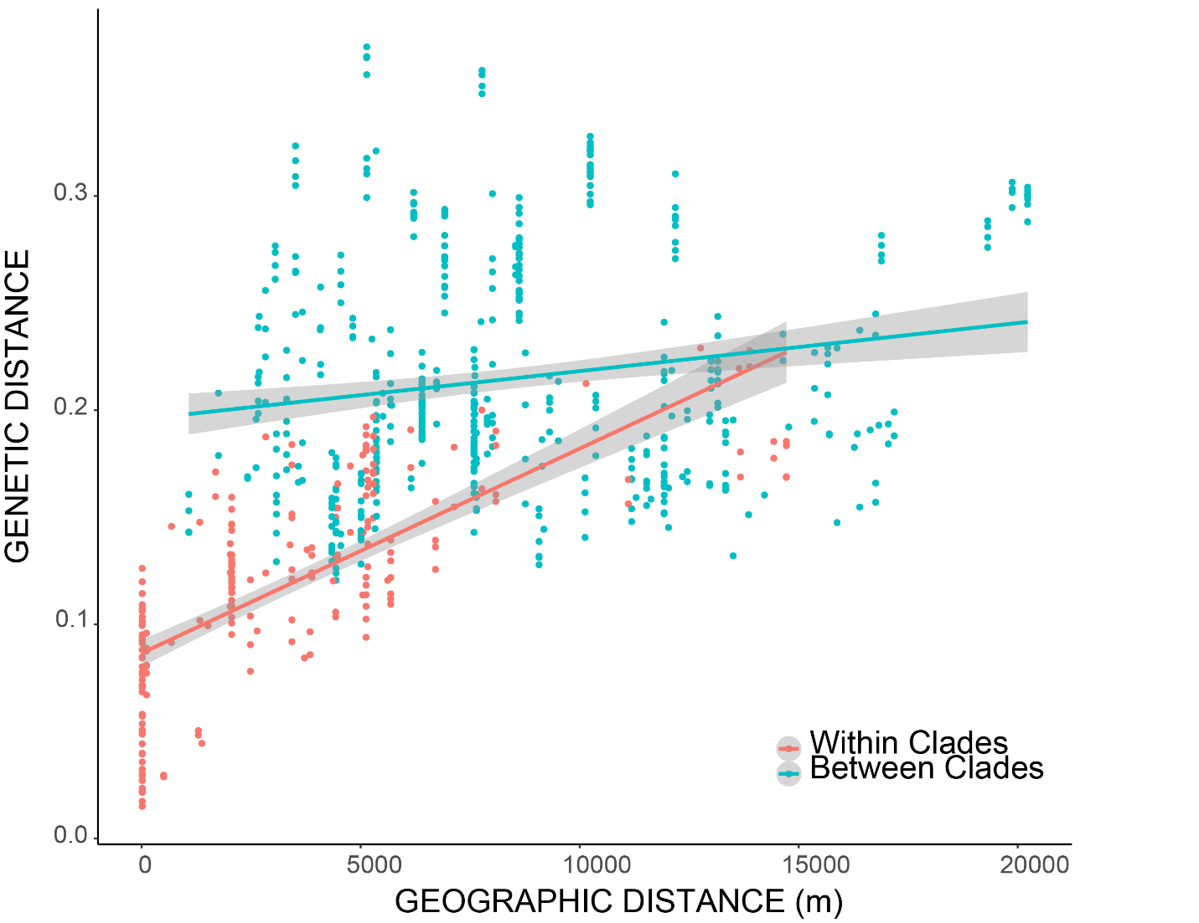

Figure S3. Genetic distances plotted by geographic distance among all individuals within the Batrisodes cryptotexanus +texanus group. Genetic isolation by geographic distance was more strongly apparent among individuals within clades (salmon dots) but not among individuals between clades (blue), where genetic differences were high even among individuals from proximate caves.

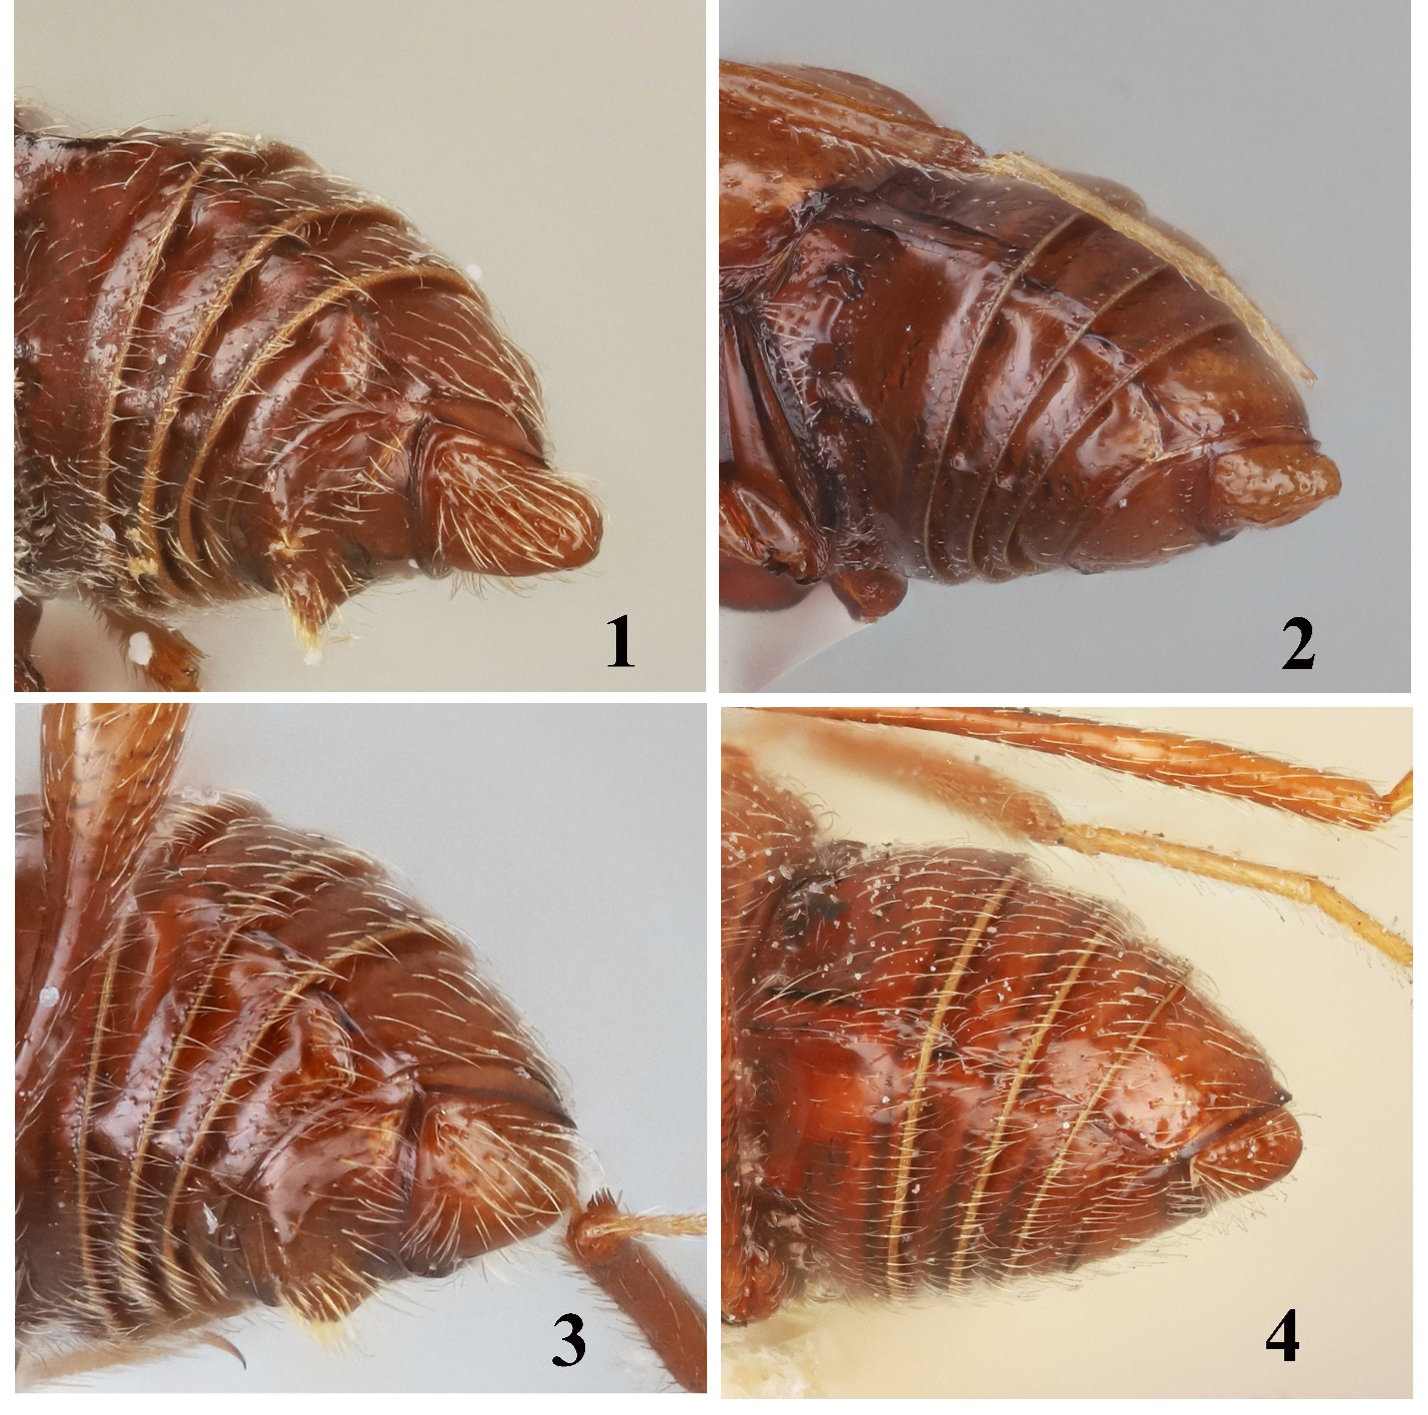

Figure S4. Examples of abdominal morphological differences between Batrisodes cryptotexanus (1) male, (2) female and Batrisodes texanus (3) male, (4) female. Panels 1 and 3 are lateroventral views of male abdomens; 2 and 4 are lateral views of female abdomens. Specimen information: Batrisodes cryptotexanus, male: TX: Williamson Co., Dragon Fly Cave, Sun City, V-29-2001, M. Reyes; female: TX: Williamson Co., Corn Cobb Cave, X-15-2008, P. Paquin, B. Parker, L. Baird, under rocks, clayish soil. Batrisodes texanus, male: TX: Wiliamson Co., Shamrock Cave, I-22-2021, L. Colucci, K. McDermid, BATE30 13696; female, TX: Williamson Co., Inner Space Caverns, VIII-1968, Wm. Elliott (Paratype).

