Supplemental Information
Title: Using genomic tools to evaluate assumptions in a conservation breeding program for endangered red siskins (Spinus cucullatus)
Journal: Conservation Genetics
Authors: Karen M. Holm^{1,2,3}, Kathryn M. Rodriguez-Clark^{2,3}, Brian J. Coyle^{4,5}, Rebecca M. Gooley^{6,7}, Erica Royer². Emperatriz Gamero García^{2,8}, Haw Chuan Lim^{1,9}
Corresponding author: Karen M Holm kholm2@gmu.edu

Content:
Figures: S1-S2
Tables: supplemental excel file for S1-S3
Methods
Supplemental figures
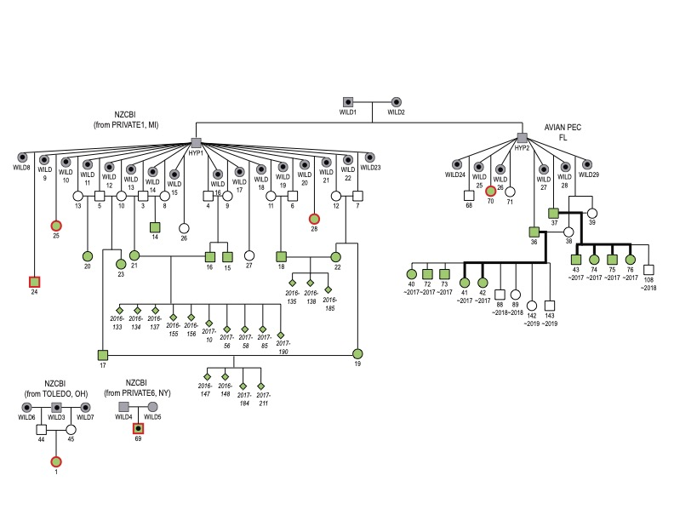
Fig. S1 Assumed (gray) and observed (white) pedigree relationship between genotyped (green) individuals in the NZCBI Red Siskin Studbook. Females are represented by circles, males by squares, and individuals of unknown sex by diamonds. Hypothetical (HYP) and presumed wild (WILD) ancestors are shaded in light gray. All WILD individuals are presumed to be unrelated. Central black dots indicate pedigree terminals as well as those genotyped encircled in red. A line connecting a male and a female indicate a cross. Siblings are connected by a horizontal line above their centers, with a vertical line from there to their parents. Numbers indicate NZCBI studbook IDs (SB#), with hatch year above for eggs in italics and each clutch is offset. Names in all caps represent ZIMS facility mnemonics, with location in US state. SB1 and SB69 are unrelated to everyone and each other. SB36 and SB37 were considered MULT3 because true parentage of their offspring is unknown. Bold black lines indicate parentage relationships inferred with molecular data

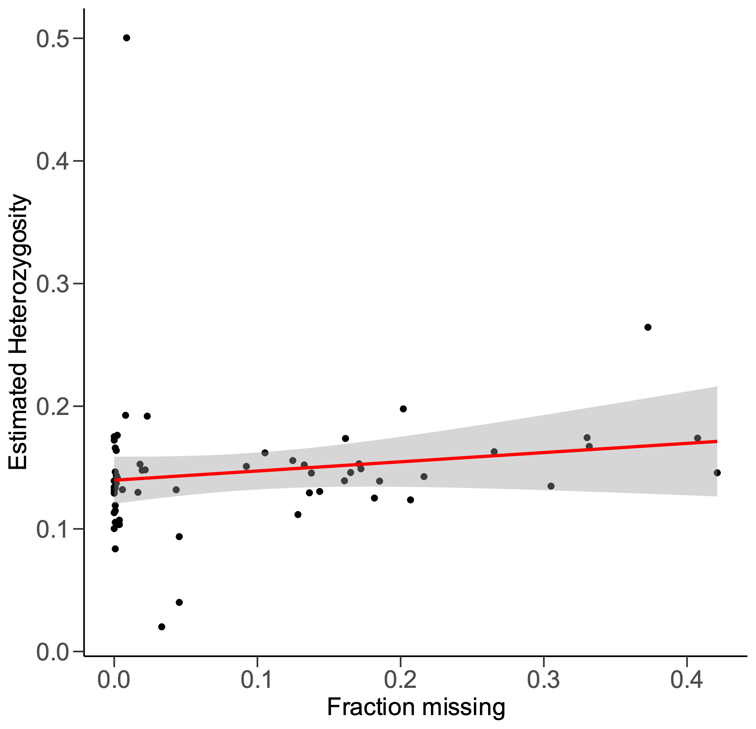
Fig. S2 Pearson’s r correlation between estimated heterozygosity of the full filtered dataset and fraction of missing data

Supplemental Tables
Table S1. Details for 154 pairwise comparisons including observed relationships, King-robust pairwise kinship estimates, and PMx kinship estimates, theoretical kinships, sequoia results of match status to observational relationship: either yes, no or unassigned; CalcPairLL results for top relationship, Notes with plausible explanations for mismatches or unassignments. ID1 and ID2 are pairwise individual identification; Abbreviations: PO - Parent-Offspring, FS - Full-Sibling, HS - Half-Sibling, FC – Full Cousin, and from the Sequoia user guide for CalcPairLL (Huisman, 2023): 2nd – unclear which type of second order relatives (HS, GG – grandparent- grandoffspring, or full avuncular), HA – Half avuncular and other 3rd order relatives, U - unrelated. XXXX-XX birthyear- egg number; XX_216XXX studbook number_NZCBI ID number; XX_XX_XX_Cefst -studbook number_APEC ID number

Table S2. King-robust pairwise kinship estimates between all possible pairs of 44 red siskins sampled from National Zoo and Conservation Biology Institute (NZCBI) and Avian Preservation and Education Conservancy (APEC) including number of SNPs shared by the pair. Numbers before the first underscore indicate studbook number, while after they indicate local institutional ID number. XXXX-XXX indicates birth year-egg number. * denotes pairs with pedigree terminal birds.

Table S3. PMx pairwise kinship between all possible pairs of 44 red siskins sampled from collections at Smithsonian’s National Zoo & Conservation Biology Institute (NZCBI) and the Avian Preservation and Education Conservancy (APEC), calculated using standard zoo industry assumptions. ID numbers before the first underscore indicate studbook number, while after they indicate local institutional ID number. XXXX-XXX indicates birth year-egg number.

Supplemental Methods:
To estimate the relationships from molecular data, we used the function sequoia, as implemented in the R package Sequoia v2.4.1 (Huisman, 2017; Huisman, 2023). Sequoia assigns the most likely relationship (choosing between first- to third-degree relationships, as well as no relationship) between a focal individual and a pool of plausible relatives based on log-likelihood ratios (LLRs) derived from SNP genotype data, with life history data (birth year and sex) used to refine the pool of potential relatives. During sibship clustering, Sequoia creates “dummy” individuals as placeholders for non-genotyped parents. When assigning a relationship to a pair over alternative relationships, we applied two default thresholds based on LLRs: 1) a threshold (Tfilter default of -2, in which more negative values reduced non-assignments) to select candidate relatives, as opposed to a pair being unrelated, and 2) a threshold (Tassign default 0.5) that allowed us to accept a proposed relationship over the next most likely relationship (higher values led to more conservative assignments). We also set the genotyping error rate to 1-3% based on the manual’s recommendations for our type of data. Sequoia also used the presence of opposing homozygotes between individuals (e.g., one possessing aa and the other AA) to exclude them as parent-offspring as needed as an initial filter.

