Supplementary Table ST1. Quality control filtering criteria for SNPs showing numbers of loci and individuals retained at each step.
Step | # Loci | # Ind
 | 34,133 | 111 (AR = 69, LEI = 22, RI = 18)
Reproducibility >0.99 | 20,517
Call rate >0.99 | 12,018
Secondaries (keep 1 SNP) | 11,262
Tag length (20-69) | 11,262
Overshoot | 11,261
Read depth (5-1000) | 11,137
Monomorphs | 11,110
Minor allele count (>3) | 8,393
Drop First Degree Relatives for population genetic analysis | 8,369 | 82 (AR = 50, LEI = 13, RI = 17)

Supplementary Table ST2. Table of individuals removed to reduce first degree relatives in data sets
Population | Individual List
AR | 19357, 19304, 19305, 19378, 19382, 19349, 19355, 19360, 19352, 19400, 19377, 20095, 19367, 19370, 19327, 20093, 19393, 19366, 19325
LEI | 21227, 21204, 21203, 21216, 21208, 21209, 21228, 21207, 21215
RI | 20263

Supplementary Figure SF1 - Network of all 1st degree relatives in LEI and AR

LEI:9
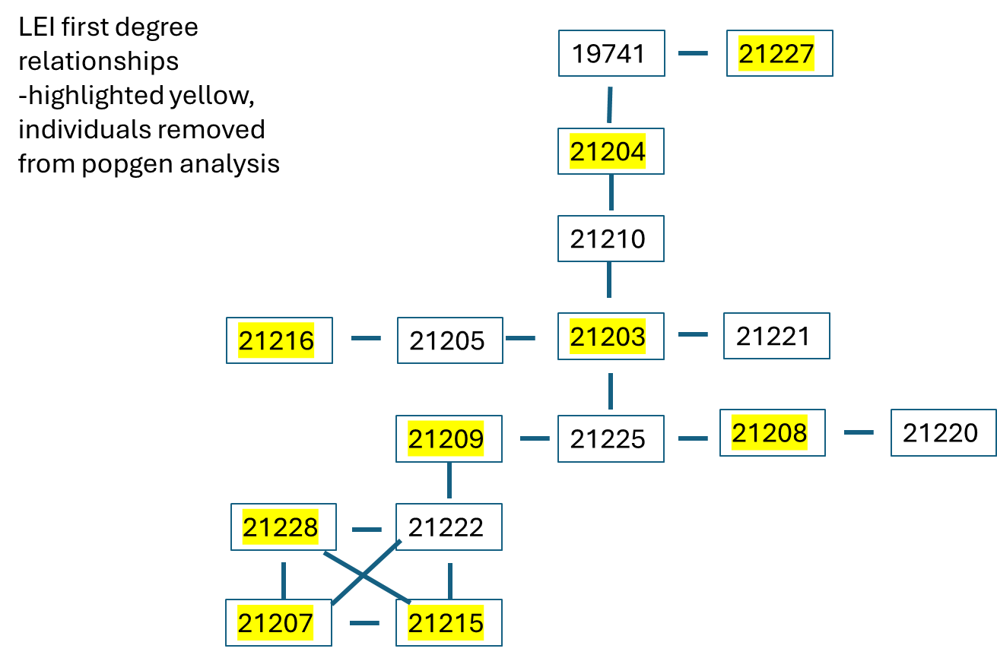

AR:
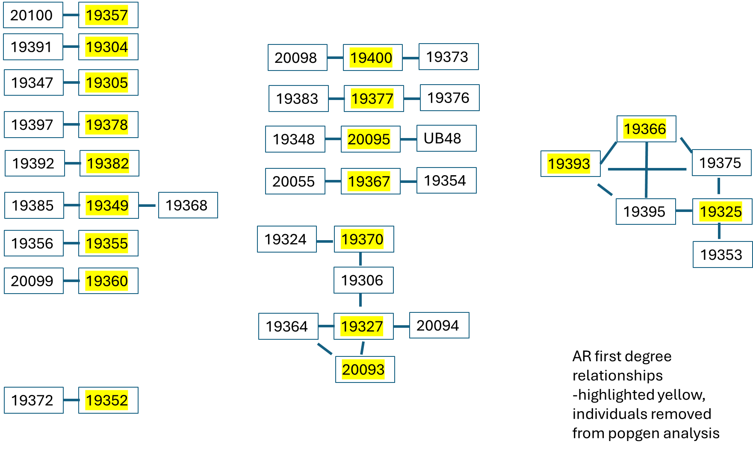

Supplementary Figure SF2 - Snmf entropy (i.e. k) showing the relative likelihood of each population size as calculated and compared from structure analyses. Lowest value indicates most likely number of populations (i.e., two populations).
