Supporting Information
Title: Six Genetically Distinct Endangered Cricket Frog Populations Identified in New York: Implications for Reintroduction Efforts and Management
Journal: Conservation Genetics
Authors: Elise M. Edwards^{*1}, Maria Akopyan², Brittany A. Mosher³, Nina Overgaard Therkildsen ¹ Patrick Sullivan¹
¹ Department of Natural Resources and the Environment, Cornell University, Ithaca, NY 14850
²Department of Quantitative and Computational Biology, University of Southern California, Los Angeles, California, USA
³ Rubenstein School of Environment and Natural Resources, University of Vermont, Burlington, VT, 05405, USA
Corresponding Author: Elise Edwards, eme42@cornell.edu

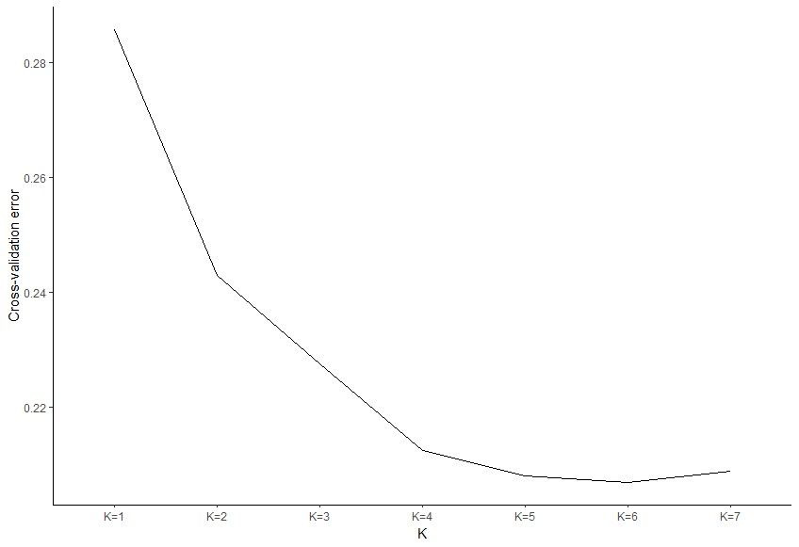

Fig 1S Plot of cross validation error for clusters K=1 to K=7 from ADMIXTURE analysis of Acris crepitans populations in New York. K=6 shows the lowest cross validation error
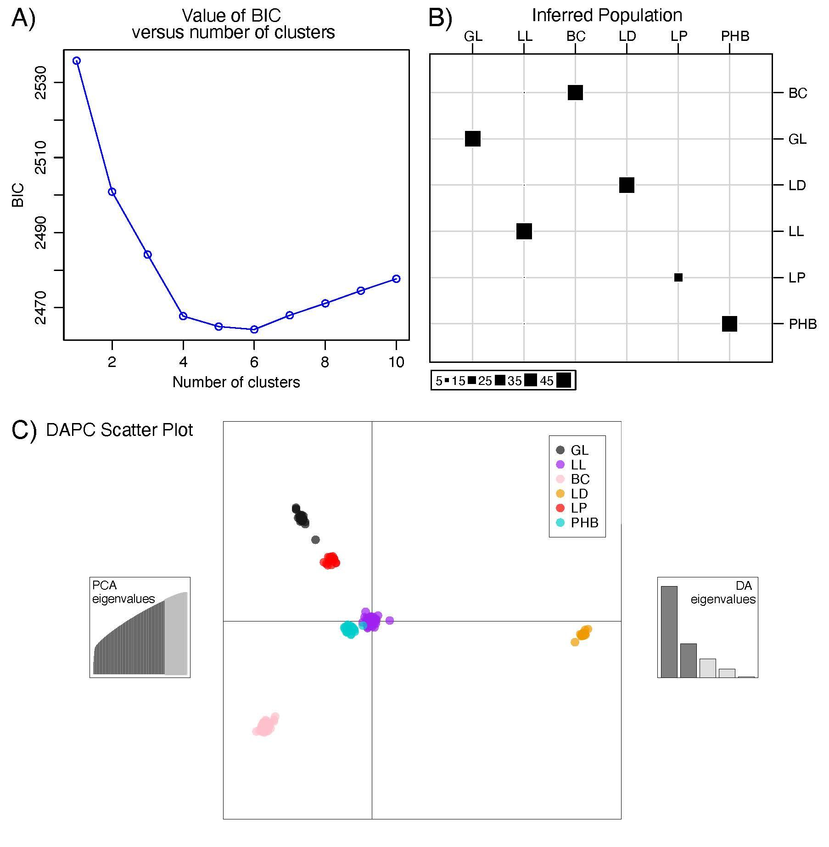Fig 2S Plots of a discriminant analysis of principal components analysis, showing the value of bayesian information criterion BIC) compared to the number of clusters in panel A, the inferred population in panel B and a scatter plot of the six populations with corresponding PCA and DA eigenvalues in Panel C.

Determining the relative influence of each parameter on the growth rate of the 2-stage system

We begin with our 2-stage model matrix,
$\left[a_{11} a_{12} a_{21} a_{22} \right]$.
Or goal is to get the eigenvalue ($λ$), so we take the determinant of:
$\left[a_{11} a_{12} a_{21} a_{22} \right]-λ\left[1 0 0 1 \right]$, (1)
which is:
Det$\left[a_{11}-λ a_{12} a_{21} a_{22}-λ \right]$, (2)
which expands to:
$\left(a_{11}-λ\right)\left(a_{22}-λ\right)-\left(a_{21}\right)\left(a_{12}\right)=0$, (3)
$a_{11}a_{22}-a_{11}λ-λa_{22}+λ^{2}-a_{21}a_{12}=0$, (4)
and
$λ^{2}-\left(a_{11}+a_{22}\right)λ+\left(a_{11}a_{22}-a_{21}a_{12}\right)=0$. (5)
The quadratic formula is:
$λ=\frac{-b±\sqrt{b^{2}-4ac}}{2a}$, (6)
which gives:
$λ=\frac{\left(a_{11}+a_{22}\right)+\sqrt{{\left(-a_{11}-a_{22}\right)}^{2}-4\left(a_{11}a_{22}-a_{21}a_{12}\right)}}{2}$, (7)
and
$λ=\frac{\left(a_{11}+a_{22}\right)-\sqrt{{\left(-a_{11}-a_{22}\right)}^{2}-4\left(a_{11}a_{22}-a_{21}a_{12}\right)}}{2}$. (8)
Simplifying gives:
$λ=\frac{\left(a_{11}+a_{22}\right)+\sqrt{\left({a_{11}}^{2}+2a_{11}a_{22}+{a_{22}}^{2}\right)-4\left(a_{11}a_{22}-a_{21}a_{12}\right)}}{2}$, (9)
and
$λ=\frac{\left(a_{11}+a_{22}\right)-\sqrt{\left({a_{11}}^{2}+2a_{11}a_{22}+{a_{22}}^{2}\right)-4\left(a_{11}a_{22}-a_{21}a_{12}\right)}}{2}$. (10)
Additional simplification gives:
$λ=\frac{\left(a_{11}+a_{22}\right)+\sqrt{{a_{11}}^{2}+2a_{11}a_{22}+{a_{22}}^{2}-4a_{11}a_{22}+4a_{21}a_{12}}}{2}$, (11)
and
$λ=\frac{\left(a_{11}+a_{22}\right)-\sqrt{{a_{11}}^{2}+2a_{11}a_{22}+{a_{22}}^{2}-4a_{11}a_{22}+4a_{21}a_{12}}}{2}$. (12)
Finally,
$λ=\frac{\left(a_{11}+a_{22}\right)+\sqrt{{a_{11}}^{2}+{a_{22}}^{2}-2a_{11}a_{22}+4a_{21}a_{12}}}{2}$, (13)
and
$λ=\frac{\left(a_{11}+a_{22}\right)-\sqrt{{a_{11}}^{2}+{a_{22}}^{2}-2a_{11}a_{22}+4a_{21}a_{12}}}{2}$. (14)

For cricket frogs, $a_{11}=0$, so:
$λ=\frac{a_{22}+\sqrt{{a_{22}}^{2}+4a_{21}a_{12}}}{2}$, (15)
and
$λ=\frac{a_{22}-\sqrt{{a_{22}}^{2}+4a_{21}a_{12}}}{2}$. (16)
Due to the plus sign, the top eigenvalue will be dominant, and the bottom will be subdominant.

The sensitivities (derivatives) of the dominant eigenvalue with respect to each parameter are:
$s_{12}=\frac{dλ}{da_{12}}\left(\frac{a_{22}+\sqrt{{a_{22}}^{2}+4a_{21}a_{12}}}{2}\right)$, (17)
$s_{12}=\frac{dλ}{da_{12}}\left(a_{22}\right)+\frac{dλ}{da_{12}}\left(\left(\frac{1}{2}\right){\left({a_{22}}^{2}+4a_{21}a_{12}\right)}^{\left(\frac{1}{2}\right)}\right)$, (18)
$s_{12}=\left(\frac{1}{2}\right)\frac{dλ}{da_{12}}\left({\left({a_{22}}^{2}+4a_{21}a_{12}\right)}^{\left(\frac{1}{2}\right)}\right)$, (19)
$s_{12}=\left(\frac{1}{2}\right)\left(\frac{1}{2}\right){\left({a_{22}}^{2}+4a_{21}a_{12}\right)}^{\left(-\frac{1}{2}\right)}\left(4a_{21}\right)$, (20)
and
$s_{12}=\frac{a_{21}}{\sqrt{{a_{22}}^{2}+4a_{21}a_{12}}}$. (21)
Similarly,
$s_{21}=\frac{dλ}{da_{21}}\left(\frac{a_{22}+\sqrt{{a_{22}}^{2}+4a_{21}a_{12}}}{2}\right)$, (22)
$s_{21}=\frac{dλ}{da_{21}}\left(a_{22}\right)+\frac{dλ}{da_{21}}\left(\left(\frac{1}{2}\right){\left({a_{22}}^{2}+4a_{21}a_{12}\right)}^{\left(\frac{1}{2}\right)}\right)$, (23)
$s_{21}=\left(\frac{1}{2}\right)\frac{dλ}{da_{21}}\left({\left({a_{22}}^{2}+4a_{21}a_{12}\right)}^{\left(\frac{1}{2}\right)}\right)$, (24)
$s_{21}=\left(\frac{1}{2}\right)\left(\frac{1}{2}\right){\left({a_{22}}^{2}+4a_{21}a_{12}\right)}^{\left(-\frac{1}{2}\right)}\left(4a_{12}\right)$, (25)
and
$s_{21}=\frac{a_{12}}{\sqrt{{a_{22}}^{2}+4a_{21}a_{12}}}$. (26)
Finally,
$s_{22}=\frac{dλ}{da_{22}}\left(\frac{a_{22}+\sqrt{{a_{22}}^{2}+4a_{21}a_{12}}}{2}\right)$, (27)
$s_{22}=\frac{dλ}{da_{22}}\left(a_{22}\right)+\frac{dλ}{da_{22}}\left(\left(\frac{1}{2}\right){\left({a_{22}}^{2}+4a_{21}a_{12}\right)}^{\left(\frac{1}{2}\right)}\right)$, (28)
$s_{22}=1+\left(\frac{1}{2}\right)\frac{dλ}{da_{22}}\left({\left({a_{22}}^{2}+4a_{21}a_{12}\right)}^{\left(\frac{1}{2}\right)}\right)$, (29)
$s_{22}=1+\left(\frac{1}{2}\right)\left(\frac{1}{2}\right){\left({a_{22}}^{2}+4a_{21}a_{12}\right)}^{\left(-\frac{1}{2}\right)}\left(2a_{22}\right)$, (30)
and
$s_{22}=1+\left(\frac{a_{22}}{2\sqrt{{a_{22}}^{2}+4a_{21}a_{12}}}\right)$. (31)

The elasticities are:
$e_{12}=\left(\frac{a_{12}}{λ}\right)\left(s_{12}\right)$, (32)
$e_{12}=\left(\frac{a_{12}}{λ}\right)\left(\frac{a_{21}}{\sqrt{{a_{22}}^{2}+4a_{21}a_{12}}}\right)$, (33)
$e_{12}=\left(\frac{a_{12}a_{21}}{λ\sqrt{{a_{22}}^{2}+4a_{21}a_{12}}}\right)$. (34)
Similarly,
$e_{21}=\left(\frac{a_{21}}{λ}\right)\left(s_{21}\right)$, (35)
$e_{21}=\left(\frac{a_{21}}{λ}\right)\left(\frac{a_{12}}{\sqrt{{a_{22}}^{2}+4a_{21}a_{12}}}\right)$, (36)
and
$e_{21}=\left(\frac{a_{12}a_{21}}{λ\sqrt{{a_{22}}^{2}+4a_{21}a_{12}}}\right)$. (37)
Finally,
$e_{22}=\left(\frac{a_{22}}{λ}\right)\left(s_{22}\right)$, (38)
$e_{22}=\left(\frac{a_{22}}{λ}\right)\left(1+\left(\frac{a_{22}}{2\sqrt{{a_{22}}^{2}+4a_{21}a_{12}}}\right)\right)$, (39)
and
$e_{22}=\left(\frac{a_{22}}{λ}+\left(\frac{{a_{22}}^{2}}{2λ\sqrt{{a_{22}}^{2}+4a_{21}a_{12}}}\right)\right)$. (40)

In summary, the influence of fertility on the growth rate is:
$\left(\frac{a_{12}a_{21}}{λ\sqrt{{a_{22}}^{2}+4a_{21}a_{12}}}\right)$. (41)
The influence of stage-1 survival on the growth rate is:
$\left(\frac{a_{12}a_{21}}{λ\sqrt{{a_{22}}^{2}+4a_{21}a_{12}}}\right)$. (42)
And the influence of stage-2 survival on the growth rate is:
$\left(\frac{a_{22}}{λ}+\left(\frac{{a_{22}}^{2}}{2λ\sqrt{{a_{22}}^{2}+4a_{21}a_{12}}}\right)\right)$. (43)
The influence of fertility and stage-1 survival is identical, meaning that management can manipulate one or the other and get identical response in the growth rate.

