Supplementary table 1
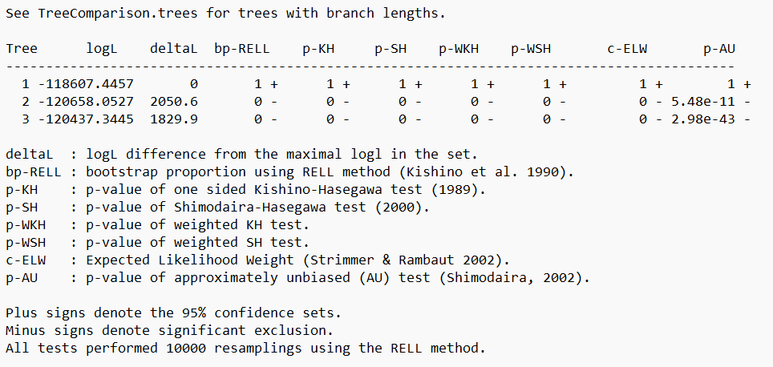
Model testing results for tree topology test.

