Electronic Supplementary Material
Conservation genetics of the Brolga (Antigone rubicunda) across eastern Australia reveals genetic structure and potential loss of adaptive capacity
Conservation Genetics

Abby L E Bryce^{1*}(ORCID: 0009-0005-9639-0158), Skye Davis¹ (ORCID: 0000-0002-8488-0345), Inka Veltheim^{2,4} (ORCID: 0000-0003-3395-2756), Kate J Brandis³ (ORCID: 0000-0001-6807-0142), Jessica A O’Hare¹ (ORCID: 0000-0002-1914-8393), and Adam J Stow¹ (ORCID: 0000-0002-6796-4854)

¹School of Natural Sciences, Faculty of Science and Engineering, Macquarie University, North Ryde, NSW 2109, Australia
²Federation University Australia, Future Regions Research Centre, University Drive, Mt Helen, Australia
³Centre for Ecosystem Science, School of Biological, Earth and Environmental Sciences, University of New South Wales, NSW 2052, Australia
⁴Arthur Rylah Institute, Department of Energy, Environment and Climate Action, 123 Brown Street, Heidelberg, VIC 3084, Australia

*Corresponding author: missabbybryce@gmail.com
Supporting Methods
1. Data collection and filtering
1.1 Supporting Methods: Sample collection
Prior to DNA extraction, feathers were visually assessed and selected based on condition, including cleanliness, feather size, and presence of visible tissue or blood clots, with heavily degraded or contaminated samples excluded where possible. A total of 216 feathers were selected for DNA extraction based on these criteria and geographic representation.

Table S1. Sample collection sites between 2009 and 2023 within the north and south regions. The number of specific locations sampled, total tissue extractions, and post-filtering sample counts for each site.
Site | State |  | No. of specific locations within each site | No. of samples post-filtering
North
NNT | Northern Territory |  | 2 | 5
NGC | Queensland |  | 12 | 21
NMI | Queensland |  | 1 | 1
NWI | Queensland |  | 1 | 1
NCH | Queensland |  | 3 | 19
NEU | Queensland |  | 1 | 1
NMM | New South Wales |  | 2 | 1
NGW | New South Wales |  | 5 | 4
South
SCO | Victoria |  | 1 | 7
SSS | Victoria |  | 36 | 71
 |  | Total samples |  | 131

1.2 Supporting Methods: DNA extraction
Feathers were stored at room temperature and briefly washed with RNase/DNase-free water prior to tissue extraction. Tissue was extracted from the basal tip of the calamus; comprising of any internal and external skin, and the superior umbilicus blood clot if present (Guilfoyle et al. 2017; Selås et al. 2017). DNA was extracted using the Isolate II Genomic DNA Kit (Bioline), carrying out the standard protocol with a few modifications. For instance, two digestion periods were carried out for a total of 5 hours at 56ºC to aid in the digestion of potentially degraded DNA from feathers. 20µL of proteinase K (19.4mg/ml, Roche Diagnostics) and 5µL of 1M Dithiothreitol (Merck Millipore) were added and vortexed frequently for 2.5 hours, and repeated for another 2.5 hours for any samples which still had visible tissue. The elution process was completed twice using 50µL each time to optimise the amount of DNA extracted, incubated at 70ºC for 10 minutes both times. The resulting 100µL elution was concentrated to 40µL with the Labconco Refrigerated CentriVap Concentrator at 25ºC. DNA concentration within each sample was then determined using spectrophotometry (NanoDrop One/OneC, Thermo Scientific). Samples with a concentration over 100ng/µL were diluted to around 100ng/µL.
1.3 Supporting Methods: In-silica RFLP assays
The mitochondrial genomes of the Brolga (Antigone rubicunda, GenBank accession NC_020580.1) and Sarus Crane (Antigone antigone, GenBank accession NC_020581.1) were accessed from GenBank. Using MEGA v.11.0.13 (Tamura et al. 2021), the genomes were aligned with AWC (Patel et al. 2010) and APPS (Davis 2024) primers, and sequences between the primers (including the primers) were extracted: 847 bp for AWC and 539 bp for APPS. These sequences were then aligned in CodonCode Aligner v.11.0.2 (CodonCode Corporation, Dedham, MA, USA). RFLP analysis was performed using MspI and AciI restriction enzymes, with AciI selected for clearer band differentiation between the Brolga and Sarus Crane, across all primer sets.

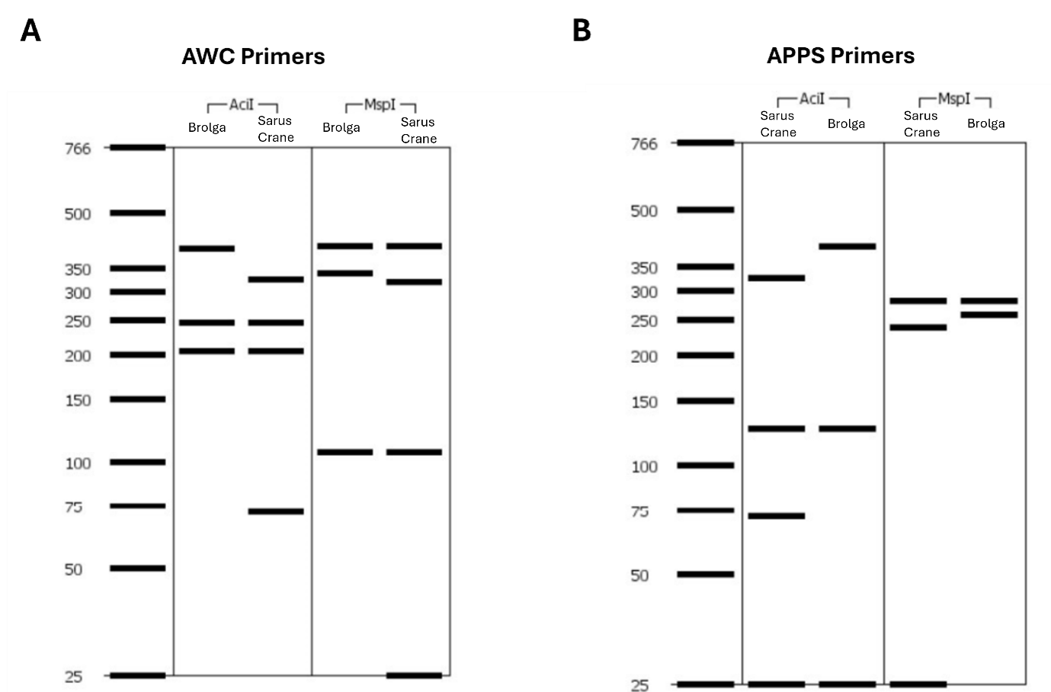

Fig. S1 In-silica RFLP assays. Banding using AciI or MspI restriction enzymes with sequences from the Brolga or Sarus Crane. A) AWC primer set and B) APPS primer set. AciI was chosen because MspI produced very similar banding patterns for both species, making differentiation via gel electrophoresis comparably more difficult.

1.4 Supporting Methods: SNP filtering
Depth of coverage thresholds were selected by examining the distribution of read depth per locus and SNPs retained using summary tables and histograms.
Missing data filtering was conducted iteratively by varying call rate thresholds for both loci and individuals. Multiple intermediate thresholds were assessed, and final thresholds (60% for loci, 90% for individuals, and 80% for loci) were selected to balance retention of loci with minimisation of individual loss.
Hardy–Weinberg equilibrium (HWE) filtering was applied as a quality-control step to remove loci showing significant deviation from expected genotype proportions. This was conducted within regions where there was a priori expectation of HWE. The impact of this filtering step was limited, with 187 loci removed and no individuals excluded.
1.5 Supporting Methods: Kinship filtering
To identify potential duplicates, samples with a kinship coefficient (k) > 0.4 were removed using the function ‘snpgdsIBDMLE’ in the R package SNPRelate v.1.36.0 (Zheng et al. 2012), following previously defined kinship thresholds (Loiselle et al. 1995; Iacchei et al. 2013). This function was applied to each genetic group identified in the initial PCoA. An individual kinship matrix was created using an identity-by-descent approach, implementing the maximum likelihood estimation (MLE) method (Milligan 2003). The individual with the least missing data in each pair was retained.
1.6 Supporting Methods: The reciprocal effects of kinship and structure
The presence of related individuals within a dataset can strongly influence the inferred population structure (Anderson & Dunham 2008). In particular, it can suggest that population structure is present, even when it may not be (Anderson & Dunham 2008). Concurrently, multiple kinship estimators can be strongly biased when population structure is present, as a result of similar ancestry grouping unrelated individuals as close relatives (Wang 2018).
Subsequently, the R package GENESIS v.2.32.0 (Gogarten et al. 2019) was used to decipher the effects of kinship and structure within the dataset, utilising two available methods to infer kinship and ancestry: PC-AiR (Conomos et al. 2015) and PC-Relate (Conomos et al. 2016). The following steps were then taken to assess whether the presence of ancestry would affect downstream analyses for population structure. Firstly, provisional kinship coefficients were determined using the KING-robust estimator (Manichaikul et al. 2010) within SNPRelate, which are calculated independently of population structure but influenced by admixture (Conomos et al. 2016). Next, PC-AiR was used to create a Principal Component Analysis (PCA) using ‘unrelated’ individuals (kinship coefficient thresholds = 0.025), and then project ‘related’ relatives onto the PCA. Subsequently, PC-Relate was used to optimise the kinship coefficient estimates using the top two PCs (ancestry informative PCs) which considers population structure. Two iterations of PC-AiR and PC-Relate were carried out, and the correlations between these top two PCs of each iterations was checked (pairwise correlations = 1). By comparing a standard PCA with an ancestry-adjusted PCA (Figure S2), it was determined that samples with high kinship did not affect downstream analyses. Therefore, no individuals were removed based on kinship filtering.

Fig. S2 Standard principal component analysis (PCA) with an ancestry-adjusted PCA. The influence of related individuals on the genetic structure within the NS dataset was inferred using PC-AiR and PC-Relate. A) and C) are the first two principal components plotted, and B) and D) are the percentage of variance between the two clusters explained by the principal components.
1.7 Supporting Methods: Outlier filtering and retention
OutFLANK (Whitlock & Lotterhos 2015), used in dartR, is based on a method by Lewontin and Krakauer (1973) suggesting that significant deviation in inbreeding coefficients between loci may indicate selection. The following parameters were used: left trim = 0.02, right trim = 0.02, minimum heterozygosity = 0.1, and false discovery rate (FDR) = 0.05. Arlequin v.3.5.2.2 utilises coalescent-based approaches to detect loci showing deviations from neutral expectations of genetic differentiation, which may indicate selection(Excoffier & Lischer 2010). Default parameters were used, including 20,000 simulations and 100 demes. To take into account various tests, resulting p-values were transformed to q-values using the package qvalue v.2.34.0 (Storey et al. 2019). Loci which constantly deviated from HWE at an FDR of 5% (q-value <0.05) were identified as outliers. The Bayesian simulation approaches was implemented with BayeScan v2.1 (Beaumont & Balding 2004; Foll & Gaggiotti 2008; Foll 2012), using the subsequent default parameters: sample size = 5,000, thinning interval = 10, pilot runs = 20, pilot run length = 5,000 and additional burn in = 50,000; however, the prior odds for the neutral model was adjusted to 100 to consider the number of loci within the dataset. The R package pcadapt v.4.3.5 (Luu et al. 2017; Privé et al. 2020) detects outliers by genetic clusters, standardising the data to scale allele frequencies and then carrying out a PCA and identifying outliers using the Mahalanobis distance test statistic (with correction for several tests using a FDR of 0.05) (Luu et al. 2017). Loci detected by more than one of the approaches were suggested to potentially be under selection and therefore removed as outliers. Any loci identified by only one of the outlier techniques were retained and had no impact on subsequent analyses (Fig. S3).

Fig. S3 Impact of outlier retention or removal on principal coordinates analysis (PCoA). The ‘outlier group’ comprises of six individuals identified as potential hybrids. A-B) PCoA plots excluding the ‘outlier group’; C-D) PCoA plots including the ‘outlier group’. Each point represents an individual sample, coloured by collection site region: north (orange), south (teal), as well as the ‘outlier group’ (dark blue). A) No outlier loci removed. B) 327 loci identified as outliers by pcadapt only removed. C) 1,131 loci identified as outliers by both pcadapt and Arlequin removed. D) All detected outlier loci removed. In the dataset excluding the ‘outlier group’, all loci were retained as outliers were only detected by one method. With the ‘outlier group’ included, removal of all outlier loci (D) reduced differentiation between these individuals and other samples; therefore, only shared outliers (C) were removed.

2. Hybrid phylogenetic tree
2.1 Supporting Methods: PCR and gel electrophoresis for hybrid investigation
Potential hybrids were investigated using PCR and gel electrophoresis on selected individuals from the southern sites, all northern individuals and the individuals identified as potential hybrids (i.e., ‘outlier group’). The primer set used to amplify the COI region was based on Sorenson et al. (1999) and modified by Davis (2024) to remove degenerate bases: L6615 forward primer (5’-CCTCTGTAAAAAGGACTACAGCC-3’) and a slightly modified H8121 reverse primer (5’-GGGCAGCCGTGGATTCATTC-3’). PCR amplification was carried out in a 25µL reaction mixture, containing 12.5µL of PCR Master Mix, 1.25µL each of the forward and reverse primers (0.5µM final concentration), 0.5µL of MgCl2 (2mM final concentration), any remaining DNA (3-8µL), with the volume topped up with DNase-free water. PCR cycling conditions were: 2 min at 95°C; 35 cycles of: 1) 1 min at 95°C, 2) 45 sec at 58°C, 3) 1:30 min at 72°C; followed by a final extension for 5 minutes at 72°C. Banding was visualised by gel electrophoresis on a 2% agarose gel. PCR product showing bright banding were deemed successfully amplified for multiple individuals, including one potential hybrid between Brolga and Sarus Crane. These PCR products were subsequently sent to Macrogen Inc. (Seoul, Korea) for bidirectional sequencing.
2.2 Supporting Methods: Sequence alignment and phylogenetic tree
Phylogenetic analysis was performed using Geneious Prime v. 2025.0.3 (https://www.geneious.com). Forward and reverse sequences obtained from Macrogen Inc. were assembled using the default de novo assembly settings, generating a consensus sequence for each sample. A random sample was subjected to BLAST analysis, and similar crane species were included in the resulting phylogenetic tree. The consensus sequences and BLAST result were aligned using Clustal Omega. All sequences were trimmed to 1,000 bp to ensure high-quality DNA across all samples. The optimal substitution method, SYM, was determined using JModelTest (Posada 2008). The phylogenetic tree was constructed using PHYML (Guindon & Gascuel 2003), applying a maximum likelihood approach with 1,000 bootstrap replicates. The great bustard (Otis tarda, assembly NC_014046.1) was used as the outgroup.
3. Sex inference
3.1 Supporting Methods: PCR conditions optimisation
Testing of the optimal PCR conditions for sexing samples was carried out, considering the optimal annealing temperature and the use of diluted or undiluted DNA. To achieve this, a gradient PCR was used, covering a range of temperatures (49.7°C to 57.5°C) with both undiluted and 1:10 dilutions. The gradient PCR followed these conditions: 4 min at 94°C; 35 cycles of: 1) 30 sec at 94°C, 2) 45 sec at either 49.7°C, 50.0°C, 51.0°C, 52.5°C, 54.5°C, 56.0°C, 57.0°C, or 57.5°C, 3) 1 min at 72°C; with a final extension for 5 min at 72°C. Each sample was tested undiluted and at a 1:10 dilution, and in a 15µL reaction with the same quantities as the other sexing PCRs: 7.5µL of PCR Master Mix, 0.75µL each of the forward and reverse primers (0.5µM final concentration), 3µL of DNase-free water and 3µL of DNA. A 250mL 2% gel was used to visualise the results, running at 110V for 2 to 2.5 hours. The conclusions from these gels were that a touchdown PCR was optimal, as banding appeared across the annealing temperatures. Furthermore, using undiluted DNA was the best option, with clear banding only appearing in the undiluted samples.
Further optimisation involved modifying the PCR cycles. Initially, the touchdown PCR consisted of: 4 min at 94°C; 16 cycles of: 1) 30 sec at 94°C, 2) 45 sec at 50-57°C, 3) 1 min at 72°C; then 45 cycles of: 1) 30 sec at 94°C, 2) 45 sec at 50°C, 3) 1 min at 72°C; followed by a final extension for 5 min at 72°C. The cycles were then adjusted to 8 cycles and 30 cycles, with the final conditions set to 16 cycles and 30 cycles. Additionally, a 10µL reaction was also trialled with increased primer concentration of 1µM, containing: 5µL of PCR Master Mix, 1µL each of the forward and reverse primers (1µL final concentration) and 3µL of DNA.

3.2 Supporting Methods: Sex inference and sex-linked loci removal
Unfiltered loci, which have only undergone preliminary filtering by DArT, were used to infer the sex of each sample (excluding the ‘outlier group’) using an approach modified by Davis (2024) from seGMM (Liu et al. 2022) and seXY (Qian et al. 2016). Loci were mapped to the Z and W chromosomes of the East African grey crowned-crane (Balearica regulorum gibbericeps, Order Gruiformes, assembly GCA_011004875.1). The top hit for each locus was then retained, and alignments with the following parameters were subsequently removed: a percentage identity < 80%, e value of > 1x10-10, duplicates clone ID’s (i.e. SNPs on the same fragment), loci with a reproducibility average < 1, loci which map to both the Z and W chromosomes, and those residing within the pseudoautosomal regions. The maximum PAR1 length was inferred to be similar to that of the crested ibis (Nipponia nippon), ~ 0.4 Mb (Zhou et al. 2014). The length of PAR2 was estimated not to exceed 330 kb, attributed to the greater length of the PAR1 region in humans at 2.7 Mb compared to the crested ibis (Ross et al. 2005). Consequently, loci which mapped within the first 0.4 Mb or last 0.33 Mb of each chromosome were removed.
In turn, three sex-associated features were calculated: W missing rate, which represents the proportion of W-mapped loci with missing data; Z/W ratio, which is the ratio of Z-mapped loci to W-mapped loci (excluding loci with missing calls); and Z heterozygosity, which indicates the proportion of Z-mapped loci that were heterozygous for each sample (excluding loci with missing calls). For these measures, males (ZZ) were predicted to have higher W missing rates, Z/W ratios and Z heterozygosity. All measures were standardised by division with the overall missing rate for each sample, applying the following filters: reproducibility average of 1 and removal of secondaries. The unstandardised data showed clearer clustering of samples compared to the standardised, and therefore unstandardised data were used for the following sex identification.
The R package mclust v.6.1.1 (Scrucca et al. 2016) was then used to infer the sex of each sample, clustering samples into two groups with the model-based clustering function ‘Mclust’ using the EM algorithm. Samples were grouped into two clusters, males and females, inferred with assignment uncertainty of < 0.0001. Provisionally, 69 females and 56 males were identified. Sex-linked loci were detected using the functions ‘filter.sex.linked’ and ‘infer.sex’ from Robledo-Ruiz et al. (2022) (preprint), using the ‘zw’ system. Subsequently, the sex of each sample was re-inferred using these identified sex-linked loci. Samples that showed discrepancies when re-inferred were labelled 'inconsistent' and excluded from the final identification process of sex-linked loci. Finally, the sex-linked loci were confirmed for the final time based on 69 females and 52 males, identifying 23 Z-linked and 1 ZW gametolog.
Any individuals which fell halfway between the inferred male and female clusters, as well as samples which did not match the previously inferred sex by the collaborator and/or gel results, were classified as ‘uncertain’. The sex of samples were labelled ‘inconsistent’ if the initial sex inferred by R and the re-inferred sex were different. Consequently, any identified sex-linked loci and samples with ‘inconsistent’ or ‘uncertain’ sexes were removed for downstream analyses.

4. Effective population size
4.1 Supporting Methods: Effective population size bias adjustment
Table S2. Equations used to adjust the provisional population effective size estimates from NeEstimator. Equations derived by Waples et al. (2013) and Waples et al. (2014).
Adjustment | Equation
Overlapping generations | $${\hat{N}}_{b(Adj)}= \frac{{raw\hat{N}}_{b}}{1.103-0.245 × log⁡({AL}/α)}$$
Estimate $N_{e}$ from $N_{b}$ | $${\hat{N}}_{e(Adj)}= \frac{{\hat{N}}_{b(Adj)}}{0.485+0.758 × log⁡({AL}/α)}$$

4.2 Supporting Methods: Life-history traits
Table S3. Life-history traits used to adjust the provisional population effective size estimates. Adult lifespan was determined using the equation $AL= ω- α+1$, whereby $ω$ is maximum age and $α$ is age at sexual maturity.
Life history trait | Brolga
Maximum age $(ω)$ | 30 years (Wasser & Sherman 2010)
Age at sexual maturity $(α)$ | *3 years (Veyret 2008)
Adult lifespan $(AL= ω- α+1)$ | 28
*The Brolga reach sexual maturity at an estimated age of 2-3 years (Veyret 2008). Although sexual maturity varies among crane species, an upper estimate of 3 years was used in this study due to its prevalence across crane species (Tacha et al. 1989; Veyret 2008).

5. Forward simulations
5.1 Supporting Methods: Summary statistics – all loci and subset loci
Table S4. Summary statistics for all loci and subset loci. Summary statistics include expected heterozygosity (H_{e}), observed heterozygosity (H_{o}), inbreeding coefficient (F_{IS}) and allelic richness (A_{r}). Individuals were grouped by collection region, which was consistent with the identified genetic clusters (north and south). Within-population gene diversity (H_{s}) is used as a measure of expected heterozygosity.
Statistic | All loci | Subset loci
North
No. of individuals | 47 | 47
No. of loci | 6, 593 | 2,000
Expected heterozygosity (H_{e}) | 0.1011 | 0.1017
Observed heterozygosity (H_{o}) | 0.0831 | 0.0836
Inbreeding coefficient (F_{IS}) | 0.1783 | 0.1782
Allelic richness (A_{r}) | 1.951 | 1.951
South
No. of individuals | 78 | 78
No. of loci | 6,095 | 2,000
Expected heterozygosity (H_{e}) | 0.1119 | 0.1083
Observed heterozygosity (H_{o}) | 0.0965 | 0.0947
Inbreeding coefficient (F_{IS}) | 0.1373 | 0.1254
Allelic richness (A_{r}) | 1.976 | 1.981

5.2 Supporting Methods: Inference of BOTTLESIM metrics and scenarios
Table S5. Management scenarios used in BOTTLESIM simulation. Resources used to infer BOTTLESIM simulations, based on population declines observed in crane species under various threats.
Main threats | Study species | Population | Population size |  |  | Simulation scenario | Ref
 |  |  | Before | During | Impact
Wetland fragmentation, followed by population increase | Red-crowned Crane  (Grus japonensis) | Sanjiang Plain – Qixing/  Naoli River | 176 (1981 -1989) | 45 (1996-2001), 197 (2002-2009) | ↓~75%, ↑~340% | 75% bottleneck, 5% recovery | (Su & Zou 2012)
Wetland degradation, adult mortality | Wattled Crane (Bugeranus carunculatus) | All populations | 13,000-15,000 (1985) | <8,000 (2004) | ↓ ~38-~47% | 50% bottleneck | (Beilfuss et al. 2007)
Recovery from habitat loss and overexploitation | Whooping Crane (Grus americana) | Winter - Aransas National Wildlife Refuge, USA | 18 (1938-1939) | 283 (2010-2011) | ↑~1472% in 72 years | 50% or 75% bottleneck, 5% recovery | (Canadian Wildlife Service & U.S. Fish and Wildlife Service 2007; Stehn 2011)

5.3 Supporting Methods: Sex ratio justification
The sex ratio for Brolgas is currently unknown. Therefore, for the BOTTLESIM simulations, sex ratio estimates were inferred from studies on closely related crane species.
Research shows that sex ratios in cranes can vary, with a female-biased ratio of around 0.3 observed in Red-crowned Cranes (Nesterenko & Kashentseva 2021). This female bias has been hypothesised to result from declining maternal condition, leading to a lower proportion of male offspring (Trivers & Willard 1973). Additionally, female chicks in Red-crowned Cranes tend to be less active and grow more slowly than males, which may contribute to the production of more females (Nesterenko & Kashentseva 2021). In contrast, an equal sex ratio has been consistently found in Siberian Cranes from the 1990s to 2024, determined through both embryo sexing and molecular markers (Mudrik et al. 2015; Nesterenko & Kashentseva 2021). Similarly, Florida Sandhill Cranes exhibited an equal sex ratio between 1980 and 1989 (Nesbitt et al. 2001). This could be suggested as a result of heightened aggression between chicks, and therefore it is often the older chick that survives, no matter the sex (Nesterenko & Kashentseva 2021).
Given the variability in sex ratios among crane species and the lack of specific data on Brolga chick behaviour, an equal sex ratio was deemed the most appropriate assumption for the BOTTLESIM simulations. This approach aligns with findings from multiple sources and accounts for the uncertainty surrounding the sex ratio in Brolgas.
Supporting Results
1. Hybrid Investigation
1.1 Supporting Results: Sequencing results
The phylogenetic tree was constructed using Clustal Omega alignment and PHYML in Geneious Prime. The potential hybrid (NGC_J_Br1), whose PCR product was successfully amplified, clusters with the Sarus Crane (Antigone antigone). Another sample (NGC_I_Br1), confirmed as Brolga through gel electrophoresis but which did not pass DArT sequencing, also clusters with the Sarus Crane and was collected from the Gulf of Carpentaria. All other Brolga samples, representing the species’ geographic distribution, cluster with the Brolga (Antigone rubicunda).
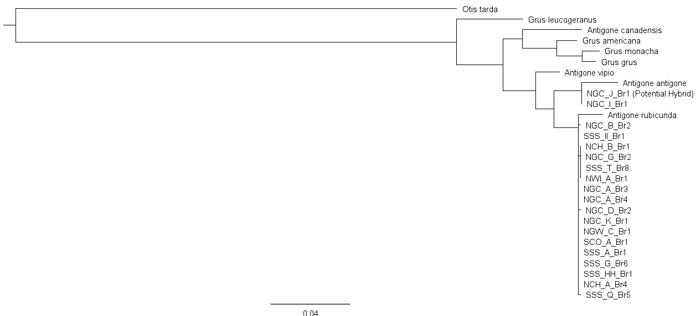
Fig. S4 Phylogenetic tree of hybrid investigation. The phylogenetic tree was created using Geneious Prime, with the great bustard (Otis tarda) used as an outgroup. The tree was generated based on a high-quality 1,000 bp sequence of the COI region, aligned using Clustal Omega and analysed with PHYML. A scale bar representing 0.04 substitutions per site is shown at the bottom of the tree.

1.2 Supporting Discussion: The importance of hybrid consideration
The interaction between Sarus Cranes and Brolgas has gained increasing attention in recent years. Visual confirmation of hybrids was first noted in 1972, and later substantiated by genetic evidence using Bayesian clustering of microsatellite loci in 2019 (Nevard et al. 2020a). Importantly, the study established the fertility of these hybrids, termed ‘Sarolgas’, as four of the nine individuals were identified as backcrosses (Nevard et al. 2020a). The coexistence of these species has been observed, likely driven by agricultural crop availability and suitable habitats, with both species intermingling at the same site and even sharing roosts (Scambler et al. 2020). As these species interactions highlight the ecological interconnectedness, preserving wetland habitats becomes even more crucial. Such sympatry between closely related crane species is rare (Mirande & Harris 2019), and warrants further investigation into the ecological factors that support this behaviour (Scambler et al. 2020). The Sarus Crane is globally classified as ‘Vulnerable’ on the IUCN Red List, primarily due to declining populations in Asia. Notably, a study by Nevard et al. (2020b) revealed that the Australian Sarus Crane Antigone antigone gillae varies largely from both A. a. antigone (South Asia) and A. a. sharpie (Myanmar and Indochina) based on mitochondrial DNA. This finding emphasises the importance of protecting the Australian Sarus Crane population but also raises concerns about hybridisation with the Brolga. The impact of ongoing hybridisation on the northern population should be considered in conservation management strategies. This is crucial not only for preserving the genetic integrity of the Australian Sarus Crane but also for addressing the emerging concerns regarding the northern Brolga population, which may be at greater risk than previously recognised.

2. Data collection and filtering
2.1 Supporting Results: Filtering stages
Table S6. Quality filtering stages of SNP dataset. The sequential filtering stages applied to the SNP dataset obtained from Diversity Arrays Technology (DArT) in dartR are outlined. This includes the number of loci and individuals retained and removed at each stage, as well as the specific thresholds used for retention. The dataset is then divided at the duplicate stage: one that includes individuals from the north and south regions along with the ‘outlier group’, and another that excludes the ‘outlier group’. For the dataset with the ‘outlier group’, 119 loci were randomly removed to run PopCluster, and the resulting dataset was used for any downstream analyses. Sex-linked loci were removed for both datasets.
Filter | Loci retained | Loci removed | Individuals retained | Individuals removed | Threshold
DArT preliminary filters | 58,074 | 0 | 172 | 0 | -
Monomorphs | 58,074 | 0 | 172 | 0 | -
Reproducibility average | 38,680 | 19,394 | 172 | 0 | 1
Depth of coverage | 24,976 | 13,704 | 172 | 0 | 8<X<172
Iterative call rate | 13,866 | 11,110 | 150 | 12 | Ind ≥ 0.6;  Loc ≥ 0.9;  Ind ≥ 0.8
Minor allele frequency | 10,727 | 3,139 | 150 | 0 | ≥ 0.01
Secondaries | 9833 | 894 | 150 | 0 | -
HWE | 9646 | 187 | 150 | 0 | α = 0.05
Dataset including ‘outlier group’
Duplicate removal | 9646 | 0 | 131 | 19 | k > 0.40
Outlier filtering | 8333 | 1313 | 131 | 0 | -
Sex-linked loci | 8309 | 24 | 131 | 0 | -
Loci removed for PopCluster | 8190 | 119 | 131 | 0 | Random
Dataset excluding ‘outlier group’
Duplicate and ‘outlier group’ removal | 7736 | 1910 | 125 | 25 | -
Outlier filtering | 7736 | 0 | 125 | 0 | -
Sex-linked loci | 7712 | 24 | 125 | 0 | -

Table S7. Outliers identified using OutFLANK, Arlequin, BayeScan and pcadapt. Identified loci under selection for datasets consisting of individuals from the north and south regions, both with and without the ‘outlier group’.
Outlier detection method | Loci detected under selection
Dataset including ‘outlier group’
OutFLANK | 0
Arlequin | 1569
BayeScan | 0
pcadapt | 4218
Dataset excluding ‘outlier group’
OutFLANK | 0
Arlequin | 0
BayeScan | 0
pcadapt | 327

Fig. S5 Outliers identified using OutFLANK, Arlequin, BayeScan and pcadapt. Loci identified under selection for the dataset which includes the ‘outlier group’. OutFLANK and BayeScan detected 0 outliers. 1,313 outliers were detected by both Arlequin and pcadapt, and subsequently removed from the dataset.

3. Sex inference
3.1 Supporting Results: Sex inference and sex-linked loci removal
Table S8. Loci retained after each filtering step in the sex inference analysis. The number of Z and W loci retained at each filtering stage, along with the corresponding thresholds, are shown. The DArT preliminary filtered loci include only the raw data for individuals retained after initial filtering and duplicate removal.
 | Z loci | W loci | Threshold
DArT preliminary filters | 44,666 |  | -
Blast Z or W chromosomes | 26,169 | 19,597 | -
Retain only top hit for each locus | 399 | 2,065 | -
Percentage identity | 399 | 2,065 | > 80%
E value | 366 | 2,012 | < 1x10⁻¹⁰
Remove duplicate clones | 292 | 1,652 | -
Reproducibility average | 201 | 1,163 | 1
Remove pseudoautosomal loci | 194 | 1,151 | Between > 400,000 bp and < 30,753, 356 bp
Remove loci which map to both the Z and W chromosome | 55 | 1,012 | -

Fig. S6 Sex inference results using the Mclust function. Each point represents a sample, coloured according to sex inference results (yellow = females, green = males). A-C) Correlations between the sex-associated features: W missing rate, Z heterozygosity and Z/W ratio. D) Assignment probability of samples to each cluster (cluster 1 = females, cluster 2 = males).

4. Genetic structure and diversity
4.1 Supporting Results: Principal Coordinate Analysis (PCoA)

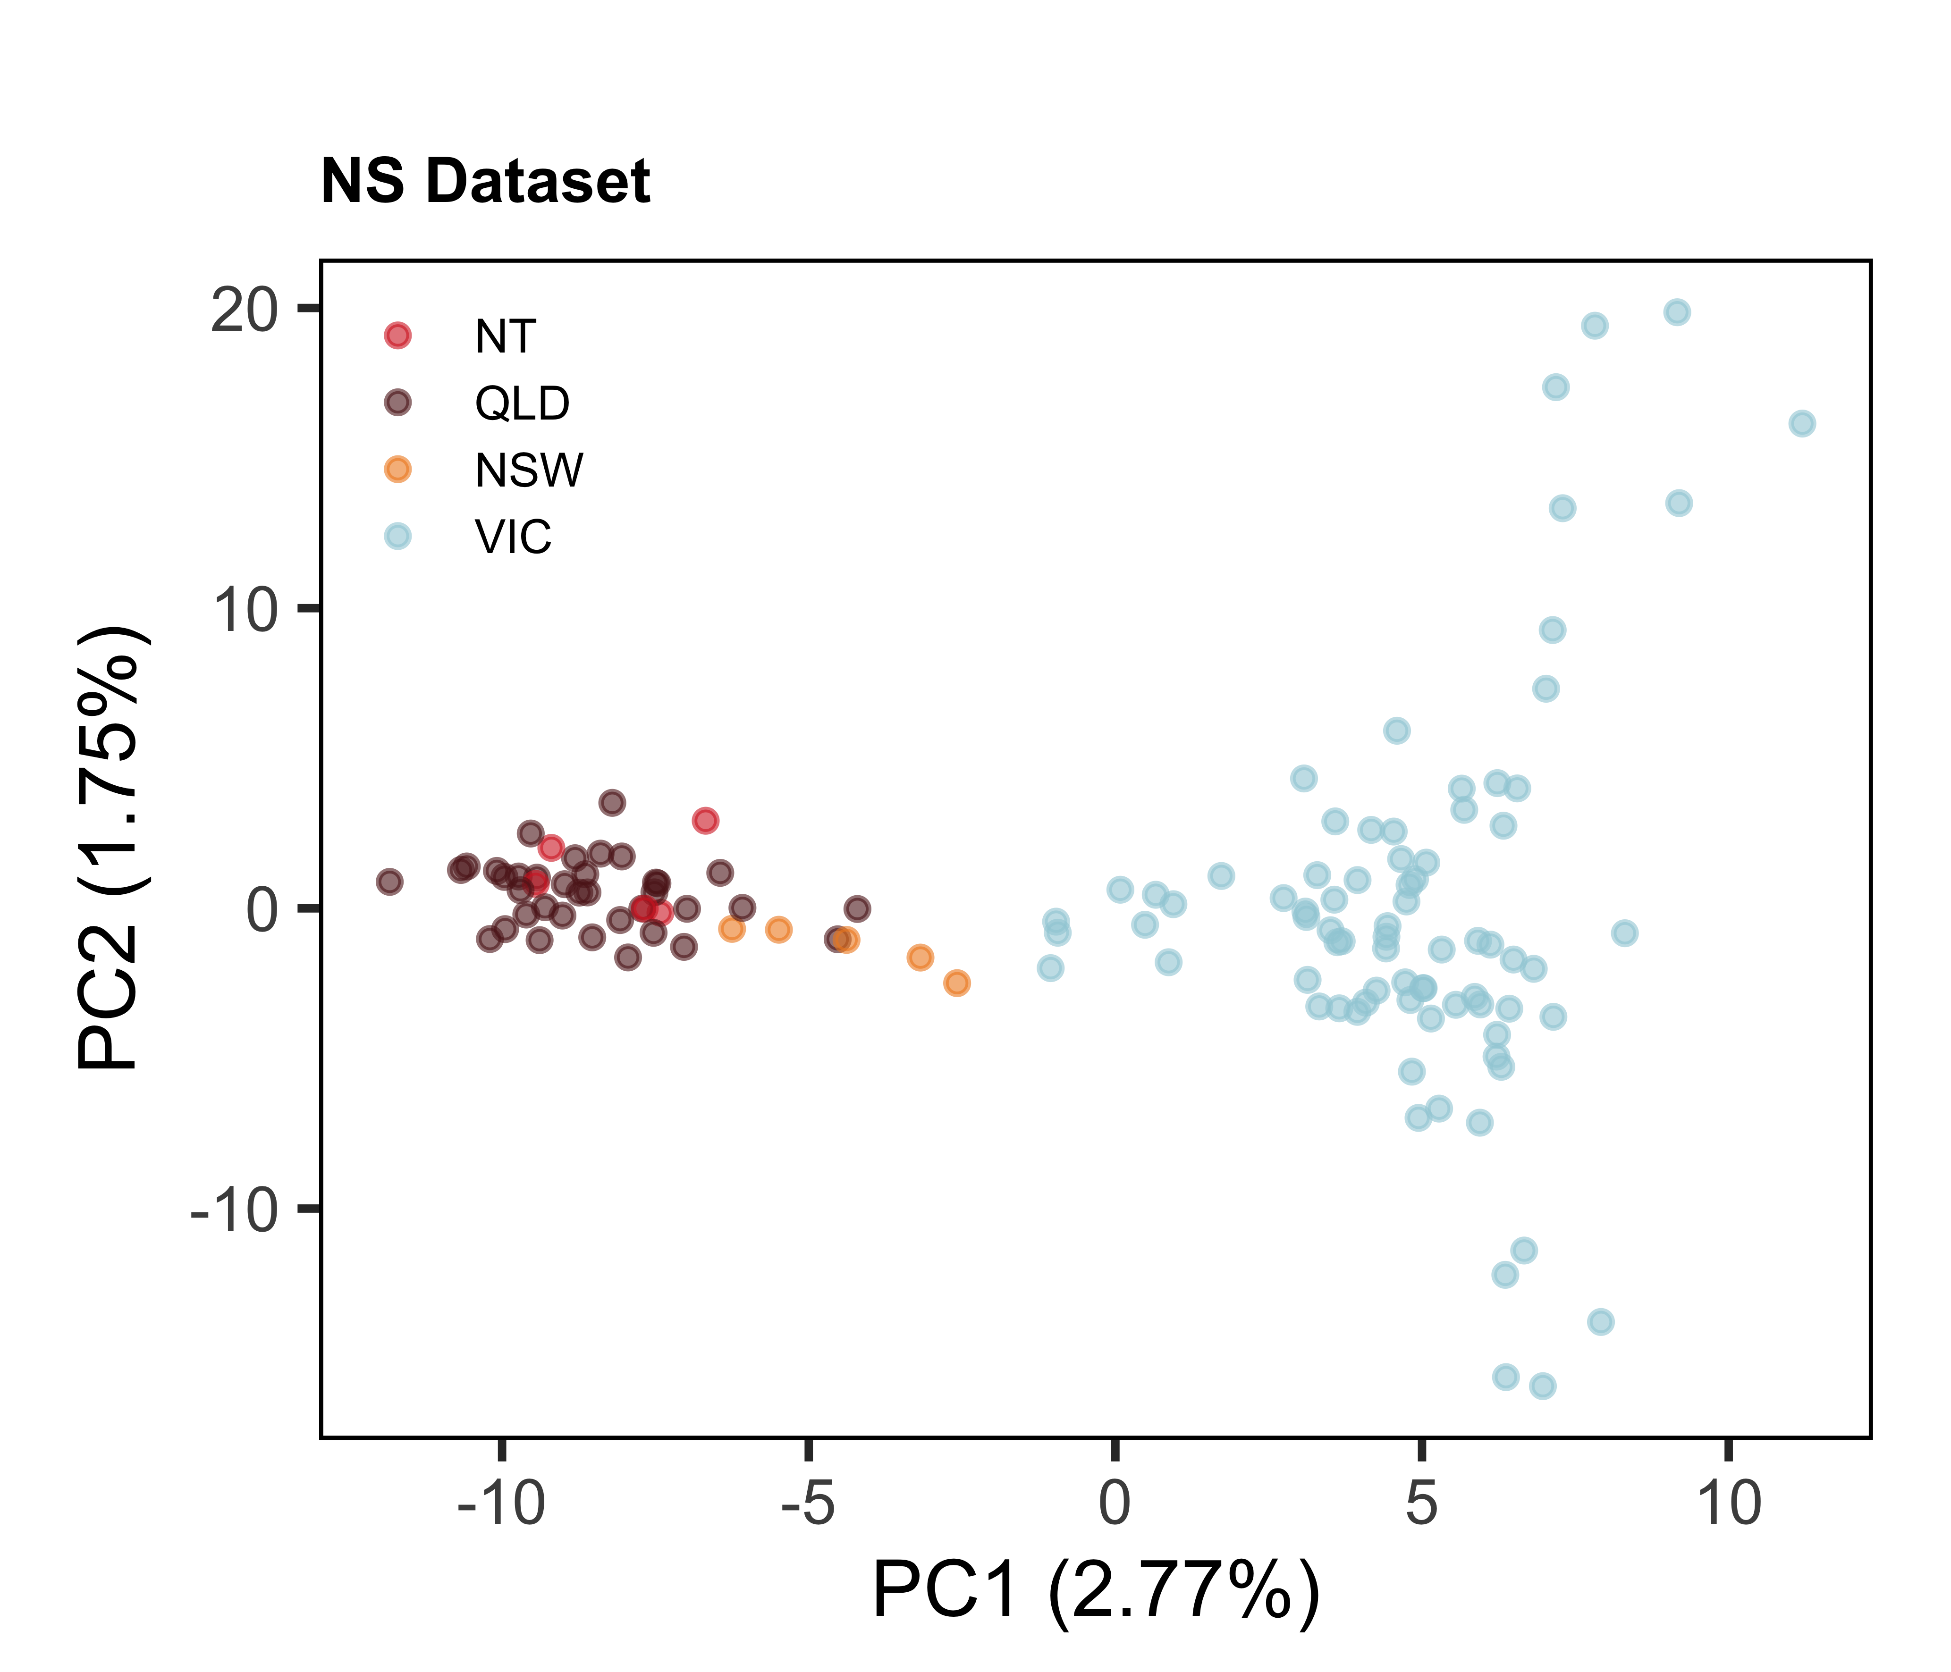
Fig. S7 Principal coordinates analysis (PCoA) of the NS dataset using neutral, autosomal loci. The NS dataset excludes the outlier group (i.e. potential hybrids). Points represent individuals and are coloured by Australian states and territories of collection: Northern Territory (NT; red), Queensland (QLD; purple), New South Wales (NSW; orange), and Victoria (VIC; blue). PC1 and PC2 correspond to the first and second principal coordinates, respectively, and axis labels indicate the percentage of variation explained.
4.2 Supporting Results: Discriminant Analysis of Principal Components (DAPC)
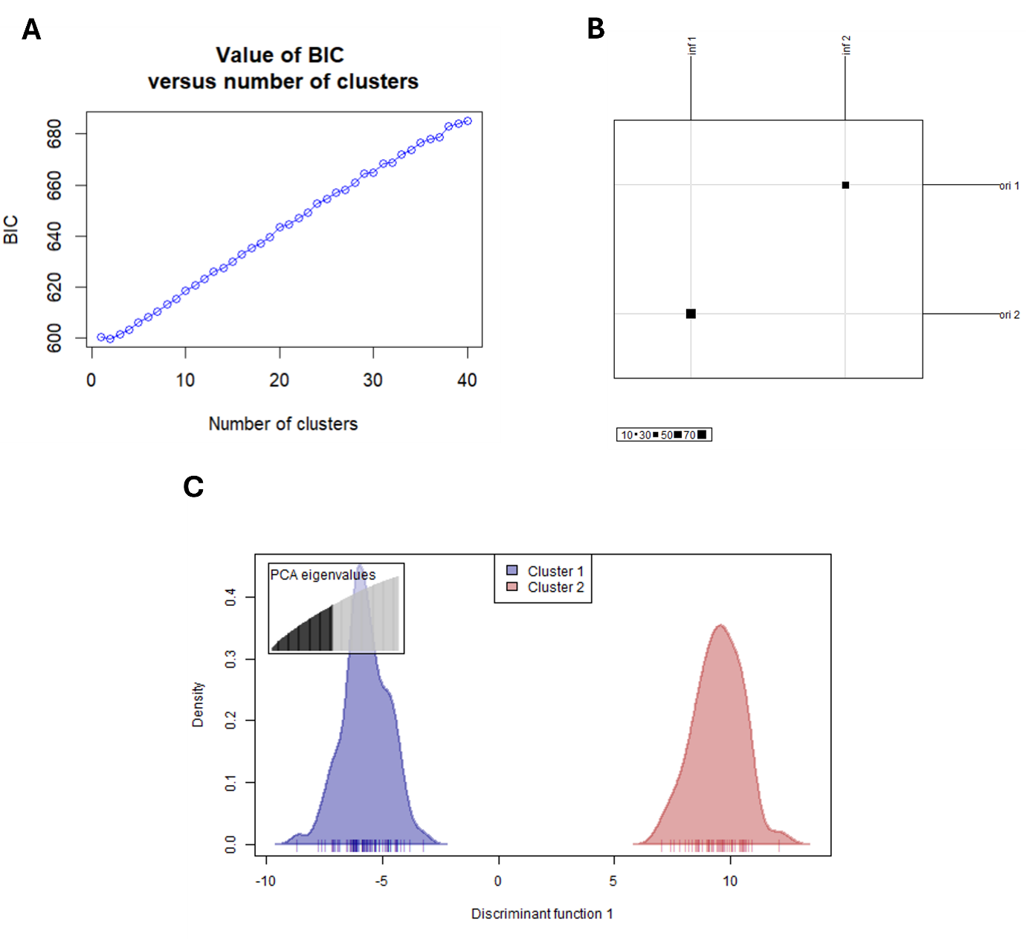

Fig. S8 Discriminant Analysis of Principal Components (DAPC) using the NS dataset. A) Bayesian information criteria (BIC) values for K-means clustering, with the lowest BIC informing the number of clusters for the DAPC. B) Assignment of Brolga individuals into two genetic clusters identified by K-means clustering. The original group of every individual was perfectly identified using the DAPC. C) Individual density plot on the first discriminant function (K = 2).

4.3 Supporting Results: NS dataset – admixture analyses
Beyond the K = 2 cluster described in the main text, PopCluster also identified K = 4 ($D_{LK2}$= ≈0.17; $F_{STIS}$ = 1) as an optimal K estimator. This clustering resulted in each genetic cluster being divided into two subpopulations. These results were subsequently visualised using a PCoA and were mapped (Figure S7). Upon review, it was determined that K = 4 did not yield a biologically meaningful genetic structure, as there was no clear justification for the assignment of individuals to these subpopulations. Consequently, the use of K = 4 was considered uninformative.
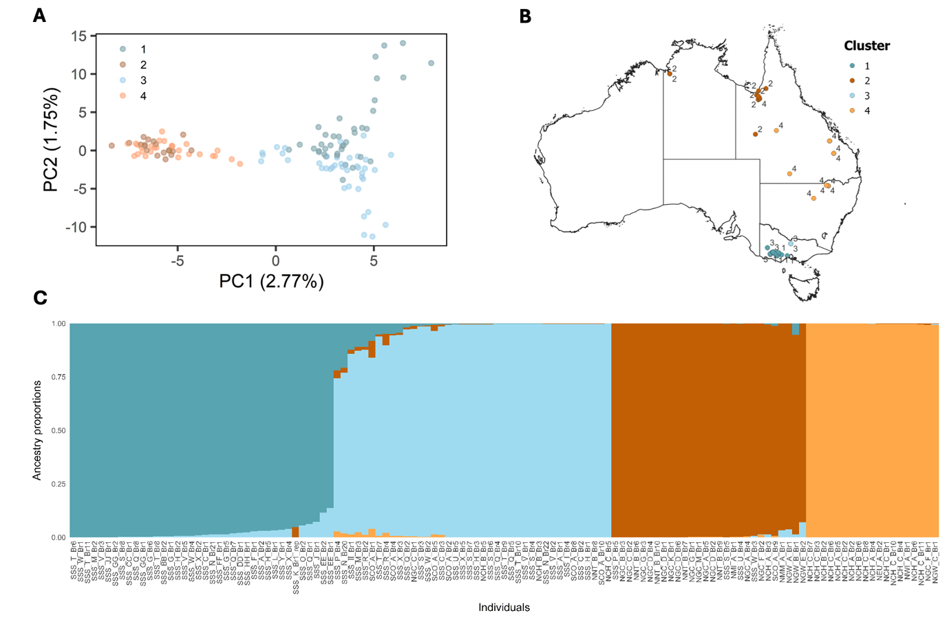

Fig. S9 Proportions of admixture per individual using the NS dataset with PopCluster of K = 4. PopCluster also identified K = 4 as an optimal K estimate, which divided the northern and southern Brolga clusters into two. A) PCoA showing genetic variation among individuals, coloured according to population clusters identified by PopCluster at K = 4. B) Geographic distribution of individuals visualised using QGIS, with sampling locations represented on the map. C) Admixture plot generated with PopCluster, illustrating the proportion of ancestry for each individual across the four genetic clusters (K = 4).

4.4 Supporting Results: NSO dataset - admixture analyses
LEA and PopCluster were run for the NSO dataset, which included the ‘outlier group’. PopCluster identified K = 2 for both estimators ($D_{LK2}$= 1; $F_{STIS}$ = 1), grouping northern and southern genetic clusters together as one ancestral cluster and the ‘outlier group’ as another cluster (Figure S8). There are a few individuals which shared minimal ancestral genes with the ‘outlier group’, in which notably most of these individuals were from the Gulf of Carpentaria. LEA maintained the separation of north and south individuals, with the ‘outlier group’ another distinct group (K = 3; minimum cross-entropy = 0.27).
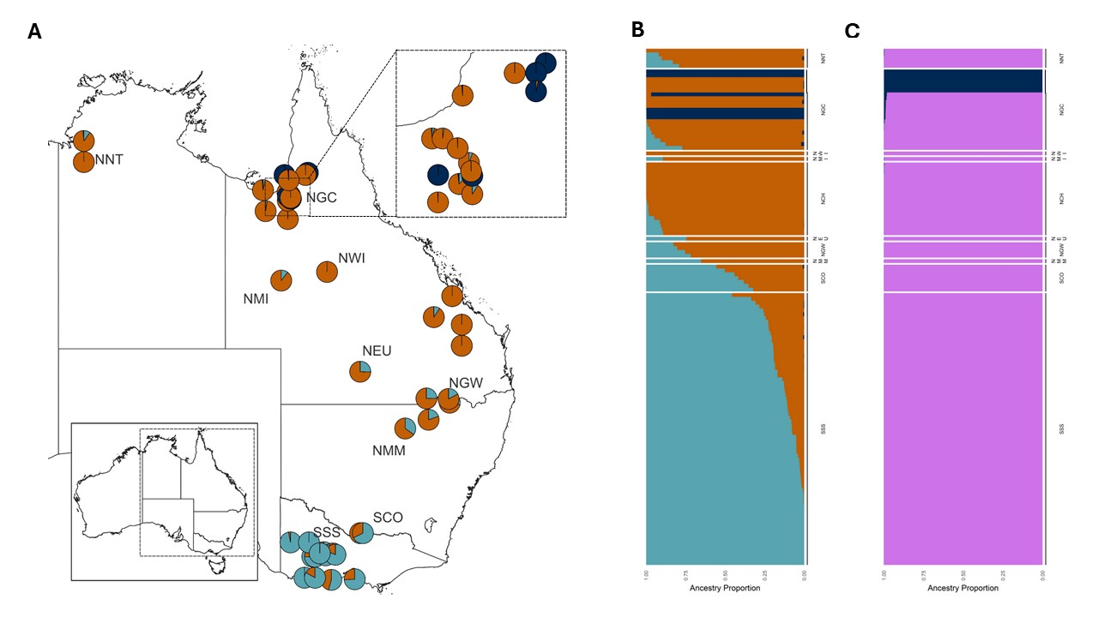

Fig. S10 Proportions of admixture per individual using the NSO dataset. A) Geographic map showing the admixture proportions of each individual, represented by a pie chart at their respective sampling locations. Admixture proportions were generated using LEA. B) Admixture proportions inferred using LEA at K = 3. C) Admixture proportions generated by PopCluster at K = 2. Individuals are grouped by both collection site and genetic clustering: north (orange), south (teal), ‘outlier group’ (i.e., potential hybrids) (dark blue), and individuals from both north and south clusters combined (purple).

5. Sex-biased dispersal and fine-scale gene flow
5.1 Supporting Results: Sex-biased dispersal tests
Table S9. Sex-biased dispersal tests. Four statistics were used to assess sex-biased dispersal: two F-statistics (F_{IS} and F_{ST}), and the mean (mAIc) and variance (vAIc) of corrected assignment index. Bootstrapped p-values are also provided.
Statistic | Value | p-value
mAIc | -0.232 | 0.85
vAIc | 1.281 | 0.15
F_{IS} | 0.0292 | 0.03
F_{ST} | 0.000567 | 0.79

5.2 Supporting Results: Kinship analyses
Mean kinship varied among clusters, with slightly higher values among individuals in the northern cluster (mean = 0.0040, 95% CI: 0.0029-0.0051) than in the southern cluster (mean = 0.0036, 95% CI: 0.0028-0.0044). Kinship between northern and southern cluster individuals was low (mean = 0.0003, 95% CI: -0.0001-0.0007), with confidence intervals overlapping zero. Similarly, mean kinship was higher within clusters (mean = 0.0038, 95% CI: 0.0030-0.0043) than between clusters (mean = 0.00029, 95% CI: -0.0001-0.00065), consistent with patterns of spatial genetic structuring. Kinship also varied among sex groupings, with higher values observed between males (mean = 0.0027, 95% CI: 0.0017-0.0037) than females (mean = 0.0017, 95% CI: 0.0011-0.0023), and intermediate values between sexes (mean = 0.0022, 95% CI: 0.0016-0.0028).

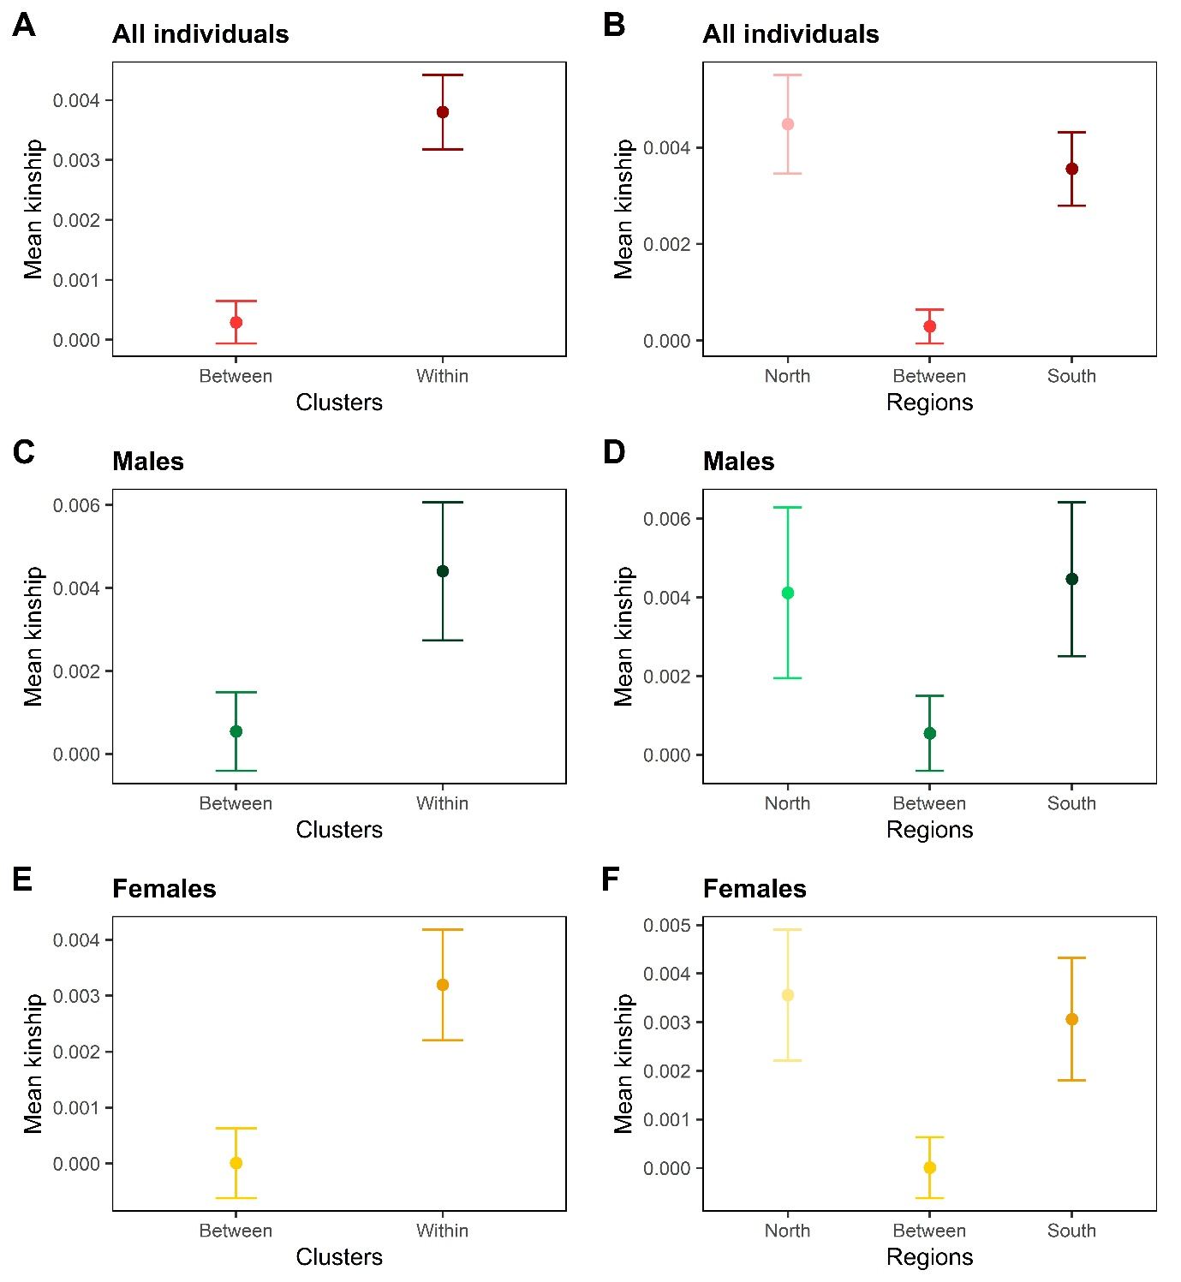

Fig. S11 Mean kinship compared between and within clusters. Results are shown for A-B) all individuals, C-D) for males, and E-F) for females. Kinship was estimated using the Maximum Likelihood Estimation method (MLE). Error bars represent 95% confidence intervals.
5.3 Supporting Results: Spatial autocorrelation analyses (SAA)

Fig. S12 Spatial autocorrelation analyses (SAA) for northern and southern clusters. Spatial correlograms are created using neutral autosomal loci for males (A-B) and females (C-D) in both the northern and southern clusters. Irregular distance classes were used to maximise sample size within each distance class. Solid error bars represent bootstrapped 95% confidence intervals around the mean correlation coefficient (r) for each distance class (10,000 bootstraps), with the dashed line denoting the 95% confidence intervals for the null hypothesis (9,999 permutations).

5.4 Supporting Results: Mantel tests
All Mantel tests indicated positive correlation between genetic and geographic distance in both genetic clusters, although not all were statistically significant. For the northern cluster: all individuals ($r_{M}$ = 0.27; 95% CI: 0.21-0.33; p < 0.001), males ($r_{M}$ = 0.23; 95% CI: 0.086-0.33; p = 0.079) and females ($r_{M}$ = 0.19; 95% CI: 0.14-0.27; p = 0.007). For the southern cluster: all individuals ($r_{M}$ = 0.20; 95% CI: 0.16-0.24; p < 0.001), males ($r_{M}$ = 0.25; 95% CI: 0.091-0.35; p = 0.007) and females ($r_{M}$ = 0.11; 95% CI: 0.054-0.16; p = 0.089). See Fig. S13 for all figures.

Fig. S13 Relationship between geographic distance and linear genetic distance. Mantel tests for the northern and southern clusters, shown for all individuals (A-B), males (C-D), and females (E-F). Black line represents the linear regression, with the grey shaded area indicating the standard error. Sample sizes are annotated in each panel. Note that the x-axis scales differ across panels to accommodate the varying ranges of the data and to allow accurate visualisation within each plot.
6. Effective population size
6.1 Supporting Results: Estimated effective population size
 |  | P_{crit}
 | 0.01 |  | 0.02 | 0.03 | 0.04 | 0.05
North
N_{e} | 473 |  | 549 | 524 | 470 | 443
N_{e(lwr)} | Infinite |  | 116 | 195 | 467 | 207
N_{e(upr)} | Infinite |  | 188 | 1,523 | Infinite | Infinite
South
N_{e} | 398 |  | 323 | 288 | 260 | 249
N_{e(lwr)} | Infinite |  | 380 | 368 | 231 | 157
N_{e(upr)} | Infinite |  | Infinite | Infinite | 1,221 | 425
Table S10. Estimated effective population sizes (N_{e}) along with upper (N_{e(upr)}) and lower (N_{e(lwr)}) limits, accounting for biases due to overlapping generations (Table S6). The estimates are provided for both the northern and southern clusters using a sexual maturity age of 3 years and adult lifespan of 28 years (maximum age of 30 years). Minor allele frequency thresholds (P_{crit}) range from 0.01 and 0.05. Grey text highlights statistics where the upper 95% CI lies below the mean.

 |  | P_{crit}
 | 0.01 |  | 0.02 | 0.03 | 0.04 | 0.05
North
N_{e} | 546 |  | 632 | 604 | 541 | 510
N_{e(lwr)} | Infinite |  | 134 | 225 | 538 | 238
N_{e(upr)} | Infinite |  | 216 | 1,755 | Infinite | Infinite
South
N_{e} | 459 |  | 372 | 332 | 300 | 287
N_{e(lwr)} | Infinite |  | 437 | 425 | 266 | 181
N_{e(upr)} | Infinite |  | Infinite | Infinite | 1,407 | 489
Table S11. Estimated effective population sizes (N_{e}) along with upper (N_{e(upr)}) and lower (N_{e(lwr)}) limits, accounting for biases due to overlapping generations (Table S6). The estimates are provided for both the northern and southern clusters using a sexual maturity age of 3 years and adult lifespan of 13 years (maximum age of 15 years). Minor allele frequency thresholds (P_{crit}) range from 0.01 and 0.05. Grey text highlights statistics where the upper 95% CI lies below the mean.

Table S12. Estimated effective population sizes (N_{e}) with the upper (N_{e(upr)}) and lower (N_{e(lwr)}) limits for the northern and southern clusters, using different values for sexual maturity. Due to uncertainty regarding the age of sexual maturity for Brolga, values of 2, 3 and 4 years were used in the calculations for both clusters, with a maximum age of 30 years. A P_{crit} of 0.05 is reported.
Sexual maturity age
 | 2 years old | 3 years old | 4 years old
North
N_{e} | 419 | 443 | 467
N_{e(lwr)} | 196 | 207 | 218
N_{e(upr)} | Infinite | Infinite | Infinite
South
N_{e} | 236 | 249 | 263
N_{e(lwr)} | 149 | 157 | 166
N_{e(upr)} | 401 | 425 | 448

Table S13. Estimated effective population sizes (N_{e}) with the upper (N_{e(upr)}) and lower (N_{e(lwr)}) limits for the northern and southern clusters, using different values for sexual maturity. Due to uncertainty regarding the age of sexual maturity for Brolga, values of 2, 3 and 4 years were used in the calculations for both clusters, with a maximum age of 15 years. A P_{crit} of 0.05 is reported.
Sexual maturity age
 | 2 years old | 3 years old | 4 years old
North
N_{e} | 464 | 510 | 560
N_{e(lwr)} | 217 | 238 | 262
N_{e(upr)} | Infinite | Infinite | Infinite
South
N_{e} | 261 | 287 | 315
N_{e(lwr)} | 165 | 181 | 199
N_{e(upr)} | 445 | 489 | 537

7. Forward simulations
7.1 Supporting Results: Minimum population size justification and all scenarios
A small population size has many implications for a species' survival, including reduced genetic diversity, increased inbreeding risk, and greater susceptibility to environmental and demographic fluctuations. Life-history traits can further exacerbate these challenges, as they influence key factors like breeding success, parental investment, and dispersal behaviour. Brolgas, for example, provide moderate parental care to their young, with juveniles often remaining with their parents until the next breeding season, or even longer if the parents do not re-nest (White 1992; DuGuesclin 2003). This extended care likely increases juvenile survival, but further research is needed, as knowledge of the species' overall breeding success remains limited (White 1992). Furthermore, while Brolgas are typically considered non-migratory (DuGuesclin 2003), partial migration and nomadic movements have been observed, particularly in southern Australia (Veltheim et al. 2022).
In terms of population viability, Frankham et al. (2014) proposed the ‘100/1000’ rule, suggesting that an effective population size ($N_{e}$) of at least 100 individuals is necessary to limit total fitness loss to under 10% and prevent short-term inbreeding depression. To maintain long-term evolutionary potential, however, a larger N_{e} of 1,000 is required. Similarly, Shaffer (1981) modelled grizzly bear dynamics and concluded that populations with only 50 to 100 individuals would struggle to survive for more than a century, when factoring in both demographic and environmental variables.
In this study, a minimum population size of eight individuals was used as a lower bound in the BOTTLESIM forward simulations when projecting across the 85-year period. This threshold reflects a modelling constraint rather than a biologically defined minimum viable population size. Populations at or below this number were therefore classified as functionally extinct for the purposes of the simulations.

Fig. S14 Percentage of genetic diversity retained for the northern and southern clusters under different management scenarios. Retained genetic diversity (OA, the observed number of alleles) is shown over 85 years, using a maximum lifespan of 30 years, for the north (solid line) and south (dashed line) clusters, rounded to the nearest even number to maintain equal sex ratios. Bottlenecks of either A/C) 50% or B/D) 75% are used, simulated using BOTTLESIM. All plots include no bottleneck (dark green) = maintained constant effective population sizes. A-B) ‘Bottleneck (maintained or with recovery)’ scenarios include: Bottleneck, 3% yearly recovery (light green) = reducing N_{e} by 50% or 75%, followed by a 3% recovery each year; Bottleneck, 5% yearly recovery (yellow) = reducing N_{e} by 50% or 75%, followed by a 5% recovery each year; and single bottlenecks (purple) = reducing N_{e} by 50% or 75% in year 1, and then maintaining the effective population size for the following years. C-D) ‘Decline with intervention’ scenarios include: 3% yearly, maintained at 50% or 25% (dark blue) = reducing N_{e} by 3% each year until reaching 50% or 25% of original size; 5% yearly, maintained at 50% or 25% (light blue) = reducing N_{e} by 5% each year until reaching 50% or 25% of original size. E) Finally, ‘decline with no intervention’ scenarios, with a constant N_{e} decrease of either 3% (orange) or 5% (red) every year. An asterisk indicates when the population reaches eight individuals and is deemed unviable.

Fig. S15 Percentage of heterozygosity retained for the northern and southern clusters under different management scenarios. Retained observed heterozygosity (H_{o}) is shown over 85 years, using a maximum lifespan of 30 years, for the north (solid line) and south (dashed line) clusters, rounded to the nearest even number to maintain equal sex ratios. Bottlenecks of either A/C) 50% or B/D) 75% are used, simulated using BOTTLESIM. All plots include no bottleneck (dark green) = maintained constant effective population sizes. A-B) ‘Bottleneck (maintained or with recovery)’ scenarios include: Bottleneck, 3% yearly recovery (light green) = reducing N_{e} by 50% or 75%, followed by a 3% recovery each year; Bottleneck, 5% yearly recovery (yellow) = reducing N_{e} by 50% or 75%, followed by a 5% recovery each year; and single bottlenecks (purple) = reducing N_{e} by 50% or 75% in year 1, and then maintaining the effective population size for the following years. C-D) ‘Decline with intervention’ scenarios include: 3% yearly, maintained at 50% or 25% (dark blue) = reducing N_{e} by 3% each year until reaching 50% or 25% of original size; 5% yearly, maintained at 50% or 25% (light blue) = reducing N_{e} by 5% each year until reaching 50% or 25% of original size. E) Finally, ‘decline with no intervention’ scenarios, with a constant N_{e} decrease of either 3% (orange) or 5% (red) every year. An asterisk indicates when the population reaches eight individuals and is deemed unviable.

References
Anderson EC, Dunham KK (2008) The influence of family groups on inferences made with the program Structure. Mol Ecol Resour, 8, 1219-1229. https://doi.org/10.1111/j.1755-0998.2008.02355.x.
Beaumont MA, Balding DJ (2004) Identifying adaptive genetic divergence among populations from genome scans. Mol Ecol, 13, 969-980. https://doi.org/10.1111/j.1365-294X.2004.02125.x.
Beilfuss RD, Dodman T, Urban EK (2007) The status of cranes in Africa in 2005. Ostrich, 78, 175-184. https://doi.org/10.2989/ostrich.2007.78.2.11.91.
Canadian Wildlife Service, U.S. Fish and Wildlife Service (2007) International recovery plan for the whooping crane. p. 162. Canadian Wildlife Service and U.S. Fish and Wildlife Service, Ottawa and Albuquerque, New Mexico.
Conomos MP, Miller MB, Thornton TA (2015) Robust Inference of Population Structure for Ancestry Prediction and Correction of Stratification in the Presence of Relatedness. Genet Epidemiol, 39, 276-293. https://doi.org/10.1002/gepi.21896.
Conomos Matthew P, Reiner Alexander P, Weir Bruce S, Thornton Timothy A (2016) Model-free Estimation of Recent Genetic Relatedness. Am J Hum Genet, 98, 127-148. https://doi.org/10.1016/j.ajhg.2015.11.022.
Davis S (2024) Conservation genomics and metagenomics of Australian waterbirds. Macquarie University.
DuGuesclin P (2003) Flora and Fauna Guarantee Act Action Statement No. 119: Brolga Grus rubicunda. Victoria, Australia: Department of Sustainability and Environment.
Excoffier L, Lischer HEL (2010) Arlequin suite ver 3.5: a new series of programs to perform population genetics analyses under Linux and Windows. Mol Ecol Resour, 10, 564-567. https://doi.org/10.1111/j.1755-0998.2010.02847.x.
Foll M (2012) BayeScan v2.1 user manual. Ecol, 20, 1450-1462.
Foll M, Gaggiotti O (2008) A Genome-Scan Method to Identify Selected Loci Appropriate for Both Dominant and Codominant Markers: A Bayesian Perspective. Genetics, 180, 977-993. https://doi.org/10.1534/genetics.108.092221.
Frankham R, Bradshaw CJA, Brook BW (2014) Genetics in conservation management: Revised recommendations for the 50/500 rules, Red List criteria and population viability analyses. Biol Conserv, 170, 56-63. https://doi.org/10.1016/j.biocon.2013.12.036.
Gogarten SM, Sofer T, Chen H, Yu C, Brody JA, Thornton TA, Rice KM, Conomos MP (2019) Genetic association testing using the GENESIS R/Bioconductor package. Bioinform, 35, 5346-5348. https://doi.org/10.1093/bioinformatics/btz567.
Guilfoyle MP, Farrington HL, Lance RF, Hanson-Dorr KC, Dorr BS, Fischer RA (2017) Movement of Hypophthalmichthys DNA in the Illinois River Watershed by the Double-Crested Cormorant (Phalacrocorax auritus). Waterbirds, 40, 63-68. https://doi.org/10.1675/063.040.0109.
Guindon S, Gascuel O (2003) A simple, fast, and accurate algorithm to estimate large phylogenies by maximum likelihood. Syst Biol, 52, 696-704. https://doi.org/10.1080/10635150390235520.
Iacchei M, Ben-Horin T, Selkoe KA, Bird CE, García-Rodríguez FJ, Toonen RJ (2013) Combined analyses of kinship and FST suggest potential drivers of chaotic genetic patchiness in high gene-flow populations. Mol Ecol, 22, 3476-3494. https://doi.org/10.1111/mec.12341.
Lewontin RC, Krakauer J (1973) Distribution of gene frequency as a test of the theory of the selective neutrality of polymorphisms. Genetics, 74, 175-195. https://doi.org/10.1093/genetics/74.1.175.
Liu S, Zeng Y, Wang C, Zhang Q, Chen M, Wang X, Wang L, Lu Y, Guo H, Bu F (2022) seGMM: A New Tool for Gender Determination From Massively Parallel Sequencing Data. Front Genet, 13. https://doi.org/10.3389/fgene.2022.850804.
Loiselle BA, Sork VL, Nason J, Graham C (1995) Spatial Genetic Structure of a Tropical Understory Shrub, Psychotria officinalis (Rubiaceae). Am J Bot, 82, 1420-1425. https://doi.org/10.2307/2445869.
Luu K, Bazin E, Blum MGB (2017) pcadapt: an R package to perform genome scans for selection based on principal component analysis. Mol Ecol Resour, 17, 67-77. https://doi.org/10.1111/1755-0998.12592.
Manichaikul A, Mychaleckyj JC, Rich SS, Daly K, Sale M, Chen W-M (2010) Robust relationship inference in genome-wide association studies. Bioinform, 26, 2867-2873. https://doi.org/10.1093/bioinformatics/btq559.
Milligan BG (2003) Maximum-Likelihood Estimation of Relatedness. Genetics, 163, 1153-1167. https://doi.org/10.1093/genetics/163.3.1153.
Mirande CM, Harris JT (2019) Crane Conservation Strategy, Baraboo, Wisconsin, USA.
Mudrik EA, Kashentseva TA, Postelnykh KA, Nosachenko GV, Politov DV (2015) Offspring sex ratio in the captive population of the Siberian crane (Grus leucogeranus Pallas). Russ J Genet, 51, 1249-1252. https://doi.org/10.1134/S102279541512008X.
Nesbitt SA, Folk MJ, Schwikert ST, Schmidt JA (2001) Aspects of reproduction and pair bonds in Florida sandhill cranes. Proceedings North American Crane Workshop, 8, 31-35.
Nesterenko ON, Kashentseva TA (2021) Sex ratio of Red-crowned and Siberian Cranes offspring in Oka Crane Breeding Center, Russia. Cranes of Eurasia.
Nevard TD, Haase M, Archibald G, Leiper I, Garnett ST (2020a) The sarolga: conservation implications of genetic and visual evidence for hybridization between the brolga Antigone rubicunda and the Australian sarus crane Antigone antigone gillae. Oryx, 54, 40-51. https://doi.org/10.1017/S003060531800073X.
Nevard TD, Haase M, Archibald G, Leiper I, van Zalinge RN, Purchkoon N, Siriaroonrat B, Nwe Latt T, Wink M, Garnett ST (2020b) Subspecies in the Sarus Crane Antigone antigone revisited; with particular reference to the Australian population. PLoS One, 15, e0230150. https://doi.org/10.1371/journal.pone.0230150.
Patel S, Waugh J, Millar CD, Lambert DM (2010) Conserved primers for DNA barcoding historical and modern samples from New Zealand and Antarctic birds. Mol Ecol Resour, 10, 431-438. https://doi.org/10.1111/j.1755-0998.2009.02793.x.
Posada D (2008) jModelTest: phylogenetic model averaging. Mol Biol Evol, 25, 1253-1256. https://doi.org/10.1093/molbev/msn083.
Privé F, Luu K, Vilhjálmsson BJ, Blum MGB (2020) Performing Highly Efficient Genome Scans for Local Adaptation with R Package pcadapt Version 4. Mol Biol Evol, 37, 2153-2154. https://doi.org/10.1093/molbev/msaa053.
Qian DC, Busam JA, Xiao X, O’Mara TA, Eeles RA, Schumacher FR, Phelan CM, Amos CI (2016) seXY: a tool for sex inference from genotype arrays. Bioinform, 33, 561-563. https://doi.org/10.1093/bioinformatics/btw696.
Robledo-Ruiz D, Austin L, Amos J, Castrejón-Figureoa J, Magrath M, Sunnucks P, Pavlova A (2022) Easy-to-use R functions to separate reduced-representation genomic datasets into sex-linked and autosomal loci, and conduct sex-assignment. Authorea Preprints.
Ross MT, Grafham DV, Coffey AJ, Scherer S, McLay K, Muzny D, Platzer M, Howell GR, Burrows C, Bird CP, et al. (2005) The DNA sequence of the human X chromosome. Nature, 434, 325-337. https://doi.org/10.1038/nature03440.
Scambler E, Nevard T, Harrington G, Edwards E, Simmonds V, Franklin D (2020) Numbers, distribution and behaviour of Australian Sarus Cranes Antigone antigone gillae and Brolgas A. rubicunda at wintering roosts on the Atherton Tablelands, far north Queensland, Australia. Aust Field Ornithol, 37, 87-99. https://doi.org/10.20938/afo37087099.
Scrucca L, Fop M, Murphy TB, Raftery AE (2016) mclust 5: Clustering, Classification and Density Estimation Using Gaussian Finite Mixture Models. R J, 8, 289-317.
Selås V, Kleven O, Steen OF (2017) Female turnover rate differs between two Northern Goshawk Accipiter gentilis nesting areas, as revealed by DNA analysis of moulted feathers. Ibis, 159, 554-566. https://doi.org/10.1111/ibi.12475.
Shaffer ML (1981) Minimum Population Sizes for Species Conservation. Biosci, 31, 131-134. https://doi.org/10.2307/1308256.
Sorenson MD, Ast JC, Dimcheff DE, Yuri T, Mindell DP (1999) Primers for a PCR-Based Approach to Mitochondrial Genome Sequencing in Birds and Other Vertebrates. Mol Phyl Evol, 12, 105-114. https://doi.org/10.1006/mpev.1998.0602.
Stehn TV (2011) Whooping Cranes During the 2010-2011 Winter. US Fish and Wildlife Service, Austwell, Texas, USA.
Storey JD, Bass AJ, Dabney A, Robinson D (2019) qvalue: Q-value estimation for false discovery rate control. R package version 2.34.0, http://github.com/jdstorey/qvalue.
Su L, Zou H (2012) Status, threats and conservation needs for the continental population of the Red-crowned Crane. Chin Birds, 3, 147-164. https://doi.org/10.5122/cbirds.2012.0030.
Tacha TC, Haley DE, Vohs PA (1989) Age of Sexual Maturity of Sandhill Cranes from Mid-Continental North America. J Wildl Manag, 53, 43-46. https://doi.org/10.2307/3801303.
Tamura K, Stecher G, Kumar S (2021) MEGA11: Molecular Evolutionary Genetics Analysis Version 11. Mol Biol Evol, 38, 3022-3027. https://doi.org/10.1093/molbev/msab120.
Trivers RL, Willard DE (1973) Natural Selection of Parental Ability to Vary the Sex Ratio of Offspring. Science, 179, 90-92.
Veltheim I, Cook S, McCarthy MA, Palmer GC, Hill FAR (2022) Partial migration of Brolgas (Antigone rubicunda) within a restricted range is revealed by GPS tracking. Emu, 122, 39-50. https://doi.org/10.1080/01584197.2022.2036196.
Veyret L (2008) Brolga (Grus rubicunda) Husbandry Guidelines - 2008.
Wang J (2018) Estimating genotyping errors from genotype and reconstructed pedigree data. Methods Ecol Evol, 9, 109-120. https://doi.org/10.1111/2041-210X.12859.
Waples RS, Antao T, Luikart G (2014) Effects of Overlapping Generations on Linkage Disequilibrium Estimates of Effective Population Size. Genetics, 197, 769-780. https://doi.org/10.1534/genetics.114.164822.
Waples RS, Luikart G, Faulkner JR, Tallmon DA (2013) Simple life-history traits explain key effective population size ratios across diverse taxa. Proceedings of the Royal Society B: Biological Sciences, 280, 20131339. https://doi.org/10.1098/rspb.2013.1339.
Wasser DE, Sherman PW (2010) Avian longevities and their interpretation under evolutionary theories of senescence. J Zool, 280, 103-155. https://doi.org/10.1111/j.1469-7998.2009.00671.x.
White DM (1992) 1992 Brolga Census. Brolga News, 1.
Whitlock MC, Lotterhos KE (2015) Reliable Detection of Loci Responsible for Local Adaptation: Inference of a Null Model through Trimming the Distribution of FST. Am Nat, 186, S24-S36. https://doi.org/10.1086/682949.
Zheng X, Levine D, Shen J, Gogarten SM, Laurie C, Weir BS (2012) A High-performance Computing Toolset for Relatedness and Principal Component Analysis of SNP Data. Bioinform, 28, 3326-3328. https://doi.org/10.1093/bioinformatics/bts606.
Zhou Q, Zhang J, Bachtrog D, An N, Huang Q, Jarvis ED, Gilbert MTP, Zhang G (2014) Complex evolutionary trajectories of sex chromosomes across bird taxa. Science, 346, 1246338. https://doi.org/10.1126/science.1246338.

