Online supplementary material for: Extremely poor genetic health in the Critically Endangered Nangur Spiny Skink (Nangura spinosa) of eastern Australia

Nicholas J. Bail^{1,2*}, Megan Higgie^{1,2}, Daniel J. Ferguson³, & Conrad J. Hoskin¹

¹College of Science & Engineering, James Cook University, Townsville, Qld 4811, Australia
²Centre for Tropical Bioinformatics and Molecular Biology, James Cook University, Townsville, Qld 4811, Australia
³Queensland Herbarium & Biodiversity Science, The Department of Environment, Tourism, Science and Innovation, Toowong, Qld 4066, Australia
*Corresponding author email: nicholas.bail@my.jcu.edu.au

ORCID:
Nicholas Bail 0009-0005-1518-7722
Megan Higgie 0000-0002-2397-0240
Daniel Ferguson 0009-0007-5222-2966
Conrad Hoskin 0000-0001-8116-6085

Section 1: demultiplexing and genotype calling

Online Resources 1–6
This section includes figures and tables that supplement the methods and results dedicated to demultiplexing and genotype calling in Stacks version 2.62, including numbers of reads retained, read depth of individual samples, results of the R80 method of parameter optimisation, and results output by TIGER.
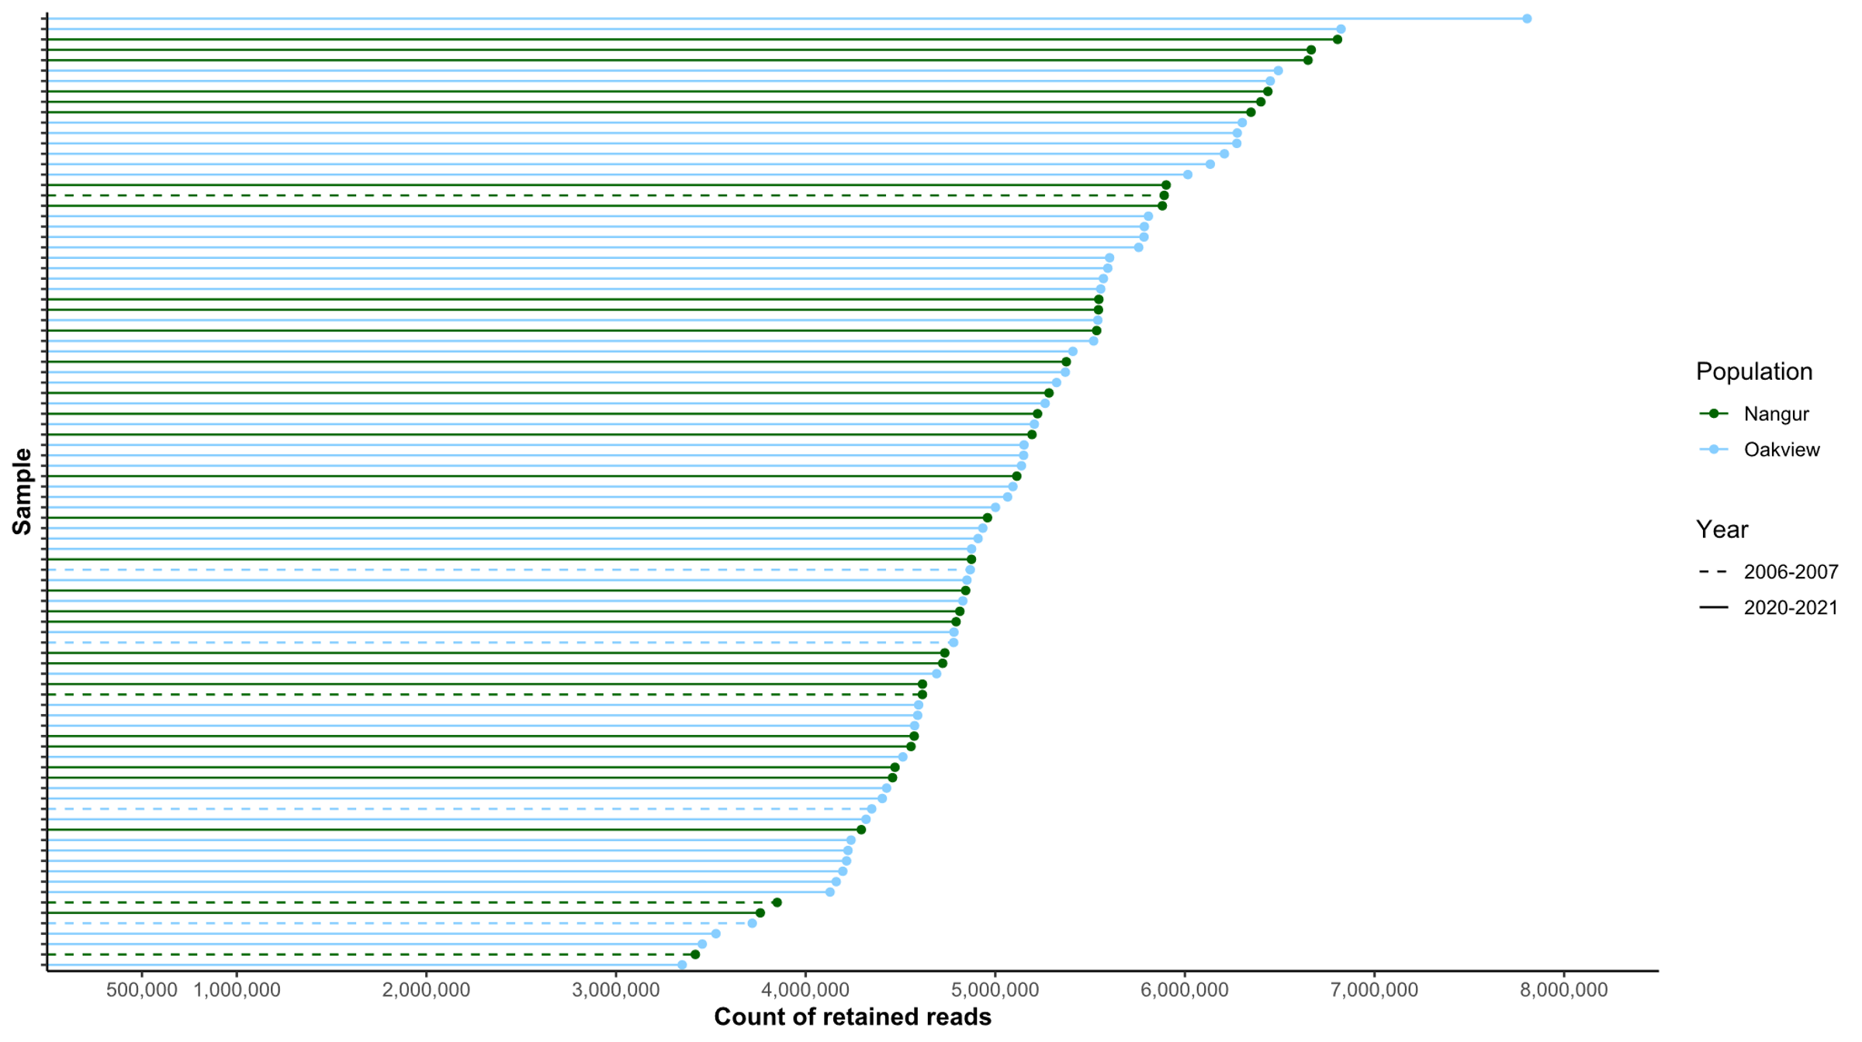
Online Resource 1 Reads retained per sample during demultiplexing using Stacks, the population and year of collection are indicated.

Online Resource 2 Numbers of reads retained and dropped during demultiplexing using Stacks, with primary reason for dropping given.
 | Read type |  | Number of reads |  | Approximate percentage of total reads (%)
Total reads |  | 495,156,679 |  | 100.0
Retained reads |  | 476,907,150 |  | 96.3
Dropped reads |  | 18,249,529 |  | 3.7
RAD cutsite not found |  | 12,088,854 |  | 2.4
Barcode not found |  | 5,957,164 |  | 1.2
Low quality |  | 203,511 |  | 0.0

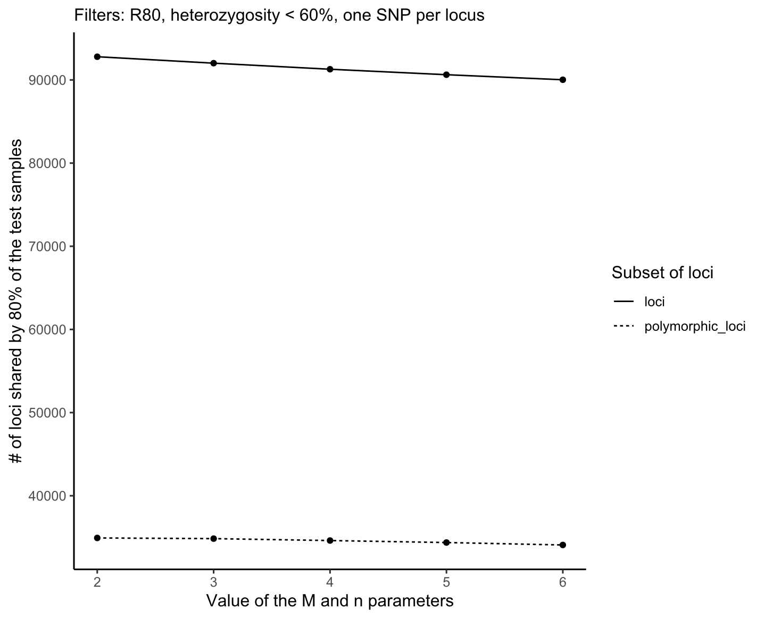

Online Resource 3 The number of loci and polymorphic loci retained by 80% of the samples in the dataset, for varying values of the M and n parameters (M = n) in the denovo_map.pl of Stacks. The parameter m was kept at 3.

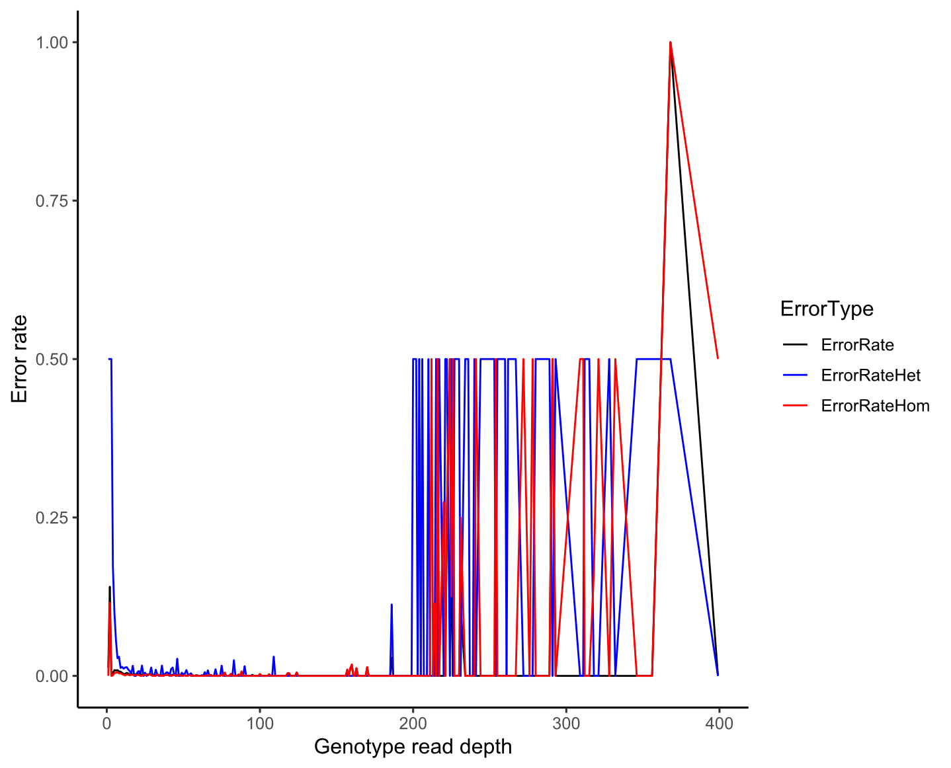 Online Resource 4 Error rates per read depth for all sites (black), homozygous sites (red), and heterozygous sites (blue), from duplicated samples in three pairs as calculated by TIGER. This has been averaged across values of the M and n parameters (M = n) ranging from 2–6 in the denovo_map.pl of Stacks. The parameter m was kept at 3.

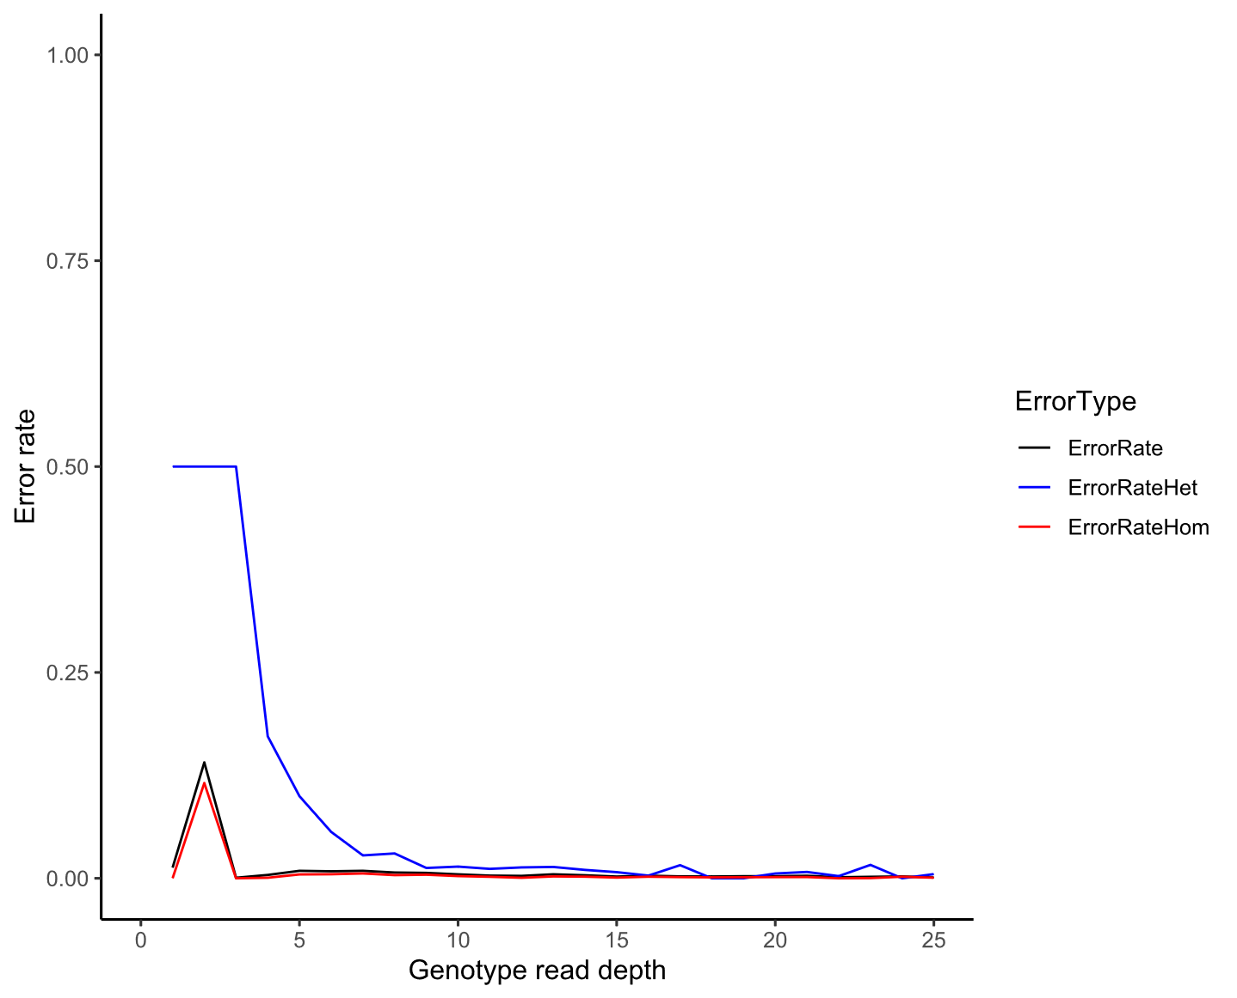

Online Resource 5 Error rates per read depth (for read depths less than 25) for all sites (black), homozygous sites (red), and heterozygous sites (blue), from duplicated samples in three pairs as calculated by TIGER. This has been averaged across values of the M and n parameters (M = n) ranging from 2–6 in the denovo_map.pl of Stacks. The parameter m was kept at 3.

All read depths

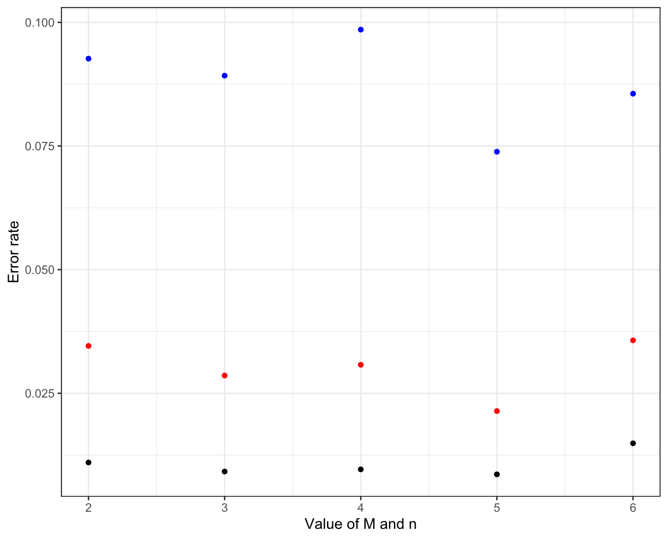
Read depths > 10 and < 60
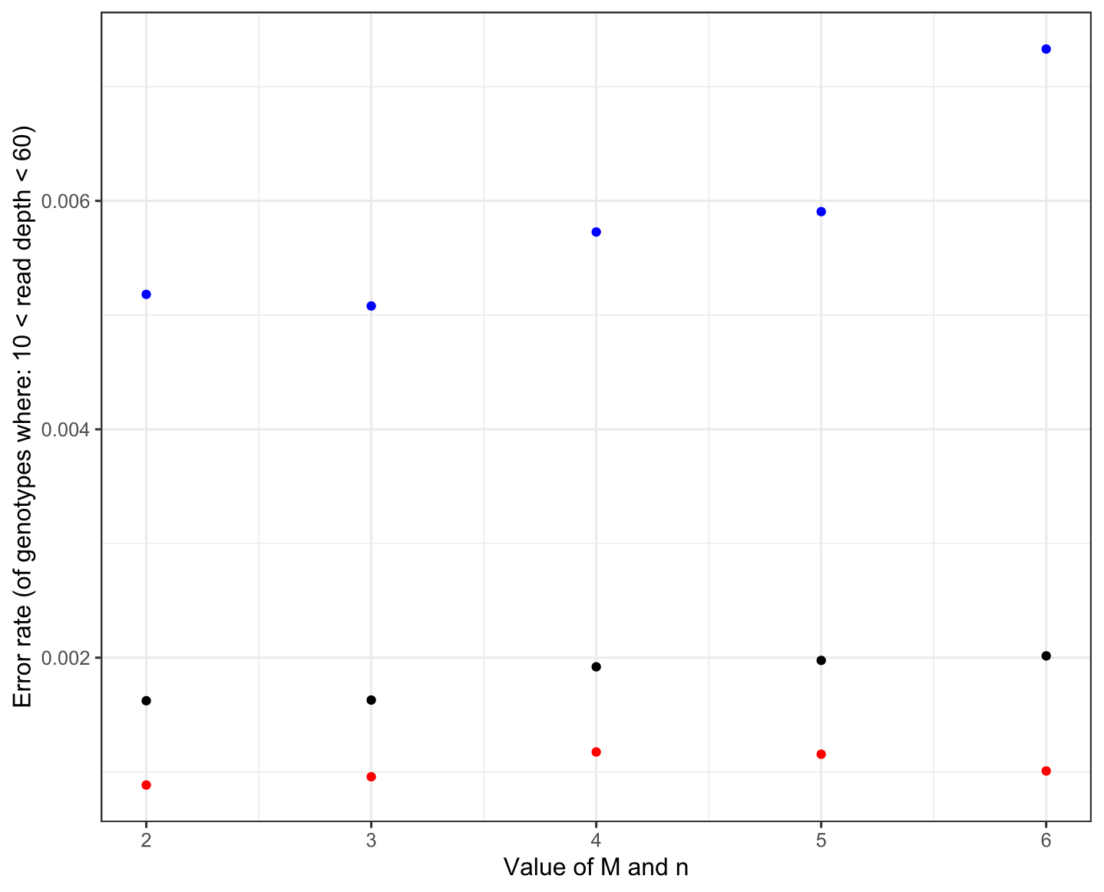

Online Resource 6 Error rates for all sites (black), homozygous sites (red), and heterozygous sites (blue), from duplicated samples in three pairs as calculated by TIGER. The upper plot shows error rates at all read depths, while the lower plot shows error rates at read depths greater than 10 and less than 60. This was done for varying values of the M and n parameters (M = n) in the denovo_map.pl of Stacks. The parameter m was kept at 3 for all runs.

Section 2: SNP filtering and quality control

Online Resources 7–9
This section provides tables that outline the SNP filtering and quality control steps, and their cumulative impacts on the three datasets used in the study.

Online Resource 7 Number of SNPs and individuals for each stage of filtering for Dataset 1.
Quality Control Step | # Individuals | # SNPs | % of initial output # SNPs | % of previous step # SNPs
Initial output from population module of Stacks, biallelic loci only. | 92 | 222776 | 100% | -
Minimum call rate 80% | 92 | 48066 | 22% | 22%
Maximum SNP heterozygosity >60% | 92 | 47448 | 21% | 99%
One SNP per locus | 92 | 34926 | 16% | 74%
Minimum call rate 100% | 92 | 11093 | 5% | 32%
Minimum mean site read depth 10 | 92 | 11083 | 5% | 100%
Maximum mean site read depth 60 | 92 | 8641 | 4% | 78%
Minimum MAC 3 | 92 | 6568 | 3% | 76%
Dataset 1  Removed individuals (contamination, duplicated samples, irrelevant samples). | 80 | 6568 | 3% | 100%
Dataset 1 with first-degree relationship filtering | 68 | 6568 | 3% | 100%

Online Resource 8 Number of sites (including SNPs and invariant sites) and individuals for each stage of filtering for Dataset 2.
Quality Control Step | # Individuals | Total sites | # SNPs | % of initial output # SNPs | % of previous step # SNPs
Initial output from population module of Stacks, biallelic loci only. | 92 | 89713391 | 222776 | 100% | -
Removed individuals (contamination, duplicated samples, irrelevant samples). | 80 | 89713391 | 210469 | 94% | 94%
Minimum call rate 100% | 80 | 3989817 | 15723 | 7% | 7%
Maximum SNP heterozygosity 60% | 80 | 3989817 | 15641 | 7% | 99%
Dataset 2  Removed loci that possessed SNPs with mean read depths below 10 or above 60. | 80 | 3742811 | 12314 | 6% | 79%
Dataset 2 with first-degree relationship filtering | 68 | 3742811 | 11858 | 5% | 96%

Online Resource 9 Number of sites (including SNPs and invariant sites) and individuals for each stage of filtering for Dataset 3.
Quality Control Step | # Individuals | Total sites | # SNPs | % of initial output # SNPs | % of previous step # SNPs
Initial output from population module of Stacks, biallelic loci only. | 92 | 89713391 | 222776 | 100% | -
Removed individuals (contamination, duplicated samples). | 88 | 89713391 | 218850 | 98% | 98%
Minimum call rate 100% | 88 | 3756125 | 14541 | 7% | 7%
Maximum SNP heterozygosity 60% | 88 | 3756125 | 14466 | 6% | 99%
Dataset 3  Removed loci that possessed SNPs with mean read depths below 10 or above 60. | 88 | 3518795 | 11306 | 5% | 78%

Section 3: Population structure and connectivity analyses

Online Resources 10–25
This section provides figures and tables that supplement the methods and results relating to population structure and connectivity, including for K-means clustering, netviewr, AMOVAs, Colony, and genetic neighbourhood radius estimation.
(a)
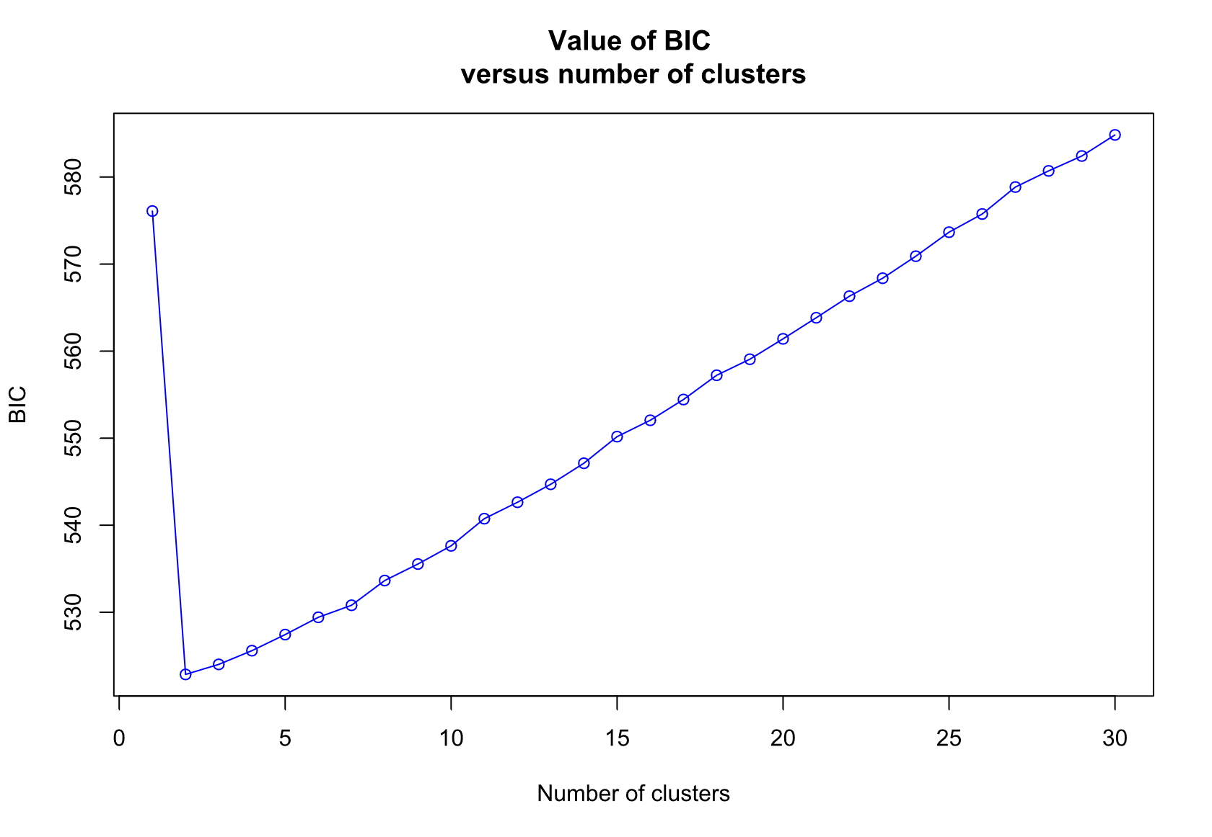
(b)
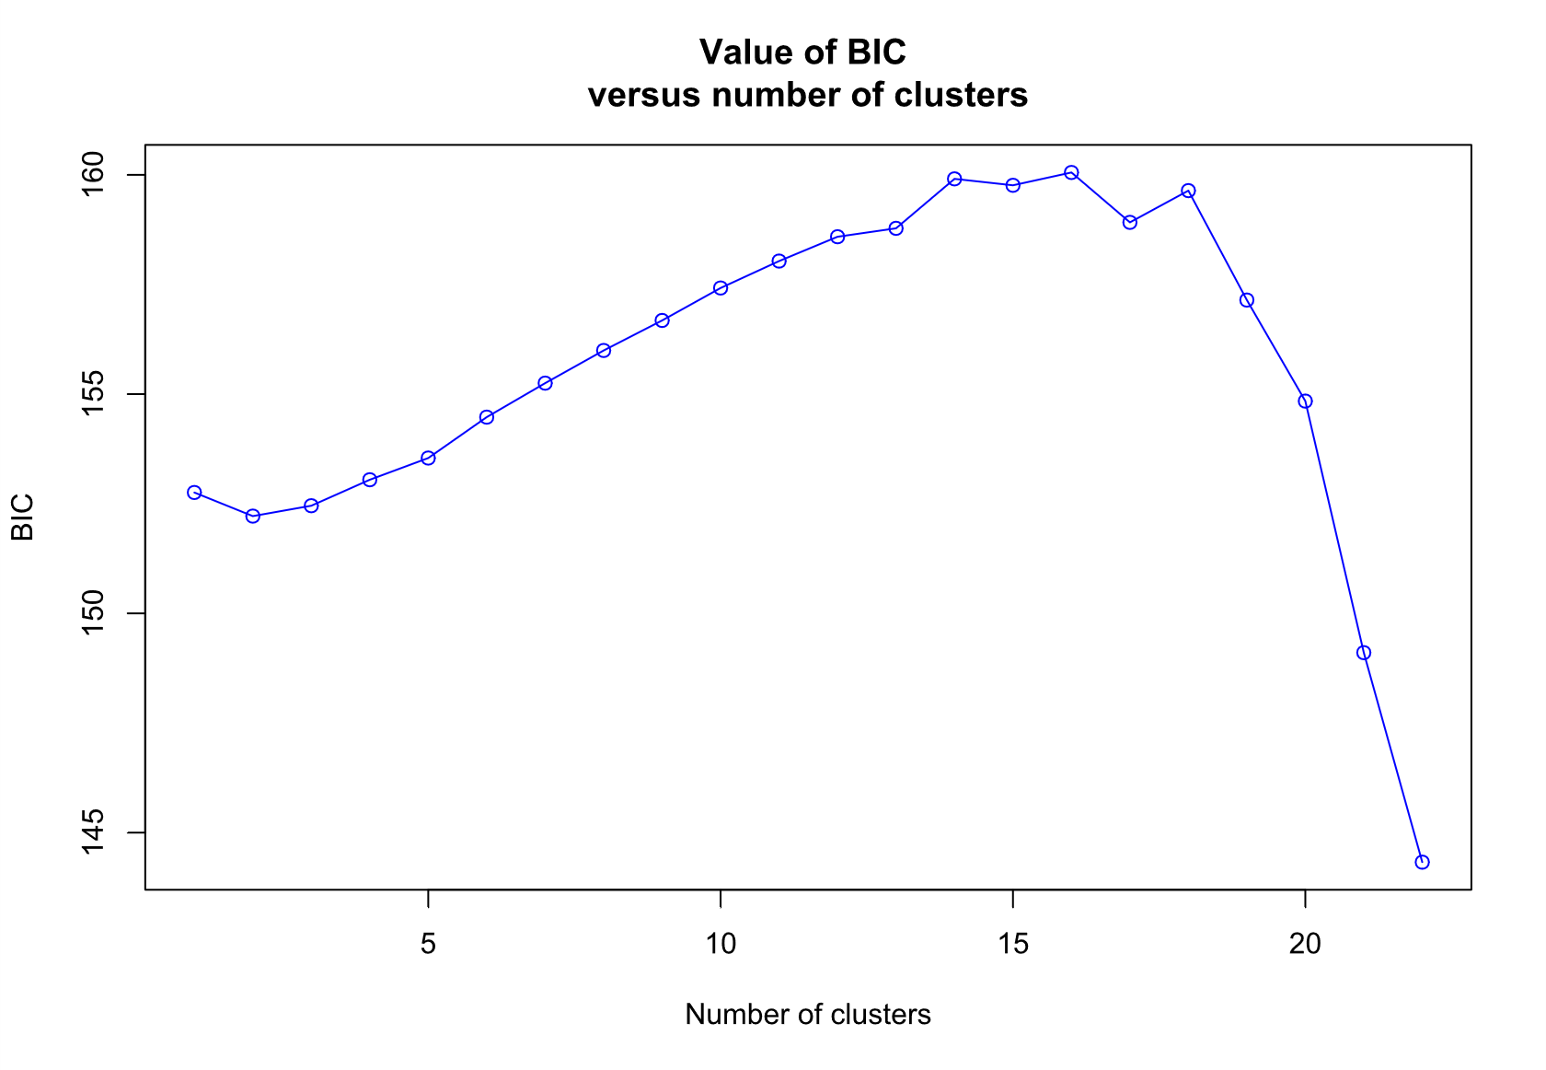
(c)
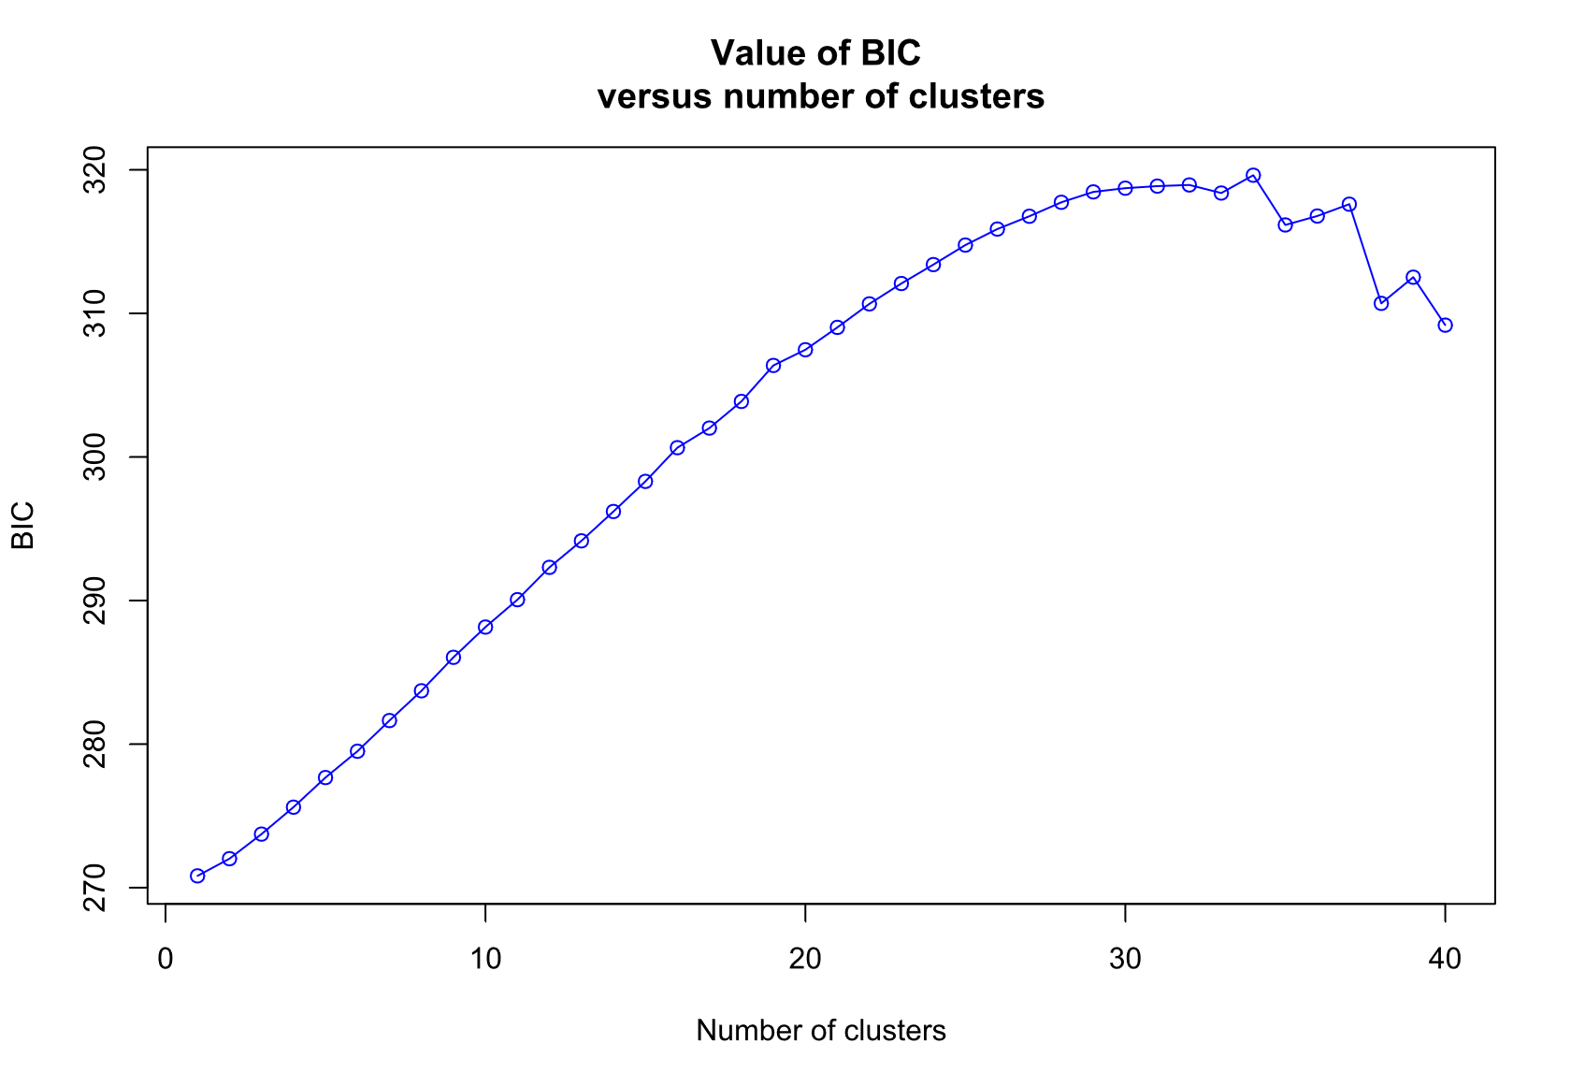

Online Resource 10 Bayesian Information Criterion (BIC) from k-means clustering in (a) Dataset1, (b) Dataset 1 with only Nangur samples, and (c) Dataset 1 with only Oakview samples.
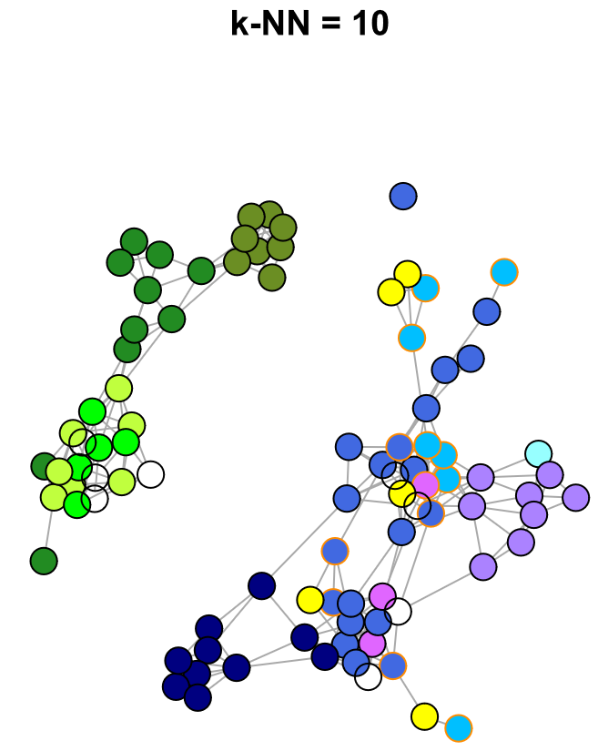

Online Resource 11 Netviewr networks demonstrating population structure and connectivity within Nangura spinosa populations at Nangur and Oakview for Dataset 3, showing also captive-born individuals (yellow circles) and 2006–2007 samples (transparent circles). Individuals have been colour coded by rough geographic sampling area for comparison with Figure 2 in the main text. Wild-born individuals that have been captured and now form part of the captive population are highlighted in orange.

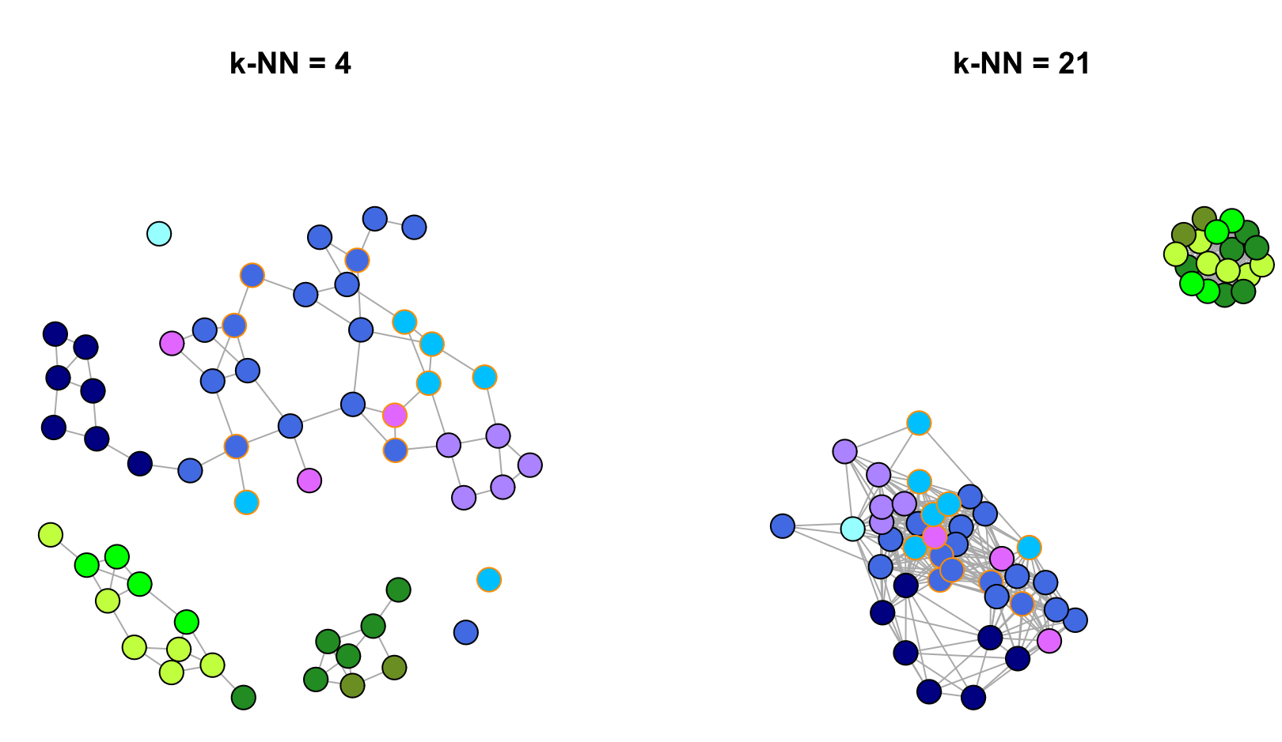

Online Resource 12 Netviewr networks demonstrating population structure and connectivity within Nangura spinosa populations at Nangur and Oakview for Dataset 1 with the first-degree relationship filter applied. Netviewr network plots show within-population structure at fine (k-NN = 4) and coarse (k-NN = 21) scales. Individuals have been colour coded by rough geographic sampling area for comparison with Figure 2 in the main text. Individuals that have been captured and now form part of the captive population are highlighted in orange.

Online Resource 13 AMOVA on Dataset 1, with two ‘populations’ defined

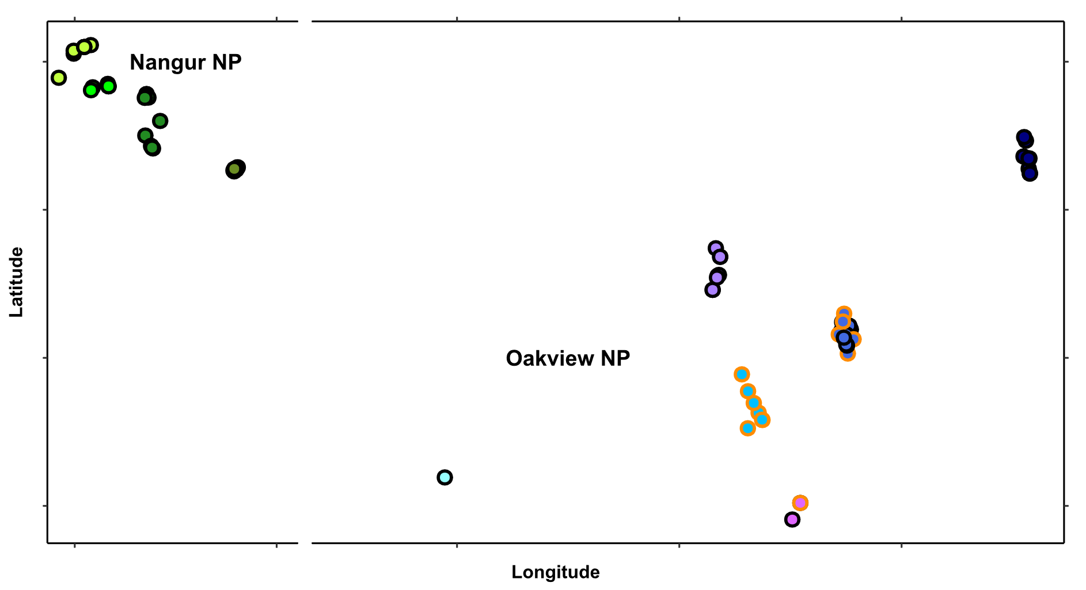
Online Resource 13.1 Map indicating population definitions in red boxes for AMOVA in Online Resource 13. Populations defined as ‘Oakview’ or ‘Nangur’. Captive-born individuals were excluded from the analysis. First-degree relationships were not filtered from this dataset.

Online Resource 13.2 Analysis of Molecular Variation (AMOVA) for the Nangur Spiny Skink (Nangura spinosa). Populations defined as ‘Oakview’ or ‘Nangur’. Captive-born individuals were excluded from the analysis. Analysed using a refined dataset of 6,568 biallelic SNPs. First-degree relationships were not filtered from this dataset. AMOVA performed using the R package poppr, using both the ade4 and pegas method (ade4 method results shown). Variance components are significance tested under 1000 random permutations using the R package ade4. Percentage total variance may not add up to 100% due to rounding.
Variance component | Variance | Percentage total variance | p-value | ϕ-statistic
Between populations | 493.88 | 48% | <0.001 | ϕ_{CT} = 0.4795
Between individuals within populations | 11.97 | 1% | 0.134 | ϕ_{SC} = 0.0223
Within individuals | 524.23 | 51% | <0.001 | ϕ_{ST} = 0.4911

Online Resource 14 AMOVA on Dataset 1, with two ‘populations’ defined, and first-degree relationships filtered
Online Resource 14.1 Map indicating population definitions in red boxes for AMOVA in Online Resource 14. Populations defined as ‘Oakview’ or ‘Nangur’. Captive-born individuals and were excluded from the analysis. First-degree relationships have been filtered.

Online Resource 14.2 Analysis of Molecular Variation (AMOVA) for the Nangur Spiny Skink (Nangura spinosa). Populations defined as ‘Oakview’ or ‘Nangur’. Captive-born individuals were excluded from the analysis. Analysed using a refined dataset of 6,568 biallelic SNPs. First-degree relationships have been filtered. AMOVA performed using the R package poppr, using both the ade4 and pegas method (ade4 method results shown). Variance components are significance tested under 1000 random permutations using the R package ade4. Percentage total variance may not add up to 100% due to rounding.
Variance component | Variance | Percentage total variance | p-value | ϕ-statistic
Between populations | 490.07 | 47% | <0.001 | ϕ_{CT} = 0.4740
Between individuals within populations | 11.19 | 1% | 0.190 | ϕ_{SC} = 0.0206
Within individuals | 532.66 | 52% | <0.001 | ϕ_{ST} = 0.4848

Online Resource 15 AMOVA on Dataset 1, with only Nangur samples, and two ‘populations’ defined.

“East”
“West”

Online Resource 15.1 Map indicating population definitions in red boxes for AMOVA in Online Resource 15. Populations defined as “Nangur East” and ‘Nangur West”. Oakview was excluded from the analysis. First-degree relationships have not been filtered.

Online Resource 15.2 Analysis of Molecular Variation (AMOVA) for the Nangur population of the Nangur Spiny Skink (Nangura spinosa). Populations defined as “Nangur East” and ‘Nangur West”. Oakview was excluded from the analysis. Analysed using a refined dataset of 6,568 biallelic SNPs. First-degree relationships were not filtered from this dataset. AMOVA performed using the R package poppr, using both the ade4 and pegas method (ade4 method results shown). Variance components are significance tested under 1000 random permutations using the R package ade4. Percentage total variance may not add up to 100% due to rounding.
Variance component | Variance | Percentage total variance | p-value | ϕ-statistic
Between populations | 34.71 | 7% | <0.001 | ϕ_{CT} = 0.0410
Between individuals within populations | -15.20 | -3% | 0.742 | ϕ_{SC} = -0.0344
Within individuals | 456.54 | 96% | 0.441 | ϕ_{ST} = 0.0729

Online Resource 16 AMOVA on Dataset 1, with only Nangur samples, two ‘populations’ defined, and first-degree relationships filtered
“East”
“West”

Online Resource 16.1 Map indicating population definitions in red boxes for AMOVA in Online Resource 16. Populations defined as “Nangur East” and ‘Nangur West”. Oakview was excluded from the analysis. First-degree relationships have been filtered.

Online Resource 16.2 Analysis of Molecular Variation (AMOVA) for the Nangur population of the Nangur Spiny Skink (Nangura spinosa). Populations defined as “Nangur East” and ‘Nangur West”. Oakview was excluded from the analysis. Analysed using a refined dataset of 6,568 biallelic SNPs. First-degree relationships were filtered from this dataset. AMOVA performed using the R package poppr, using both the ade4 and pegas method (ade4 method results shown). Variance components are significance tested under 1000 random permutations using the R package ade4. Percentage total variance may not add up to 100% due to rounding.
Variance component | Variance | Percentage total variance | p-value | ϕ-statistic
Between populations | 26.08 | 6% | <0.001 | ϕ_{CT} = 0.0553
Between individuals within populations | -16.65 | -4% | 0.740 | ϕ_{SC} = -0.0373
Within individuals | 462.50 | 98% | 0.538 | ϕ_{ST} = 0.0199

Online Resource 17 AMOVA on Dataset 1, with only Nangur samples, and two ‘populations’ defined.

An equivalent AMOVA with first-degree relationships filtered was not possible, because (as a result of the filter) only two individuals remained in the Far-East ‘population’.

Online Resource 17.1 Map indicating population definitions in red boxes for AMOVA in Online Resource 17. Populations defined as “Nangur Far-East” and ‘Nangur West”. Oakview was excluded from the analysis. First-degree relationships have not been filtered.
“Far-East”
“West”

Online Resource 17.2 Analysis of Molecular Variation (AMOVA) for the Nangur population of the Nangur Spiny Skink (Nangura spinosa). Populations defined as “Nangur Far-East” and ‘Nangur West”. Oakview was excluded from the analysis. Analysed using a refined dataset of 6,568 biallelic SNPs. First-degree relationships were not filtered from this dataset. AMOVA performed using the R package poppr, using both the ade4 and pegas method (ade4 method results shown). Variance components are significance tested under 1000 random permutations using the R package ade4. Percentage total variance may not add up to 100% due to rounding.
Variance component | Variance | Percentage total variance | p-value | ϕ-statistic
Between populations | 51.49 | 10% | <0.001 | ϕ_{CT} = 0.1049
Between individuals within populations | -17.32 | -4% | 0.804 | ϕ_{SC} = -0.0394
Within individuals | 456.54 | 93% | 0.427 | ϕ_{ST} = 0.0696

Online Resource 18 AMOVA on Dataset 1, with only Nangur samples, and three ‘populations’ defined.

An equivalent AMOVA with first-degree relationships filtered was not possible, because (as a result of the filter) only two individuals remained in the Far-East ‘population’.
“Far-East”
“West”
“Mid-East”

Online Resource 18.1 Map indicating population definitions in red boxes for AMOVA in Online Resource 21. Populations defined as “Nangur Far-East”, ‘Nangur Mid-East”, and ‘Nangur West”. Oakview was excluded from the analysis. First-degree relationships have not been filtered.

Online Resource 18.2 Analysis of Molecular Variation (AMOVA) for the Nangur population of the Nangur Spiny Skink (Nangura spinosa). Populations defined as “Nangur Far-East”, ‘Nangur Mid-East”, and ‘Nangur West”. Oakview was excluded from the analysis. Analysed using a refined dataset of 6,568 biallelic SNPs. First-degree relationships were not filtered from this dataset. AMOVA performed using the R package poppr, using both the ade4 and pegas method (ade4 method results shown). Variance components are significance tested under 1000 random permutations using the R package ade4. Percentage total variance may not add up to 100% due to rounding.
Variance component | Variance | Percentage total variance | p-value | ϕ-statistic
Between populations | 49.43 | 10% | <0.001 | ϕ_{CT} = 0.1039
Between individuals within populations | -30.11 | -6% | 0.804 | ϕ_{SC} = -0.0706
Within individuals | 475.85 | 96% | 0.427 | ϕ_{ST} = 0.0406

Online Resource 19 AMOVA on Dataset 1, with only Oakview samples, and two ‘populations’ defined.

“West”
“East”
Online Resource 19.1 Map indicating population definitions in red boxes for AMOVA in Online Resource 19. Populations defined as ‘Oakview East’ and ‘Oakview West’. Nangur, captive-born individuals, and the western-most Oakview individual were excluded from the analysis. First-degree relationships were not filtered from this dataset.

Online Resource 19.2 Analysis of Molecular Variation (AMOVA) for the Oakview population of the Nangur Spiny Skink (Nangura spinosa). Populations defined as ‘Oakview East’ and ‘Oakview West’. Nangur, captive-born individuals, and the western-most Oakview individual were excluded from the analysis. Analysed using a refined dataset of 6,568 biallelic SNPs. First-degree relationships were not filtered from this dataset. AMOVA performed using the R package poppr, using both the ade4 and pegas method (ade4 method results shown). Variance components are significance tested under 1000 random permutations using the R package ade4. Percentage total variance may not add up to 100% due to rounding.
Variance component | Variance | Percentage total variance | p-value | ϕ-statistic
Between populations | 30.06 | 5% | <0.001 | ϕ_{CT} = 0.0500
Between individuals within populations | 6.04 | 1% | 0.344 | ϕ_{SC} = 0.0106
Within individuals | 564.92 | 94% | 0.154 | ϕ_{ST} = 0.0601

Online Resource 20 AMOVA on Dataset 1, with only Oakview samples, two ‘populations’ defined, and first-degree relationships filtered.

“West”
“East”
Online Resource 20.1 Map indicating population definitions in red boxes for AMOVA in Online Resource 15. Populations defined as ‘Oakview East’ and ‘Oakview West’. Nangur, captive-born individuals, and the western-most Oakview individual were excluded from the analysis. First-degree relationships have been filtered.

Online Resource 20.2 Analysis of Molecular Variation (AMOVA) for the Oakview population of the Nangur Spiny Skink (Nangura spinosa). Populations defined as ‘Oakview East’ and ‘Oakview West’. Nangur, captive-born individuals, and the western-most Oakview individual were excluded from the analysis. Analysed using a refined dataset of 6,568 biallelic SNPs. First-degree relationships have been filtered. AMOVA performed using the R package poppr, using both the ade4 and pegas method (ade4 method results shown). Variance components are significance tested under 1000 random permutations using the R package ade4. Percentage total variance may not add up to 100% due to rounding.
Variance component | Variance | Percentage total variance | p-value | ϕ-statistic
Between populations | 21.50 | 4% | <0.001 | ϕ_{CT} = 0.0361
Between individuals within populations | 9.87 | 2% | 0.264 | ϕ_{SC} = 0.0526
Within individuals | 564.65 | 95% | 0.141 | ϕ_{ST} = 0.0172

Online Resource 21 AMOVA on Dataset 1, with only Oakview samples, and three ‘populations’ defined.

“Central”
“East”
“North”
Online Resource 21.1 Map indicating population definitions in red boxes for AMOVA in Online Resource 21. Populations defined as ‘Oakview Central’, ‘Oakview North’, and ‘Oakview East’. Nangur, captive-born individuals, and the western-most Oakview individual were excluded from the analysis. First-degree relationships have not been filtered.

Online Resource 21.2 Analysis of Molecular Variation (AMOVA) for the Oakview population of the Nangur Spiny Skink (Nangura spinosa). Populations defined as ‘Oakview Central’, ‘Oakview North’, and ‘Oakview East’. Nangur, captive-born individuals, and the western-most Oakview individual were excluded from the analysis. Analysed using a refined dataset of 6,568 biallelic SNPs. First-degree relationships were not filtered from this dataset. AMOVA performed using the R package poppr, using both the ade4 and pegas method (ade4 method results shown). Variance components are significance tested under 1000 random permutations using the R package ade4. Percentage total variance may not add up to 100% due to rounding.
Variance component | Variance | Percentage total variance | p-value | ϕ-statistic
Between populations | 30.59 | 5% | <0.001 | ϕ_{CT} = 0.0514
Between individuals within populations | -0.76 | 0% | 0.542 | ϕ_{SC} = -0.0013
Within individuals | 564.92 | 95% | 0.147 | ϕ_{ST} = 0.0502

Online Resource 22 AMOVA on Dataset 1, with only Oakview samples, three ‘populations’ defined, and first-degree relationships filtered
“East”
“Central”
“North”
Online Resource 22.1 Map indicating population definitions in red boxes for AMOVA in Online Resource 22. Populations defined as ‘Oakview Central’, ‘Oakview North’, and ‘Oakview East’. Nangur, captive-born individuals, and the western-most Oakview individual were excluded from the analysis. First-degree relationships have been filtered.

Online Resource 22.2 Analysis of Molecular Variation (AMOVA) for the Oakview population of the Nangur Spiny Skink (Nangura spinosa). Populations defined as ‘Oakview Central’, ‘Oakview North’, and ‘Oakview East’. Nangur, captive-born individuals, and the western-most Oakview individual were excluded from the analysis. Analysed using a refined dataset of 6,568 biallelic SNPs. First-degree relationships were filtered from this dataset. AMOVA performed using the R package poppr, using both the ade4 and pegas method (ade4 method results shown). Variance components are significance tested under 1000 random permutations using the R package ade4. Percentage total variance may not add up to 100% due to rounding.
Variance component | Variance | Percentage total variance | p-value | ϕ-statistic
Between populations | 21.50 | 2% | <0.001 | 0.0361
Between individuals within populations | 9.87 | 4% | 0.289 | 0.0172
Within individuals | 564.65 | 95% | 0.159 | 0.0526

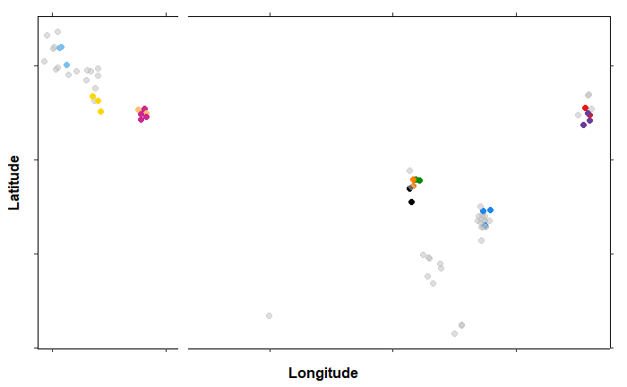
Online Resource 23 Mapped first-degree families of sampled individuals. Individuals colour-coded to reflect membership to a first-degree family (i.e., groups of individuals that were connected directly or indirectly via first-degree relationships, as inferred using Colony version 2.0.7.1). Transparent grey individuals do not belong to any identified second-degree family of sampled individuals. Compare to Figure 5a in the main text.

(a)

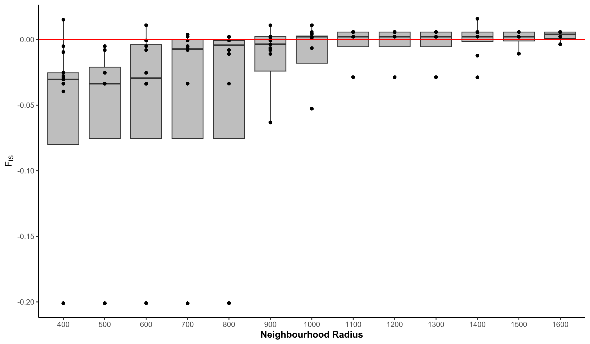
(b)

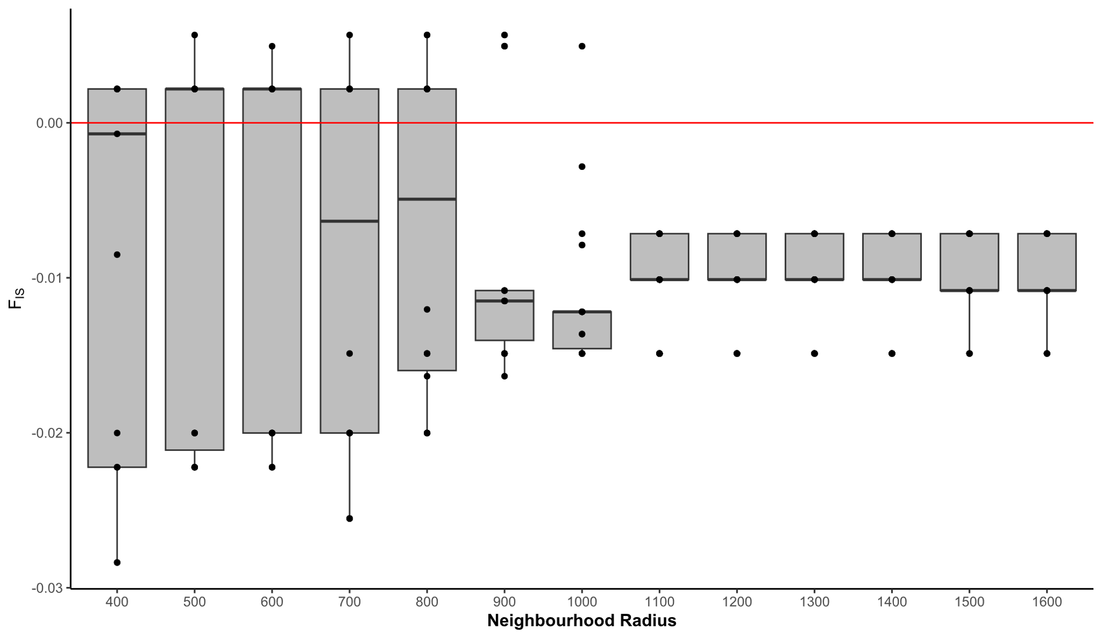

Online Resource 24 The radius of a genetic neighbourhood in the Nangur population is estimated to be (a) 1000 m using Dataset 1, or (b) 400m with the first-degree relationship filter applied. To estimate this, a neighbourhood of each radius indicated by the x-axis was defined around each individual in the population, and F_{IS} was calculated for the individuals in that neighbourhood. The best estimate for the radius of the genetic neighbourhood is the radius at which the F_{IS} distribution is closest to centring on zero. The distribution of F_{IS} values for each radius is visualised using a boxplot, showing the median and inter-quartile range.

(a)

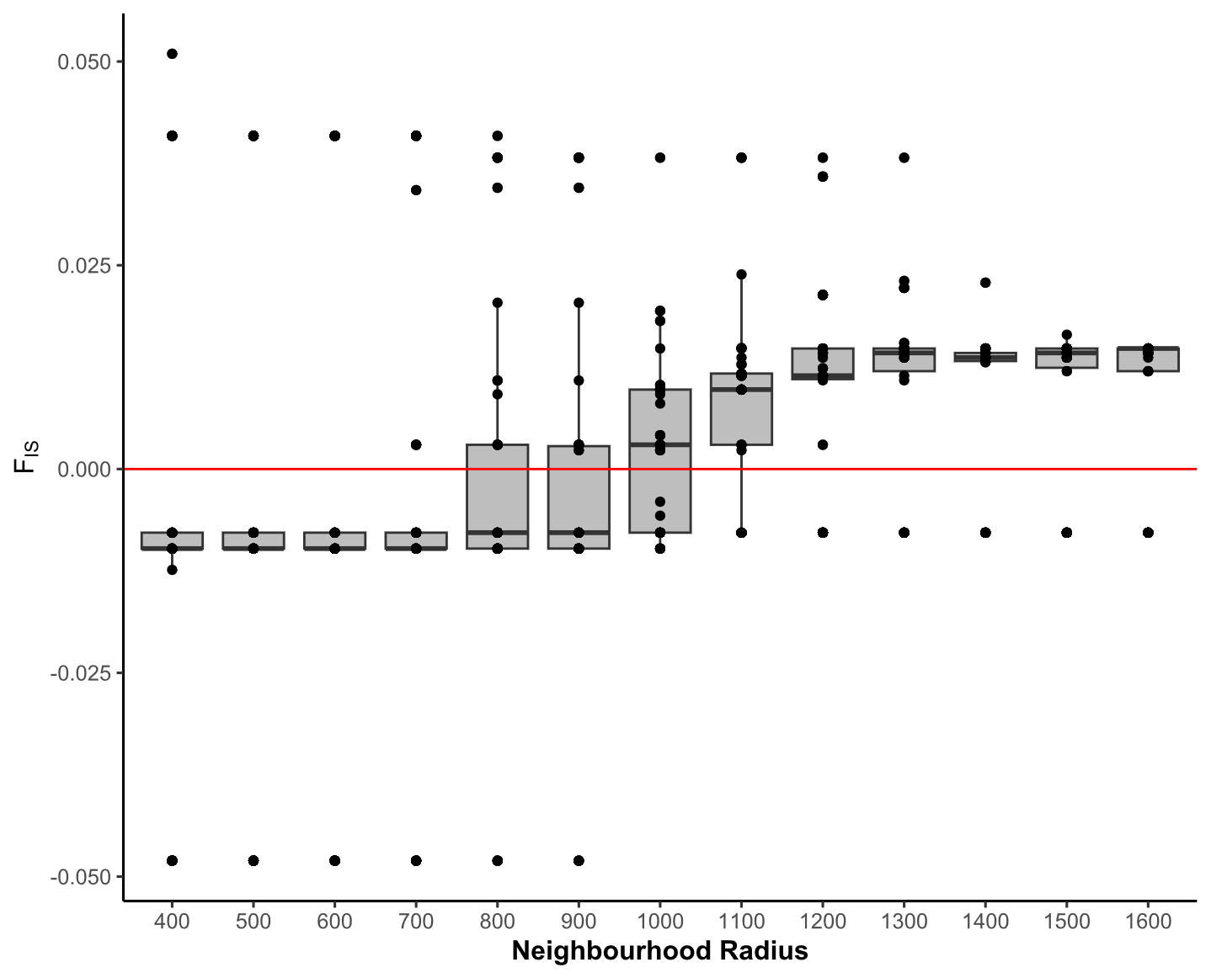
(b)

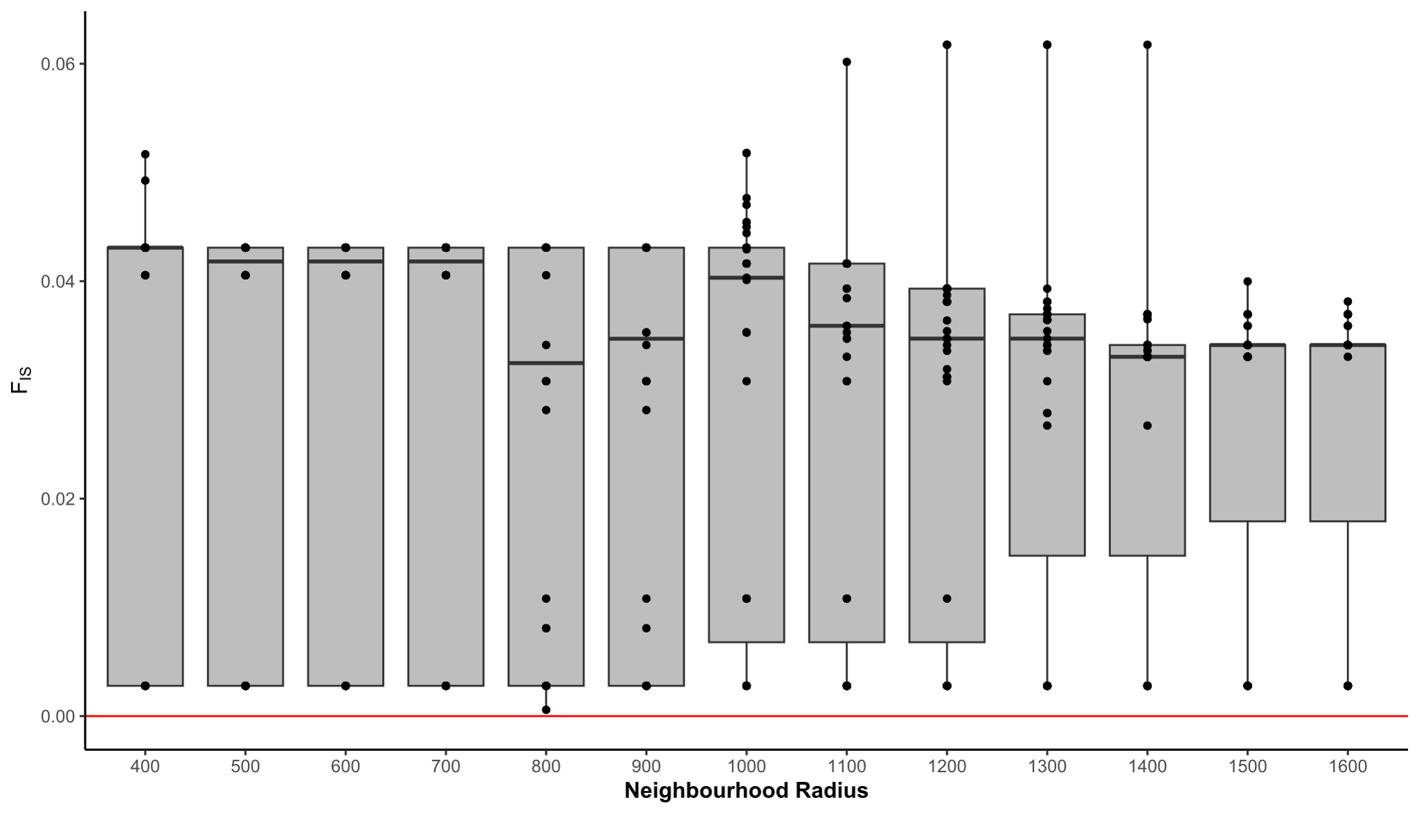
Online Resource 25 The radius of a genetic neighbourhood in the Oakview population is estimated to be (a) 1000 m using Dataset 1, but (b) was not calculable with the first-degree relationship filter applied. To estimate this, a neighbourhood of each radius indicated by the x-axis was defined around each individual in the population, and F_{IS} was calculated for the individuals in that neighbourhood. The best estimate for the radius of the genetic neighbourhood is the radius at which the F_{IS} distribution is closest to centring on zero. The distribution of F_{IS} values for each radius is visualised using a boxplot, showing the median and inter-quartile range.

Section 4: Genetic health

Online Resources 26–31
This section provides figures and tables that supplement the methods and results relating to genetic health, including genetic diversity metrics and effective population size estimation.
(a) 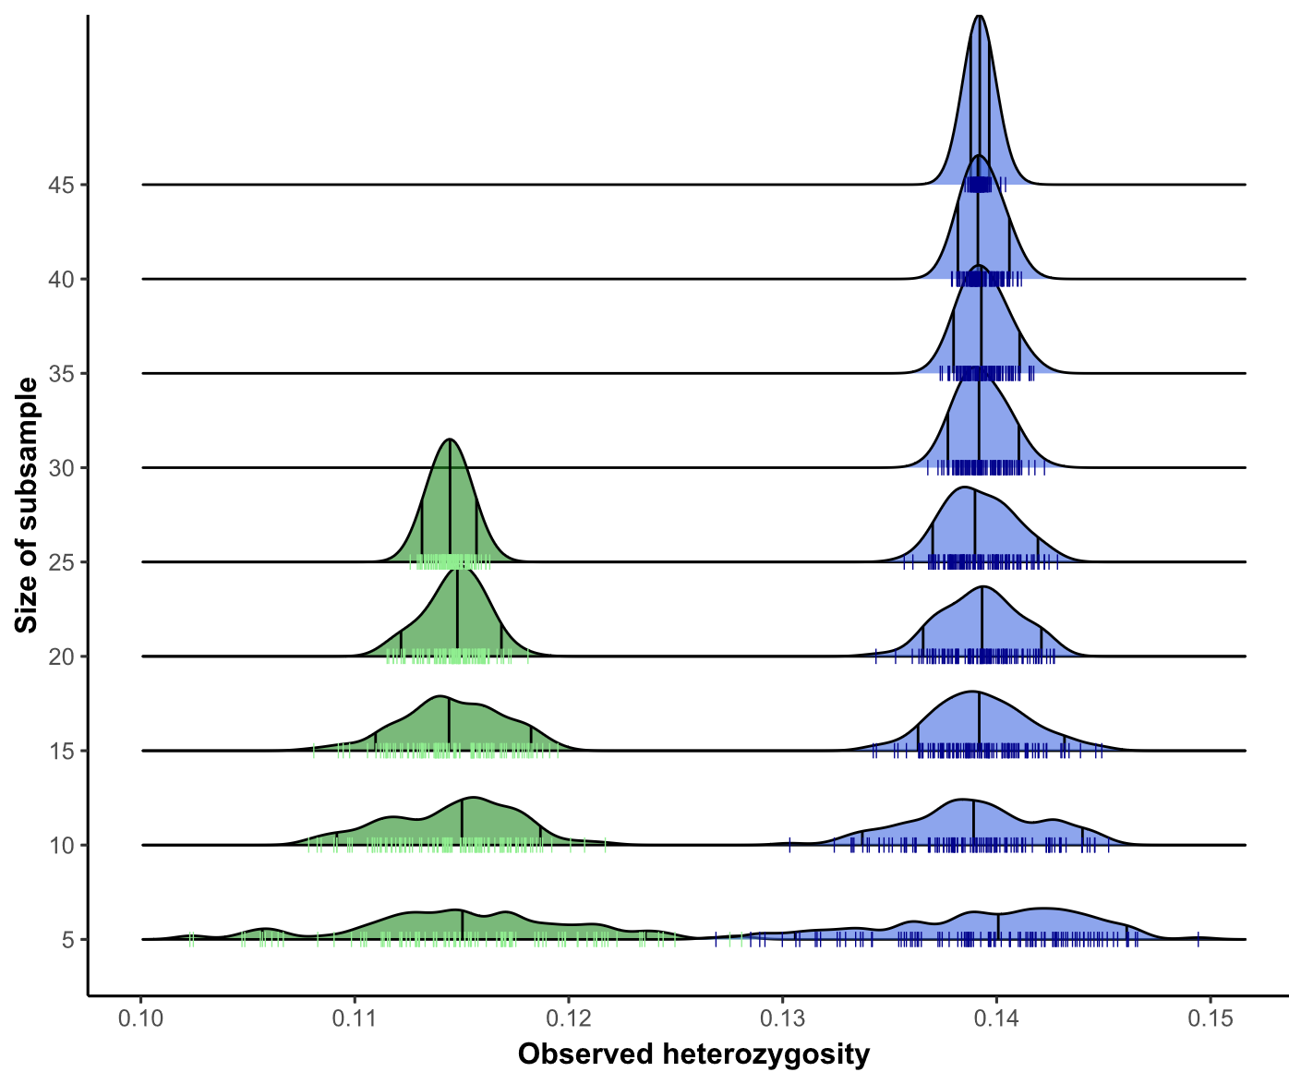 | (b) 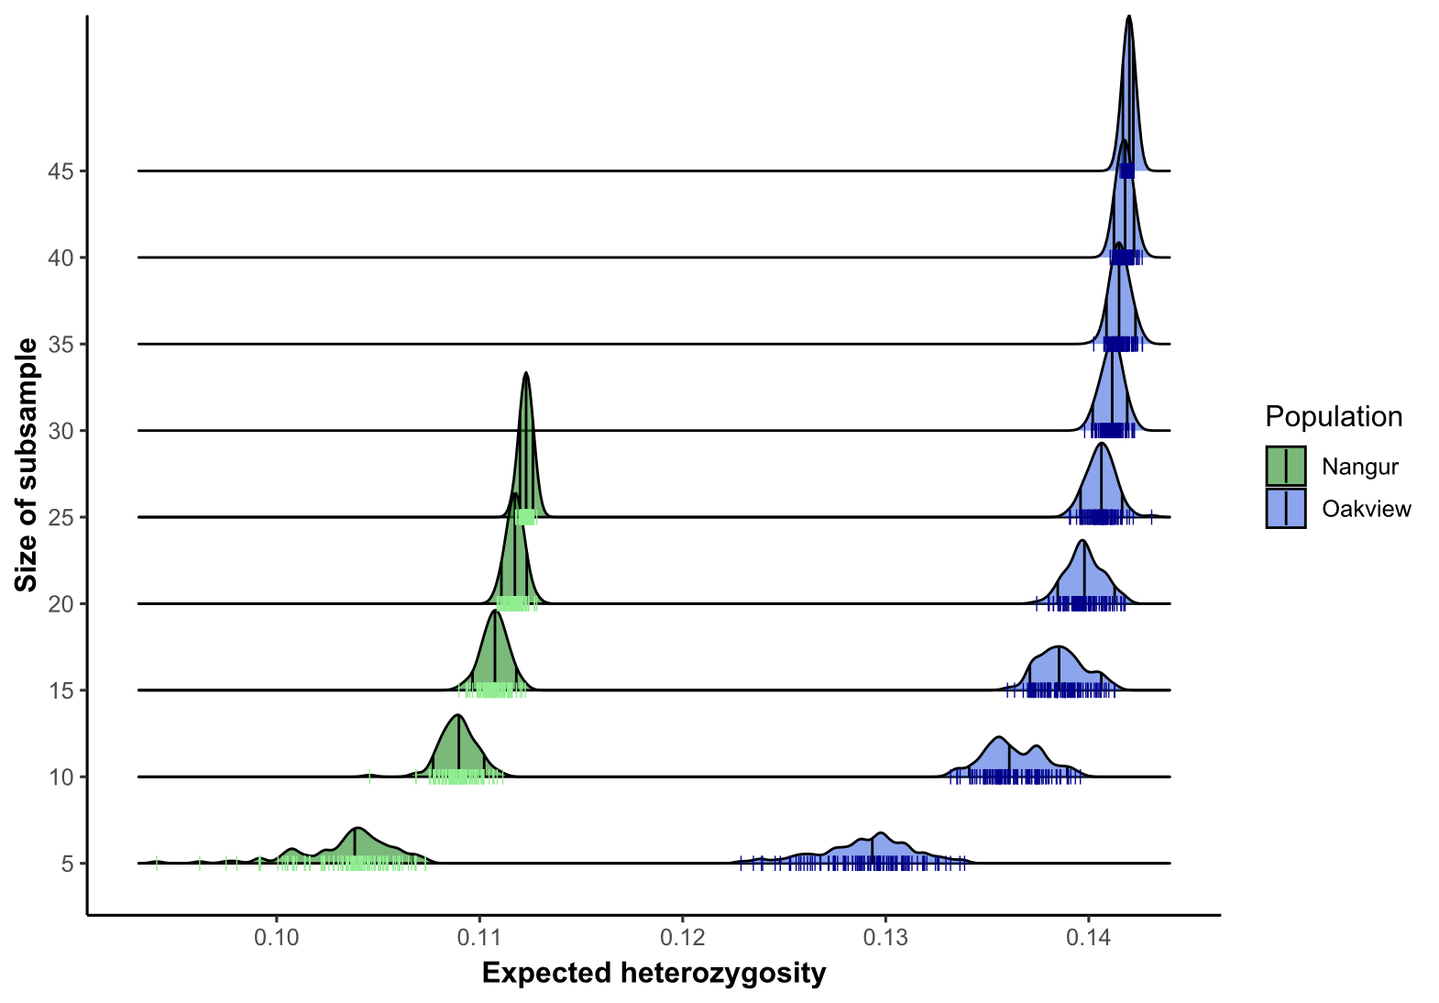
(c) 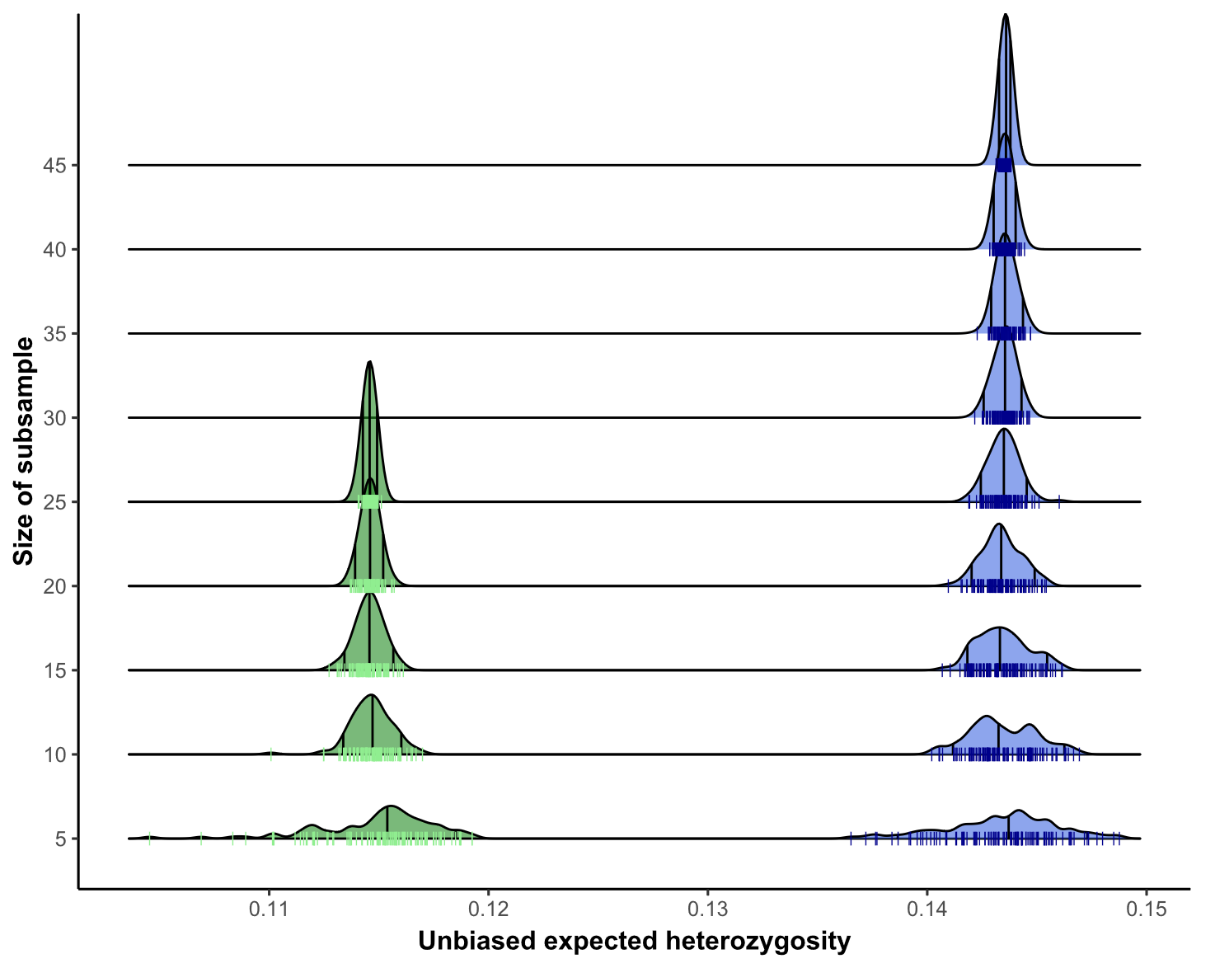 | (d)  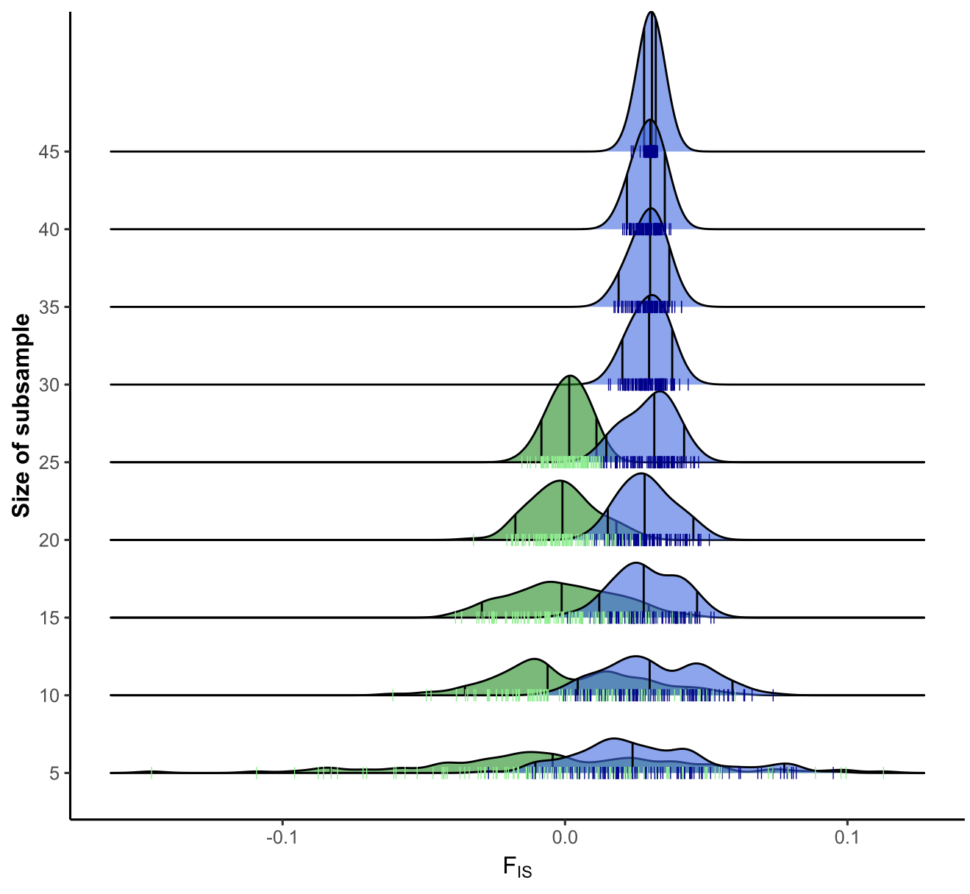
Online Resource 26 The effect of sample size on heterozygosity estimates for Nangur (green, always the distribution to the left) and Oakview (blue, always the distribution to the right). Distributions were generated by randomly subsampling each population 100 times without replacement, and estimating each measure of heterozygosity for the subsample. The size of the subsamples is on the y-axis. Shown are distributions for (a) observed heterozygosity, (b) expected heterozygosity, (c) unbiased expected heterozygosity, and (d) F_{IS}. Genetic diversity metrics estimated using Dataset 2, without the first-degree relationship filter applied. Final estimates for full sample sizes are shown in Table 1 in the main text.

(a) 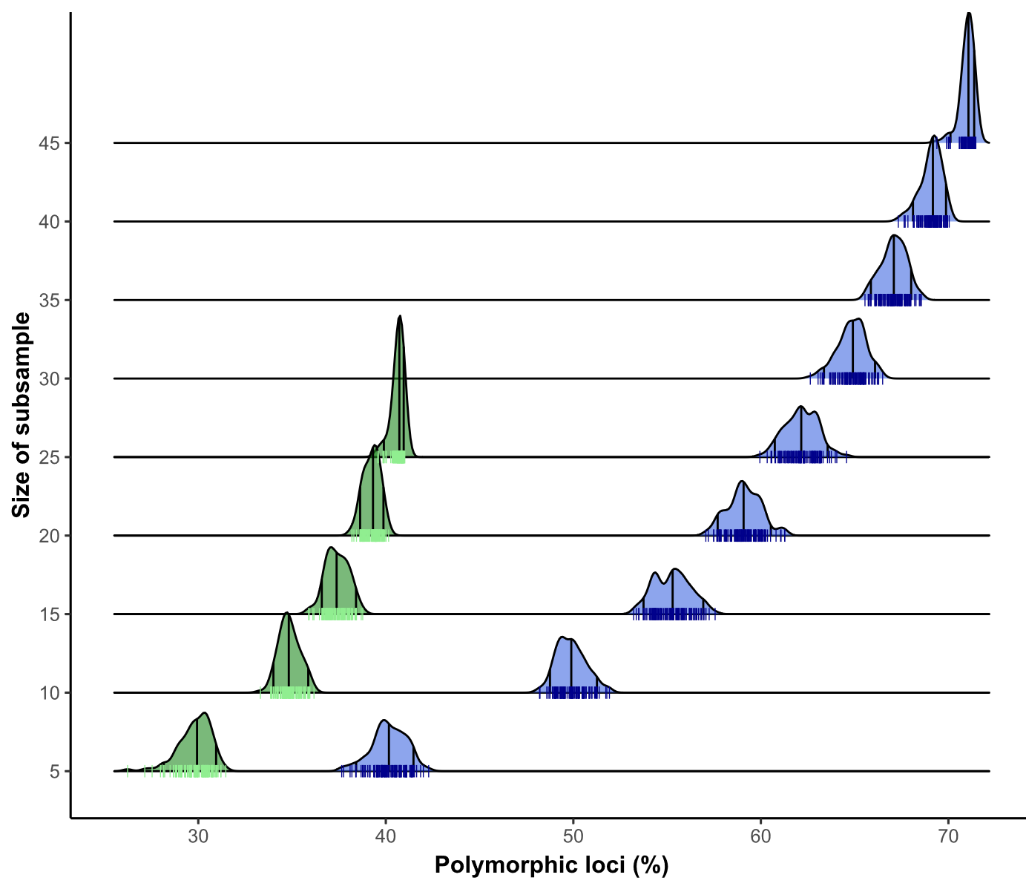 | (b)  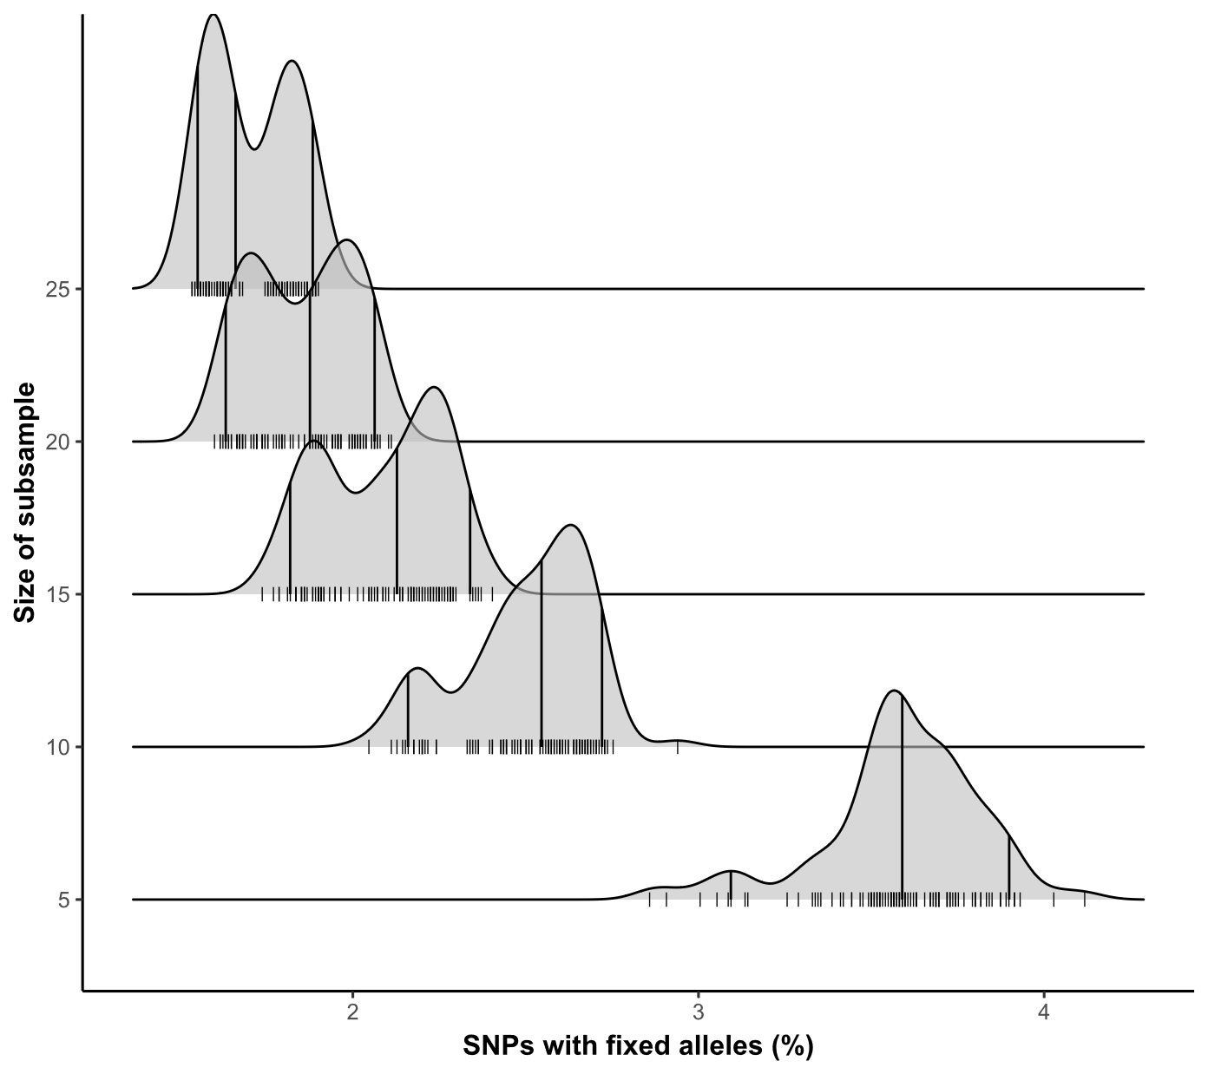
(c) 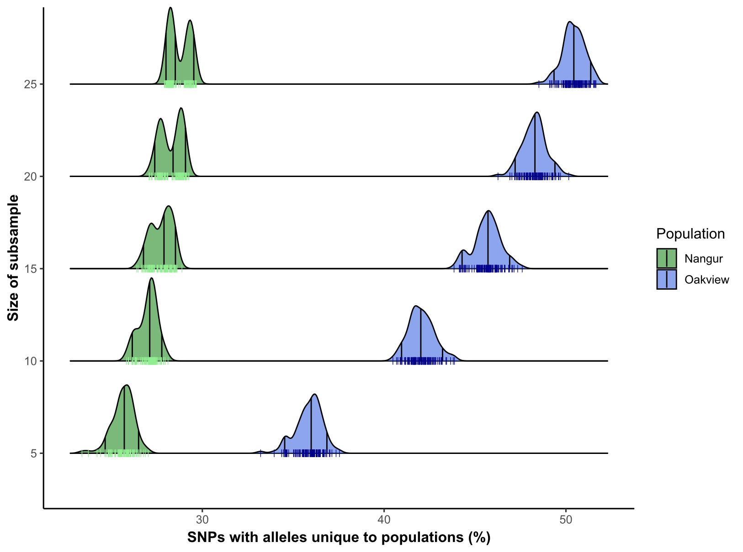

Online Resource 27 The effect of sample size on genetic diversity metrics for Nangur (green, always the distribution to the left) and Oakview (blue, always the distribution to the right). Distributions were generated by randomly subsampling each population 100 times without replacement, and estimating each measure of genetic diversity for the subsample. The vertical black lines in the distribution represent the 5th percentile, median, and 95th percentile of the data, while the coloured dashes along each x-axis represent the estimate for each random subsample. The size of the subsamples is on the y-axis. Shown are distributions for (a) percentage of SNPs that are polymorphic in each population, (b) percentage of SNPs with fixed alleles between populations, and (c) percentage of SNPs with alleles unique to only one population (i.e., private alleles). Genetic diversity metrics estimated using Dataset 2, without the first-degree relationship filter applied. Final estimates for full sample sizes are shown in Table 1 in the main text.

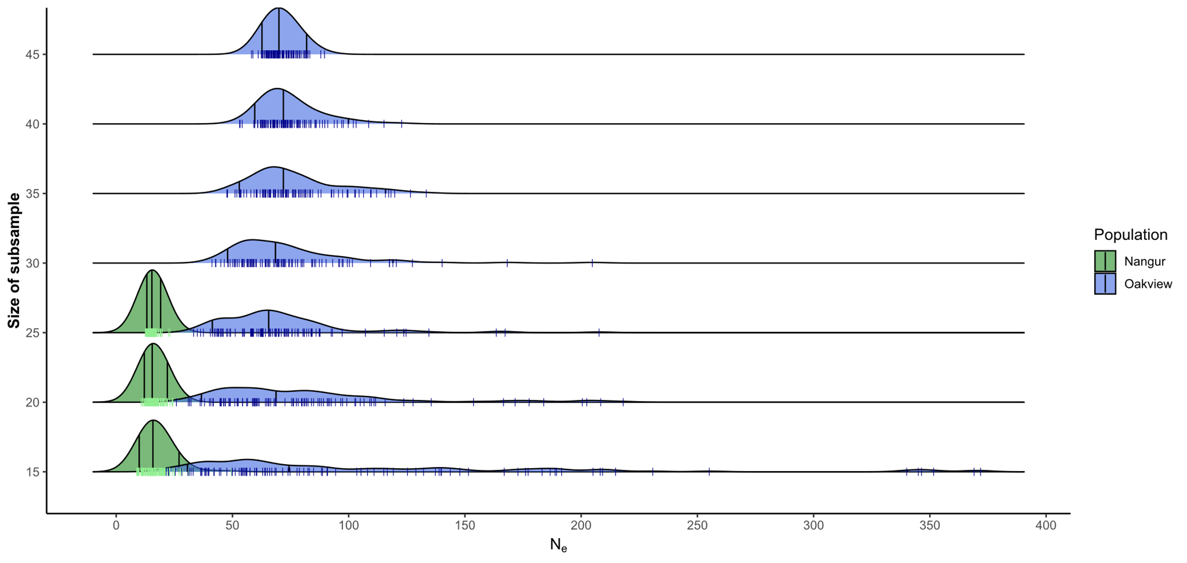
Online Resource 28 The effect of sample size on effective population size (N_{e}) estimates for Nangur (green, always the distribution to the left) and Oakview (blue, always the distribution to the right). The median N_{e} remains consistent down to a subsample size of 15, but the variance in the N_{e} estimates becomes much larger, particularly in the larger Oakview population. Distributions were generated by randomly subsampling each population 100 times without replacement, and estimating effective population size for the subsample. The vertical black lines in the distribution represent the 5th percentile, median, and 95th percentile of the data, while the coloured dashes along each x-axis represent the estimate for each random subsample. The size of the subsamples is on the y-axis. Estimates at subsamples below 15 are frequently infinite in value. Effective population size estimated using Dataset 1, with a minor allele frequency lower threshold of 0.05, and without the first-degree relationship filter applied. Final estimates for full sample sizes are shown in Figure 6 in the main text.

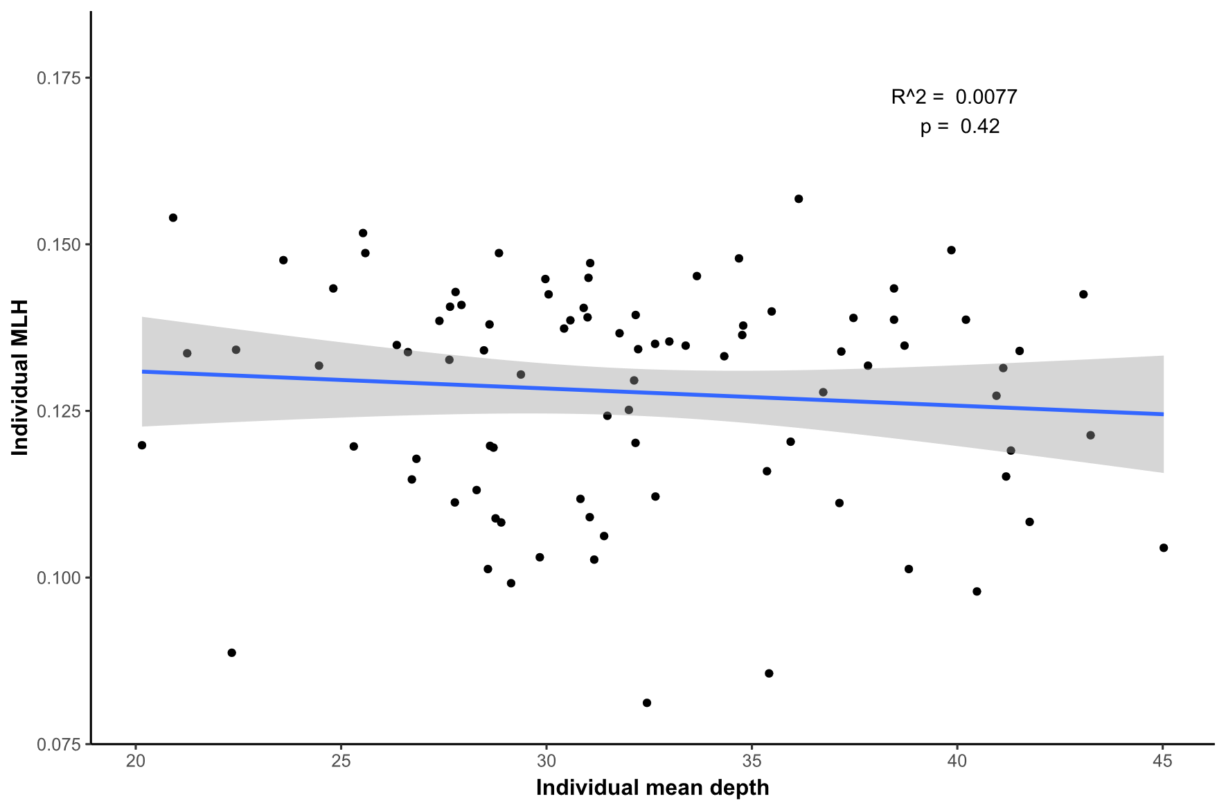
Online Resource 29 There is no relationship between individual mean read depth of samples on individual multiple-locus heterozygosity (MLH) in Dataset 3. Of the variation in individual MLH, 0.7% was explained my individual mean read depth (p = 0.42).

Online Resource 30 Metrics of genetic diversity and inbreeding from the Genetic Health Assessment for Nangura spinosa calculated after the application of the first-degree relationship filter using Dataset 2: a refined dataset of 11,858 biallelic SNPs from a total of 3,742,811 sites (used for genome-wide metrics).
Metricª | Nangur | Oakview^{b} | Captive Population^{b}
Sample size | 18 | 40 | 12
SNP H_{obs} | 0.120 (0.188) | 0.145 (0.170) | 0.139 (0.190)
Genome-wide H_{obs} | 0.000381 (0.0125) | 0.000458 (0.0125) | 0.000441 (0.0129)
SNP H_{exp} | 0.116 (0.173) | 0.147 (0.168) | 0.138 (0.171)
Genome-wide H_{exp} | 0.000367 (0.0117) | 0.000466 (0.0126) | 0.000438 (0.0124)
F_{IS} | -0.0110 | 0.0303 | 0.0346
MLH | Q₁: 0.112, Q₃: 0.127 | Q₁: 0.140, Q₃: 0.150 | Q₁: 0.140, Q3: 0.146
Individual F | Q₁: 0.287, Q₃: 0.191 | Q₁: 0.108, Q₃: 0.044 | Q₁: 0.108, Q₃: 0.070
%Poly | 40% | 72% | 52%
A_{unique} | 28% | 60%
A_{fixed} | 2%
ªShown are: observed heterozygosity, H_{obs}; expected heterozygosity, H_{exp}; population inbreeding (i.e., non-random mating) coefficient, F_{IS}; the first (Q1) and third (Q3) quartiles of individual multi-locus heterozygosity, MLH; Q1 and Q3 of individual inbreeding, F; percentage of SNPs that are polymorphic, %Poly; percentage of SNPs that have a population-unique allele, A_{unique}; percentage of SNPs that have fixed differences between Oakview and Nangur, A_{fixed}. Standard deviations shown in brackets where appropriate. Standard deviations shown in brackets where appropriate. ^{b}Oakview includes 12 individuals who are also included in the captive population.

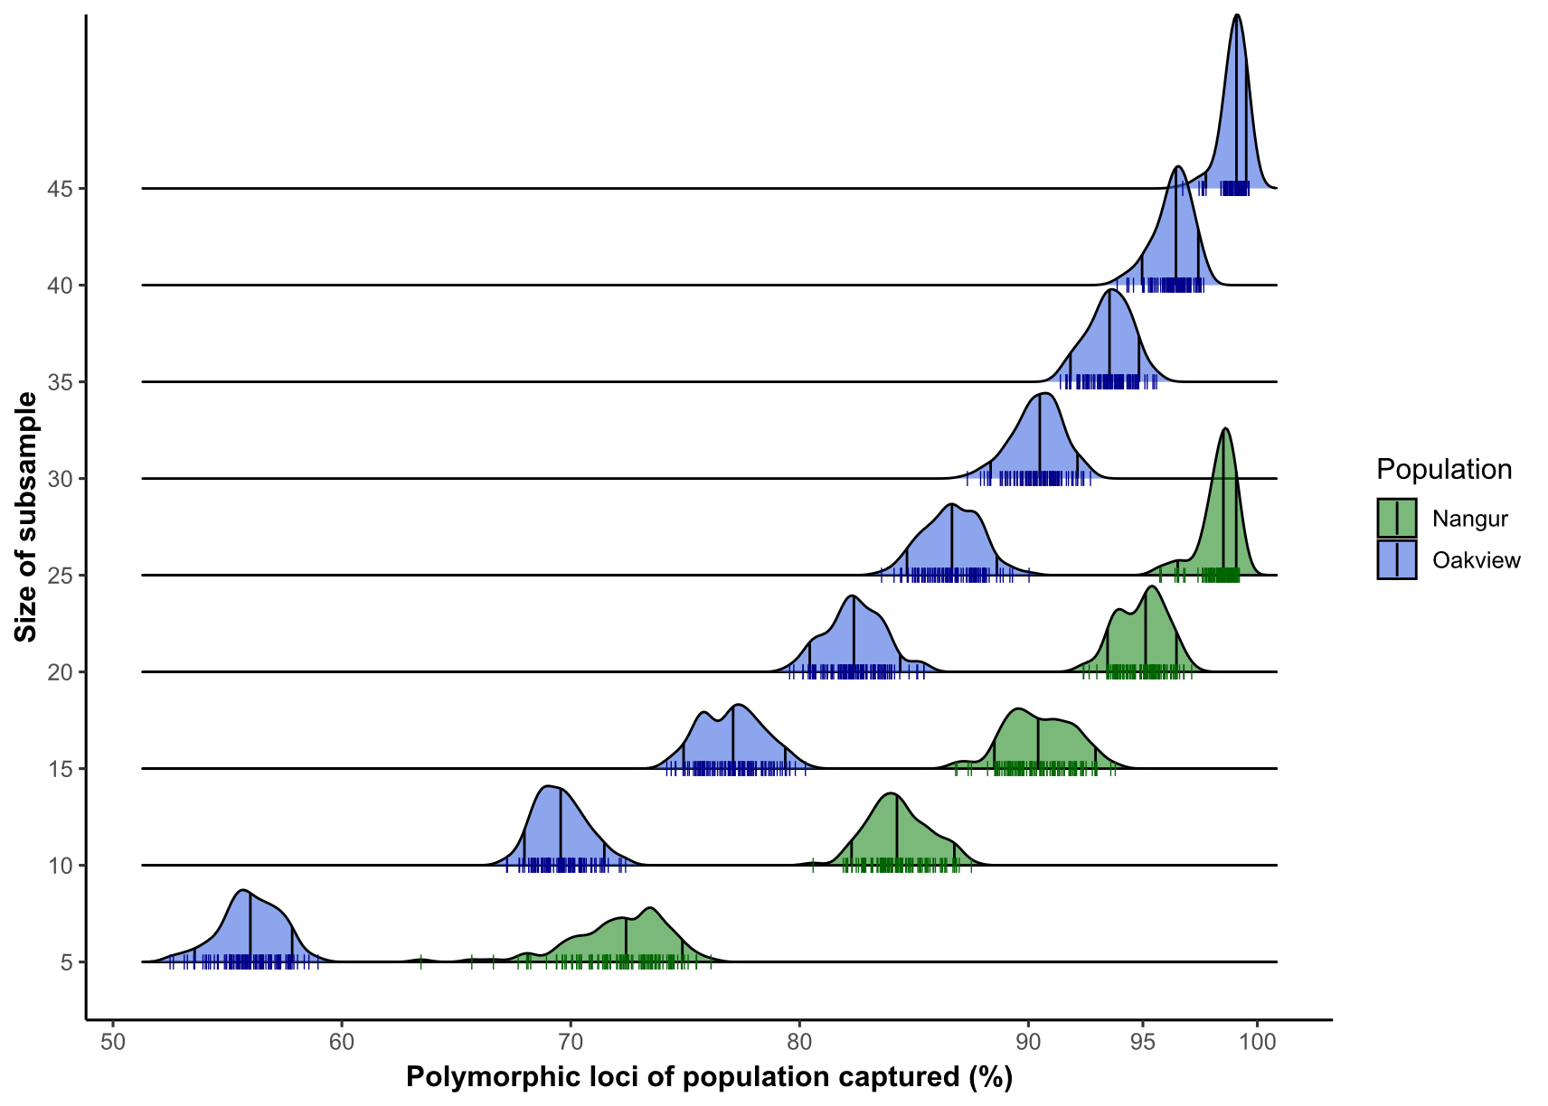
Online Resource 31 Amount of diversity from each Nangura spinosa population captured by a subsample of individuals from that population. A subsample of 25 Nangur and 40 Oakview individuals are required to have at least a 95% chance of capturing > 95% of the diversity measured in Nangur (green, always the distribution to the right) and Oakview (blue, always the distribution to the left), respectively. This suggested subsample size may be too small for Oakview, as the population is much bigger than what was sampled in this study. Distributions were generated by randomly subsampling each population 100 times without replacement, and calculating the percentage of SNPs that are polymorphic in that population captured by the subsample. The vertical black lines in the distribution represent the 5th percentile, median, and 95th percentile of the data, while the coloured dashes along each x-axis represent the estimate for each random subsample. The size of the subsamples is on the y-axis. Percentage polymorphic loci calculated using Dataset 2, without the first-degree relationship filter applied.

