Supplementary Data, Conservation Genetics
Comparatively high genetic connectivity of red deer management units in Saxony-Anhalt within a standardized supraregional framework
Julian Laumeier, Jette Diekmann, Hermann Willems, Natascha Schumann, Wolf Last, Gerald Reiner
Wildlife Biology Working Group, Justus Liebig University Giessen, Frankfurter Strasse 112, 35390 Giessen, Germany

Supplementary Table 1. Data for Saxony-Anhalt (ST), North Rhine-Westphalia (NRW), and Hesse (HE). All Data is given by German Federal Statistical Office (DESTATIS, DATUM).
Federal State | HE | NRW | ST
Population | 6280793 | 18034454 | 2135597
Area (km²) | 21115.64 | 34112.65 | 20555
Populationdensity | 297 | 529 | 104
Agriculture (km²) | 8687 | 15882 | 12321
Agriculture (%) | 41.14% | 46.56% | 59.94%
Forest (km²) | 8469 | 8477 | 4655
Forest (%) | 40.11% | 24.85% | 22.65%
Settlement and Transport (km²) | 3423 | 8180 | 2371
Sealing (%) | 16.21% | 23.98% | 11.53%
Motorway_(km) | 1007 | 2251 | 507
Motorwaydensity (km/1000km²) | 47.7 | 66.0 | 24.7
Roads (km) | 16078 | 29496 | 10950
Roaddensity (km/1000km²) | 761.4 | 864.7 | 532.7

Supplementary Table 2. Number of allelic variants by microsatellite marker and population of Saxony -Anhalt.
Locus | AH | CL | DH | FH | GH | HAV | KH | MH1 | MH2 | NA | NWA | OH | OSH | ZF
CSSM14 | 2 | 4 | 4 | 3 | 4 | 4 | 2 | 3 | 2 | 3 | 3 | 4 | 4 | 2
CSSM16 | 5 | 6 | 5 | 5 | 5 | 6 | 4 | 6 | 5 | 6 | 6 | 7 | 6 | 6
CSSM22 | 4 | 5 | 4 | 3 | 4 | 5 | 2 | 3 | 2 | 3 | 3 | 5 | 5 | 2
ETH225 | 9 | 13 | 13 | 9 | 13 | 11 | 7 | 9 | 7 | 12 | 11 | 16 | 14 | 11
CSSM19 | 11 | 13 | 11 | 10 | 12 | 13 | 4 | 7 | 6 | 8 | 9 | 16 | 14 | 6
T501 | 9 | 9 | 8 | 7 | 9 | 8 | 6 | 7 | 5 | 8 | 6 | 10 | 10 | 9
Haut14 | 9 | 13 | 10 | 10 | 12 | 11 | 5 | 9 | 4 | 9 | 8 | 14 | 16 | 7
BM4208 | 10 | 12 | 10 | 10 | 11 | 12 | 4 | 9 | 3 | 12 | 11 | 14 | 13 | 8
INRA35 | 8 | 8 | 7 | 10 | 9 | 10 | 5 | 9 | 4 | 7 | 7 | 9 | 8 | 7
T172 | 13 | 11 | 11 | 10 | 14 | 12 | 6 | 9 | 6 | 9 | 12 | 14 | 14 | 8
BM1818 | 8 | 9 | 8 | 9 | 10 | 10 | 4 | 8 | 6 | 8 | 9 | 12 | 13 | 9
RT1 | 8 | 10 | 8 | 9 | 11 | 11 | 5 | 4 | 6 | 11 | 10 | 13 | 13 | 10
MM12 | 2 | 3 | 2 | 3 | 2 | 3 | 2 | 2 | 2 | 3 | 3 | 4 | 4 | 3
RT6 | 13 | 12 | 10 | 10 | 14 | 13 | 7 | 8 | 5 | 10 | 11 | 15 | 17 | 9
NVHRT73 | 13 | 21 | 14 | 14 | 18 | 18 | 6 | 13 | 7 | 19 | 12 | 17 | 19 | 13
NVHRT48 | 13 | 16 | 12 | 12 | 16 | 20 | 6 | 11 | 6 | 17 | 12 | 23 | 25 | 9

Supplementary Table 3. Frequencies of null alleles by microsatellite marker and population of Saxony-Anhalt. Calculation is done by Brookfield method. Just significant values are displayed.
Locus | AH | CL | DH | FH | GH | HAV | MH1 | MH2 | NA | NWA | OH | OSH | ZF
CSSM14 | Nd | nd | 0.149 | nd | nd | 0.103 | nd | nd | nd | nd | nd | 0.069 | nd
CSSM16 | Nd | nd | nd | nd | nd | nd | nd | nd | nd | nd | nd | nd | nd
CSSM22 | Nd | nd | nd | nd | nd | nd | nd | nd | 0.112 | nd | nd | nd | nd
ETH225 | Nd | nd | 0.078 | nd | nd | nd | nd | nd | nd | nd | nd | nd | nd
CSSM19 | Nd | nd | nd | nd | nd | nd | nd | nd | nd | nd | nd | nd | nd
T501 | Nd | nd | nd | nd | nd | nd | nd | nd | nd | nd | nd | nd | nd
Haut14 | Nd | nd | nd | nd | nd | nd | nd | nd | nd | nd | nd | nd | 0.094
BM4208 | Nd | nd | nd | nd | nd | nd | nd | nd | nd | nd | nd | nd | nd
INRA35 | Nd | nd | nd | nd | nd | nd | nd | nd | nd | nd | nd | nd | 0.266
T172 | Nd | nd | nd | nd | nd | 0.087 | nd | nd | nd | nd | 0.054 | 0.098 | 0.122
BM1818 | Nd | nd | nd | nd | nd | nd | nd | nd | nd | nd | nd | nd | nd
RT1 | Nd | nd | nd | nd | nd | nd | nd | nd | nd | nd | nd | nd | nd
MM12 | Nd | nd | nd | nd | nd | nd | nd | nd | nd | nd | nd | nd | nd
RT6 | Nd | nd | nd | nd | nd | 0.066 | nd | nd | nd | nd | nd | nd | nd
NVHRT73 | Nd | nd | nd | nd | nd | nd | nd | nd | nd | nd | nd | nd | nd
NVHRT48 | Nd | nd | nd | nd | nd | nd | nd | nd | nd | nd | nd | nd | nd
Nd: not detected; KH (n=5) was merged with GH.
Supplementary Table 4. Significant deviations from Hardy-Weinberg-Equilibrium by microsatellite marker and population of Saxony-Anhalt.
Locus | AH | CL | DH | FH | GH | HAV | KH | MH1 | MH2 | NA | NWA | OH | OSH | ZF
CSSM14 | ns | ns | Sig | ns | Sig | Sig | ns | ns | ns | ns | ns | Sig | Sig | ns
CSSM16 | ns | ns | ns | ns | ns | ns | ns | ns | ns | ns | Sig | ns | ns | ns
CSSM22 | ns | Sig | ns | ns | ns | ns | ns | ns | ns | Sig | ns | ns | Sig | ns
ETH225 | ns | Sig | Sig | ns | Sig | ns | ns | ns | ns | ns | ns | ns | ns | Sig
CSSM19 | ns | ns | ns | ns | ns | Sig | ns | ns | ns | ns | ns | Sig | ns | ns
T501 | ns | ns | ns | Sig | ns | ns | ns | ns | ns | ns | ns | ns | ns | ns
Haut14 | ns | Sig | ns | ns | ns | Sig | ns | ns | Sig | ns | ns | ns | ns | Sig
BM4208 | ns | Sig | ns | ns | ns | ns | ns | Sig | ns | ns | ns | ns | Sig | ns
INRA35 | ns | ns | ns | ns | ns | ns | ns | ns | ns | ns | ns | ns | ns | Sig
T172 | ns | ns | ns | ns | ns | ns | ns | ns | ns | Sig | ns | ns | Sig | Sig
BM1818 | ns | ns | ns | ns | Sig | Sig | ns | ns | ns | Sig | ns | Sig | ns | ns
RT1 | ns | ns | Sig | ns | Sig | Sig | ns | ns | ns | Sig | ns | ns | Sig | ns
MM12 | ns | ns | ns | ns | ns | ns | ns | ns | ns | ns | ns | ns | Sig | ns
RT6 | ns | Sig | ns | ns | ns | Sig | ns | ns | ns | ns | ns | ns | ns | ns
NVHRT73 | ns | ns | ns | ns | Sig | Sig | ns | ns | ns | ns | Sig | ns | ns | ns
NVHRT48 | ns | ns | ns | ns | ns | ns | ns | ns | ns | Sig | ns | Sig | ns | ns
ns: not significant; Sig: P ≤ 0.05.
Supplementary Table 5. Deviation from Hardy-Weinberg-Equilibrium for the whole Population as one.
Locus | chi² | Df | Pr(chi² >) | Pr.exact
CSSM14 | 143.6 | 6 | <0.001 | <0.001
CSSM16 | 36.3 | 28 | 0.136 | 0.014
CSSM22 | 102.0 | 10 | <0.001 | <0.001
ETH225 | 214.8 | 120 | 2.419e-07 | <0.001
CSSM19 | 183.5 | 136 | 0.004 | 0.002
T501 | 75.5 | 45 | 0.003 | 0.011
Haut14 | 208.5 | 136 | 6.293e-05 | <0.001
BM4208 | 264.1 | 105 | 1.110e-15 | <0.001
INRA35 | 218.5 | 78 | 3.0e-15 | <0.001
T172 | 614.8 | 105 | <0.001 | <0.001
BM1818 | 498.7 | 136 | <0.001 | <0.001
RT1 | 1782.5 | 136 | <0.001 | <0.001
MM12 | 9.4 | 15 | 0.855 | 0.454
RT6 | 1586.7 | 190 | <0.001 | 0.002
NVHRT73 | 2398.0 | 276 | <0.001 | 0.000
NVHRT48 | 811.7 | 561 | 1.890e-11 | 0.000
All markers deviated significantly (after Bonferoni-correction) from Hardy-Weinberg-Equilibrium, except for MM12.

Supplementary Table 6. Number of private allels by administrative management unit (AMU) of Saxony-Anhalt.
AMU | private Allels
CL | 2
GH | 6
HV | 4
M1 | 1
NK | 2
OH | 9
OS | 6
ZF | 3

Supplementary Table 7. Pairwise genetic differentiation among red deer management units in Saxony-Anhalt. Values below the diagonal represent pairwise FST estimates, whereas values above the diagonal represent Jost’s D. Higher values indicate increased genetic differentiation and reduced genetic exchange between populations.
POP | AH | CL | DH | FH | GH | HV | KH | MH1 | MH2 | NA | NWA | OH | OSH | ZF
AH |  | 0.109 | 0.121 | 0.088 | 0.009 | 0.137 | 0.001 | 0.127 | 0.185 | 0.143 | 0.127 | 0.122 | 0.116 | 0.201
CL | 0.041 |  | 0.123 | 0.01 | 0.124 | 0.086 | 0.069 | 0.08 | 0.177 | 0.08 | 0.043 | 0.089 | 0.086 | 0.195
DH | 0.048 | 0.047 |  | 0.145 | 0.102 | 0.118 | 0.101 | 0.113 | 0.112 | 0.173 | 0.188 | 0.188 | 0.189 | 0.207
FH | 0.038 | 0.007 | 0.049 |  | 0.121 | 0.068 | 0.038 | 0.043 | 0.13 | 0.082 | 0.027 | 0.091 | 0.088 | 0.16
GH | 0.011 | 0.036 | 0.039 | 0.031 |  | 0.154 | 0 | 0.073 | 0.179 | 0.141 | 0.11 | 0.139 | 0.135 | 0.166
HV | 0.052 | 0.026 | 0.048 | 0.028 | 0.042 |  | 0.096 | 0.061 | 0.134 | 0.083 | 0.101 | 0.139 | 0.152 | 0.212
KH | 0.011 | 0.04 | 0.049 | 0.034 | -0.002 | 0.043 |  | 0.052 | 0.12 | 0.042 | 0.027 | 0.078 | 0.124 | 0.12
MH1 | 0.049 | 0.029 | 0.041 | 0.023 | 0.031 | 0.025 | 0.038 |  | 0.138 | 0.158 | 0.061 | 0.142 | 0.155 | 0.23
MH2 | 0.092 | 0.072 | 0.072 | 0.06 | 0.08 | 0.062 | 0.1 | 0.072 |  | 0.201 | 0.214 | 0.184 | 0.203 | 0.241
NA | 0.055 | 0.027 | 0.061 | 0.03 | 0.046 | 0.03 | 0.032 | 0.054 | 0.088 |  | 0.057 | 0.138 | 0.133 | 0.196
NWA | 0.044 | 0.019 | 0.071 | 0.016 | 0.035 | 0.029 | 0.027 | 0.027 | 0.093 | 0.026 |  | 0.123 | 0.113 | 0.218
OH | 0.044 | 0.028 | 0.063 | 0.032 | 0.037 | 0.041 | 0.039 | 0.048 | 0.075 | 0.041 | 0.036 |  | 0.015 | 0.158
OSH | 0.04 | 0.027 | 0.058 | 0.028 | 0.035 | 0.043 | 0.042 | 0.042 | 0.075 | 0.041 | 0.033 | 0.006 |  | 0.161
ZF | 0.075 | 0.067 | 0.085 | 0.058 | 0.06 | 0.073 | 0.055 | 0.081 | 0.112 | 0.063 | 0.075 | 0.054 | 0.053

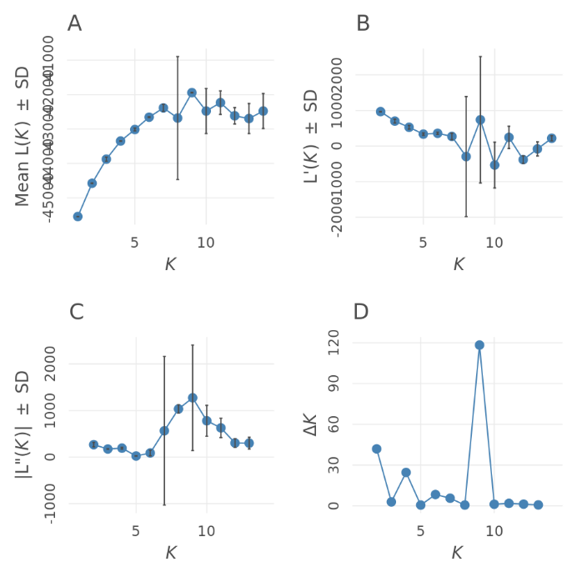
Supplementary Figure S1. Results of the Evanno method used to determine the optimal number of genetic clusters (K) in the STRUCTURE analysis. (A) Mean log-likelihood of the data [Mean lnP(K) ± SD], (B) first-order rate of change [L′(K) ± SD], (C) second-order rate of change [L″(K) ± SD], and (D) ΔK values. The pronounced peak at K = 9 identified nine genetic clusters as the most likely population structure for the Saxony-Anhalt dataset.
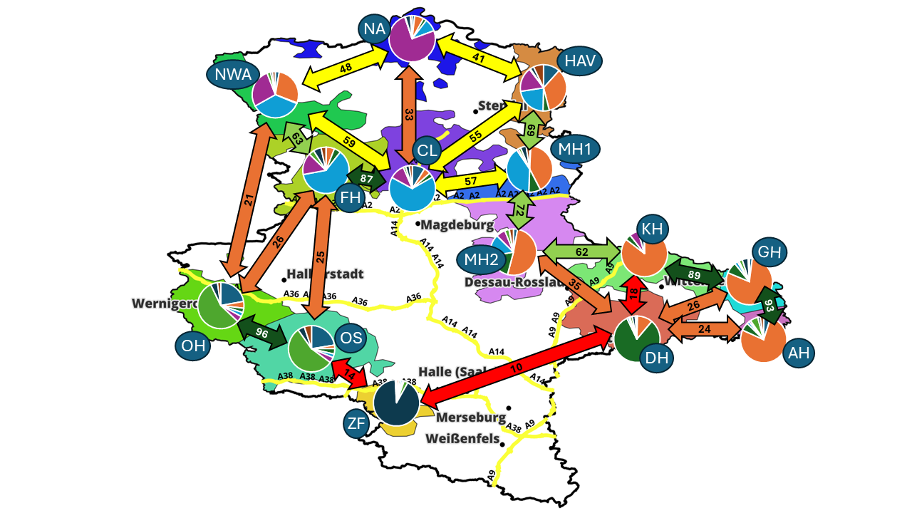
Supplementary Figure S2. Genetic differentiation and connectivity among red deer populations based on BAPS. The analyses confirmed the major population structure identified by DAPC and supported the existence of several genetically differentiated peripheral populations as well as varying degrees of genetic connectivity among administrative management units.
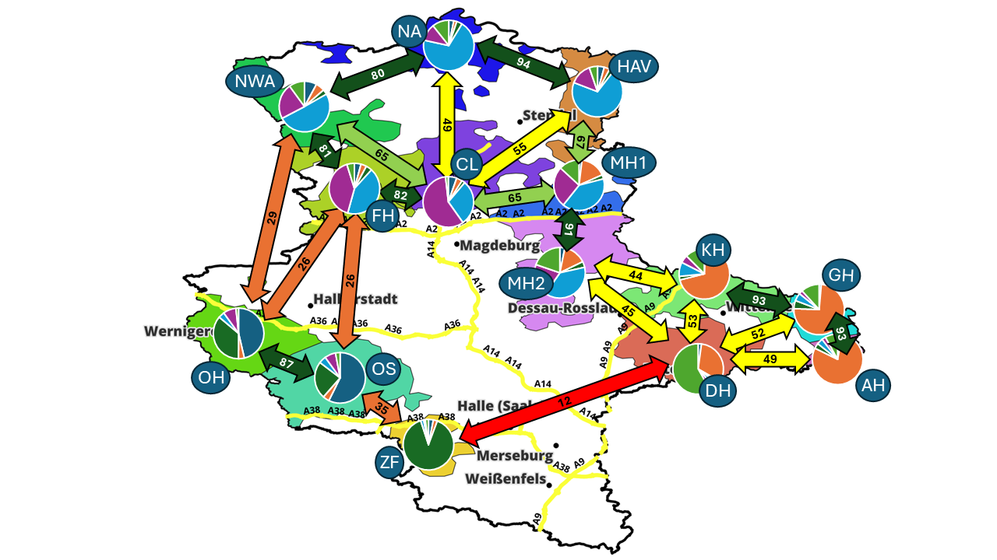
Supplementary Figure S3. Genetic differentiation and connectivity among red deer populations based on TESS. The analyses confirmed the major population structure identified by DAPC and supported the existence of several genetically differentiated peripheral populations as well as varying degrees of genetic connectivity among administrative management units.
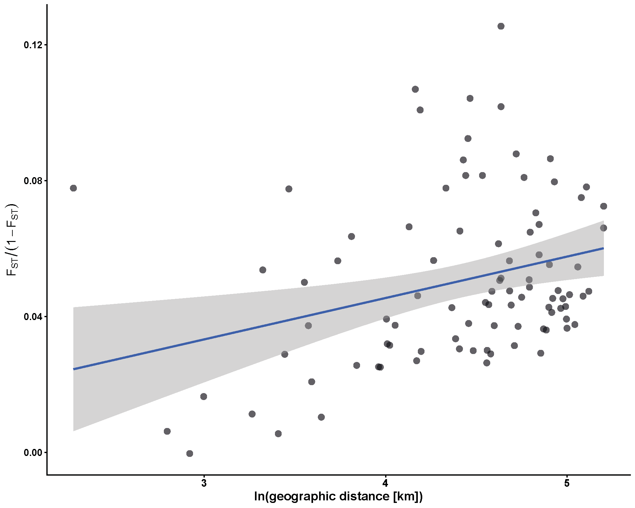
Supplementary Figure S4. Isolation-by-distance (IBD) analysis based on pairwise comparisons among adaptive management units (AMUs) in Saxony-Anhalt. Linearized genetic differentiation (F<sub>ST</sub>/(1 − F<sub>ST</sub>)) is plotted against the natural logarithm of geographic distance. The fitted regression line (blue) and shaded 95% confidence interval illustrate the significant positive relationship detected by the Mantel test.

References
German Federal Statistical Office (DESTATIS) (2025) Regional statistics and land-use data for the federal states of Germany. Wiesbaden, https://www.destatis.de/DE/Home/_inhalt.html, accessed on 01.06.2026.

