Table S1. Overview of sample descriptions. Sample ID refers to the identifier used in the laboratory; Field ID to the identifier used in the field; and Museum ID to the museum’s catalog code for each sample. Origin indicates whether the sample was obtained from the field or a museum collection. Museum abbreviations: AMNH – American Museum of Natural History; CM – Carnegie Museum of Natural History; EBD – Doñana Biological Station; MISRM – Museo del Institut Scientifique de Rabat Marruecos; MNHN – Muséum national d’Histoire naturelle (Paris); MUHNAC – Museu Nacional de História Natural e da Ciência, Universidade de Lisboa; NMW – Museum of Natural History, Vienna; NHM – Natural History Museum, London; YPM – Yale Peabody Museum of Natural History. DNA source indicates the sample material used for the DNA extraction and the Individual Status indicate where or how that sample was obtained. Population codes: BAL – Balearic Islands; CV – Cabo Verde (contemporary); CV_hist – historical Cabo Verde; CAN – Canary Islands; MAG_hist – historical Maghreb; OM – Oman; SOC – Socotra; IB – Iberian Peninsula. Collection Year indicates the year of collection; Estimated Birth Year the approximate birth year of the individual based on age class determined from plumage coloration; and QI the Quality Index of museum samples.

Sample Id | Field/Museum_ID | Origin of the Sample | DNA source | Individual Status | Population | Collection Year | Estimated Birth year | QI sample
11215 | 00C | Field | Blood | Live-capture | BAL | 2002 | 1996?
11216 | 00L | Field | Blood | Live-capture | BAL | 2002 | 2001
11217 | 00T | Field | Blood | Live-capture | BAL | 2002 | 1996?
11218 | 00U | Field | Blood | Live-capture | BAL | 2002 | 1996?
11219 | 00W | Field | Blood | Live-capture | BAL | 2002 | 1996?
11277 | 0C1 | Field | Blood | Live-capture | BAL | 2002 | 2002
11278 | 0C2 | Field | Blood | Live-capture | BAL | 2002 | 2002
11279 | 0C3 | Field | Blood | Live-capture | BAL | 2002 | 2002
11280 | 0C4 | Field | Blood | Live-capture | BAL | 2002 | 2002
11281 | 0C5 | Field | Blood | Live-capture | BAL | 2002 | 2002
11282 | 0F0 | Field | Blood | Live-capture | BAL | 2002 | 2002
11283 | 0F1 | Field | Blood | Live-capture | BAL | 2002 | 2002
11284 | 0F2 | Field | Blood | Live-capture | BAL | 2002 | 2002
11285 | 0F3 | Field | Blood | Live-capture | BAL | 2002 | 2002
11286 | 0F4 | Field | Blood | Live-capture | BAL | 2002 | 2002
11287 | 0F5 | Field | Blood | Live-capture | BAL | 2002 | 2002
11288 | 0F7 | Field | Blood | Live-capture | BAL | 2002 | 2002
11482 | OO1 | Field | Blood | Live-capture | BAL | 2001 | 1996?
11483 | OO3 | Field | Blood | Live-capture | BAL | 2001 | 2000
11484 | OOO | Field | Blood | Live-capture | BAL | 2000 | 2000
1608 | CZ000004467 | MUHNAC | footpad tissue | Museum specimen | CV | 1969 | 1964 | 0,646
1614 | CZ000004470/1369150 | MUHNAC | footpad tissue | Museum specimen | CV | 1969 | 1966 | 0,542
1630 | CZ000004477/1370137 | MUHNAC | footpad tissue | Museum specimen | CV | 1970 | 1966 | 0,438
1782 | YPM_44540 | YPM | footpad tissue | Museum specimen | CV | 1923 | 1923 | 0,542
176 | 3F5 | Field | Blood | Live-capture | CAN | 2013 | 2013
177 | 3F6 | Field | Blood | Live-capture | CAN | 2013 | 2013
179 | 3F8 | Field | Blood | Live-capture | CAN | 2013 | 2013
180 | 3F9 | Field | Blood | Live-capture | CAN | 2013 | 2013
185 | 3P0 | Field | Blood | Live-capture | CAN | 2013 | 2013
186 | 3P1 | Field | Blood | Live-capture | CAN | 2013 | 2013
188 | 3P3 | Field | Blood | Live-capture | CAN | 2013 | 2013
189 | 3P4 | Field | Blood | Live-capture | CAN | 2013 | 2013
190 | 3P5 | Field | Blood | Live-capture | CAN | 2013 | 2013
191 | 3P6 | Field | Blood | Live-capture | CAN | 2013 | 2013
192 | 3P7 | Field | Blood | Live-capture | CAN | 2013 | 2013
193 | 3P8 | Field | Blood | Live-capture | CAN | 2015 | 2013
194 | 3P9 | Field | Blood | Live-capture | CAN | 2013 | 2013
199 | 3NP | Field | Blood | Live-capture | CAN | 2013 | 2013
1557 | 3TL | Field | Blood | Live-capture | CAN | 2015 | 2014
1558 | 3T0 | Field | Blood | Live-capture | CAN | 2014 | 2014
1561 | 3FU | Field | Blood | Live-capture | CAN | 2014 | 2014
1562 | 3FH | Field | Blood | Live-capture | CAN | 2015 | 2014
1563 | 3T3 | Field | Blood | Live-capture | CAN | 2014 | 2014
1564 | 3T5 | Field | Blood | Live-capture | CAN | 2014 | 2014
1565 | 3PF | Field | Blood | Live-capture | CAN | 2014 | 2014
1567 | 3TA | Field | Blood | Live-capture | CAN | 2014 | 2014
1569 | 3TP | Field | Blood | Live-capture | CAN | 2014 | 2014
1570 | 3PH | Field | Blood | Live-capture | CAN | 2014 | 2014
1573 | 3T4 | Field | Blood | Live-capture | CAN | 2014 | 2014
1574 | 3TW | Field | Blood | Live-capture | CAN | 2014 | 2014
1576 | 3TV | Field | Blood | Live-capture | CAN | 2014 | 2014
1577 | 3T9 | Field | Blood | Live-capture | CAN | 2014 | 2014
1578 | 3TH | Field | Blood | Live-capture | CAN | 2014 | 2014
1579 | 3T1 | Field | Blood | Live-capture | CAN | 2014 | 2014
1580 | 3PC | Field | Blood | Live-capture | CAN | 2014 | 2014
1581 | 3T7 | Field | Blood | Live-capture | CAN | 2014 | 2014
1582 | 3TU | Field | Blood | Live-capture | CAN | 2014 | 2014
1583 | 3T6 | Field | Blood | Live-capture | CAN | 2014 | 2014
1584 | 3TC | Field | Blood | Live-capture | CAN | 2014 | 2014
1585 | 3T2 | Field | Blood | Live-capture | CAN | 2014 | 2014
1586 | 3T8 | Field | Blood | Live-capture | CAN | 2014 | 2014
1587 | 3PN | Field | Blood | Live-capture | CAN | 2014 | 2014
1588 | 3TN | Field | Blood | Live-capture | CAN | 2014 | 2014
1589 | 3TT | Field | Blood | Live-capture | CAN | 2014 | 2014
1590 | 3TJ | Field | Blood | Live-capture | CAN | 2014 | 2014
1875 | 3XF | Field | Blood | Live-capture | CAN | 2015 | 2015
1876 | 3XM | Field | Blood | Live-capture | CAN | 2015 | 2015
1877 | 3XR | Field | Blood | Live-capture | CAN | 2015 | 2015
1878 | 3XU | Field | Blood | Live-capture | CAN | 2015 | 2015
1881 | 406 | Field | Blood | Live-capture | CAN | 2015 | 2005
1889 | 40N | Field | Blood | Live-capture | CAN | 2015 | 2014
1891 | 409 | Field | Blood | Live-capture | CAN | 2015 | 2015
1892 | 400 | Field | Blood | Live-capture | CAN | 2015 | 2015
1893 | 407 | Field | Blood | Live-capture | CAN | 2015 | 2015
1894 | 404 | Field | Blood | Live-capture | CAN | 2015 | 2015
1895 | 401 | Field | Blood | Live-capture | CAN | 2015 | 2015
1896 | 405 | Field | Blood | Live-capture | CAN | 2015 | 2015
1900 | 3XP | Field | Blood | Live-capture | CAN | 2015 | 2015
1902 | 3XL | Field | Blood | Live-capture | CAN | 2015 | 2015
1903 | 3XH | Field | Blood | Live-capture | CAN | 2015 | 2015
1904 | 3XJ | Field | Blood | Live-capture | CAN | 2015 | 2015
1906 | 3XA | Field | Blood | Live-capture | CAN | 2015 | 2015
1968 | 99A | Field | Blood | Live-capture | CAN | 2016 | 2015
1705 | AMNH535752 | AMNH | footpad tissue | Museum specimen | CV | 1987 | 1987 | 0,750
1750 | Juste1 | Field | umbilical clot | Perch feather | CV | 2000 | 2000
1751 | Juste2 | Field | umbilical clot | Perch feather | CV | 2000 | 2000
1849 | Pedro_CV | Field | umbilical clot | Road-Killed | CV | 2014 | 2014
1866 | Pedro_CV_1866 | Field | umbilical clot | Nest feather | CV | 2015 | 2015
1870 | Pedro_CV_1870 | Field | umbilical clot | Nest feather | CV | 2015 | 2015
1605 | CZ000004478 | MUHNAC | umbilical clot | Museum specimen | CV | 1969 | 1966 | 0,917
1606 | CZ000004479/136924 | MUHNAC | footpad tissue | Museum specimen | CV | 1969 | 1967 | 0,938
1619 | CZ000004469/1369045 | MUHNAC | footpad tissue | Museum specimen | CV | 1969 | 1966 | 0,959
1621 | CZ000004475/1369166 | MUHNAC | Footpad tissue | Museum specimen | CV | 1969 | 1968 | 0,979
1702 | AMNH269819 | AMNH | Footpad tissue | Museum specimen | CV_hist | 1912 | 1912 | 0,875
1704 | AMNH269388 | AMNH | Footpad tissue | Museum specimen | CV_hist | 1923 | 1923 | 0,833
1706 | AMNH269390 | AMNH | Footpad tissue | Museum specimen | CV_hist | 1923 | 1923 | 0,625
1856 | NMHN_CG1930_245 | MNHN | Footpad tissue | Museum specimen | CV_hist | 1930 | 1930 | 0,917
1768 | YPM_44536 | YPM | Footpad tissue | Museum specimen | CV_hist | 1923 | 1923 | 0,605
1769 | YPM_44531 | YPM | Footpad tissue | Museum specimen | CV_hist | 1923 | 1923 | 0,750
1770 | YPM_44541 | YPM | Footpad tissue | Museum specimen | CV_hist | 1923 | 1923 | 0,771
1771 | YPM_44534 | YPM | Footpad tissue | Museum specimen | CV_hist | 1923 | 1923 | 0,729
1774 | YPM_44535 | YPM | Footpad tissue | Museum specimen | CV_hist | 1923 | 1923 | 0,833
1775 | YPM_44537 | YPM | Footpad tissue | Museum specimen | CV_hist | 1924 | 1924 | 0,687
1776 | YPM_44532 | YPM | Footpad tissue | Museum specimen | CV_hist | 1923 | 1923 | 0,667
1777 | YPM_44542 | YPM | Footpad tissue | Museum specimen | CV_hist | 1923 | 1923 | 0,667
1778 | YPM_44543 | YPM | Footpad tissue | Museum specimen | CV_hist | 1924 | 1924 | 0,729
1779 | YPM_44533 | YPM | Footpad tissue | Museum specimen | CV_hist | 1923 | 1923 | 0,833
1780 | YPM_44538 | YPM | Footpad tissue | Museum specimen | CV_hist | 1923 | 1923 | 0,625
1781 | YPM_44539 | YPM | Footpad tissue | Museum specimen | CV_hist | 1923 | 1923 | 0,792
1671 | AMNH535769 | AMNH | Footpad tissue | Museum specimen | MAG_hist | 1897 | 1897 | 0,938
1679 | AMNH535766 | AMNH | Footpad tissue | Museum specimen | MAG_hist | 1909 | 1909 | 0,958
1683 | AMNH535770 | AMNH | Footpad tissue | Museum specimen | MAG_hist | 1897 | 1897 | 0,854
1686 | AMNH535765 | AMNH | Footpad tissue | Museum specimen | MAG_hist | 1912 | 1912 | 0,854
1687 | AMNH535767 | AMNH | Footpad tissue | Museum specimen | MAG_hist | 1909 | 1909 | 0,771
1688 | AMNH535768 | AMNH | Footpad tissue | Museum specimen | MAG_hist | 1914 | 1914 | 0,938
1689 | AMNH535758 | AMNH | Footpad tissue | Museum specimen | MAG_hist | 1905 | 1905 | 0,958
1691 | AMNH535762 | AMNH | Footpad tissue | Museum specimen | MAG_hist | 1905 | 1905 | 0,958
1692 | AMNH535761 | AMNH | Footpad tissue | Museum specimen | MAG_hist | 1905 | 1905 | 0,938
1693 | AMNH535760 | AMNH | Footpad tissue | Museum specimen | MAG_hist | 1906 | 1905 | 0,917
1694 | AMNH535764 | AMNH | Footpad tissue | Museum specimen | MAG_hist | 1903 | 1905 | 0,542
1697 | AMNH535759 | AMNH | Footpad tissue | Museum specimen | MAG_hist | 1905 | 1905 | 0,650
1699 | AMNH535757 | AMNH | Footpad tissue | Museum specimen | MAG_hist | 1905 | 1905 | 0,583
1701 | AMNH535763 | AMNH | Footpad tissue | Museum specimen | MAG_hist | 1903 | 1903 | 0,813
1752 | CM_P30295 | CM | Footpad tissue | Museum specimen | MAG_hist | 1908 | 1908 | 0,542
467 | Sahara | EBD | Blood | Museum specimen | MAG_hist | 1960 | 1950 | 0,550
1636 | EBD10781A | EBD | umbilical clot | Museum specimen | MAG_hist | 1940 | 1940 | 0,917
1826 | Palma_NPM1 | MISRM | footpad tissue | Museum specimen | MAG_hist | 1932 | 1932 | 0,917
1857 | NMHN_CG1903_1799 | MNHN | footpad tissue | Museum specimen | MAG_hist | 1900 | 1900 | 0,917
1858 | NHMN_CG1951_453 | MNHN | footpad tissue | Museum specimen | MAG_hist | 1950 | 1950 | 0,917
1860 | NHMN_CG2005_1920 | MNHN | footpad tissue | Museum specimen | MAG_hist | 1916 | 1916 | 0,917
1764 | NMW_56610 | MNW | footpad tissue | Museum specimen | MAG_hist | 1930 | 1930 | 1
1853 | NHM_318 | NHM | umbilical clot | Museum specimen | MAG_hist | 1857 | 1857 | 0,833
1723 | Oman1723 | Field | umbilical clot | Roost feather | OM | 2015 | 2015
1724 | Oman1724 | Field | umbilical clot | Roost feather | OM | 2015 | 2015
1725 | Oman1725 | Field | umbilical clot | Roost feather | OM | 2015 | 2015
1726 | Oman1726 | Field | umbilical clot | Roost feather | OM | 2015 | 2015
1727 | Oman1727 | Field | umbilical clot | Roost feather | OM | 2015 | 2015
1729 | Oman1729 | Field | umbilical clot | Roost feather | OM | 2015 | 2015
1730 | Oman1730 | Field | umbilical clot | Roost feather | OM | 2015 | 2015
1731 | Oman1731 | Field | umbilical clot | Roost feather | OM | 2015 | 2015
1733 | Oman1733 | Field | umbilical clot | Roost feather | OM | 2015 | 2015
1735 | Oman1735 | Field | umbilical clot | Roost feather | OM | 2015 | 2015
1736 | Oman1736 | Field | umbilical clot | Roost feather | OM | 2015 | 2015
1737 | Oman1737 | Field | umbilical clot | Roost feather | OM | 2015 | 2015
1738 | Oman1738 | Field | umbilical clot | Roost feather | OM | 2015 | 2015
1739 | Oman1739 | Field | umbilical clot | Roost feather | OM | 2015 | 2015
1741 | Oman1741 | Field | umbilical clot | Roost feather | OM | 2015 | 2015
1742 | Oman1742 | Field | umbilical clot | Roost feather | OM | 2015 | 2015
13 | 3XA | Field | Blood | Live-capture | SOC | 2009 | 2002
14 | 3XT | Field | Blood | Live-capture | SOC | 2009 | 2008
16 | SA(1) | Field | Blood | Live-capture | SOC | 2009 | 2006
17 | 3XH | Field | Blood | Live-capture | SOC | 2009 | 2008
18 | 3XU | Field | Blood | Live-capture | SOC | 2009 | 2002
19 | 3XW | Field | Blood | Live-capture | SOC | 2009 | 2008
20 | 3XL | Field | Blood | Live-capture | SOC | 2009 | 2002
21 | 3XJ | Field | Blood | Live-capture | SOC | 2009 | 2004
23 | 3XC | Field | Blood | Live-capture | SOC | 2009 | 2003
24 | 3XR | Field | Blood | Live-capture | SOC | 2009 | 2005
25 | 3XV | Field | Blood | Live-capture | SOC | 2009 | 2006
26 | 3XF | Field | Blood | Live-capture | SOC | 2009 | 2002
27 | Inmaduro atropellado | Field | umbilical clot | Road-Killed | SOC | 2009 | 2006
28 | Adulto atropellado | Field | umbilical clot | Road-Killed | SOC | 2009 | 2002
29 | Adulto atropellado | Field | umbilical clot | Road-Killed | SOC | 2009 | 2002
30 | Atropellado 1. 2ºaño | Field | umbilical clot | Road-Killed | SOC | 2009 | 2002
31 | Atropellado aeropuerto p1 | Field | umbilical clot | Road-Killed | SOC | 2009 | 2002
32 | Adulto muerto basurero | Field | umbilical clot | Road-Killed | SOC | 2009 | 2002
33 | Adulto atropellado 1 | Field | umbilical clot | Road-Killed | SOC | 2009 | 2002
34 | wpt 371 | Field | umbilical clot | Road-Killed | SOC | 2009 | 2009
35 | Dormidero | Field | umbilical clot | Roost feather | SOC | 2009 | 2009
37 | Dormidero | Field | umbilical clot | Roost feather | SOC | 2009 | 2009
38 | Dormidero | Field | umbilical clot | Roost feather | SOC | 2009 | 2009
39 | Dormidero | Field | umbilical clot | Roost feather | SOC | 2009 | 2009
44 | Dormidero | Field | umbilical clot | Roost feather | SOC | 2009 | 2009
49 | Dormidero | Field | umbilical clot | Roost feather | SOC | 2009 | 2009
50 | Dormidero | Field | umbilical clot | Roost feather | SOC | 2009 | 2009
51 | Dormidero | Field | umbilical clot | Roost feather | SOC | 2009 | 2009
52 | Dormidero | Field | umbilical clot | Roost feather | SOC | 2009 | 2009
53 | Dormidero | Field | umbilical clot | Roost feather | SOC | 2009 | 2009
54 | Dormidero | Field | umbilical clot | Roost feather | SOC | 2009 | 2009
55 | Dormidero | Field | umbilical clot | Roost feather | SOC | 2009 | 2009
56 | Dormidero | Field | umbilical clot | Roost feather | SOC | 2009 | 2009
57 | Dormidero | Field | umbilical clot | Roost feather | SOC | 2009 | 2009
58 | Dormidero | Field | umbilical clot | Roost feather | SOC | 2009 | 2009
59 | Dormidero | Field | umbilical clot | Roost feather | SOC | 2009 | 2009
60 | Dormidero | Field | umbilical clot | Roost feather | SOC | 2009 | 2009
61 | Dormidero | Field | umbilical clot | Roost feather | SOC | 2009 | 2009
62 | Dormidero | Field | umbilical clot | Roost feather | SOC | 2009 | 2009
63 | Dormidero | Field | umbilical clot | Roost feather | SOC | 2009 | 2009
64 | Dormidero | Field | umbilical clot | Roost feather | SOC | 2009 | 2009
65 | Dormidero | Field | umbilical clot | Roost feather | SOC | 2009 | 2009
66 | Dormidero | Field | umbilical clot | Roost feather | SOC | 2009 | 2009
67 | Dormidero | Field | umbilical clot | Roost feather | SOC | 2009 | 2009
68 | Dormidero | Field | umbilical clot | Roost feather | SOC | 2009 | 2009
69 | Dormidero | Field | umbilical clot | Roost feather | SOC | 2009 | 2009
70 | Dormidero | Field | umbilical clot | Roost feather | SOC | 2009 | 2009
72 | Dormidero | Field | umbilical clot | Roost feather | SOC | 2009 | 2009
73 | Dormidero | Field | umbilical clot | Roost feather | SOC | 2009 | 2009
74 | Dormidero | Field | umbilical clot | Roost feather | SOC | 2009 | 2009
75 | Dormidero | Field | umbilical clot | Roost feather | SOC | 2009 | 2009
554 | 23R | Field | Blood | Live-capture | IB | 2013 | 2013
555 | 23T | Field | Blood | Live-capture | IB | 2013 | 2013
556 | 23U | Field | Blood | Live-capture | IB | 2013 | 2013
557 | 23V | Field | Blood | Live-capture | IB | 2013 | 2013
559 | 23W | Field | Blood | Live-capture | IB | 2013 | 2013
560 | 260 | Field | Blood | Live-capture | IB | 2013 | 2013
561 | 261 | Field | Blood | Live-capture | IB | 2013 | 2013
562 | 262 | Field | Blood | Live-capture | IB | 2013 | 2013
563 | 263 | Field | Blood | Live-capture | IB | 2013 | 2013
564 | 264 | Field | Blood | Live-capture | IB | 2013 | 2013
565 | 265 | Field | Blood | Live-capture | IB | 2013 | 2013
578 | 3NM | Field | Blood | Live-capture | IB | 2013 | 2013
579 | 3NN | Field | Blood | Live-capture | IB | 2013 | 2013
741 | 1NV | Field | Blood | Live-capture | IB | 2003 | 1999
800 | 2W0 | Field | Blood | Live-capture | IB | 2010 | 2010
801 | 2W1 | Field | Blood | Live-capture | IB | 2010 | 2010
813 | 2W3 | Field | Blood | Live-capture | IB | 2011 | 2011
908 | 01F | Field | Blood | Live-capture | IB | 2000 | 1990
930 | 07L | Field | Blood | Live-capture | IB | 2000 | 1993
1006 | 045 | Field | Blood | Live-capture | IB | 1999 | 1999
1008 | 030 | Field | Blood | Live-capture | IB | 1999 | 1999
1090 | 0PF | Field | Blood | Live-capture | IB | 2002 | 2002
1097 | 0PC | Field | Blood | Live-capture | IB | 2002 | 2002
1339 | 4CL | Field | Blood | Live-capture | IB | 1995 | 1995
1366 | 90J | Field | Blood | Live-capture | IB | 1996 | 1996
1367 | 90L | Field | Blood | Live-capture | IB | 1996 | 1996
1452 | 3RF | Field | Blood | Live-capture | IB | 2014 | 2014
1462 | 3RH | Field | Blood | Live-capture | IB | 2014 | 2014
1477 | 91N | Field | Blood | Live-capture | IB | 1997 | 1997

Table S2: DNA extraction protocol from museum samples.
DNA extraction protocol from museum samples
- Clean surfaces and material | All laboratory surfaces and materials were cleaned daily prior to use. Cleaning consisted of sequential washing with distilled water, followed by 15% bleach, and a final rinse with distilled water. Subsequently, all working areas and equipment were exposed to ultraviolet (UV) light for 30 min to degrade potential contaminant DNA. All procedures were conducted within a UV-sterilized cabinet. The same cleaning procedure was repeated at the end of each working day.
- Wash the sample:
Cover the sample with TE 9 and keep it in a rotor for 24 h, remove the TE 9. Repeat this step.
Cover the sample with GTE 1×. Keep it on a rotating platform with continuous gentle movement for 24 h.
Air dry the material at room temperature and transfer it to a new vial.
- Digestion:
Add 500 µl l of digestion buffer (see below), 20 µl of 1 M DTT, 50 µl of proteinase K (20 mg/ml). Add extra 50 µl of proteinase K if needed.
Incubate overnight at 65 °C on a rotating platform with continuous gentle movement.
- DNA extraction
- Keep 400 μl and store the rest in the freezer.
  - Add 400 μl of phenol and vortex. Centrifuge for 5 min at 13,000 rpm. Transfer the supernatant into a new vial.
  - Add 400 μl of phenol/chloroform/isoamyl alcohol (25:24:1). Centrifuge for 5 min at 13,000 rpm. Transfer the supernatant to a new vial. Repeat this step.
  - Add 400 μl of chloroform/isoamyl alcohol (20:1). Centrifuge for 5 min at 13,000 rpm. Transfer the supernatant to a new vial. Repeat this step.
  - Add 1/10 volume of 3 M sodium acetate (pH 7.0).
- DNA precipitation: Add 2 volumes of 96% ethanol or absolute ethanol (stored at -20 °C). Mix by inversion and store at -20 °C.
Centrifuge for 20 min at 13,000 rpm and 4 °C. Carefully remove the ethanol.
- DNA cleaning: Add 2 volumes of 70% ethanol (-20 °C). Mix by inversion or vortex.
Centrifuge for 5 min at 13,000 rpm and 4 °C.
Carefully remove the ethanol. Centrifuge again and, if needed, repeat this step.
Let the sample dry.
- DNA resuspension: Add 20-100 µl of TLE and store at 4 °C for the first 24 h.

Digestion Buffer:
Component | Stock concentration: | For 50 ml
25 mM Tris, pH 7.5 | 1 M | 1.25 ml
100 mM EDTA, pH 8 | 500 mM | 10 ml
1% SDS | 10% SDS | 5 ml
Fill up to 50 ml
TE 9 buffer:
Component | Stock concentration: | For 50 ml
50 mM Tris, pH 9 | 1 M | 2.5 ml
20 mM EDTA, pH 8 | 500 mM | 2 ml
10 mM NaCl | 5 M | 100 µl

1 M TRIS pH 9
For 500 ml of 1 M Tris, pH 9: 60.55 g in 400 ml of water, add HCl until pH 9 and fill up to 500 ml with water

GTE 10X:
Component | Stock concentration: | For 50 ml
1 M Glycine | 75.07 g/mol | 3.75 g
100 mM Tris, pH 7.5 | 1 M | 5 ml
10 mM EDTA | 500 mM | 1 ml
Make up to 50 ml with water

TLE (Tris Low EDTA):
Final concentration: | For 100 ml
0.1 mM EDTA, pH 8 | 0.02 ml of 0.5 M stock
10 mM Tris, pH 8 | 20 ml of 0.5 M stock or 1 ml of 1 M stock

Table S3: Microsatellite details, their references, the number and range of the alleles found in this study, the primer combinations for each multiplex and Panel for the sequencer. Observed Heterozygosity (Ho), Expected Heterozygosity (He), Polymorphic information content (PIC), Null allele frequencies (Null_allele_freq) and Missing data (Missing rate).

Locus | Reference | Number alleles | Range size | Panel | Multiplex | Ho | He | PIC | Null_allele_freq | Missing_rate
Bv6 | Gautschi et al. 2000 | 12 | 97-172 | 2 | 1 | 0.364 | 0.572 | 0.636 | 0.132 | 0.031
Bv13 | Gautschi et al. 2000 | 6 | 171-181 | 1 | 2 | 0.551 | 0.635 | 0.657 | 0.051 | 0.022
Bv14 | Gautschi et al. 2000 | 2 | 164-166 | 1 | 7 | 0.43 | 0.397 | 0.323 | 0 | 0.018
Bv20 | Gautschi et al. 2000 | 4 | 134-140 | 2 | 5 | 0.377 | 0.421 | 0.383 | 0.031 | 0
Np51 | Agudo et al. 2008 | 5 | 144-174 | 1 | 2 | 0.143 | 0.134 | 0.117 | 0 | 0.009
Np163 | Agudo et al. 2008 | 5 | 222-237 | 2 | 5 | 0.607 | 0.711 | 0.775 | 0.061 | 0.031
Np166 | Agudo et al. 2008 | 9 | 190-200 | 1 | 7 | 0.542 | 0.658 | 0.674 | 0.07 | 0.089
Np229 | Agudo et al. 2008 | 10 | 159-192 | 2 | 5 | 0.637 | 0.657 | 0.664 | 0.012 | 0.036
Np249 | Agudo et al. 2008 | 5 | 235-245 | 1 | 2 | 0.663 | 0.743 | 0.8 | 0.046 | 0.018
Np257 | Agudo et al. 2008 | 4 | 109-116 | 2 | 5 | 0.134 | 0.149 | 0.123 | 0.013 | 0.183
Np259 | Agudo et al. 2008 | 5 | 123-133 | 1 | 2 | 0.435 | 0.39 | 0.435 | 0 | 0.009
Np296 | Agudo et al. 2008 | 11 | 167-189 | 2 | 5 | 0.713 | 0.713 | 0.799 | 0 | 0.018

Table S4: Multiplex PCR concentrations for the different primers. Fluorescence is specified after the name of the primer with *FAM, *PET, *VIC or *NED, and Thermocycler conditions for each multiplex

Multiplex 1
 | stock (Ci) | final conc (Cf) | 1 reaction |  | Temp | Time | Cycle
Qiagen MM | 2x | 1x | 7,5 |  | 92ºc | 2min
BSA | 2% (0.2 µg/µL) | 0,0008 | 0,6 |  | 92ºc | 30s
H2O |  |  | 7,4 |  | 58ºc | 30s
BV6 *FAM | 10microM | 0.25microM | 0,5 |  | 72ºc | 30s | *39
ADN |  |  | 4 |  | 72ºC | 5min
Total Volume |  | 20 | 20 |  | 4ºC | pause
Multiplex 2
 | stock conc | final conc | 1 reaction |  | Temp | Time | Cycle
Qiagen MM | 2x | 1x | 10 |  | 95ºc | 5min
BSA | 2% (0.2 µg/µL) | 0,08% | 0,8 |  | 95ºc | 30s
H2O |  |  | 3,2 |  | 50ºc | 90s
NP259 *FAM | 10microM | 0.25microM | 0,5 |  | 72ºc | 30s | *39
NP51 *VIC | 10microM | 0.25microM | 0,5 |  | 60ºC | 30m
NP249 *PET | 10microM | 0.25microM | 0,5 |  | 4ºC | pause
BV13 *NED | 10microM | 0.25microM | 0,5
ADN |  |  | 4
Total Volume |  | 20 | 20
Multiplex 5
 | stock conc | final conc | 1 reaction |  | Temp | Time | Cycle
Qiagen MM | 2x | 1x | 10 |  | 95ºc | 5min
BSA | 2% (0.2 µg/µL) | 0,08% | 0,8 |  | 95ºc | 30s
H2O |  |  | 2,7 |  | 52ºc | 90s
BV20 *NED | 10microM | 0.25microM | 0,5 |  | 72ºc | 30s | *39
NP163 *FAM | 10microM | 0.25microM | 0,5 |  | 60ºC | 30m
NP229 *NED | 10microM | 0.25microM | 0,5 |  | 4ºC | pause
NP296 *PET | 10microM | 0.25microM | 0,5
NP257 *PET | 10microM | 0.25microM | 0,5
ADN |  |  | 4
Total Volume |  | 20 | 20
Multiplex 7
 | stock conc | final conc | 1 reaction |  | Temp | Time | Cycle
Qiagen MM | 2x | 1x | 10 |  | 92ºc | 2min
H2O |  |  | 4,2 |  | 92ºc | 30s
BSA | 2% (0.2 µg/µL) | 0,08% | 0,8 |  | 53ºc | 30s
NP166 *FAM | 10microM | 0.25microM | 0,5 |  | 72ºc | 30s | *39
BV14 *PET | 10microM | 0.25microM | 0,5 |  | 72ºC | 5min
ADN |  |  | 4 |  | 4ºC | pause
Total Volume |  | 20 | 20

Fig S1. Marker information on Missing data, Null allele frequency and the Polymorphic Information Content (PIC)
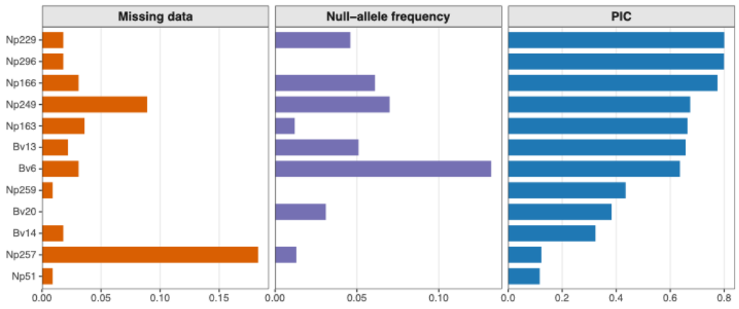

Figure S2. Comparison fo genetic diversity and inbreeding indexes between island and mainland populations

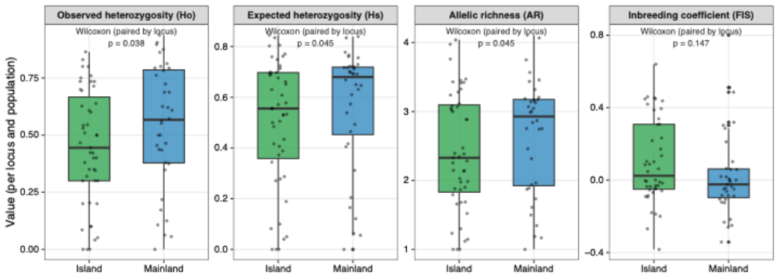

Fig S3. Discriminant Analysis of Principal Components (DAPC) scatterplot showing the distribution of individuals along the first two discriminant functions. Each point represents an individual and is colored according to population of origin 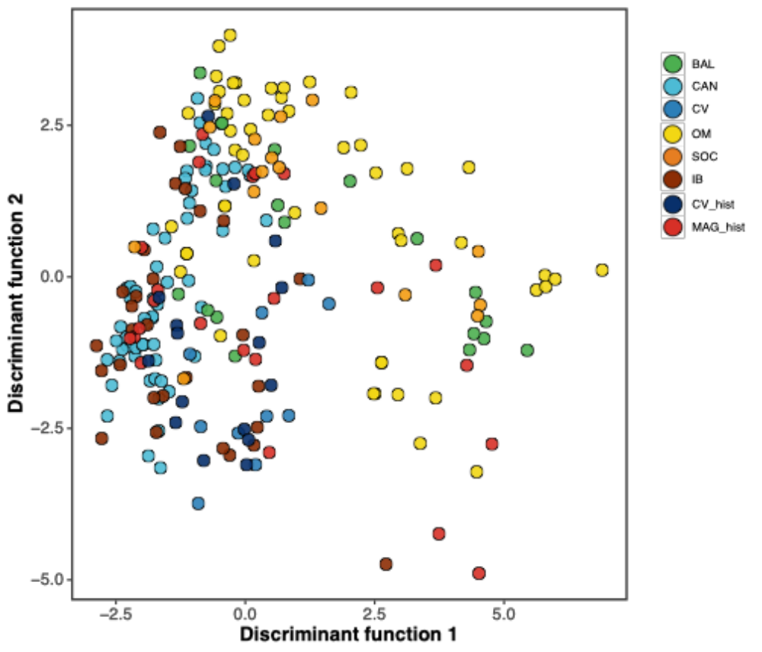
Fig S4. Population genetic structure inferred using STRUCTURE. (A) Mean log probability of the data [Ln P(D)] across K values (K = 2–10), (B) ΔK values, and (C) individual assignment probabilities for K = 2–5. Individuals are grouped by population: contemporary Cabo Verde (CV), historical Cabo Verde (CV_hist), Canary Islands (CAN), Balearic Islands (BAL), Socotra (SOC), Iberian Peninsula (IB), historical Maghreb (MAG_hist), and Oman (OM).
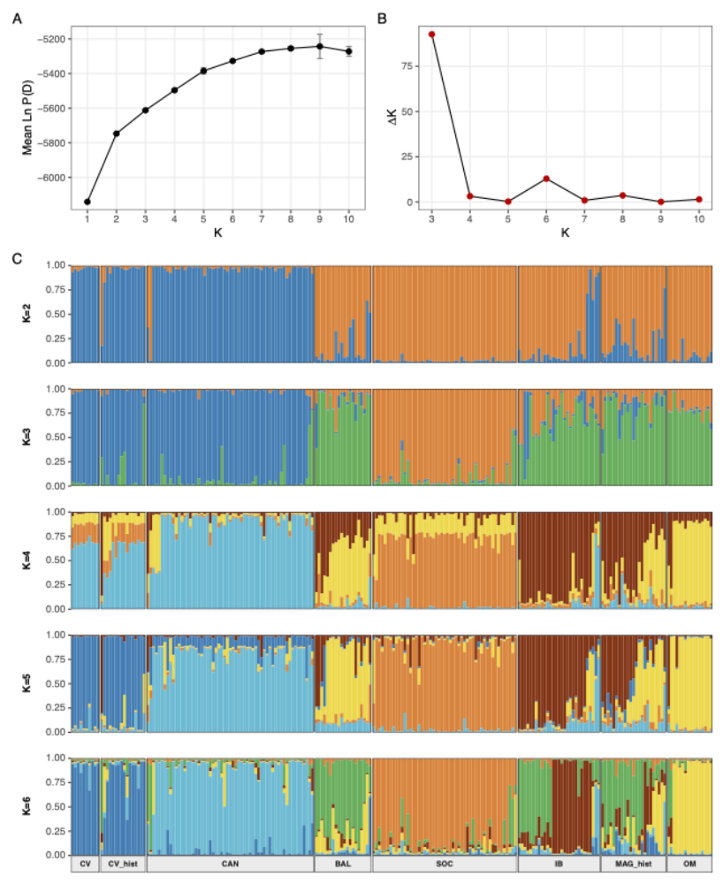

References in the Supplementary Material:
Gautschi, B., Tenzer, I. M., Mueller, J., & Schmid, B. (2001). Isolation and characterization of microsatellite loci in the Bearded Vulture (Gypaetus barbatus) and cross-amplification in three Old World vulture species. Molecular Ecology, 9, 2193–2195.
Agudo, R., Roques, S., Galarza, J. A., et al. (2008). Isolation and characterization of 18 microsatellite loci in the Egyptian vulture (Neophron percnopterus). Conservation Genetics, 9, 1345–1348. https://doi.org/10.1007/s10592-007-9486-9

