Figure 1
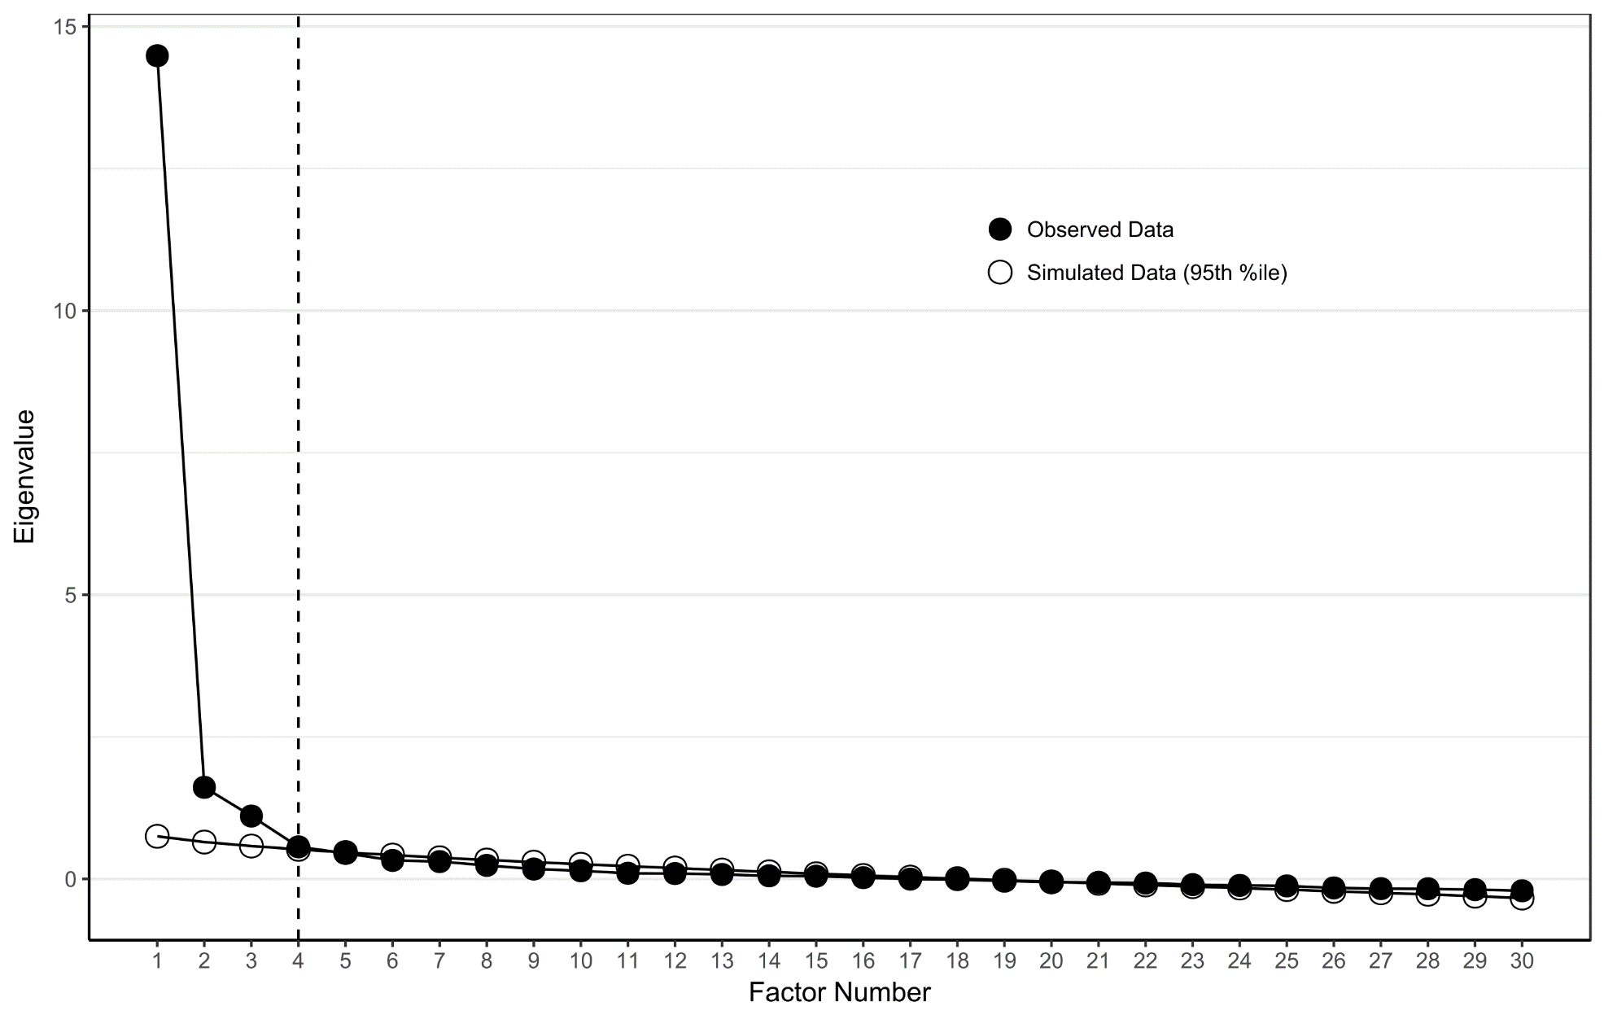
Figure S1: Scree plot with results from principal axis factor analysis for the full sample (n=361)

