Supplementary online material: Appendix A, B and C

Appendix A. Ambivalence over the expression of anger and sadness questionnaire
This questionnaire was administered twice; for anger and sadness separately.
Please indicate below how often you have these feelings. Note: answer the questions about the whole statement.
- I worry that if I express my anger/sadness, other people will not approve of me.
Never / sometimes / often / always.
- I want to express my anger/sadness honestly but I am afraid that it may cause me embarrassment or hurt.
Never / sometimes / often / always.
- Often I'd like to show my anger/sadness to others, but something seems to be holding me back.
Never / sometimes / often / always.
- I would like to be more spontaneous in expressing my anger/sadness but I just can't seem to do it.
Never / sometimes / often / always.
- I would like to express my anger/sadness more physically, but I am afraid others will get the wrong impression.
Never / sometimes / often / always.
- I try to suppress my anger/sadness, but I would like other people to know how I feel.
Never / sometimes / often / always.
- I make an effort to control my anger/sadness at all times even though I'd like to act on these feelings at times.
Never / sometimes / often / always.

Appendix B. Structural Equation Model of AEE sadness and anger

Displayed: standardized coefficients

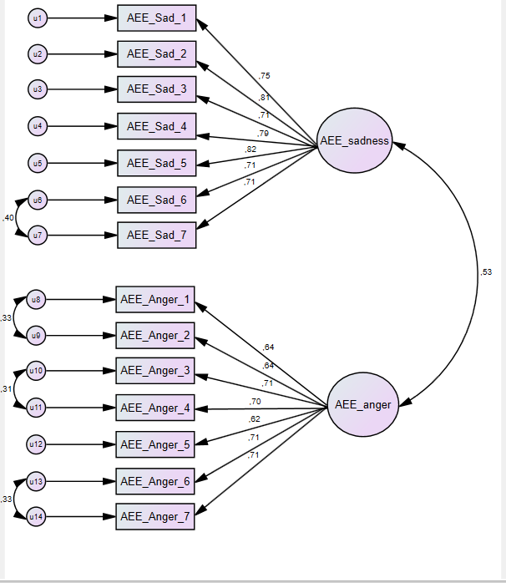

RMR = .027; CFI = .958; RMSEA = .065
Appendix C. Supplementary tables

Table 4.
Correlations of variables under study (N = 550)
 | 1 | 2 | 3 | 4 | 5 | 6 | 7
1. Male gender | –
2. Depression | -.13** | –
3. AEE sadness | -.15*** | .52*** | –
4. AEE anger | .10* | .32*** | .46*** | –
5. Need to express sadness | -.26*** | .03 | .03 | .21*** | –
6. Need to express anger | .08 | .06 | .05 | .24*** | .28*** | –
7. Age | .14** | -.16*** | -.15*** | -.04 | -.09* | .04 | –
8. Education | .06 | .10* | .05 | -.01 | .08 | .02 | .12**
* p < .05, ** p < .01, *** p < .001

Table 5.
Average scores of women (N = 368), men (N = 182) and total (N = 550)
 | Women |  | Men |  | Total |  | Effect size
 | M | SD | M | SD | M | SD | Cohen’s d
Depressive symptoms | 5.9 | 4.3 | 4.8 | 3.5 | 5.6 | 4.1 | 0.28
Ambivalence sadness | 13.6 | 4.8 | 12.1 | 4.4 | 13.1 | 4.7 | 0.36
Ambivalence anger | 13.1 | 4.3 | 12.2 | 4.0 | 12.8 | 4.2 | 0.22
Need to express sadness | 3.9 | 1.2 | 3.2 | 1.1 | 3.7 | 1.2 | 0.61
Need to express anger | 3.5 | 1.3 | 3.2 | 1.3 | 3.4 | 1.3 | 0.23

