Supplementary material

Table 6. Pooled correlations between MCQ and rumination.
 | k | Pooled r | SE | Z | p-value | tau | I²
MCQ-30
MCQ-PB_R | 2 | -0.014 | 0.310 | -0.044 | .965 | 0.187 | 97.79
MCQ-NB_R | 3 | 0.451 | 0.349 | 1.210 | .226 | 0.361 | 98.93
MCQ-CC_R | 2 | 0.051 | 0.407 | 0.125 | .900 | 0.327 | 98.72
MCQ-CT_R | 3 | 0.236 | 0.284 | 0.818 | .413 | 0.237 | 98.38
MCQ-SC_R | 2 | 0.101 | 0.369 | 0.273 | .785 | 0.268 | 98.45
Note. R = Rumination; MCQ-30 = Meta-Cognitions Questionnaire-30, MCQ-PB = positive beliefs about worry, MCQ-NB = negative beliefs about worry, MCQ-CC = cognitive confidence, MCQ-CT = need to control thoughts, MCQ-SC = self-consciousness (Wells & Cartwright-Hatton, 2004); SE = standard error; tau= between-studies variance.
Table 7. Meta-regression models testing differences between subscales.
RUMINATION
 | k | Pooled r | SE | Z | p-value | tau | I²
Positive beliefs
MCQ-PB | 2 | 0.227 | 0.022 | 10.442 | <.001 | 0.004 | 53.01%
PBRS | 13 | 0.265 | 0.027 | 10.068 | <.001
Difference |  | 0.040 | 0.035 | 1.141 | .254
Negative beliefs
MCQ-NB | 3 | 0.394 | 0.171 | 2.428 | <.05 | 0.086 | 93.19%
NBRS | 9 | 0.443 | 0.103 | 4.633 | <.001
Difference |  | 0.059 | 0.200 | 0.293 | .770
DEPRESSION
 | k | Pooled r | SE | Z | p-value | tau | I²
Positive beliefs
MCQ-PB | 19 | 0.227 | 0.022 | 10.442 | <.001 | 0.004 | 53.01%
PBRS | 12 | 0.265 | 0.027 | 10.067 | <.001
Difference |  | 0.040 | 0.035 | 1.141 | .254
Negative beliefs
MCQ-NB | 20 | 0.500 | 0.039 | 14.09 | <.001 | 0.024 | 83.19%
NBRS | 10 | 0.491 | 0.059 | 9.18 | <.001
Difference |  | -0.012 | 0.070 | -0.173 | .863

Note. Below each pooled effect size, the difference among the pooled Fisher’s Z is shown, together with a statistical test that test whether this difference is statistically relevant. Because Fisher’s Z were transformed to Pearson correlations for showing the results, this difference does not exactly correspond to the difference between correlation coefficients. NBRS = Negative Beliefs about Rumination Scale (Papageorgiou & Wells, 2001a); PBRS = Positive Beliefs about Rumination Scale (Papageorgiou & Wells, 2001b); MCQ-PB = positive beliefs about worry, MCQ-NB = negative beliefs about worry. SE = standard error; tau= between-studies variance.

Table 8. Meta-regression analyses on the correlations between the PBRS/NBRS-MCQ scales and depression to see whether there are differences among types of sample: clinical versus non-clinical.
 | k | Pooled r | SE | Z | p-value | tau | I²
PBRS/NBRS
NBRS_DEP
Clinical | 2 | 0.431 | 0.136 | 3.383 | <.001 | 0.020 | 75.65%
Non-clinical | 8 | 0.505 | 0.060 | 9.294 | <.001
Difference |  | 0.094 | 0.149 | 0.637 | .524
NBRS_R
Clinical | 3 | 0.395 | 0.073 | 5.746 | <.001 | 0.002 | 23.51%
Non-clinical | 6 | 0.492 | 0.037 | 14.556 | <.001
Difference |  | 0.122 | 0.082 | 1.489 | .136
NBRS (Uncontroll & harm)_DEP | 8 |  |  |  |  | 0.034 | 92.85%
Clinical | 2 | 0.561 | 0.141 | 3.607 | <.001
Non-clinical | 6 | 0.551 | 0.080 | 6.303 | <.001
Difference |  | -0.007 | 0.162 | -0.046 | .963
NBRS (Uncontroll & harm)_R | 7 |  |  |  |  | 0.027 | 91.87%
Clinical | 2 | 0.511 | 0.128 | 3.676 | <.001
Non-clinical | 5 | 0.683 | 0.078 | 7.600 | <.001
Difference |  | 0.122 | 0.150 | 0.816 | .415
NBRS (Social)_DEP | 8 |  |  |  |  | 0.022 | 89.18%
Clinical | 2 | 0.438 | 0.117 | 3.531 | <.001
Non-clinical | 6 | 0.478 | 0.065 | 6.846 | <.001
Difference |  | 0.033 | 0.134 | 0.246 | .806
NBRS (Social)_R | 7 |  |  |  |  | 0.011 | 81.58%
Clinical | 2 | 0.405 | 0.090 | 4.284 | <.001
Non-clinical | 5 | 0.448 | 0.052 | 8.053 | <.001
Difference |  | 0.036 | 0.104 | 0.346 | .730
PBRS_DEP | 12 |  |  |  |  | 0.0006 | 14.53%
Clinical | 3 | 0.302 | 0.048 | 6.066 | <.001
Non-clinical | 9 | 0.271 | 0.020 | 13.383 | <.001
Difference |  | -0.029 | 0.052 | -0.556 | .578
PBRS_R | 13 |  |  |  |  | 0.011 | 74.31%
Clinical | 4 | 0.422 | 0.068 | 5.896 | <.001
Non-clinical | 9 | 0.536 | 0.042 | 11.696 | <.001
Difference |  | 0.091 | 0.080 | 1.149 | .251
R_DEP | 9 |  |  |  |  | 0.026 | 89.61%
Clinical | 2 | 0.605 | 0.129 | 4.190 | <.001
Non-clinical | 7 | 0.731 | 0.065 | 9.549 | <.001
Difference |  | 0.083 | 0.145 | 0.572 | .568

MCQ
MCQ-PB_DEP | 19 |  |  |  |  | 0.006 | 59.05%
Clinical | 3 | 0.200 | 0.075 | 2.685 | <.01
Non-clinical | 16 | 0.229 | 0.025 | 9.183 | <.001
Difference |  | 0.031 | 0.080 | 0.391 | .695
MCQ-NB_DEP | 20 |  |  |  |  | 0.027 | 86.35%
Clinical | 3 | 0.432 | 0.114 | 4.058 | <.001
Non-clinical | 17 | 0.509 | 0.043 | 12.936 | <.001
Difference |  | 0.098 | 0.122 | 0.807 | .420
MCQ-CC_DEP | 16 |  |  |  |  | 0.015 | 78.58%
Clinical | 2 | 0.323 | 0.115 | 2.921 | <.05
Non-clinical | 14 | 0.350 | 0.038 | 9.718 | <.001
Difference |  | 0.030 | 0.121 | 0.250 | .802
MCQ-CT_DEP | 19 |  |  |  |  | 0.032 | 88.47%
Clinical | 3 | 0.436 | 0.121 | 3.859 | .230
Non-clinical | 16 | 0.408 | 0.048 | 9.068 | <.001
Difference |  | -0.033 | 0.130 | -0.254 | .800
MCQ-SC_DEP | 16 |  |  |  |  | 0.023 | 85.00%
Clinical | 2 | 0.134 | 0.132 | 1.026 | .305
Non-clinical | 14 | 0.224 | 0.045 | 5.109 | <.001
Difference |  | 0.093 | 0.139 | 0.668 | .504
Note. DEP = Depression; R = Rumination; NBRS = Negative Beliefs about Rumination Scale (Papageorgiou & Wells, 2001a); PBRS = Positive Beliefs about Rumination Scale (Papageorgiou & Wells, 2001b); MCQ-30 = Meta-Cognitions Questionnaire-30, MCQ-PB = positive beliefs about worry, MCQ-NB = negative beliefs about worry, MCQ-CC = cognitive confidence, MCQ-CT = need to control thoughts, MCQ-SC = self-consciousness (Wells & Cartwright-Hatton, 2004). SE = standard error; tau= between-studies variance.

Table 9. Meta-regression analyses on the correlations between the PBRS/NBRS-MCQ scales and depression to see whether the percentage of women has an impact.
 | k | Pooled (R) | SE | Z | p-value | tau | I²
PBRS/NBRS
NBRS_DEP | 10 |  |  |  |  | 0.013 | 65.42%
Intercept |  | 0.554 | 0.047 | 11.701 | <.001
% Female |  | -0.011 | 0.006 | -1.916 | .055
NBRS_R | 9 |  |  |  |  | 0.006 | 46.54%
Intercept |  | 0.499 | 0.041 | 12.235 | <.001
% Female |  | -0.003 | 0.005 | -0.589 | .556
NBRS (Uncontroll & harm)_DEP | 8 |  |  |  |  | 0.025 | 89.98%
Intercept |  | 0.519 | 0.061 | 8.544 | <.001
% Female |  | -0.009 | 0.006 | -1.440 | .150
NBRS (Uncontroll & harm)_R | 7 |  |  |  |  | 0.032 | 92.48%
Intercept |  | 0.559 | 0.071 | 7.845 | <.001
% Female |  | -0.001 | 0.007 | -0.111 | .912
NBRS (Social)_DEP | 8 |  |  |  |  | 0.014 | 83.63%
Intercept |  | 0.451 | 0.048 | 9.419 | <.001
% Female |  | -0.008 | 0.005 | -1.657 | .098
NBRS  (Social)_R | 7 |  |  |  |  | 0.008 | 75.20%
Intercept |  | 0.414 | 0.040 | 10.302 | <.001
% Female |  | -0.005 | 0.004 | -1.199 | .231
PBRS_DEP | 12 |  |  |  |  | 0.001 | 28.41%
Intercept |  | 0.269 | 0.021 | 12.712 | <.001
% Female |  | -0.0002 | 0.003 | -0.074 | .941
PBRS_R | 13 |  |  |  |  | 0.011 | 73.69%
Intercept |  | 0.469 | 0.036 | 13.002 | <.001
% Female |  | 0.005 | 0.004 | 1.061 | .288
R_DEP | 9 |  |  |  |  | 0.017 | 83.91%
Intercept |  | 0.625 | 0.049 | 12.701 | <.001
% Female |  | -0.011 | 0.005 | -2.032 | .042 (<.05)
MCQ
MCQ-PB_DEP | 19 |  |  |  |  | 0.006 | 58.49%
Intercept |  | 0.230 | 0.024 | 9.424 | <.001
% Female |  | -0.0001 | 0.002 | -0.041 | .968
MCQ-NB_DEP | 20 |  |  |  |  | 0.016 | 77.92%
Intercept |  | 0.561 | 0.033 | 16.912 | <.001
% Female |  | 0.011 | 0.004 | 2.985 | .003 (<.01)
MCQ-CC_DEP | 16 |  |  |  |  | 0.009 | 66.92%
Intercept |  | 0.370 | 0.030 | 12.484 | <.001
% Female |  | 0.007 | 0.003 | 2.283 | .022 (<.05)
MCQ-CT_DEP | 19 |  |  |  |  | 0.020 | 82.00%
Intercept |  | 0.456 | 0.038 | 12.152 | <.001
% Female |  | 0.011 | 0.004 | 2.734 | .006 (<.01)
MCQ-SC_DEP | 16 |  |  |  |  | 0.022 | 82.98%
Intercept |  | 0.223 | 0.042 | 5.354 | <.0001
% Female |  | 0.003 | 0.004 | 0.790 | .430
Note. DEP = Depression; R = Rumination; NBRS = Negative Beliefs about Rumination Scale (Papageorgiou & Wells, 2001a); PBRS = Positive Beliefs about Rumination Scale (Papageorgiou & Wells, 2001b); MCQ-30 = Meta-Cognitions Questionnaire-30, MCQ-PB = positive beliefs about worry, MCQ-NB = negative beliefs about worry, MCQ-CC = cognitive confidence, MCQ-CT = need to control thoughts, MCQ-SC = self-consciousness (Wells & Cartwright-Hatton, 2004). SE = standard error; tau= between-studies variance.

Table 10. Pooled correlation matrix obtained in the first stage of the TSSEM approach.
 | PBRS | R | NBRS (Uncontroll & harm) | NBRS (Social) | DEP
PBRS | 1
Rumination | .414 | 1
NBRS (Uncontroll & harm) | .235 | .560 | 1
NBRS (Social) | .141 | .429 | .622 | 1
Depression | .263 | .603 | .549 | .466 | 1
Note. PBRS= Positive Beliefs about Rumination Scale (Papageorgiou & Wells, 2001b); NBRS= Negative Beliefs about Rumination Scale (Papageorgiou & Wells, 2001a).

Figure 3. Funnel plots.
A) Correlations between positive Beliefs about Rumination Scale and Depression
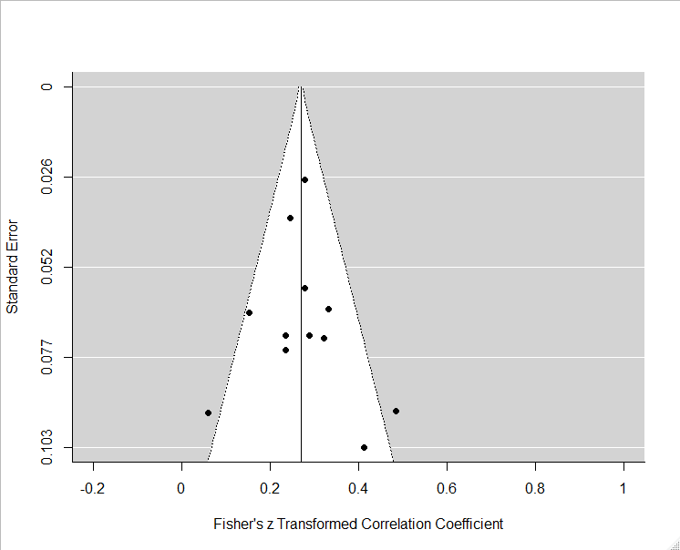
B) Correlations between positive Beliefs about Rumination Scale and Rumination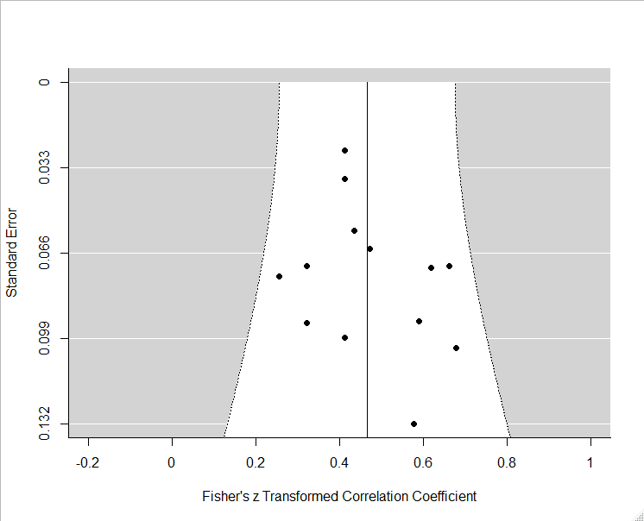

C) Correlations between negative Beliefs about Rumination Scale and Depression
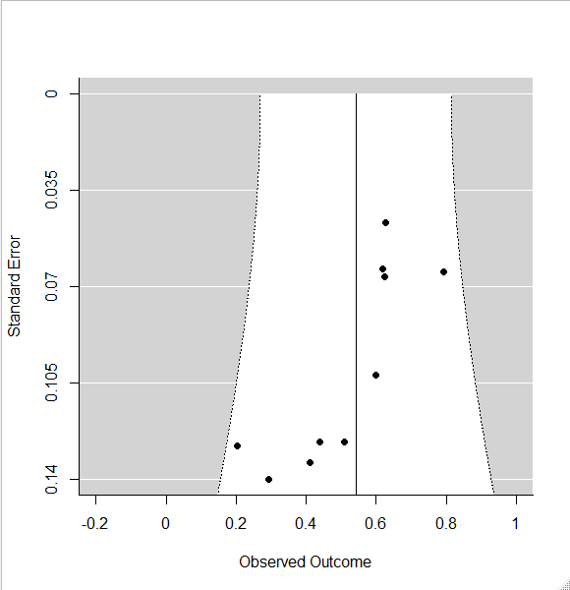
D) Correlations between Negative Beliefs about Rumination Scale and Rumination

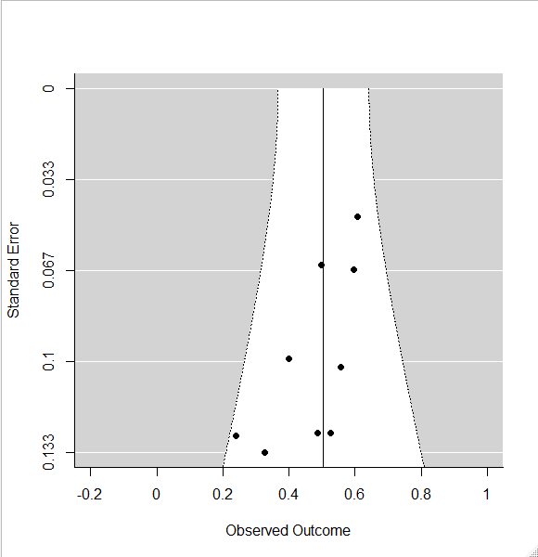

E) Correlation between Metacognitions Questionnaire, Positive Beliefs subscale and Depression
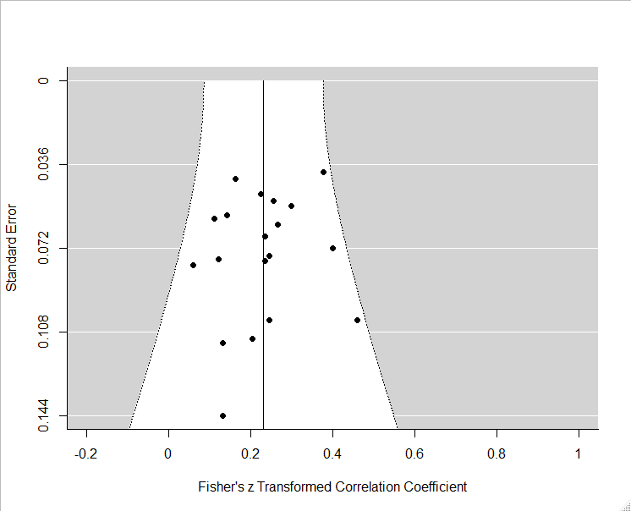

F) Correlation between Metacognitions Questionnaire, Negative Beliefs subscale and Depression
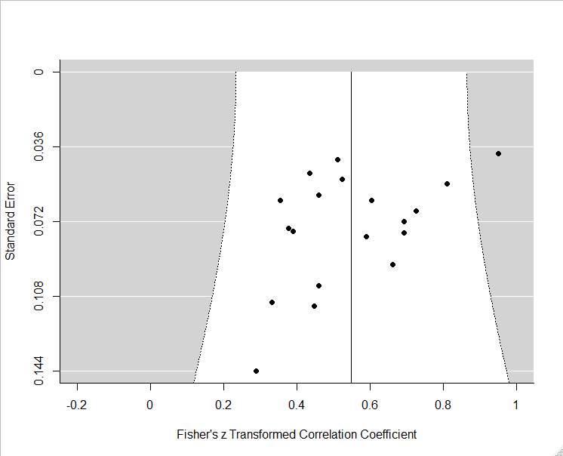

G) Correlation between Metacognitions Questionnaire, Cognitive Control subscale and Depression
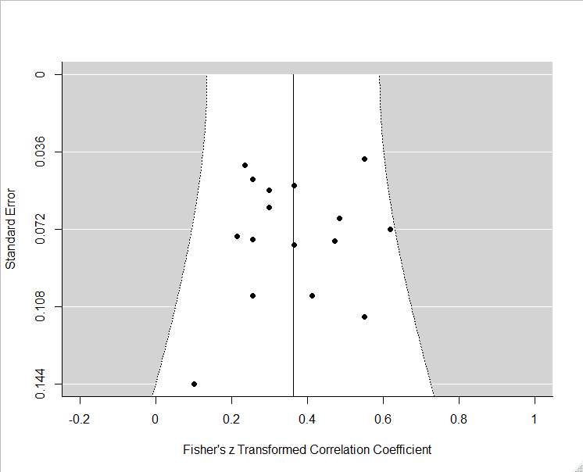

H) Correlation between Metacognitions Questionnaire, need to control thoughts subscale and Depression
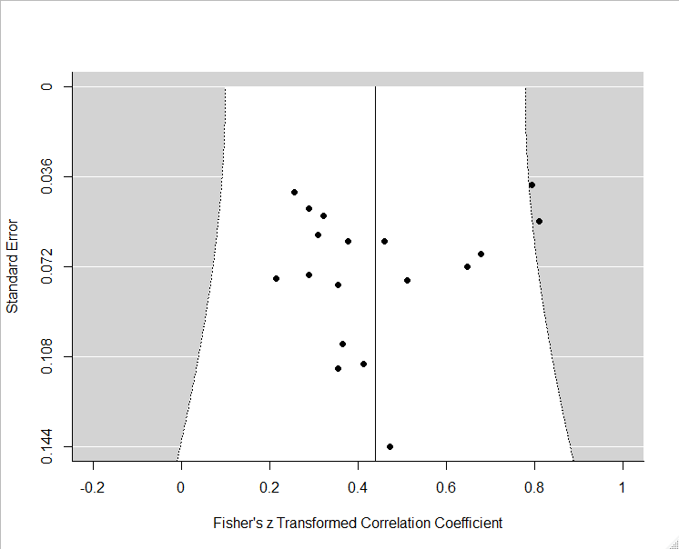

I) Correlation between Metacognitions Questionnaire, Self-Consciousness subscale and Depression
