Supplementary Online Materials

Appendix A
Full PsycInfo Search

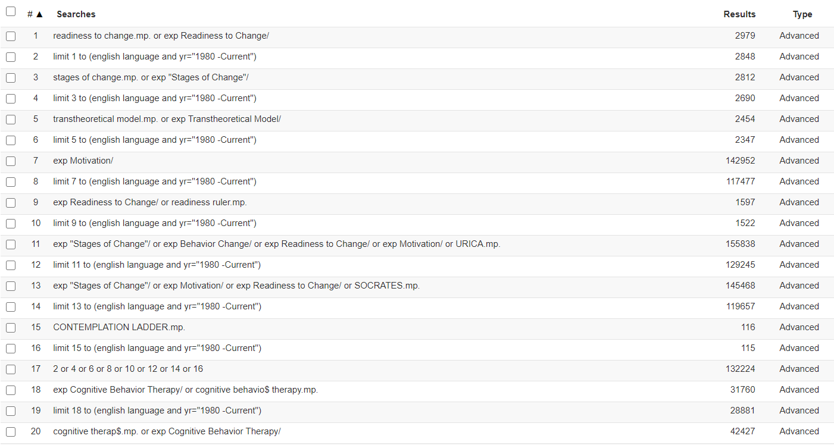
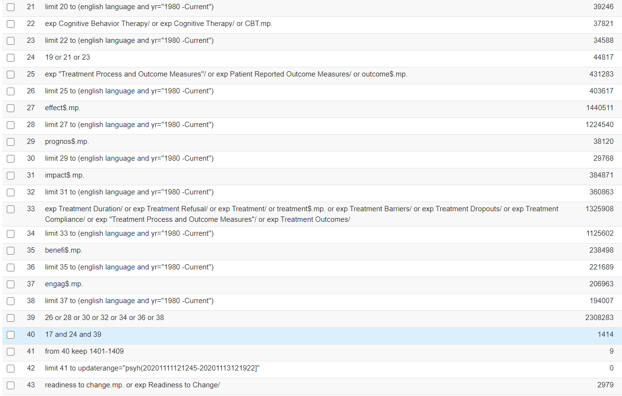
Appendix 2
Appendix B
Detailed Title/Abstract and Full Text Screening Criteria

Detailed Title/Abstract Screening Criteria
All titles and abstracts were screened against the following exclusion criteria. They were excluded if ANY of the following applied. If there is no reason for exclusion at this stage progress to full text screening.

Criteria
Study does not include a CBT arm. At this stage studies that do not include an active psychological intervention at all, or which include an active intervention other than CBT are excluded. Excluded studies include those offering derivatives of CBT (e.g. MBCT, ACT, DBT, CST, BA, CBSAP) and those offering alternative psychotherapeutic interventions (e.g. psychodynamic psychotherapy, peer support, counselling). If the details of the psychotherapeutic intervention are unclear from the abstract the paper should be progressed to full-text screening.
The population under investigation is not defined by the presence of a mental health problem. Studies are excluded if the population of interest is defined by the presence of an addictive behaviour (e.g., to gambling, pornography, smoking) or other forms of substance abuse / dependence. Studies are excluded if the population under investigation is defined by the presence of traumatic brain injury, chronic pain, insomnia, physical health problems including diabetes, cancer, obesity, sexual dysfunction or other similar conditions. Studies on forensic populations are excluded due to the likelihood of different drivers of motivations for treatment in these populations.
The clinical target of the intervention is not a mental health problem. Studies where the clinical target is related to an addictive behaviour (e.g., craving, abstinence), are excluded.
The study does not include original data (e.g., a commentary, opinion piece or protocol), or was a qualitative study, a case study or case series, a cross-sectional study or a review.

Detailed Full Text Screening Criteria
Exclude if:
1. Meets title/abstract exclusion criteria (if includes people with dual diagnosis outcome and readiness measures must relate to non-substance misuse outcomes)
2. Study does not include a measure of motivational readiness linked to transtheoretical model of stages of change
Eligible measures including, but not limited to ....URICA, Change Questionnaire, Stages of Change Questionnaire/Scale, Anorexia Nervosa/Bulimia Nervosa Stages of Change Questionnaire, Readiness Ruler, etc
Ineligible measures: measures such as Nijmegen Motivation List (NML/NML-2/NML-child version), Willingness Scale, or measures focused on Treatment Expectancy, Treatment Credibility, Treatment Efficacy or Importance, or Therapeutic Alliance/Resistance, etc)
3. Measure of motivational readiness is not taken prior to intervention or session 1 (initial measure must be taken at baseline or session 1 only)
4. Study does not include a CBT intervention (note: ERP included for OCD spectrum disorders). CBT plus medication or CBT as main psychological treatment in context of inpatient admission where there are other adjunctive psychological interventions included. Combined CBT and Motivational interviewing not included. Unguided (pure self-help) CBT bibliotherapy not included.
5. Study does not report analysis which directly examines link between motivational readiness and outcome/engagement. NOTE: if study includes multiple treatment arms comprising a CBT treatment arm and other non-CBT treatment arms analysis must either examine the association between motivational readiness and CBT outcome separately or examine the overall association across treatment arms and report the interaction between motivation and treatment arm on outcome.
3. No measure of clinical symptoms post intervention or engagement with intervention symptom outcome, attendance, duration of treatment etc included- e.g. needs to have one or the other to be included, but does not need both.
6. No original data included

