Supplementary Material

Article title: Modulating the value of positive feedback does not influence expectation change in major depression – What can be learned from a failed replication?

Additional Variables
Dispositional Optimism. To control for dispositional optimism as potential confounding variable, we measured dispositional optimism using the Life Orientation Test Revised (LOT-R) (Glaesmar et al., 2008). The LOT-R compromises 10 items with a 5-point Likert scale ranging from 0 to 4. The sum score ranges between 0 and 40, with high values indicating high dispositional optimism. Internal Consistency in the present sample was α=.695.
Socio-demographics. We assessed age, sex, education and employment status using a short self-report questionnaire.
Furthermore, we assessed additional diagnosis given by the hospital, duration of inpatient treatment, late (age > 21) vs. early (age < 21) onset, number of depressive episodes, date of survey (summer vs. winter).
Additional sample characteristics
Additional sample characteristics are depicted in table A.1.
Table A.1.
Additional sociodemographic characteristics
Variable | Immunization  Enhancing group (n= 34) | Immunization  Inhibition group (n=36) | No-task  control group  (n= 33) | Distraction control group  (n=36)
LOT-R score, M (SD) | 16.15 (4.22) | 17.25 (4.56) | 14.97 (4.53) | 15.22 (4.40)
Diagnosis, N (%)
Non-persistent MDD | 21 (61.8) | 18 (50.0) | 18 (54.5) | 19 (52.8)
PDD | 13 (38.2) | 18 (50.0) | 15 (45.5) | 17 (47.2)
Hospital diagnosis, N (%)
MDD only | 34 (100) | 34 (96) | 31 (94) | 34 (95)
Agoraphobia | 0 (0) | 1 (2) | 0 (0) | 0 (0)
Panic disorder | 0 (0) | 1 (2) | 2 (6) | 0 (0)
PTSD | 0 (0) | 0 (0) | 0 (0) | 2 (5)
Onset of MDD, N (%)
early | 13 (38) | 14 (39) | 13 (36) | 20 (56)
late | 21 (62) | 21 (58) | 18 (58) | 15 (42)
missing | 0 (0) | 1 (3) | 2 (6) | 1 (2)
Number of depressive Episodes, M (SD) | 2.8 (1.7) | 2.8 (2.7) | 3.7 (4.7) | 3.4 (3.1)
Date of Survey, N (%)
winter | 21 (62) | 23 (64) | 17 (52) | 22 (61)
summer | 13 (38) | 13 (36) | 16 (58) | 14 (39)
Note. M, mean; SD, standard deviation; N, number; LOT-R, Life Orientation Test Revised; MDD, Major depressive disorder; PDD, Persistent depressive disorder; MDD, major depressive disorder; PTSD, post-traumatic stress disorder; early onset < age 21, late onset > age 21

Check for Baseline Differences
The groups did not differ in age (F (3, 135) = 0.43; p = .988; η²_{p} = .001, 95%CI [0 - 0]), sex χ²(3) = 1.00, p = .800, education level χ²(15) = 6.53, p = .969, employment status χ²(18) = 23.72, p = .164, treatment duration (F (3, 135) = 0.31; p = .819; η²_{p} = .007, 95%CI [0 – 0.33]) and BDI-II scores (F (3, 135) = 0.30; p = .823; η²_{p} = .007, 95%CI [0 - .33]), LOT-R scores (F (3, 135) = 1.92; p = .130; η²_{p} = .041, 95%CI [0- .106]), Diagnosis (χ²(3) = 1.16, p = .762), Onset of MDD (χ²(3) = 2.84, p = .417), Number of depressive Episodes (F (3, 116) = 0.81; p = .489; η²_{p} = .021, 95%CI [0 – 0.07]), Date of survey χ²(3) = 1.27, p = .736, initial task-specific expectations (F (3, 135) = 0.58; p = .632; η²_{p} = .013, 95%CI [0- .051]) and initial generalized expectations (F (3, 135) = 0.55; p = .648; η²_{p} = .012, 95%CI [0- .050]).
Main Analyses: Data visualization
Per group
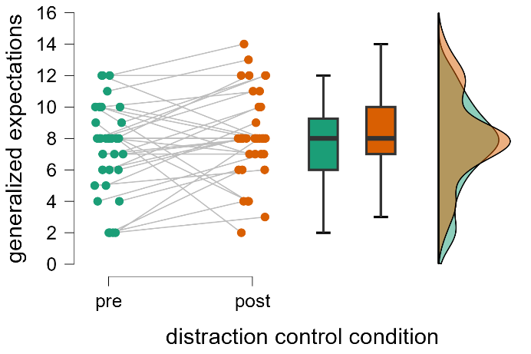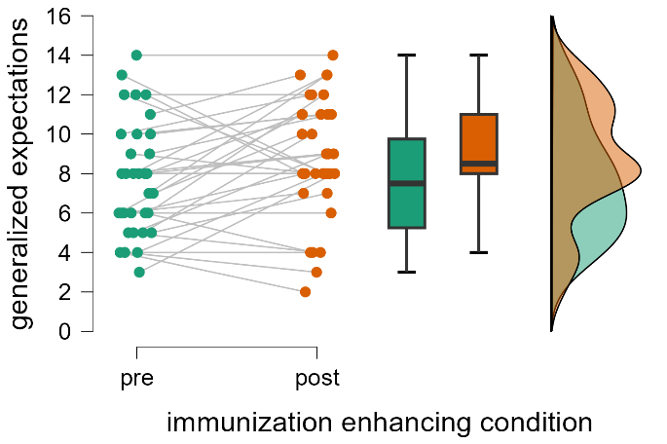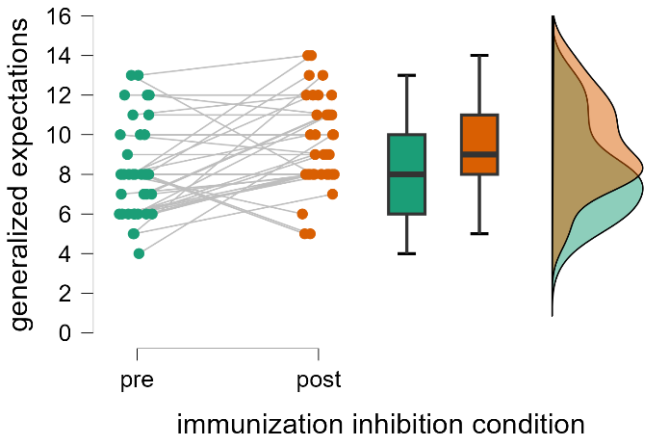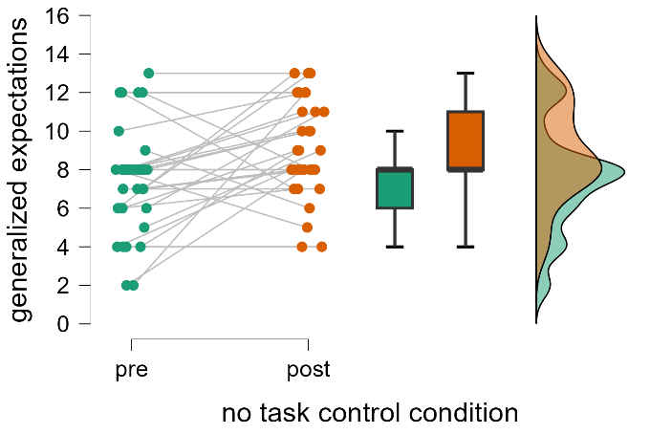
Pre to Post
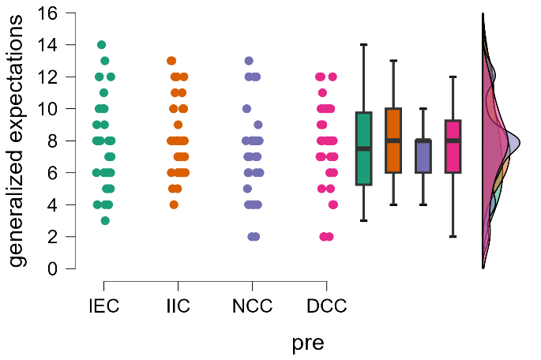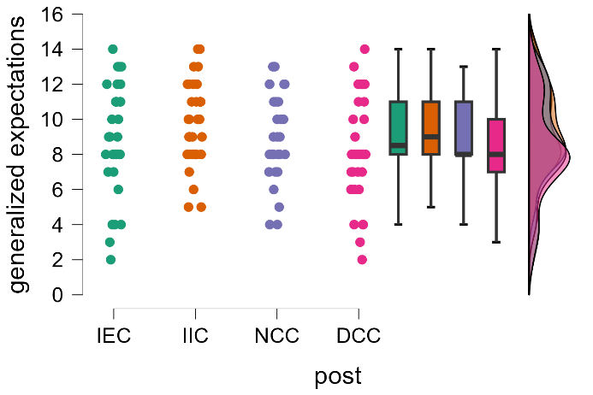

Main analyses: Changes in task-specific expectations
To our surprise, the four groups did not significantly differ in the extent to which they updated their task specific expectations, as indicated by a non-significant Time by Condition interaction, F (3, 135) = 0.794; p = .499; η²_{p} = 0.017; 95%CI [0, 0.062]. Overall, participants updated their task specific expectations in a positive direction, as indicated by a significant main effect of Time, F (1, 135) = 86.964; p < .001; η²_{p} = .391; 95%CI [.267, .494]. As expected, the main effect of Condition was not significant, F (3, 135) = 0.702; p = .553; η²_{p} = .015; 95%CI [0, .058].
Additional Analyses: task specific expectations
Other than in generalized expectations, there was a significant correlation of interpretation and task-specific expectation update (r = -.193; p = .023). Similarly, there was a significant correlation of memory error and task-specific expectation update (r = .203; p = .018).
Similar to generalized expectations symptom severity was significantly correlated with more negative baseline (generalized) expectations (r = .249; p < .003), but not with less change of generalized expectations (r = .044; p = .606).
Therefore, we also reran the main analysis with baseline expectations as a covariate. As the main effect for group remained insignificant, F (3, 134) = 0.994, p = .398, η²_{p}= .022; 95%CI [0, .071], differences in task-specific baseline expectations can be ruled out as a confounding factor. Since depressive symptoms – similar to generalized expectations- were related to more negative task-specific baseline expectations, we also computed the partial correlation between depressive symptoms and expectation update, while controlling for baseline expectations, which was significant (r = -.190; p < .025), indicating that higher depressive symptoms were associated with reduced task-specific expectation update.
Exploratory analysis for potentially confounding variables
To generate additional hypotheses for the failure of the manipulation, we conducted several additional exploratory analyses. These analyses did not reveal any factors that could account for the non-significant group differences in expectation update.
After controlling for following covariates in generalized expectation update, the time x group interaction remained not significant: symptom severity according to BDI-II (F (3, 134) = 0.499; p = .281; η²_{p} = .011), number of depressive episodes (F (3, 108) = 0.811; p = .009; η²_{p} = .024), age (F (3, 134) = 0.833; p = .478; η²_{p} = .018), treatment duration (F (3, 134) = 0.501; p = .682; η²_{p} = .011) and dispositional optimism (F (3, 134) = 0.539; p = .657; η²_{p} = .012). Regarding subgroup analyses for generalized expectations interaction was not significant for: early onset (F (3, 56) = 0.734; p = .536; η²_{p} = .038) and late onset (F (3, 71) = 0.349; p = .790; η²_{p} = .015), female (F (3, 84) = 0.563; p = .641; η²_{p} = .020) and male (F (3, 47) = 0.222; p = .881; η²_{p} = .014), surveys conducted in summer (F (3, 52) = 0.041; p = .989; η²_{p} = .002) and winter (F (3, 79) = 1.425; p = .242; η²_{p} = .051).
Same accounts for task-specific expectations. After controlling for following covariates in, the time x group interaction remained not significant: symptom severity according to BDI-II (F (3, 134) = 0.821; p = .484; η²_{p} = .018), number of depressive episodes (F (3, 108) = 0.882; p = .453; η²_{p} = .024), age (F (3, 134) = 0.558; p = .644; η²_{p} = .012), treatment duration (F (3, 134) = 0.760; p = .519; η²_{p} = .017) and dispositional optimism (F (3, 134) = 0.978; p = .405; η²_{p} = .021). Similar Subgroup analyses for task-specific expectations revealed that the time x group interaction was not significant for: early onset (F (3, 56) = 0.391; p = .760; η²_{p} = .021) and late onset (F (3, 71) = 1.507; p = .220; η²_{p} = .060), female (F (3, 84) = 0.787; p = .504; η²_{p} = .027) and male (F (3, 47) = 1.024; p = .904; η²_{p} = .012), for surveys conducted in summer (F (3, 52) = 0.321; p = .817; η²_{p} = .018) and winter (F (3, 79) = 0.567; p = .639; η²_{p} = .021).
References
Glaesmer, H., Hoyer, J., Klotsche, J., & Herzberg, P. Y. (2008). Die deutsche version des Life-Orientation-Tests (LOT-R) zum dispositionellen Optimismus und Pessimismus. Zeitschrift für Gesundheitspsychologie, 16(1), 26-31.

