Supplementary Material

Hierarchical regression with demographic variables
The demographic variables (e.g. international site, sex assigned at birth, and educational attainment) were categorical and thus were dummy coded for the hierarchical regression. Dummy coding consisted of creating a variable per category (e.g. site 1, site 2), and a value of 1 or 0 was assigned if participants met that category or not. Each of these dummy coded variables was added into the hierarchal regression model: five for international site, 1 for sex assigned at birth, 6 for educational attainment).
In step 1 of the regression analysis, negative beliefs about the self and other, and demographic factors (e.g. international site, age, sex assigned at birth, and educational attainment) were entered as the independent variables and IU was entered as the dependent variable. In step 2, of the regression analysis, all of the interpersonal trauma types were entered as the independent variables.
Supplementary Table 1. Summary of hierarchical regression analysis
 | IU
Predictors | R² | F | DF | ∆ R² | β
Step 1. | .23** | 64.33 | 12, 2489
Negative beliefs about self, negative beliefs about others, international site, sex assigned at birth, and educational attainment
Step 2. |  | 7.315 | 4, 2489 | .009**
Negative beliefs about self, negative beliefs about others, international site, sex assigned at birth, and educational attainment
Emotional Neglect |  |  |  |  | .06*
Psychological Abuse |  |  |  |  | .04
Physical Abuse |  |  |  |  | .01
Sexual Abuse |  |  |  |  | .02
Note: constructs were measured using the four independent questions for the trauma experiences (emotional neglect, psychological abuse, physical abuse, and sexual abuse), the IU-12 (IU) and BCSS (negative beliefs about self and others). * p = .005.

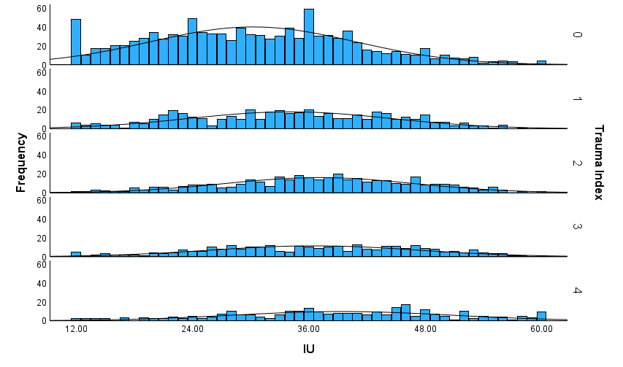
Supplementary Fig 1. A visual representation of how the trauma index varies by IU scores. A higher trauma index is associated with higher IU scores. 0 (M = 30.86, SD = 10.60), 1 (M = 34.04, SD = 10.45), 2 (M = 37.09, SD = 9.77), 3 (M = 36.55, SD = 10.70), 4 (M = 39.43, SD = 11.26). This figure serves to allow for comparisons of IU in other populations (community, clinical). Trauma Index = the number of interpersonal trauma types (emotional neglect, psychological abuse, physical abuse, sexual abuse) experienced (0,1,2,3,4). IU = intolerance of uncertainty measured via the IU-12.

