Supplement 2: Network Centrality, Stability, and Node Predictability
To identify the most central nodes in the network, the expected influence of each node in the network was estimated (Robinaugh et al., 2016) using the R-package networktools (Version 1.4.0; Jones, 2018). Expected influence is defined as the sum of all edges extending from a given node (maintaining the sign of each edge). Note that the expected influence centrality estimate is more appropriate than alternatives (e.g., strength centrality, which uses absolute values of edge weights) when the network contains both positive and negative edges (Robinaugh et al., 2016). Importantly, the expected influence values and standard deviations (SDs) of the individual nodes in the estimated network were not significantly correlated in the present study (r = .30, p = .300). The expected influence and the means of the nodes were also not significantly correlated (r = .17, p = .500). This indicates that the centrality of the nodes was not driven by the differential node variability or averages.
Figure S1 shows the centrality (i.e., expected influence) of each node in the network model. The expected influence estimates indicate that co-dampening was the most central node in the network, whereas rejection sensitivity was the least central node. With respect to interpretation processes, centrality difference tests (see Figure S2) suggested that negative interpretation inflexibility was significantly more connected to other nodes within the network than positive interpretation bias. There was no difference in centrality between negative interpretation inflexibility and negative interpretation bias.
The robustness of the network estimates was examined through network stability analyses (Epskamp et al., 2018) using the R-package bootnet (Version 1.5). Specifically, the stability of the edge weights was estimated by constructing a 95% CI around each edge weight using nonparametric bootstrapping with 1000 re-samples (see Figure S3) and performing bootstrapped edge weights difference tests (see Figure S4). Additionally, the stability of the expected influence was estimated using case-dropping bootstrapping with 1000 samples (see Figure S5). The correlation stability (CS) coefficient was calculated as an index for network stability. CS refers to the percentage of cases that can be dropped while maintaining a sufficiently high correlation between the set of edges in the network based on the full and sub-sample. The stability of the expected influence was .67, which is well above the .25 minimum threshold recommended by Epskamp et al. (2018).
The predictability of each node in the network is the proportion of variance (R²) in that node which can be explained by all nodes adjacent to it (Haslbeck & Fried, 2017; Haslbeck & Waldorp, 2018). High predictability, on average, across nodes indicates that the network is largely determined by itself through strong mutual interactions, whereas low average predictability indicates that the network is mostly determined by other factors that are not included in the network (Haslbeck & Waldorp, 2018). Figure S6 shows the network predictability plot. The average predictability of the nodes was .58, suggesting that 58% of the variance of a node not predicted by the intercept model is explained by its neighbors in the network (Haslbeck & Fried, 2017)

Figure S1
Centrality Plot Expected Influence
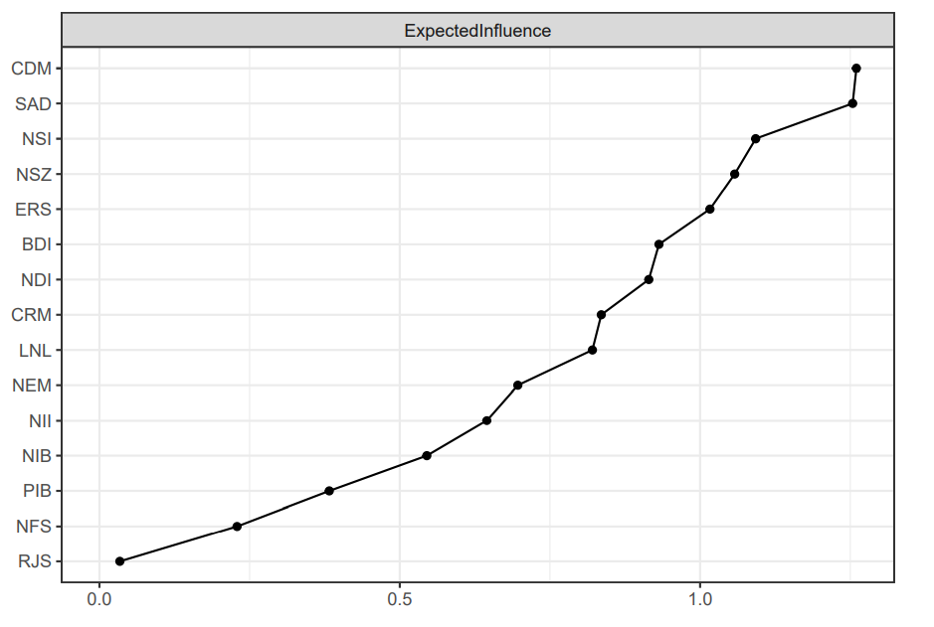
Note. CDM = Co-Dampening. SAD = Social Anxiety. NSI = Negative Social Interactions. NSZ = Network Size. ERS = Excessive Reassurance-Seeking. BDI = Depression. NDI = Network Diversity. CRM = Co-Rumination. LNL = Loneliness. NEM = Number of Embedded Networks. NII = Negative Interpretation Inflexibility. NIB = Negative Interpretation Bias. PIB = Positive Interpretation Bias. NFS = Negative Feedback-Seeking. RJS = Rejection Sensitivity.

Figure S2
Centrality Difference Test

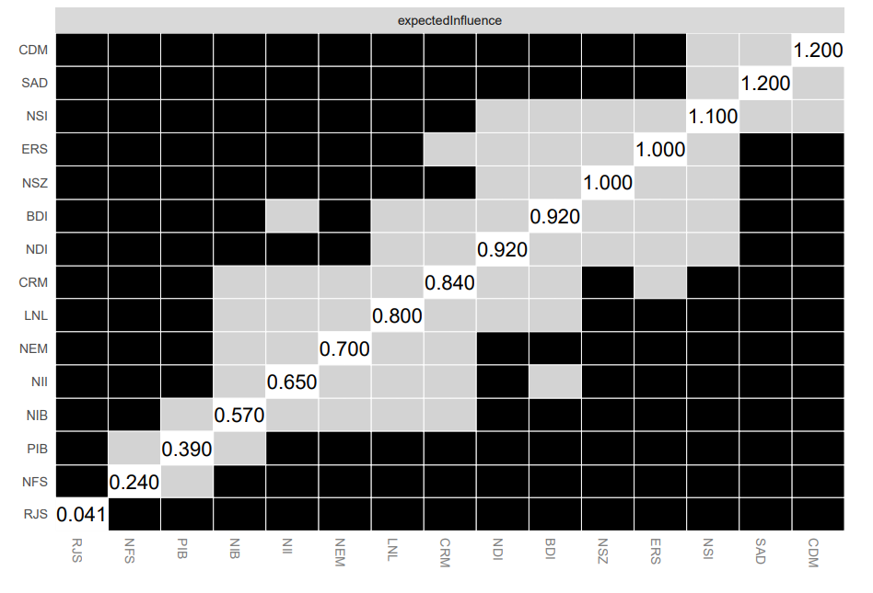Note. Gray boxes represent nodes or edges that are not significant and black boxes represent nodes or edges that are significant. NII = Negative Interpretation Inflexibility. NIB = Negative Interpretation Bias. PIB = Positive Interpretation Bias. BDI = Depression. SAD = Social Anxiety. RJS = Rejection Sensitivity. NFS = Negative Feedback-Seeking. ERS = Excessive Reassurance-Seeking. CRM = Co-Rumination. CDM = Co-Dampening. NSI = Negative Social Interactions. LNL = Loneliness. NDI = Network Diversity. NSZ = Network Size. NEM = Number of Embedded Networks.

Figure S3
Edge Weight Stability Analysis
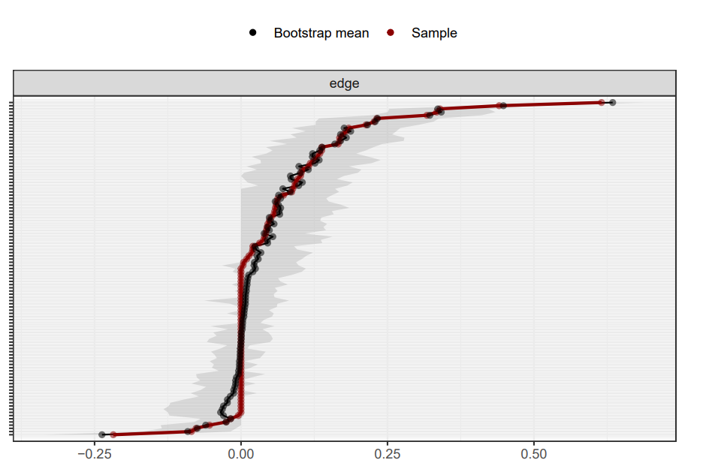
Note. The edge weight stability is .67.

Figure S4
Edge Weight Difference Test
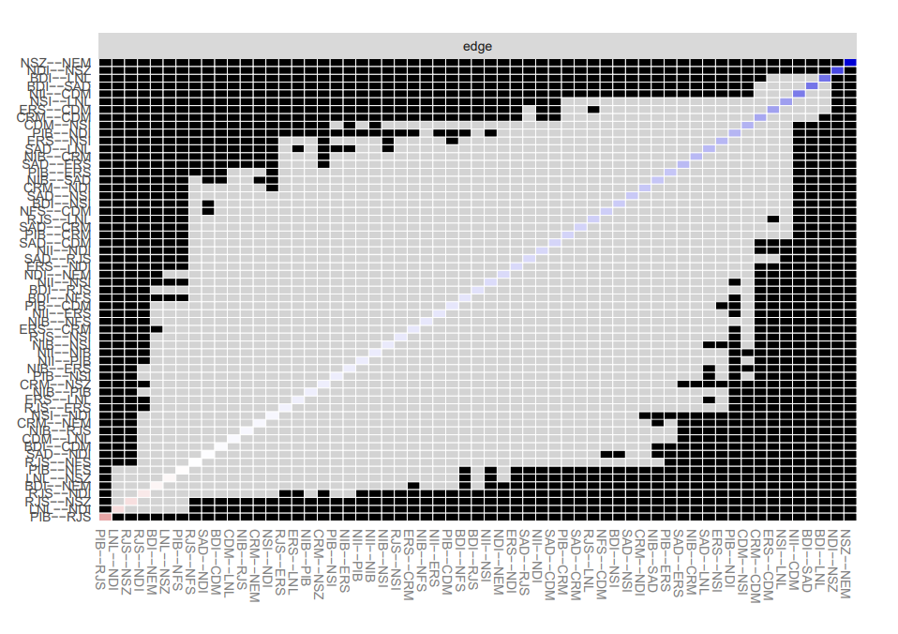
Note. Gray boxes represent nodes or edges that are not significant and black boxes represent nodes or edges that are significant. NIB = Negative Interpretation Bias. PIB = Positive Interpretation Bias. BDI = Depression. SAD = Social Anxiety. RJS = Rejection Sensitivity. NFS = Negative Feedback-Seeking. ERS = Excessive Reassurance-Seeking. CRM = Co-Rumination. CDM = Co-Dampening. NSI = Negative Social Interactions. LNL = Loneliness. NDI = Network Diversity. NSZ = Network Size. NEM = Number of Embedded Networks.

Figure S5
Centrality Stability Analysis
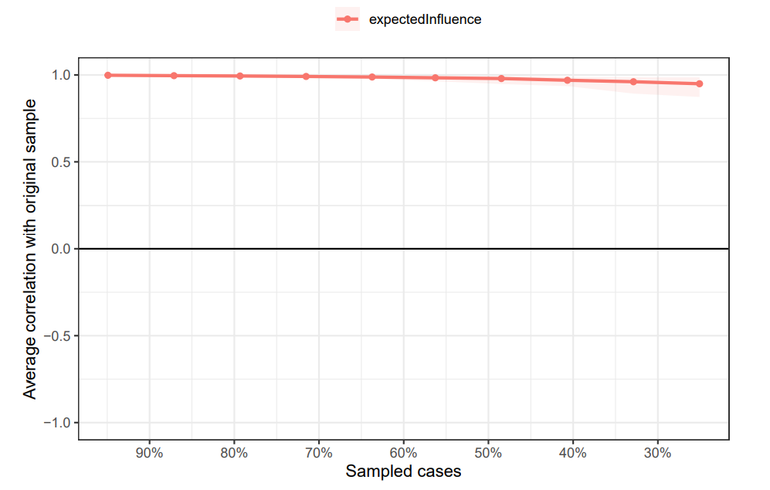
Note. The stability of the expected influence is .67.

Figure S6
Network Predictability Plot
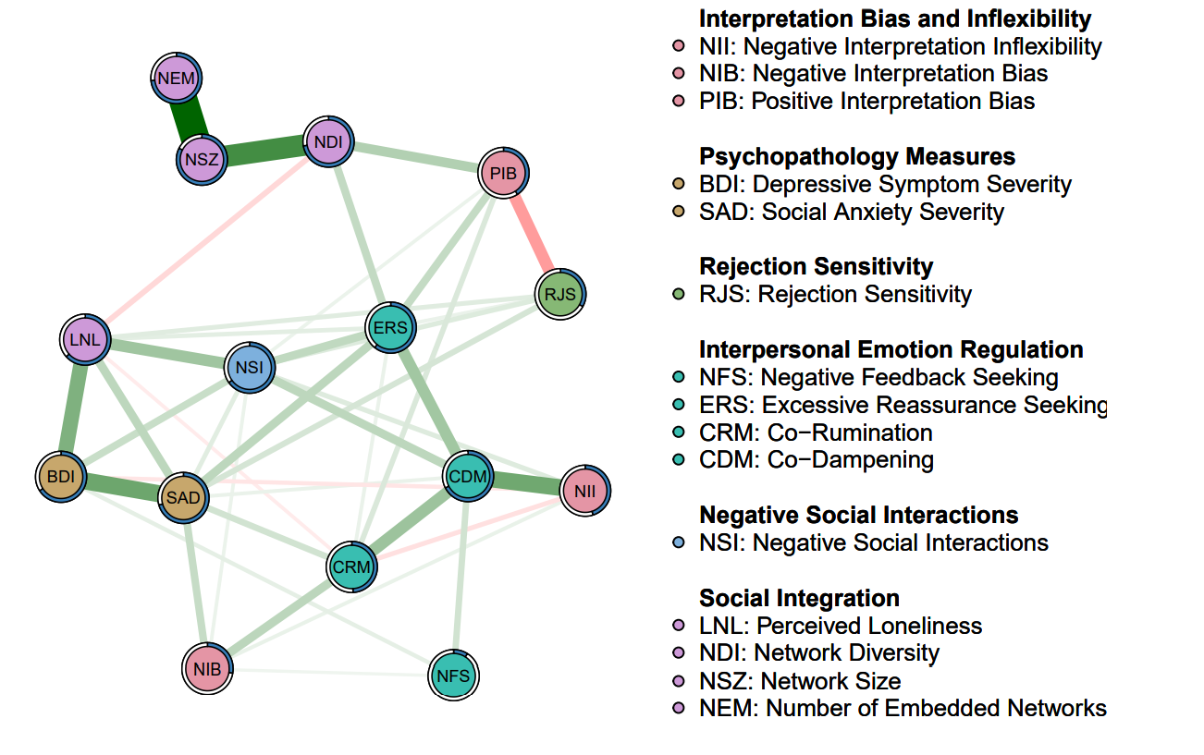
Note. Green edges indicate positive associations, whereas red edges indicate negative associations.

References
Epskamp, S., Borsboom, D., & Fried, E. I. (2018). Estimating psychological networks and their accuracy: A tutorial paper. Behavior Research Methods, 50(1), 195-212. https://doi.org/10.3758/s13428-017-0862-1
Haslbeck, J. M. B., & Fried, E. I. (2017). How predictable are symptoms in psychopathological networks? A reanalysis of 18 published datasets. Psychological Medicine, 47(16), 2767-2776. https://doi.org/10.1017/S0033291717001258
Haslbeck, J. M. B., & Waldorp, L. J. (2018). How well do network models predict observations? On the importance of predictability in network models. Behavior Research Methods, 50(2), 853-861. https://doi.org/10.3758/s13428-017-0910-x
Jones, P. (2018). networktools: Tools for identifying important nodes in networks.
Robinaugh, D. J., Millner, A. J., & McNally, R. J. (2016). Identifying highly influential nodes in the complicated grief network. Journal of Abnormal Psychology, 125(6), 747-757. https://doi.org/10.1037/abn0000181

