Appendix A: Technical Implementation of the Ergodicity Information Index (EII) proposed by Golino et al. (2025).

Core Formula
The EII is defined as:

$$EEI=\sqrt{F_{P}+1}∙(\frac{K_{X}}{K_{P*}})∙ln⁡(L_{v})$$

Where:
F_{P} = number of latent factors (communities) in the group-level network
K_{X} = Kolmogorov complexity of the multiplex network (individual networks)
K_{P*} = Kolmogorov complexity of the group-level network (prime-weight encoded)
L_{v} = number of unique edges in the multiplex network.

Kolmogorov Complexity Approximation
We approximate Kolmogorov complexity by compressing the weighted edge list using the memCompress() function (base R, Gzip algorithm). The estimate is the length of the compression of the string formed by their edge list. Final complexity estimates are computed as the average over 5,000 random permutations of the edge list.

Prime-Weight Encoding
Each individual network (layer) in the multiplex is assigned a distinct prime number. A shared edge across networks i,j is encoded as the product of the primes corresponding to layers in which the edge appears. This transformation preserves the multiplex structure in a single matrix while ensuring identifiability.

Bootstrap Significance Testing
We used a permutation-based bootstrap procedure (n = 5,000) to generate the null distribution of the EII under the assumption that all individuals are drawn from a single ergodic process. The empirical p-value reflects the proportion of simulated EIIs that exceed the observed value.

Software
All steps are implemented in version 2.3.0 of the EGAnet package (Golino & Christensen, 2022) available for the R statistical programming language.

Appendix B: Robustness Check of Group-Level Network Estimation

Stacking individual observations and treating them as independent is only one approach to estimating the group-level covariance matrix. To test whether our findings depend on the specific method used to estimate the group-level network, we replicated the analysis using an alternative aggregation procedure based on Fisher Z-transformed averaging of individual correlation matrices, weighted by the number of observations available for each subject. The resulting group-level matrix was then subjected to the same regularization procedure (graphical LASSO) to obtain a group-level network structure. The resulting matrix was back-transformed and substituted into the dynEGA object in place of the pooled data-based group-level correlation matrix. The Ergodicity Information Index (EII) and its bootstrap significance were then re-computed using this alternative group-level structure.

The bootstrap test again indicated that the empirical group-level structure did not preserve the information content of the individual networks, i.e., the empirical EII of 1.209 was not significantly different from the EEI of 1.202 that would have been expected under structural ergodicity. These results support the conclusion that a single pooled network structure fails to adequately represent person-specific dynamics, regardless of the aggregation method used.

Appendix C: Full Model Coefficients for Multinomial Regression Model of Baseline Characteristics for Different Clusters

Predictors include the following MEDI scales: Neurotic temperament (neurotic), Positive temperament (positive), Depression (depression), Autonomic arousal (arousal), Somatic anxiety (somatic), Intrusive cognition (intrusive), Traumatic reexperiencing (traumatic), Avoidance (avoidance); the following PID5-BF+M scales: Negative affect (negaff), Antagonism (antagonism), Disinhibition (disinhib), Anankastia (anankast), Psychoticism (psychot); ICD-10 diagnostic codes: F3X, F4X, F5X, F6X.

Following the guidelines proposed by Chen, Cohen, and Chen (2010), the effect size of an odds ratio (OR) can be interpreted as follows: ORs from 1.68 are considered “small”, from 3.47 “medium”, and from 6.71 “large” effects.

Uncertainty estimates (95% equal-tailed confidence intervals), standard errors, and two-tailed p-values were computed using a Wald normal distribution approximation.

Table C1: Multinomial regression coefficients predicting Cluster 2 vs. Cluster 1 membership.
Predictor | Odds Ratio | SE | 95% CI | z | p-value
(Intercept) | 5.08 | 10.45 | [0.09, 286.24] | 0.79 | 0.430
neurotic | 1.94 | 0.57 | [1.09, 3.47] | 2.26 | 0.024
positive | 1.25 | 0.40 | [0.67, 2.34] | 0.71 | 0.477
depression | 0.42 | 0.12 | [0.24, 0.72] | -3.17 | 0.002
arousal | 0.45 | 0.13 | [0.26, 0.78] | -2.84 | 0.004
somatic | 0.87 | 0.23 | [0.52, 1.46] | -0.53 | 0.597
intrusive | 0.75 | 0.22 | [0.42, 1.33] | -0.99 | 0.323
traumatic | 2.18 | 0.52 | [1.37, 3.48] | 3.28 | 0.001
avoidance | 4.27 | 1.65 | [2.00, 9.12] | 3.74 | < .001
negaff | 0.54 | 0.21 | [0.26, 1.14] | -1.62 | 0.106
antagonism | 0.16 | 0.09 | [0.05, 0.50] | -3.18 | 0.001
disinhib | 0.81 | 0.34 | [0.36, 1.84] | -0.51 | 0.610
anankast | 0.46 | 0.14 | [0.25, 0.85] | -2.49 | 0.013
psychot | 1.29 | 0.54 | [0.57, 2.93] | 0.61 | 0.544
F3 (depr. dx) | 0.24 | 0.14 | [0.08, 0.73] | -2.53 | 0.012
F4 (anx. dx) | 0.24 | 0.16 | [0.07, 0.85] | -2.21 | 0.027
F5 (ED dx) | 0.31 | 0.23 | [0.07, 1.35] | -1.56 | 0.119
F6 (PD dx) | 0.28 | 0.21 | [0.06, 1.22] | -1.69 | 0.090

Table C2. Multinomial regression coefficients predicting Cluster 3 vs. Cluster 1 membership.
Predictor | Odds Ratio | SE | 95% CI | z | p-value
(Intercept) | 617.91 | 1553.46 | [4.48, 85287.55] | 2.56 | 0.011
neurotic | 0.55 | 0.21 | [0.26, 1.17] | -1.55 | 0.122
positive | 0.33 | 0.14 | [0.15, 0.75] | -2.66 | 0.008
depression | 0.52 | 0.19 | [0.25, 1.07] | -1.79 | 0.074
arousal | 0.96 | 0.36 | [0.46, 2.02] | -0.10 | 0.918
somatic | 0.17 | 0.09 | [0.06, 0.46] | -3.50 | < .001
intrusive | 1.05 | 0.47 | [0.44, 2.51] | 0.12 | 0.907
traumatic | 1.23 | 0.37 | [0.68, 2.23] | 0.67 | 0.500
avoidance | 3.48 | 2.01 | [1.12, 10.78] | 2.16 | 0.031
negaff | 0.81 | 0.40 | [0.31, 2.11] | -0.42 | 0.671
antagonism | 1.71 | 1.07 | [0.50, 5.84] | 0.86 | 0.389
disinhib | 1.41 | 0.63 | [0.59, 3.40] | 0.77 | 0.439
anankast | 0.86 | 0.32 | [0.42, 1.79] | -0.40 | 0.691
psychot | 1.51 | 0.72 | [0.59, 3.85] | 0.85 | 0.394
F3 (depr. dx) | 0.29 | 0.26 | [0.05, 1.69] | -1.38 | 0.169
F4 (anx. dx) | 0.99 | 0.96 | [0.15, 6.63] | -0.01 | 0.991
F5 (ED dx) | 1.11 | 1.06 | [0.17, 7.18] | 0.11 | 0.912
F6 (PD dx) | 0.94 | 1.17 | [0.08, 10.76] | -0.05 | 0.961

Appendix D. Network plots and node centrality metrics of the five structurally ergodic subgroups.

Figure D1. Network plot for the first cluster.

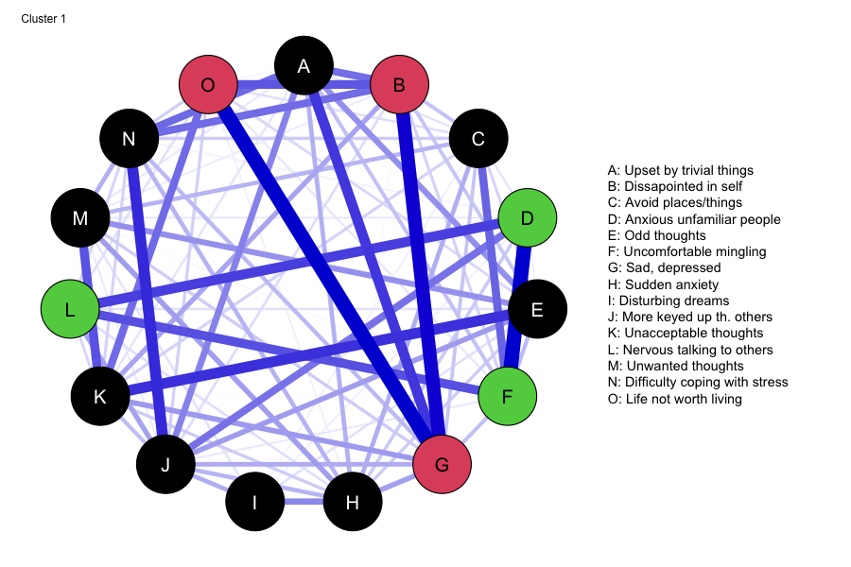
Table D1. Node centralities of the first cluster.
Symptom | Betweenness | Closeness | Strength | Expected Influence
Upset by trivial things | 1 | 0.004 | 0.786 | 0.786
Disappointed in self | 3 | 0.004 | 0.860 | 0.860
Avoid places/things | 4 | 0.004 | 0.539 | 0.539
Anxious unfamiliar people | 5 | 0.004 | 0.642 | 0.642
Odd thoughts | 6 | 0.004 | 0.697 | 0.697
Uncomfortable mingling | 11 | 0.004 | 0.755 | 0.755
Sad, depressed | 11 | 0.005 | 1.067 | 1.067
Sudden anxiety | 6 | 0.004 | 0.658 | 0.658
Disturbing dreams | 0 | 0.003 | 0.232 | 0.232
More keyed up than others | 18 | 0.005 | 0.893 | 0.893
Unacceptable thoughts | 5 | 0.004 | 0.813 | 0.813
Nervous talking to others | 0 | 0.003 | 0.529 | 0.529
Unwanted thoughts | 4 | 0.004 | 0.568 | 0.568
Difficulty coping with stress | 4 | 0.005 | 0.763 | 0.763
Life not worth living | 2 | 0.004 | 0.709 | 0.709

Figure D2. Network plot for the second cluster.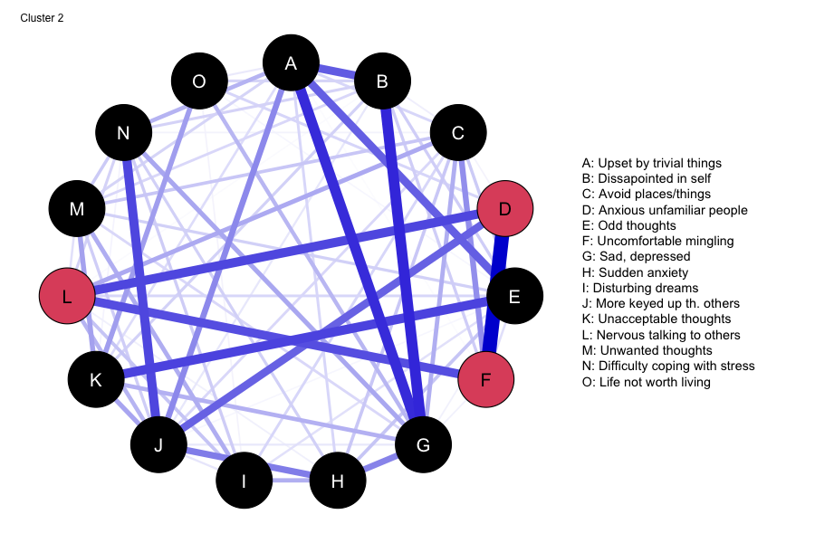
Table D2. Node centralities of the second cluster.
Symptom | Betweenness | Closeness | Strength | Expected Influence
Upset by trivial things | 13 | 0.005 | 0.946 | 0.946
Disappointed in self | 0 | 0.004 | 0.719 | 0.719
Avoid places/things | 2 | 0.004 | 0.604 | 0.604
Anxious unfamiliar people | 17 | 0.005 | 0.731 | 0.731
Odd thoughts | 4 | 0.004 | 0.705 | 0.705
Uncomfortable mingling | 3 | 0.004 | 0.718 | 0.718
Sad, depressed | 12 | 0.005 | 1.001 | 1.001
Sudden anxiety | 4 | 0.005 | 0.554 | 0.554
Disturbing dreams | 2 | 0.003 | 0.378 | 0.378
More keyed up than others | 23 | 0.006 | 0.948 | 0.948
Unacceptable thoughts | 8 | 0.005 | 0.652 | 0.652
Nervous talking to others | 2 | 0.004 | 0.738 | 0.738
Unwanted thoughts | 3 | 0.003 | 0.532 | 0.532
Difficulty coping with stress | 0 | 0.005 | 0.620 | 0.620
Life not worth living | 0 | 0.003 | 0.297 | 0.297

Figure D3. Network plot of the third cluster.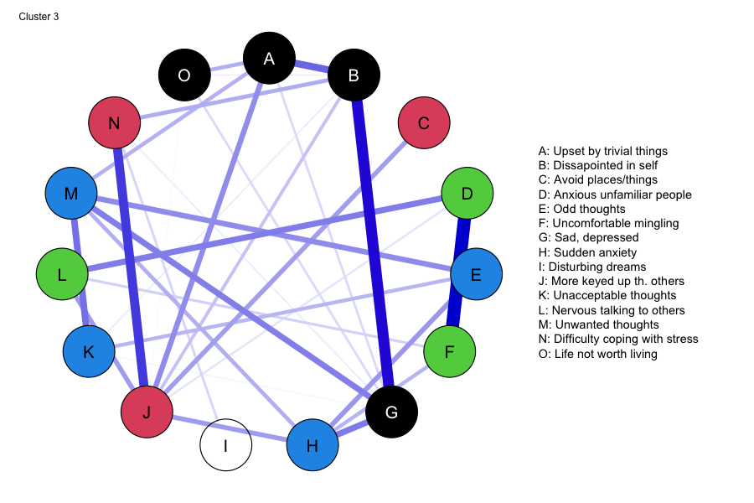
Table D3. Node centralities of the third cluster.
Symptom | Betweenness | Closeness | Strength | Expected Influence
Upset by trivial things | 22 | 0.003 | 0.328 | 0.328
Disappointed in self | 10 | 0.003 | 0.418 | 0.418
Avoid places/things | 0 | 0.002 | 0.068 | 0.068
Anxious unfamiliar people | 7 | 0.002 | 0.334 | 0.334
Odd thoughts | 0 | 0.002 | 0.208 | 0.208
Uncomfortable mingling | 6 | 0.002 | 0.306 | 0.306
Sad, depressed | 12 | 0.003 | 0.442 | 0.442
Sudden anxiety | 18 | 0.003 | 0.346 | 0.346
Disturbing dreams | 0 | 0.001 | 0.028 | 0.028
More keyed up than others | 39 | 0.003 | 0.502 | 0.502
Unacceptable thoughts | 0 | 0.002 | 0.175 | 0.175
Nervous talking to others | 12 | 0.002 | 0.195 | 0.195
Unwanted thoughts | 16 | 0.002 | 0.389 | 0.389
Difficulty coping with stress | 13 | 0.003 | 0.246 | 0.246
Life not worth living | 0 | 0.002 | 0.093 | 0.093

Figure D4. Network plot of the fourth cluster.

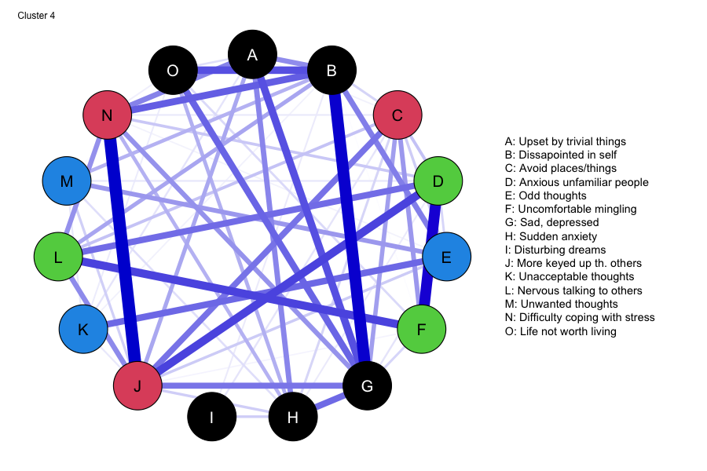
Table D4. Node centralities of the fourth cluster.
Symptom | Betweenness | Closeness | Strength | Expected Influence
Upset by trivial things | 0 | 0.004 | 0.622 | 0.622
Disappointed in self | 35 | 0.005 | 0.999 | 0.999
Avoid places/things | 0 | 0.004 | 0.579 | 0.579
Anxious unfamiliar people | 6 | 0.004 | 0.725 | 0.725
Odd thoughts | 13 | 0.004 | 0.502 | 0.502
Uncomfortable mingling | 1 | 0.003 | 0.590 | 0.590
Sad, depressed | 25 | 0.005 | 1.065 | 1.065
Sudden anxiety | 13 | 0.004 | 0.546 | 0.546
Disturbing dreams | 0 | 0.002 | 0.083 | 0.083
More keyed up than others | 17 | 0.005 | 1.042 | 1.042
Unacceptable thoughts | 0 | 0.003 | 0.228 | 0.228
Nervous talking to others | 5 | 0.004 | 0.640 | 0.640
Unwanted thoughts | 0 | 0.003 | 0.271 | 0.271
Difficulty coping with stress | 10 | 0.005 | 0.888 | 0.888
Life not worth living | 0 | 0.004 | 0.465 | 0.465

Figure D5. Network plot of the fifth cluster.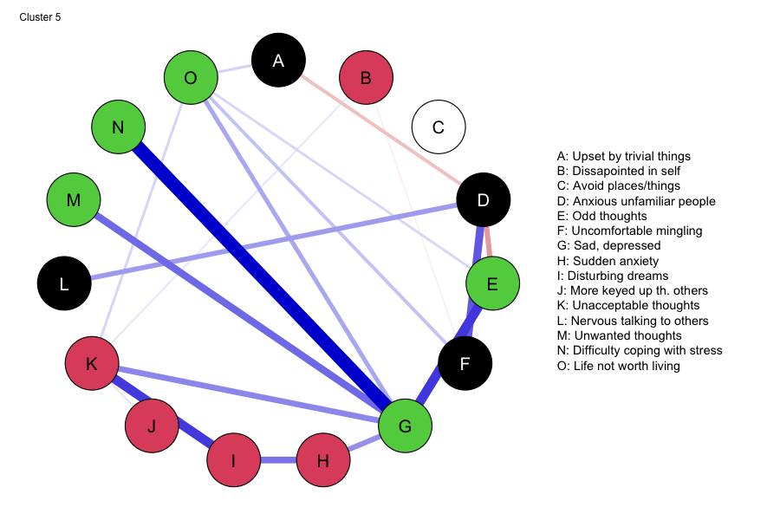

Table D5. Node centralities of the fifth cluster.
Symptom | Betweenness | Closeness | Strength | Expected Influence
Upset by trivial things | 0 | 0.001 | 0.079 | -0.014
Disappointed in self | 0 | 0.001 | 0.027 | 0.006
Avoid places/things | 0 | 0 | 0.000 | 0.000
Anxious unfamiliar people | 30 | 0.002 | 0.325 | 0.079
Odd thoughts | 31 | 0.003 | 0.262 | 0.109
Uncomfortable mingling | 2 | 0.002 | 0.183 | 0.161
Sad, depressed | 53 | 0.003 | 0.737 | 0.737
Sudden anxiety | 0 | 0.002 | 0.186 | 0.186
Disturbing dreams | 3 | 0.002 | 0.260 | 0.260
More keyed up than others | 0 | 0.001 | 0.018 | 0.018
Unacceptable thoughts | 31 | 0.003 | 0.309 | 0.309
Nervous talking to others | 0 | 0.002 | 0.074 | 0.074
Unwanted thoughts | 0 | 0.002 | 0.114 | 0.114
Difficulty coping with stress | 0 | 0.003 | 0.231 | 0.231
Life not worth living | 0 | 0.002 | 0.199 | 0.199

Table D6. Node centralities for the population model.
Symptom | Betweenness | Closeness | Strength | Expected Influence
Upset by trivial things | 9 | 0.005 | 0.768 | 0.768
Disappointed in self | 1 | 0.004 | 0.859 | 0.859
Avoid places/things | 2 | 0.003 | 0.528 | 0.528
Anxious unfamiliar people | 9 | 0.004 | 0.662 | 0.662
Odd thoughts | 3 | 0.004 | 0.650 | 0.650
Uncomfortable mingling | 4 | 0.003 | 0.703 | 0.703
Sad, depressed | 18 | 0.005 | 1.060 | 1.060
Sudden anxiety | 14 | 0.004 | 0.631 | 0.631
Disturbing dreams | 0 | 0.003 | 0.220 | 0.220
More keyed up than others | 28 | 0.005 | 0.924 | 0.924
Unacceptable thoughts | 4 | 0.003 | 0.679 | 0.679
Nervous talking to others | 0 | 0.003 | 0.578 | 0.578
Unwanted thoughts | 0 | 0.003 | 0.488 | 0.488
Difficulty coping with stress | 8 | 0.004 | 0.741 | 0.741
Life not worth living | 5 | 0.004 | 0.565 | 0.565

References for the appendix

Chen, H., Cohen, P., & Chen, S. (2010). How Big is a Big Odds Ratio? Interpreting the Magnitudes of Odds Ratios in Epidemiological Studies. Communications in Statistics - Simulation and Computation, 39(4), 860–864. https://doi.org/10.1080/03610911003650383
Golino, H., & Christensen, A. P. (2022). EGAnet: Exploratory Graph Analysis – A framework for estimating the number of dimensions in multivariate data using network psychometrics. https://cran.r-project.org/web/packages/EGAnet/
Golino, H., Nesselroade ,John, & and Christensen, A. P. (2025). Toward a Psychology of Individuals: The Ergodicity Information Index and a Bottom-up Approach for Finding Generalizations. Multivariate Behavioral Research, 1–28. https://doi.org/10.1080/00273171.2025.2454901

