Supplementary Material
Table S.1
Description of treatment arms
Treatment arm | Brief description / core targets (examples) | n
Schema therapy | - Transdiagnostic psychological treatment  - Exploration of pre-dominant schemas and modes  - Change of early maladaptive schemas and dysfunctional and maladaptive modes by applying specific interventions such as mode dialogues on chairs, imagery rescripting, validation and empathic confrontation, and limited reparenting  - Strategies for transfer and relapse prevention | 20
Cognitive behavioral therapy | - Psychoeducation  - Behavioral activation  - Modification of dysfunctional attitudes and automatic thoughts  - Social competence training  - Relapse prevention | 18
Individual supportive therapy | - Active and nonspecific approach  - techniques being supportive, applying an understanding and acknowledging conversational style, calming assertions, putting the focus on perceiving progress, or using interested inquiries  - three pillars: the patients’ personal resources, the therapeutic alliance between him/her and the therapist, and the focus on emotions | 21
Note. N = 59 included in data analysis.

Table S.2
Wordings of all EMA Items
EMA Item Construct | Item Wording  (German Original) | Item Wording  (English Translation)
Loss of interest | Hast du gerade das Gefühl, zu nichts mehr Lust zu haben? | Do you feel like you don't want to do anything anymore?
Withdrawal | Ziehst du dich gerade von  sozialen Kontakten oder Aktivitäten zurück? | Are you currently withdrawing from social contacts or activities?
Psychomotor agitation /inhibition | Fühlst du dich gerade besonders  körperlich gehemmt oder aktiviert? | Are you feeling particularly physically inhibited or agitated?
Mood* | Wie fühlst du dich? | How are you feeling?
Difficulties in emotion regulation (DER)* | Fällt es Dir gerade schwer mit negativen Gefühlen umzugehen? | Are you having a hard time dealing with negative emotions right now?
Psychological stress | Hast Du seit der letzten Befragung etwas erlebt, das dich belastet hat? | Since the last survey, have you experienced anything that has caused you mental distress?
Repetitive Negative Thinking
(RNT)
Repetitiveness of RNT* | Dieselben negative Gedanken gehen mir immer  und immer wieder durch den Kopf. | The same negative thoughts keep going through my mind again and again.
Uncontrollability of RNT* | Ich hänge an bestimmten negativen Gedanken fest und kann mich nicht davon lösen. | I get stuck on certain negative thoughts and can’t move on.
Intrusiveness RNT* | Negative Gedanken tauchen auf, ohne dass ich dies will. | Negative thoughts come to my mind without me wanting them to.
Subjective burden through RNT* | Ich fühle mich durch  negative Gedanken beeinträchtigt. | I feel weighted down by negative thoughts.
Note. * Based on theoretical and methodological considerations, only these six EMA items were included in the network analysis;
therefore, RNT was represented by the mean score of the four items. The response scale of all EMA items, except for the mood
item, was two-stepped. Participants responded to a binary yes-no scale. If yes was selected, a five-point Likert scale followed,
which assessed the extent of agreement (labeling: not at all, a bit, moderately, considerably, very much). The mood item was
rated by selecting one of five emojis (recoded indicating: very bad, bad, moderate, good, very good). For further details on the
development of the EMA items, the designated timeframe of each EMA prompt, and the use of semi-randomized reminders to
encourage prompt completion, see Tamm et al. (2024).

Assumption Checks and Robustness for the (Quasi-)Stationary Two-Step mlVAR

Rationale and Scope
Our primary focus was to estimate the short-term (lag-1) associations among daily processes (i.e., repetitive negative thinking (RNT), mood, difficulties in emotion regulation (DER), and activity) over a six-week period based on daly aggregated data. To prevent slow improvement under active treatment or other external factors from contaminating short-lag dynamics, we removed linear time trends where present and then estimated a two-step multilevel VAR (mlVAR) under a working assumption of weak stationarity; all lagged paths are interpreted descriptively (associational predictions), not causally.

Step-1 Preprocessing: Trend Detection and Detrending
For each node we tested for linear time trends via fixed-effects regressions. When a trend was significant, we detrended and used the residuals for network estimation; otherwise, we centered around the intercept to maintain a common metric. Because the data were aggregated at the daily level, within-day fluctuations did not require explicit modeling.
Descriptive support. A substantial share of patients showed theoretically expected directions of mean change during 6-week treatment with sizeable between-person variance components (RNT: 69% negative trend; Mood: 69% positive trend; DER: 62% negative trend; activity: 71% positive trend; ~45–65% of variance going back to interindividual differences).

Level Stationarity: Kwiatkowski–Phillips–Schmidt–Shin test (KPSS) and Augmented Dickey–Fuller test (ADF)
Besides visual inspections, we used the Kwiatkowski–Phillips–Schmidt–Shin test (KPSS; Kwiatkowski, Phillips, Schmidt, & Shin, 1992) and Augmented Dickey–Fuller test (ADF; Dickey & Fuller, 1979) to evaluate the stationarity assumption for each patient and variable. The KPSS test examines the null hypothesis of stationarity and, in our data, rarely rejected it (>91% of non-detrended and >93% of detrended series were not flagged as non-stationary). Given short EMA series, we treated this cautiously and included only time series with <30 valid observations in stationarity testing due to unavailable critical values at very short lengths. The AFD test addresses the opposite null hypothesis (i.e., the presence of a unit root, indicating non-stationarity) and yielded significant results for only ~11–20% (raw) and ~13–20% (detrended). We interpret this low rejection rate not as strong evidence for non-stationarity, but rather as a reflection of the well-known low power of unit-root tests with short time series (≤ 42 observations per person).
Together with detrending, these results support plausible level stationarity over six weeks.

Variance Stationarity: Levene’s test and Visual Proxies
We compared variances across early/mid/late phases (days 1-14 / 15-28 / 29-42) using Levene’s test (Levene, 1960). Test results indicated variance heterogeneity across the three phases, both before and after detrending. Nonetheless, absolute differences were small by descriptive summaries and graphics (see boxplots and residual scatters in Figure S.1). Smoothed trajectories of absolute detrended values (a variance proxy) were largely flat, with only minor drifts (slightly decreasing for RNT; slightly increasing for mood), indicating no substantive variance drift in the detrended data.
Figure S.1
Distributions of detrended values by phase (early, mid, late) for RNT, mood, DER and activity
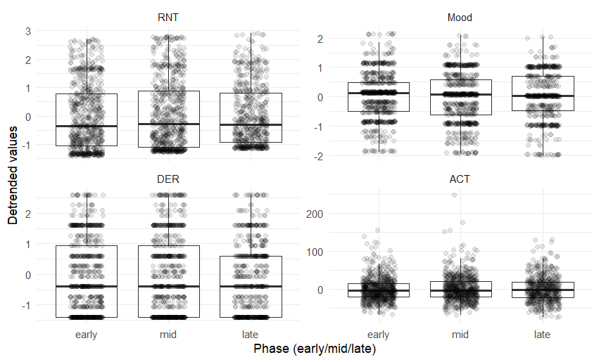
Note. Boxes show the median and interquartile range (IQR) and whiskers extend to 1.5 x IQR. RNT = Repetitive negative thinking;
DER = Difficulties in emotion regulation; ACT = Physical activity.

Figure S.2
Smoothed trajectories of absolute detrended values across therapy days for RNT, mood, DER and activity
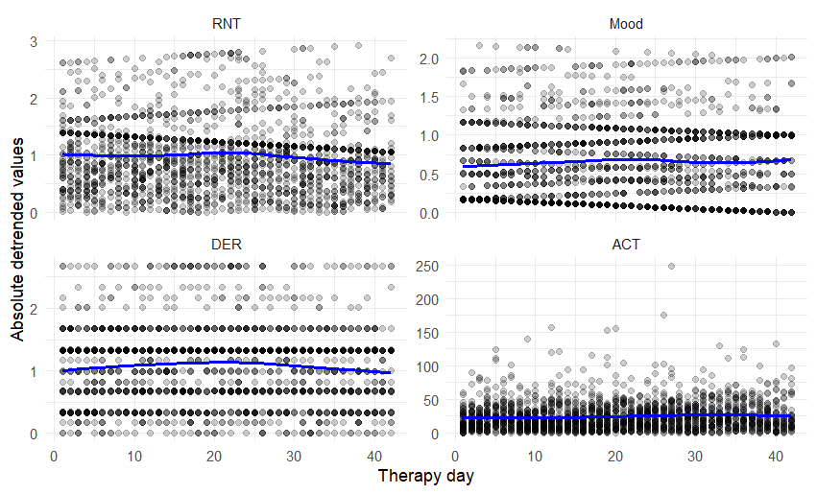
Note. The blue lines represent the smoothed trends. RNT = Repetitive negative thinking; DER = Difficulties in emotion regulation;
ACT = Physical activity.

Covariance Stationarity: Cross-Lag Variation and AR(1)
We examined whether short-lag (lag-1) cross- and autocorrelations changed across therapy. Mixed models with lagged predictors and a Phase factor (early vs. late) identified some minor Lag × Phase interactions, but none survived false discovery rate control (FDR; Benjamini & Hochberg, 1995). Person-specific first-order autoregression (AR(1)) coefficients differed only modestly on average (Δ ≈ .07–.10) with non-significant paired comparisons, suggesting largely stable within-person associations. Overall, the short-lag (co)variance structure appears reasonably stable over the six weeks.

Figure S.3
Person-specific first-order autoregression (AR(1)) coefficients in early versus late phases for RNT, mood, DER and activity
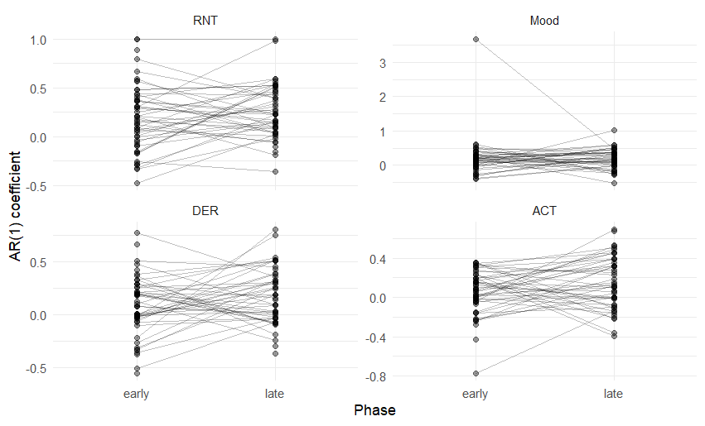
Note. Gray lines connect the same participant across phases. AR(1) coefficients were estimated from detrended, day-level series and
index same-day-to-next-day persistence. Phases: early = days 1–21; late = days 22–42. RNT = Repetitive negative thinking;
DER = Difficulties in emotion regulation; ACT = Physical activity.

Comparison of Residual Estimation Techniques and Robustness Checks
To identify the best fitting model and evaluate the robustness of our results, we compared networks models using correlated and orthogonal residual estimation techniques. Both approaches yielded highly similar results, as reflected by the strong correlations between their adjacency matrices (r = .99 for contemporaneous associations, r = .96 for temporal associations). Model fit comparisons using mlVAR indicated that the orthogonal estimation method outperformed the correlated estimation in three out of four nodes based on AIC and in all nodes based on BIC (see Table S.3.). Given its superior fit, we selected the orthogonal estimation for further robustness checks.
Specifically, we (1) applied stricter exclusion criteria by removing patients with fewer than 20 valid measurement points across the four key variables and (2) reanalyzed the data without detrending. The results remained highly consistent across these analyses. Compared to the main model (full sample with detrended data), the stricter exclusion criteria (resulting in N = 52) led to only minimal changes, with adjacency matrix correlations of r = .99 for contemporaneous and r = .97 for temporal associations. However, as the difference in sample size is relatively small, these findings should be interpreted with caution. Likewise, using non-detrended data yielded highly similar estimates (r = .99 for contemporaneous and r = .92 for temporal associations). These findings suggest that detrending might have had little impact on the overall network structure.
Table S.3
AIC and BIC for Correlated and Orthogonal Residual Model Estimation
Variable | AIC |  | BIC
 | Correlated | Orthogonal | Correlated | Orthogonal
RNT | 3077.169 | 3072.990 | 3207.634 | 3149.094
Mood | 3859.328 | 3843.488 | 3989.793 | 3919.593
DER | 3480.012 | 3471.674 | 3610.477 | 3547.779
ACT | 3437.544 | 3454.030 | 3568.008 | 3530.135
Note. Superior model is displayed in bold type. RNT = Repetitive negative thinking; DER = Difficulties in emotion regulation;
ACT = Physical activity.

Consolidated Interpretation
Across complementary checks we find no gross violations of stationarity after detrending: level stationarity (KPSS/ADF) is plausible; variance drift is small; cross-lagged dynamics and AR(1) appear stable; and network solutions are robust to preprocessing and estimator choice (r≈.99/.96; AIC/BIC). Treating the six-week, once-daily window as quasi-stationary is therefore reasonable for descriptively summarizing short-lag dynamics using two-step mlVAR.

Table S.4
Univariate Linear Regression Models
Variable | B | SE | t | p | R²
RNT |  |  |  |  | .007
(Constant) | 1.40 | 0.05 | 27.09 | < .001
Therapy Day | -0.01 | 0.00 | -3.84 | < .001
Mood |  |  |  |  | .004
(Constant) | 1.83 | 0.04 | 49.00 | < .001
Therapy Day | 0.00 | 0.00 | 2.67 | 0.008
DER |  |  |  |  | .001
(Constant) | 1.40 | 0.06 | 25.29 | < .001
Therapy Day | -0.00 | 0.00 | -1.64 | 0.102
ACT |  |  |  |  | .006
(Constant) | 77.54 | 1.47 | 52.91 | < .001
Therapy Day | 0.22 | 0.06 | 3.48 | < .001
Note. RNT = Repetitive negative thinking; DER = Difficulties in emotion regulation;
ACT = Physical activity.

Figure S.4
Individual trends for RNT across therapy
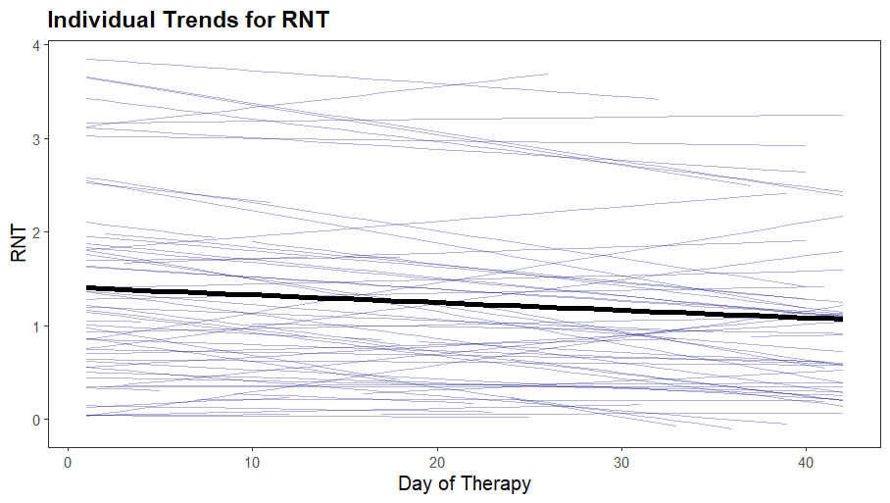
Note. Thin lines show participant-specific random-slope fits from a mixed-effects model; Thick black line shows the sample-
mean trend. Steeper slope indicates greater improvement during therapy. RNT = Repetitive negative thinking.

Figure S.5
Individual trends for mood across therapy
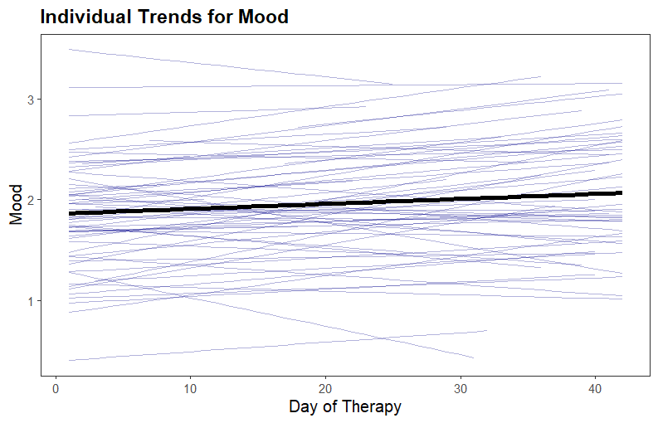
Note. Thin lines show participant-specific random-slope fits from a mixed-effects model; Thick black line shows the sample-
mean trend. Increasing mood values indicate improvement during therapy.

Figure S.6
Individual trends for DER across therapy
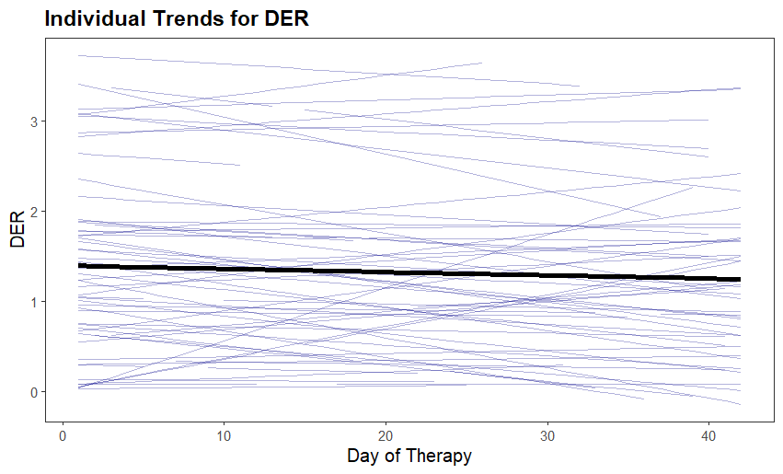
Note. Thin lines show participant-specific random-slope fits from a mixed-effects model; Thick black line shows the sample-
mean trend. Decreasing DER values indicate improvement during treatment. DER = Difficulties in emotion regulation.

Figure S.7
Individual trends for activity across therapy
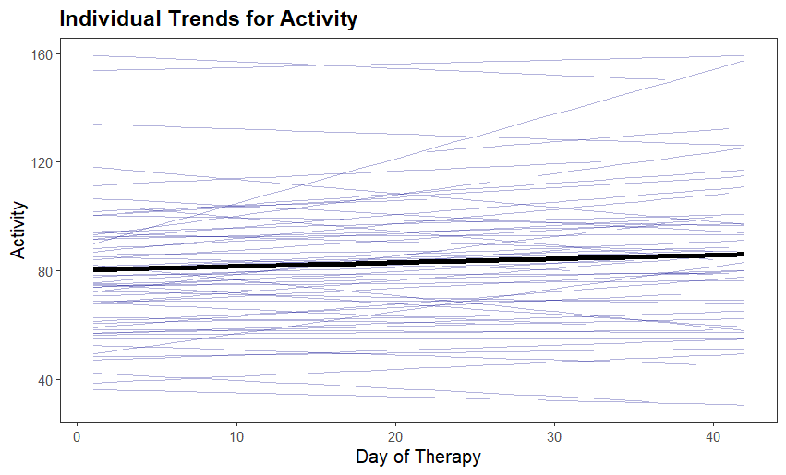
Note. Thin lines show participant-specific random-slope fits from a mixed-effects model; Thick black line shows the sample-
mean trend. Increasing activity values indicate improvement during treatment.

